Supplementry Material
Catalytic Hydrolysis of Sodium Borohydride for Hydrogen Production using Phosphorylated Silica Particles
K. Ganesan¹, C. Hayagreevan², R. Rahul², A. John Jeevagan², T. Adinaveen³,
D.S. Bhuvaneshwari¹, P. Muthukumar⁴, M. Amalraj²*
¹ Department of Chemistry, Thiagarajar College, Madurai, Tamil Nadu, India.
² Department of Chemistry, Arul Anandar College (Autonomous), Karumathur, Madurai- 625514, Tamil Nadu, India
³ Department of Chemistry, Loyola College (Autonomous), Nungambakkam,
Chennai – 600034, Tamil Nadu, India
⁴Department of Chemistry, Bannari Amman Institute of Technology (Autonomous), Sathyamangalam - 638401, Tamil Nadu, India
Corresponding author - Email: amalraj@aactni.edu.in

Corresponding author: Tel:+91-9940711883
E-mail : amalraj@aactni.edu.in

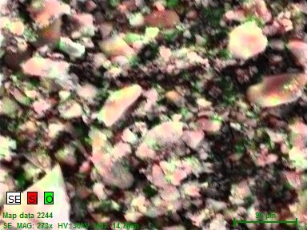
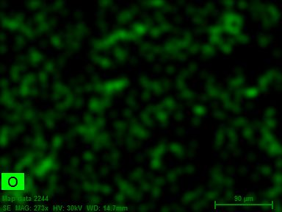
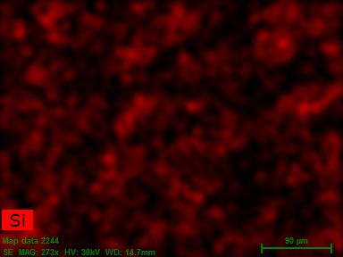

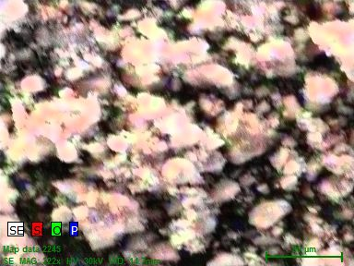
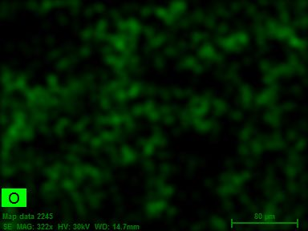
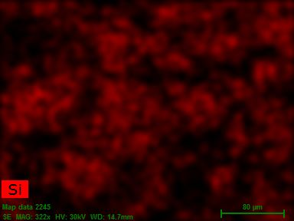
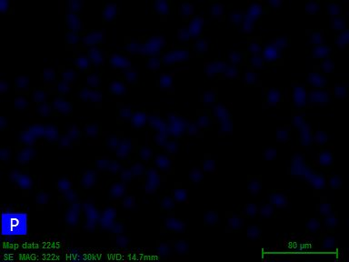

Fig. S1. Elemental mapping images of SP and SP-PA particles and the corresponding elements mapping obtained in EDAX spectra.

Fig. S2 Hydrolysis of 2% solution of NaBH₄ using SP-PA catalyst (5 mg) in neutral medium at 298 K. (Hydrogen evolution rate is calculated from the linear portion of the plot)

Table S1 Elemental analysis of SP and SP-PA using EDAX spectral data
Element | Atomic number | Series | SP |  | SP-PA
Element | Atomic number | Series | Weight % | Atomic % | Weight % | Atomic %
Silicon | 14 | K-series | 40.67 | 28.08 | 47.27 | 34.29
Oxygen | 8 | K-series | 59.33 | 71.92 | 49.13 | 63.31
Phosphorus | 15 | K-series | -- | -- | 3.60 | 2.40

Table S2. Effect of substrate concentration on the hydrogen production rate from sodium borohydride hydrolysis.
[NaBH₄] | 0.54 M | 1.35 M | 2.7 M | 4.054 M
Hydrogen evolution rate (mL min⁻¹ g⁻¹ of catalyst) | 762.4 | 1158.4 | 1590.4 | 1844.0

Table S3. Effect of catalyst concentration on the hydrogen production rate from sodium borohydride hydrolysis
[catalyst] | 5 mg | 10 mg | 15 mg | 20 mg
Hydrogen evolution rate (mL min⁻¹ g⁻¹ of catalyst) | 762.4 | 866.36 | 718.53 | 636.65

Table S4 Hydrogen evolution rate of NaBH₄ hydrolysis at SP-PA catalyst at various temperature
S. No | Temperature (K) | Hydrogen evolution rate  (mL min⁻¹ g⁻¹ of catalyst) for SP-PA
1 | 298 | 762.4
2 | 308 | 1266.0
3 | 318 | 1796.4
4 | 328 | 2303.2
5 | 338 | 3357.0

