Supplementary Information
A bifunctional-iodine coordination bismuth crystallization material: excellent photocatalytic and adsorption properties as well as mechanism investigation
Xue Min Wang^{a#}, Min Liu^{a#}, Qing Lin Guanª, Qiao Sun^{b}, Yong Heng Xing^{a*} Feng Ying Bai^{a*}
^{a#.} The authors: Xue Min Wang and Min Liu were contributed equally to this work.
ª College of Chemistry and Chemical Engineering, Liaoning Normal University, Huanghe Road 850#, Dalian, 116029, P. R. China.
^{b} School for Radiological and Interdisciplinary Sciences, Soochow University, Suzhou, 215123, P. R. China.

Table of contents
X-ray crystallographic determination 3
Section S1 The crystalline materials datas of compounds 1 and 2 4
Section S2 PXRD characterizations of the crystalline materials 6
Section S3 IR characterizations of the crystalline materials 7
Section S4 UV-vis characterizations before and after adsorption of the crystalline materials 9
Section S5 TG characterizations of the crystalline materials 11
Section S6 The structures of the dyes 12
Section S7 The degradation result of the RhB for crystalline material 2 15
Section S8 Standard curve of the dyes 16
Section S9 Crystalline material 1 @ CBB photodegradation curves of cationic dyes 19
Section S10 Dynamic linear relationship 20
Section S11 The PXRD of before and after reaction of the crystalline material 1 23
Section S12 The IR of before and after reaction of the crystalline material 1 24
Section S13 The AFM image of before and after reaction of the crystalline material 1 25

X-ray crystallographic determination
Single crystals of the compounds of block orange 1 and pale yellow 2 were mounted on glass fibers for X-ray measurement, respectively. Reflection data were collected at room temperature on a Bruker AXS SMART APEX II CCD diffractometer with graphite monochromatized Mo-Kα radiation (λ = 0.71073 Å). All the measured independent reflections (I>2σ (I)) were used in the structural analyses, and semi-empirical absorption corrections were applied using the SADABS program^{[1]}. All calculations were performed in OLEX2 platform^{[2,3]}. All non-hydrogen atoms were refined anisotropically. The hydrogen atoms of the organic frameworks were geometrically fixed at calculated positions and refined using a riding model. For compound 1, the lattice phen was protonated for the charge balance. The crystal was measured using a single axis diffractometer, we made various attempt to grow crystals of the better quality without success. Making many attempts to synthesize a good quality crystal, however, present result is the best data. We tried to resolve alerts A and B of Checkcif in compound 1, unfortunately, all the efforts failed. For A and B alerts, we make the following explanations. (I) PLAT971_ALERT_2_A: This alert A may be because the relatively large residual density is close toheavy halogen atom, which might be caused by the electronicpolarization of the corresponding halogen atom, or unsuitableabsorption correction. (Ⅱ) PLAT972_ALERT_2_A: These issues of alert level A possibly result from residual density to remain near heavy atoms, the size of the positive and negative ripples is less than 4% of the number of electrons on the heaviest atom (Bi) and approximately equal. The low symmetry of the structure means the multi-scan absorption correction may not be optimal. (Ⅲ) PLAT973_ALERT_2_A: Bi1 is a heavy atom and this alert is often found for molecules. (Ⅳ) PLAT342_ALERT_3_B: This problem arised from the weak X-ray diffraction of the crystal at high angles. (Ⅴ) PLAT972_ALERT_2_B: This alert, probably due to difficulties in absorption correction. The crystallographic data for compounds were given in Table S1. The selected bond distances (Å) were given in Table S2.

Section S1 The crystalline materials datas of compounds 1 and 2
Table S1 Crystal data and structure refinement for 1 and 2
Compounds | 1 | 2
Empirical formula | C₄₈H₃₄N₈I₈Bi₂ | C₂₄H₁₆N₇O₉Bi
Formula weight | 2155.99 | 755.42
Temperature / K | 296.15 | 296.15
Crystal system | Monoclinic | Monoclinic
Space group | P2₁/c | C2/c
a / Å | 16.073(2) | 11.176(4)
b / Å | 22.268(3) | 17.789(5)
c / Å | 15.168(2) | 12.990(6)
α (deg) | 90 | 90
β (deg) | 100.448(2) | 100.843(4)
γ (deg) | 90 | 90
V / Å ³ | 5338.6(13) | 2536.3(16)
Z | 4 | 4
D_{c} / (g.cm⁻³) | 2.682 | 1.978
μ / mm⁻¹ | 11.252 | 7.020
F(000) | 3872 | 1456
θ range for data collection / (°) | 2.576 to 50.054 | 4.36 to 62.854
Reflections collected | 30263 | 8810
Goodness-of-fit on F² | 1.048 | 1.048
Data / restraints / parameters | 9411/27/599 | 3687/0/187
R₁[I>2σ(I)]ª | 0.0792(0.1024)^{b} | 0.0228(0.0270)^{b}
wR₂[I>2σ(I)]ª | 0.2356(0.2543)^{b} | 0.0517(0.0534)^{b}
ªR=Σ⎢⎢Fo⎢–⎢Fc⎢⎢/Σ⎢Fo⎢, wR₂ =(Σ(w(Fo²–Fc²)²/Σ(w(Fo²)²)^{1/2}; [Fo>4σ(Fo)]. ^{b}Based on all data.

Table S2 Select the bond length (Å) of the compounds 1 and 2*
1
Bi1-N1 | 2.541(16) | Bi1-N2 | 2.579(18)
Bi1-I4 | 2.926(4) | Bi1-I1 | 2.972(2)
Bi1-I2 | 3.0113(16) | Bi1-I3 | 3.0178(18)
Bi2-N4 | 2.501(15) | Bi2-N3 | 2.562(17)
Bi2-I8 | 2.786(6) | Bi2-I5 | 2.9936(17)
Bi2-I7 | 3.0178(18) | Bi2-I6 | 3.0195(17)
2
Bi1-N1 | 2.516 (2) | Bi1-O1^{#1} | 2.590(2)
Bi1-N1^{#1} | 2.516(2) | Bi1-O2 | 2.608(2)
Bi1-N2 | 2.499(2) | Bi1-O2^{#1} | 2.608(2)
Bi1-N2^{#1} | 2.499(2) | Bi1-O4 | 2.629(3)
Bi1-O1 | 2.590(2) | Bi1-O4^{#1} | 2.629(3)
*Symmetry codes: #1: -x+1, y, -z+3/2.

Table S3 The bond lengths (Å) and bond angles (°) of hydrogen bond in 2*
2
D-H···A | d(D-H) | d(H···A) | d(D···A) | <(DHA)
C11^{#2}-H11^{#2}...O5^{#3} | 0.93 | 2.43 | 3.277(5) | 152.2
*Symmetry codes: compound 2: #2: 2-x, -2+y, -0.5-z; #3: 2-x, -1-y, -z.

Section S2 PXRD characterizations of the crystalline materials
Figure S1 The PXRD of the compound 1
Figure S2 The PXRD of the compound 2

Section S3 IR characterizations of the crystalline materials

.
Figure S3 The IR spectra of the compound 1
Figure S4 The IR spectra of the compound 2

Table S4 The IR spectra adscription (cm⁻¹) and comparison of the ligand and the compounds
 | Compound 1 | Compound 2 | phen
ν_{(Ar-H)} | 3039 | 3064 | 3060
ν _{C=N} | 1515 | 1520 | 1586
ν_{C=C} | 1535 | 1480 | 1504
δ_{C}-_{H} | 846,712 | 844,723 | 882,738
ν_{NO3}⁻ | - | 1310 | -

Section S4 UV-vis characterizations before and after adsorption of the crystalline materials

a
b
Figure S5 a. The UV–vis spectra of the compounds 1 and 2, b. The UV–vis spectra of the compound 1 after adsorption dyes
Table S5 The attribution of UV-vis spectra (nm) of compounds 1 and 2
Compounds | 1 | 2
LLCT(π-π*, n-π*) | 220, 261 | 214, 255
LMCT | 426, 490 | 307, 340

Section S5 TG characterizations of the crystalline materials
Figure S6 The TG curve of compound 1
Figure S7 The TG curve of compound 2

Section S6 The structures of the dyes
Rhodamine B(RhB)
Crystal Violet(CV)
Methylene Blue (MB)

4.Methyl Violet(MV)
- Safranine T(SFT)

6.Rose Bengal sodium salt(RBS)

7. Orange G(OG)
8. Eosin
9. Coomassie Brilliant Blue,(CBB)
10. Methyl Orange(MO)
Figure S8 The structures of dyes used in the article

Section S7 The degradation result of the RhB for crystalline material 2
Figure S9 The result of compound 2 degraded the RhB

Section S8 Standard curve of the dyes

Figure S10 Standard curve of the dyes used in the work

Section S9 Crystalline material 1 @ CBB photodegradation curves of cationic dyes

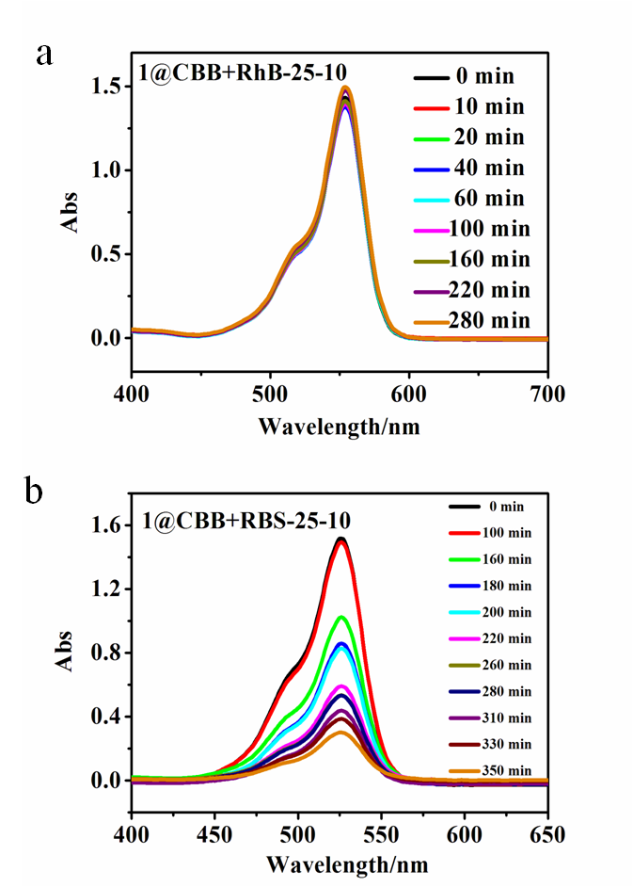
Figure S11 a. Compound 1 after absorbing CBB degrade curves of dye RhB (Each dye concentration is 10 mg/L); b. Compound 1 after absorbing CBB degrade curves of dye RBS (Each dye concentration is 10 mg/L)

Section S10 Dynamic linear relationship

(a)

(b)

(c)

(d)

(e)

(f)
Figure S12 Dynamic linear relationship of log(Qe-Qt) against the reaction time of the photodegradation of different concentration dyes(a-c) and t/Qt against the reaction time of the adsorption of different concentration dyes(d-f)

Section S11 The PXRD of before and after reaction of the crystalline material 1

a
b
Figure S13 a. The PXRD of before and after photocatalytic of the compound 1; b. The PXRD of before and after adsorption of the compound 1

Section S12 The IR of before and after reaction of the crystalline material 1
a
b
Figure S14 a. The IR of before and after photocatalytic of the compound 1; b. The IR of before and after adsorption of the compound 1

Section S13 The AFM image of before and after reaction of the crystalline material 1
a b
c d
Figure S15 a, c. Before absorbing of the surface compound 1; b, d. After absorbing CBB and MO molecules of the surface compound 1

References
[1]. SMART and SAINT (software packages); Siemens Analytical X-ray Instruments, Inc.: Madison, WI, 1996.
[2]. O. V. Dolomanov，L.J. Bourhis，R.J. Gildea，J. Howard，H. Puschmann, Journal of Applied Crystallography, 2009, 42, 339-341.
[3]. G. M. Sheldrick, Acta Crystallographica, 2015, 71, 3-8.

