Inhibition of nucleophosmin/B23 sensitizes gynecological cancer cells to anti-PD-L1 therapy

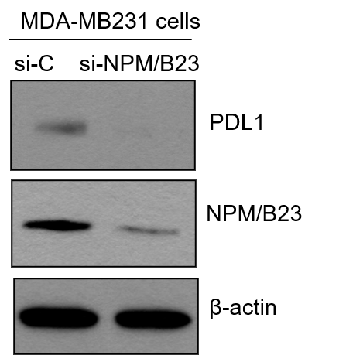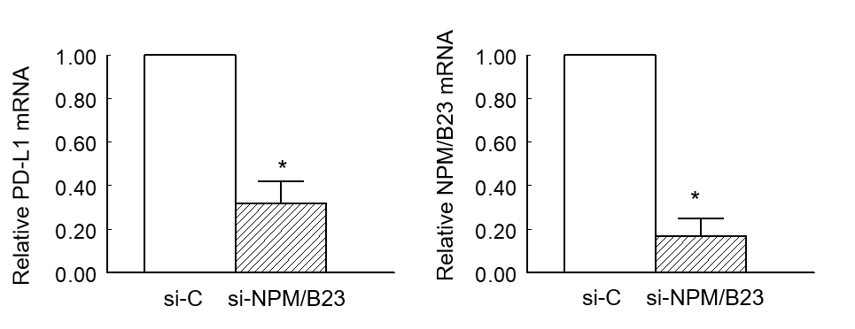
Supplementary Fig. 1 Effect of NPM/B23 regulates PD-L1 expression. MDA-MB231 cells were harvested after exposure to si-C or si-NPM/B23 for 72h. Equal amounts of whole-cell extracts were subjected to immunoblots with antibodies raised against specific antibodies and quantitative real-time PCR with specific primers. * p <0.05 as compared to the controls.

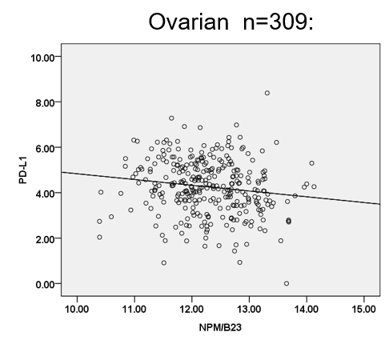

Supplementary Fig. 2 A significant negative correlation between NPM/B23 and PD-L1 expression levels in the Cancer Genome Atlas. Scattergram and regression line showing a significant negative correlation (r=-0.145, p=0.010) between NPM/B23 and PD-L1 expression levels in the RNAseq dataset of The Cancer Genome Atlas Ovarian was downloaded from the cBioPortal for Cancer Genomics (http://www.cbioportal.org/).

