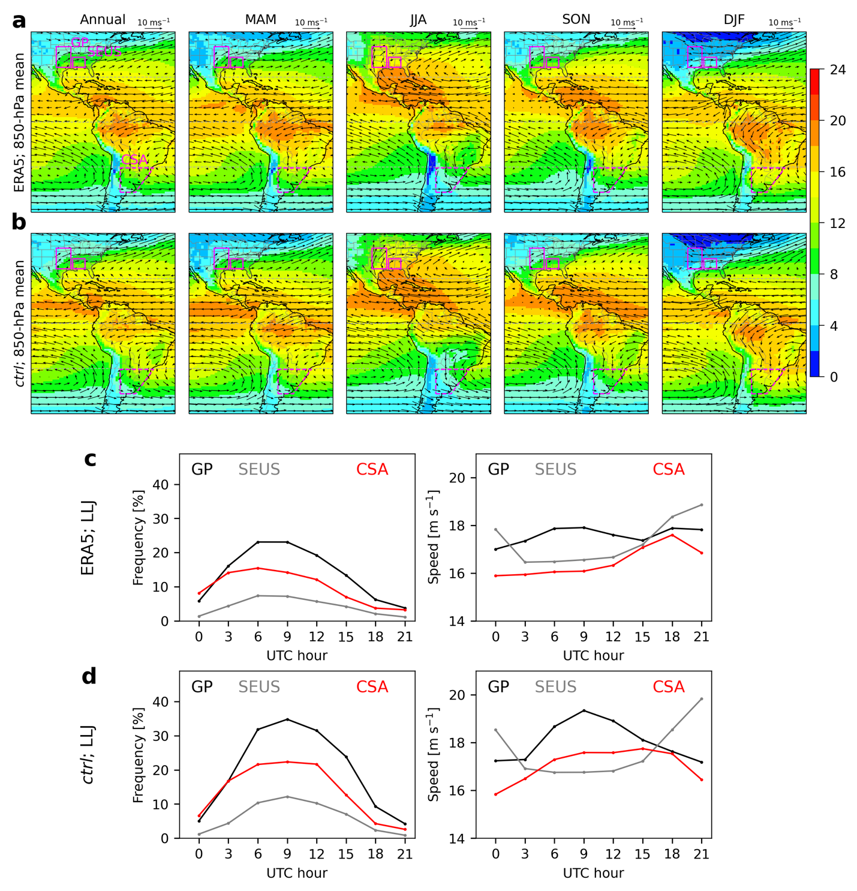
Extended Data Fig. 1 | Climatological low-level mean state and statistics of low-level jet (LLJ)in ERA5 reanalysis data versus CESM ctrl simulation. (a) Annual and seasonal mean wind vector at 850 hPa (m s⁻¹) and 2-m specific humidity (color; g kg⁻¹) for 1980–2014 from ERA5. (b) As in (a) but from ctrl. (c) Diurnal cycle of mean frequency (%) and core wind speed (m s⁻¹) for LLJ within the Great Plains (GP), Southeast U.S. (SEUS), and central South America (CSA) from ERA5. (d) As in (c) but from ctrl. GP, SEUS, and CSA are indicated by boxes in (a–b). Criteria for detecting LLJ are the same as (107), except that the core wind vector must have a southerly component over North America or a northerly component over South America (detail in 83).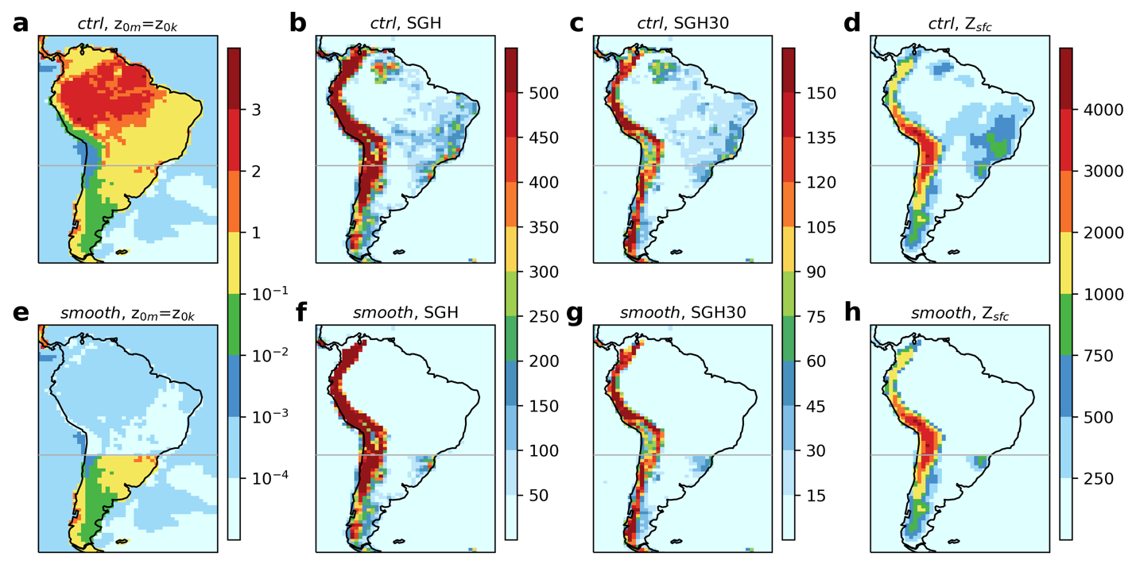
Extended Data Fig. 2 | CESM representations of tropical South American land surface in ctrl versus smooth. (a–d) Momentum and enthalpy roughness length (z_{0m}, z_{0k}; [m]), standard deviation of 10-min elevations (SGH; [m]), standard deviation of elevations from 30 s to 10 min (SGH30; [m]), and surface elevations (Z_{sfc}; [m]) in ctrl. (e–h) As in (a–d) but in smooth.
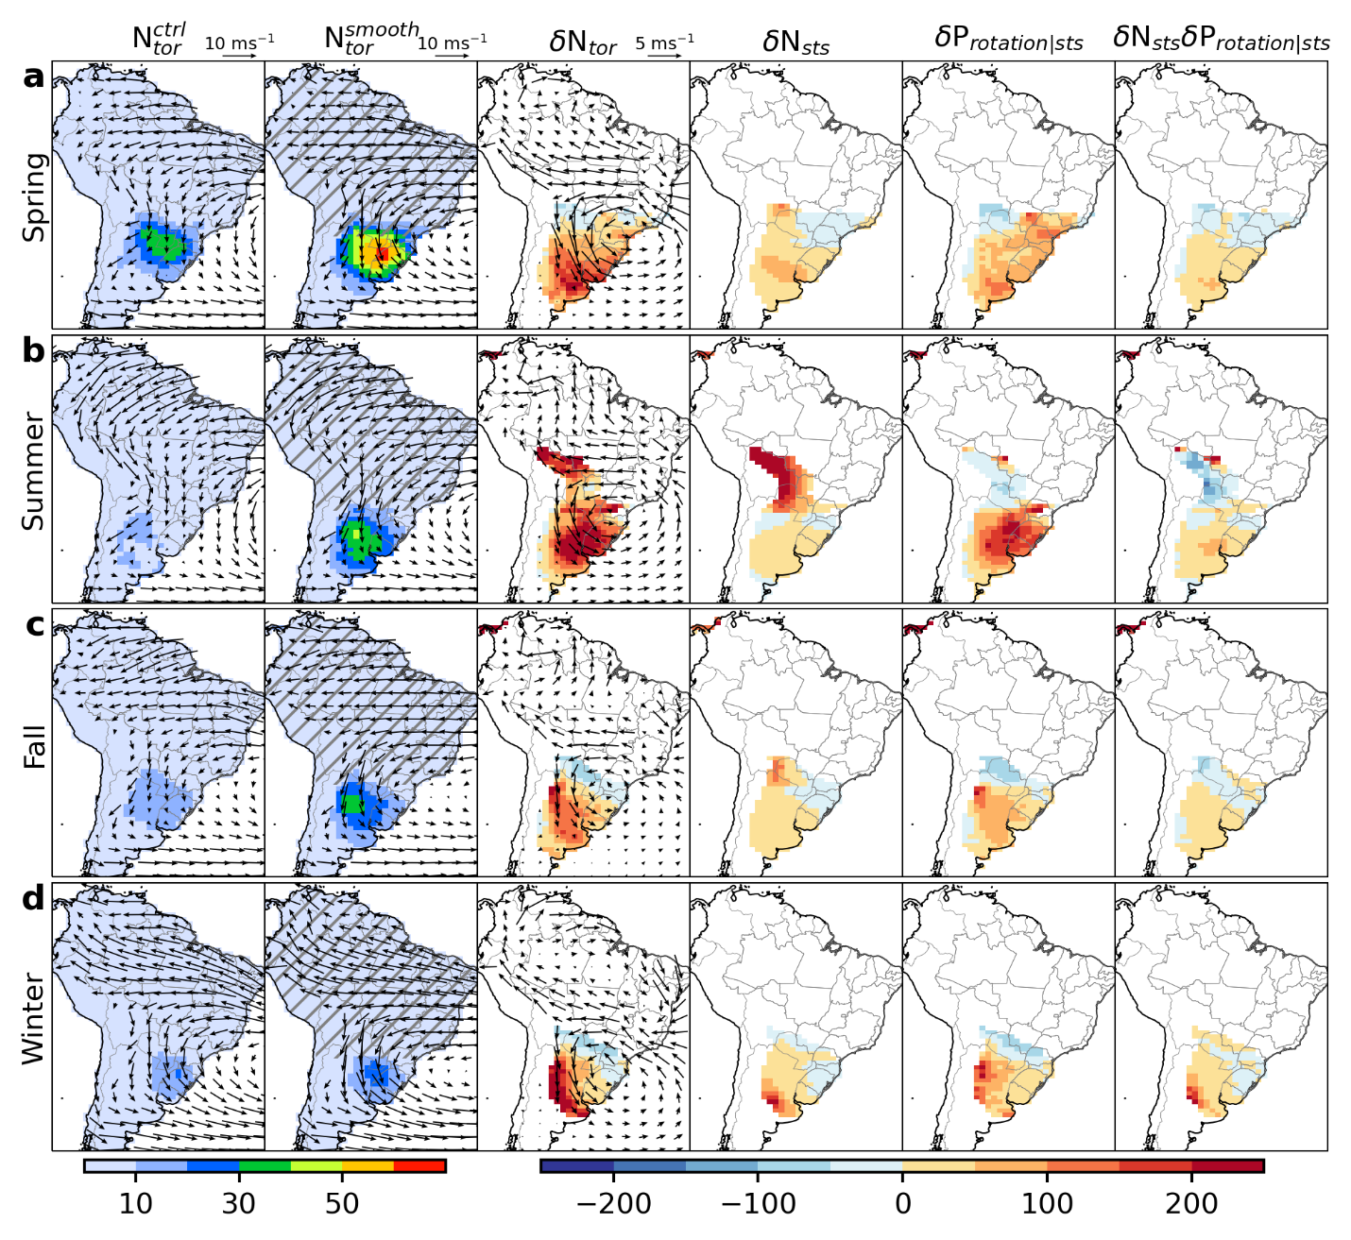
Extended Data Fig. 3 | Seasonal responses in smooth as compared to ctrl. As in Fig. 2 but for each austral season: (a) spring, September–November, (b) summer, December–February, (c) fall, March–May, (d) winter, June–August.

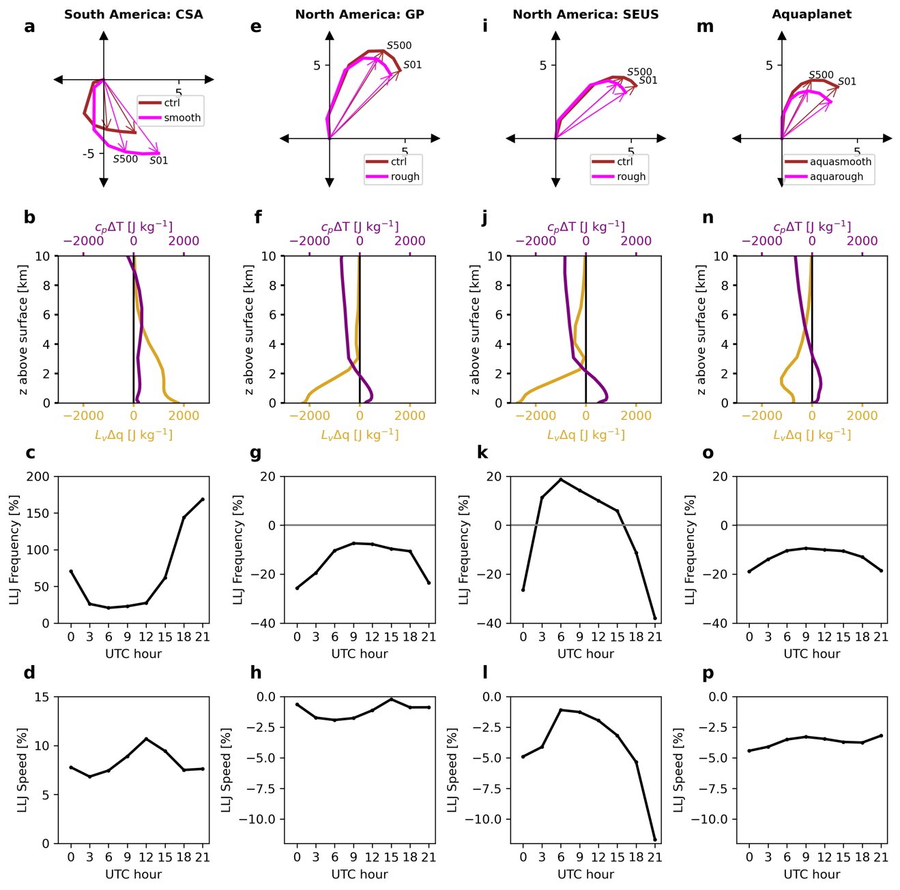
Extended Data Fig. 4 | Responses in composite vertical profiles of wind shear, temperature (T), and specific humidity (q), and responses in LLJ across all experiments. (a) Annual mean vertical wind shear profiles (m s⁻¹) conditioned on severe thunderstorm environments for CSA (dashed box in Fig. 2) from ctrl and smooth. Arrows indicate vertical wind shear from the surface to 500 m (denoted as S500) and to 1 km above (denoted as S01). (b) Differences of annual mean $c_{p}T$ and $L_{v}q$ in smooth as compare to ctrl for CSA. The factors c_{p} = 1004.64 J kg⁻¹ K⁻¹ and L_{v} = 2.501$×$10⁶ J kg⁻¹ normalize their changes in terms of contributions to moist static energy. (c) Percentage differences (%) of annual LLJ frequency within CSA from smooth relative to ctrl, as a function of UTC hours. (d) As in (c) but for percentage differences of annual mean core wind speed of LLJ. LLJ is detected using the same criteria as in Extended Data Fig. 1c–d (detail in 83). (e–h) As in (a–d) but for rough as compare to ctrl for the Great Plains of CNA (large solid box within the dashed box in Fig. 3). (i–l) As in (a–d) but for rough as compare to ctrl for the Southeast of CNA (small solid box within the dashed box in Fig. 3). (m–p) As in (a–d) but for aquasmooth as compare to aquarough for the continent al interior region (dashed box in Fig. 4).
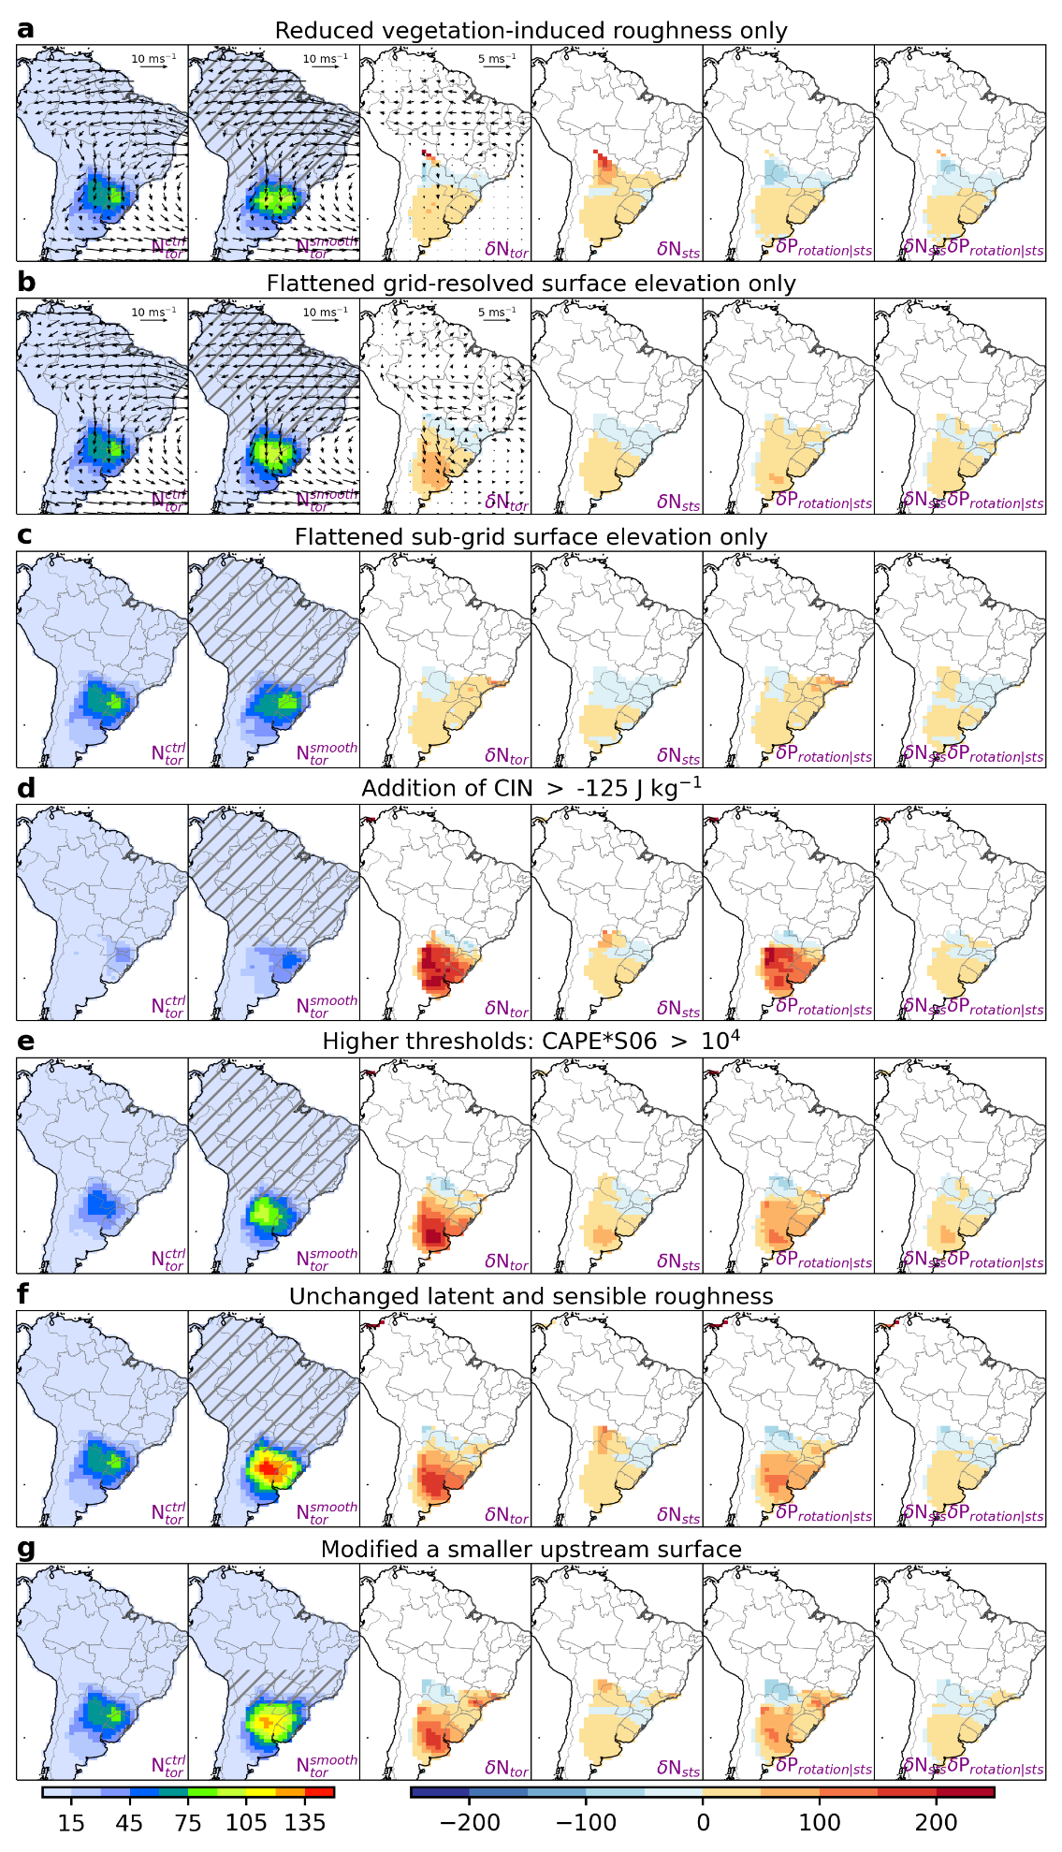
Extended Data Fig. 5 | Robustness tests for the finding that a smooth and flat ocean-like upstream land surface (the hatched area) enhances tornado potential over CSA. As in Fig. 2, but for (a) responses in the experiment with only reduced z_{0m} and z_{0k}, (b) responses in the experiment with only flattened grid-resolved elevation, (c) responses in the experiment with only flattened sub-grid elevation, (d) responses in smooth given modified definition of severe thunderstorm environments with the addition of CIN > -125 J kg⁻¹, (e) responses in smooth given modified definition of severe thunderstorm environments using higher thresholds for CAPE and S06 such that CAPE$×$S06 > 10⁴, (f) responses in the experiment that is the same as smooth but with z_{0k} remained the same as in ctrl, and (g) responses in the experiment that is the same as smooth but with modifications over a smaller upstream surface.
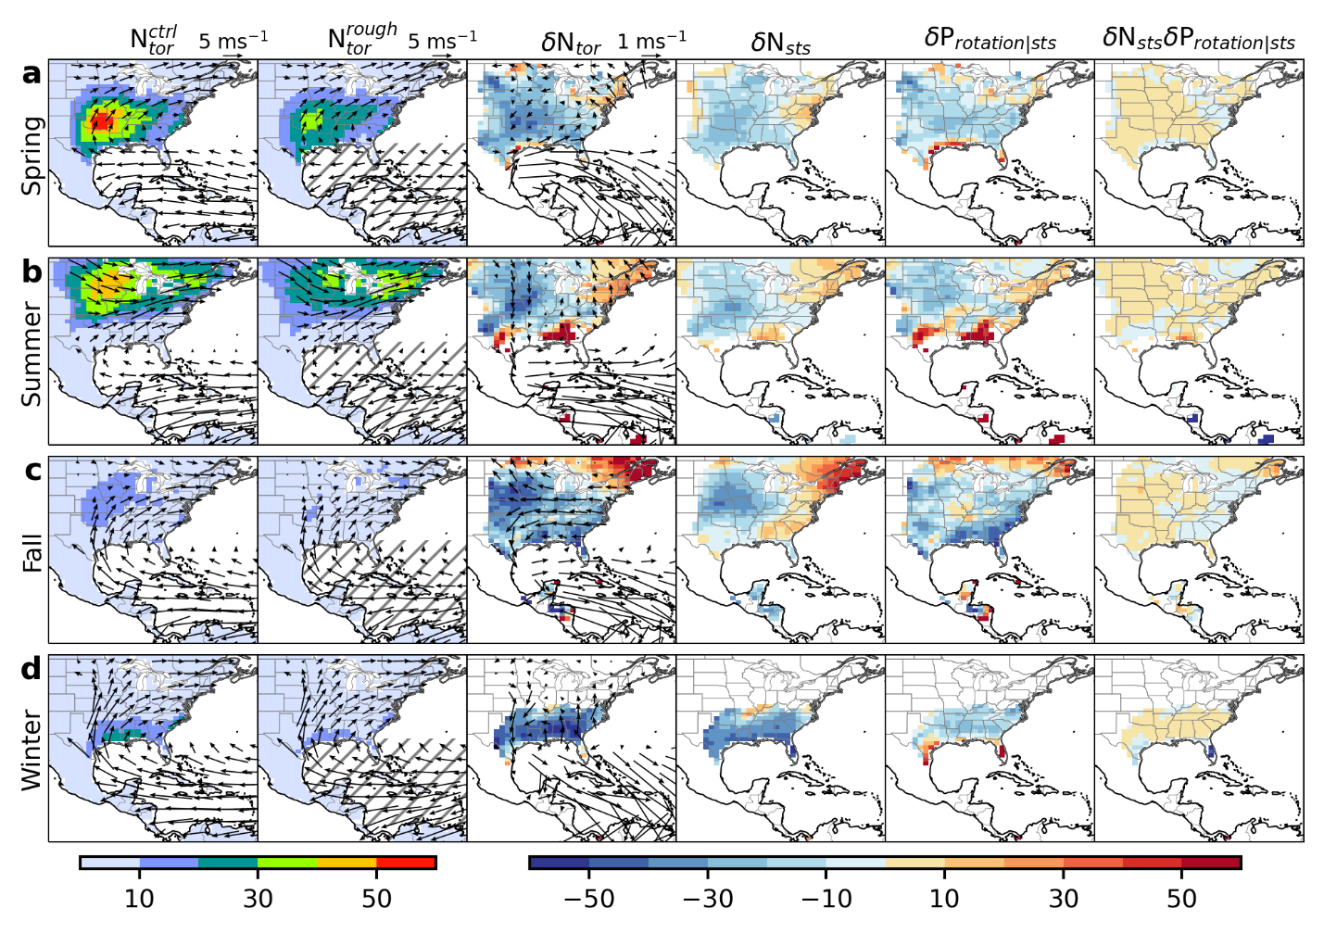
Extended Data Fig. 6 | Seasonal responses in rough as compared to ctrl. As in Fig. 3 but for each boreal season: (a) spring, March–May, (b) summer, June–August, (c) fall, September–November, (d) winter, December–February.

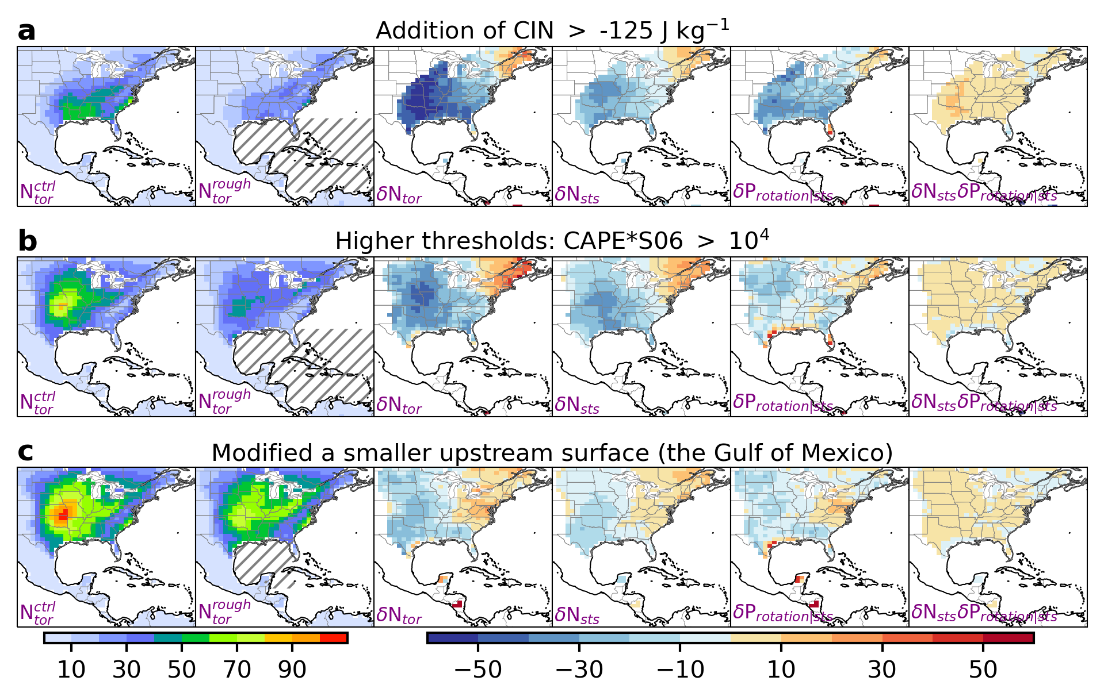

Extended Data Fig. 7 | Robustness tests for that a roughened upstream ocean surface (the hatched area) suppresses tornado potential over CNA. As in Fig. 3, but for (a) responses in rough given modified definition of severe thunderstorm environments with the addition of CIN > -125 J kg⁻¹, (b) responses in rough given modified definition of severe thunderstorm environments using higher thresholds for CAPE and S06 such that CAPE$×$S06 > 10⁴, and (c) responses in the experiment that is the same as rough but with modifications over a smaller upstream surface (i.e., the Gulf of Mexico only).
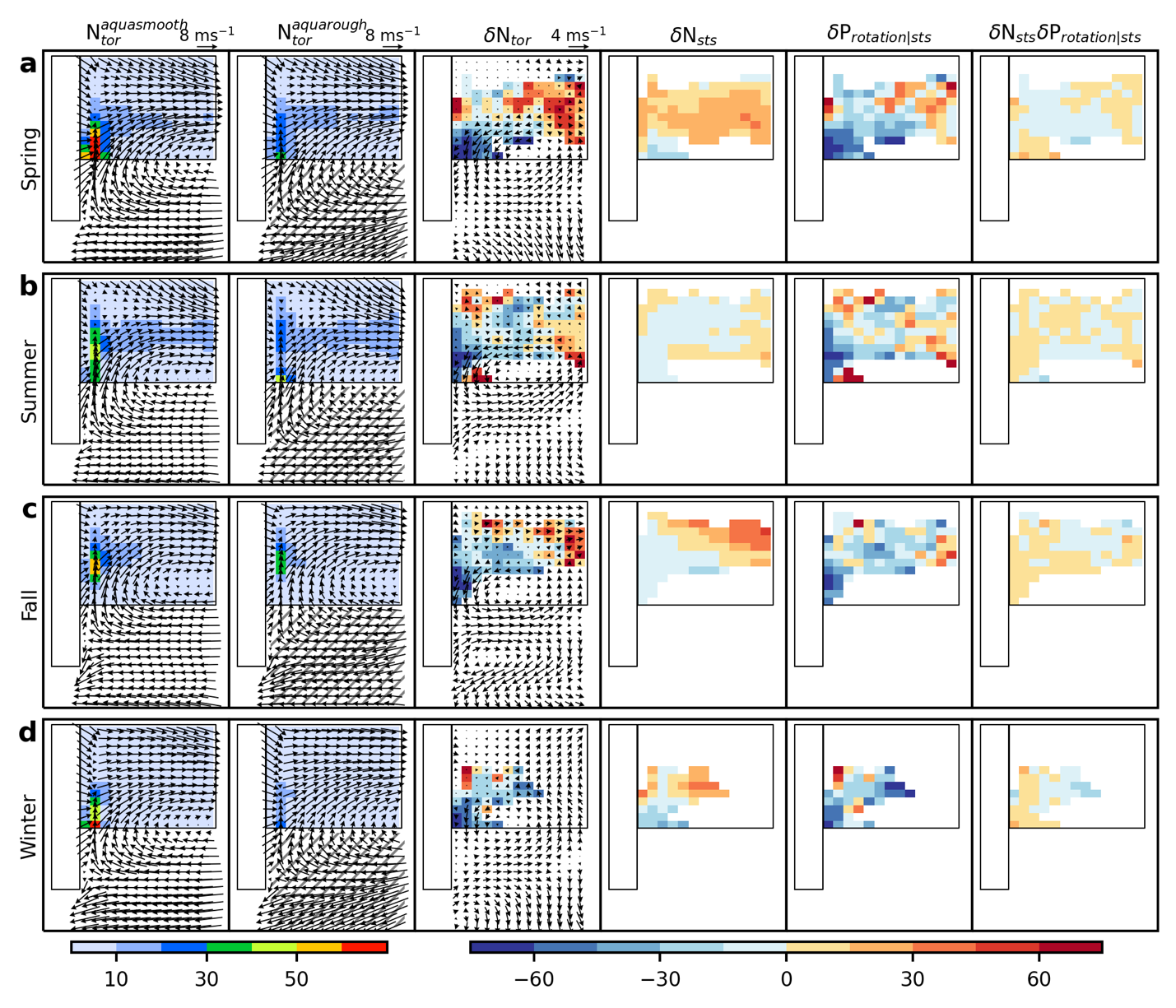
Extended Data Fig. 8 | Seasonal responses in aquarough as compared to auqactrl. As in Fig. 4 but for each boreal season: (a) spring, March–May, (b) summer, June–August, (c) fall, September–November, (d) winter, December–February.
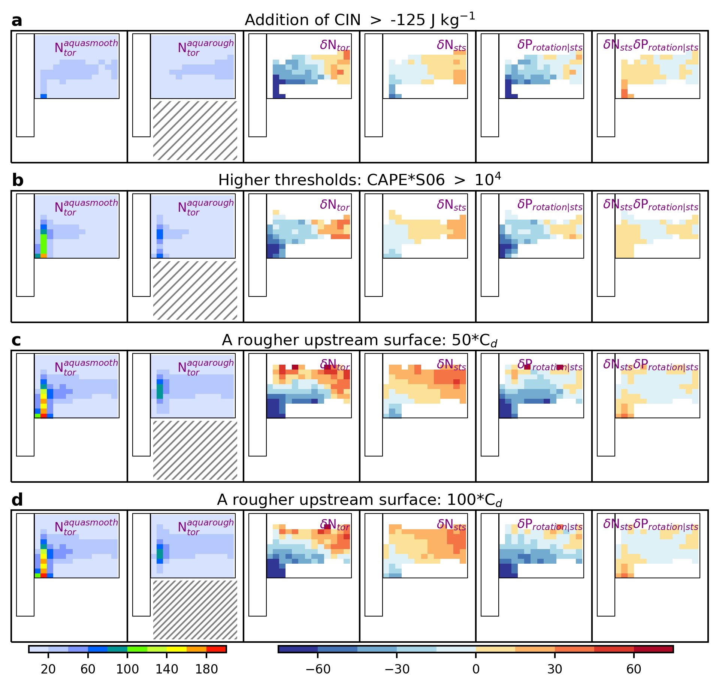
Extended Data Fig. 9 | Robustness tests for the generalized results in idealized aquaplanet GCM experiments. As in Fig. 4, but for (a) responses in aquarough given modified definition of severe thunderstorm environments with the addition of CIN > -125 J kg⁻¹, (b) responses in aquaarough given modified definition of severe thunderstorm environments using higher thresholds for CAPE and S06 such that CAPE$×$S06 > 10⁴, (c) responses in the experiment that is the same as aquarough but with the upstream surface roughness enhanced by a factor of 50, and (d) responses in the experiment that is the same as aquarough but with the upstream surface roughness enhanced by a factor of 100.
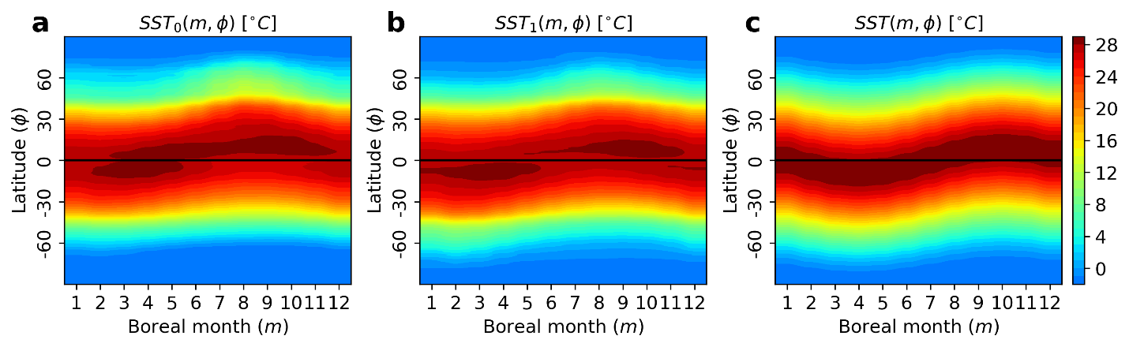
Extended Data Fig. 10 | Prescribed SST in idealized aquaplanet experiments. (a) Monthly and zonal mean SST (ºC) as a function of boreal month ($m$) and latitude ($∅$) for 1980–2014 from ERA5 reanalysis data, denoted as ${SST}_{0}(m,∅)$. (b) Hemispherically symmetric SST based on Eq. 7, denoted as ${SST}_{1}\left(m, ∅\right)$. (c) Parameterized $SST\left(m, ∅\right)$ based on Eq. 8.
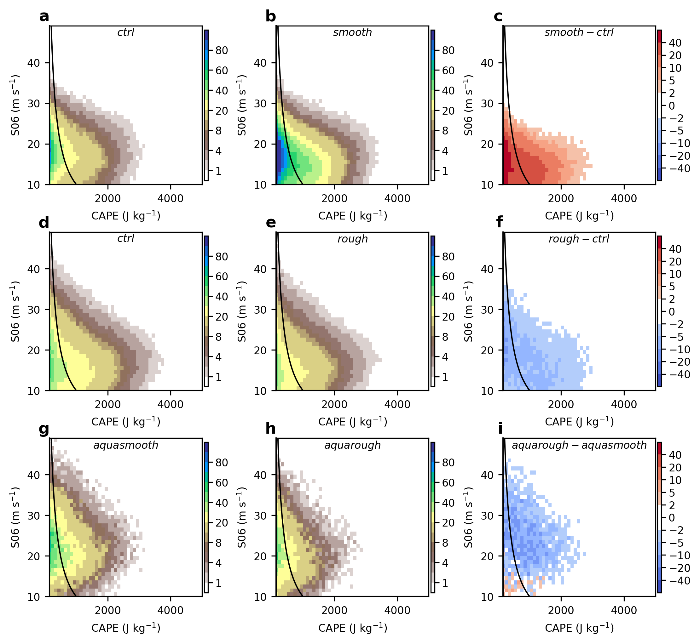

Extended Data Fig. 11 | Joint histogram (annual mean counts) of CAPE and S06 for samples conditioned on tornadic environments (i.e., CAPE > 150 J kg⁻¹, S06 > 10 m s⁻¹, and SRH01 > 200 m² s⁻²). (a–c) for CSA (dashed box in Fig. 2) from ctrl (a), smooth (b), and difference between smooth and ctrl (c). (d–f) for CNA (dashed box in Fig. 3) from ctrl (d), rough (e), and difference between rough and ctrl (f). (g–i) for the continental interior region (dashed box in Fig. 4) from aquasmooth (g), aquarough (h), and difference between aquarough and aquasmooth (i). Counts in (d–f) and (g–i) are normalized by the number of grids in CSA in (a–c) for comparability. Black lines represent CAPE$×$S06 = 10⁴.

