Supplement to: Multiomics analysis reveals that hepatocyte nuclear factor 1β regulates axon guidance genes in the developing mouse kidney

Annie Shao^{1,2}, Micah D Gearhart³, Siu Chiu Chan¹, Zhen Miao⁴, Katalin Susztak⁴, and *Peter Igarashi^{1,2}

*Address for correspondence: Peter Igarashi, M.D., Department of Medicine, University of Minnesota Medical School, 420 Delaware Street SE, MMC 194, Minneapolis, MN 55455, USA, igarashi@umn.edu

¹Department of Medicine, University of Minnesota Medical School, Minneapolis, Minnesota, USA
²Molecular, Cellular, Developmental Biology and Genetics Graduate Program, University of Minnesota, Minneapolis, Minnesota, USA
³Department of Genetics, Cell Biology and Development, University of Minnesota, Minneapolis, Minnesota, USA
⁴Renal, Electrolyte, and Hypertension Division, Department of Medicine, University of Pennsylvania, Perelman School of Medicine, Philadelphia, Pennsylvania, USA

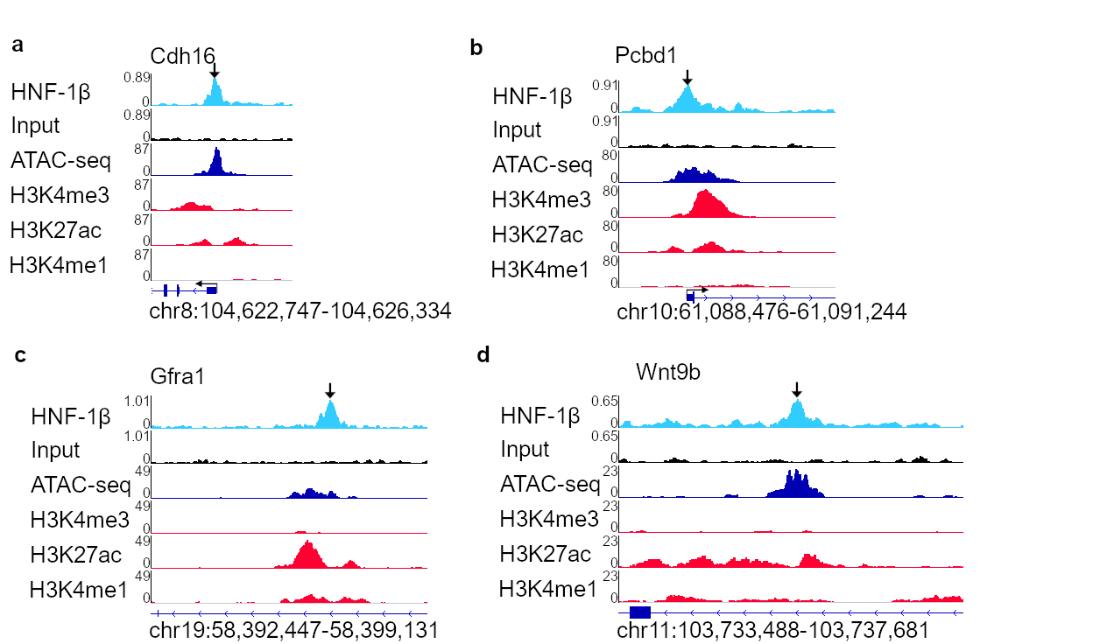
Supplementary Figure 1. Open chromatin and activating histone marks at known HNF-1β binding sites. HNF-1β binding, input DNA, ATAC-seq, H3K4 trimethylation (H3K4me3), H3K27 acetylation (H3K27ac), and H3K4 monomethylation (H3K4me1) are shown for the Cdh16 promoter (A), Pcbd1 promoter (B), Gfra1 intron 4 (C), and Wnt9b intron 1 (D). Thin blue lines indicate introns, and thick blue lines indicate exons. The transcription start site and direction of transcription are indicated by the bent arrow. HNF-1β ChIP-seq peaks are indicated with vertical arrows.
Supplementary Figure 2. Comparison of epigenetic marker enrichment at HNF-1β binding sites. A) Overlap of ATAC-seq, H3K27 acetylation (H3K27ac), H3K4 monomethylation (H3K4me1), and H3K4 trimethylation (H3K4me3) with HNF-1β binding peaks. The total number of peaks in each category is shown in the histograms. B) Comparison of HNF-1β binding, ATAC-seq signal, H3K27ac, and H3K4me1 in genes that are directly activated (A) or repressed (R) by HNF-1β. Binding in promoter regions is shown. Normalized enrichment values are shown as reads per kilobase of transcript (RPKM). Boxplots indicate the median and interquartile range. Asterisks indicate statistically significant differences using the Wilcoxon test (*, p<0.05. ns, p≥0.05). Median and mean enrichment values and individual Wilcoxon test results can be found in Supplementary Table 5.
Supplementary Figure 3. Isolation of ureteric bud cells from wild-type E14.5 mouse kidneys. A) Sagittal section of a Hoxb7/Cre;Hnf1b^{fl/+};tdT E14.5 kidney stained with anti-RFP (TdTomato) antibody (red). DAPI nuclear staining is shown in blue. Scale bar indicates 50 µm. B) Flow cytometry forward and side scatter used to purify single cells. Right panel shows gating of TdTomato fluorescence to purify UB cells (red) from non-UB controls (blue). C) Yield of cells is shown as numbers and percentages.

Supplementary Figure 4. Isolation of UB cells from HNF-1β mutant E14.5 mouse kidneys. A) Sagittal section of a Hoxb7/Cre;Hnf1b^{fl/fl};tdT E14.5 kidney stained with anti-RFP (TdTomato) antibody (red). DAPI nuclear staining is shown in blue. Scale bar indicates 50 µm. B) Flow cytometry forward and side scatter used to purify single cells. Right panel shows gating of TdTomato fluorescence to purify UB cells (red) from non-UB controls (blue). C) Yield of cells is shown as numbers and percentages.

Supplementary Figure 5. Lack of enrichment of repressive histone marks at HNF-1β binding sites. Enrichment of H3K27 trimethylation (H3K27me3) and H3K9 trimethylation (H3K9me3) at HNF-1β binding sites in chromatin from E14.5 kidney. Enrichment is shown for genes that are activated by HNF-1β (upper panel), repressed by HNF-1β (middle panel), or unchanged in expression (lower panel). Peaks are centered on HNF-1β binding sites (left panels). Top panel shows total binding in the activated (red line), repressed (blue line), and unchanged genes (green line).

Supplementary Figure 6. Pathway analysis of HNF-1β gene targets in E14.5 kidney. Pathway analysis was performed on genes that contained nearby HNF-1β binding sites by ChIP-seq and were also differentially expressed in HNF-1β mutant UB cells compared to wild-type UB cells.

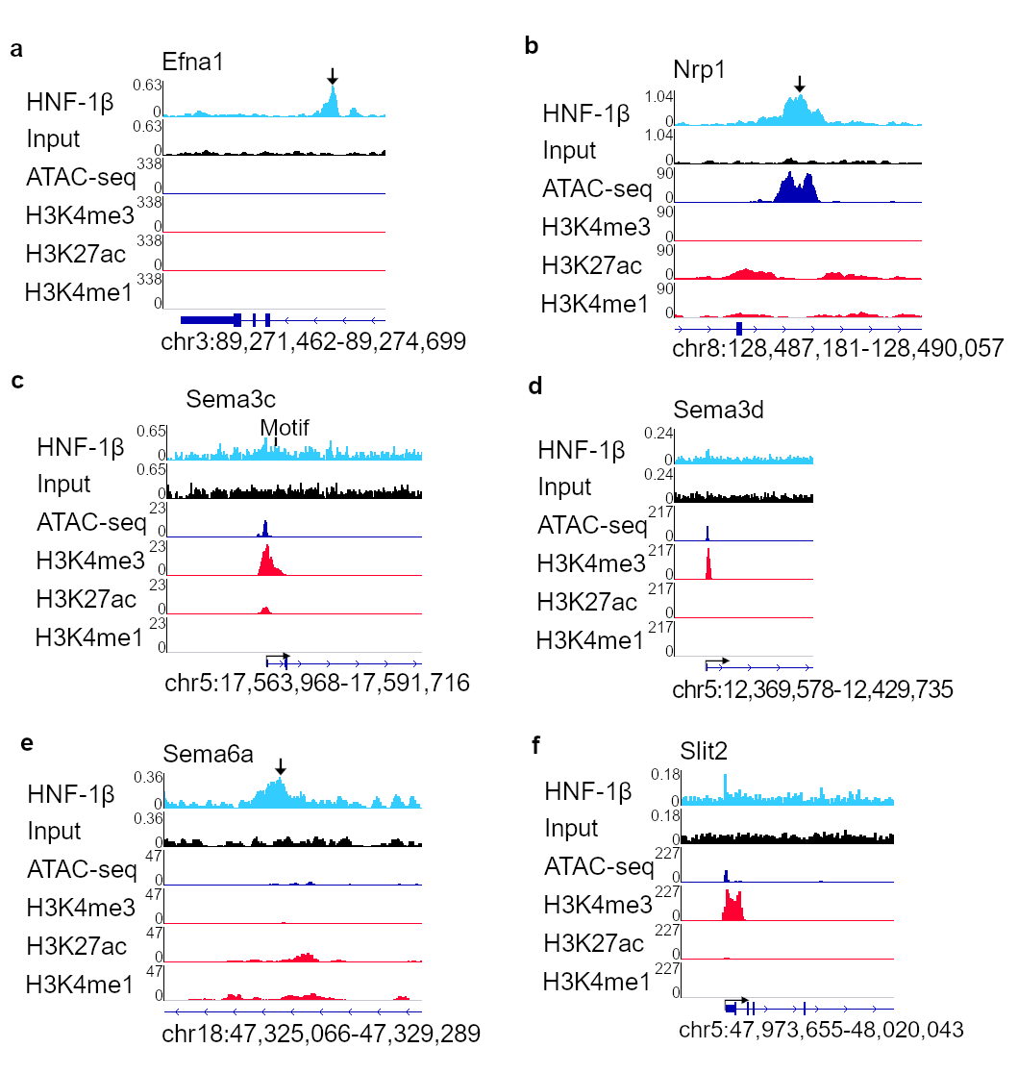
Supplementary Figure 7. Open chromatin and activating histone marks at HNF-1β binding sites in axon guidance genes. HNF-1β binding, input DNA, ATAC-seq, H3K4 trimethylation (H3K4me3), H3K27 acetylation (H3K27ac), and H3K4 monomethylation (H3K4me1) are shown for Efna1 intron 4(A), Nrp1 intron 13 (B), Sema3c promoter (C), Sema3d promoter (D), Sema6a intron 1 (E), and Slit2 promoter (F). Thin blue lines indicate introns, and thick blue lines indicate exons. The transcription start site and direction of transcription are indicated by the bent arrow. HNF-1β ChIP-seq peaks are indicated with vertical arrows.

Sample | Starting Reads | Uniquely Mapped Reads | Nonredundant Fraction (NRF) | NSC | RSC | Fraction of Reads in Peaks (FRiP)
HNF-1β replicate 1 | 81030889 | 20132359 | 0.29 | 1.03 | 1.26 | 2.50
Input replicate 1 | 34536260 | 24472358 | 0.71 | 1.01 | 0.89
HNF-1β replicate 2 | 90201392 | 21256370 | 0.29 | 1.03 | 1.35 | 1.35
Input replicate 2 | 36540752 | 25711586 | 0.71 | 1.01 | 1.02

Supplementary Table 1. ChIP-seq quality analysis. Starting reads, uniquely mapped reads, nonredundant fraction (NRF), normalized strand cross-correlation (NSC), relative strand cross-correlation (RSC), and fraction of reads in peaks for two biological replicates of HNF-1β ChIP-seq in E14.5 kidneys.

Gene Classification | Promoter | Intragenic | Distal Intergenic | Total
Protein Coding | 1509 | 2592 | 967 | 5068
Processed Pseudogene | 162 | 5 | 902 | 1069
lncRNA | 166 | 270 | 546 | 982
Antisense | 72 | 88 | 52 | 212
Unannotated | 60 | 3 | 119 | 182
snRNA | 39 | 0 | 102 | 141
miRNA | 39 | 0 | 95 | 134
snoRNA | 22 | 0 | 106 | 128
Processed Transcript | 35 | 41 | 46 | 122
Unprocessed Pseudogene | 14 | 4 | 48 | 66
Miscellaneous RNA | 7 | 0 | 39 | 46
Transcribed Processed Pseudogene | 8 | 6 | 16 | 30
rRNA | 3 | 0 | 19 | 22
Bidirectional Promoter lncRNA | 2 | 1 | 8 | 11
Transcribed Unprocessed Pseudogene | 1 | 5 | 4 | 10
Polymorphic Pseudogene | 2 | 5 | 2 | 9
Unitary Pseudogene | 2 | 0 | 7 | 9
Sense Intronic | 7 | 1 | 0 | 8
Sense Overlapping | 0 | 7 | 0 | 7
Pseudogene | 2 | 0 | 4 | 6
scaRNA | 0 | 0 | 5 | 5
Transcribed Unitary Pseudogene | 1 | 3 | 1 | 5
IG V gene | 2 | 0 | 1 | 3
TR V gene | 1 | 0 | 2 | 3
Ribozyme | 0 | 0 | 2 | 2
TR V Pseudogene | 0 | 0 | 2 | 2
sRNA | 0 | 0 | 1 | 1
TR C gene | 0 | 0 | 1 | 1

Supplementary Table 2. Gene classification of HNF-1β targets in E14.5 kidneys. Number of HNF-1β peaks in promoter, intragenic, and distal intergenic regions and total number of peaks are shown for each gene class. Genes were assigned based on nearest proximity to HNF-1b binding sites. Gene classifications were defined by Ensembl.

Sample Name | Raw Count | Trimmed Count
Mutant m7641-2 | 19102076 | 18451895
Mutant m7641-3 | 19617748 | 19003173
Mutant m8867-8 | 21765630 | 21009362
Mutant m9072-5 | 22139248 | 21483206
Mutant m9072-7 | 21311410 | 20576424
Wild-type w7641-1 | 18884817 | 18195948
Wild-type w7641-5 | 16475092 | 15893519
Wild-type w8867-5 | 18436501 | 17720074
Wild-type w9072-1 | 22035885 | 21348846
Wild-type w9072-2 | 22488116 | 21798231

Supplementary Table 3. Read depth of RNA-seq samples. Raw read count and trimmed read count of RNA-seq data from wild-type and HNF-1β-deficient UB cells.

Supplementary Table 4. Differentially expressed genes in HNF-1β-deficient UB cells. RNA-seq was performed on UB cells purified from wild-type E14.5 kidneys and HNF-1β mutant kidneys. Log2(fold change) in expression between wild-type and HNF-1β deficient UB cells, FDR adjusted p-value, RNA-seq count data for each sample, and mean counts for wild-type and HNF-1β deficient samples are shown.

Mark | Activated/Repressed by HNF-1β | Annotation | n | n_zero | q1 | q3 | median | mean | se
HNF-1β | Activated | Promoter | 239 | 0 | 2.03 | 2.48 | 2.20 | 2.27 | 0.02
HNF-1β | Repressed | Promoter | 174 | 0 | 1.97 | 2.38 | 2.15 | 2.19 | 0.02
ATAC | Activated | Promoter | 239 | 0 | 0.68 | 2.58 | 1.34 | 2.62 | 0.22
ATAC | Repressed | Promoter | 174 | 0 | 0.57 | 3.53 | 1.41 | 2.90 | 0.28
H3K27ac | Activated | Promoter | 239 | 0 | 0.85 | 2.18 | 1.43 | 1.84 | 0.11
H3K27ac | Repressed | Promoter | 174 | 0 | 0.59 | 2.62 | 1.06 | 1.94 | 0.15
H3K4me1 | Activated | Promoter | 239 | 0 | 0.71 | 1.26 | 0.97 | 1.01 | 0.03
H3K4me1 | Repressed | Promoter | 174 | 0 | 0.64 | 1.23 | 0.87 | 0.97 | 0.04
HNF-1β | Activated | Intragenic | 361 | 0 | 2.07 | 2.44 | 2.23 | 2.27 | 0.02
HNF-1β | Repressed | Intragenic | 539 | 0 | 2.01 | 2.41 | 2.22 | 2.24 | 0.01
ATAC | Activated | Intragenic | 361 | 0 | 0.38 | 1.42 | 0.73 | 1.08 | 0.06
ATAC | Repressed | Intragenic | 539 | 0 | 0.25 | 0.96 | 0.45 | 0.75 | 0.04
H3K27ac | Activated | Intragenic | 361 | 0 | 0.53 | 1.50 | 0.88 | 1.15 | 0.05
H3K27ac | Repressed | Intragenic | 539 | 0 | 0.36 | 0.87 | 0.54 | 0.72 | 0.03
H3K4me1 | Activated | Intragenic | 361 | 0 | 0.61 | 1.26 | 0.90 | 0.98 | 0.03
H3K4me1 | Repressed | Intragenic | 539 | 0 | 0.39 | 0.97 | 0.63 | 0.74 | 0.02
HNF-1β | Activated | Distal Intergenic | 139 | 0 | 2.01 | 2.46 | 2.23 | 2.28 | 0.03
HNF-1β | Repressed | Distal Intergenic | 154 | 0 | 2.02 | 2.42 | 2.19 | 2.24 | 0.02
ATAC | Activated | Distal Intergenic | 139 | 0 | 0.32 | 1.32 | 0.61 | 1.02 | 0.10
ATAC | Repressed | Distal Intergenic | 154 | 0 | 0.26 | 0.80 | 0.43 | 0.81 | 0.12
H3K27ac | Activated | Distal Intergenic | 139 | 0 | 0.40 | 1.21 | 0.66 | 1.03 | 0.09
H3K27ac | Repressed | Distal Intergenic | 154 | 0 | 0.36 | 0.73 | 0.50 | 0.69 | 0.07
H3K4me1 | Activated | Distal Intergenic | 139 | 0 | 0.43 | 0.99 | 0.69 | 0.77 | 0.04
H3K4me1 | Repressed | Distal Intergenic | 154 | 0 | 0.36 | 0.86 | 0.55 | 0.66 | 0.03
Mann-Whitney Wilcoxon Test | p-value
Intragenic HNF-1β | 2.55E-01
Intragenic ATAC | 2.32E-09
Intragenic H3K27ac | 2.56E-19
Intragenic H3K4me1 | 3.91E-15
Distal Intergenic HNF-1β | 3.49E-01
Distal Intergenic ATAC | 1.46E-03
Distal Intergenic H3K27ac | 3.55E-04
Distal Intergenic H3K4me1 | 2.27E-02
Promoter HNF-1β | 2.94E-02
Promoter ATAC | 8.89E-01
Promoter H3K27ac | 1.78E-01
Promoter H3K4me1 | 1.10E-01

Supplementary Table 5. Enrichment of ATAC-seq, H3K27ac, and H3K4me1 at HNF-1β binding sites. Median and mean enrichment values of HNF-1β binding, ATAC-seq, H3K27 acetylation (H3K27ac), and H3K4 monomethylation (H3K4me1) in intragenic and distal intergenic regions of genes that are activated or repressed by HNF-1β are shown as RPKM (Reads Per Kilobase of sequence range per Million mapped reads). Mann-Whitney Wilcoxon tests were used to test whether the differences between activated and repressed genes were significant for each mark and region.

Cell Type | n | n_zero | q1 | q3 | median | mean | se
Immune | 1606 | 655 | 0.00 | 2.80 | 0.65 | 3.42 | 0.24
NP | 1606 | 126 | 0.16 | 3.47 | 0.94 | 3.80 | 0.20
PC | 1606 | 226 | 0.18 | 8.34 | 2.32 | 6.49 | 0.25
IC | 1606 | 406 | 0.00 | 7.75 | 1.62 | 6.47 | 0.30
Cell Type | Activated/Repressed by HNF-1β | n | n_zero | q1 | q3 | median | mean | se
IC | Activated by HNF-1β | 739 | 115 | 0.47 | 11.40 | 3.47 | 8.43 | 0.46
IC | Repressed by HNF-1β | 867 | 291 | 0.00 | 4.86 | 0.66 | 4.81 | 0.38
PC | Activated by HNF-1β | 739 | 63 | 0.55 | 12.39 | 4.37 | 8.74 | 0.42
PC | Repressed by HNF-1β | 867 | 163 | 0.09 | 5.43 | 1.07 | 4.58 | 0.29
Mann-Whitney Wilcoxon Test | p-value
Immune vs NP snATAC | 1.3E-22
Immune vs PC snATAC | 1.29E-54
Immune vs IC snATAC | 1.21E-29
NP vs PC snATAC | 3.48E-13
NP vs IC snATAC | 0.002289
PC Activated vs Repressed snATAC | 8.46E-26
IC Activated vs Repressed snATAC | 3.61E-24

Supplementary Table 6. Enrichment of principal cell and intercalated cell snATAC-seq at HNF-1β binding sites. Median and mean enrichment values of snATAC-seq (single nuclear ATAC-seq) at HNF-1β binding sites in immune cells, nephron progenitors (NP), principal cells (PC), and intercalated cells (IC) are shown as RPKM (Reads Per Kilobase of sequence range per Million mapped reads). The Mann-Whitney Wilcoxon Test was used to test the significance of differences in enrichment.

Canonical Pathways | -log(p-value) | Ratio | Genes
Hepatic Fibrosis / Hepatic Stellate Cell Activation | 11.60 | 0.240 | FGFR2,IGFBP4,FGFR1,IL1RL1,FGF1,MMP9,MMP2,COL6A1,PGF,IL6R,COL1A1,IFNGR1,COL12A1,COL9A3,LY96,COL20A1,ECE1,EDN1,TGFB3,PDGFRB,COL8A2,COL6A3,LAMA1,TNFRSF1B,VEGFA,CD14,PDGFRA,COL3A1,TGFB2,COL1A2,MYL9,COL6A2,COL5A1,TIMP2,PDGFC,COL4A6,BCL2,IL18RAP,COL2A1,TIMP1,COL24A1,COL11A2,FAS,ICAM1
Axonal Guidance Signaling | 10.90 | 0.171 | BMP5,MMP2,TUBB3,ADAMTS2,SEMA4A,FZD5,ENPEP,TUBA1A,BMP4,SEMA3C,UNC5B,FZD6,ADAM12,WNT6,BDNF,EFNB2,PIK3R3,EPHB3,VEGFA,PLCB4,NGEF,SEMA6A,ADAM19,MYL9,SRGAP1,SEMA3D,FZD4,PDGFC,EPHA1,SHANK2,GNG12,TUBA4A,NTRK1,BMP3,SEMA4D,GNAI1,ARHGEF15,GNB4,MMP9,WNT5A,NRP2,WNT10A,PAPPA,ITGA2,FZD2,PGF,SEMA3F,PLXNC1,MICAL1,PTCH2,TUBB2A,ADAMTS6,FYN,ADAMTS9,PLCL1,KALRN,BMP7,PLCB1,NFATC4,SEMA6B,ADAMTS4,SDC2,PAK1,SEMA3B,WNT5B,ECEL1,RASSF5,PIK3CG,UNC5C,SEMA3G,MYLPF,SEMA3A,ADAMTS7,PRKCG
LPS/IL-1 Mediated Inhibition of RXR Function | 7.39 | 0.186 | IL1RL1,CPT1A,PPARA,MGST2,NR5A2,ACSL6,ALDH1A2,LY96,PPARGC1A,HS3ST5,GSTM2,FABP5,CHST1,IL33,CHST2,CHST3,GSTA3,ALDH1L1,NDST3,FABP4,TNFRSF1B,CD14,NR1H4,ABCG5,ABCA1,SLCO1A2,Sult1d1,ABCG8,UST,CHST11,ALDH4A1,SULT1C2,IL18,MAP3K1,IL18RAP,ALDH5A1,ACSBG1,GSTM4,HS3ST1,ALDH1A3,CHST15
Regulation of the Epithelial-Mesenchymal Transition Pathway | 7.12 | 0.196 | FGFR2,CDH2,LOX,FGFR1,FGF1,MMP9,MMP2,WNT5A,WNT10A,FZD2,ZEB2,FZD5,SNAI1,SNAI2,PARD6B,FGF13,FZD6,CDH1,WNT6,FGFR4,TGFB3,PDGFRB,PIK3R3,NOTCH1,JAG1,LEF1,WNT5B,FGF7,TGFB2,NOTCH4,JAG2,FZD4,PIK3CG,ESRP2,TWIST2,HNF1A
Human Embryonic Stem Cell Pluripotency | 6.29 | 0.209 | FGFR2,FGFR1,BMP5,WNT5A,WNT10A,FZD2,NOG,FZD5,BMP4,FZD6,WNT6,FGFR4,BDNF,BMP7,S1PR1,TGFB3,PDGFRB,PIK3R3,PDGFRA,LEF1,WNT5B,TGFB2,FZD4,PIK3CG,PDGFC,HNF1A,NTRK1,BMP3
Role of Osteoblasts, Osteoclasts and Chondrocytes in Rheumatoid Arthritis | 5.66 | 0.169 | IL1RL1,BMP5,DKK3,WNT5A,WNT10A,ITGA2,FZD2,COL1A1,CSF1R,FZD5,FOS,BMP4,FZD6,LRP1,WIF1,WNT6,SPP1,IL33,BMP7,NFATC4,ADAMTS4,MAP3K5,PIK3R3,TNFRSF1B,LEF1,WNT5B,TRAF5,FZD4,PIK3CG,SMAD9,ALPL,IL18,PTK2B,BCL2,IL18RAP,HNF1A,BMP3
Colorectal Cancer Metastasis Signaling | 5.28 | 0.161 | MMP25,GNB4,MMP9,MMP2,WNT5A,WNT10A,TLR1,FZD2,PGF,IL6R,FZD5,ADCY1,FOS,IFNGR1,FZD6,LRP1,CDH1,WNT6,TLR6,MMP28,RND3,ADCY4,TGFB3,PIK3R3,ADCY7,VEGFA,LEF1,WNT5B,TGFB2,PTGER4,FZD4,PIK3CG,PDGFC,NOS2,MMP19,GNG12,HNF1A,MMP16
Granulocyte Adhesion and Diapedesis | 5.17 | 0.175 | GNAI1,Ccl2,MMP25,IL1RL1,MMP9,MMP2,ITGA2,CCL20,HRH1,CLDN1,CLDN2,CX3CL1,Cxcl11,ITGA1,CCL17,CLDN20,MMP28,SDC3,IL33,Ccl7,TNFRSF1B,SDC2,ITGA6,IL18,MMP19,CLDN9,IL18RAP,JAM3,ICAM1,PECAM1,MMP16
FXR/RXR Activation | 4.29 | 0.183 | GC,FOXA3,SERPINF1,PKLR,VLDLR,NR1H4,ABCG5,PPARA,ABCG8,NR5A2,PPARG,IL18,C4A/C4B,PPARGC1A,CLU,KNG1,FETUB,HNF1A,LCAT,FGFR4,AMBP,IL33,G6PC2
Dermatan Sulfate Biosynthesis (Late Stages) | 4.10 | 0.267 | CHST2,CHST3,DSE,NDST3,HS3ST5,Sult1d1,HS3ST1,CHST1,UST,CHST11,SULT1C2,CHST15
Inhibition of Matrix Metalloproteases | 4.05 | 0.282 | MMP25,MMP9,MMP19,MMP2,SDC2,ADAM12,LRP1,TIMP1,MMP28,TIMP2,MMP16
Chondroitin Sulfate Biosynthesis (Late Stages) | 3.90 | 0.255 | CHST2,CHST3,NDST3,HS3ST5,CHSY3,Sult1d1,HS3ST1,CHST1,UST,CHST11,SULT1C2,CHST15
Leukocyte Extravasation Signaling | 3.81 | 0.152 | GNAI1,MMP25,MMP9,MMP2,ITGA2,CLDN1,CLDN2,NCF2,ITGA1,DLC1,CLDN20,MMP28,SPN,PIK3R3,ITGA6,RASSF5,TIMP2,PIK3CG,MMP19,PTK2B,CLDN9,MAPK13,JAM3,TIMP1,ICAM1,Actn3,PECAM1,ARHGAP9,MMP16,PRKCG
Agranulocyte Adhesion and Diapedesis | 3.80 | 0.153 | GNAI1,Ccl2,MMP25,MMP9,MMP2,ITGA2,CCL20,HRH1,CLDN1,Podxl,CLDN2,CX3CL1,Cxcl11,ITGA1,CCL17,CLDN20,MMP28,IL33,Ccl7,ITGA6,MYL9,IL18,MMP19,CLDN9,AOC3,JAM3,ICAM1,PECAM1,MMP16
Role of Macrophages, Fibroblasts and Endothelial Cells in Rheumatoid Arthritis | 3.74 | 0.135 | CAMK2B,IL1RL1,DKK3,WNT5A,SOCS3,WNT10A,TLR1,FZD2,PGF,IL6R,FZD5,FOS,FZD6,LRP1,WIF1,WNT6,TLR6,PLCL1,IL33,PLCB1,NFATC4,ADAMTS4,PIK3R3,TNFRSF1B,VEGFA,LEF1,PLCB4,LTA,WNT5B,TRAF5,FZD4,PIK3CG,PDGFC,IL18,NOS2,IL18RAP,HNF1A,SOCS1,ICAM1,PRKCG
LXR/RXR Activation | 3.65 | 0.174 | GC,IL1RL1,MMP9,TNFRSF1B,CD14,SERPINF1,NR1H4,ABCG5,ABCA1,ABCG8,LYZ,LY96,IL18,C4A/C4B,NOS2,CLU,IL18RAP,KNG1,LCAT,AMBP,IL33
Basal Cell Carcinoma Signaling | 3.64 | 0.208 | BMP5,WNT5A,WNT10A,LEF1,FZD2,WNT5B,PTCH2,FZD4,FZD5,BMP4,HNF1A,FZD6,WNT6,BMP7,BMP3
Xenobiotic Metabolism Signaling | 3.56 | 0.136 | CAMK2B,MGST2,NQO1,ALDH1A2,PPARGC1A,HS3ST5,GSTM2,CHST1,CYP1B1,NRIP1,CHST2,CHST3,GCLC,GSTA3,MAP3K5,PIK3R3,ALDH1L1,NDST3,UGT2B10,Ugt1a7c,CAMK1D,Sult1d1,MAF,UST,CHST11,ALDH4A1,SULT1C2,PIK3CG,NOS2,MAP3K1,ALDH5A1,MAPK13,GSTM4,HS3ST1,ALDH1A3,PRKCG,CHST15
Dermatan Sulfate Biosynthesis | 3.56 | 0.224 | CHST2,CHST3,DSE,NDST3,CHSY3,Sult1d1,UST,CHST11,SULT1C2,HS3ST5,HS3ST1,CHST1,CHST15
Hepatic Cholestasis | 3.44 | 0.155 | IL1RL1,CYP7B1,PPARA,NR5A2,ADCY1,LY96,FGFR4,ESR1,IL33,ADCY4,TGFB3,ADCY7,TNFRSF1B,CD14,NR1H4,ABCG5,LTA,SLCO1A2,TGFB2,LIF,ABCG8,IL18,IL18RAP,HNF1A,PRKCG
Factors Promoting Cardiogenesis in Vertebrates | 3.39 | 0.185 | TGFB3,BMP5,LEF1,FZD2,TGFB2,NOX4,NOG,FZD4,FZD5,SMAD9,BMP4,HNF1A,FZD6,LRP1,BMP7,BMP3,PRKCG
Sphingosine-1-phosphate Signaling | 3.38 | 0.174 | PLCB1,GNAI1,ADCY4,PDGFRB,PIK3R3,SMPD3,ADCY7,PDGFRA,PLCB4,CASP1,CASQ1,PIK3CG,PDGFC,ADCY1,PTK2B,CASP4,RND3,PLCL1,S1PR1
HIF1α Signaling | 3.30 | 0.176 | MMP25,PIK3R3,MMP9,SLC2A3,MMP2,VEGFA,EGLN3,SLC2A2,PGF,PIK3CG,PDGFC,NOS2,MMP19,MAPK13,EDN1,MMP28,MMP16,LDHB
Maturity Onset Diabetes of Young (MODY) Signaling | 3.24 | 0.333 | GCK,PKLR,SLC2A2,CACNA1C,HNF1A,HNF1B,PDX1
Molecular Mechanisms of Cancer | 3.23 | 0.123 | CAMK2B,GNAI1,ARHGEF15,BMP5,WNT5A,WNT10A,ITGA2,FZD2,IRS1,PTCH2,FZD5,ADCY1,FOS,FYN,ARHGEF16,BMP4,CDKN1A,FZD6,LRP1,CDH1,WNT6,ARHGEF4,RND3,BMP7,PLCB1,ADCY4,TGFB3,MAP3K5,PIK3R3,NOTCH1,ADCY7,LEF1,PLCB4,PAK1,WNT5B,TGFB2,FZD4,PIK3CG,SMAD9,GAB2,BCL2,MAPK13,FAS,BMP3,PRKCG

Supplementary Table 7. Axon guidance is a highly enriched pathway in HNF-1β-deficient mIMCD3 cells. Ingenuity pathway analysis was performed on 1,894 differentially-expressed genes with log₂ fold-change >1 or <-1 in HNF-1β-deficient mIMCD3 cells compared to wild-type cells. Table shows -log(p-value), ratio of differentially-expressed genes to total genes, and list of differentially-expressed genes. The 25 most significantly enriched pathways are shown.

