Supporting Information
Moisture uptake in nanocellulose: The effect of relative humidity, temperature and degree of crystallinity

Mohit Garg^{1†}, Varvara Apostolopoulou-Kalkavoura^{2†}, Mathieu Linares^{1,3,4}, Tahani Kaldéus^{5,6}, Eva Malmström^{5,6}, Lennart Bergström^{2*} and Igor Zozoulenko^{1,6*}

¹Laboratory of Organic Electronics, Department of Science and Technology (ITN), Campus Norrköping, Linköping University, SE-601 74 Norrköping, Sweden
²Department of Materials and Environmental Chemistry
Stockholm University, Svante Arrhenius väg 16C, SE-106 91 Stockholm , Sweden
³ Group of Scientific Visualization, Department of Science and Technology (ITN), Campus Norrköping, Linköping University, SE-601 74 Norrköping, Sweden
⁴ Swedish e-Science Center (SeRC), Linköping University, SE-581 83 Linköping, Sweden
⁵ Department of Fibre and Polymer Technology, KTH Royal Institute of Technology, School of Engineering Sciences in Chemistry, Biotechnology and Health, Teknikringen 56-58 SE-100 44 Stockholm, Sweden
⁶Wallenberg Wood Science Center, KTH Royal Institute of Technology, Teknikringen 56-58, SE-100 44 Stockholm, Sweden
⁷Wallenberg Wood Science Center, Linköping University, SE-601 74 Norrköping ,Sweden

†authors contributed equally
*corresponding authors: igor.zozoulenko@liu.se; lennart.bergstrom@mmk.su.se

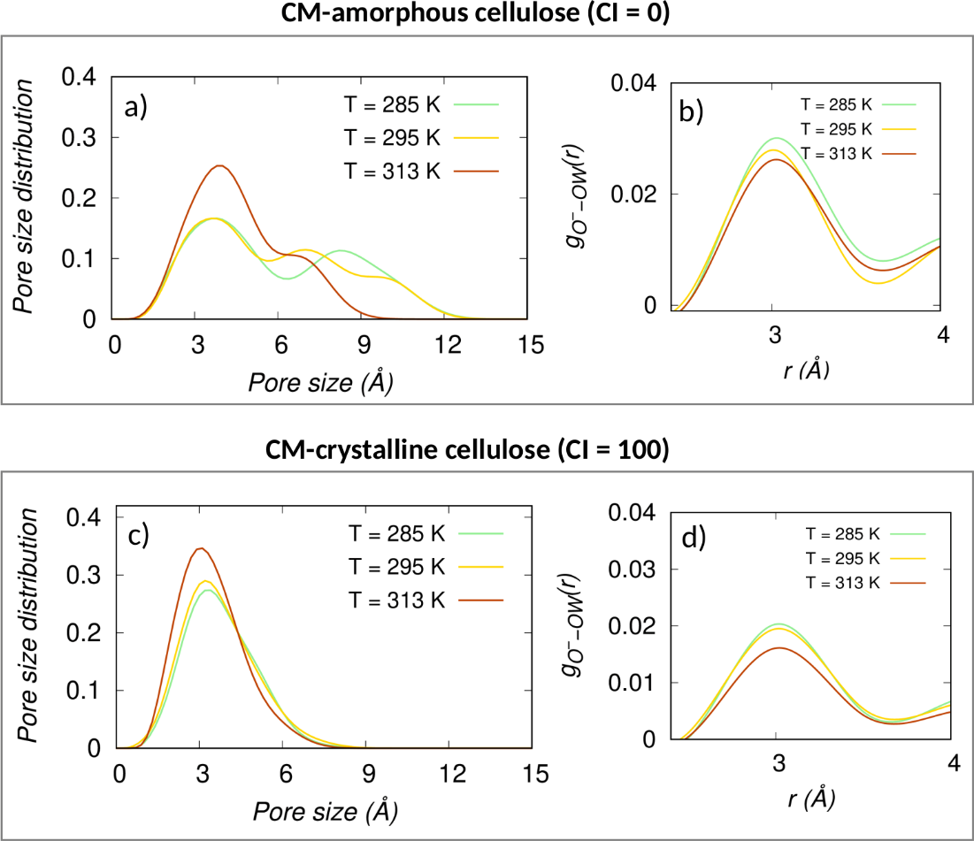

Figure S1: (a),(c) Pore size distribution as a function of pore size and (b),(c) the radial pair distribution g_{O}⁻_{-OW}(r) between the oxygen (O⁻) of carboxyl group and oxygen (OW) of water for different temperatures T=285K, 295K, 313K. Upper and lower panels correspond to respectively CM-amorphous cellulose and CM-crystalline cellulose. The relative humidity is 80%.

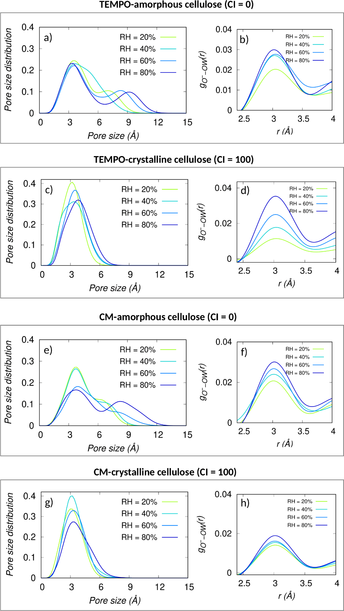
Figure S2: (a),(c),(e),(g) Pore size distribution as a function of pore size and (b),(c),(f),(h) the radial pair distribution g_{O}⁻_{-OW}(r) between the oxygen (O⁻) of carboxyl group and oxygen (OW) of water for different RH=20%, 40%, 60%, 80%. First and second panels correspond to respectively TEMPO-amorphous cellulose and TEMPO-crystalline cellulose, third and fourth panels correspond to respectively CM-amorphous cellulose and CM-crystalline cellulose. Temperature T=285 K.

