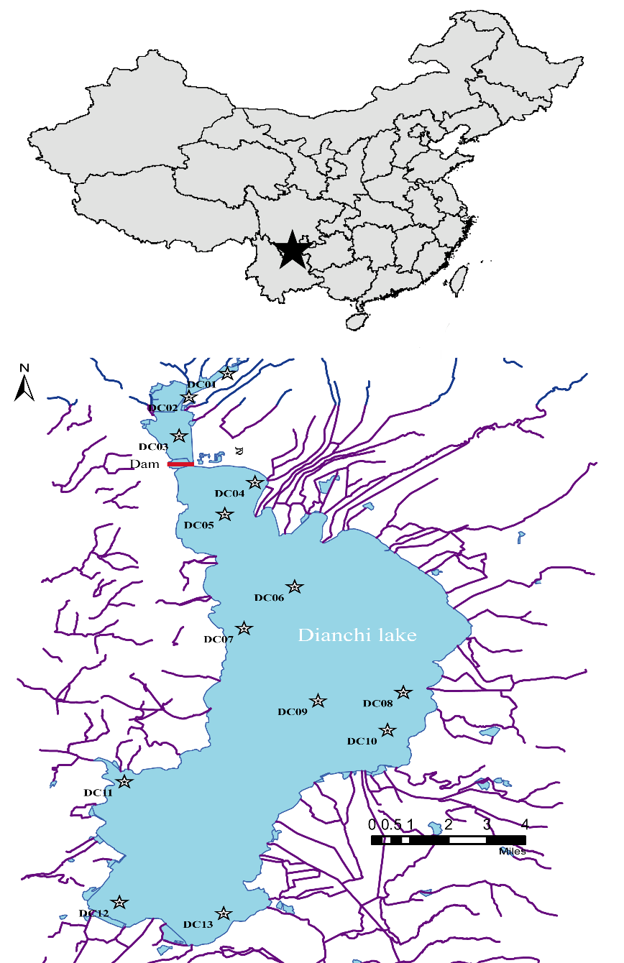
Fig. S1 The distribution and location Map of the 13 sediments sampling stations across the Dianchi Lake region.
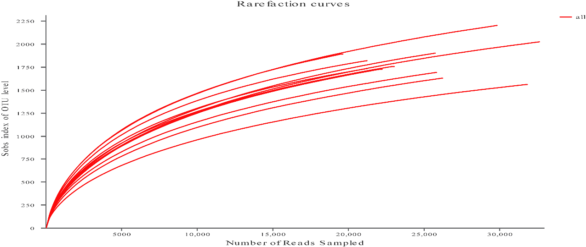
Fig. S2 Rarefaction curves depicted in a random sampling of 16S rRNA gene sequences.

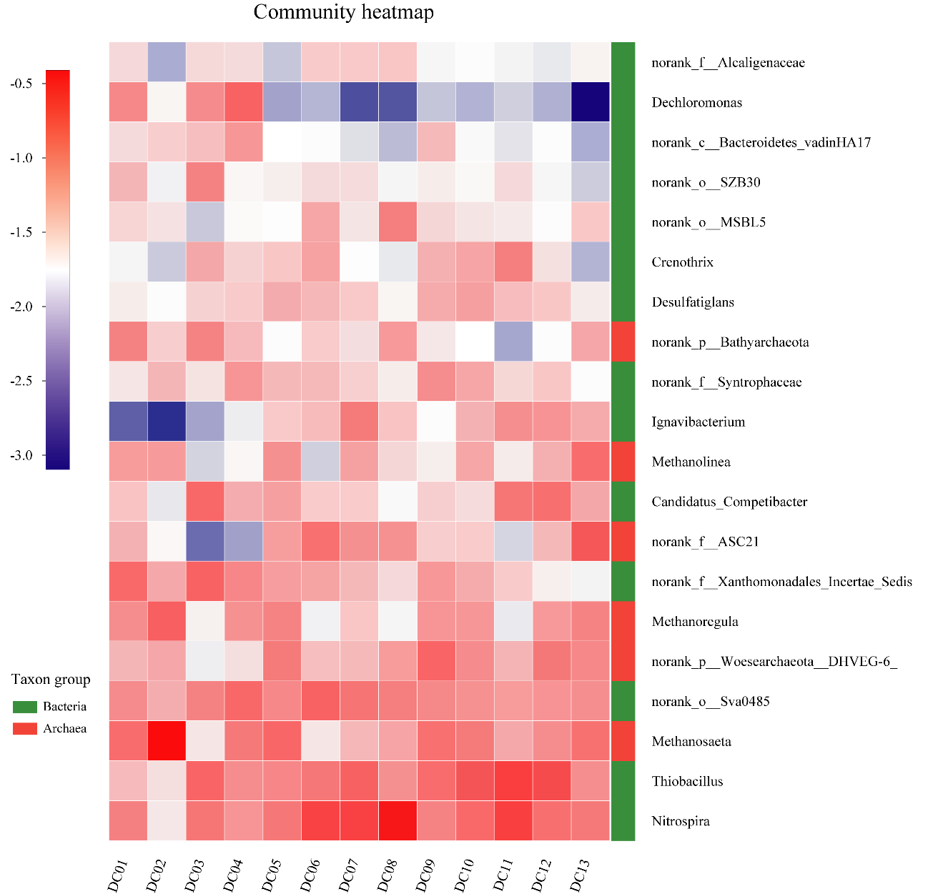
Fig. S3 Relative abundances of dominant bacteria and archaea at the genus level derived from sediment samples.
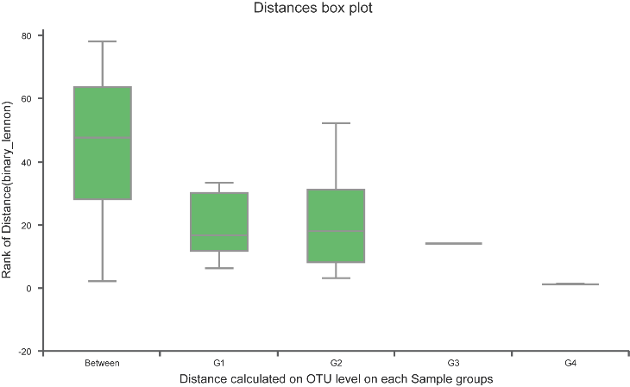
Fig. S4 Inter-group difference analysis using ANOSIM
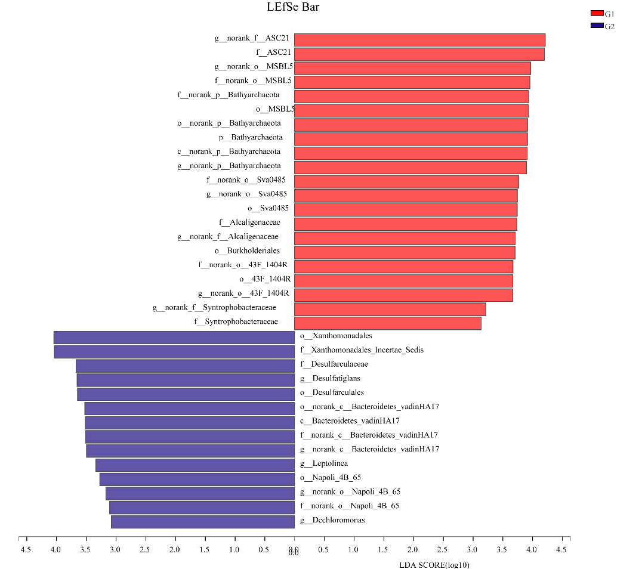
Fig. S5 Histogram of LDA scores for bacteria with richness differences between Gs1 and G2. Different colored regions indicates different group (red, G1; blue, G2).
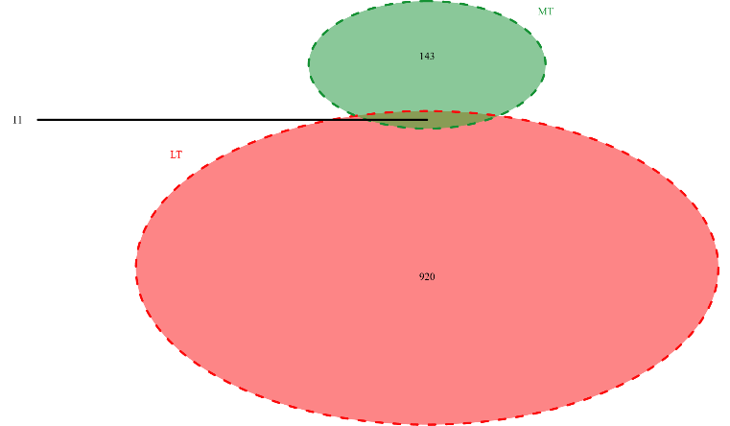
Fig. S6 Venn diagram showing overlaps of edges between the LT network and MT network.

Table S1 Redundancy analysis (RDA) analysis of environmental variables and dominant communities
Factors | RDA1 | RDA2 | r2 | p_values
WT | -0.946 | -0.324 | 0.111 | 0.527
TOC | -1.000 | -0.026 | 0.728 | 0.020
TN | -0.987 | -0.158 | 0.538 | 0.046
TP | -0.979 | 0.206 | 0.344 | 0.151
N5 | -0.797 | 0.604 | 0.580 | 0.008
N3 | -0.998 | -0.069 | 0.272 | 0.228
Temp | 0.840 | -0.542 | 0.439 | 0.059
Depth | 0.854 | -0.520 | 0.342 | 0.112

Table S2 common topological properties widely used in network analysis
 | nodes | edges | Average degree (AD) | no.clusters (NC) | Modularity | Density
LT | 146 | 931 | 12.8 | 17 | 0.833 | 0.088
MT | 121 | 154 | 2.5 | 41 | 0.937 | 0.021

