Table S1. Material list and description of use.
System of use | Part number | Components | Company | Product description
Hydroponic | 1 | Air pump | Simple Deluxe | Continuously aerates the hydroponic solution.
Hydroponic | 2 | 12-way air flow splitter | uxcell | Divert pressure from the air pump into a greater number of parts (each 1-way junction will aerate one hydroponic pot).
Hydroponic | 3 | Air stone | Pawfly | Creates bubbles from the air pump pressure while submerged in the hydroponic solution
Shared | 4 | Hydroponic sponge | JpGdn | Provides lateral support to plants
Shared | 5 | 1 Gallon black plastic pail with lid | House Naturals | Basin for plants during hydroponics. The 1-gallon lids contain the mesh net cups that plants remain in throughout experimentation (19cm diameter).
Shared | 6 | Mesh net cup | JpGdn | Provides support while plants are in hydroponics and aeroponics
 | 7 | 2 Gallon black plastic pail with lid | Uline | Basin for plants during aeroponics; clean buckets are replaced during root exudate sampling. The 2-gallon lid had a circle cut out from it so that the 1-gal lid would fit into it (25cm diameter).
Aeroponic | 8 | Cycle timer | BN-LINK | Used for supplying user defined time-intervals to the solenoids. These timers are set to seconds on/min off.
Aeroponic | 9 | Misting nozzles | Uxcell | Deliver nutrient/sampling solution to the root system (0.1mm orifice diameter).
Aeroponic | 10 | Misting nozzle tees | Dreamtop | Threaded on top for nozzle replacement with push-to-connect tubing on both sides.
Aeroponic | 11 | High-pressure booster water pump | Bacoeng | Pressurizes nutrient/sampling solution to the delivered to the plant roots. Contains pressure shut off switch set to user-defined condition.
Aeroponic | 12 | Solenoid valve | Beduan | Normally-closed valve that when opened allows for flow to treatment blocks. Solenoids are activated by stripped 2-prong extension cord that has been stripped and outfitted with appropriate fittings
Aeroponic | 13 | Pressure gauge | Malida | Ensures pressure is maintained throughout the experiment without requiring modification to the system. Aids in troubleshooting and leak detection.
Aeroponic | 14 | 1/4-inch Tee 3-way tube | Mattox | Spray rings and other junctions of the aeroponic system are created using these push-to-connect fittings
Aeroponic | 15 | Pressurized accumulator tank | Seaflow | Stores pressurized nutrient/sampling solution so that when solenoids are opened there is a sufficient supply to saturate demand of all spray nozzles; creates fully pressurized spray intervals to minimize pump delay.
Aeroponic | 16 | Nutrient solution container | HDX | Stores nutrient solution throughout experimentation. Is equipped with a threaded barb to connect with tubing that will go directly to the pump.
Aeroponic | 17 | 1/4-inch black tubing | MIXC | Connects all components of the aeroponic system.

Table S2. The ABA concentration in the root exudates from two cultivars under drought control treatments. The root exudates were collected with 0.05 mM CaCl₂ in the morning (10 am-11:59 am) and afternoon (2-4 pm) on the same day. Approximately 50 mL of collected sample was freeze-dried, and the ABA was quantified using LC-MS.
Sample ID | Treatment | Collection Time | Misting Cycle  (min on, min off) |  | Cotton Cultivar | Sample (g) for LC-MS | ABA  (pmol g⁻¹)
LE037 | Drought | AM | 0:10, 60:00 |  | TAM X-26-3 | 0.0013 | 8,811
LE039 | Drought | AM | 0:10, 60:00 |  | TAM X-26-3 | 0.0001 | 40,828
LE040 | Drought | AM | 0:10, 60:00 |  | TAM421 | 0.0038 | 36,378
LE042 | Drought | AM | 0:10, 60:00 |  | TAM421 | 0.0019 | 9,529
LE043 | Control | AM | 0:10, 5:00 |  | TAM421 | 0.0013 | 2,929
LE049 | Drought | PM | 0:10, 60:00 |  | TAM X-26-3 | 0.0018 | 11,457
LE051 | Drought | PM | 0:10, 60:00 |  | TAM X-26-3 | 0.0008 | 12,998
LE052 | Drought | PM | 0:10, 60:00 |  | TAM421 | 0.0031 | 47,431
LE054 | Drought | PM | 0:10, 60:00 |  | TAM421 | 0.0017 | 47,108
LE055 | Control | PM | 0:10, 5:00 |  | TAM421 | 0.0014 | 6,523
LE059 | Control | PM | 0:10, 5:00 |  | TAM_X-26-3 | 0.0004 | 3,450

Table S3. Pearson correlation analysis for the drought severity index (visual), morphological traits, fluorescence parameters, and plant hormone data. All the data from water deficit phase were included for analysis. The top value indicates the correlation coefficient, and the bottom value indicates the p-value. ns=non-significant.
 | Morphological traits |  |  | Fluorescence parameters |  |  |  |  |  |  | Plant hormone
 | Shoot Length | Number of green leaves |  | Fv/Fm | Fv/Fo | Tro/ABS | ETo/ABS | (1-Vj)/Vj | PI_{abs} |  | ABA
Drought severity index | -0.27 | -0.46 |  | -0.25 | -0.24 | -0.25 | -0.19 | -0.15 | -0.02 |  | 0.48
Drought severity index | 0.0003 | <.0001 |  | 0.0006 | 0.001 | 0.0007 | 0.0117 | 0.0451 | ns |  | 0.0001
Shoot Length | - | 0.62 |  | 0.23 | 0.23 | 0.23 | 0.17 | 0.15 | 0.09 |  | -0.15
Shoot Length | - | <.0001 |  | 0.0019 | 0.0021 | 0.0018 | 0.0234 | 0.0405 | ns |  | ns
Number of green leaves | - | - |  | 0.26 | 0.26 | 0.26 | 0.20 | 0.20 | 0.14 |  | -0.16
Number of green leaves | - | - |  | 0.0004 | 0.0005 | 0.0004 | 0.0075 | 0.0084 | ns |  | ns
Fv/Fm | - | - |  | - | 0.99 | 1.00 | 0.88 | 0.80 | 0.78 |  | -0.13
Fv/Fm | - | - |  | - | <0.0001 | <0.0001 | <0.0001 | <0.0001 | <0.0001 |  | ns
Fv/Fo | - | - |  | - | - | 0.99 | 0.90 | 0.84 | 0.82 |  | -0.09
Fv/Fo | - | - |  | - | - | <0.0001 | <0.0001 | <0.0001 | <0.0001 |  | ns
Tro/ABS | - | - |  | - | - | - | 0.88 | 0.80 | 0.78 |  | -0.12
Tro/ABS | - | - |  | - | - | - | <0.0001 | <0.0001 | <0.0001 |  | ns
ETo/ABS | - | - |  | - | - | - | - | 0.96 | 0.93 |  | 0.017
ETo/ABS | - | - |  | - | - | - | - | <0.0001 | <0.0001 |  | ns
(1-Vj)/Vj | - | - |  | - | - | - | - | - | 0.97 |  | 0.15
(1-Vj)/Vj | - | - |  | - | - | - | - | - | <0.0001 |  | ns
PI_{abs} | - | - |  | - | - | - | - | - | - |  | 0.23
PI_{abs} | - | - |  | - | - | - | - | - | - |  | ns

Table S4. Pearson correlation analysis for the drought severity index (visual), morphological traits, fluorescence parameters, and plant hormone data. All the data from recovery phase were included for analysis. The top value indicates the correlation coefficient, and the bottom value indicates the p-value. ns=non-significant.
 | Morphological traits |  |  | Fluorescence parameters |  |  |  |  |  |  | Plant hormone
 | Shoot Length | Number of green leaves |  | Fv/Fm | Fv/Fo | Tro/ABS | ETo/ABS | (1-Vj)/Vj | PI_{abs} |  | ABA
Drought severity index | -0.51 | -0.44 |  | 0.21 | 0.23 | 0.21 | 0.25 | 0.26 | 0.29 |  | -0.15
Drought severity index | <0.0001 | <0.0001 |  | 0.0427 | 0.0319 | 0.0431 | 0.0165 | 0.0128 | 0.0061 |  | ns
Shoot Length | - | 0.57 |  | -0.18 | -0.18 | -0.18 | -0.27 | -0.26 | -0.26 |  | 0.20
Shoot Length | - | <0.0001 |  | 0.087 | 0.0908 | 0.0859 | 0.0097 | 0.014 | 0.0134 |  | ns
Number of green leaves | - | - |  | -0.10 | -0.11 | -0.10 | -0.13 | -0.16 | -0.19 |  | 0.46
Number of green leaves | - | - |  | ns | ns | ns | ns | ns | 0.0659 |  | ns
Fv/Fm | - | - |  | - | 0.99 | 1.00 | 0.93 | 0.89 | 0.88 |  | -0.29
Fv/Fm | - | - |  | - | <0.0001 | <0.0001 | <0.0001 | <0.0001 | <0.0001 |  | ns
Fv/Fo | - | - |  | - | - | 0.99 | 0.92 | 0.91 | 0.91 |  | -0.27
Fv/Fo | - | - |  | - | - | <0.0001 | <0.0001 | <0.0001 | <0.0001 |  | ns
Tro/ABS | - | - |  | - | - | - | 0.93 | 0.89 | 0.88 |  | -0.29
Tro/ABS | - | - |  | - | - | - | <0.0001 | <0.0001 | <0.0001 |  | ns
ETo/ABS | - | - |  | - | - | - | - | 0.96 | 0.94 |  | -0.34
ETo/ABS | - | - |  | - | - | - | - | <0.0001 | <0.0001 |  | ns
(1-Vj)/Vj | - | - |  | - | - | - | - | - | 0.99 |  | -0.29
(1-Vj)/Vj | - | - |  | - | - | - | - | - | <0.0001 |  | ns
PI_{abs} | - | - |  | - | - | - | - | - | - |  | -0.29
PI_{abs} | - | - |  | - | - | - | - | - | - |  | ns

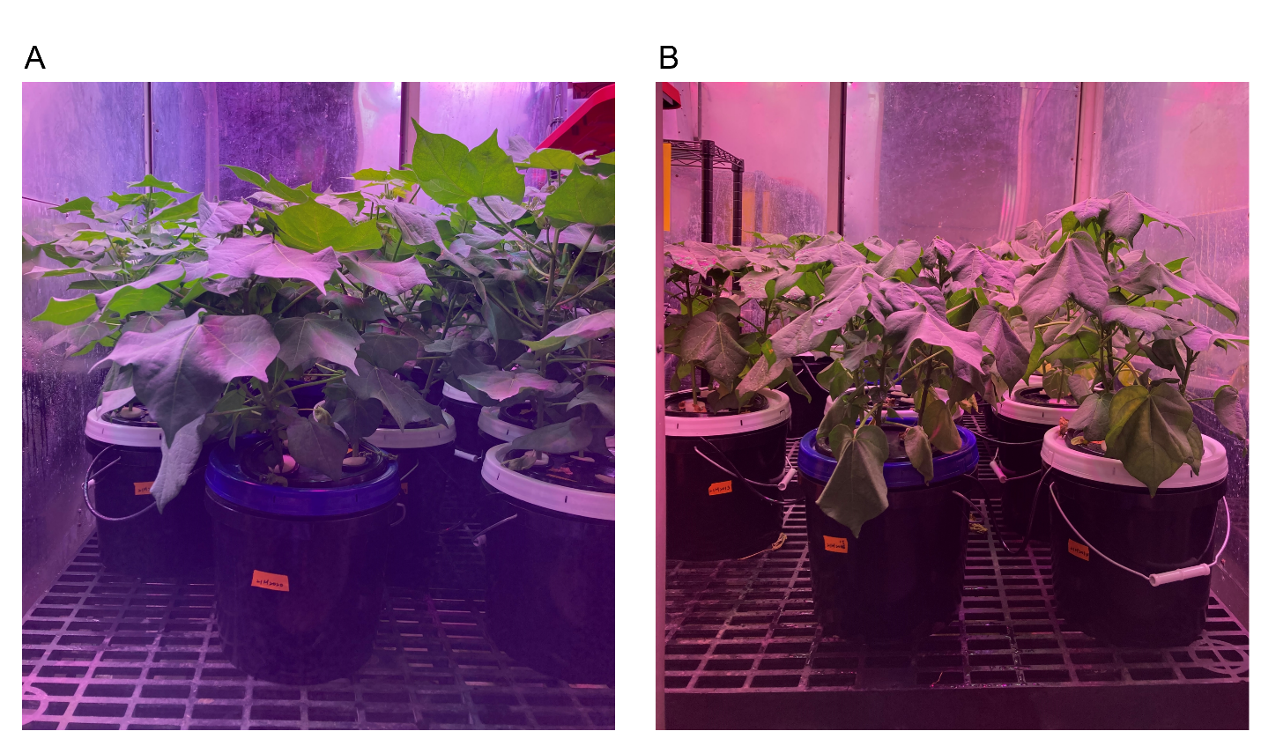
Fig. S1. Growth performance of cotton (cv. TAM 421) at 11 days after treatment in the growth chamber. (A) control (full-irrigated) treated plants (B) drought-treated plants.

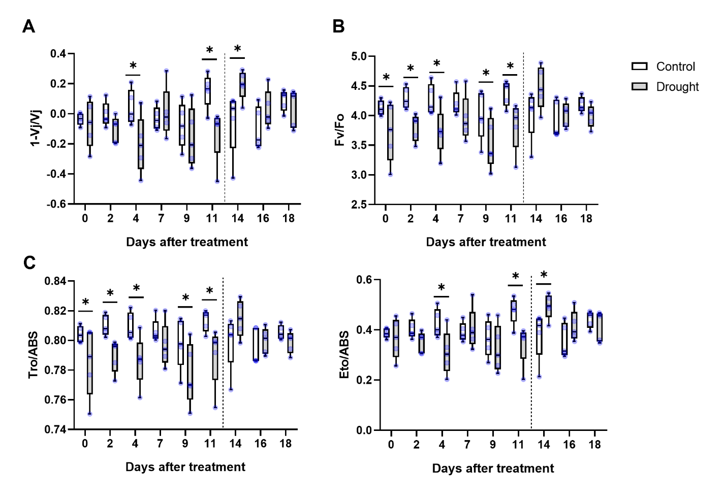Fig. S2. Boxplot of four fluorescence parameters under progression drought and recovery treatment. (A) Fv/Fo (B) 1-Vj/Vj (C) Tro/ABS (D) Eto/ABS. The control treatment was under full irrigation (131 mL hr⁻¹, 100%), while the drought treatment received progressively limited water for 11 days (11 DAT: 13 mL hr⁻¹ 10%). During the recovery phase, all plants received full irrigation. Error bars indicate 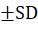. Asterisk indicates significant differences (one-way ANOVA, p<0.05) between drought and control treatments at each collection day. Blue points represent the mean of three data points from each sampled pot.
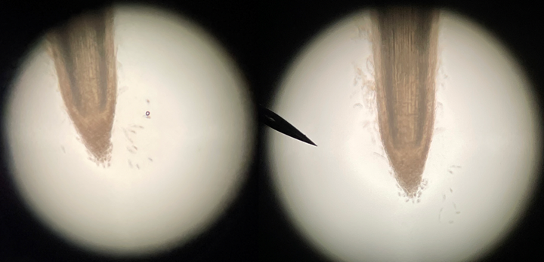
Fig. S3. Root border cells of aeroponic cotton. A dispersion of root border cells was observed on a 10 cm section of root tip after immersion in water for 3 min. Picture was taken with a compound microscope at 10 x resolution.

