Supplementary information
Supplementary Table 1 Site characteristics of the 23 flower strips with mean annual temperature (MAT) derived from DWD (2022a) and mean annual precipitation (MAP) derived from DWD (2022b) for the last 30 years. Soil texture and pH provided for the upper layer (0-10 cm)
Site | Soil texture |  | pH | Age | MAT | MAP | Longitude | Latitude
 | Silt | Clay
 | (%) | (%) | (CaCl₂) | (years) | (°C) | (mm) | (ETRS 89 UTM32)
BG 1 | 81.0 | 16.2 | 7.14 | 3 | 9.5 | 788 | 5749614 | 573829
BG 2 | 71.2 | 23.9 | 6.38 | 10 | 9.5 | 761 | 5752226 | 570049
Br | 71.7 | 26.4 | 7.12 | 2 | 9.2 | 862 | 5722113 | 510515
Do 1 | 68.3 | 29.1 | 6.64 | 5 | 9.4 | 828 | 5761919 | 540118
Do 2 | 81.0 | 15.8 | 5.43 | 3 | 9.8 | 774 | 5761661 | 539177
Em | 46.1 | 32.7 | 7.15 | 1 | 9.8 | 817 | 5919278 | 368271
GG 1 | 27.7 | 9.7 | 6.40 | 4 | 9.4 | 666 | 5943389 | 650637
GG 2 | 27.3 | 10.9 | 6.25 | 3 | 9.4 | 666 | 5943389 | 650637
Ha | 67.0 | 29.8 | 7.05 | 3 | 9.4 | 665 | 5530666 | 574218
HB | 12.3 | 5.3 | 6.25 | 2 | 9.1 | 611 | 5969166 | 765462
Hoe 1 | 52.1 | 43.4 | 7.32 | 1 | 9.6 | 720 | 5545271 | 555592
Hoe 2 | 60.8 | 31.9 | 7.15 | 3 | 9.6 | 717 | 5547017 | 556615
Is | 69.3 | 29.3 | 7.18 | 10 | 9.4 | 885 | 5725200 | 506954
Kr 1 | 11.7 | 7.6 | 7.40 | 1 | 10.0 | 518 | 5808153 | 742139
Kr 2 | 6.0 | 4.9 | 5.64 | 1 | 10.0 | 536 | 5802761 | 740295
Lue | 5.9 | 4.7 | 5.19 | 2 | 9.9 | 553 | 5762658 | 841084
Me 1 | 24.2 | 27.3 | 6.48 | 5 | 10.0 | 650 | 5804065 | 611147
Me 2 | 14.3 | 4.4 | 5.02 | 4 | 10.0 | 641 | 5801617 | 606572
Sch | 9.2 | 5.3 | 6.77 | 1 | 9.9 | 599 | 5798901 | 622370
Si | 19.0 | 12.6 | 7.29 | 4 | 9.5 | 630 | 6017046 | 632678
TE 1 | 19.7 | 38.3 | 7.34 | 1 | 9.9 | 632 | 5794666 | 616554
TE 2 | 47.3 | 36.7 | 7.33 | 4 | 9.8 | 638 | 5790272 | 615879
Zo | 14.8 | 7.2 | 6.81 | 1 | 9.2 | 578 | 5615497 | 673710

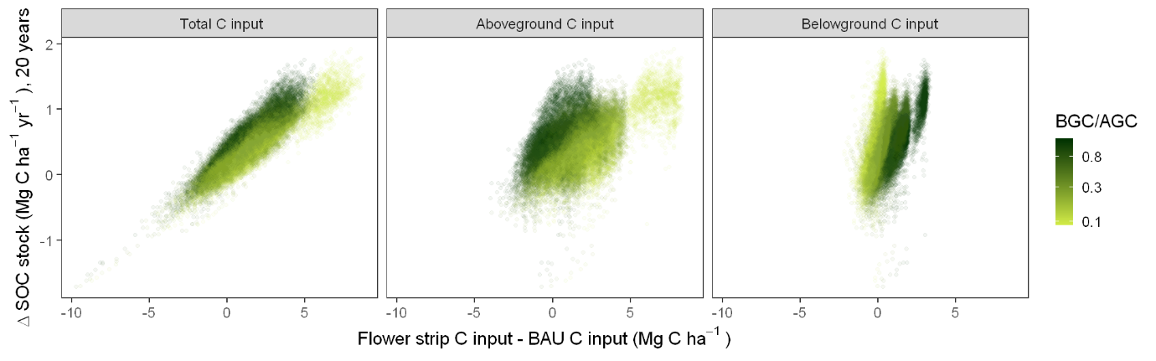
Supplementary Fig. 1 Scatterplot of the change in total soil C stock (Mg C/ha) at 20 years (flower strip scenario - business as usual) against A) the difference total C input (above ground + below ground, excluding fertiliser) of the flower strip scenario and of the business as usual scenario, B) the difference above ground C input from biomass of the flower strip scenario and of the business as usual scenario, excluding fertiliser, C) the difference below ground C input, including exudates, of the flower strip scenario and of the business as usual scenario. The colour scales with the belowground C input/aboveground C input ratio (BGC/AGC) of the flower strip scenario

