Spatiotemporal changes in rainfall and droughts of Iraq for bias corrected CMIP6 models
Mohammed Magdy Hamed ^{1,2}, Saad Sh. Sammen ³, Mohamed Salem Nashwan ⁴, Shamsuddin Shahid ²*

Table S-1: Global climate models (GCMs) used in this study
No | GCM | Source | Country | Resolution  (Lon x Lat)
1 | ACCESS-CM2 | Australian Research Council Centre of Excellence for Climate System Science | Australia | 1.25°×1.875°
2 | ACCESS-ESM1-5 |  | Australia | 1.25°×1.875°
3 | AWI-CM-1-1-MR | Alfred Wegener Institute, Helmholtz Centre for Polar and Marine Research, Bremerhaven | Germany | 0.935°×0.937°
4 | BCC-CSM2-MR | Beijing Climate Center | China | 1.125°×1.125°
5 | CanESM5 | Canadian Centre for Climate Modelling and Analysis | Canada | 2.79°×2.81°
6 | CIESM | Community Integrated Earth System Model | China | 1.25°×0.94°
7 | CMCC-CM2-SR5 | Euro‐Mediterranean Centre on Climate Change coupled climate model | Italy | 0.942°×1.25°
8 | EC-Earth3-Veg | EC-Earth Consortium | Europe | 0.35°×0.35°
9 | EC-Earth3 | EC-Earth Consortium | Europe | 0.35°×0.35°
10 | FGOALS-g3 | Chinese Academy of Sciences Flexible Global Ocean-Atmosphere–Land System model | China | 2°×2°
11 | FIO-ESM-2-0 | First Institute of Oceanography Earth System Model | China | 1.25°×0.9°
12 | GISS-E2-1-G | Goddard Institute for Space Studies (NASA-GISS) | USA | 1.25°×1.25°
13 | INM-CM4-8 | Institute for Numerical Mathematics | Russia | 2°×1.5°
14 | INM-CM5-0 | Institute for Numerical Mathematics | Russia | 2 °×1.5°
15 | IPSL-CM6A-LR | Institute Pierre Simon Laplace (IPSL) | France | 2.5°×1.27°
16 | KACE-1-0-G | National Institute of Meteorological Sciences (NIMS) and Korea Meteorological Administration (KMA) | South Korea | 1.875°×1.25°
17 | MIROC6 | Japan Agency for Marine-Earth Science and Technology (JAMSTEC) | Japan | 1.4°×1.4°
18 | MPI-ESM1-2-HR | Max Planck Institute for Meteorology (MPI-M) | Germany | 0.94°×0.94°
19 | MPI-ESM1-2-LR | Max Planck Institute for Meteorology (MPI-M) | Germany | 1.875°×1.86°
20 | MRI-ESM2-0 | Meteorological Research Institute | Japan | 1.125°×1.125°
21 | NESM3 | Nanjing University of Information Science and Technology Earth System Model | China | 1.87°×1.87°

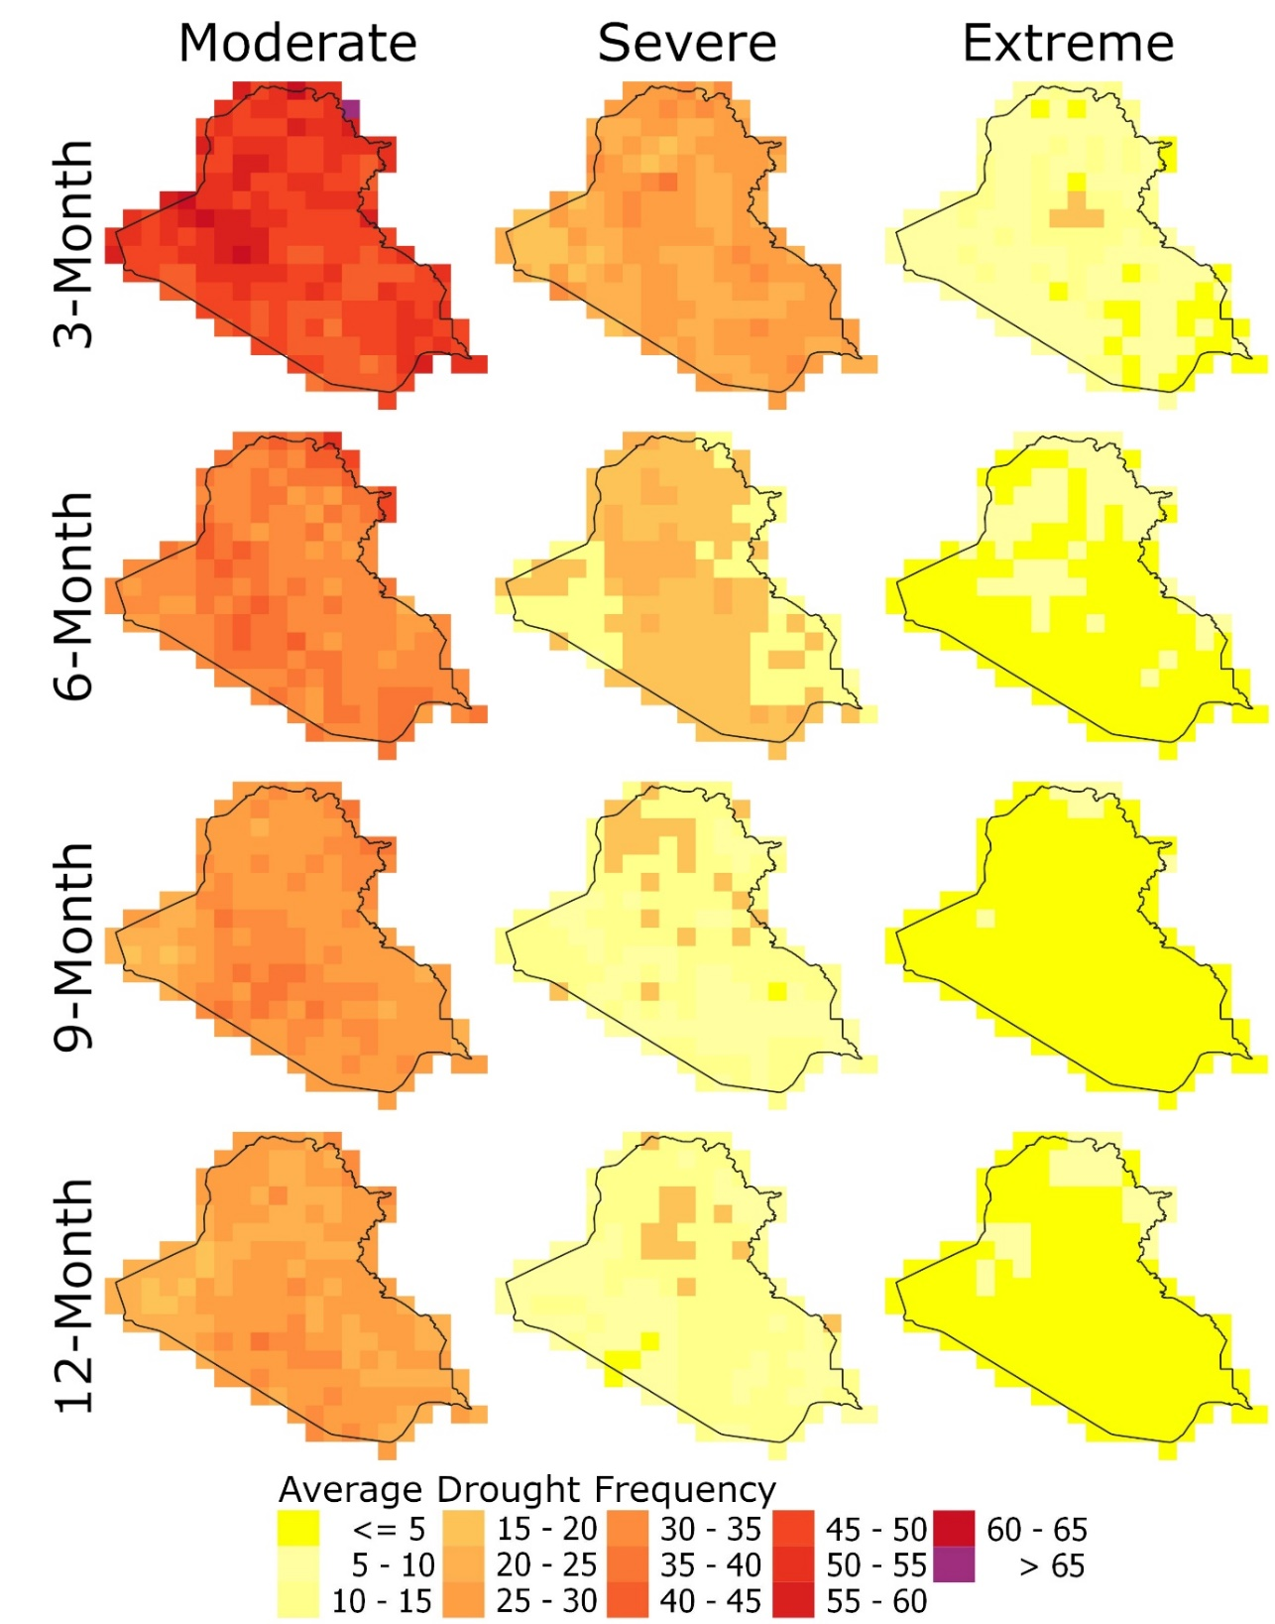
Fig. S-1 Occurrence frequency of different severities of 3-, 6-, 9- and 12-month droughts in Iraq during the reference period (1975 − 2014) using BCC-CSM2-MR GCM

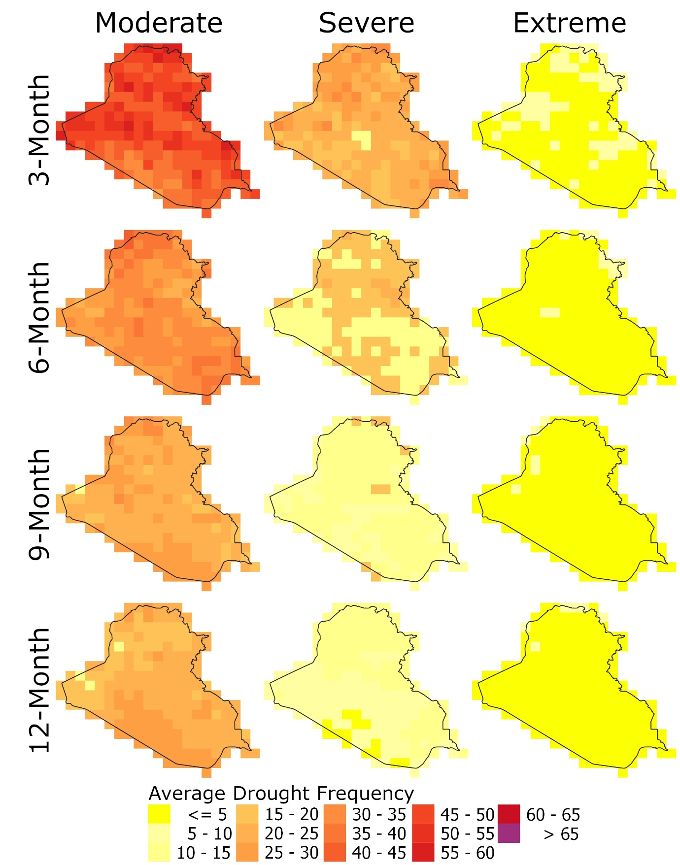
Fig. S-2 Occurrence frequency of different severities of 3-, 6-, 9- and 12-month droughts in Iraq during the reference period (1975 − 2014) using EC-Earth3-Veg GCM

