A single nucleotide polymorphism in an R2R3 MYB transcription factor triggers ms6 (Ames1) male sterility in soybean
Junping Yu^{1#}, Guolong Zhao^{2#}, Wei Li^{1#}, Ying Zhang², Peng Wang¹, Aigen Fu¹, Limei Zhao², Chunbao Zhang²*, Min Xu¹*
1 Chinese Education Ministry’s Key Laboratory of Western Resources and Modern Biotechnology, Key Laboratory of Biotechnology Shaanxi Province, College of Life Sciences, Northwest University, Xi'an, 710069, China
2 Soybean Research Institute, National Engineering Research Center for Soybean, Jilin Academy of Agricultural Sciences, Changchun, 130033, China
#These authors contribute equally to this work.
*Corresponding email: minxu@nwu.edu.cn; cbzhang@cjaas.com

Supplementary figures and tables
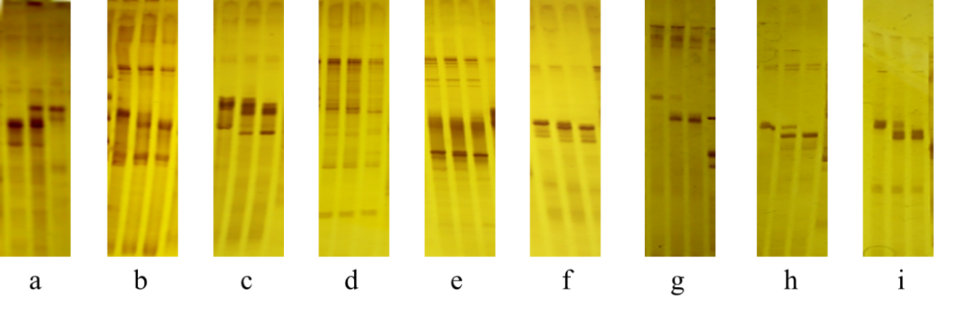
Supplementary Figure 1 The electrophoresis patterns of SSR markers used in fine mapping.
For each panel, Lane1, ‘JiuB’; Lane2, BC₅F₁; Lane3, ms6 from T295H. a, BARCSOYSSR-13-0243; b, BARCSOYSSR-13-0244; c, BARCSOYSSR-13-0245; d, BARCSOYSSR-13-0249; e, BARCSOYSSR-13-0257; f, BARCSOYSSR-13-0259; g, BARCSOYSSR-13-0275; h, BARCSOYSSR-13-0277; i, BARCSOYSSR-13-0283.

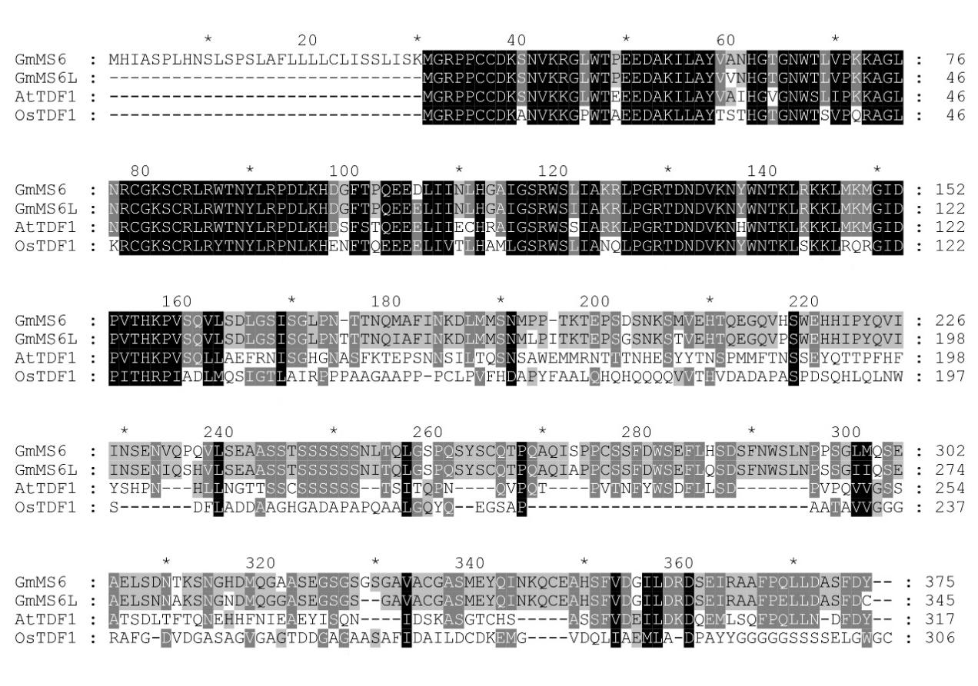
Supplementary Figure 2 Multiple sequence alignment of GmMS6, GmMS6L, AtTDF1, and OsTDF1.

Supplementary Table 1 The list of primers used in this paper.
Primer Name | Sequence (5’-3’) | Function
13-0243-F | CGTTTCGTGCTAACAAAAATTG | Fine mapping
13-0243-R | AAAATTATTTGTCATCTCATTCATACA | Fine mapping
13-0244-F | TCTCTCCCTTCCACACTCTCA | Fine mapping
13-0244-R | CGAGAGTTAACCTCAAGATTATGC | Fine mapping
13-0245-F | TTGCACATTCTTTTTGGTAAACAGTCATAA | Fine mapping
13-0245-R | GTTGGAGGCCATAGTCACATTAATCTTAGA | Fine mapping
13-0249-F | CAAAGCAAAAGCATGACGAG | Fine mapping
13-0249-R | TCCCACTTAGGATCTTGGTTC | Fine mapping
13-0257-F | CCGTATCCTACCCGTTAATGA | Fine mapping
13-0257-R | CATCGCAAACGAATTGGTAG | Fine mapping
13-0259-F | TTTGGTTATTAGTTATTTTGGCATGA | Fine mapping
13-0259-R | CCACTACTCTCATTATTTTTAAACCG | Fine mapping
13-0275-F | TTGCATATTCAATTATATTTGTTGG | Fine mapping
13-0275-R | CGAACGCGAAGCTAGAAGAT | Fine mapping
13-0277-F | TTTTCTTTCCACCAAAATTTGTA | Fine mapping
13-0277-R | CGCATCATATTAATAAAAAGGATAACA | Fine mapping
13-0283-F | CGATGGCAATTATGCGGTTA | Fine mapping
13-0283-R | TCGTACCTTTCATTTTATCTCGC | Fine mapping
GmMS6CAPS-F | GGCTCTTTTCTTGAACTTGTTTGC | Ms6 genotyping
GmMS6CAPS-R | CCAATTAGATCTTCTTCTTGGGG | Ms6 genotyping
AC1F | ATGGGAAGACCTCCTTGTTG | AtTDF1^{L46H}
AC1R | GCTCTTTCCACATCGATTGT | AtTDF1^{L46H}
AC2F | ACAATCGATGTGGAAAGAGC | AtTDF1^{L46H}
AC2R | CAATAGGGAAAAGAAGGGATC | AtTDF1^{L46H}
KpnI-AtTDF1proF | AAGGTACCCTGTTCTTCAATCTTCACC | 1301-AtTDF1pro
XbaI-AtTDF1proR | TCTAGATTTTTGGTATTCAAACACAAG | 1301-AtTDF1pro
GmMS6F | CCTCTAGAATGCATATTGCATCACCATT | 1301-AtTDF1pro-GmMS6/  1301-AtTDF1pro-GmMS6^{L76H}
BstEII-GmMS6R | CCGGTCACCTTAGTAGTCAAAAGAAGCATCC | 1301-AtTDF1pro-GmMS6/  1301-AtTDF1pro-GmMS6^{L76H}
AtTDF1F | CCTCTAGAATGGGAAGACCTCCTTGTTG | 1301-AtTDF1pro-AtTDF1/  1301-AtTDF1pro-AtTDF1^{L46H}
BstEII-AtTDF1R | CCGGTCACCCTAATAATCGAAATCATTCAAGAG | 1301-AtTDF1pro-AtTDF1/  1301-AtTDF1pro-AtTDF1^{L46H}
GmMS6LF | CCTCTAGAATGGGAAGGCCTCCTTGTTG | 1301-AtTDF1pro-GmMS6L
BstEII-GmMS6LR | CCGGTCACCTTAGCAGTCAAAAGAAGCATCC | 1301-AtTDF1pro-GmMS6L
AtActin-F | CTCTCCCGCTATGTATGTCGCCATCC | AtActin Semi RT-qPCR
AtActin-R | CTGTGAACGATTCCTGGACCTGCCTC | AtActin Semi RT-qPCR
CAPSTDF1-F | GCTTGTAACCTCTGATGTTTTC | Genotyping GmMs6 locus
CAPSTDF1-R | GAGTATAGAGTTGTTAGATGG | Genotyping GmMs6 locus
NdeI-BK-GmMS6-F | TCCATATGCATATTGCATCACCATTAC | PGBKT7-GmMS6
EcoRI-BK-GmMS6-R | GGAATTCTTAGTAGTCAAAAGAAGCATCC | PGBKT7-GmMS6
NdeI-BK-GmMS6L-F | TCCATATGGGAAGGCCTCCTTGTTGTG | PGBKT7-GmMS6L
EcoRI-BK-GmMS6L-R | GGAATTCTTAGCAGTCAAAAGAAGCATCC | PGBKT7-GmMS6L
NdeI-BK-GmMS6-F | TCCATATGCATATTGCATCACCATTAC | PGBKT7-GmMS6B
EcoRI-BK-GmMS6B-R | GGAATTCCATGTTGCTCATCATCAAGTC | PGBKT7-GmMS6B
XbaI-GmMS6-F | CCTCTAGAATGCATATTGCATCACCATT | PLM-35S-GmMS6-GFP
XbaI-GmMS6-R | CCTCTAGAGTAGTCAAAAGAAGCATCCA | PLM-35S-GmMS6-GFP
XbaI-GmMS6L-F | CCTCTAGAATGGGAAGGCCTCCTTGTTG | PLM-35S-GmMS6L-GFP
XbaI-GmMS6L-R | CCTCTAGAGCAGTCAAAAGAAGCATCCA | PLM-35S-GmMS6L-GFP
GmMS6qRT-F | CTCCCCAAGAAGAAGATCTA | GmMS6 qRT-PCR
GmMS6qRT-R | GCTTATGTGTCACTGGATCG | GmMS6 qRT-PCR
GmMS6LqRT-F | CTCCCCAAGAAGAAGAGCTC | GmMS6L qRT-PCR
GmMS6LqRT-R | TACCGGCTTATGTGTTACCG | GmMS6L qRT-PCR
GmActin11qRT-F | CGGTGGTTCTATCTTGGCATC | GmActin11 qRT-PCR
GmActin11qRT-R | GTCTTTCGCTTCAATAACCCTA | GmActin11 qRT-PCR
A6qRT-F | TAACAACAATGAAAGCTGGTCG | A6 qRT-PCR
A6qRT-R | CTGAATTGTAGCTCAGCACTTC | A6 qRT-PCR
10g281800qRT-F | TTCCATCCATCAGAACATGTCA | AMS-Glyma.10g281800 qRT-PCR
10g281800qRT-R | CATGAGGCTTTTCTGATACGTG | AMS-Glyma.10g281800 qRT-PCR
20g107500qRT-F | GCAACTGCATGAATTGTGTAAG | AMS-Glyma.20g107500 qRT-PCR
20g107500qRT-R | GTGTTCAATGCCTCCATCAG | AMS-Glyma.20g107500 qRT-PCR
1g05770qRT-1F | AATGAGACATGGTTTGGCAG | MS1-Glyma.01g047400qRT-PCR
1g05770qRT-1R | TTAGTGGAATGCCATGGCTA | MS1-Glyma.01g047400qRT-PCR
2g11970qRT-F | GAAAGTTGACGTAGTTGGGAAC | MS1-Glyma.02g107600qRT-PCR
2g11970qRT-R | GATTCAATGCTGCCTCTATTGG | MS1-Glyma.02g107600qRT-PCR
2g26670qRT-F | GAGAGGGGATATTCCAGTTG | MS2-Glyma.02g169100qRT-PCR
2g26670qRT-R | GGGACCACATCTAGTACTCC | MS2-Glyma.02g169100qRT-PCR
9g15895qRT-F | GCATGTCTGAAGAAGAAAAG | MS2-Glyma.09g104800qRT-PCR
9g15895qRT-R | ACTGACTCCCCATTCCTCTC | MS2-Glyma.09g104800qRT-PCR
13g32360qRT-1F | GCAAGCCTTTTGATGCTGCG | DYT1-Glyma.13g250200qRT-PCR
13g32360qRT-1R | GCTCCTTTTGTGGTTGCGAG | DYT1-Glyma.13g250200qRT-PCR
13g250300qRT-F | CGTACCTGAACTAACTTGGGAC | DYT1-Glyma.13g250300qRT-PCR
13g250300qRT-R | ATGGGTCTTGAGGAAAGGAG | DYT1-Glyma.13g250300qRT-PCR
15g063900qRT-F | TTTGATGCTGCGGTCTATGATG | DYT1-Glyma.15g063900qRT-PCR
15g063900qRT-R | CAGAGTTTATTCTCGTTTATTTGCG | DYT1-Glyma.15g063900qRT-PCR
15g064000qRT-F | CCTCTCAAAAAGGTGCACCTT | DYT1-Glyma.15g064000qRT-PCR
15g064000qRT-R | GTGAAAATATTATGAGCTGACACC | DYT1-Glyma.15g064000qRT-PCR
08g336500qRT-F | AATTAACTTCCACCAGGGACAG | MYB80-Glyma.08g336500
08g336500qRT-R | GGGAAAACACCGTATGGCATTG | MYB80-Glyma.08g336500
18g071600qRT-F | ATTAACTTCCACCAGGGGCAA | MYB80-Glyma.18g071600
18g071600qRT-R | GGAAAAACACCGTATGGCATCA | MYB80-Glyma.18g071600

