Supplementary Material
DNA extraction, PCR amplification, sequencing, and data analysis
Microbial DNA was extracted from biofilm and sediment biomass samples using the E.Z.N.A.® Soil DNA Kit (Omega Bio-tek, Norcross, GA, U.S.) according to the manufacturer’ s protocols. The extracted DNA was stored at −80 °C until required for amplification. The DNA samples were sent for PCR amplification targeting the V3-V4 regions of the 16S rRNA gene using primers 341F (5’-CCTAYGGGRBGCASCAG-3’) and 806R (5’-GGACTACNNGGGTATCTAAT-3’). The PCR products were purified using the AxyPrep DNA Gel Extraction Kit (Axygen Biosciences, Union City, CA, US) and then sent to an Illumina MiSeq sequencing platform (Shanghai BIOZERON Co., Ltd). Taxonomic classification of each phylotype was determined using the SILVA rRNA database project with over 97% of sequence similarity.

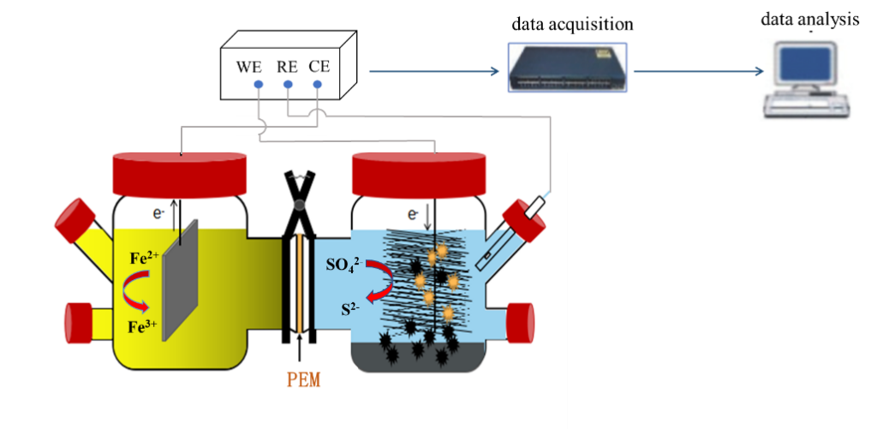
Fig. S1 Schematic diagram of the bioelectrochemical reactor.

Table S1 Composition of trace elements.
Composition | Concentration | Composition | Concentration
FeCl₂·4H₂0 | 1500 mg/L | MnCl₂.4H₂O | 100 mg/L
ZnCl₂ | 70 mg/L | H₃BO₃ | 62 mg/L
CuCl₂·H₂O | 17 mg/L | NiCl₂.6H₂O | 24 mg/L
Na₂MoO₄·2H₂O | 36 mg/L | EDTA | 500 mg/L
37% HCl | 7 mL/L

Table S2 Different operational modes.
Operation modes | Carbon source | Potential(V) |  | SO₄²⁻ (mg/L) | CODcr(mg/L) | pH
closed-circuit reactor | NaHCO₃ | −0.5 |  | 500 | 0 | 7.0
closed-circuit reactor | Ethanol | −0.5 |  | 500 | 1000 | 7.0
closed-circuit reactor | NaAc | −0.5 |  | 500 | 1000 | 7.0
open-circuit reactor | NaHCO₃ | 0 |  | 500 | 0 | 7.0
open-circuit reactor | Ethanol | 0 |  | 500 | 1000 | 7.0
open-circuit reactor | NaAc |  | 0 | 500 | 1000 | 7.0

