Additional file 1: Supplementary figures and tables
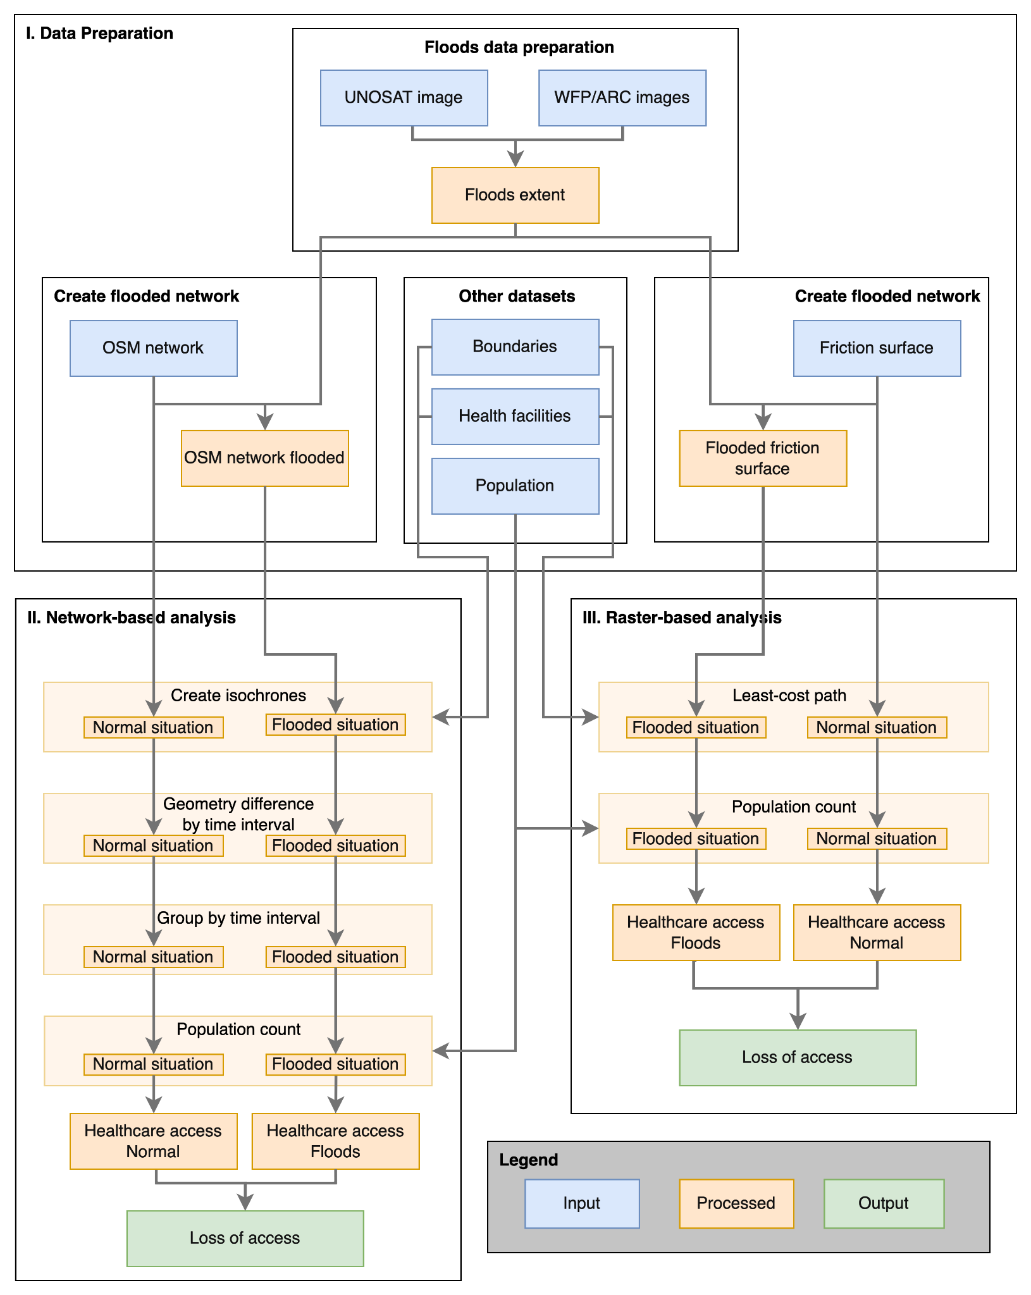Figure S1. Accessibility workflow: raster- and network-based methods

Package | Reference | Package | Reference
ggpubr | Alboukadel Kassambara (2020). ggpubr: 'ggplot2' Based Publication Ready Plots. R package version 0.4.0.  https://CRAN.R-project.org/package=ggpubr | ggplot2 | H. Wickham. ggplot2: Elegant Graphics for Data Analysis. Springer-Verlag New York, 2016.
geojsonsf | David Cooley (2020). geojsonsf: GeoJSON to Simple Feature Converter. R package version 2.0.1.  https://CRAN.R-project.org/package=geojsonsf | knitr | Yihui Xie (2021). knitr: A General-Purpose Package for Dynamic Report Generation in R. R package version 1.33.
units | Pebesma E, Mailund T, Hiebert J (2016). “Measurement Units in R.” _R Journal_, *8*(2), 486-494. doi: 10.32614/RJ-2016-061  (URL: https://doi.org/10.32614/RJ-2016-061). | gridExtra | Baptiste Auguie (2017). gridExtra: Miscellaneous Functions for "Grid" Graphics. R package version 2.3.  https://CRAN.R-project.org/package=gridExtra
RJSONIO | Duncan Temple Lang and Jonathan Wallace (2020). RJSONIO: Serialize R Objects to JSON, JavaScript Object Notation. R package  version 1.3-1.4. https://CRAN.R-project.org/package=RJSONIO | grid | R Core Team (2021). R: A language and environment for statistical computing. R Foundation for Statistical Computing,  Vienna, Austria. URL https://www.R-project.org/.
geojsonio | Scott Chamberlain and Andy Teucher (2021). geojsonio: Convert Data from and to 'GeoJSON' or 'TopoJSON'. R package version  0.9.4. https://CRAN.R-project.org/package=geojsonio | OpenStreetMap | Ian Fellows and using the JMapViewer library by Jan Peter Stotz (2019). OpenStreetMap: Access to Open Street Map Raster  Images. R package version 0.3.4. https://CRAN.R-project.org/package=OpenStreetMap
RCurl | Duncan Temple Lang (2021). RCurl: General Network (HTTP/FTP/...) Client Interface for R. R package version 1.98-1.3.  https://CRAN.R-project.org/package=RCurl | tmaptools | Martijn Tennekes (2021). tmaptools: Thematic Map Tools. R package version 3.1-1.  https://CRAN.R-project.org/package=tmaptools
sfnetworks | Lucas van der Meer, Lorena Abad, Andrea Gilardi and Robin Lovelace (2021). sfnetworks: Tidy Geospatial Networks. R package  version 0.5.2. https://CRAN.R-project.org/package=sfnetworks | tmap | Tennekes M (2018). “tmap: Thematic Maps in R.” _Journal of Statistical Software_, *84*(6), 1-39. doi: 10.18637/jss.v084.i06  (URL: https://doi.org/10.18637/jss.v084.i06).
tidygraph | Thomas Lin Pedersen (2020). tidygraph: A Tidy API for Graph Manipulation. R package version 1.2.0.  https://CRAN.R-project.org/package=tidygraph | polylabelr | Larsson J (2020). _polylabelr: find the pole of inaccessibility (visual center) of a polygon_. R package version 0.2.0, <URL:  https://cran.r-project.org/package=polylabelr>.
classInt | Roger Bivand (2020). classInt: Choose Univariate Class Intervals. R package version 0.4-3.  https://CRAN.R-project.org/package=classInt | exactextractr | Daniel Baston (2021). exactextractr: Fast Extraction from Raster Datasets using Polygons. R package version 0.6.0.  https://CRAN.R-project.org/package=exactextractr
jsonlite | Jeroen Ooms (2014). The jsonlite Package: A Practical and Consistent Mapping Between JSON Data and R Objects.  arXiv:1403.2805 [stat.CO] URL https://arxiv.org/abs/1403.2805. | rjson | Alex Couture-Beil (2018). rjson: JSON for R. R package version 0.2.20. https://CRAN.R-project.org/package=rjson
httr | Hadley Wickham (2020). httr: Tools for Working with URLs and HTTP. R package version 1.4.2.  https://CRAN.R-project.org/package=httr | sfheaders | David Cooley (2020). sfheaders: Converts Between R Objects and Simple Feature Objects. R package version 0.4.0.  https://CRAN.R-project.org/package=sfheaders
gdistance | van Etten, J. (2017). R package gdistance: Distances and routes on geographical grids. Journal of Statistical Software,  76(1), 1–21. https://doi.org/10.18637/jss.v076.i13 | rmapshaper | Andy Teucher and Kenton Russell (2020). rmapshaper: Client for 'mapshaper' for 'Geospatial' Operations. R package version  0.4.4. https://CRAN.R-project.org/package=rmapshaper
doParallel | Microsoft Corporation and Steve Weston (2020). doParallel: Foreach Parallel Adaptor for the 'parallel' Package. R package  version 1.0.16. https://CRAN.R-project.org/package=doParallel | stars | Edzer Pebesma (2021). stars: Spatiotemporal Arrays, Raster and Vector Data Cubes. R package version 0.5-2.  https://CRAN.R-project.org/package=stars
osmextract | Andrea Gilardi and Robin Lovelace (2021). osmextract: Download and Read OpenStreetMap Data Extracts. R package version  0.2.1. https://CRAN.R-project.org/package=osmextract | tictoc | Sergei Izrailev (2021). tictoc: Functions for Timing R Scripts, as Well as Implementations of Stack and List Structures. R  package version 1.0.1. https://CRAN.R-project.org/package=tictoc
tidyverse | Wickham et al., (2019). Welcome to the tidyverse. Journal of Open Source Software, 4(43), 1686,  https://doi.org/10.21105/joss.01686 | raster | Robert J. Hijmans (2020). raster: Geographic Data Analysis and Modeling. R package version 3.4-5.  https://CRAN.R-project.org/package=raster
sf | Pebesma, E., 2018. Simple Features for R: Standardized Support for Spatial Vector Data. The R Journal 10 (1), 439-446,  https://doi.org/10.32614/RJ-2018-009 | readxl | Hadley Wickham and Jennifer Bryan (2019). readxl: Read Excel Files. R package version 1.3.1.  https://CRAN.R-project.org/package=readxl
rgeoboundaries)
Table S1. Comparison of mapped health facilities in OSM with field observation : facilities inventory, localisation comparison and damages inventory.

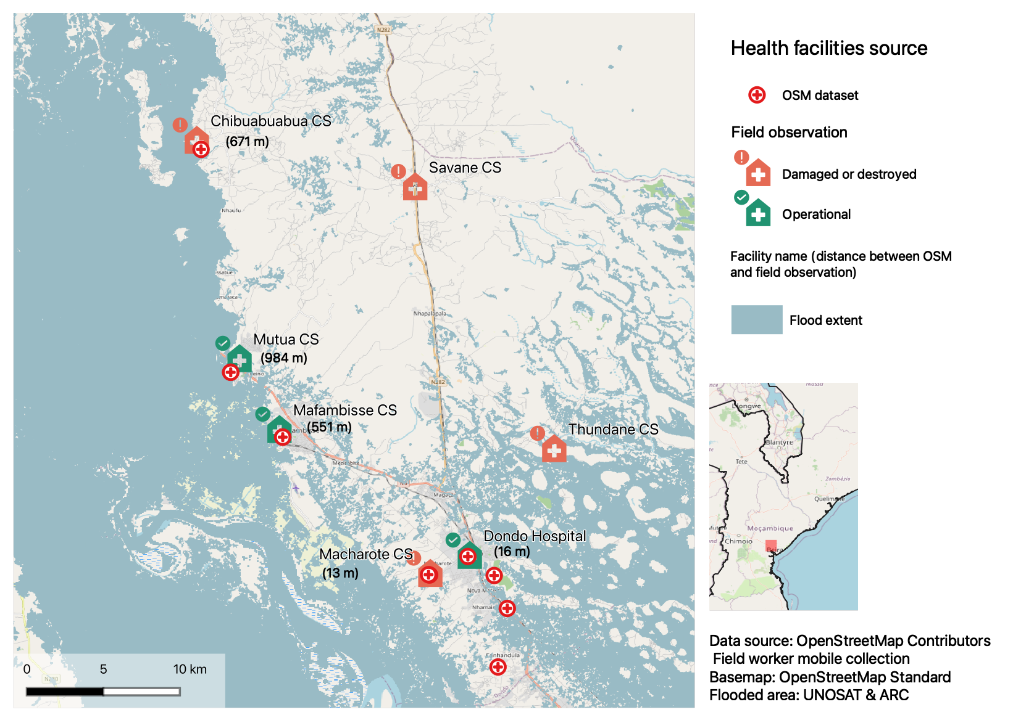
Figure S2. Comparison of mapped health facilities in OSM with field observation : facilities inventory, localisation comparison and damages inventory.

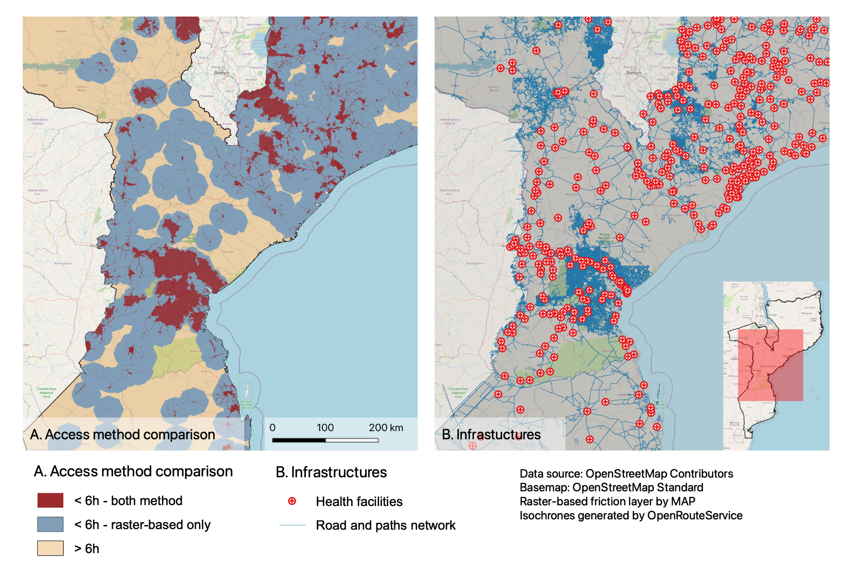
Figure S3. Accessibility to health facility, raster- vs. network-based method comparison A. Under six hours walking time to access healthcare estimations between raster- and network-based methods and B. mapped infrastructures
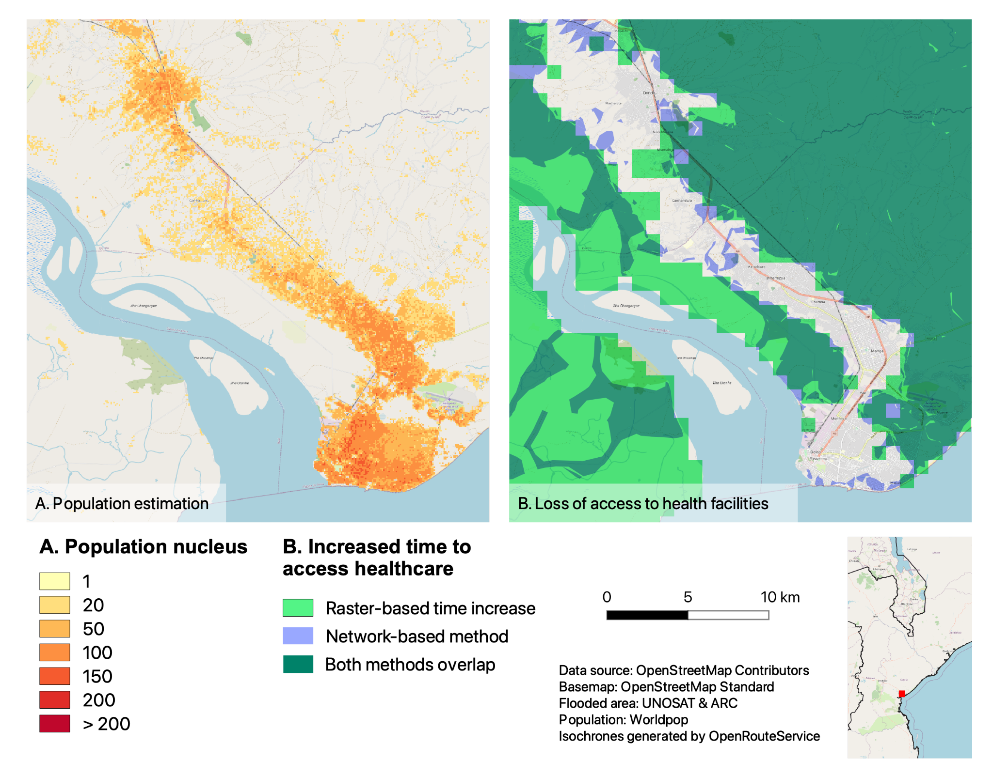
Figure S4. Accessibility to health facilities in urban context, raster- vs. network-based method comparison A. population estimation B. extent of under 6 walking hours access to health facilities

