Supplemental figure 1: Jitter plots for trend scores of patients and controls in either matched or unmatched groups
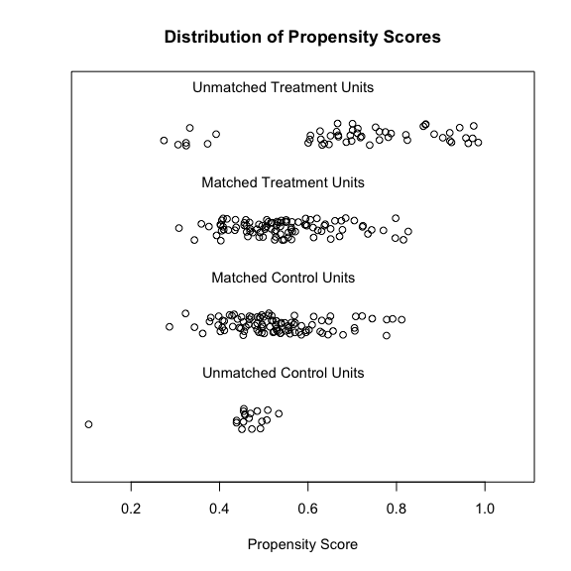

Supplemental figure 2: Lineplot of standardized differences before and after PS matching

