Supplementary Information for

A fast ceramic mixed OH⁻/H⁺ ionic conductor for low temperature fuel cells

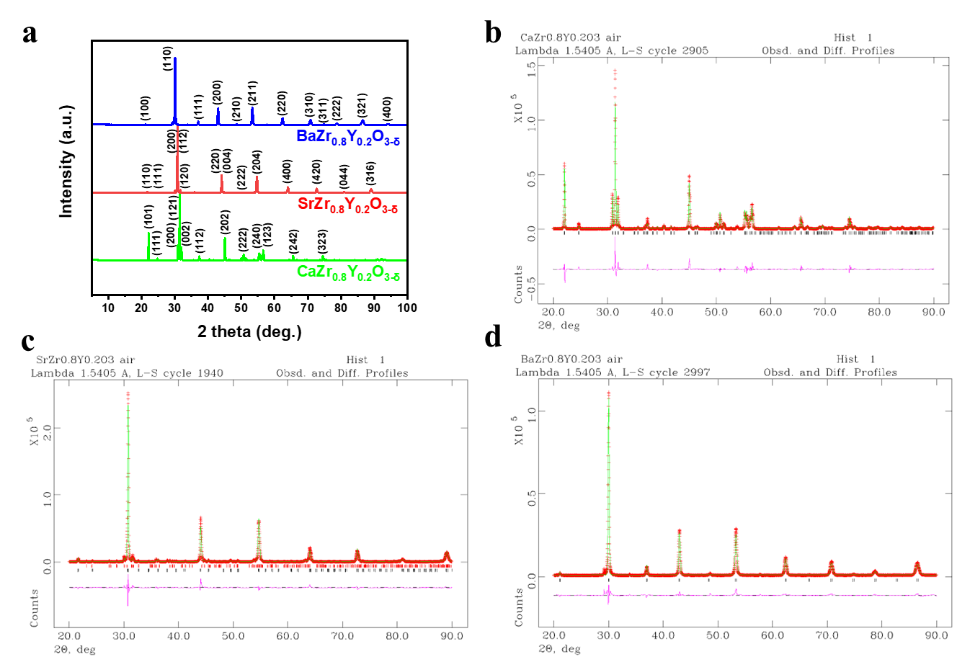
Supplementary Figure 1. XRD patterns of perovskite oxides synthesized by a combustion method. a, The XRD patterns of AZr_{0.8}Y_{0.2}O_{3-δ} where A = Ca, Sr, Ba. b-d, Representation of an experimental (crossed) and calculated (solid line) XRD profiles for (b) CaZr_{0.8}Y_{0.2}O_{3-δ}, (c) SrZr_{0.8}Y_{0.2}O_{3-δ} (92% SrZr_{0.8}Y_{0.2}O₃ and 8% SrY₂O₄. Black lines, perovskite SrZr_{0.8}Y_{0.2}O_{3-δ}; red lines SrY₂O₄), (d) BaZr_{0.8}Y_{0.2}O_{3-δ}. The difference profile (purple line) is shown at the bottom of the profile.

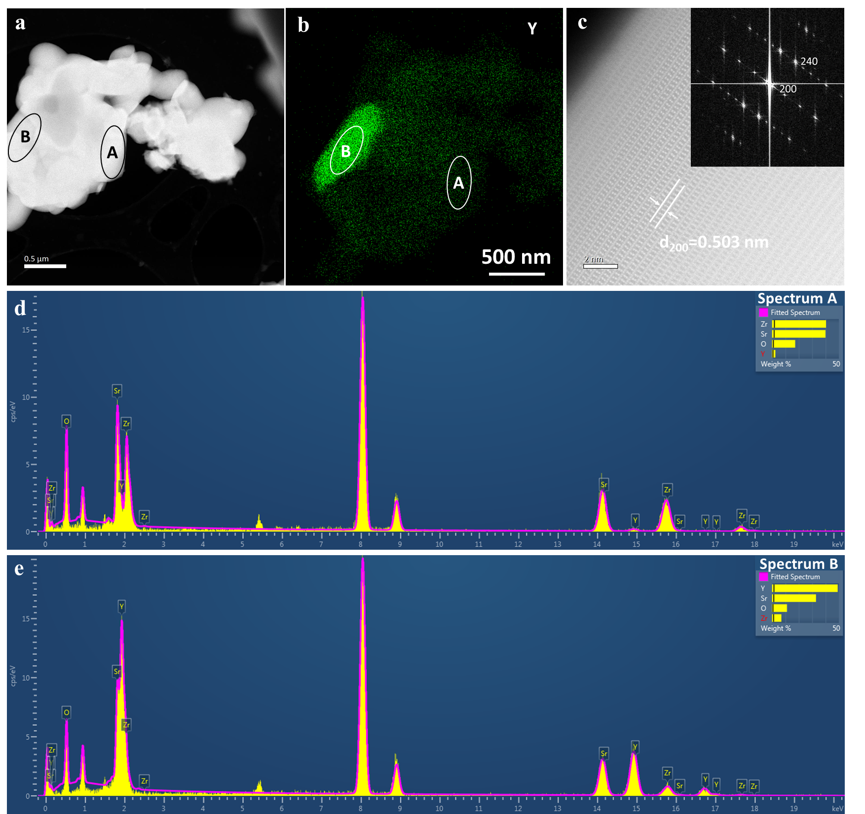
Supplementary Figure. 2. STEM and EDX analysis of SrZr_{0.8}Y_{0.2}O_{3-δ} powders. a, ADF-STEM image. b, EDX map of Y, indicating area B is Y-rich. c, High resolution ADF-STEM image taken from area B in a (inset: corresponding FFT of the image). d,e, EDX spectra extracted from area A (d) and B (e) in b, respectively.

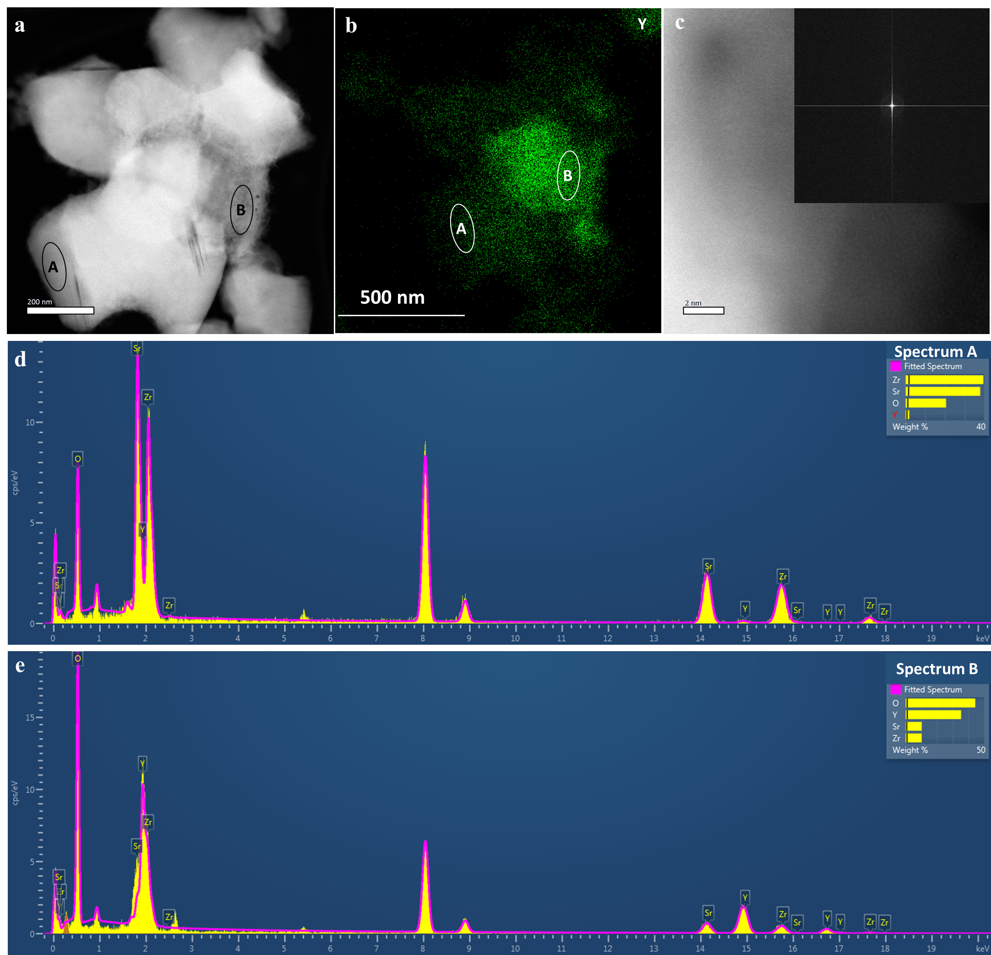
Supplementary Figure. 3. STEM and EDX analysis of washed SrZr_{0.8}Y_{0.2}O_{3-δ} powders. a, ADF-STEM image. b, EDX map of Y, indicating area B is Y-rich. c, High resolution ADF-STEM image taken from area B in a (inset: corresponding FFT of the image). d,e, EDX spectra extracted from area A (d) and B (e) in b, respectively.

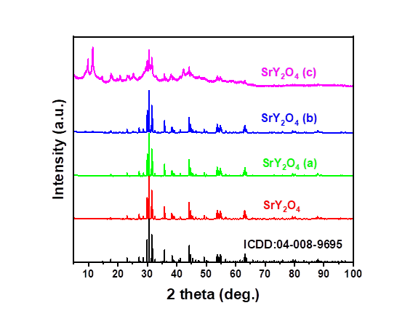
Supplementary Figure. 4 The XRD patterns of synthesized SrY₂O₄ and sample after immersed in water (a) at room temperature for 4 days, (b) heated to 90°C for 1 hour and (c) heated to 90°C for over 10 hours.

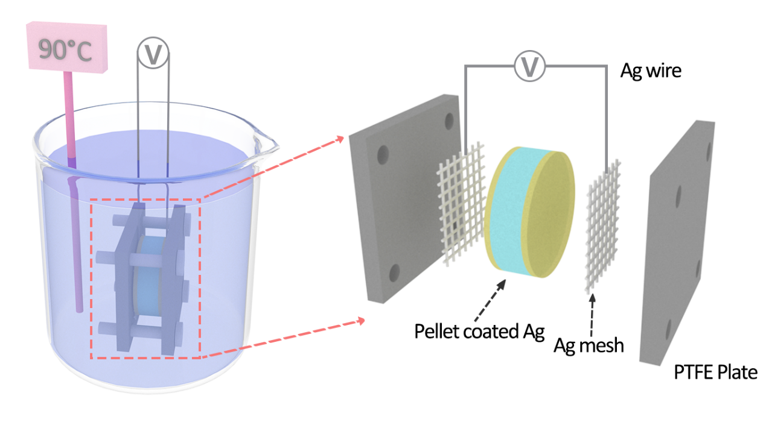
Supplementary Figure 5. Schematic diagram of the home-made set-up for conductivity measurements in water.

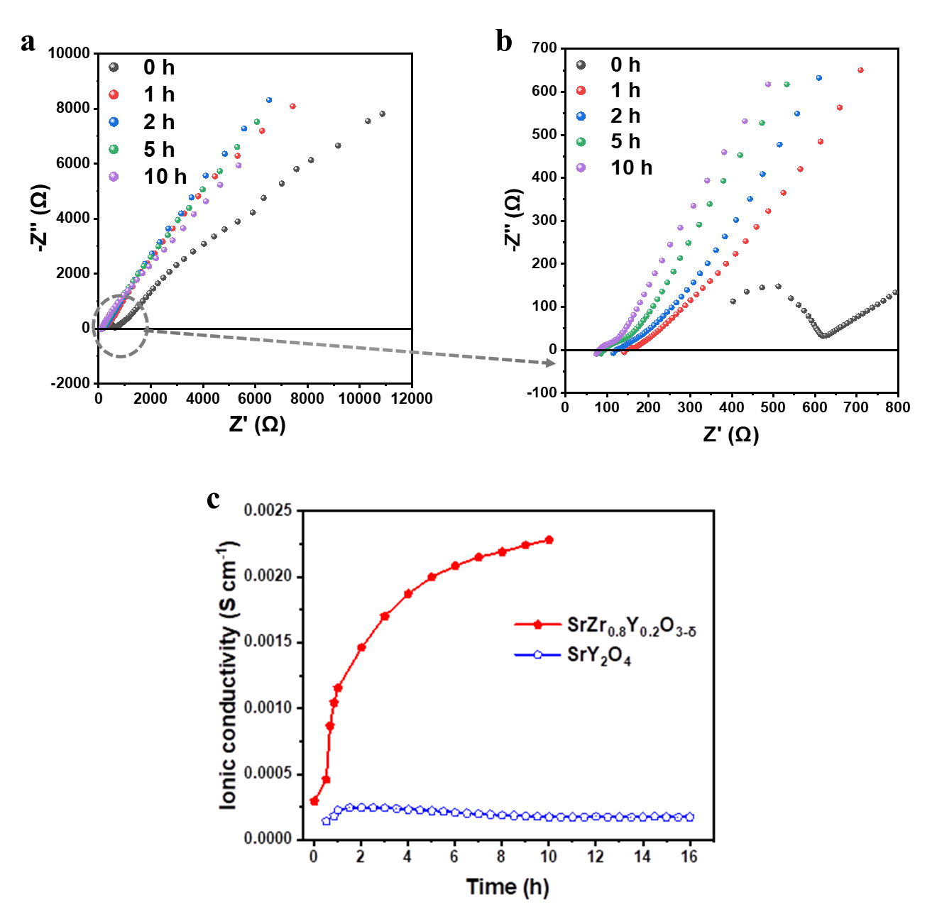
Supplementary Figure 6. The conductivity of un-washed SrZr_{0.8}Y_{0.2}O_{3-δ} pellet and the second phase SrY₂O₄. a,b, The (a) representative a.c. impedance of sample SrZr_{0.8}Y_{0.2}O_{3-δ} in water at room temperature at 0, 1, 2, 5 and 10 hours, and (b) enlarged impedance spectra. c, The conductivity changes against time of sample SrZr_{0.8}Y_{0.2}O_{3-δ} and SrY₂O₄ in water at room temperature.

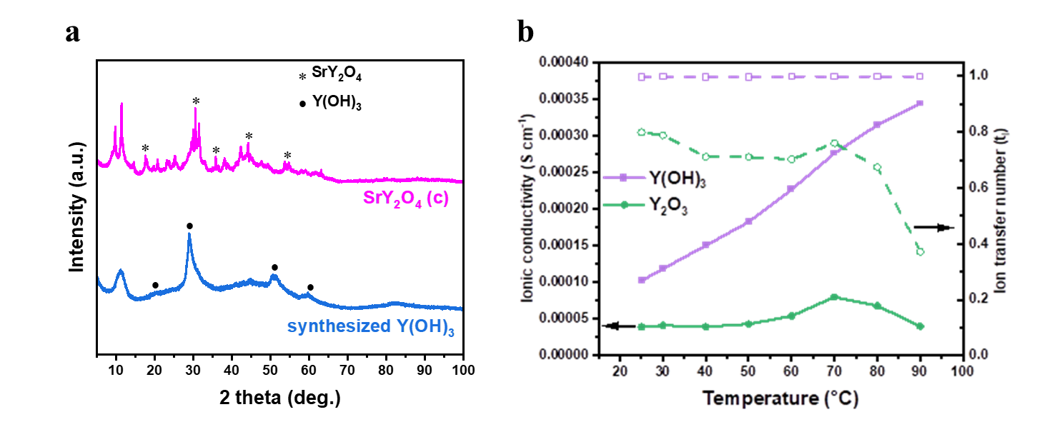
Supplementary Figure 7. The effect of the hydrolysis of second phase SrY₂O₄ on conductivity. a, The XRD patterns of synthesized amorphous Y(OH)₃. b, The ionic conductivity of synthesized amorphous Y(OH)₃ and commercial Y₂O₃ pellets.

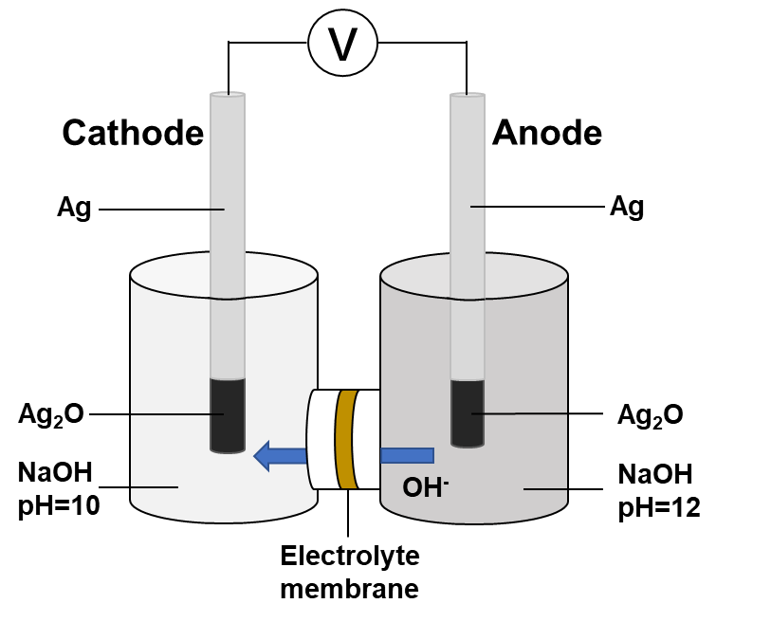
Supplementary Figure 8. Schematic diagram of the concentration cell to measure electrolyte membrane potential.

Supplementary Discussion 1. Identification of the charge carrier in ionic conductors
The Ag/Ag₂O electrode was prepared through the electrochemical oxidation of sterling silver. Pieces of silver foil were sanded smooth with a fine silicon carbide sandpaper. Then, the silver foil was oxidized electrochemically in 1 mol L⁻¹ of NaOH (98%, Alfa Aesar) at a current density of 1 mA cm⁻² through a conventional three-electrode set-up which consisted of a silver foil, Pt mesh and Ag/AgCl (sat. KCl) electrode used as the working, counter, and reference electrode respectively. To avoid forming silver peroxide (AgO), the electrochemical oxidation process was stopped after the power voltage increasing to 0.6 V vs the standard hydrogen electrode (SHE) ¹, i.e. 0.4 V vs Ag/AgCl reference electrode.
In a concentration cell of NaOH, the concentrations of Na⁺ and OH⁻ were 10⁻² M (pH=12) for the anode and 10⁻⁴ M (pH=10) for the cathode respectively. Ag/Ag₂O electrodes were sensitive to the concentration of OH⁻ because of the following reactions happened on the electrodes²:
Anode: 2Ag + 2OH⁻ → Ag₂O + H₂O + 2e⁻ pH=12 [OH]=10⁻² M
Cathode: Ag₂O + H₂O + 2e⁻ → 2Ag + 2OH⁻ pH=10 [OH]=10⁻⁴ M
The concentration difference of Na⁺ and OH⁻ on the two sides of the electrolyte membrane generated the membrane potential (ΔE). If the permeabilities of Na⁺ and OH⁻ are equal (i.e., membrane potential (ΔE) is 0), the standard electromotive force (E⁰) can be calculated by the Nernst’s equation ³:
E⁰= - RT/F log a(OH⁻)_{Cathode}/a(OH⁻)_{Anode} = - 0.059×log 10⁻⁴/10⁻² = 0.118 V
The electromotive force (E) between the cathode and anode electrodes of concentration cell were measured by a Solartron 1470E CellTest System for at least 30 mins to record the voltage potential of plateau. The membrane potential (ΔE) can be determined using the electromotive force (E):
ΔE = E – E⁰ = E - 0.118 V
If the electrolyte membrane shows cation conductivity, Na⁺ moves from the anode side (high concentration) to the cathode side (low concentration), the cathode side of the membrane will become positively charged (ΔE >0). If the membrane shows anion conductivity, OH⁻ moves from the anode side to the cathode side, the cathode side of the membrane will become negatively charged (ΔE <0).
Hittorf’s method was used to evaluate the permeabilities of Na⁺ and OH⁻ as follows ⁴:
ΔE =-RT/F (t_{Na+} log (a(Na⁺) _{Cathode} / a(Na⁺) _{Anode})-t_{OH-} log (a(OH⁻) _{Cathode} / a(OH⁻) _{Anode}))
t_{Na+} + t_{OH-} =1
According to equations above, transport numbers of Na⁺ (t_{Na+}) and of OH⁻ (t_{OH-}) are obtained. As shown in Supplementary Table 3, when a Nafion® membrane was used as the electrolyte of the cell, ΔE_{Nafion} was +0.077 V, indicating that Na⁺ in the anode moved to the cathode side more easily than OH⁻ did, and Nafion® membrane shows a high t_{Na+} value of 0.87. On the other hand, when an anion exchange membrane FAA was used as the electrolyte, ΔE_{FAA} was -0.104 V, indicating that OH⁻ in the anode moved to the cathode side more easily than Na⁺ did. According to the calculation, FAA membrane shows a high t_{OH-} value of 0.93. The membrane potential (ΔE) of hydrated SrZr_{0.8}Y_{0.2}O_{3-δ} and SrZrO₃ shows negative value. Therefore, the main carriers in these perovskite oxides are OH⁻ ions ³. The transport number of OH⁻ for SrZr_{0.8}Y_{0.2}O_{3-δ} is about 0.7, not only the main anion conductivity, but also the cation conductivity is presented. Although it is Na⁺ used in the concentration cell to determine the transport number of cation, in this study, the available cations for perovskite oxide SrZr_{0.8}Y_{0.2}O_{3-δ} itself are only Sr²⁺, Zr⁴⁺ and Y³⁺ which are too large to be conducted in the oxide. The likely mobile cations in hydrated SrZr_{0.8}Y_{0.2}O_{3-δ} are protons. This is also consistent with the solid state NMR results in which signals assigned to OH⁻ and to H⁺ were detected in wet SrZr_{0.8}Y_{0.2}O_{3-δ} samples. Therefore, the hydrated SrZr_{0.8}Y_{0.2}O_{3-δ} is a mixed OH⁻/H⁺ conductor. The electronic conduction is very small according to measured electronic transfer number.

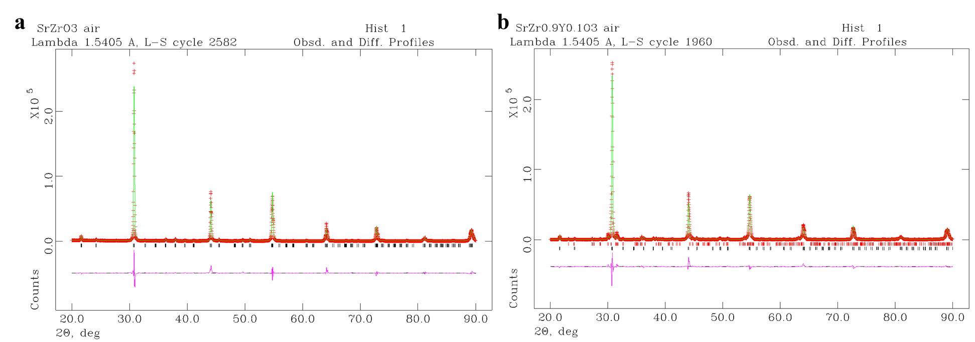

Supplementary Figure 9. Representation of an experimental (crossed) and calculated (solid line) XRD profiles. a, The XRD pattern of SrZrO₃ prepared by a combustion method. b, The XRD pattern of SrZr_{0.9}Y_{0.1}O_{3-δ} prepared by a combustion method. 98% SrZr_{0.9}Y_{0.1}O₃ and 2% SrY₂O₄. Black lines, perovskite SrZr_{0.9}Y_{0.1}O_{3-δ}; red lines, SrY₂O₄. The difference profile (purple line) is shown at the bottom of the profile.

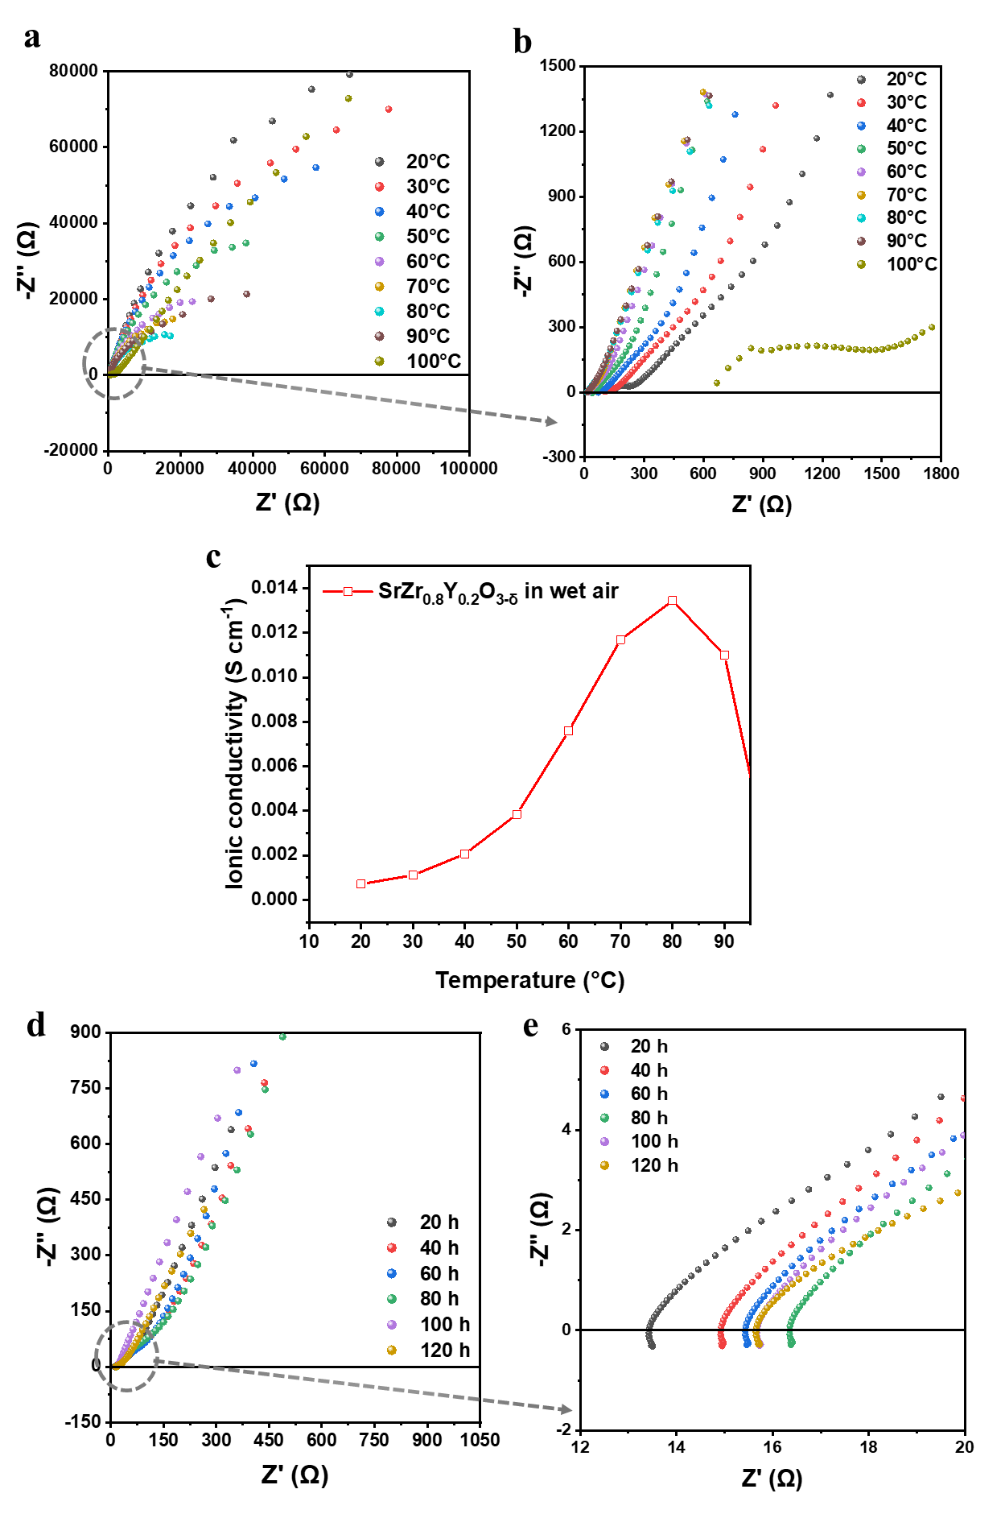
Supplementary Figure 10. Conductivity of SrZr_{0.8}Y_{0.2}O_{3-δ} in wet air. a,b, The (a) representative a.c. impedance spectra of SrZr_{0.8}Y_{0.2}O_{3-δ} in wet air and (b) enlarged impedance spectra. c, The conductivity of SrZr_{0.8}Y_{0.2}O_{3-δ} in wet air, enlarged plot between 20 and 90°C associated with Fig. 4c. d,e, The (d) representative a.c. impedance spectra of SrZr_{0.8}Y_{0.2}O_{3-δ} in wet air at 70°C at 20, 40, 60, 80, 100 and 120 hours associated with Fig. 4d, and (e) enlarged impedance spectra.
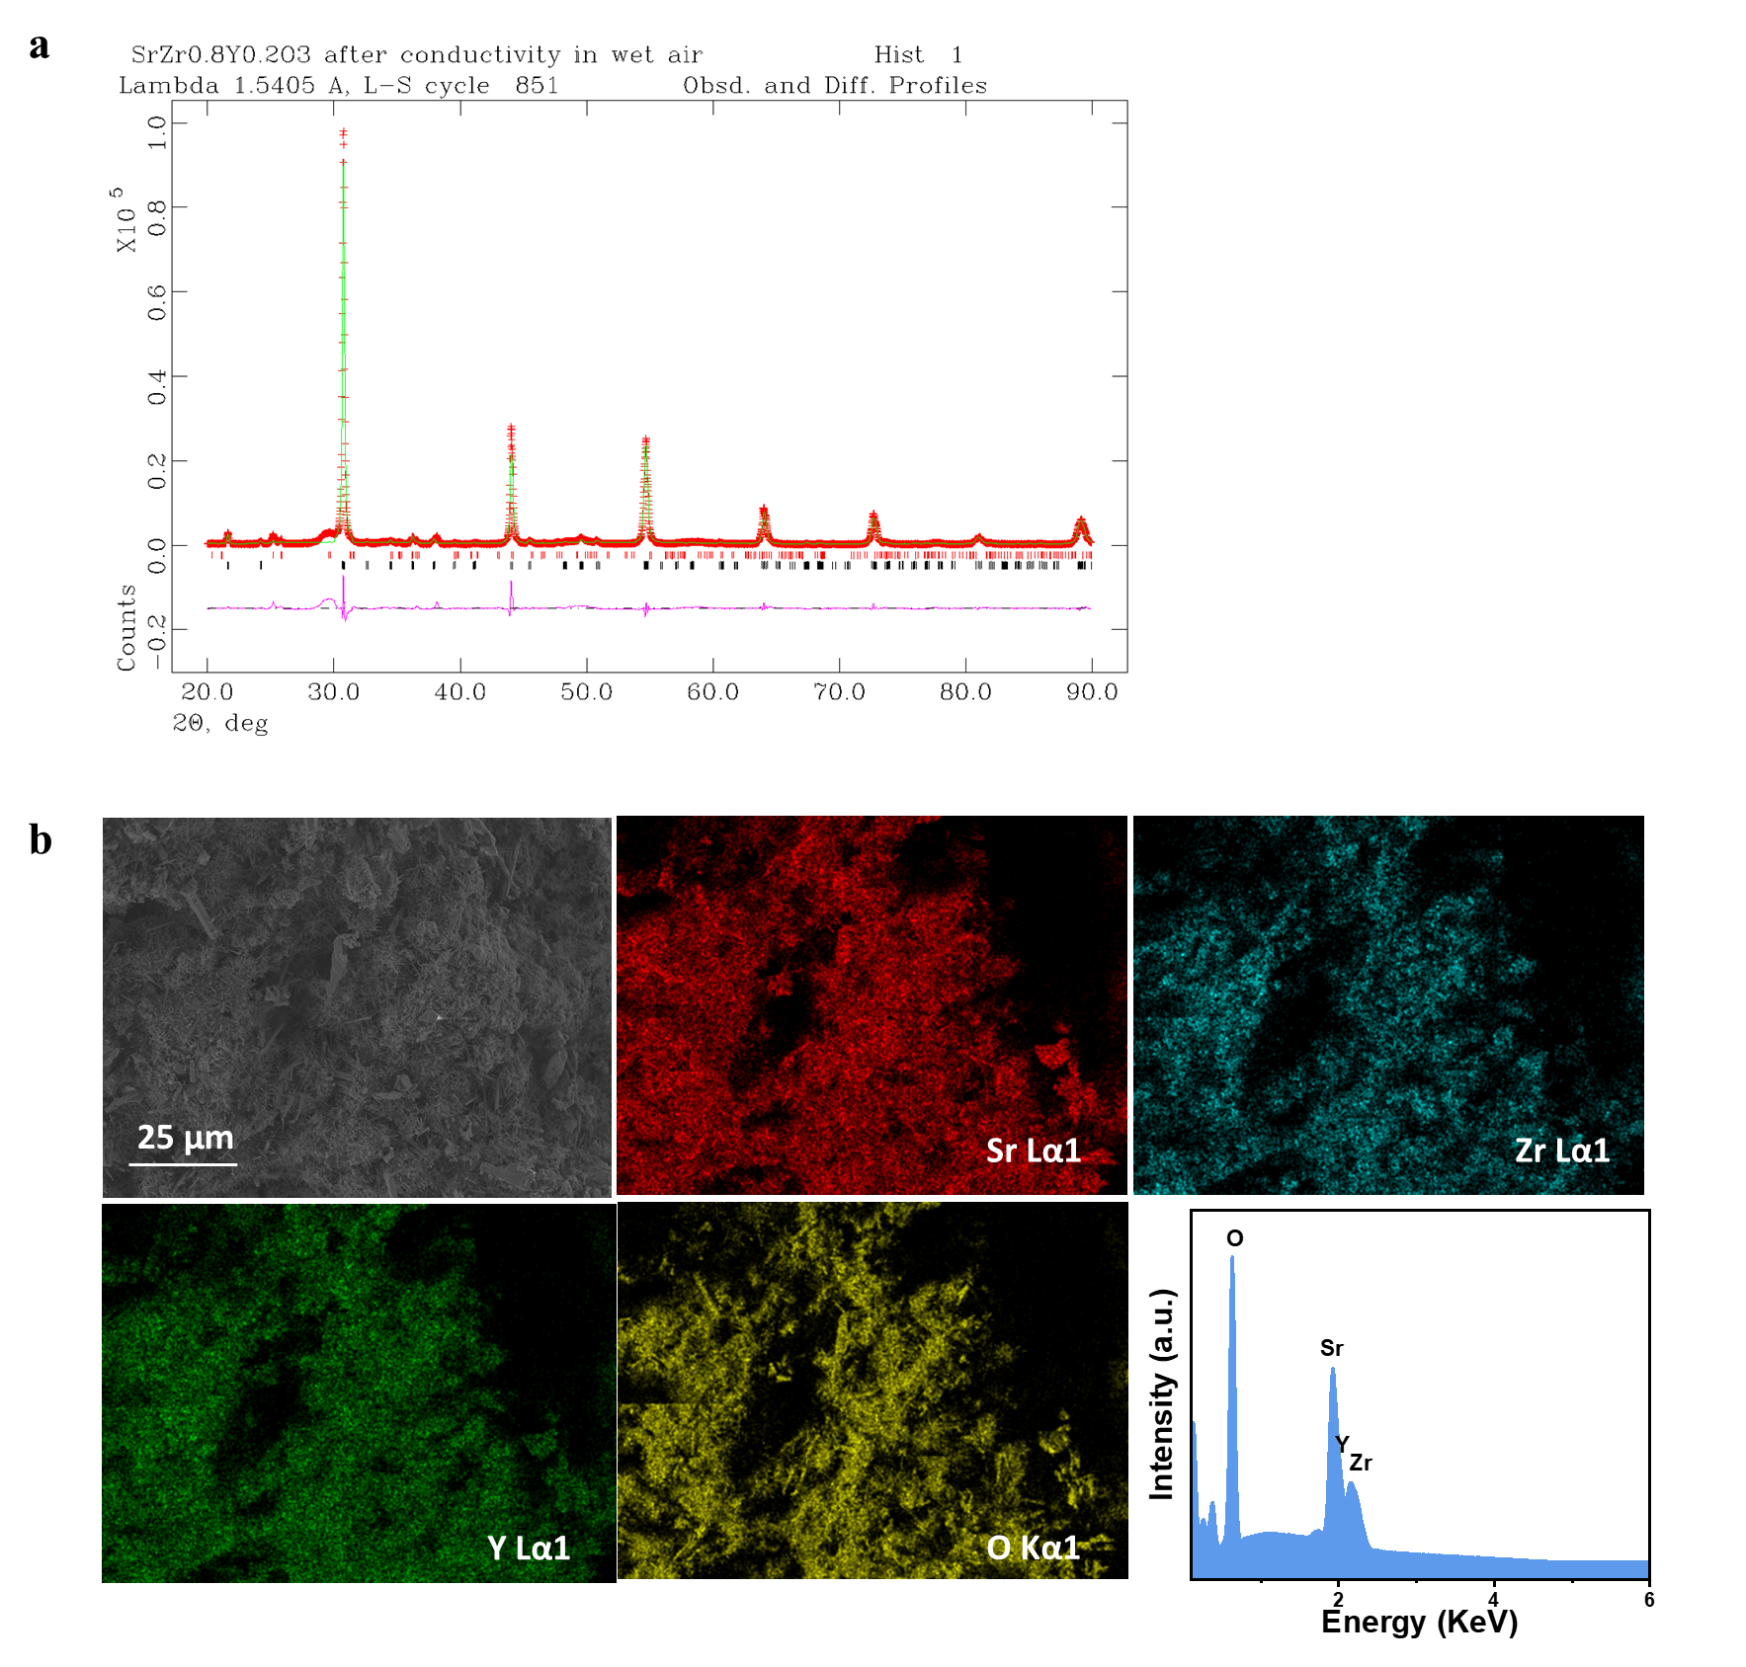
Supplementary Figure 11. Characterizations of SrZr_{0.8}Y_{0.2}O_{3-δ} in wet air. a, Representation of an experimental (crossed) and calculated (solid line) XRD profiles for SrZr_{0.8}Y_{0.2}O_{3-δ} after conductivity measurement in wet air. 98% SrZr_{0.8}Y_{0.2}O₃ and 2% SrCO₃. b, SEM image of SrZr_{0.8}Y_{0.2}O_{3-δ} pellet after the conductivity measurements in wet air under 25 μm resolution, corresponding EDX maps of Sr, Zr, Y, O elements and integrated EDX spectra from EDX element analysis.

Supplementary Discussion 2. Kinetic isotope effect analysis
For proton conducting materials, the conductivity in D₂O will be reduced due to the decreased mobility of D⁺ ions^{5,6}. This is also called the kinetic isotope effect (KIE). The conductivity and ion transfer number of SrZr_{0.8}Y_{0.2}O_{3-δ} in D₂O are much lower than those in H₂O (Fig. 4e). At room temperature, the conductivity in H₂O, 3.28×10⁻³ S cm⁻¹, is 4.8 times of that in D₂O, 6.77×10⁻⁴ S cm⁻¹. At 90°C, the conductivity in H₂O is 5.28 time of that in D₂O. As the KIE is much larger than 1.4, it is presumed that SrZr_{0.8}Y_{0.2}O_{3-δ} is a not a pure protonic conductor. In previous report, OH⁻ ionic conduction was also proposed in similar perovskite oxides SrCe_{0.95}Yb_{0.05}O_{3-δ} and BaCe_{1-x}Gd_{x}O_{3-δ} in the presence of water vapour at high temperature (≥ 150°C) while the observed ionic conduction does not follow the kinetic isotope effect either ^{7,8}. This is consistent with the observed KIE of ionic conduction of SrZr_{0.8}Y_{0.2}O_{3-δ} in H₂O and D₂O in this study. The large difference between the conductivity in H₂O and D₂O implies the large OH⁻ ions are the major charge carriers while jumping or diffusion of large OD⁻ ions could be more difficult than that for OH⁻ ions.

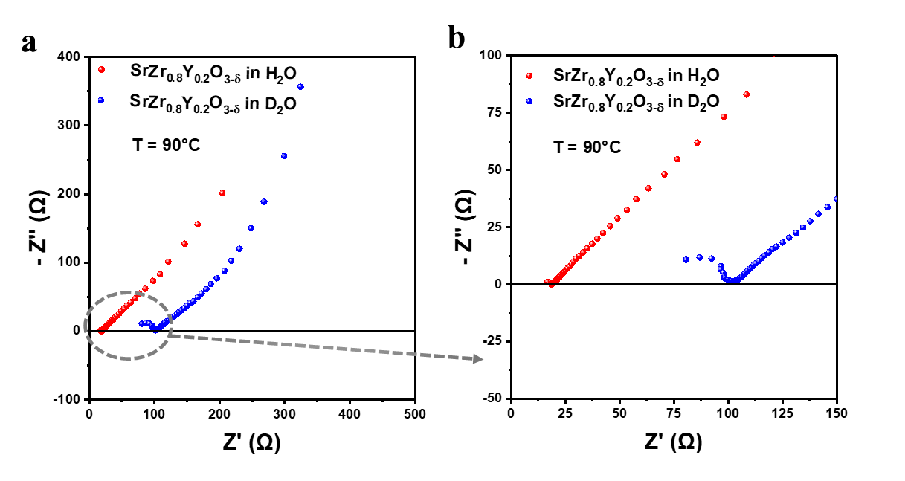
Supplementary Figure 12. Impedance spectra of SrZr_{0.8}Y_{0.2}O_{3-δ} sample. a, The representative a.c. impedance spectra of SrZr_{0.8}Y_{0.2}O_{3-δ} at 90℃ in H₂O and D₂O and b, Enlarged impedance spectra.

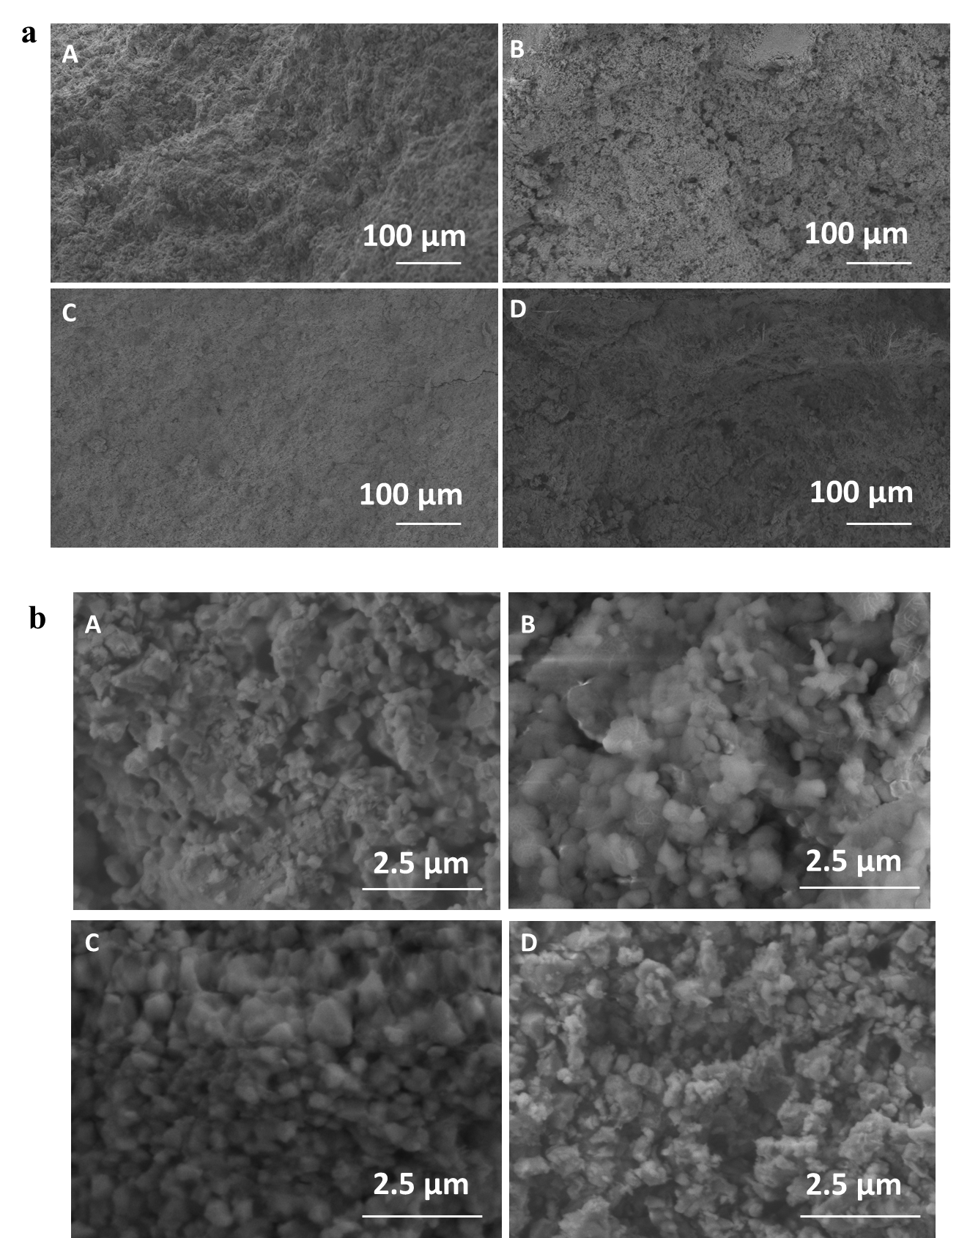
Supplementary Figure 13. SEM images of the cross section of SrZr_{0.8}Y_{0.2}O_{3-δ} pellets. The SEM image of (A) pure SrZr_{0.8}Y_{0.2}O_{3-δ} pellet, and after the conductivity measurements in (B) water, (C) D₂O and (D) wet air under a, 100 μm resolution, and b, 2.5 μm resolution, respectively.

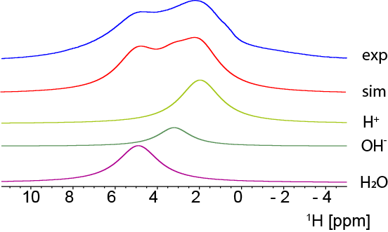
Supplementary Figure 14. Deconvolution of ¹H spectrum of the partially hydrated SrZr_{0.8}Y_{0.2}O_{3-δ}.

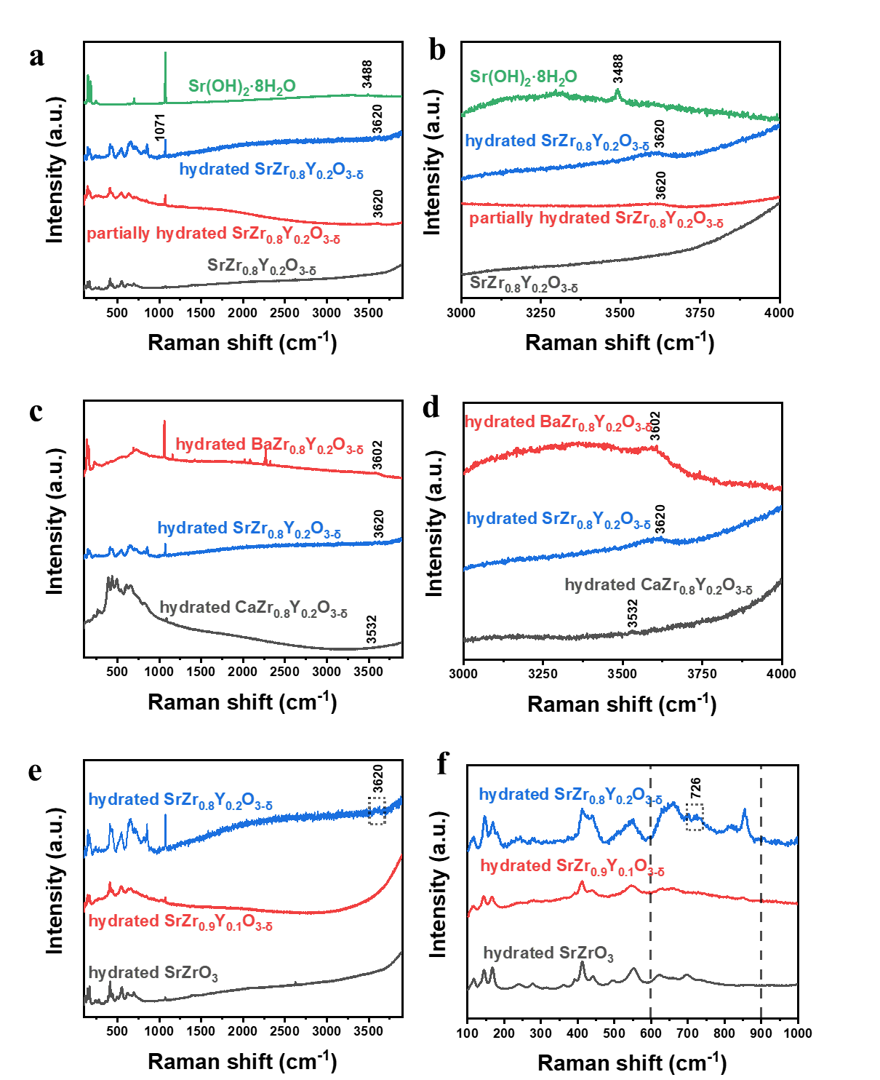
Supplementary Figure 15. Raman spectra of perovskite oxide pellets at room temperature. a,b, Raman spectra of SrZr_{0.8}Y_{0.2}O_{3-δ} samples and Sr(OH)₂·8H₂O. (a) extended grating scan from 100 to 3900 cm⁻¹; (b) standard grating scan from 3000 to 4000 cm⁻¹. c,d, Raman spectra of AZr_{0.8}Y_{0.2}O_{3-δ} (A= Ca, Sr, Ba) (c) extended grating scan from 100 to 3900 cm⁻¹; (d) standard grating scan from 3000 to 4000 cm⁻¹. e,f, Raman spectra of SrZr_{1-x}Y_{x}O_{3-δ} (x=0, 0.1, 0.2) (e) extended grating scan from 100 to 3900 cm⁻¹ and (f) enlarged spectra between 100 and 1000 cm⁻¹.
Supplementary Discussion 3. Raman spectra measurements and analyses
The second phase SrY₂O₄ hydrolysed when the SrZr_{0.8}Y_{0.2}O_{3-δ} sample was hydrated. The Raman features at 1071 cm⁻¹ is related to SrCO₃ ⁹, which is the product from hydrolysis of SrY₂O₄. The stronger signal of SrCO₃ indicates the higher hydration level of small second phase SrY₂O₄ in SrZr_{0.8}Y_{0.2}O_{3-δ} samples (Supplementary Fig. 15a). It was reported that the hydroxyl groups formed at ceramic surface can be detected in Raman spectra shown as narrow peaks at 3500-3650 cm⁻¹ ¹⁰. In Supplementary Fig. 15b, for SrZr_{0.8}Y_{0.2}O_{3-δ} samples with different hydration levels, the peak at 3620 cm⁻¹ is stronger when the pellet is wetter. This peak is different from the typical peak at 3488 cm⁻¹ ¹⁰ observed in the Raman spectra for commercial Sr(OH)₂·8H₂O, indicating the hydroxyl groups formed on the perovskite oxide the SrZr_{0.8}Y_{0.2}O_{3-δ} did not from Sr(OH)₂. It is very likely to form hydrated metal oxyhydroxide, for example, SrZr_{1-x}Y_{x}O_{3-y}(OH)_{2y}⋅zH₂O.
The hydroxyl peak shifts to 3602 and 3532 cm⁻¹ when A-site element was changed to Ba and Ca respectively (Supplementary Fig. 15c,d). After treated in water, the solid samples appear to be substances with strong fluorescence, so the Raman peaks were not sharp. It is possible that the fluorescence annihilates the Raman peaks, especially after 3000 cm⁻¹.
The Raman peak at 726 cm⁻¹ for SrZr_{0.8}Y_{0.2}O_{3-δ} samples shown in Supplementary Fig. 15f indicates the that the Y doping, proton defects and oxygen vacancies perturbed the vibration of ZrO₆ octahedron in perovskite ⁹. Part of Zr⁴⁺ in B-site of SrZrO₃ is replaced by Y³⁺ upon yttrium doping forms negatively charged defects which must be compensated by creating extra oxygen vacancies ¹¹. The Raman spectra in the 600-900 cm⁻¹ spectral region presents a peak shift of lattice vibrations in perovskite which is caused by the oxygen defects ¹¹.

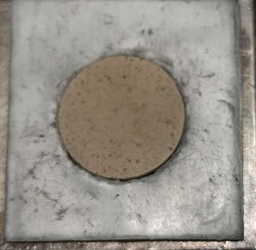

Supplementary Figure 16. Photo of the SrZr_{0.8}Y_{0.2}O_{3-δ} electrolyte sealed in the fuel cell jig.

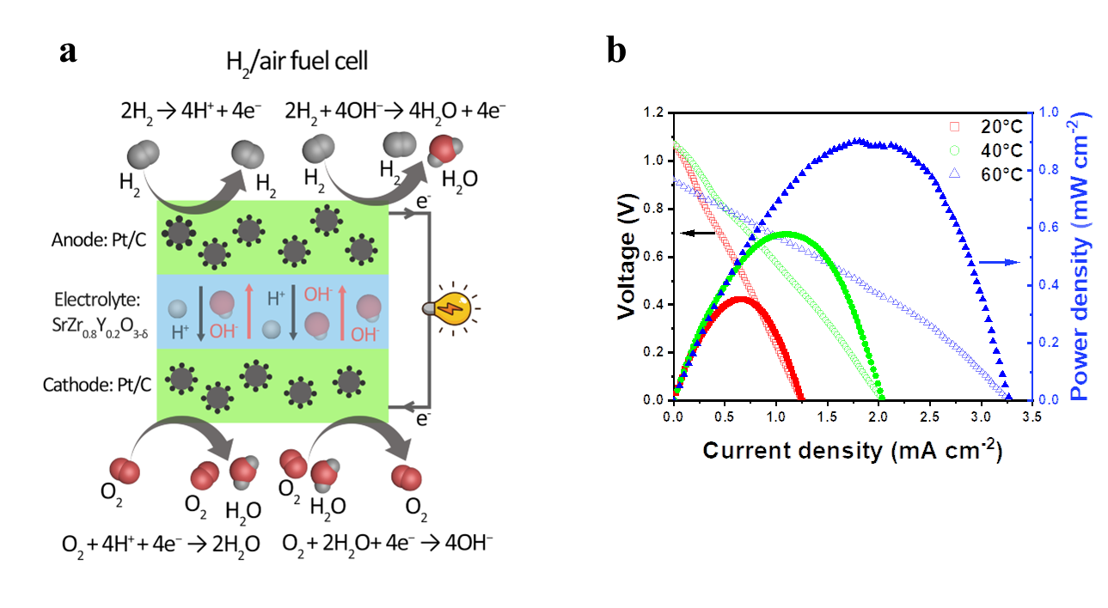
Supplementary Figure 17. Fuel cell demonstration when SrZr_{0.8}Y_{0.2}O_{3-δ} was used as electrolyte. a, Working principle of low temperature SOFCs for a H₂/air fuel cell. b, The performance of a H₂/air fuel cells at different temperatures.

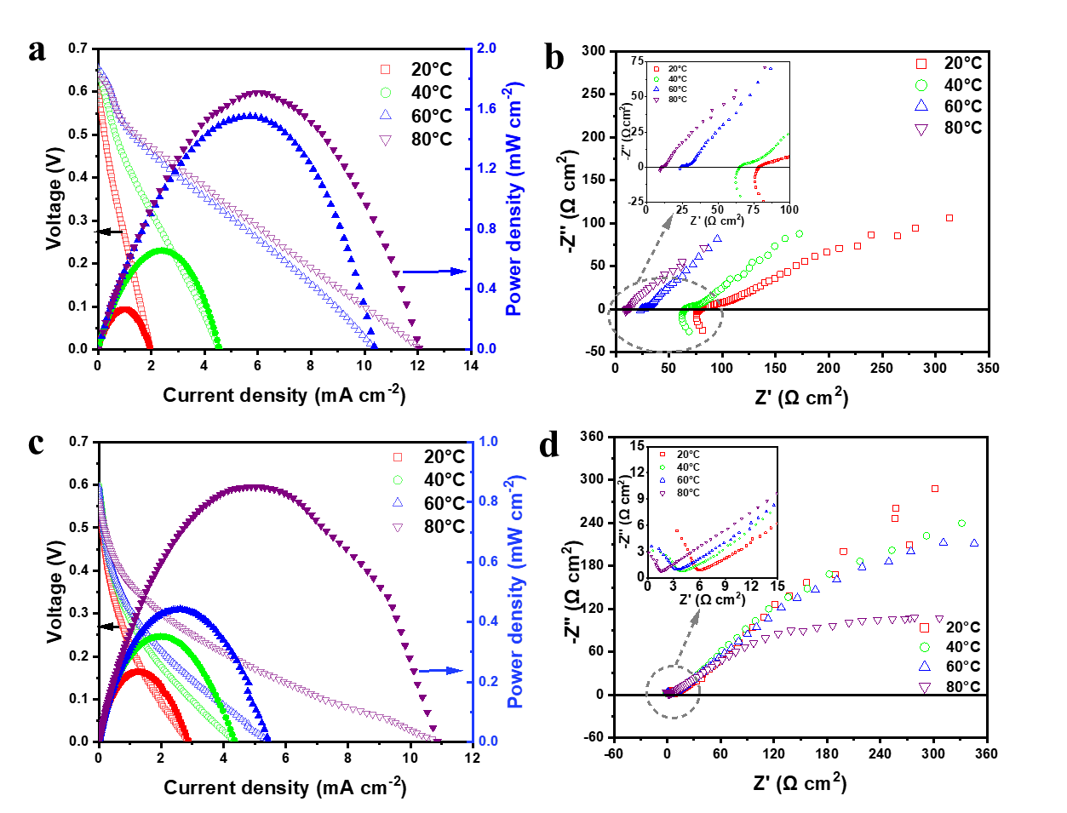
Supplementary Figure 18. Fuel cell demonstration when SrZr_{0.8}Y_{0.2}O_{3-δ} and AEM were used as electrolyte. a,b, (a) Fuel cell performance and (b) a.c. impedance of an NH₃/air fuel cell using SrZr_{0.8}Y_{0.2}O_{3-δ} pellet as electrolyte. Enlarged impedance spectra is displayed in insert. 35% NH₃H₂O solution was used as a fuel. PtIr as anode and Pt as cathode. c,d, (c) Fuel cell performance and (d) a.c. impedance of an NH₃/air fuel cell using FAA-3-50 electrolyte membrane. Enlarged impedance spectra is displayed in insert. 35 wt% NH₃H₂O solution was used as a fuel. PtIr as anode and Pt as cathode.

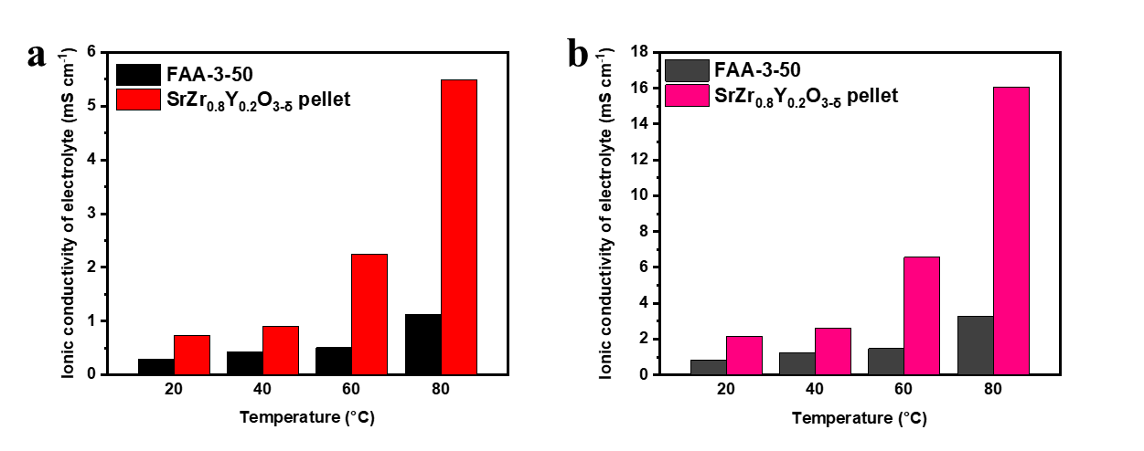

Supplementary Figure 19. Ionic conductivity of SrZr_{0.8}Y_{0.2}O_{3-δ} and AEM electrolyte in the direct ammonia fuel cell (35 wt% NH₃H₂O solution as the fuel). a, Calculation according to total area of the electrolyte pellet including the parts without electrode. b, Calculation according to the cell area coated with electrode only, of 1 cm².

Supplementary Discussion 4. XRD of synthesized amorphous Y(OH)₃
The Y-rich area in washed SrZr_{0.8}Y_{0.2}O_{3-δ} is amorphous (Supplementary Fig. 3a-c). In order to rule out the contribution of hydrolysis products of SrY₂O₄ on the conductivity measurement, the poorly crystallized Y(OH)₃ was prepared. XRD pattern of synthesized Y(OH)₃ (Supplementary Fig. 7a) shows a bumped background, which reveals the presence of large amount of amorphous phase, and the diffraction peaks are consist with that of a monoclinic lattice of Y(OH)₃ (JCPDS No. 21-1447).¹² X-ray diffraction patterns have shown that the as-prepared Y(OH)₃ was poorly crystallized, as same as the cathodic electrodeposited yttrium hydroxide in a literature.¹³

Supplementary Table 1. Crystallographic refinement parameters of perovskite oxides.
Crystallographic parameters | SrZrO₃ | SrZr_{0.9}Y_{0.1}O_{3-δ} | SrZr_{0.8}Y_{0.2}O_{3-δ} | SrZr_{0.8}Y_{0.2}O_{3-δ} after treated in H₂O | SrZr_{0.8}Y_{0.2}O_{3-δ} after treated in D₂O | SrZr_{0.8}Y_{0.2}O_{3-δ} after conductivity test in wet air | CaZr_{0.8}Y_{0.2}O_{3-δ} | BaZr_{0.8}Y_{0.2}O_{3-δ}
Crystal system | Orthombic | Orthombic | Orthombic | Orthombic | Orthombic | Orthombic | Orthombic | Cubic
Space group | P bnm (62) | P bnm (62) | P bnm (62) | P bnm (62) | P bnm (62) | P bnm (62) | P nma (62) | P m-3m (221)
a (Å) | 5.7994(1) | 5.8204(2) | 5.8265(3) | 5.8226(2) | 5.8146(6) | 5.8028(7) | 5.7853(1) | 4.2084(1)
b (Å) | 5.8176(1) | 5.8062(2) | 5.8092(3) | 5.8044(2) | 5.8181(4) | 5.8222(4) | 8.0525(2)
c (Å) | 8.2111(2) | 8.2085(3) | 8.2194(4) | 8.2025(3) | 8.2142(8) | 8.2254(10) | 5.6052(1)
V (Å³) | 277.03(1) | 277.40(2) | 278.21(2) | 277.22(2) | 277.88(5) | 277.89(5) | 261.13(1) | 74.534(1)
Position
Sr | x = 0.0037(5);  y = 0.5235(3);  z = 1/4 | x = 0.0011(3);  y = 0.5161(3);  z = 1/4 | x = 0.0024(4);  y = 0.5142(3);  z = 1/4 | x = -0.0019(12);  y = 0.4791(4);  z = 1/4 | x = -0.0057(3);  y = 0.4786(3);  z = 1/4 | x = -0.0129(10);  y = 0.5206(6);  z = 1/4 | Ca: x = -0.0482(6);  y = 1/4;  z = 0.0212(8) | Ba: x = ½;  y = 1/2;  z = 1/2
Zr | x = 0;  y = 0;  z = 0 | x = 0;  y = 0;  z = 0 | x = 0;  y = 0;  z = 0 | x = 0;  y = 0;  z = 0 | x = 0;  y = 0;  z = 0 | x = 0;  y = 0;  z = 0 | x = 0;  y = 0;  z = 1/2 | x = 0;  y = 0;  z = 0
Y | / | x = 0;  y = 0;  z = 0 | x = 0;  y = 0;  z = 0 | x = 0;  y = 0;  z = 0 | x = 0;  y = 0;  z = 0 | x = 0;  y = 0;  z = 0 | x = 0;  y = 0;  z = 1/2 | x = 0;  y = 0;  z = 0
O1 | x = 0.222(4);  y = -0.306(4);  z =1/4 | x = 0.316(4);  y = -0.281(3);  z =1/4 | x = 0.283(4);  y = -0.285(3);  z =1/4 | x = -0.137(4);  y = -0.009(3);  z =1/4 | x = -0.084(4);  y = 0.008(3);  z = 1/4 | x = 0.013(12);  y = -0.008(3);  z = 1/4 | x = -0.4504(17);  y = 1/4;  z =-0.1188(17) | x = 1/2;  y = 0;  z = 0
O2 | x = 0.217(4);  y = 0.330(3);  z = 0.165(2) | x = 0.304(3);  y = 0.313(2);  z = 0.1547(9) | x = 0.283(3);  y = 0.318(1);  z = 0.1486(9) | x = 0.288(3);  y = 0.215(2);  z = 0.015(2) | x = 0.293(3);  y = 0.235(2);  z = 0.042(2) | x = 0.219(4);  y = 0.302(3);  z = 0.055(4) | x = 0.288(3);  y = 0.215(2);  z = 0.015(2)
Occupancy
Sr | 1 | 1 | 1 | 1 | 1 | 1 | Ca:1 | Ba: 1
Zr | 1 | 0.9 | 0.8 | 0.8 | 0.8 | 0.8 | 0.8 | 0.8
Y |  | 0.1 | 0.2 | 0.2 | 0.2 | 0.2 | 0.2 | 0.2
O1 | 1 | 1 | 1 | 1 | 1 | 1 | 1 | 1
O2 | 1 | 1 | 1 | 1 | 1 | 1 | 1
Uiso (Å²)
Sr | 0.0076(7) | 0.0016(5) | 0.0062(5) | 0.0184(7) | 0.0198(5) | 0.0217(9) | Ca:0.0043(11) | Ba:0.0166(6)
Zr | 0.0102(6) | 0.0211(6) | 0.0261(7) | 0.0080(5) | 0.0119(4) | 0.0110(7) | 0.0145(6) | 0.0076(7)
Y | / | 0.0211(6) | 0.0261(7) | 0.0080(5) | 0.0119(4) | 0.0110(7) | 0.0145(6) | 0.0076(7)
O1 | 0.025 | 0.025 | 0.025 | 0.025 | 0.025 | 0.025 | 0.0331(31) | 0.0189(22)
O2 | 0.0076(11) | 0.025 | 0.025 | 0.025 | 0.025 | 0.025 | 0.00150(6)
χ² | 68.68 | 40.43 | 61.99 | 30.71 | 16.40 | 58.37 | 82.10 | 34.06
R_{wp} (%) | 16.94 | 11.73 | 14.19 | 12.25 | 7.87 | 17.57 | 20.67 | 8.73
R_{p} (%) | 13.17 | 9.18 | 11.42 | 9.83 | 6.47 | 11.84 | 15.21 | 7.80

Supplementary Table 2. Atomic concentration of SrZr_{0.8}Y_{0.2}O_{3-δ} as on STEM-EDX analysis.
Samples | Atomic composition (%)
Samples | Sr | Zr | Y | O | Sr/(Zr+Y) | Zr/Y
SrZr_{0.8}Y_{0.2}O_{3-δ} | 20.65 | 15.93 | 4.60 | 58.82 | 1.006 (1) | 3.46 (4)
Washed SrZr_{0.8}Y_{0.2}O_{3-δ} | 22.97 | 19.56 | 3.50 | 53.97 | 0.996 | 5.59

brackets indicate the expected ratio.
Supplementary Table 3. The measurement of ion transfer number of SrZr_{0.8}Y_{0.2}O_{3-δ} for H⁺ and OH⁻ ions using the Ag/Ag₂O electrode and concentration cell.
Electrolyte | ΔE(mV) | t_{Na+} | t_{OH-}
SrZr_{0.8}Y_{0.2}O_{3-δ} | -51.7692 | 0.3029 | 0.6971
SrZrO₃ | -63.0016 | 0.244 | 0.756
Anion exchange membrane, (Fumapem FAA) | -104.4 | 0.073 | 0.9269
Nafion 212 membrane | +76.6945 | 0.8717 | 0.1282

The perovskite oxide electrolyte SrZrO₃ and SrZr_{0.8}Y_{0.2}O_{3-δ} had been treated in water at 90℃ before measured in a concentration cell.

Supplementary References
1 Dai, H.-Y., Yang, H.-M., Jian, X., Liu, X. & Liang, Z.-H. Performance of Ag2O/Ag Electrode as Cathodic Electron Acceptor in Microbial Fuel Cell. Acta Metallurgica Sinica (English Letters) 30, 1243-1248, doi:10.1007/s40195-017-0616-1 (2017).
2 Takahashi, H. et al. Ion conduction in layered oxide solid electrolyte. ECS Transactions 33, 1861 (2010).
3 Watanabe, H., Takahashi, H., Takeguchi, T., Yamanaka, T. & Ueda, W. Performance of solid alkaline fuel cells employing layered perovskite-type oxides as electrolyte. ECS Transactions 33, 1825 (2010).
4 Takeguchi, T. et al. Layered perovskite oxide: a reversible air electrode for oxygen evolution/reduction in rechargeable metal-air batteries. J Am Chem Soc 135, 11125-11130, doi:10.1021/ja403476v (2013).
5 Iwahara, H., Yajima, T., Hibino, T., Ozaki, K. & Suzuki, H. Protonic conduction in calcium, strontium and barium zirconates. Solid State Ionics 61, 65-69, doi:10.1016/0167-2738(93)90335-z (1993).
6 Qian, X. T. et al. CdPS₃ nanosheets-based membrane with high proton conductivity enabled by Cd vacancies. Science 370, 596-600, doi:10.1126/science.abb9704 (2020).
7 Bonanos, N., Ellis, B. & Mahmood, M. Oxide ion conduction in ytterbium-doped strontium cerate. Solid State Ionics 28, 579-584 (1988).
8 Bonanos, N., Ellis, B., Knight, K. & Mahmood, M. Ionic conductivity of gadolinium-doped barium cerate perovskites. Solid State Ionics 35, 179-188 (1989).
9 Slodczyk, A., Colomban, P., Upasen, S., Grasset, F. & André, G. Structural stability of anhydrous proton conducting SrZr0. 9Er0. 1O3− δ perovskite ceramic vs. protonation/deprotonation cycling: Neutron diffraction and Raman studies. Journal of Physics and Chemistry of Solids 83, 85-95 (2015).
10 Colomban, P., Tran, C., Zaafrani, O. & Slodczyk, A. Aqua oxyhydroxycarbonate second phases at the surface of Ba/Sr‐based proton conducting perovskites: a source of confusion in the understanding of proton conduction. Journal of Raman Spectroscopy 44, 312-320 (2013).
11 Shkerin, S. et al. Raman spectroscopy of SrZrO3 based proton conducting electrolyte: Effect of Y-doping and Sr-nonstoichiometry. International Journal of Hydrogen Energy 46, 17007-17018 (2021).
12 Huang, G., Zhanglian, H., Shizhu, Z., Pengyue, Z. & Xianping, F. Synthesis of yttrium oxide nanocrystal via solvothermal process. Journal of rare earths 24, 47-50 (2006).
13 Aghazadeh, M., Ghaemi, M., Nozad Golikand, A., Yousefi, T. & Jangju, E. Yttrium oxide nanoparticles prepared by heat treatment of cathodically grown yttrium hydroxide. International Scholarly Research Notices 2011 (2011).

