Supplement Materials

USP25 inhibits renal fibrosis by regulating TGFβ-SMAD signaling pathway in Ang II-induced hypertensive mice

Supplemental File: Materials and Methods, 1 Table, and 5 Figures

SUPPLEMENTAL TABLES
Supplementary Table S1. Primer sequences for qPCR.
Gene | Species | Forward primer | Reverse primer
Col-4 | mouse | GCTCCACCACTCAAAGGTGTT | GGCACAGTCGAGTCTTCCA
Col-1 | mouse | TGGCCTTGGAGGAAACTTTG | CTTGGAAACCTTGTGGACCAG
USP25 | mouse | GTGTTACCGACGATCCGTGTC | GTTCATGCAGATATAGAGGCCAC

SUPPLEMENTAL FIGURES
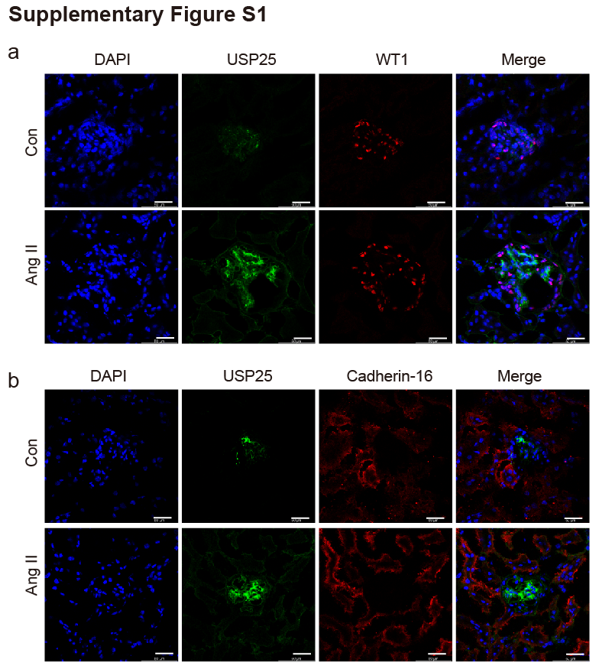

Supplement Figure S1. Representative immunofluorescence staining images of kidney tissue from wild-type control and Ang II-induced hypertensive mice. (A) Immunoreactivity to USP25 (green) and podocyte marker protein (red) is shown. (B) Immunoreactivity to USP25 (green) and tubular epithelial marker protein (red) is shown.Tissues were counterstained with DAPI (blue). Capture images at 400x magnification. (Scale bar = 25 μm).

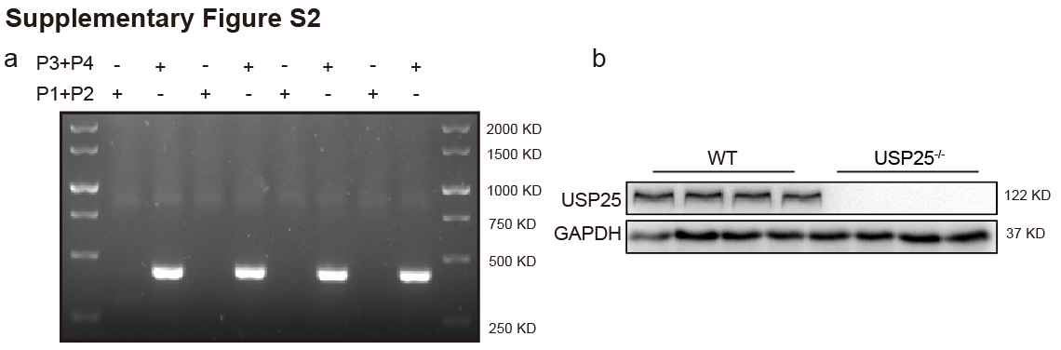
Supplement Figure S2. Identification of USP25 knockout mice. (A) (P1, P2) has no band, (P3, P4) amplifies a 420bp band, which is the USP25 knockout homozygous mouse. (B) Western Blot verification of USP25 knockout efficiency in mouse kidney tissue

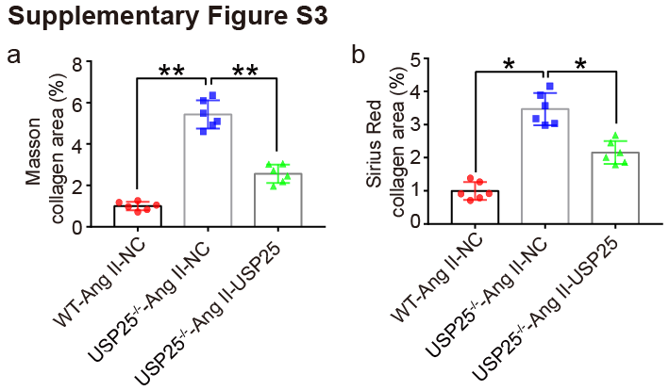
Supplement Figure S3. (A) and (B) are the statistical data of collagen volume fraction stained with Masson and Sirius red for figure 3E. Date reported as Mean + SEM；n = 6 in each group, *p < 0.05 and **p < 0.01.

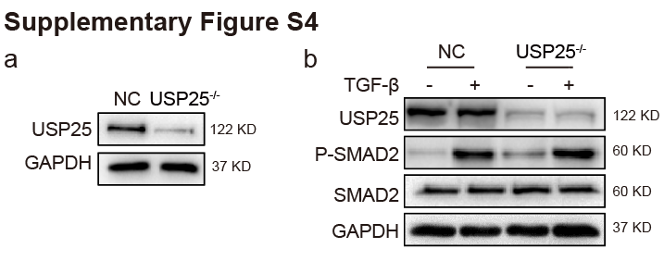
Supplement Figure S4. USP25 deletion does not affect SMAD2 phosphorylation levels. (A) The USP25 knockout mesangial cell line was obtained by CRISPR-Cas9 technology, and the knockout efficiency was verified by Western Blot. (B) Control (NC) and USP25^{-/-} SV40 MES-13 cells were stimulated with TGF-β (10 ng/mL) for 30min. Representative P-SMAD2 western blot images. SMAD2 was used as an internal reference.

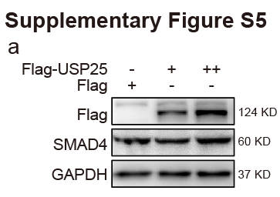
Supplement Figure S5. USP25 gradient overexpression does not affect SMAD4 degradation. (A) SV40 MES-13 cells were transfected with Flag vector plasmid or varying amounts of Flag-USP25 plasmid. Twenty-four hours after transfection, SMAD4 protein levels were analyzed by Western Blot.

