Table 1. Learning process recorded by the custom CNN (FallCNN) models considering the number of epochs, model loss, model accuracy curve respectively.

Model | Training and Validation  Loss |  | Training and Validation Accuracy
FallCNN_1 | 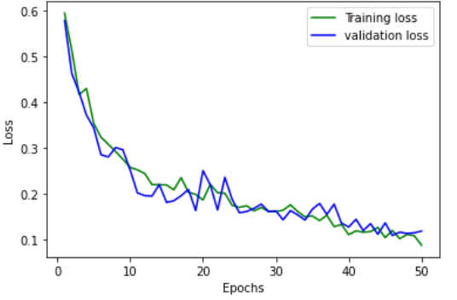 |  | 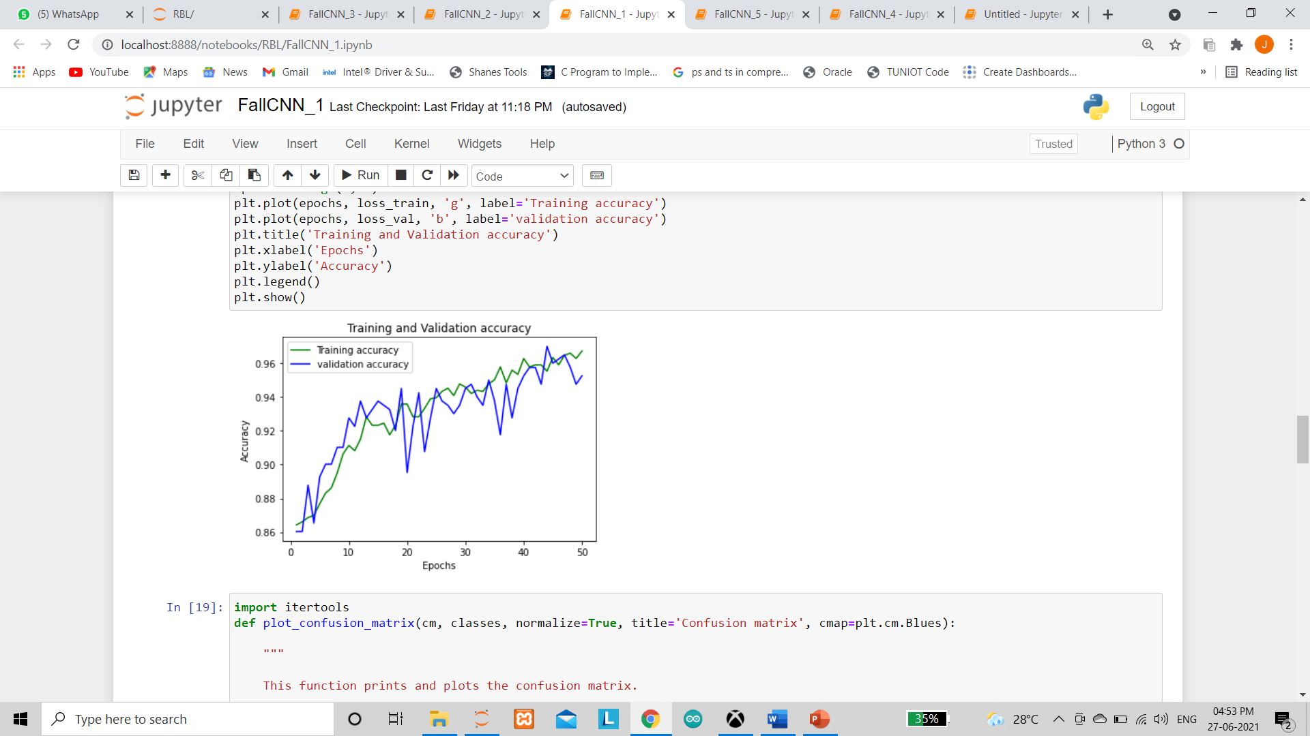
FallCNN_2 | 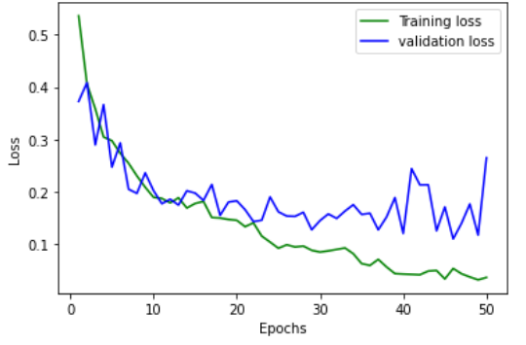 |  | 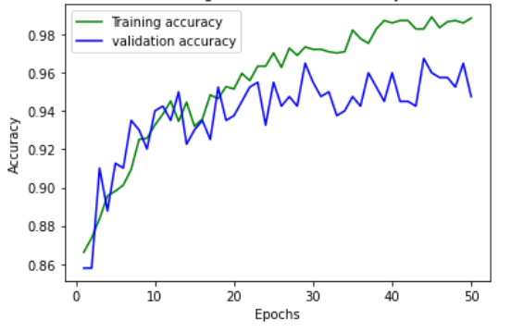
FallCNN_3 | 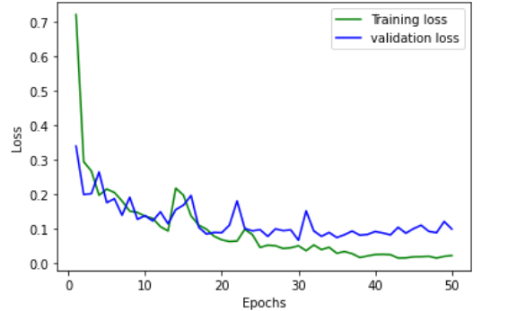 |  | 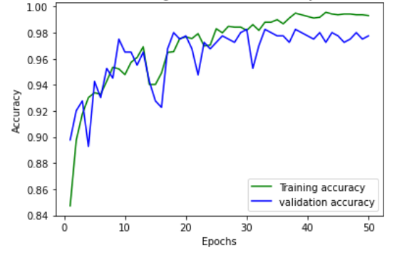
FallCNN_4 | 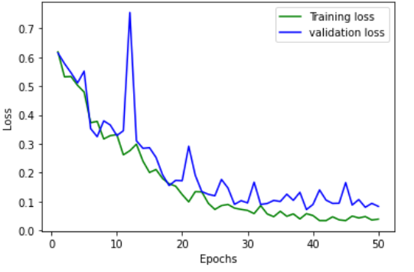 | 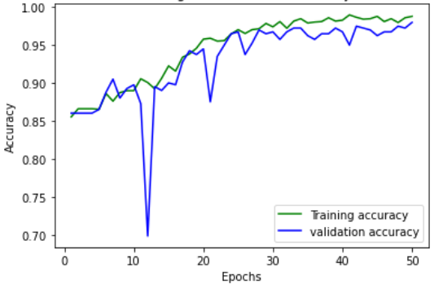

Table 6. Performance graph for FallCNN and MobileNetV2 models

FallCNN models | MobileNetV2 models
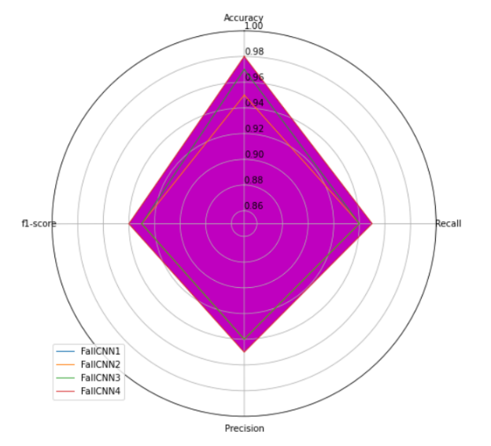 | 