Additional file
Supplement Table 1 The detection time distribution of the study population (n, P).
Characteristic | Total(n=563) | Non-MPP (n=376) | MPP(n=187) | P
RNA detection time |  |  |  | 0.005
≤7d | 241(42.81) | 175(46.54) | 66(35.29)
7～14d | 193(34.28) | 112(29.79) | 81(43.32)
14～30d | 74(13.14) | 47(12.5) | 27(14.44)
>30d | 55(9.77) | 42(11.17) | 13(6.95)
MP-Ab detection time |  |  |  | 0.005
≤7d | 269(47.78) | 193(51.33) | 76(40.64)
7～14d | 169(30.02) | 96(25.53) | 73(39.04)
14～30d | 71(12.61) | 46(12.23) | 25(13.37)
>30d | 54(9.59) | 41(10.9) | 13(6.95)

Supplement Table 2 Frequency table of diagnosis distribution in children under different diagnostic methods and age groups.
Type | MP-RNA | PA (1:80) | PA (1:160) | Age group | MP | F
1 | MP-RNA(-) | MP80(-) | MP160(-) | (37~72) | MP(+) | 2
2 | MP-RNA(-) | MP80(-) | MP160(-) | >72 | MP(+) | 2
3 | MP-RNA(-) | MP80(+) | MP160(-) | (37~72) | MP(+) | 2
4 | MP-RNA(-) | MP80(+) | MP160(+) | (1~12) | MP(+) | 2
5 | MP-RNA(-) | MP80(+) | MP160(+) | (13~36) | MP(+) | 2
6 | MP-RNA(-) | MP80(+) | MP160(+) | (37~72) | MP(+) | 1
7 | MP-RNA(-) | MP80(+) | MP160(+) | >72 | MP(+) | 2
8 | MP-RNA(+) | MP80(-) | MP160(-) | (1~12) | MP(+) | 7
9 | MP-RNA(+) | MP80(-) | MP160(-) | (13~36) | MP(+) | 18
10 | MP-RNA(+) | MP80(-) | MP160(-) | (37~72) | MP(+) | 13
11 | MP-RNA(+) | MP80(-) | MP160(-) | >72 | MP(+) | 7
12 | MP-RNA(+) | MP80(+) | MP160(-) | (1~12) | MP(+) | 3
13 | MP-RNA(+) | MP80(+) | MP160(-) | (13~36) | MP(+) | 12
14 | MP-RNA(+) | MP80(+) | MP160(-) | (37~72) | MP(+) | 5
15 | MP-RNA(+) | MP80(+) | MP160(-) | >72 | MP(+) | 10
16 | MP-RNA(+) | MP80(+) | MP160(+) | (1~12) | MP(+) | 11
17 | MP-RNA(+) | MP80(+) | MP160(+) | (13~36) | MP(+) | 22
18 | MP-RNA(+) | MP80(+) | MP160(+) | (37~72) | MP(+) | 35
19 | MP-RNA(+) | MP80(+) | MP160(+) | >72 | MP(+) | 31
20 | MP-RNA(-) | MP80(-) | MP160(-) | (1~12) | MP(-) | 125
21 | MP-RNA(-) | MP80(-) | MP160(-) | (13~36) | MP(-) | 129
22 | MP-RNA(-) | MP80(-) | MP160(-) | (37~72) | MP(-) | 55
23 | MP-RNA(-) | MP80(-) | MP160(-) | >72 | MP(-) | 27
24 | MP-RNA(-) | MP80(+) | MP160(-) | (1~12) | MP(-) | 5
25 | MP-RNA(-) | MP80(+) | MP160(-) | (13~36) | MP(-) | 12
26 | MP-RNA(-) | MP80(+) | MP160(-) | (37~72) | MP(-) | 11
27 | MP-RNA(-) | MP80(+) | MP160(-) | >72 | MP(-) | 7
28 | MP-RNA(+) | MP80(-) | MP160(-) | (1~12) | MP(-) | 1
29 | MP-RNA(+) | MP80(-) | MP160(-) | (13~36) | MP(-) | 2
30 | MP-RNA(+) | MP80(-) | MP160(-) | >72 | MP(-) | 2

Supplement Figure 1. Diagnostic decision trees for children with MP

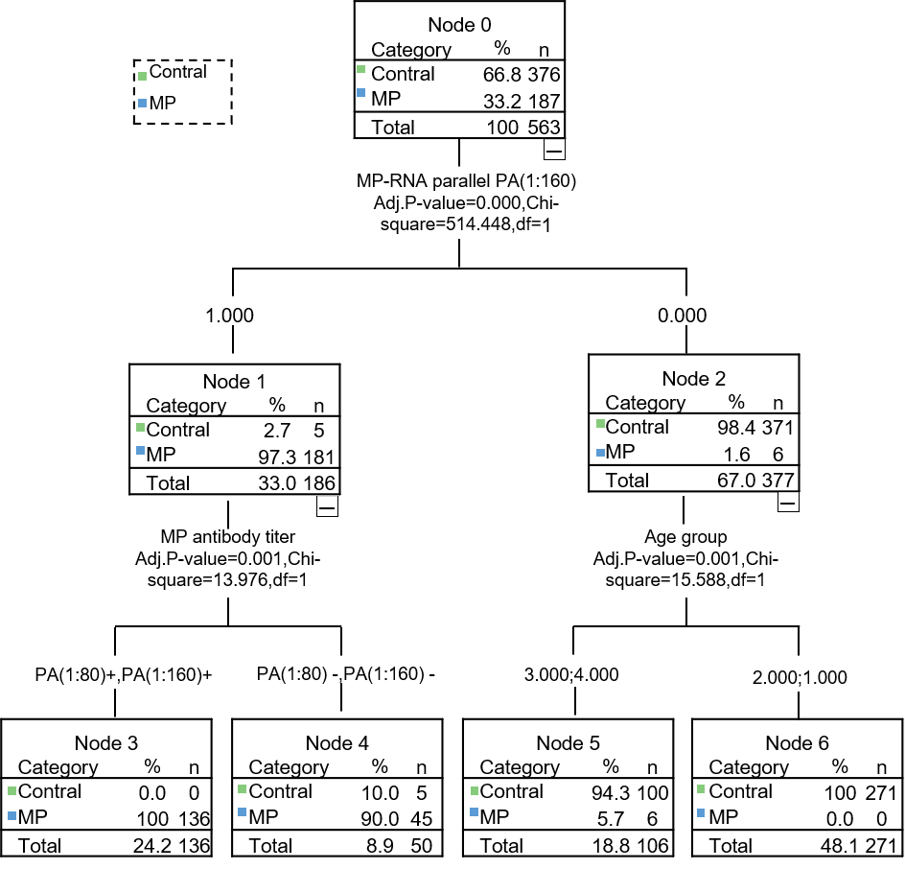
MP, Mycoplasma pneumoniae

