Supplementary Materials for

Spontaneous Radiative Cooling to Enhance the Operational Stability of Perovskite Solar Cells via a Black-body-like Full Carbon Electrode

Bingcheng Yu, * Jiangjian Shi, * Yiming Li, Shan Tan, Yuqi Cui, Fanqi Meng, Huijue Wu, Yanhong Luo, Dongmei Li, † Qingbo Meng †

*These authors contributed equally to this work.
†Corresponding author: qbmeng@iphy.ac.cn (Q.M.); dmli@iphy.ac.cn (D.L.)

Supplementary Figures:

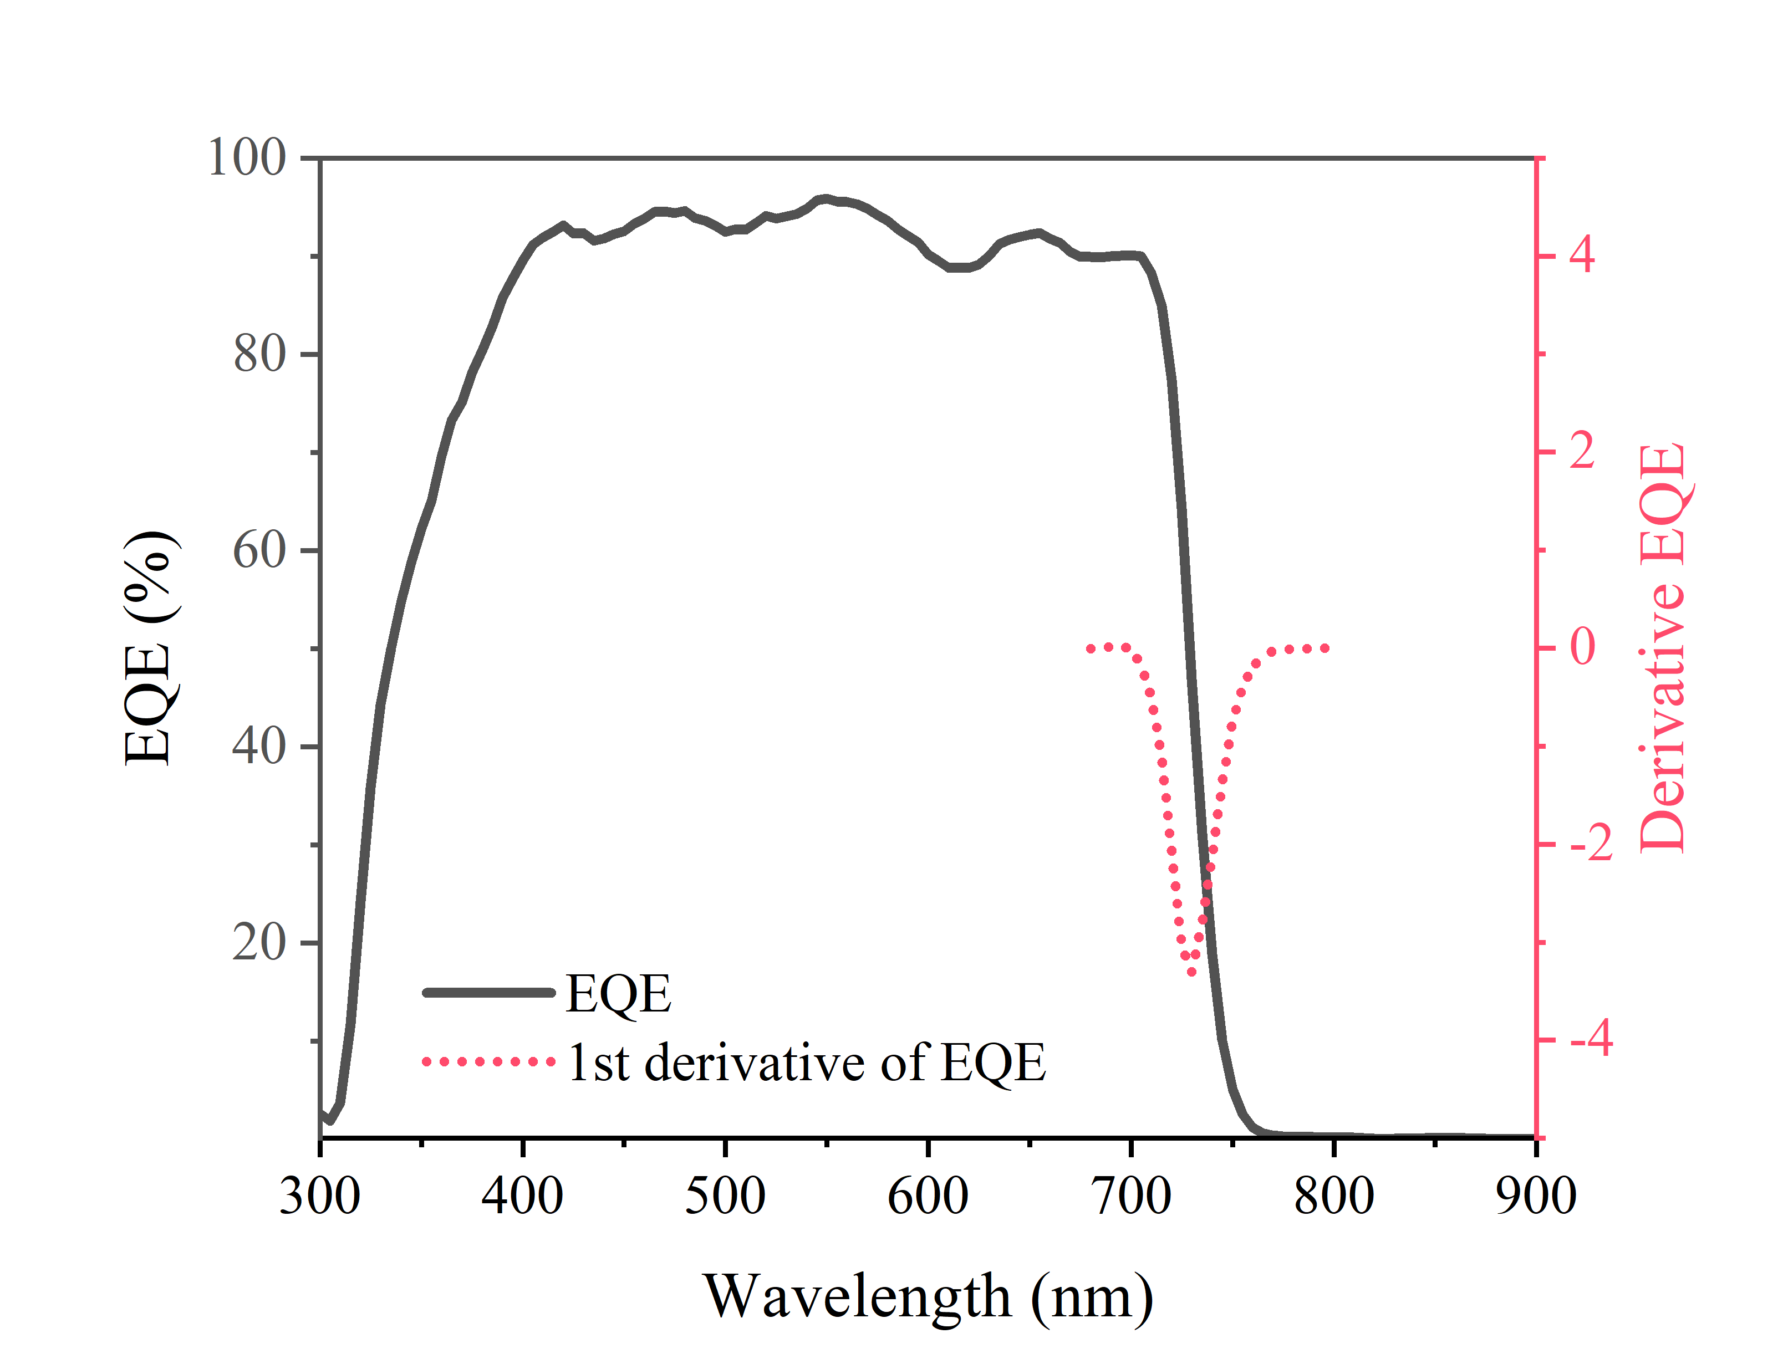

Supplementary Figure 1. The EQE and derivative of EQE for CsPbI₃ PSCs based on Au electrode.

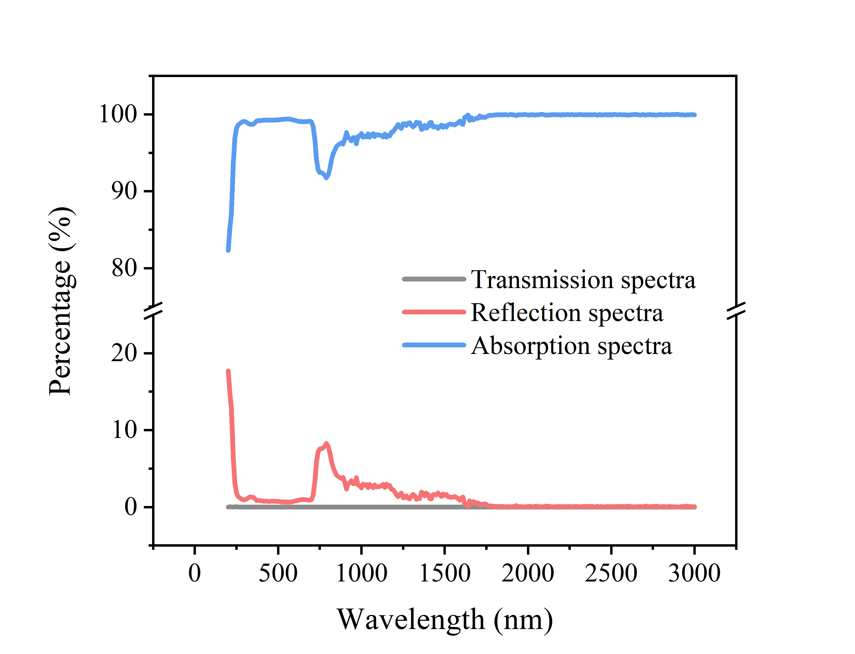

Supplementary Figure 2. The transmission/reflection/absorption spectra of the CsPbI₃ PSCs based on Au electrode.

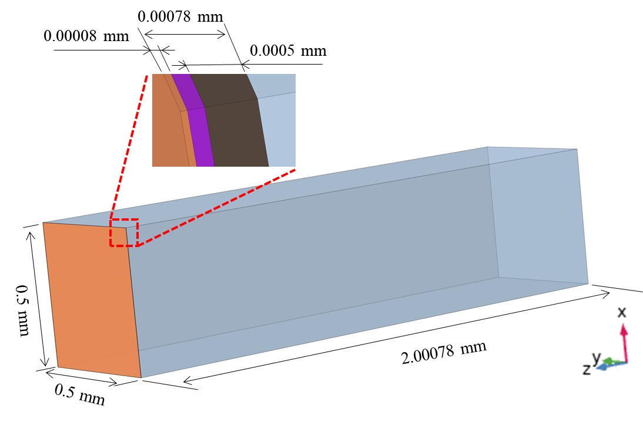

Supplementary Figure 3. FEM model for heat transfer analysis. The glass, perovskite, spiro-OMeTAD, Au electrode with the dimensions of 0.5×0.5×2.0 mm³, 0.5×0.5×0.0005 mm³, 0.5×0.5×0.0002 mm³, 0.5×0.5×0.00008 mm³ was modeled, respectively.

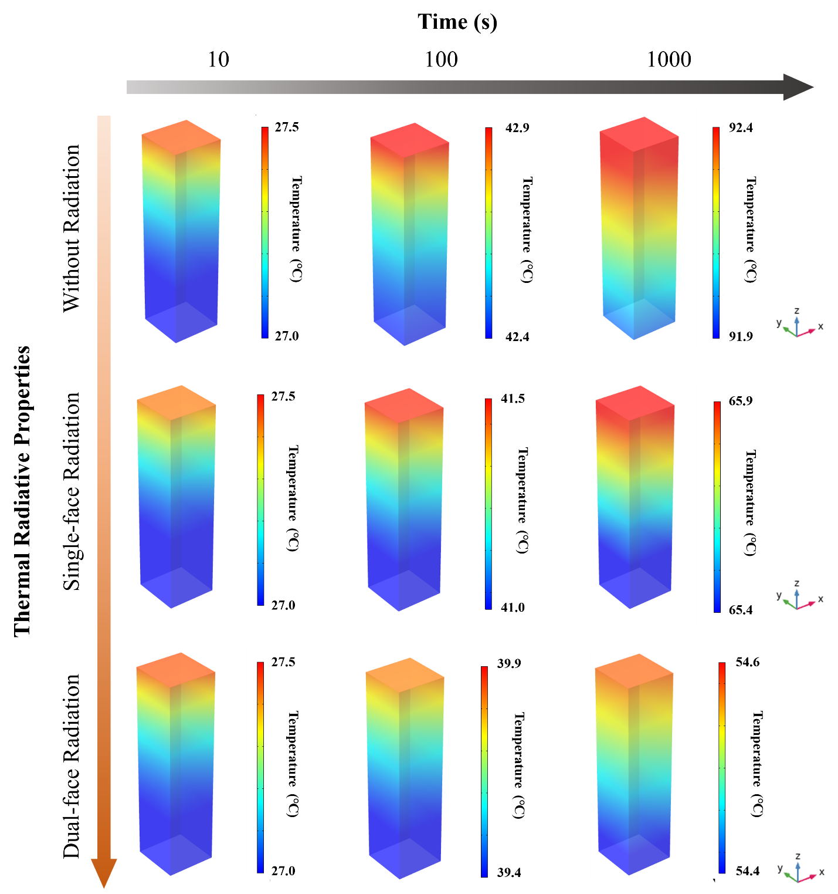

Supplementary Figure 4. The FEM analysis on the thermal field distribution with illumination time of the PSC having a heating power of about 750 W m⁻² and varied thermal radiative properties.

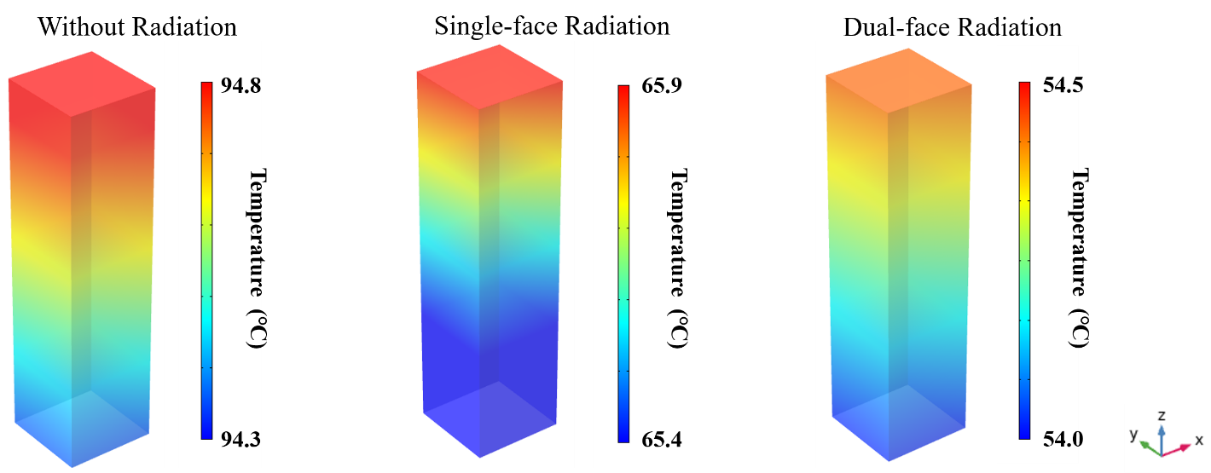

Supplementary Figure 5. FEM model for heat transfer analysis on the final thermal field distribution of the PSC having a heating power of about 750 W m⁻² and varied thermal radiative properties.

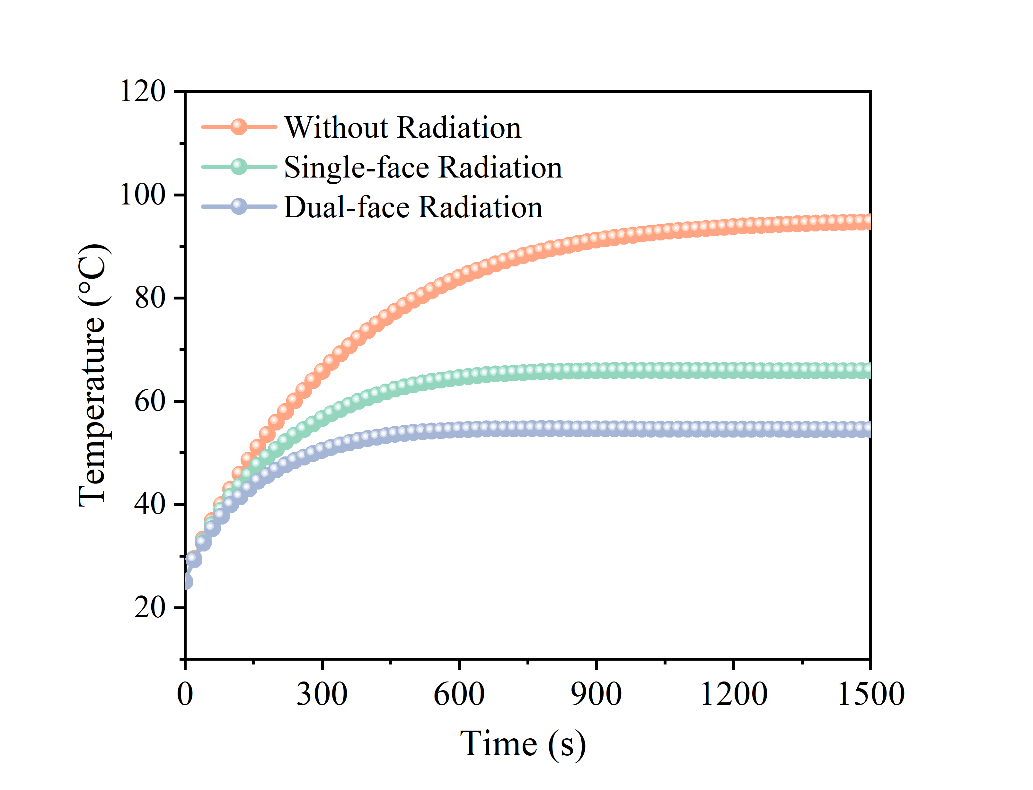

Supplementary Figure 6. Simulations of the temperature evolution trend of the PSC having a heating power of about 770 W m⁻² and varied thermal radiative properties.

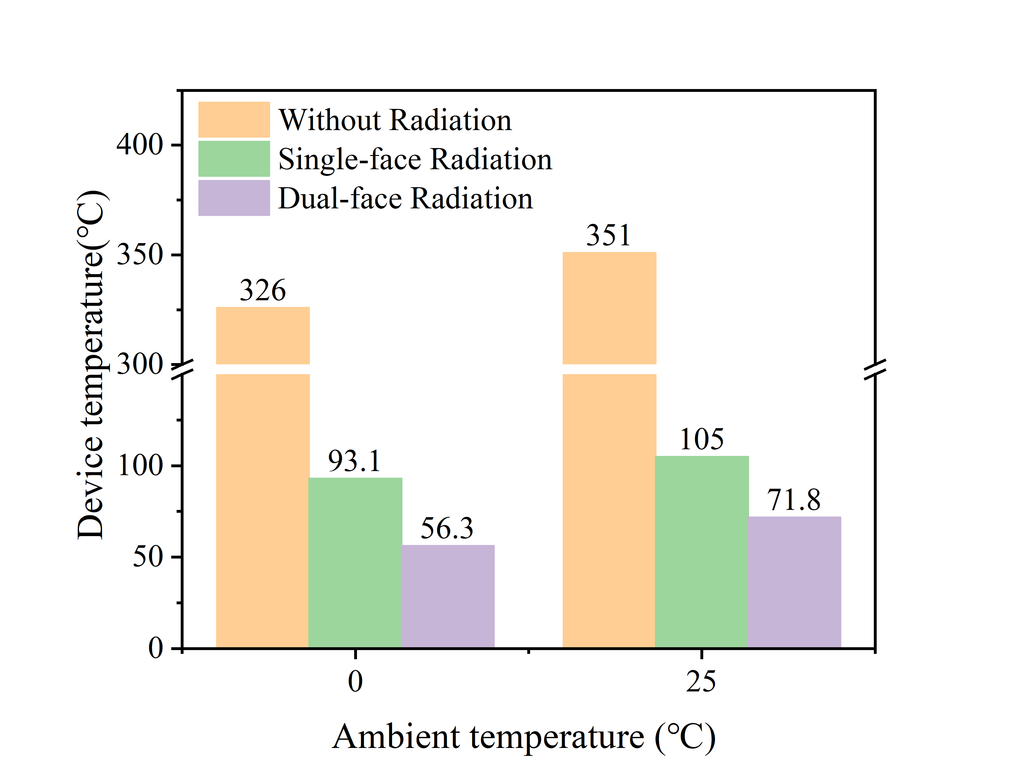

Supplementary Figure 7. The temperature of the PSC under vacuum conditions was simulated at a heating power of 770 W m⁻² and varied thermal radiative properties.

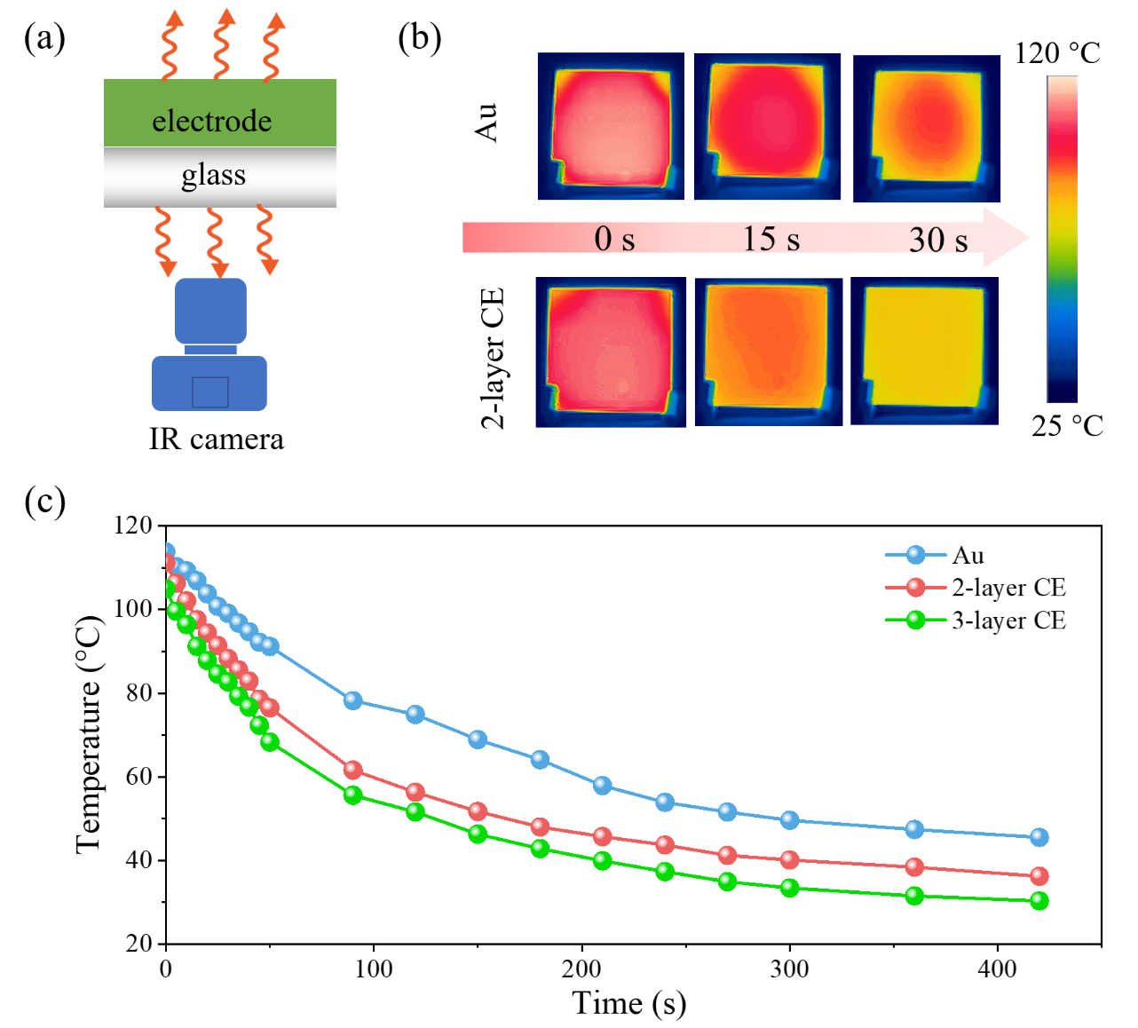

Supplementary Figure 8. The IR camera measured temperature of the glass attached with varied electrode films. (a) Schematic diagram of the measurement of the heat dissipation ability of the Au and CE. The Au and CE film is closely attached on a glass substrate and the glass/electrode has been pre-heated at 120 °C for 10 min. After stopping heating, the glass/electrode is transferred to make both its two sides face ambient atmosphere and the temperature of the glass surface is measured by the IR camera. (b) IR photos and (c) temperature evolutions of the glass attached with varied electrode films.

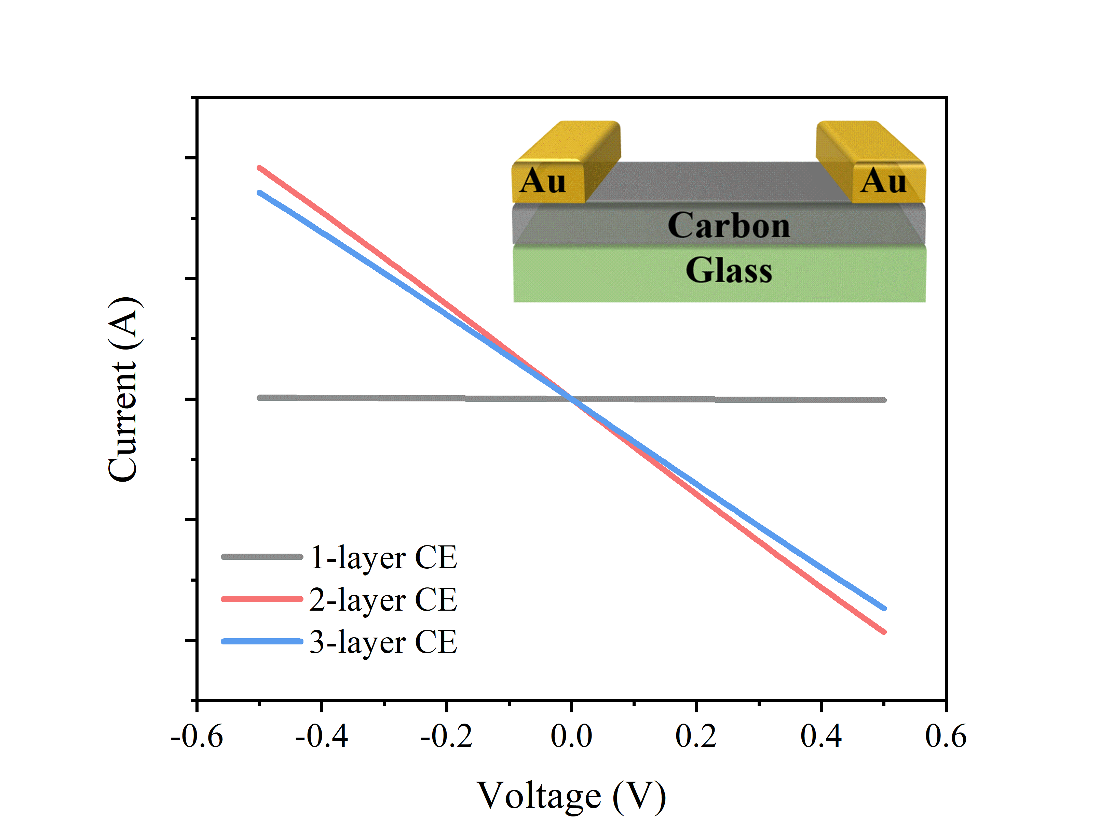

Supplementary Figure 9. Current-voltage (I–V) curves of glass/carbon film/Au lateral devices with carbon film obtained under different processing conditions. The inset shows the lateral device used for I–V characterization.

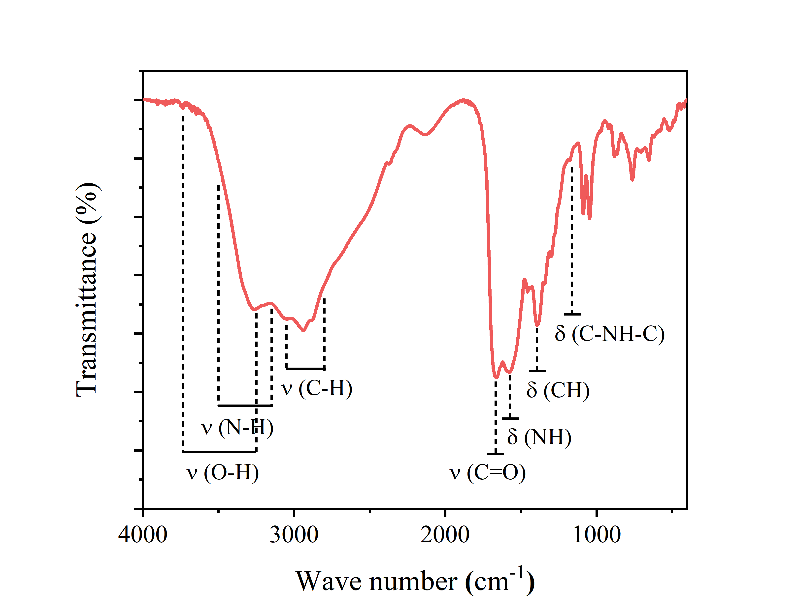

Supplementary Figure 10. FTIR spectra of CQDs.

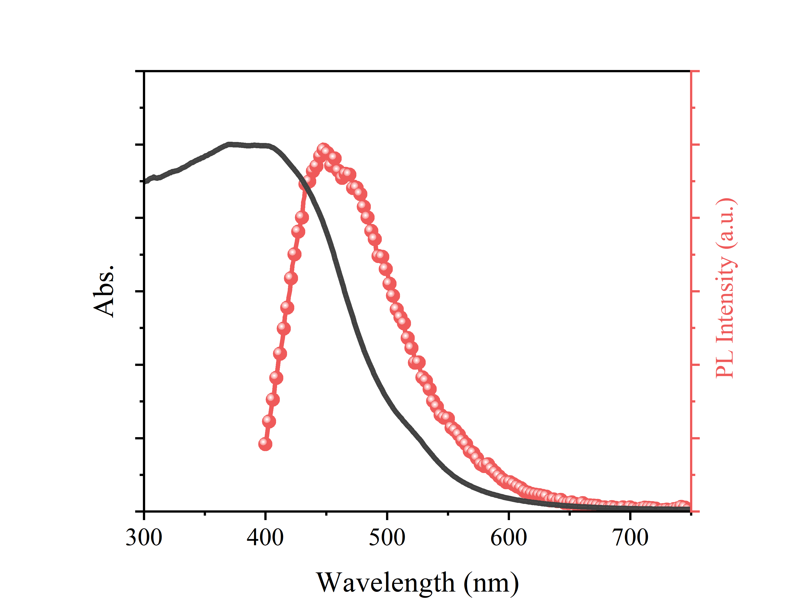

Supplementary Figure 11. UV–vis absorption and steady-state photoluminescence of CQDs.

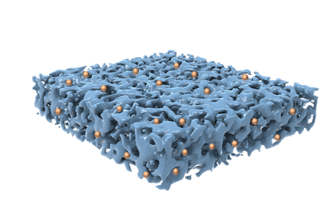

Supplementary Figure 12. Scheme image of the mesoporous carbon film modified with CQDs.

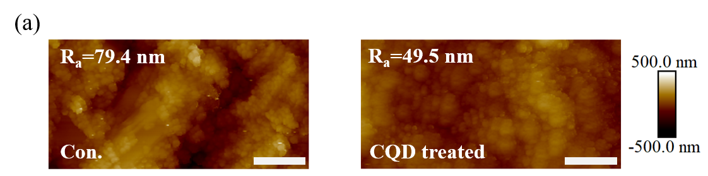

Supplementary Figure 13. Atomic force microscope morphology (AFM) image of CE films with different conditions. The scale bar is 1 μm.

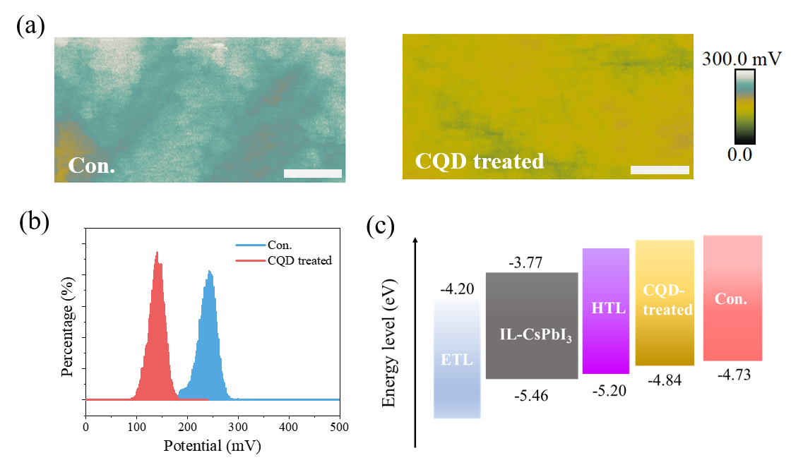

Supplementary Figure 14. (a) Kelvin probe force microscopy surface potential, (b) the distribution of surface potential of CE films with different conditions. The scale bar is 1 μm. (c) Energy band alignment of the devices.

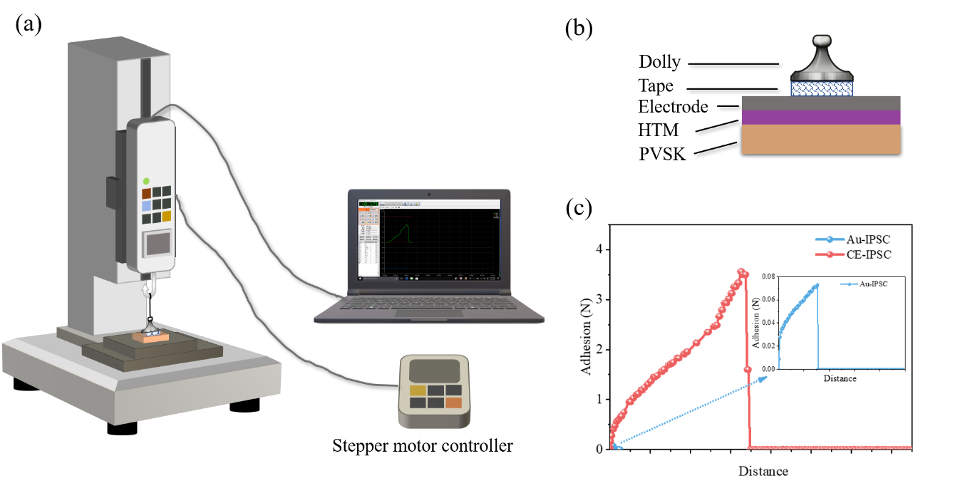

Supplementary Figure 15. (a-b) Schematic diagram of pull-off adhesion test. (c) The results of pull-off adhesive test of Au-PSC and F-CE-PSC.

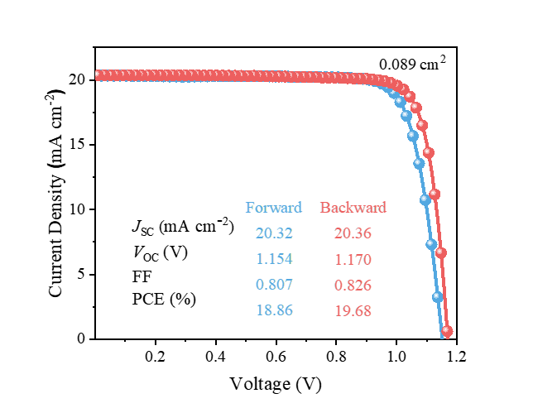

Supplementary Figure 16. Current density versus voltage (J-V) curve for champion 0.089-cm² F-CE based CsPbI₃ PSC.

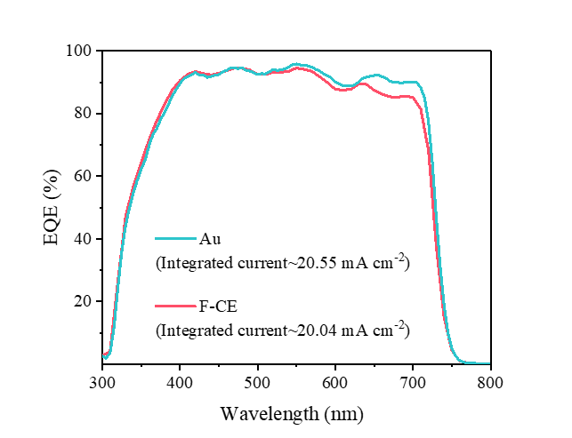

Supplementary Figure 17. External quantum efficiency (EQE) of CsPbI₃ PSCs with Au electrode and F-CE, respectively.

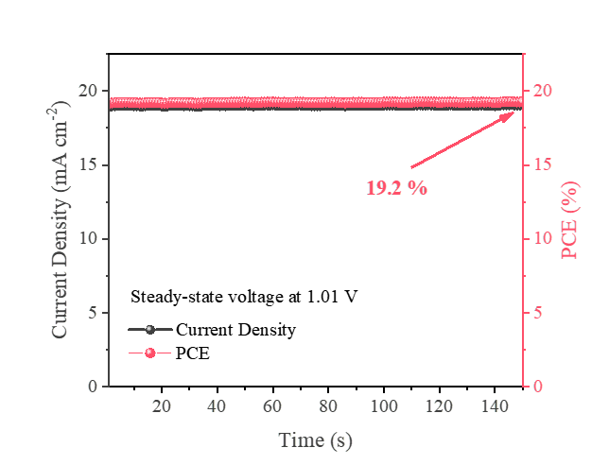

Supplementary Figure 18. Continuous current output of champion 0.089 cm⁻² F-CE based CsPbI₃ PSCs at a steady-state bias voltage of 1.01 V, demonstrating a PCE of over 19.2% after a 2 min operation.

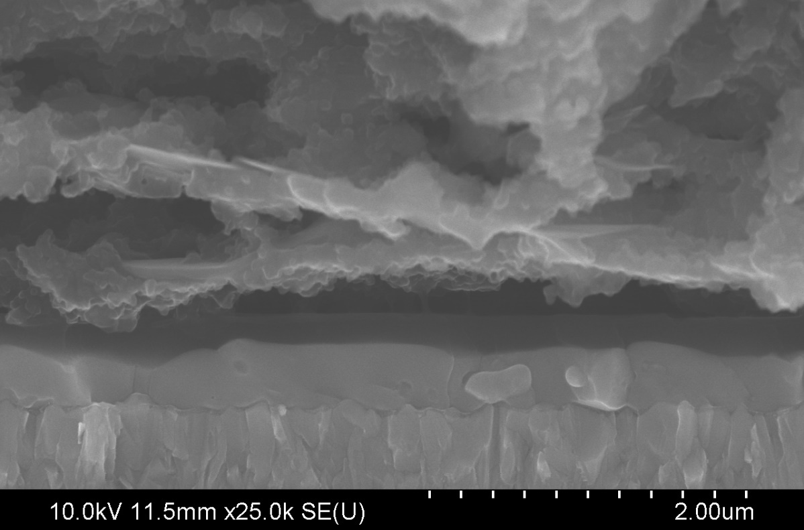

Supplementary Figure 19. Cross-sectional SEM image of F-CE based CsPbI₃ PSC.

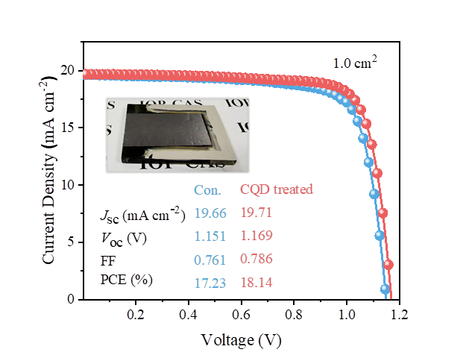

Supplementary Figure 20. J-V curve for champion 1.0-cm² F-CE based CsPbI₃ PSC.

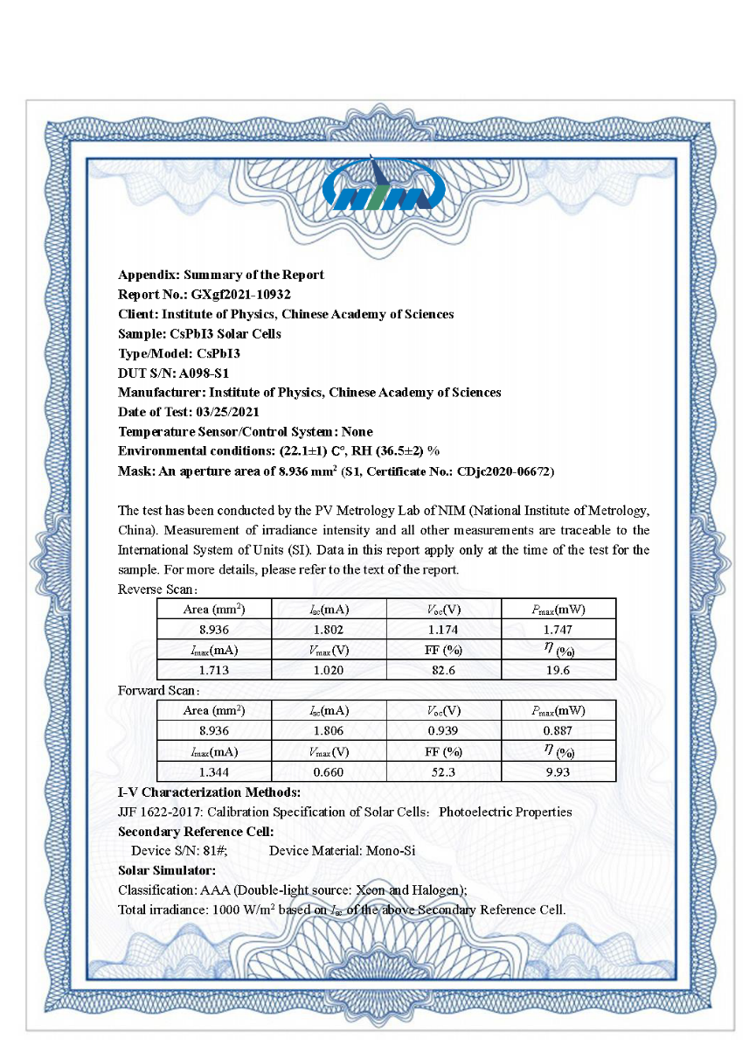
Supplementary Figure 21. An independent PCE testing report of a F-CE based CsPbI₃ PSC by an accredited PV Metrology Laboratory of National Institute of Metrology, China verified a reverse scan PCE of 19.6% (A I_{SC} of 1.802 mA, a V_{OC} of 1.174 V, and a FF of 82.6%) under a high relative humidity (36.5%) without encapsulation. Under relatively high humidity, the device performance significantly degraded during the test. Since the reverse sweep was performed first and then the forward sweep was performed, the efficiency of the forward sweep may be significantly affected.

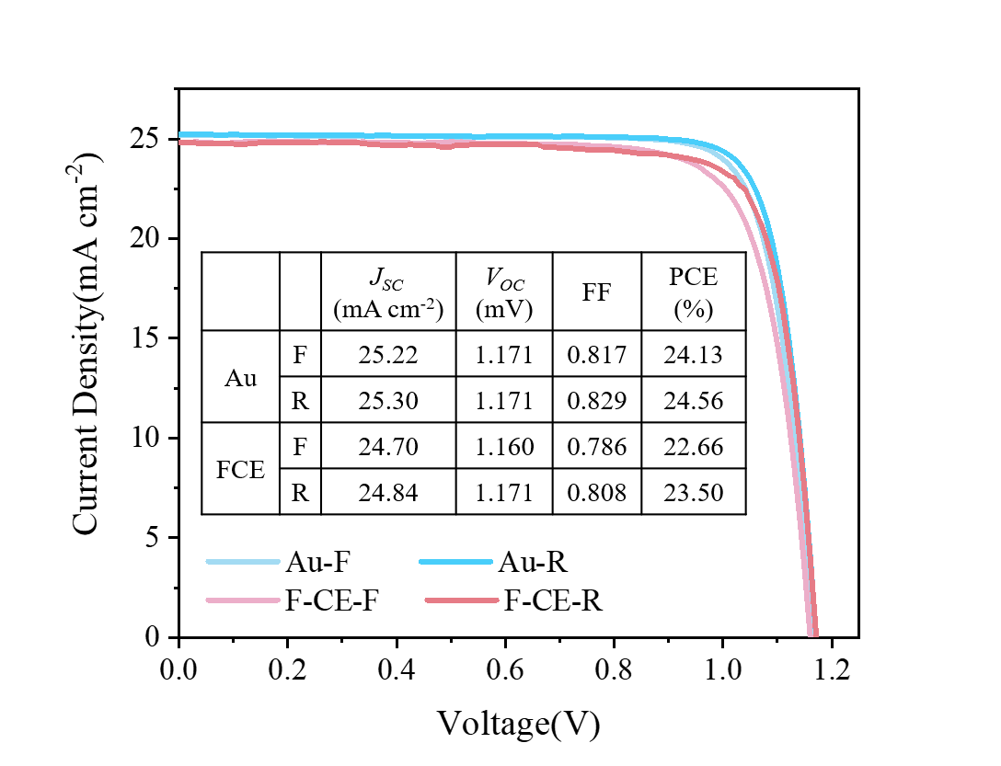

Supplementary Figure 22. J-V curve for champion 0.089-cm² organic-inorganic hybrid PSCs based on Au electrode and F-CE.

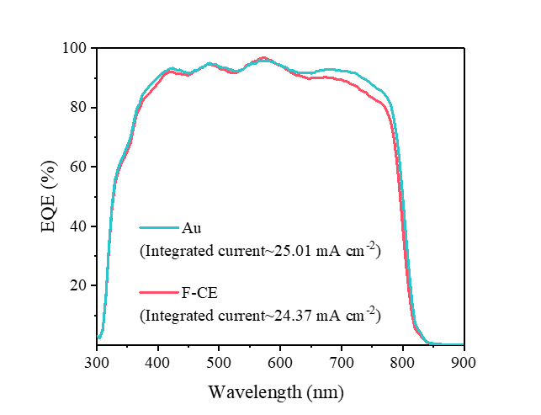

Supplementary Figure 23. The EQE for organic-inorganic hybrid PSCs based on Au electrode and F-CE.

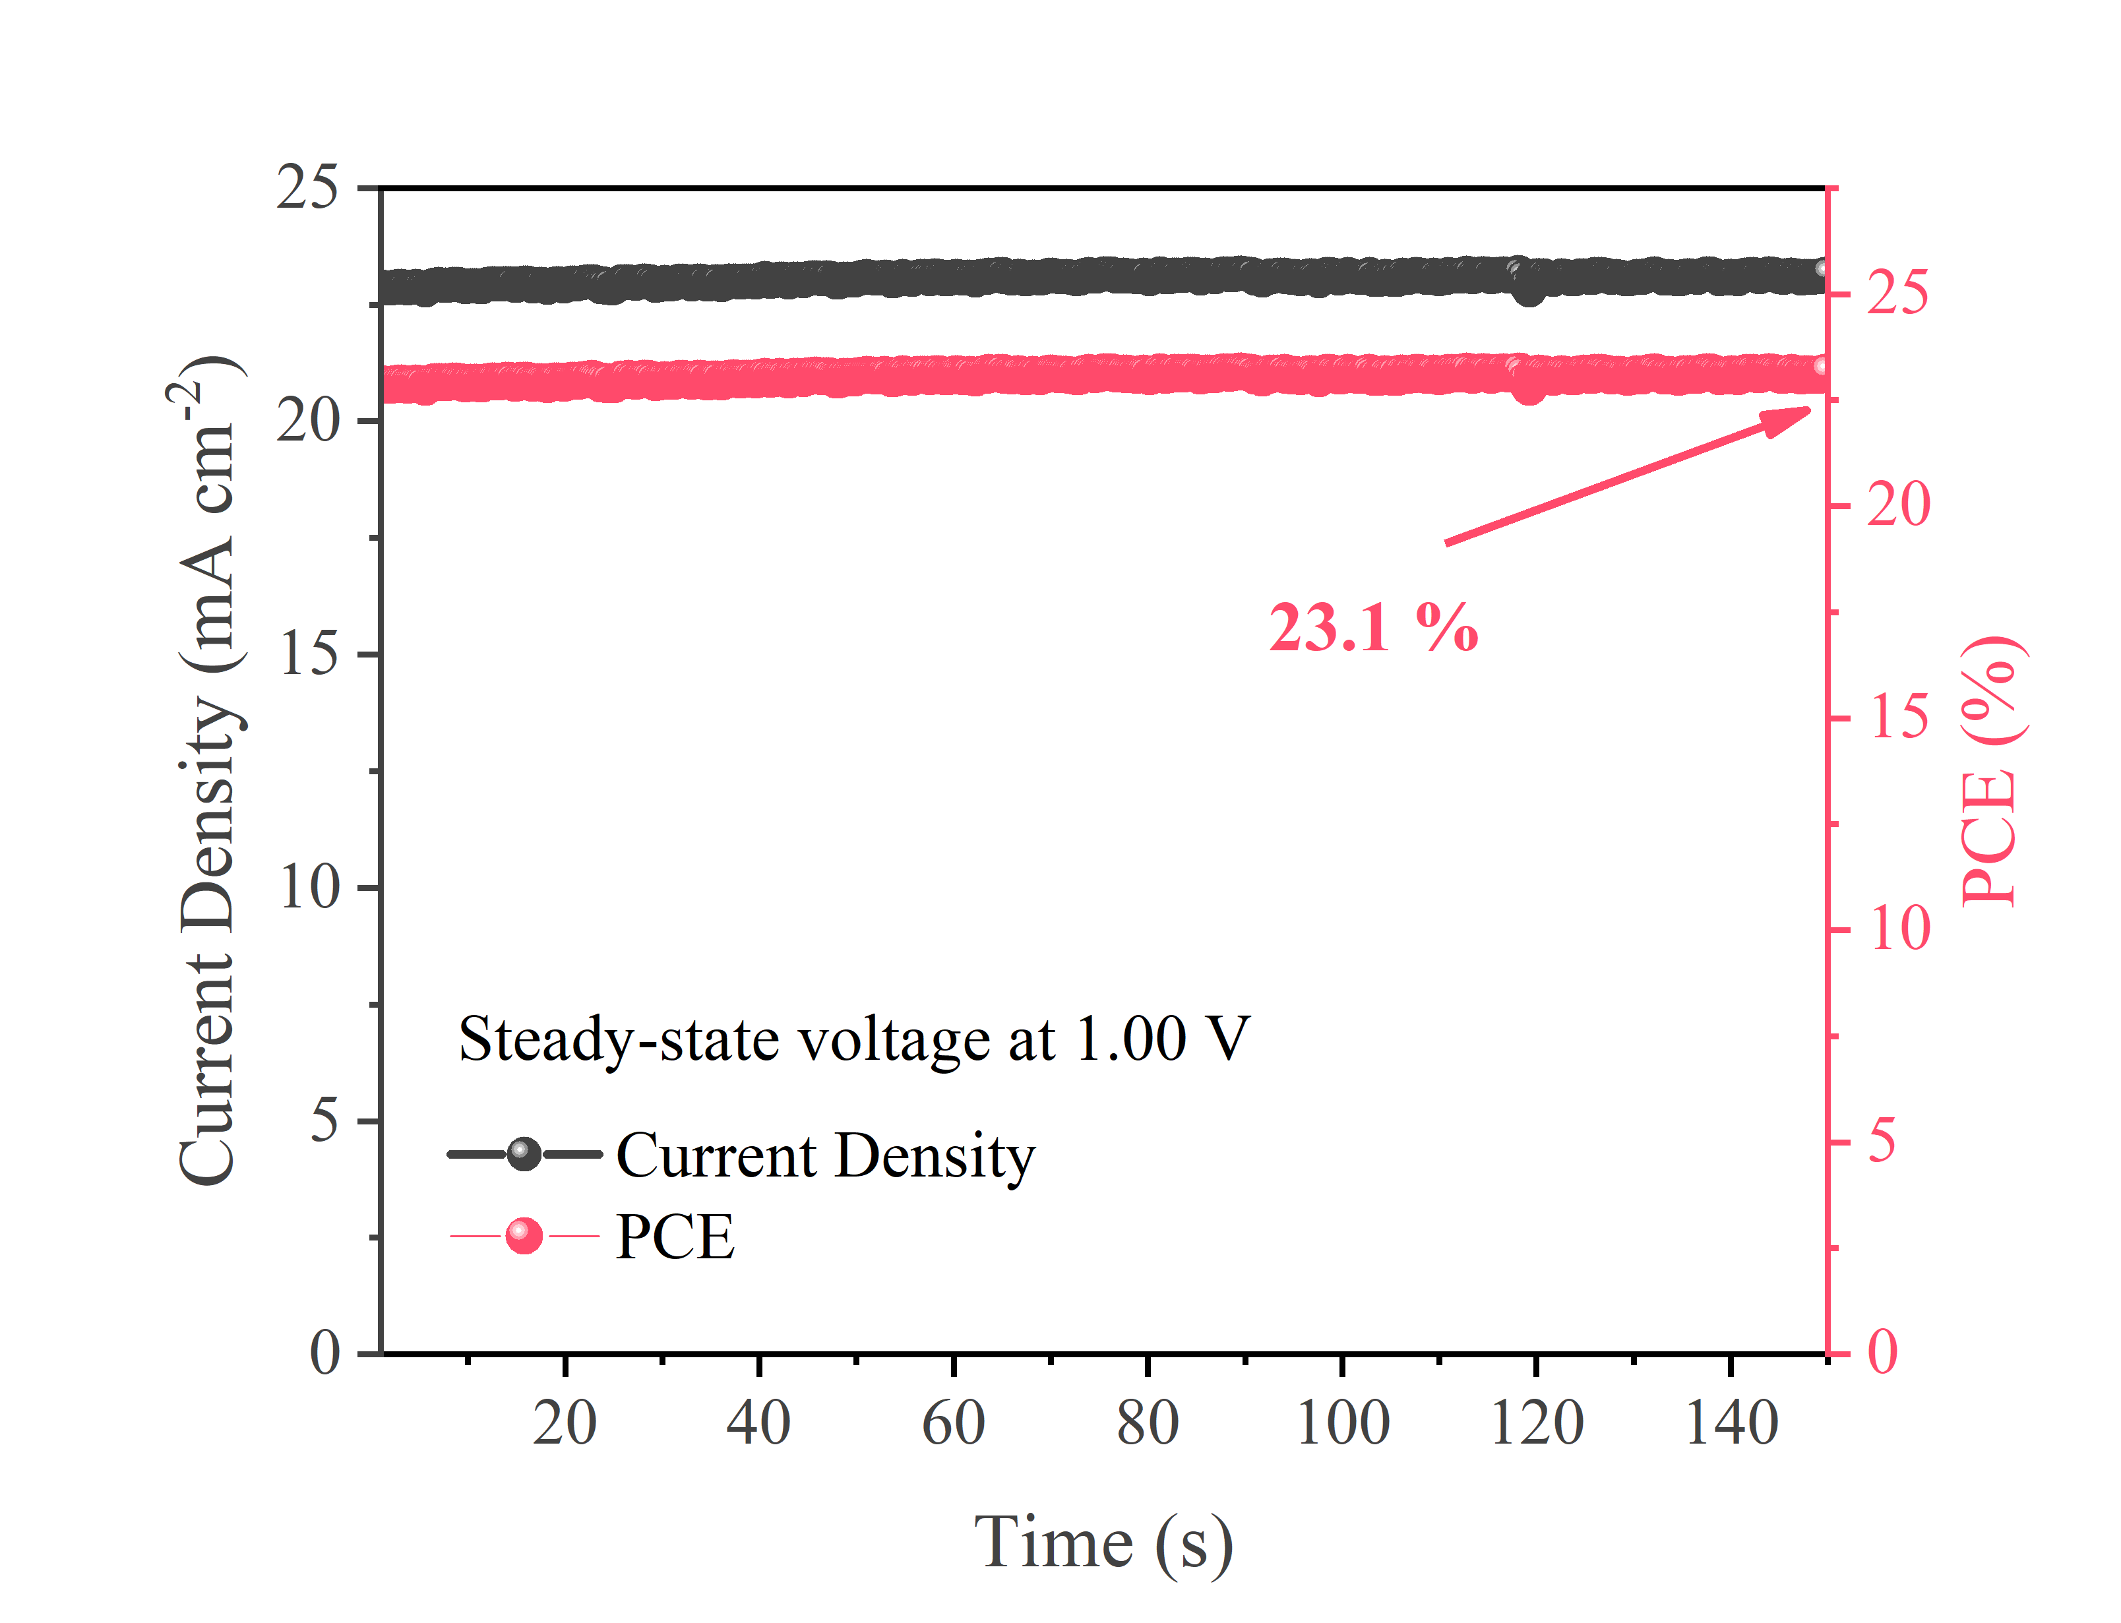

Supplementary Figure 24. Continuous current output of champion 0.089 cm⁻² organic-inorganic hybrid PSCs based on F-CE at a steady-state bias voltage of 1.00 V, demonstrating a PCE of over 23.1% after a 2 min operation.

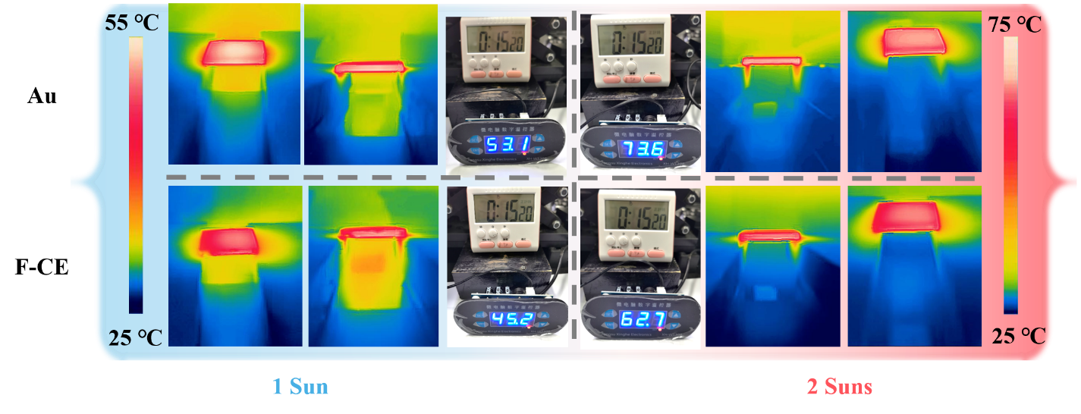

Supplementary Figure 25. IR camera measured temperature of varied electrode devices under different illumination (1 Sun and 2 Sun).

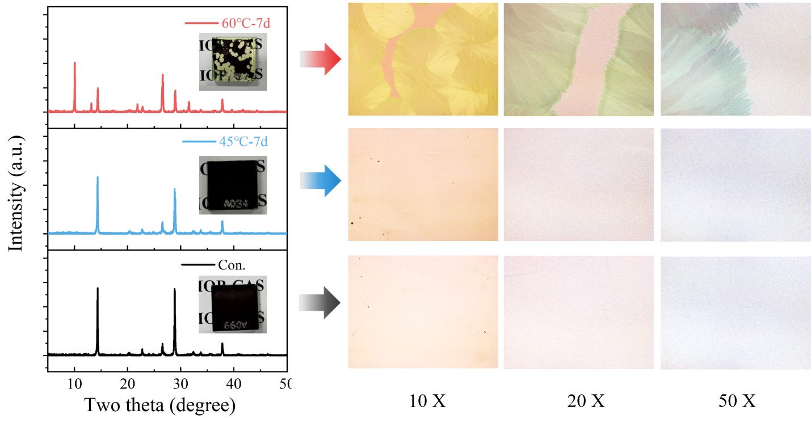

Supplementary Figure 26. XRD patterns of CsPbI₃ films under different aging conditions (unencapsulated CsPbI₃ films heated at 25℃, 45℃and 60℃ for 7 days in ambient atmosphere with 20-25% RH). Microscope observation images based on different magnifications.

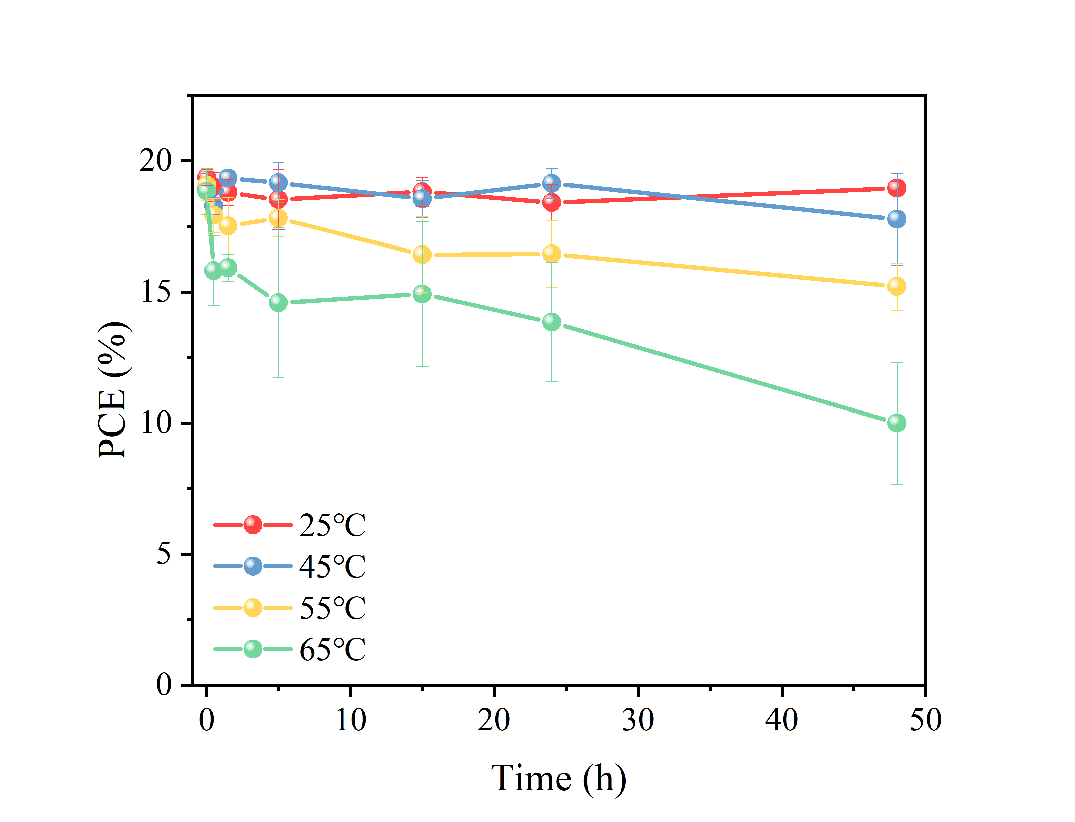

Supplementary Figure 27. PCE retentions of unencapsulated CsPbI₃ PSCs based on Au electrode continuously heated at 25℃, 40℃, 50℃ and 60℃ in ambient atmosphere with 20-25% RH.

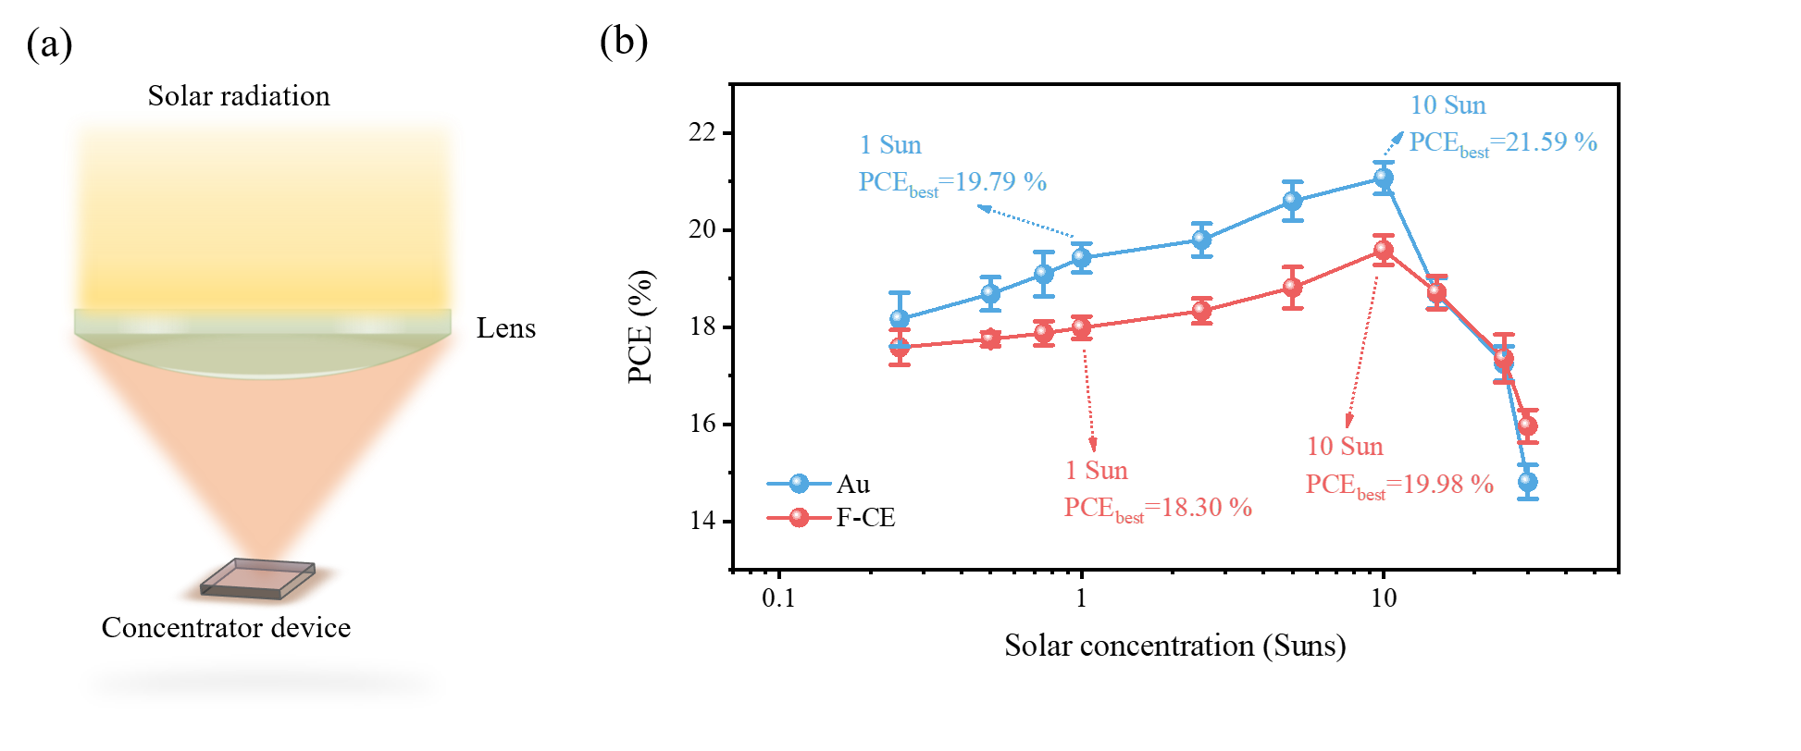

Supplementary Figure 28. (a) Schematic diagram of perovskite concentrator photovoltaic devices. The normal 1 Sun irradiance is concentrated onto a small-area PSC by a focusing lens, which delivers a higher power output. (b) PCE of CsPbI₃ PSCs measured under various solar concentration factors (up to 35 Suns). The active area was ~0.78 mm² for the devices measured under high irradiance. The area was kept small to reduce parasitic series resistance losses. The error bars represent the deviation for ten devices.

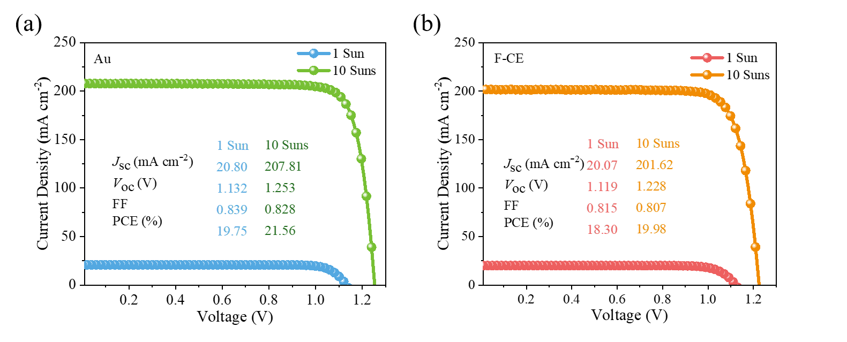

Supplementary Figure 29. The J-V characteristics of the best performance device under simulated concentrated AM 1.5G sunlight at various irradiance levels, CsPbI₃ PSC based on Au electrode (a) and CsPbI₃ PSC based on F-CE (b). All the light intensity measurements are performed on the nonencapsulated cells in the ambient condition.

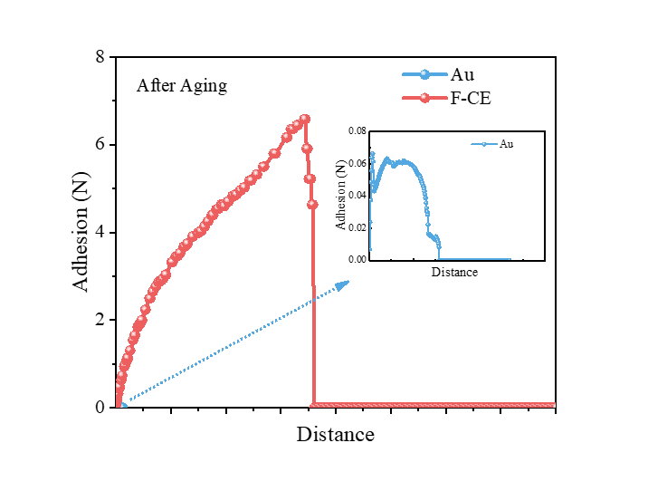

Supplementary Figure 30. The results of pull-off adhesive test of Au-IPSC and CE-IPSC after aging.

Supplementary Tables:

Supplementary Table 1.
Materials properties used in FEM for heat transfer analysis (1-2).

 | Density  (kg m⁻³) | Thermal conductivity  (W m⁻¹ K⁻¹) | Specific heat  (J kg⁻¹ K⁻¹)
Glass | 2210 | 1.4 | 730
Perovskite | 1500 | 0.3 | 800
Spiro-OMeTAD | 1100 | 0.13 | 2000
Au electrode | 19300 | 317 | 129

The surface emissivity of glass, Au electrodes and CEs are 0.02 and 0.98, respectively.
The value of natural-convection 5 W m⁻² K⁻¹.

Supplementary Table 2.
The solar cell performance parameters obtained from the devices based on CE with different condition.

Devices | J_{sc} (mA*cm⁻²) | V_{oc} (V) | FF | PCE (%)
Con. | 20.06±0.23 | 1.09±0.03 | 0.76±0.017 | 16.54±0.664
H₂O treated | 19.98±0.24 | 1.07±0.03 | 0.77±0.035 | 16.46±1.18
CQD treated | 20.18±0.15 | 1.14±0.02 | 0.816±0.01 | 18.72±0.46

Supplementary Table 3.
Performance summary of the PSCs based on CsPbX₃ (X=I and Br) inorganic perovskite layer.

Perovskite  layer | Device’s structure | PCE | Ref
CsPbBr₃ | FTO/c-TiO₂/m-TiO₂/CsPbBr₃/carbon | 5.0 | [3]
CsPbBr₃ | FTO/c-TiO₂/m-TiO₂/CsPbBr₃/carbon | 6.7 | [4]
CsPbBr₃ | FTO/c-TiO₂/CsPbBr₃/carbon | 5.86 | [5]
CsPbBr₃ | FTO/c-TiO₂/m-TiO₂/CsPbBr₃/carbon | 9.72 | [6]
CsPbBr₃ | FTO/c-TiO₂/m-TiO₂/CsPbBr₃/CsPbBr₃ NCs/carbon | 7.87 | [7]
CsPbBr₃ | FTO/c-TiO₂/m-TiO₂/CsPbBr₃/carbon | 9.53 | [8]
CsPbBr₃ | FTO/TiO₂/SnO₂/CsPbBr₃/CuPc/carbon | 8.79 | [9]
CsPbBr₃ | FTO/c-TiO₂/m-TiO₂/Cu(Cr,Ba)O₂/CsPbBr₃/carbon | 10.79 | [10]
CsPbBr₃ | FTO/c-TiO₂/m-TiO₂/CsPbBr₃/QDs/carbon | 10.85 | [11]
CsPbBr₃ | FTO/c-TiO₂/m-TiO₂/CsPbBr₃/MnS/carbon | 10.45 | [12]
CsPbBr₂I | FTO/ c-TiO₂/m-TiO₂/CsPb_{0.9}Sn_{0.1}IBr₂/carbon | 11.33 | [13]
CsPbBr₂I | FTO/c-TiO₂/CsPbIBr₂/Carbon | 9.16 | [14]
CsPbBr₂I | FTO/c-TiO₂/m-TiO₂/CsPb_{0.995}Mn_{0.005}I_{1.01}Br_{1.99}/Carbon | 7.36 | [15]
CsPbBr₂I | FTO/c-TiO₂/CsPbIBr₂/Carbon | 9.06 | [16]
CsPbBr₂I | FTO/c-TiO₂/CsPbIBr₂/Carbon | 8.31 | [17]
CsPbBr₂I | FTO/c-TiO₂/CsPbIBr₂/Carbon | 10.2 | [18]
CsPbBr₂I | FTO/c-TiO₂/CsBr/CsPbIBr₂/carbon | 10.71 | [19]
CsPbBr₂I | FTO/c-TiO₂/CsPbIBr₂/carbon | 6.55 | [20]
CsPbBr₂I | FTO/c-TiO₂/CsPbIBr₂/Bpy/carbon | 11.04 | [21]
CsPbBr₂I | FTO/TiO₂/CsPb_{0.99}Zn_{0.01}IBr₂/Carbon | 9.04 | [22]
CsPbI₂Br | FTO/Ni₂O₅/Cs_{0.99}Rb_{0.01}PbI₂Br/carbon | 12.00 | [23]
CsPbI₂Br | FTO/SnO₂/CsPbI₂Br/carbon | 12.19 | [24]
CsPbI₂Br | ITO/SnO₂/KOH/CsPbI₂Br/carbon | 11.78 | [25]
CsPbI₂Br | ITO/SnO₂/CsPbI₂Br/carbon | 10.13 | [26]
CsPbI₂Br | ITO/SnO₂/CsPbI₂Br/PMMA/carbon | 10.95 | [27]
CsPbI₂Br | FTO/c-TiO₂//CsPbI₂Br/carbon | 14.84 | [28]
CsPbI₂Br | FTO/c-TiO₂/m-TiO₂/CsPbI₂Br/carbon | 13.13 | [29]
CsPbI₂Br | ITO/SnO₂/CsPbI₂Br/Co₃O₄/carbon | 11.21 | [30]
CsPbI₂Br | FTO/c-TiO₂/m-TiO₂/CsPbI₂Br/P3HT-MWCNTs/Carbon | 10.01 | [31]
CsPbI₂Br | ITO/SnO₂/CsPbI₂Br/carbon | 10.44 | [32]
CsPbI₃ | FTO/c-TiO₂/CsPbI₃/HTM/carbon | 19.68 | This work
CsPbI₃ | FTO/c-TiO₂/CsPbI₃/carbon | 15.2 | [33]
CsPbI₃ | FTO/c-TiO₂/m-TiO₂/CsPbI₃/carbon | 4.65 | [34]
CsPbI₃ | FTO/c-TiO₂/m-TiO₂/CsPbI₃:Br:InI₃/carbon | 12.04 | [35]
CsPbI₃ | FTO/c-TiO₂/m-TiO₂/CsPbI₃/CuSCN/carbon | 6.9 | [36]
CsPbI₃ | FTO/c-TiO₂/m-TiO₂/CsPbI₃/PEI-CNT/carbon | 10.55 | [37]
CsPbI₃ | FTO/c-TiO₂/CsPbI₃/carbon | 5.18 | [38]
CsPbI₃ | FTO/c-TiO₂/CsPbI₃/carbon | 14.6 | [39]
CsPbI₃ | FTO/c-TiO₂/m-TiO₂/ Cs_{0.95}Na_{0.05}PbI₃ /carbon | 10.7 | [40]
CsPbI₃ | FTO/c-TiO₂/m-TiO₂/CsPbI₃/carbon | 9.39 | [41]

Supplementary Table 4.
Performance summary and the stability of the PSCs based on CsPbX₃ inorganic perovskite layer. Unless otherwise specified, the samples tested were un-encapsulated. “Perovskite” was abbreviated as “P” in the stable.

Perovskite layer | Device structure | PCE (%) | Stability condition | PCE under stabilization process (%) | Year | Ref
CsPbBr₃ | ITO/ZnO/P/spiro-OMeTAD/Au | 7.78 | Exposed to UV light (365 nm wavelength) under a N₂ atmosphere and a UV-light intensity of 100 mW cm⁻² for 120h | No degradation | 2018 | [42]
CsPbBr₃ | FTO/TiO₂/P/spiro-OMeTAD/Ag | 8.34 | Stored in humid air (45% RH) for 1000h | 90 | 2018 | [43]
CsPbBr₃ | FTO/TiO₂/P/C | 6.7 | Stored in humid air (90-95% RH, 25℃) for over 3 months | No degradation | 2016 | [4]
CsPbBr₃ | FTO/TiO₂/P/C | 6.7 | Heated at 100℃ in humid air (90-95% RH, 25℃) for 840h | No degradation | 2016 | [4]
CsPbBr₃ | FTO/TiO₂/Graphene Ds/P/C | 9.72 | Un-encapsulated in humid air (90 % RH at 25 °C) for 130 days | 87 | 2018 | [6]
CsPbBr₃ | FTO/TiO₂/Graphene Ds/P/C | 9.72 | Stored under 80 °C and zero humidity for 40 days | The normalized PCEs are almost unchanged | 2018 | [6]
CsPbIBr₂ | FTO/SnO₂/P/spiro-OMeTAD/Ag | 11.31 | Tested under continuous light illumination of AM 1.5 G at room temperature and humidity of ~ 30% | Decreases less than 10% of its original efficiency | 2022 | [44]
CsPbIBr₂ | FTO/SnO₂/P/spiro-OMeTAD/Ag | 11.31 | measured in the ambient conditions with humidity of ~ 30% and continuous heating at 85 °C for more than 300 min | Only 7% fall | 2022 | [44]
CsPbIBr₂ | FTO/SnO₂/P/spiro-OMeTAD/Ag | 11.31 | Stored in a drying oven for more than 1200 h | 7% PCE lose | 2022 | [44]
CsPbIBr₂ | FTO/TiO₂/P/C | 10.20 | Heated at 85℃ in N₂-filled glovebox | 97 | 2020 | [18]
CsPbIBr₂ | FTO/TiO₂/P/C | 10.20 | Stored at 25℃ in ambient atmosphere with 30-50% RH | 94 | 2020 | [18]
CsPbIBr₂ | FTO/TiO₂/P/C | 10.61 | Stored under 85 °C and 20% RH for over 35 days | No degradation | 2021 | [45]
CsPbI₂Br | FTO/TiO2/P/P3HT/Ag | 17.51 | Stored at 85℃ in N₂ for 530h. | 90 | 2022 | [46]
CsPbI₂Br | FTO/TiO2/P/P3HT/Ag | 17.51 | Tested under one sun irradiation at 15% humidity and 25 °C for 1100h. | 95 | 2022 | [46]
CsPbI₂Br | ITO/SnO₂/PN4N/P/PDCBT/MoO₃/Ag | 16.2 | Tested under continuous 1 sun equivalent illumination for 400 h | 90 | 2019 | [47]
CsPbI₂Br | FTO/TiO₂/P/C | 14.84 | Stored under room temperature and 20-25% RH for 30 days | 94 | 2021 | [28]
CsPbI₃ | FTO/TiO₂/P/spiro-OMeTAD/Au | 18.4 | Tested under continuous illumination at the maximum power point (MPP) for 500h in a N₂ glovebox. | 92 | 2018 | [48]
CsPbI₃ | FTO/TiO₂/P/spiro-OMeTAD/Au | 18.4 | Stored in a dark, dry box (RH < 10%) with oxygen. | No PV performance decay | 2018 | [48]
CsPbI₃ | FTO/TiO₂/P/spiro-OMeTAD/Au | 18.4 | Tested under continuous illumination at the MPP for 240 h in air | 95 | 2018 | [48]
CsPbI₃ | FTO/TiO₂/P/OAI/spiro-OMeTAD/Au | 20.37 | Tested under full-sunlight illumination and ambient conditions in the absence of an ultraviolet cut (UV-cut) filter at MPP tracking for 150h | 90 | 2020 | [49]
CsPbI₃ | FTO/TiO₂/P/C | 15.35 | Stored non-encapsulated device in air atmosphere (RH < 20%) for 30 days | No PCE degradation | 2022 | [50]
CsPbI₃ | FTO/TiO₂/P/ spiro-OMeTAD/C | 19.68 | Tested under a steady-state bias voltage (0.95 V) and white LED illumination (initial cell current density 20 mA cm⁻²) in N₂ atmosphere | No PCE degradation | 2022 | This work

Supplementary References
- Lee, W. et al. Ultralow thermal conductivity in all-inorganic halide perovskites. Proc. Natl. Acad. Sci.114, 8693-8697(2017).
- Pei, F. et al. Thermal Management Enables More Efficient and Stable Perovskite Solar Cells. ACS Energy Lett. 6, 3019-3036(2021).
- Chang, X. et al. Carbon-Based CsPbBr₃ Perovskite Solar Cells: All-Ambient Processes and High Thermal Stability. ACS Appl. Mater. Interfaces 8, 33649-33655(2016).
- Liang, J. et al. All-Inorganic Perovskite Solar Cells. J. Am. Chem. Soc. 138, 15829-15832 (2016).
- Teng, P. et al. Elegant Face-Down Liquid-Space-Restricted Deposition of CsPbBr₃ Films for Efficient Carbon-Based All-Inorganic Planar Perovskite Solar Cells. ACS Appl. Mater. Interfaces 10, 9541-9546(2018).
- Duan, J. Zhao, Y. He, B.& Tang, Q. High-Purity Inorganic Perovskite Films for Solar Cells with 9.72% Efficiency. Angew Chem. Int. Ed. Engl. 57, 3787-3791 (2018).
- Su, G. et al. Enhanced charge extraction in carbon-based all-inorganic CsPbBr₃ perovskite solar cells by dual-function interface engineering. Electrochim. Acta 328, 135102(2019).
- Wu, Y. et al. Cluster effect of additives in precursors for inorganic perovskites solar cells. Electrochim. Acta, 331, 135379(2020).
- Liu, X. et al. Boosting the efficiency of carbon-based planar CsPbBr₃ perovskite solar cells by a modified multistep spin-coating technique and interface engineering. Nano Energy, 56, 184-195(2019).
- Duan, J. Zhao, Y. Wang, Y. Yang, X. & Tang, Q. Hole-Boosted Cu(Cr,M)O₂ Nanocrystals for All-Inorganic CsPbBr₃ Perovskite Solar Cells. Angew Chem. Int. Ed. Engl. 58, 16147-16151(2019).
- Duan, J. Wang, Y. Yang, X. & Tang, Q. Alkyl-Chain-Regulated Charge Transfer in Fluorescent Inorganic CsPbBr₃ Perovskite Solar Cells. Angew Chem. Int. Ed. Engl. 59, 4391-4395 (2020).
- Li, X. et al. All-Inorganic CsPbBr₃ Perovskite Solar Cells with 10.45% Efficiency by Evaporation-Assisted Deposition and Setting Intermediate Energy Levels. ACS Appl. Mater. Interfaces 11, 29746-29752(2019).
- Liang, J. et al. CsPb_{0.9}Sn_{0.1}IBr₂ Based All-Inorganic Perovskite Solar Cells with Exceptional Efficiency and Stability. J. Am. Chem. Soc. 139, 14009-14012 (2017).
- Zhu, W. et al. Intermolecular Exchange Boosts Efficiency of Air-Stable, Carbon-Based All-Inorganic Planar CsPbIBr₂ Perovskite Solar Cells to Over 9%. Adv. Energy Mater. 8, 1802080(2018).
- Liang, J. et al. Enhancing Optical, Electronic, Crystalline, and Morphological Properties of Cesium Lead Halide by Mn Substitution for High-Stability All-Inorganic Perovskite Solar Cells with Carbon Electrodes. Adv. Energy Mater. 8, 1800504(2018).
- Zhu, W. et al. Benign Pinholes in CsPbIBr₂ Absorber Film Enable Efficient Carbon-Based, All-Inorganic Perovskite Solar Cells. ACS Appl. Energy Mater. 2, 5254-5262(2019).
- Guo, Y. et al. Growth control and defect passivation toward efficient and low-temperature processed carbon based CsPbIBr₂ solar cell. Org. Electron. 83, 105731(2020).
- Zhu, W. et al. Interfacial voids trigger carbon-based, all-inorganic CsPbIBr₂ perovskite solar cells with photovoltage exceeding 1.33 V. Nano-micro-Lett. 12, 87(2020).
- Zhang, X. et al. Efficient and carbon-based hole transport layer-free CsPbI₂Br planar perovskite solar cells using PMMA modification. J. Mater. Chem. C 7, 3852-3861(2019).
- Zhu, W. et al. Aged Precursor Solution toward Low-Temperature Fabrication of Efficient Carbon-Based All-Inorganic Planar CsPbIBr₂ Perovskite Solar Cells. ACS Appl. Energy Mater. 1, 4991-4997 (2018).
- Zhang, J. et al. Understanding steric-charge-dependence of conjugated passivators on π-Pb²⁺ bond strength for efficient all-inorganic perovskite solar cells. Chem. Eng. J. 431, 134230(2022).
- Guo, Y. et al. Growth control and defect passivation toward efficient and low-temperature processed carbon based CsPbIBr₂ solar cell. Org. Electron. 83, 105731(2020).
- Guo, Y.et al. Efficient and Hole-Transporting-Layer-Free CsPbI₂Br Planar Heterojunction Perovskite Solar Cells through Rubidium Passivation. ChemSusChem 12, 983-989(2019).
- Liu, C. Wu, M. Wu, Y. Wang, D. & T. Zhang, Efficient all-inorganic CsPbI₂Br perovskite solar cell with carbon electrode by revealing crystallization kinetics and improving crystal quality. J. Power Sources 447, 227389 (2020).
- Deng, F. et al. Low-Temperature Processing All-Inorganic Carbon-Based Perovskite Solar Cells up to 11.78% Efficiency via Alkali Hydroxides Interfacial Engineering. ACS Appl. Energy Mater. 3, 401-410(2019).
- Meng, X. et al. Excess Cesium Iodide Induces Spinodal Decomposition of CsPbI₂Br Perovskite Films. J. Phys. Chem. Lett. 10, 194-199 (2019).
- Zhang, X. et al. Efficient and carbon-based hole transport layer-free CsPbI₂Br planar perovskite solar cells using PMMA modification. J. Mater. Chem. C 7, 3852-3861 (2019).
- Zhu, W. et al. High-Efficiency (> 14%) and Air-Stable Carbon-Based, All-Inorganic CsPbI₂Br Perovskite Solar Cells through a Top-Seeded Growth Strategy. ACS Energy Lett. 6, 1500-1510(2021).
- Wang, J. Gong, S. Chen, Z. & Yang, S. Vacuum-Assisted Drying Process for Screen-Printable Carbon Electrodes of Perovskite Solar Cells with Enhanced Performance Based on Cuprous Thiocyanate as a Hole Transporting Layer. ACS Appl. Mater. Interfaces 13, 22684-22693(2021).
- Zhou, Y. et al. Promoting the Hole Extraction with Co₃O₄ Nanomaterials for Efficient Carbon-Based CsPbI₂Br Perovskite Solar Cells. Solar RRL 3, 1800315(2021).
- Wang, G. et al. High-performance carbon electrode-based CsPbI₂Br inorganic perovskite solar cell based on poly(3-hexylthiophene)-carbon nanotubes composite hole-transporting layer. J. Colloid Interface Sci. 555, 180-186(2019).
- Ye, Z. et al. Low Temperature-Processed Stable and Efficient Carbon-Based CsPbI₂Br Planar Perovskite Solar Cells by In Situ Passivating Grain Boundary and Trap Density. Solar RRL, 3, 1900109(2019).
- Wang, H. et al. Size mismatch induces cation segregation in CsPbI₃: Forming energy level gradient and 3D/2D heterojunction promotes the efficiency of carbon-based perovskite solar cells to over 15%. Nano Energy, 89, 106411(2021).
- Liang, J. et al. Solution synthesis and phase control of inorganic perovskites for high-performance optoelectronic devices. Nanoscale, 9, 11841-11845(2017).
- Liang, J. et al. Defect-Engineering-Enabled High-Efficiency All-Inorganic Perovskite Solar Cells. Adv. Mater. 31, 1903448(2019).
- Murugadoss, G. et al. Synthesis of ligand-free, large scale with high quality all-inorganic CsPbI₃ and CsPb₂Br₅ nanocrystals and fabrication of all-inorganic perovskite solar cells. J. Alloys Compd. 787, 17-26(2019).
- Yang, Y. Chen, H. Hu, C. & Yang, S. Polyethyleneimine-functionalized carbon nanotubes as an interlayer to bridge perovskite/carbon for all inorganic carbon-based perovskite solar cells. J. Mater. Chem. A 7, 22005-22011(2019).
- Xiang, S. et al. The synergistic effect of non-stoichiometry and Sb-doping on air-stable alpha-CsPbI₃ for efficient carbon-based perovskite solar cells. Nanoscale 10, 9996-10004(2018).
- Wang, H. et al. Composition manipulation boosts the efficiency of carbon-based CsPbI3 perovskite solar cells to beyond 14%. Nano Energy 84, 105881(2021).
- Xiang, S. Natrium Doping Pushes the Efficiency of Carbon-Based CsPbI₃ Perovskite Solar Cells to 10.7%. iScience 15, 156-164(2019).
- Wang, H. et al. Skillfully deflecting the question: a small amount of piperazine-1,4-diium iodide radically enhances the thermal stability of CsPbI₃ perovskite. J. Mater. Chem. C 7, 11757-11763(2019).
- Chen, W. et al. A Semitransparent Inorganic Perovskite Film for Overcoming Ultraviolet Light Instability of Organic Solar Cells and Achieving 14.03% Efficiency. Adv. Mater. 30, 1800855(2018).
- Li, H. et al. Interface engineering using a perovskite derivative phase for efficient and stable CsPbBr₃ solar cells. J. Mater. Chem. A 6, 14255-14261(2018).
- He, J. et al. Surface reconstruction strategy improves the all-inorganic CsPbIBr₂ based perovskite solar cells and photodetectors performance, Nano energy 94, 106960(2022).
- Zhang, Q. et al. Thermal-Triggered Dynamic Disulfide Bond Self-Heals Inorganic Perovskite Solar Cells. Angew. Chem. Int. Ed. 61, e202116632(2021).
- Liu, X. et al. Stoichiometric Dissolution of Defective CsPbI₂Br Surfaces for Inorganic Solar Cells with 17.5% Efficiency. Adv. Energy Mater. 12, 2103933(2022).
- Tian, J. et al. Dual Interfacial Design for Efficient CsPbI₂Br Perovskite Solar Cells with Improved Photostability. Adv. Mater. 31, 1901152(2019).
- Wang, Y. et al. Thermodynamically stabilized beta-CsPbI₃-based perovskite solar cells with efficiencies > 18%. Science 365, 591-595(2018).
- Yoon, S.M. et al. Surface Engineering of Ambient-Air-Processed Cesium Lead Triiodide Layers for Efficient Solar Cells. Joule 5, 183-196(2020).
- Wang, H. et al. Extracting ammonium halides by solvent from the hybrid perovskites with various dimensions to promote the crystallization of CsPbI₃ perovskite. Nano Energy 94, 106925(2022).

