Additional Files
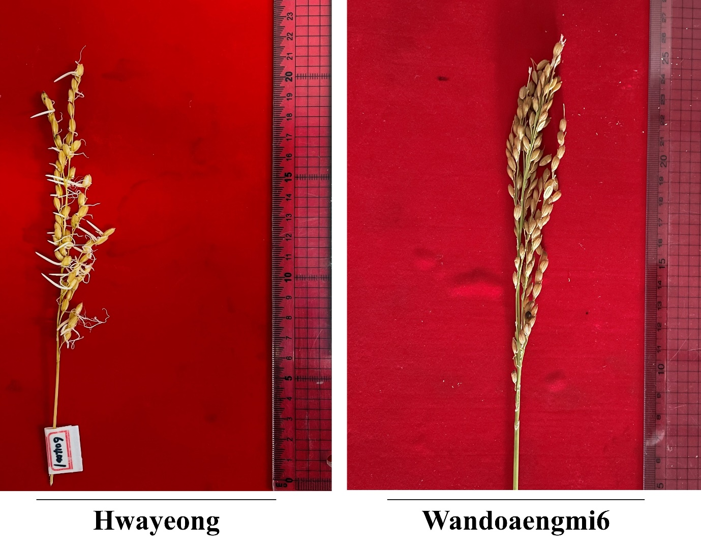Additional File 1: Fig. S1 Panicle of the parents, Hwayeong and Wandoaengmi6, after seven days of incubation

Additional File 2: Table S1. Segregation ratio of pre-harvested sprouting (PHS) in the 157 RIL lines
Reference point  (RF) | Segregation | No. of plants |  |  |  |  | X² value
Reference point  (RF) | Segregation | R^{b} | M | S | Total |  | 3:1 | 12:3:1 | 9:3:4
RF-Iª | R:S^{b} | 88 | - | 69 | 157 |  | 4.17** | - | -
RF-II | R:S | 109 | - | 48 | 157 |  | 2.60^{ns} | - | -
RF-III | R:M:S | 88 | 31 | 32 | 157 |  | - | - | 1.24^{ns}
RF-IV | R:M:S | 109 | 20 | 28 | 157 |  | - | - | 11.10**
^{a)} RF-I (R:S = 5% or less: over 5%), RF-II (R:S = 10% or less: over 10%), RF-III (R:M:S = 5% or less: 5-15%: over 15%), and RF-III (R:M:S = 10% or less: 10-20%: over 20%)
^{b)} R is low PHS, M is moderate PHS, and S is high PHS
^{ns}: Not significant
Significance levels: *P < 0.05, **P < 0.01

Additional File 3: Table S2. Summary of the linkage map constructed for QTL analysis
Chromosome | Used  markers | Polymorphic  markers | Polymorphism  (%) | Anchored  markersª | Length^{b}  (cM) | AMI^{c}  (cM)
1 | 850 | 150 | 17.66 | 64 | 131.3 | 2.08
2 | 660 | 88 | 13.33 | 38 | 48.7 | 1.31
3 | 683 | 102 | 14.93 | 40 | 134.3 | 3.44
4 | 646 | 28 | 4.33 | 15 | 60.4 | 4.31
5 | 509 | 27 | 5.30 | 15 | 356.58 | 25.47
6 | 551 | 106 | 19.23 | 21 | 221.6 | 11.08
7 | 524 | 60 | 11.45 | 20 | 31.3 | 1.64
8 | 545 | 98 | 17.98 | 50 | 186.3 | 3.80
9 | 455 | 133 | 29.23 | 35 | 68.7 | 2.02
10 | 472 | 73 | 15.46 | 26 | 80.7 | 3.22
11 | 631 | 128 | 20.38 | 29 | 76.6 | 2.73
12 | 572 | 31 | 5.41 | 15 | 284.5 | 20.32
Total (average) | 7098 | 1024 | (14.42) | 368 | 140.1 | (6.78)
^{a)} Number of selected markers
^{b)} Chromosomal length
^{c)} Average marker interval
Additional File 4: Table S3. List of CAPs markers in the target region of qPH7
Marker name | Poly-morphismª | Position^{b}  (bp) | TM  (°C) | Product size | Restrict enzyme | F | R
cPH7_1 | O | 23558763 | 64 | 776 | DraI | GTGCACGCACCGCATCGTATG | GGTGAAGTAGGGGCCGGATGG
cPH7_2 | O | 23562168 | 55 | 791 | HaeIII | AGTTTGATCAGTCACTGGTG | AGGATGCAATTT3CATTAGTC
cPH7_3 | O | 23562860 | 55 | 796 | DdeI | TTGTTGTGTAGCTACCAAGTC | TCCAACAAGAGCTACCATATG
cPH7_4 | X | 23565170 | 64 | 773 | HinfI | TGGCGGCGAGAAGAGATGGTG | GCGGCCTAGCTGTCTGTTCGG
cPH7_5 | X | 23565603 | 64 | 770 | AluI | GCCGAAAACCATAAAGGGCGCC | CGAGAAGACCAAGGGATCTGGCG
cPH7_6 | X | 23571920 | 64 | 793 | DraI | TTCTGTCGGTCCCGCACACAG | CCATTCTAGGGGCAAACGGCG
cPH7_7 | O | 23575579 | 55 | 780 | EcoRI | TGCGAACATACAAAAGGATTG | AGTAATACTTTTGGCCTGTCG
cPH7_8 | O | 23579761 | 64 | 790 | DdeI | AGTTCGCGCAATCTTTTAGCCCC | ACTCCGCATGGATTGACGGCC
cPH7_9 | O | 23579949 | 64 | 797 | TaqI | GCTAGGAGAACACCTGTTGCCATC | GATAGGGACCTCTTCGCCGCC
cPH7_10 | O | 23588066 | 55 | 758 | HaeIII | TGGTACTGTGGCTTAAATCTG | ATTTCCTTCTTGAAGGCGTC
cPH7_11 | O | 23598078 | 64 | 798 | AluI | AGATGACCACGTTGGACGGGC | ACAAAGACGACCACAAGCGGC
cPH7_12 | X | 23600018 | 64 | 777 | HinfI | TCTCGGGGAGAAGCAGAGGCC | TCAGGTGTTGGGAAGATCGTTGTG
cPH7_13 | O | 23601759 | 55 | 770 | DdeI | ATCTGTATGACTTAAGGCACG | ACTAAACTGTGCTAAATTGCG
cPH7-14 | X | 23618675 | 55.48 | 798 | AluI | GTTTGAACACCTGCATGAAG | TCGCAAATTAGTCGCAATATG
cPH7-15 | X | 23618675 | 55.48 | 796 | AluI | " | GCAAATTAGTCGCAATATGTG
cPH7-16 | X | 23662134 | 54.3 | 793 | TaqI | GTAACAGTGTAGCAAGTCTTC | TATATATAGGTCAGGCCAACG
cPH7-17 | X | 23662134 | 54.3 | 797 | TaqI | " | TGTGTATATATAGGTCAGGCC
cPH7-18 | O | 23703527 | 55.03 | 800 | HaeIII | TAGAGGAGTACAATGGCAAAG | GTATACTGTATACTCCTCCAGG
cPH7-19 | O | 23703527 | 55.05 | 799 | HaeIII | AGAGGAGTACAATGGCAAAG | "
cPH7-20 | X | 23742308 | 64.96 | 800 | AluI | TGAGACCCCTTCGCTTGTGGC | AGGTGGCTCTAGTGGAGGAAGAAG
cPH7-21 | X | 23742308 | 63.41 | 799 | AluI | GAGACCCCTTCGCTTGTGGC | "
cPH7-22 | O | 23761731 | 54.3 | 797 | TaqI | CCATCTTCCAATCATCTTTCC | GCTATGAACCCTGCATAAATG
cPH7-23 | O | 23761731 | 54.3 | 783 | TaqI | " | ATAAATGCCCCGTATAGATCC
^{a)} The presence of qPH7 (O: positive, X: negative qPH7)
^{b)} Physical position on chromosome 7

Additional File 5: Table S4. List of ORFs within the target region for pPH7
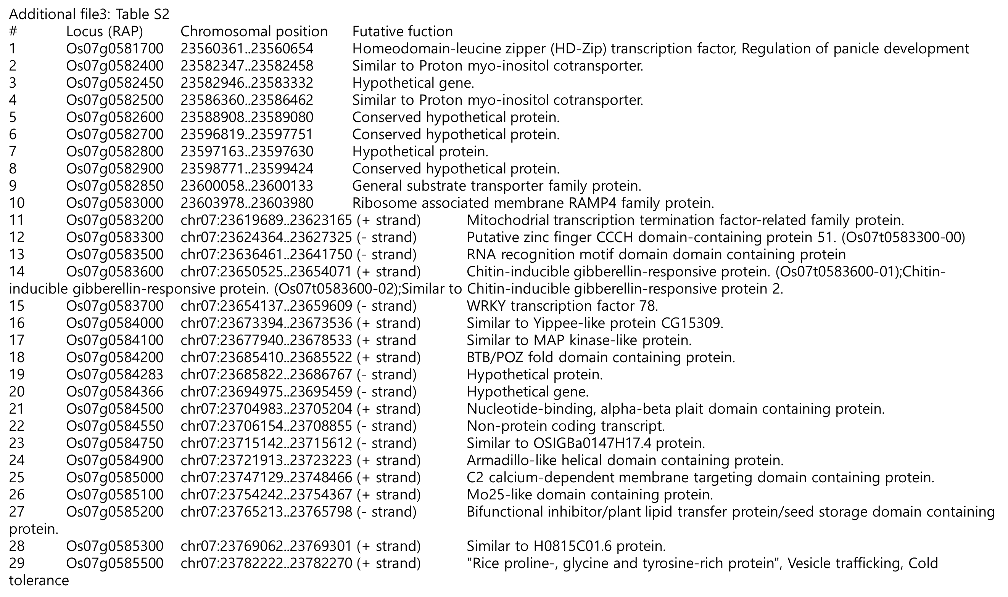
Additional File 6: Table S4. Gain traits and physicochemical characteristics of parents and three selected PHS-resistant lines
Parents and lines | Grain traits |  |  |  |  | Physicochemical characteristic
Parents and lines | Length | Width | Thickness | TGWª |  | CK^{b} | ADV^{c}  (1-7) | Protein (%) | Amylose (%)
Hwayeong | 4.88ª | 3.04ª | 2.10ª | 26.4ª |  | 0/1 | 4.9^{ab} | 6.5ª | 17.4^{b}
Wandoaengmi6 | 4.57^{d} | 2.74^{b} | 1.81^{b} | 22.8^{ab} |  | 0/0 | 5.2ª | 5.9^{b} | 19.0^{ab}
HW20 (AGT20) | 4.79^{b} | 2.60^{d} | 1.90^{b} | 21.8^{b} |  | 1/1 | 5.0ª | 6.4ª | 18.2^{b}
HW23 (AGT23) | 4.74^{c} | 2.69^{c} | 1.90^{b} | 20.4^{b} |  | 1/1 | 4.5^{b} | 5.8^{b} | 17.5^{b}
HW36 (AGT36) | 4.56^{d} | 2.75^{b} | 2.03ª | 23.0^{ab} |  | 0/1 | 5.1ª | 5.6^{b} | 20.9ª
^{a)} 1,000-grain weight
^{b)} CK: chalkiness
^{c)} ADV: alkali digestive value

Additional File 7: Table S5. List of CAPs markers within the target region of qPH2
Marker name | Poly-morphism ª | Position ^{b}  (bp) | TM (℃) | Product size | Restrict enzyme | F | R
cPH2-1 | O | 32327475 | 55 | 770 | BglII | AGCCTTCACTTCTGATACAAG | GCATATGATTTCATTCGGTCC
cPH2-2 | O | 32327475 | 55 | 788 | BglII | GTTCTGAACTTTAGGCTTAGC | GCATATGATTTCATTCGGTCC
cPH2-3 | O | 32354395 | 55 | 760 | EcoRV | AAGTAGAAAGCAGATCTGGAC | CACTAATGGAGTAAACGATGC
cPH2-4 | O | 32354395 | 55 | 755 | EcoRV | AAGTAGAAAGCAGATCTGGAC | ATGGAGTAAACGATGCTACTC
cPH2-5 | X | 32360106 | 55 | 800 | HhaI | TCACGCTGCAATAATTAATTAAC | ATTAGGATGGAGAAGGTGAAG
cPH2-6 | X | 32360106 | 55 | 800 | HhaI | TTAATTAATTAACCAATCGACCG | GAATGCGAGAGATTAATGGTG
cPH2-7 | X | 32371489 | 55 | 771 | DraI | TGTCACATGAGGTTAACAGAG | ACTAGTGGATAGCTTCACTCC
cPH2-8 | X | 32371489 | 55 | 769 | DraI | TCACATGAGGTTAACAGAGAG | ACTAGTGGATAGCTTCACTCC
cPH2-9 | X | 32374877 | 64 | 797 | BstUI | GTGGCAGCTCCTTAAAGGTCATCG | AGGAACACGCGGTAGTCGAGC
cPH2-10 | X | 32374877 | 64 | 799 | BstUI | GTGGCAGCTCCTTAAAGGTCATCG | CGAGGAACACGCGGTAGTCGAG
cPH2-11 | X | 32380597 | 64 | 782 | BglI | TCTGGCTTTGCTCAAGGTTGATGC | GTCTGGGGCGCCGACCTC
cPH2-12 | X | 32380597 | 64 | 781 | BglI | CTGGCTTTGCTCAAGGTTGATGC | GTCTGGGGCGCCGACCTC
cPH2-13 | X | 32388958 | 55 | 795 | SspI | TGGAAGTGGATACTGACAATC | AATCTTACCAATCCTCCATGC
cPH2-14 | X | 32388958 | 55 | 786 | SspI | ATACTGACAATCTCTCGGTTG | AATCTTACCAATCCTCCATGC
cPH2-15 | X | 32396000 | 64 | 765 | BslI | TCCATTGGTGCGAGTCAGGGC | TGGCGTACCGAAATAGGAGTGGG
cPH2-16 | X | 32396000 | 64 | 764 | BslI | TCCATTGGTGCGAGTCAGGGC | GGCGTACCGAAATAGGAGTGGGTG
^{a)} The presence of qPH2 (O: positive, X: negative qPH2)
^{b)} Physical position on chromosome 2

