Supplemental Information

Tracing metal footprints through global renewable-power value chains

Rao Fu^{1,5}, Kun Peng^{1,5}, Peng Wang², Honglin Zhong¹, Pengfei Zhang¹, Yiyi Zhang³, Dongyang Chen⁴, Xi Liu^{1*}, Kuishuang Feng^{5,7*}, Jiashuo Li^{1*},
¹ Institute of Blue and Green Development, Shandong University, Weihai, P. R. China. 264209;
² Key Lab of Urban Environment and Health, Institute of Urban Environment, Chinese Academy of Sciences, Xiamen, P. R. China. 361021;
³ Guangxi Key Laboratory of Power System Optimization and Energy Technology, Guangxi University, Nanning, Guangxi, P. R. China. 530004;
⁴ Shandong Key Laboratory of Blockchain Finance, Shandong University of Finance and Economics, Jinan , P R China. 250014;
⁵ Department of Geographical Sciences, University of Maryland, College Park, MD, USA. 20742.
⁶ These authors contributed equally
⁷ Lead Contact
* Correspondence: fengkuishuang@gmail.com (K.F.), lijiashuo@sdu.edu.cn (J.L.)

Appendix A. MRIO models for tracing metals embodied in RPVCs
The multiregional input–output model can be expressed as:
$\left[\begin{matrix}X^{s} \\ X^{r}\end{matrix}\right]=\left[\begin{matrix}A^{ss} & A^{sr} \\ A^{rs} & A^{rr}\end{matrix}\right]\left[\begin{matrix}X^{s} \\ X^{r}\end{matrix}\right]+\left[\begin{matrix}Y^{ss} & Y^{sr} \\ Y^{rs} & Y^{rr}\end{matrix}\right]$ (1)
After rearranging terms, we have
$\left[\begin{matrix}X^{s} \\ X^{r}\end{matrix}\right]=\left[\begin{matrix}{I-A}^{ss} & A^{sr} \\ A^{rs} & {I-A}^{rr}\end{matrix}\right]\left[\begin{matrix}Y^{ss}+Y^{sr} \\ Y^{rs}+Y^{rr}\end{matrix}\right]=\left[\begin{matrix}B^{ss} & B^{sr} \\ B^{rs} & B^{rr}\end{matrix}\right]\left[\begin{matrix}Y^{s} \\ Y^{r}\end{matrix}\right]$ (2)
Where B^{sr} represents the Leontief inverse matrix (N* N), which can be used to calculate the gross output of production country s required for one-unit increase in country r's final demand. L^{ss}=(I- A^{ss})⁻¹ represents the local Leontief inverse matrix, it differs from B^{ss} in that it does not contain any off-diagonal terms. Y^{s} is global use of final products from country s, including domestic final consumption (Y^{ss}) and final products export (Y^{sr}).
Total (including both direct and indirect) metal use in and value-added of the production of electricity via renewable power can be mathematically expressed as follows (for details on the process for rearranging the variables, see the supplementary information, equations 1-2):
$VBY=\left[\begin{matrix}v_{1}^{s} & 0 & 0 & 0 \\ 0 & v_{2}^{s} & 0 & 0 \\ 0 & 0 & v_{1}^{r} & 0 \\ 0 & 0 & 0 & v_{2}^{r}\end{matrix}\right]\left[\begin{matrix}b_{11}^{ss} & b_{12}^{ss} & b_{11}^{sr} & b_{12}^{sr} \\ b_{21}^{ss} & b_{22}^{ss} & b_{21}^{sr} & b_{22}^{sr} \\ b_{11}^{rs} & b_{12}^{rs} & b_{11}^{rr} & b_{12}^{rr} \\ b_{21}^{rs} & b_{22}^{rs} & b_{21}^{rr} & b_{22}^{rr}\end{matrix}\right]\left[\begin{matrix}y_{1}^{s} & 0 & 0 & 0 \\ 0 & y_{2}^{s} & 0 & 0 \\ 0 & 0 & y_{1}^{r} & 0 \\ 0 & 0 & 0 & y_{2}^{r}\end{matrix}\right]$
$=\left[\begin{matrix}{v_{1}^{s}b}_{11}^{ss}y_{1}^{s} & {v_{1}^{s}b}_{12}^{ss}y_{2}^{s} & {v_{1}^{s}b}_{11}^{sr}y_{1}^{r} & {v_{1}^{s}b}_{12}^{sr}y_{2}^{r} \\ {v_{2}^{s}b}_{21}^{ss}y_{1}^{s} & v_{2}^{s}b_{22}^{ss}y_{2}^{s} & {v_{2}^{s}b}_{21}^{sr}y_{1}^{r} & {v_{2}^{s}b}_{22}^{sr}y_{2}^{r} \\ {v_{1}^{r}b}_{11}^{rs}y_{1}^{s} & v_{1}^{r}b_{12}^{rs}y_{2}^{s} & {v_{1}^{r}b}_{11}^{rr}y_{1}^{r} & {v_{1}^{r}b}_{12}^{rr}y_{2}^{r} \\ v_{2}^{r}b_{21}^{rs}y_{1}^{s} & v_{2}^{r}b_{22}^{rs}y_{2}^{s} & v_{2}^{r}b_{21}^{rr}y_{1}^{r} & {v_{2}^{r}b}_{22}^{rr}y_{2}^{r}\end{matrix}\right] (3)$
where V is a matrix of the direct intensity of metal consumption (the volume of domestic metal ore extracted per unit of total output from each sector) or the direct value-added coefficient for all sectors in all economies. Summing up the first row, we can get the total metal ores consumption by country s’ sector 1, and adding up of the first column, the global metal ores consumed by the production of final goods in country s’ sector 1.
Upstream decomposition: to guage the total metals used by the production of final product in renewable power scetor along the global supply chain, we need to know the gross output $x_{j}^{s}$ related $y_{i}^{s}$. Using the Leontief inverse in equations (2) and (3) we can get it.
Extend equations (2) and (3) to G countries and N scetors, the equations become as follows:
$\left[\begin{aligned}X^{1} \\ X^{1} \\ ⋮ \\ X^{1}\end{aligned}\right]$=$\left[ \begin{matrix}B^{11} & B^{12} & … & B^{1G} \\ B^{21} & B^{22} & … & B^{2G} \\ ⋮ & ⋮ & ⋱ & ⋮ \\ B^{G1} & B^{G2} & … & B^{GG}\end{matrix}\right]\left[\begin{aligned}Y^{1} \\ Y^{2} \\ ⋮ \\ Y^{G}\end{aligned}\right]$ (4)
$\hat{V_{c}}B\hat{Y}$=$\left[ \begin{matrix}\hat{V_{c}^{1}} & 0 & … & 0 \\ 0 & \hat{V_{c}^{2}} & … & 0 \\ ⋮ & ⋮ & ⋱ & ⋮ \\ 0 & 0 & … & \hat{V_{c}^{G}}\end{matrix}\right]\left[ \begin{matrix}B^{11} & B^{12} & … & B^{1G} \\ B^{21} & B^{22} & … & B^{2G} \\ ⋮ & ⋮ & ⋱ & ⋮ \\ B^{G1} & B^{G2} & … & B^{GG}\end{matrix}\right]\left[ \begin{matrix}\hat{Y^{1}} & 0 & … & 0 \\ 0 & \hat{Y^{2}} & … & 0 \\ ⋮ & ⋮ & ⋱ & ⋮ \\ 0 & 0 & … & \hat{Y^{G}}\end{matrix}\right]$
=$\left[ \begin{matrix}\hat{V_{c}^{1}}B^{11}\hat{Y^{1}} & \hat{V_{c}^{1}}B^{12}\hat{Y^{2}} & … & \hat{V_{c}^{1}}B^{1G}\hat{Y^{G}} \\ \hat{V_{c}^{2}}B^{21}\hat{Y^{1}} & \hat{V_{c}^{2}}B^{22}\hat{Y^{2}} & … & \hat{V_{c}^{2}}B^{2G}\hat{Y^{G}} \\ ⋮ & ⋮ & ⋱ & ⋮ \\ \hat{V_{c}^{G}}B^{G1}\hat{Y^{1}} & \hat{V_{c}^{G}}B^{G2}\hat{Y^{2}} & … & \hat{V_{c}^{G}}B^{GG}\hat{Y^{G}}\end{matrix}\right]$ (5)
Here, A, B,$\hat{V}$ and $\hat{Y}$are GN*GN matrices. $B^{sr}$ is the N*N block Leontief inverse matrix, $V_{c}^{s}$ (N*1) is the direct metal consumption intensity of country s, palced it at the diagonal of $\hat{V}$ (GN*GN), subscript c indicates different metals. $Y^{s}=\sum_{r}^{G}{Y^{sr}}$
is a N*1 vector that represent the global use of final renewable goods produces by s.
Based on upstream decomposition, the total metal use of final renewable goods can be decomposed by production stages and metal types.
$M_{c}\left(Y^{s}\right)=\hat{V_{c}^{s}}B^{ss}Y^{ss}+\sum_{r≠s}^{G}{\hat{V_{c}^{r}}B^{rs}Y^{s}} c=1,2, …,10$ (6)
$M\left(Y^{s}\right)=\sum_{c=1}^{10}{M_{c}\left(Y^{s}\right)}$ (7)
The first term in (6) is the diagonal element in (5), representing the domestically produced and consumed metals. The sceond term is the off-diagonal element in (5) gauging the metals come from foreign production processes. Equation (7) means the total metal use of final renewable goods in country s, and result is shown in figure S3.
We all know that final good exports can be decomposed into domestic and foreign components using a simple Leontief method¹. But the decomposition of intermediate exports is not so simple, if we multiply the Leontief inverse with the gross intermediate exports, this will result in double calculations². To solve this problem, Wang innovated a method to express gross intermediate exports as the final demand of different economies according to the destination where they eventually absorbed³. According to Equation (3), the gross output of country r can be decomposed into four parts based on the final absorption destination:
$X^{r}=B^{rr}Y^{rr}+B^{rr}Y^{rs}+B^{rs}Y^{sr}+B^{rs}Y^{ss}$ (8)
Insert (6) into the middle term of equation (5), the gross intermediate goods exports in country s can be expressed as:
$A^{sr}X^{r}={A^{sr}B}^{rr}Y^{rr}+{A^{sr}B}^{rr}Y^{rs}+{A^{sr}B}^{rs}Y^{sr}+{A^{sr}B}^{rs}Y^{ss}$ (9)
we know:
$X^{r}=A^{rr}X^{r}+Y^{rr}+E^{sr}$ (10)
Rearranging terms:
$X^{r}={{(I-A}^{rr})}^{-1}Y^{rr}+{{(I-A}^{rr})}^{-1}E^{rs}$ (11)
Insert (6) into the middle term of equation (5), based on where it is used, the intermediate metals exports in country s can also be expressed as:
$A^{sr}X^{r}=A^{sr}L^{rr}Y^{rr}+A^{sr}L^{rr}E^{rs}$ (12)
Rearranging terms (10):
$A^{sr}X^{r}={V^{s}L}^{ss}{\#A}^{sr}X^{r}+\left({V^{s}B}^{ss}-{V^{s}L}^{ss}\right){\#A}^{sr}X^{r}+{V^{s}B}^{rs}{\#A}^{sr}X^{r}$ (13)
Where V^{s} and V^{r} are the direct intensity of metal consumption or the direct value-added coefficient of country s and r, V^{s}B^{ss} V^{r}B^{rs} is domestic and foreign metal consumption/ value-added multiplier of country s, V^{s}L^{ss} is local domestic multiplier.
According to Leontief's method, the final product exports of country s can be expressed as domestic and foreign metals consumption/value-added.
$Y^{sr}={V^{s}B}^{ss}{\#Y}^{sr}+{V^{r}B}^{rs}{\#Y}^{sr}$ (14)
Inserting (7) and (10) into (11), and combining with (11) and (12), we can decompose the export of s country as:
$$E^{sr}={\left({V^{s}B}^{ss}\right)}^{T}{\#Y}^{sr}+{\left({V^{s}L}^{ss}\right)}^{T}{\#(A^{sr}B^{rr}Y}^{rr})+{\left({V^{s}L}^{ss}\right)}^{T}{\#(A^{sr}B^{rr}Y}^{rs})$$
$$+{\left({V^{s}L}^{ss}\right)}^{T}{\#(A^{sr}B^{rs}Y}^{sr})+{\left({V^{s}L}^{ss}\right)}^{T}{\#(A^{sr}B^{rs}Y}^{ss})+{\left({{{V^{s}B}^{ss}-V}^{s}L}^{ss}\right)}^{T}{\#(A^{sr}X}^{r})$$
$+{V^{r}B}^{rs}{\#Y}^{sr}+{\left({V^{r}B}^{rs}\right)}^{T}{\#(A^{sr}L^{rr}Y}^{rr})+{\left({V^{r}B}^{rs}\right)}^{T}{\#(A^{sr}L^{rr}E}^{rs})$ (15)
Extending this model to G economies, the intermediate exports from s to r can be decomposed to 8 terms, similar to (7):
$A^{sr}X^{r}={A^{sr}B^{rr}Y}^{rr}+A^{sr}\sum_{t≠s,r}^{G}{{B^{rt}Y}^{tt}}+A^{sr}B^{rr}\sum_{t≠s,r}^{G}{Y^{rt}}+{ A}^{sr}\sum_{t≠s,r}^{G}{B^{rt}}\sum_{u≠s,t}^{G}{Y^{tu}}+{A^{sr}B^{rr}Y}^{rs}+A^{sr}\sum_{t≠s,r}^{G}{{B^{rt}Y}^{ts}}+$
${A^{sr}B^{rs}Y}^{ss}+A^{sr}\sum_{t≠s}^{G}{{B^{rs}Y}^{st}}$ (16)

Appendix B. Metal embodied in trade
Metal embodied in export (MEE) are expressed as follow according to Xu and Dietzenbacher⁴:
${MEE}^{r}=\underset{1}{\underbrace{\left[\sum_{k=1}^{N}{{(v}^{kr}})\right]\left(\sum_{s≠r}^{N}{f^{rs}}\right)}}$+$\underset{2}{\underbrace{\sum_{s≠r}^{N}{\left[{(v}^{rs})\left(\sum_{k=1}^{N}{f^{sk}}\right)\right]}}}$ (17)
Where, the metal embodied in related renewable goods export can be divided into two parts, the first part represents the metal embodied in the country r’s final renewable products export and consumed in any other country. The row vector $\sum_{k=1}^{N}{{(v}^{kr}})$ is the product of the direct metal consumption coefficient and Leontief inverse matrix, representing the metals used in all countries that are embodied in final renewable goods produce country r. $\left(\sum_{s≠r}^{N}{f^{rs}}\right)$ is column vector, represents the final renewable goods produced in country r. The second part represents the metal embodied in the country r’s intermediate products, which exported and then used to produce final renewable goods in all the other countries.$v^{rs}$ represents country r’s metals embodied in country s’ final renewable goods production. The column vector $\sum_{k=1}^{N}{f^{sk}}$ shows final renewable goods produced in country s and consumed all over the world. Thus, we get the total metal embodied in export of two parts, like the metal in final renewable products of country r (part 1) and metal in country r’ intermediate products that are finally embodied in the final renewable goods of other countries (part 2).
Metal embodied in import (MEI) are expressed as:
${MEI}^{r}=\underset{3}{\underbrace{\sum_{s≠r}^{N}{\left[\sum_{k=1}^{N}{{(v}^{ks}})\right]}f^{sr}}}$+$\underset{4}{\underbrace{\left[\sum_{s≠r}^{N}{{(v}^{sr}})\right]\left(\sum_{k=1}^{N}{f^{rk}}\right)}}$ (18)
The third part, represents the global metals embodied in the renewable goods imports by country r of final products for consumers in country r.$\sum_{k=1}^{N}{{(v}^{ks}})$ shows the global metals embodied in 1unit final renewable goods produced in country s and $f^{sr}$ shows the imports by country r of final renewable goods produced in s. The product gives the global metals embodied in the final renewable products of s that are imported by final users in r. The fourth part gives the metals in other countries that are embodied in the intermediate products imported by producers in country r to make final renewable products. The row vector $\sum_{s≠r}^{N}{{(v}^{sr}})$ gives the metals generated in all other countries for 1 unit of final renewable goods produced in country r. The column vector $\sum_{k=1}^{N}{f^{rk}}$ gives all final renewable goods produced in country r.

Appendix C. structural decomposition analysis for MRIO
In the structural decomposition analysis model, the changes in MEE and MEI are disentangled over time and how much a certain factor has contributed are clearly quantified. Here, we further distinguish the drivers between at home and abroad to quantify their differentiated contribution to the changes in MEE and MEI. Specifically, metal intensity (E), production technology (H) ($H^{r}=\sum_{s=1}^{N}{A^{sr}}$), trade structure of intermediate inputs (T) ($t_{ij}^{sr}=a_{ij}^{sr}/h_{ij}^{r}$), final demand (Q) ($Q^{r}=\sum_{s=1}^{N}{f^{sr}}$), and trade structure (D) ($D_{j}^{sr}=f_{j}^{sr}/q_{j}^{r}$) are included.
We define for the case of country r (=1, …, N)
$$E=E^{(r)}+E^{(-r)}$$
$$T=T^{(r)}+T^{(-r)}$$
$H=H^{(r)}+H^{(-r)}$ (19)
$$D=D^{(r)}+D^{(-r)}$$
$$Q=Q^{(r)}+Q^{(-r)}$$
To be specific, the vector $E^{(r)}$ only contains the elements of the metal coefficients at home and the other elements are zero, ${(E^{(r)})}^{'}=\left[0^{'}…0^{'}{(E^{(r)})}^{'}…0^{'}\right]'$. the vector $E^{(-r)}$ contains the elements of the metal coefficients abroad and country r become zero,${(E^{(-r)})}^{'}=\left[{(E^{(1)})}^{'}…{(E^{(r-1)})}^{'}{0^{'}(E^{(r+1)})}^{'}…{(E^{(N)})}^{'}\right]'$. The similar structure also used to decompose the other factors. Then, we split this factors into two parts (home and abroad).

Additional table
Table S1. The full name, abbreviation, and GDP per capita (in 2015) of the country corresponding to the input–output table.
No. | abbreviation | Country name | GDP per capita  (EUR per person) | country categories
1 | AUT | Austria | 39296 | Europe
2 | BEL | Belgium | 36462 | Europe
3 | BGR | Bulgaria | 6276 | Europe
4 | CYP | Cyprus | 20822 | Middle East
5 | CZE | Czech Republic | 15860 | Europe
6 | DEU | Germany | 36547 | Europe
7 | DNK | Denmark | 47370 | Europe
8 | EST | Estonia | 15473 | Europe
9 | ESP | Spain | 22889 | Europe
10 | FIN | Finland | 38057 | Europe
11 | FRA | France | 32590 | Europe
12 | GRC | Greece | 16056 | Europe
13 | HRV | Croatia | 10480 | Europe
14 | HUN | Hungary | 11303 | Europe
15 | IRL | Ireland | 55138 | Europe
16 | ITA | Italy | 26890 | Europe
17 | LTU | Lithuania | 12683 | Europe
18 | LUX | Luxembourg | 90174 | Europe
19 | LVA | Latvia | 12253 | Europe
20 | MLT | Malta | 22168 | Europe
21 | NLD | Netherlands | 40183 | Europe
22 | POL | Poland | 11189 | Europe
23 | PRT | Portugal | 17116 | Europe
24 | ROM | Romania | 7978 | Europe
25 | SWE | Sweden | 45850 | Europe
26 | SVN | Slovenia | 18574 | Europe
27 | SVK | Slovakia | 14509 | Europe
28 | GBR | United Kingdom | 40062 | Europe
29 | USA | United States | 50580 | North America
30 | JPN | Japan | 31097 | Other Asia
31 | CHN | China | 7176 | China
32 | CAN | Canada | 38779 | North America
33 | KOR | South Korea | 25557 | Other Asia
34 | BRA | Brazil | 7840 | Latin America
35 | IND | India | 1428 | India
36 | MEX | Mexico | 8554 | North America
37 | RUS | Russia | 8284 | Russia
38 | AUS | Australia | 50484 | Australia
39 | CHE | Switzerland | 75408 | Europe
40 | TUR | Turkey | 9790 | Middle East
41 | TWN | Taiwan | 66139 | China
42 | NOR | Norway | 2964 | Europe
43 | IDN | Indonesia | 5101 | Other Asia
44 | ZAF | South Africa | 5795 | Africa
45 | WWA | RoW Asia and Pacific | 7677 | Other Asia
46 | WWL | RoW America | 6712 | Latin America
47 | WWE | RoW Europe | 1477 | Europe
48 | WWF | RoW Africa | 5795 | Africa
49 | WWM | RoW Middle East | 24602 | Middle East
Note: GDP per capita is used to represent the economic level of a country. The data of GDP per capita comes from the World Bank. The country categories correspond to the countries in Fig. 2.

Additional figures
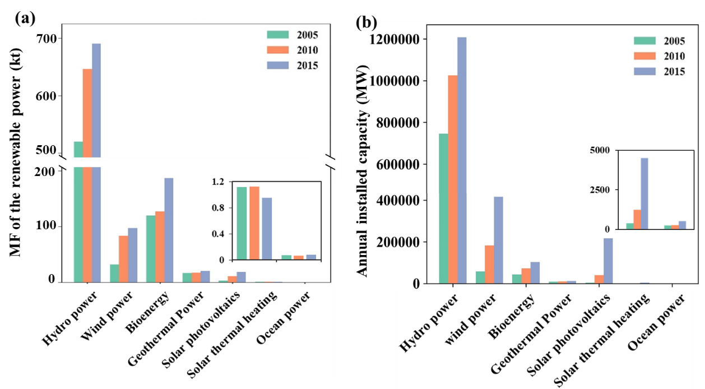
Fig. S1 The trends of the metal footprints (a) and annual installed capacity (b) of renewable power sectors

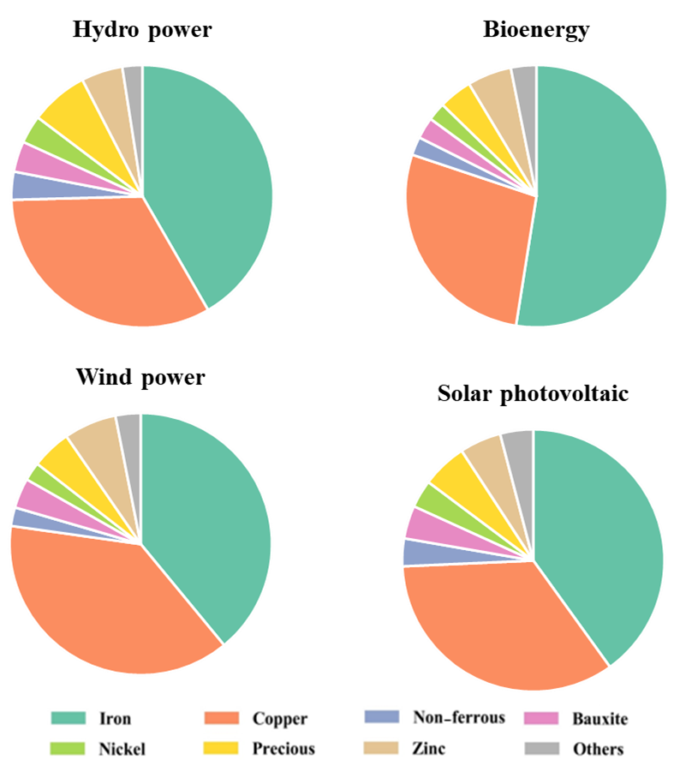
Fig S2 The structure of metal consumption in the global renewable power sectors in 2015. This figures illustrate the structure of metal consumption in the global renewable power sectors in 2015. Metals are abbreviated for convenience: “Precious” includes silver and PGMs; “Non-Ferrous” indicates nonferrous metals; Other stands for lead, tin.

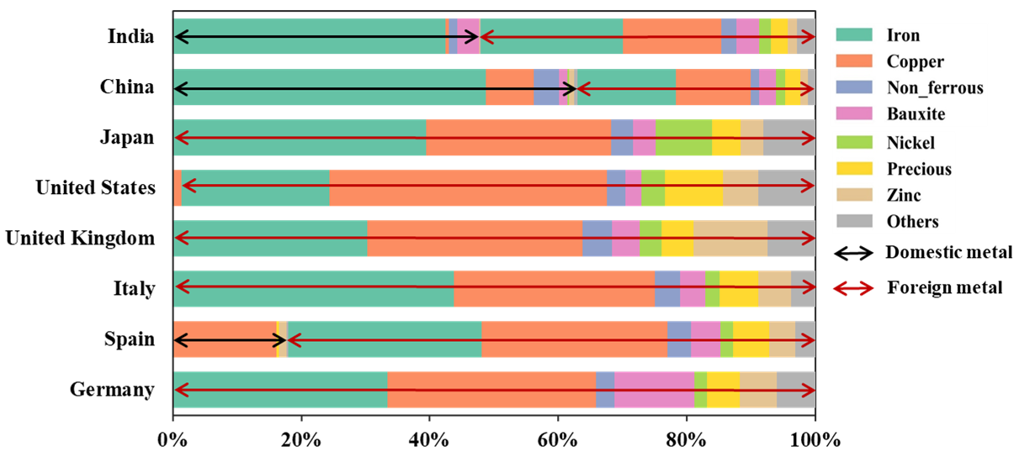
Fig. S3 Trace metals consumed by renewable power in countries from a downstream perspective of the value chain in 2015. “Precious” includes silver and PGMs; “Non-Ferrous” indicates nonferrous metals; Other stands for lead, tin. The black arrow means that the domestic total metal ores use embodied in RPVCs, the red arrow means that the foreign total metal ores use embodied in RPVCs.

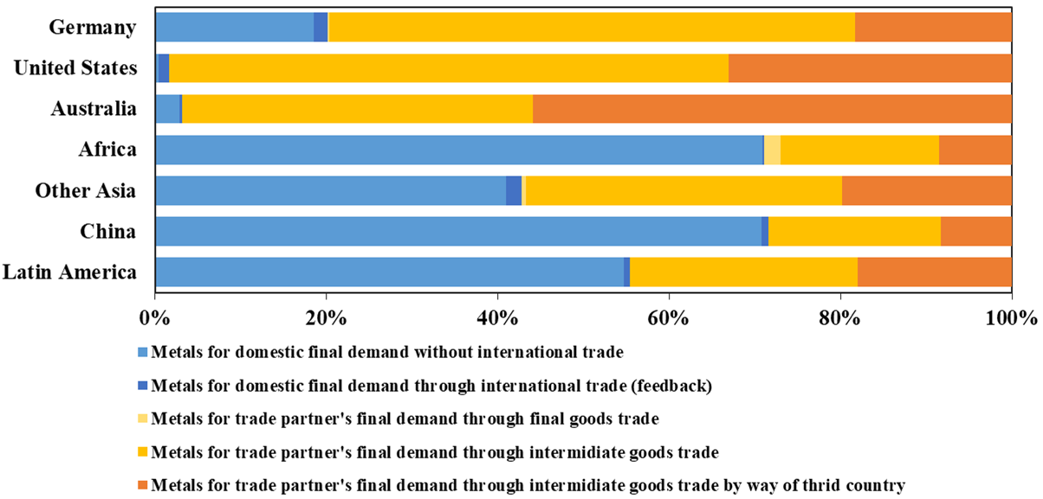

Fig. S4 Trace metals consumed by renewable power in countries from an upstream perspective in the value chain, in other words, who produces renewable goods for whom.

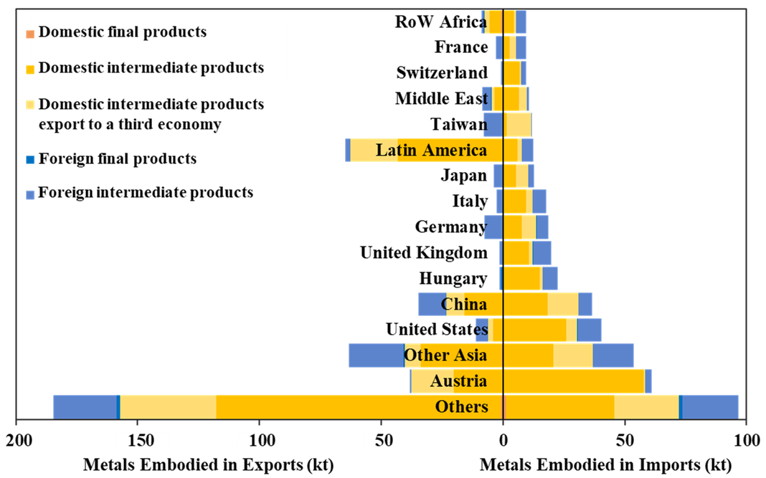
Fig. S4 The decomposition of metals embodied in exports and imports for 49 economies in 2005.
This figure illustrates the metals embodied in exports and imports for 49 economies in 2005. Yellow and blue represent domestic and foreign metals, respectively, and gradients of the same color indicate the metals embodied in intermediate and final products.

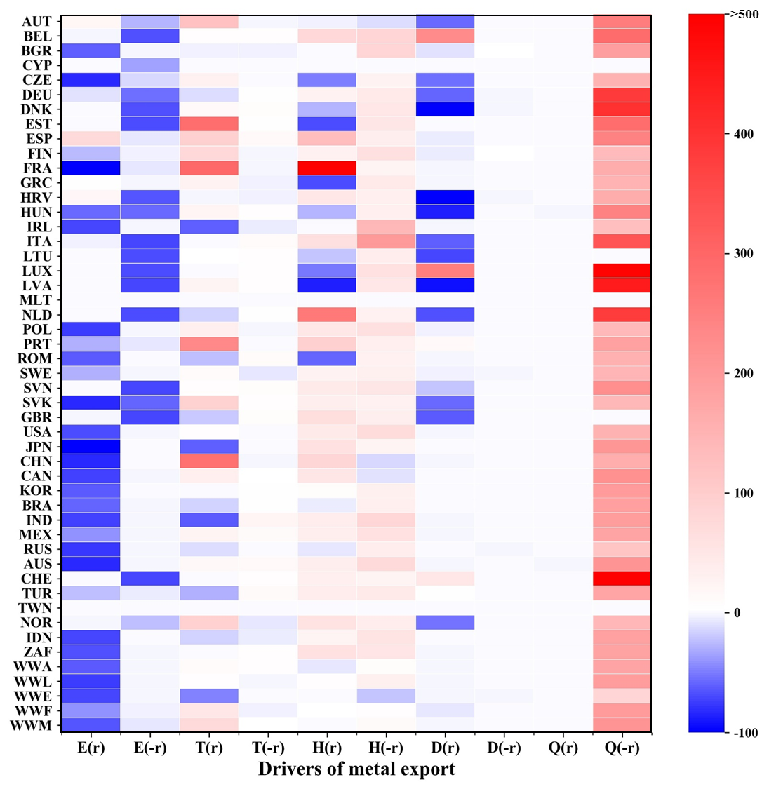
Fig. S5 The contribution of each factor to the metal embodied in export of the all economies

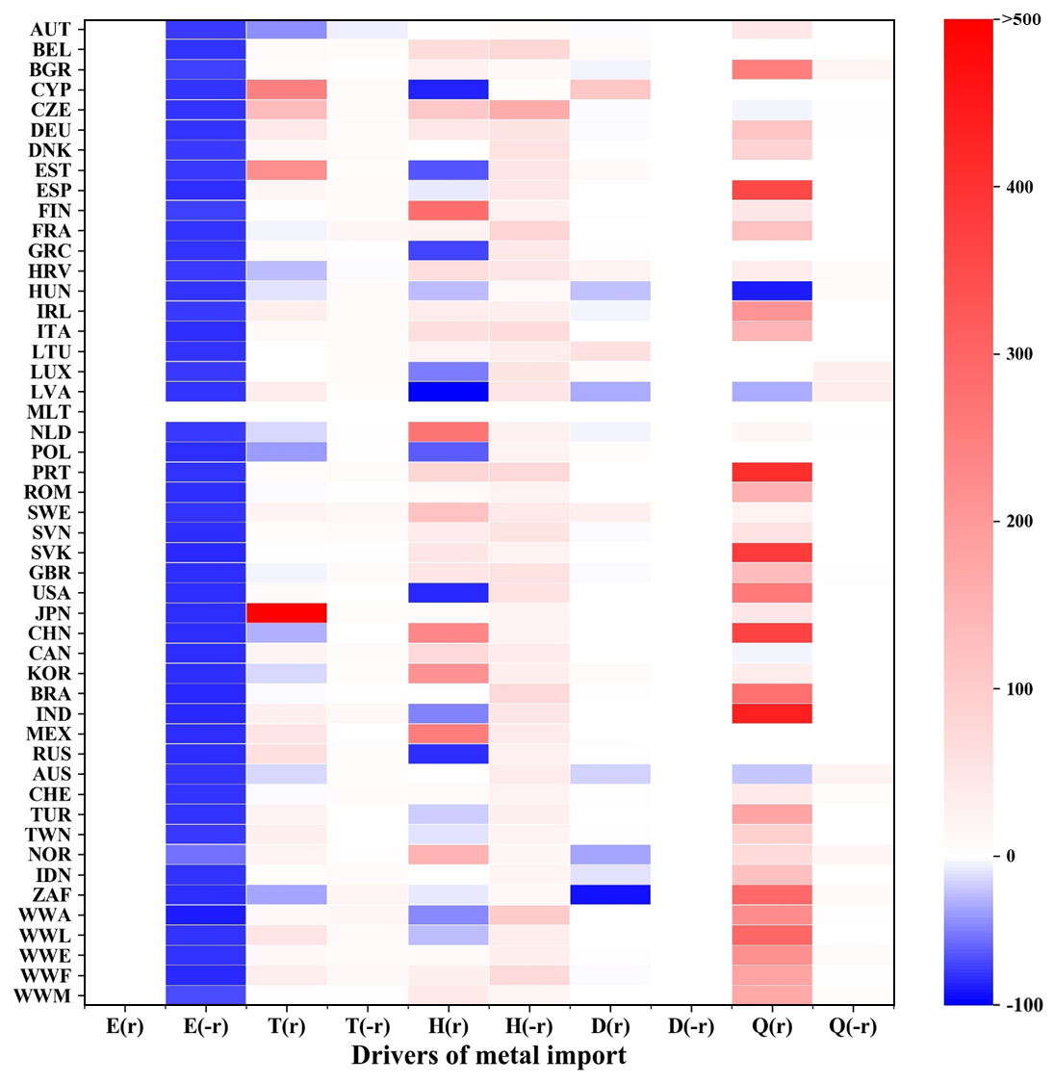
Fig S6 The contribution of each factor to the metal embodied in import of the all economies

This figure illustrates the contribution of changes in trade structure and production technology to the metal embodied in export and import for economies. The changes in production technology and trade structure contribute to a moderate growth of metal inequality. Production technology shifts (ΔH^{(r)}, ΔH^{(-r)}) causes the MEI increase in rich economies (except USA, Spain) by 10%~210%, 31%~83%, and MEE growth in poor economies by 1%~2%, 6%~12%. One possible reason is that more intermediate inputs than value-added are required per unit of renewables production globally from 2005 to 2015. The other could be that production technology shifts to a more metal-intensive pattern driven by the rich economies. For instance, the offshore wind energy capacity in EU-15 increase by 15 times in 2005-2015, which requires around 2 times of the metal inputs for onshore wind energy. Differently, the MEI increase in Japan is mostly attributed to the trade structure of intermediate goods at home (ΔT^{(r)}), with a contribution of 502%, much higher than the global average, 30%. It also generates a moderate MEE increase in poor countries by 10%~75%. Japan changes to buying intermediate goods where they are produced in a high metal-intensive fashion (e.g. from WWM and WWF to WWA) from 2005 to 2015 and induce the positive effect, resulting deeper inequality between Japan and others.

References
1. Leontief, W. Quantitative Input and Output Relations in the Economic System of the United States. Rev. Econ. Stat. 18, 105–125 (1936).
2. Sébastien, M., and Ming, Y. Investigating double counting terms in the value-added decomposition of gross exports. MPRA Pap. No. 93877 (2019).
3. Wang, Z., Wei, S. J., Zhu, K. Quantifying International Production Sharing At the Bilateral and Sector Levels. NBER Woking Pap. 19667, 1–127 (2013).
4. Xu, Y., Dietzenbacher, E. A structural decomposition analysis of the emissions embodied in trade. Ecol. Econ. 101, 10–20. https://doi.org/10.1016/j.ecolecon.2014.02.015 (2014).

