
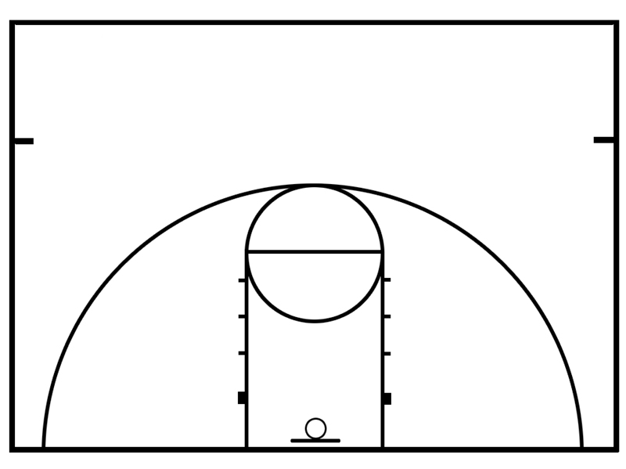
Supplement 1. Obstacle course diagram
Start Line
Finish Line
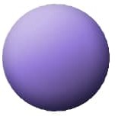

Sliding station
Throwing a ball to participants
Catching a ball
Double Leg Hop
Kicking a ball s
Single Leg
Hop - 2
Single Leg
Hop - 1
Throwing a ball to screen
Screen

