Supporting Information

Supplemental analysis
Correlation in larval abundance
Our correlation analysis presented in the main text uses species-specific larval abundances from individual sediment cores. To supplement this analysis, we examined correlations at two higher scales: (i) aggregated across site-date combinations (i.e., using mean species-specific abundances for each site-date combination), and (ii) aggregated across site-year combinations (i.e., using mean species-specific abundances for site-year combinations). When calculating the correlation between abundances aggregated at the site-date level, we standardized abundances for each species by subtracting the species-specific mean abundance for each site-year combination. We report Pearson’s correlation coefficient for these analyses.
Abundances of T. gracilentus and C. islandicus larvae were positively correlated at the levels of aggregated site-date combinations (r = 0.43; Fig. S2a) and aggregated site-year combinations (r = 0.51; Fig. S2b).

Pelagic δ¹³C signatures
During the study period, we collected a limited number of pelagic samples and submitted them for isotopic analysis. For these samples, we collected field water with a modified Schindler trap at approximately 1-m intervals. We avoided sampling within 1 m of the sediment surface to prevent disruption to the sediment. A total of 10-30 L of water per sample was homogenized and filtered through a 63-µm sieve in the field. Contents suspended in the water column that were retained on the 63-µm sieve included phytoplankton, zooplankton, and other particulate organic matter. Pelagic isotope samples were then transferred to glass vials and dried at 60 °C. Once dry, the samples were processed following the same procedures as described in the main text for larvae and surface sediment (Methods: Stable isotope samples).
In the main text, we discuss how reliance of pelagic-derived carbon may influence C. islandicus larvae δ¹³C signatures (Discussion). To supplement this discussion, we present a visualization of δ¹³C values from pelagic samples compared to those of (i) surface sediment and (ii) C. islandicus larvae (Fig. S3). For this visualization, we included a subset of our surface sediment and C. islandicus samples that had a corresponding pelagic δ¹³C value. Like the main text (Methods: Statistical analysis), samples that were paired from a given site were collected on the same date in most cases, but for some pairs, we compared samples that were collected 1-12 days apart.
Figure S1. δ¹³C signatures of T. gracilentus larvae, C. islandicus larvae, and surface sediments collected from sites in Lake Mývatn during 2016-2018.
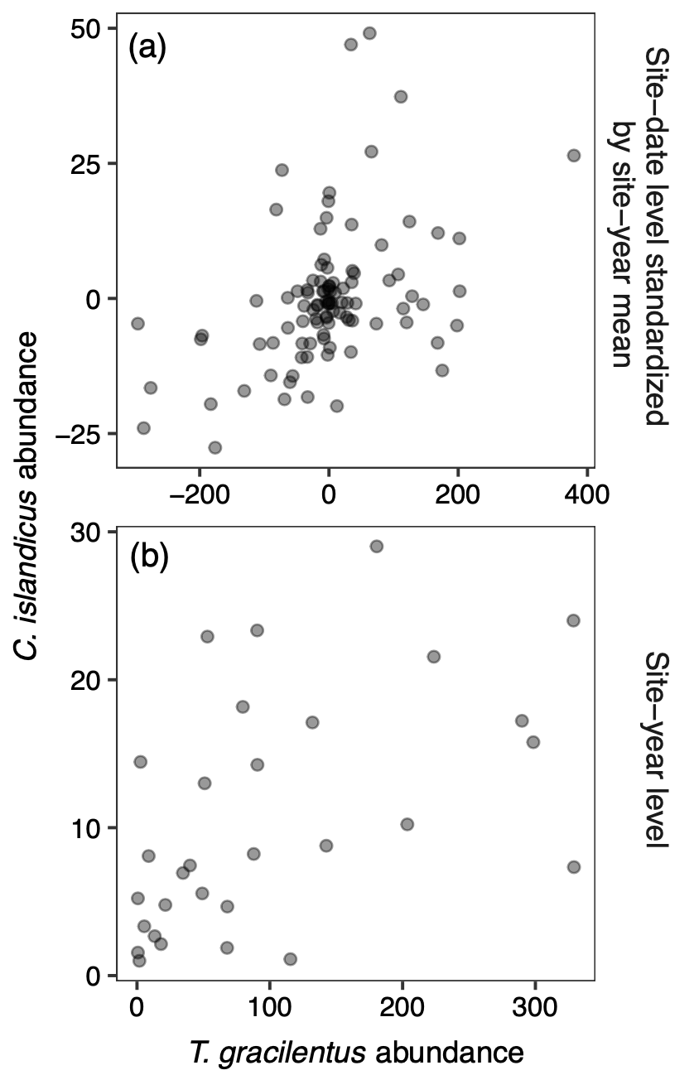
Figure S2. Comparisons of T. gracilentus and C. islandicus abundances at the levels of (a) larvae aggregated for site-date combinations, and (b) larvae aggregated for site-year combinations. In panel (a), abundances were standardized by subtracting the mean species-specific abundance for each site-year combination.
Figure S3. Comparisons of δ¹³C signatures among (a) pelagic samples and surface sediment and (b) C. islandicus larvae and pelagic samples. Lines connect a pair of samples collected from the same site and near the same date.

Table S1. List of larvae and sediment samples collected for stable isotope analysis from 2016-2018.
Sample type | Sample date | Site depth (m) | Site name | n | δ¹³C (SD)
C. islandicus | 5/29/2016 | 2.7 | E1 | 1 | -19.76
C. islandicus | 5/29/2016 | 3.3 | E3 | 1 | -20.97
C. islandicus | 5/30/2016 | 2.7 | E2 | 1 | -21.08
C. islandicus | 5/30/2016 | 2.9 | E4 | 1 | -21.77
C. islandicus | 5/31/2016 | 2.5 | E5 | 1 | -19.77
C. islandicus | 5/31/2016 | 2.8 | E6 | 1 | -20.39
C. islandicus | 6/26/2016 | 2.7 | E1 | 1 | -17.27
C. islandicus | 6/26/2016 | 3.3 | E3 | 1 | -19.07
C. islandicus | 6/26/2016 | 2.9 | E4 | 1 | -17.58
C. islandicus | 6/27/2016 | 2.7 | E2 | 1 | -16.76
C. islandicus | 6/27/2016 | 2.5 | E5 | 1 | -17.77
C. islandicus | 8/11/2016 | 2.7 | E1 | 1 | -16.49
C. islandicus | 8/11/2016 | 3.3 | E3 | 1 | -20.02
C. islandicus | 8/11/2016 | 2.9 | E4 | 1 | -18.07
C. islandicus | 8/11/2016 | 2.5 | E5 | 1 | -13.12
C. islandicus | 5/24/2017 | 3.3 | E3 | 1 | -20.55
C. islandicus | 6/25/2017 | 3.3 | E3 | 1 | -20.71
C. islandicus | 7/17/2017 | 3.3 | E3 | 1 | -21.51
C. islandicus | 8/2/2017 | 3.3 | E3 | 1 | -20.72
C. islandicus | 6/28/2018 | 4.25 | Reyk | 4 | -22.52 (0.26)
C. islandicus | 7/17/2018 | 4.25 | Reyk | 4 | -21.06 (1.35)
C. islandicus | 7/25/2018 | 3.3 | E3 | 3 | -19.77 (1.68)
C. islandicus | 8/10/2018 | 5.1 | Grim | 1 | -25.74
C. islandicus | 8/10/2018 | 4.25 | Reyk | 4 | -24.14 (1.09)
C. islandicus | 8/12/2018 | 3.3 | E3 | 2 | -20.81 (0.82)
C. islandicus | 8/12/2018 | 2.5 | E5 | 3 | -14.58 (1.06)
T. gracilentus | 5/29/2016 | 2.7 | E1 | 1 | -15.32
T. gracilentus | 5/29/2016 | 3.3 | E3 | 1 | -16.57
T. gracilentus | 5/30/2016 | 2.7 | E2 | 1 | -15.46
T. gracilentus | 5/30/2016 | 2.9 | E4 | 1 | -16.10
T. gracilentus | 5/31/2016 | 2.5 | E5 | 1 | -13.61
T. gracilentus | 6/26/2016 | 3.3 | E3 | 1 | -14.51
T. gracilentus | 5/24/2017 | 3.3 | E3 | 1 | -15.46
T. gracilentus | 7/17/2017 | 3.3 | E3 | 1 | -12.65
T. gracilentus | 8/2/2017 | 3.3 | E3 | 1 | -13.39
T. gracilentus | 6/28/2018 | 4.25 | Reyk | 3 | -15.51 (0.16)
T. gracilentus | 7/3/2018 | 2.5 | E5 | 3 | -11.95 (0.15)
T. gracilentus | 7/17/2018 | 4.25 | Reyk | 4 | -17.37 (0.09)
T. gracilentus | 8/17/2018 | 2.5 | E5 | 3 | -12.72 (0.10)
Surface sediment | 6/13/2016 | 2.7 | E1 | 1 | -16.59
Surface sediment | 6/13/2016 | 2.7 | E2 | 1 | -15.98
Surface sediment | 6/13/2016 | 3.3 | E3 | 1 | -17.88
Surface sediment | 6/13/2016 | 2.9 | E4 | 1 | -16.96
Surface sediment | 6/13/2016 | 2.5 | E5 | 1 | -16.23
Surface sediment | 6/13/2016 | 2.8 | E6 | 1 | -16.64
Surface sediment | 6/26/2016 | 2.7 | E1 | 1 | -16.57
Surface sediment | 6/26/2016 | 3.3 | E3 | 1 | -17.42
Surface sediment | 6/26/2016 | 2.9 | E4 | 1 | -16.76
Surface sediment | 6/26/2016 | 2.5 | E5 | 1 | -15.56
Surface sediment | 6/27/2016 | 2.7 | E2 | 1 | -16.09
Surface sediment | 6/27/2016 | 2.8 | E6 | 1 | -14.93
Surface sediment | 8/9/2016 | 2.9 | E4 | 1 | -15.81
Surface sediment | 8/9/2016 | 2.5 | E5 | 1 | -15.76
Surface sediment | 8/9/2016 | 2.8 | E6 | 1 | -14.94
Surface sediment | 8/10/2016 | 2.7 | E1 | 1 | -15.63
Surface sediment | 8/10/2016 | 2.7 | E2 | 1 | -15.23
Surface sediment | 8/10/2016 | 3.3 | E3 | 1 | -17.40
Surface sediment | 7/17/2017 | 3.3 | E3 | 1 | -16.23
Surface sediment | 8/2/2017 | 3.3 | E3 | 1 | -15.30
Surface sediment | 8/14/2017 | 3.3 | E3 | 1 | -17.76
Surface sediment | 6/23/2018 | 4.25 | Reyk | 1 | -17.47
Surface sediment | 6/24/2018 | 3.3 | E3 | 1 | -16.17
Surface sediment | 7/17/2018 | 5.1 | Grim | 1 | -20.65
Surface sediment | 7/17/2018 | 4.25 | Reyk | 1 | -18.82
Surface sediment | 7/25/2018 | 3.3 | E3 | 1 | -16.83
Surface sediment | 8/10/2018 | 5.1 | Grim | 1 | -21.40
Surface sediment | 8/10/2018 | 4.25 | Reyk | 1 | -19.63
Surface sediment | 8/13/2018 | 3.3 | E3 | 1 | -17.09

