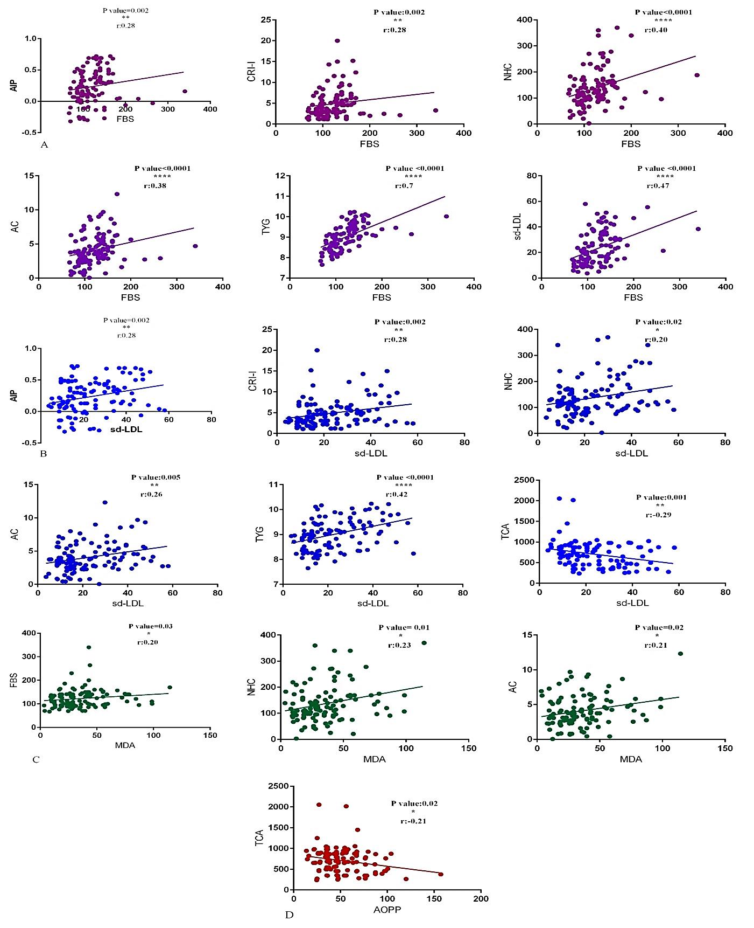
Figure S1. Correlation analysis for AIP, CRI-I, NHC, AC, TYG, Sd-LDL and FBS (A); AIP, CRI-I, NHC, AC, TYG, TCA and Sd-LDL (B); FBS, NHC, AC and MDA (C); TCA and AOPP (D). Note: FBS: Fasting Blood Sugar; sdLDL: Small dense low-density lipoprotein-cholesterol; TYG: triglyceride glucose index; CRI-1: Castelli’s Risk Index, AC: atherogenic coefficient, AIP: Atherogenic index of plasma; NHD: Non-HDL-Cholesterol, MDA: malondialdehyde; AOPP: Advanced products of protein oxidation; TCA: Total antioxidant capacity.

Table S1. Biochemical properties, Clinical and Demographic characteristics in the control and patient groups
Variables | Control (N=50)  (mean ± SD) |  | Patient (N=60)  (mean ± SD) |  | P value
Age | 51.86 ± 11.87 |  | 64.5 ± 12.73 |  | 0.54
Weight (Kg) | 76.2 ± 16.76 |  | 78.9 ± 10.36 |  | 0.037*
BMI | 27.51 ± 5.68 |  | 28.33 ± 19.78 |  | 0.374
Systolic blood pressure (mmHg) | 127.12 ± 15.87 |  | 145.68 ± 19.78 |  | <0.001***
Diastolic blood pressure (mmHg) | 77.7 ± 13.14 |  | 87.72 ± 9.67 |  | <0.001***
FBS (mg/dl) | 99.82 ± 21.46 |  | 141.8 ± 40.99 |  | <0.001***
TC (mg/dl) | 149.56± 56.62 |  | 193.45 ± 88.94 |  | <0.001***
TG (mg/dl) | 118.92 ± 42.95 |  | 190.3 ± 88.94 |  | <0.001***
HDL (mg/dl) | 40.06 ± 10.54 |  | 33.26±9.36 |  | <0.001***
LDL (mg/dl) | 86.76 ± 47.35 |  | 85.66 ± 32.26 |  | <0.001***
Frequency | N (%) |  | N (%) |  | P value
Frequency | No |  | Yes |  | P value
Smoking | 11 (22%) |  | 30 (50%) |  | <0.001***
Alcohol | 0 (0%) |  | 3 (5%) |  | 0.249
Familial hypercholesterolemia | 33 (66%) |  | 44 (73.3%) |  | 0.413
Hypertension | 15 (30%) |  | 51 (85%) |  | <0.001***
Hyperlipidemia | 14 (28%) |  | 39 (65%) |  | <0.001***
Coronary artery disease | 2 (4%) |  | 47 (78.3%) |  | <0.001***
Chronic renal failure | 1 (2%) |  | 13 (21.7%) |  | <0.001***
Gender | Female  25 (41.7%) | Male  35 (58.3%) | Female  27 (54%) | Male  23 (46%) | P value  0.25
Note: * P value<0.05, ** P value<0.01, *** P value<0.001. BP: Blood pressure; FBS: Fasting blood sugar; BMI: Body mass index; TC: Total cholesterol; TG: Triglycerides; HDL: High-density lipoprotein; LDL: Low-density lipoprotein.

Table S2. Comparison of sdLDL, MDA, TCA and AOPP and atherogenic indices in the control and patient groups
Factors | control group | patient group | P value
sdLDL | 13.51 ± 5.58 | 31.47 ± 11.71 | <0.001***
MDA | 28.62 ± 14.68 | 41.79 ± 24.75 | <0.01**
TCA | 831.56 ± 331.14 | 606.77 ± 238.20 | <0.001***
AOPP | 45.47 ± 17.75 | 56.94 ± 27.37 | <0.048*
AIP | 0.097 ± 0.22 | 0.35 ± 0.23 | <0.001***
CRI-I | 3.29 ± 1.76 | 6.22 ± 3.75 | <0.001***
CRI-II | 2.42 ± 1.63 | 2.74 ± 1.21 | 0.088
NHC | 109.5 ± 56.94 | 160.18 ± 73.21 | <0.001***
AC | 2.99 ± 1.65 | 5.03 ± 2.26 | <0.001***
TYG | 8.60 ± 0.43 | 9.36 ± 0.53 | <0.001***
Note: * P value<0.05, ** P value<0.01, *** P value<0.001. sdLDL: Small dense low-density lipoprotein-cholesterol; MDA: malondialdehyde; TCA: Total antioxidant capacity; AOPP: Advanced products of protein oxidation; AIP: Atherogenic index of plasma; CRI-1: Castelli’s Risk Index, CRI-2: Low density lipoprotein cholesterol/HDLc .NHD: Non-HDL-Cholesterol, AC: atherogenic coefficient, TYG: triglyceride glucose index

Table S3. ROC curve analysis using Sd-LDL, TCA, MDA, AOPP and atherosclerosis markers to distinguish the different groups in Control and patients group.
 | Area | Std. Error | P Value | 95% CI |  | sensitivity | Specificity | Cut-Off Point
 |  |  |  | Lower Bound | Upper Bound | sensitivity | Specificity | Cut-Off Point
Sd-LDL | 0.924 | 0.023 | <0.001*** | 0.879 | 0.969 | 64.41±33.87 | 73.84±32.62 | 17
TYG | 0.866 | 0.034 | <0.001*** | 0.799 | 0.932 | 63.75±30.32 | 72.10±31.23 | 9
CRI-I | 0.772 | 0.044 | <0.001*** | 0.685 | 0.859 | 61.64±29.45 | 65.20±30.78 | 4
AC | 0.770 | 0.045 | <0.001*** | 0.682 | 0.858 | 62.57±29.5 | 64.26±29.61 | 2
AIP | 0.769 | 0.044 | <0.001*** | 0.682 | 0.855 | 63.60±30.99 | 61.40±33.40 | 0.1
NHC | 0.709 | 0.049 | <0.001*** | 0.613 | 0.805 | 58.33±29.85 | 62.47±30.43 | 130
TCA | 0.708 | 0.049 | <0.001*** | 0.611 | 0.805 | 57.79±29.66 | 61.58±31.60 | 560
MDA | 0.654 | 0.052 | 0.006** | 0.553 | 0.755 | 55.62±28.75 | 59.27±31.87 | 29
AOPP | 0.610 | 0.053 | 0.048* | 0.505 | 0.715 | 53.31±28.67 | 57.83±30.93 | 37
Note: * P value<0.05, ** P value<0.01, *** P value<0.001. sdLDL: Small dense low-density lipoprotein-cholesterol; TYG: triglyceride glucose index; CRI-1: Castelli’s Risk Index, AC: atherogenic coefficient, AIP: Atherogenic index of plasma; NHD: Non-HDL-Cholesterol, TCA: Total antioxidant capacity; MDA: malondialdehyde; AOPP: Advanced products of protein oxidation.

