Effect of substrate fertility on tank-bromeliad performances

Authors: Tristan Lafont Rapnouil^{1,2}, Sabrina Coste², Jean-Yves Goret², Frédéric Julien³, Clément Stahl², Céline Leroy^{1,2}

The following supplementary data is available for this article:
Fig. S1 Treatment granulometry and CNP content.
Fig. S2Overnight CO₂ assimilation and stomatal conductance curves.
Fig. S3 Effect of substrate fertility on gas exchange.
Fig. S4 Effect of substrate fertility on photosynthetic apparatus.
Fig. S5 Effect of substrate fertility on leaf construction cost.
Fig. S6 Effect of substrate fertility on leaf trichomes and stomata.
Fig. S7 Effect of substrate fertility on leaf CNP content.
Fig. S8 Effect of substrate fertility on roots structure.
Fig. S9 Effect of substrate fertility on root CNP content.

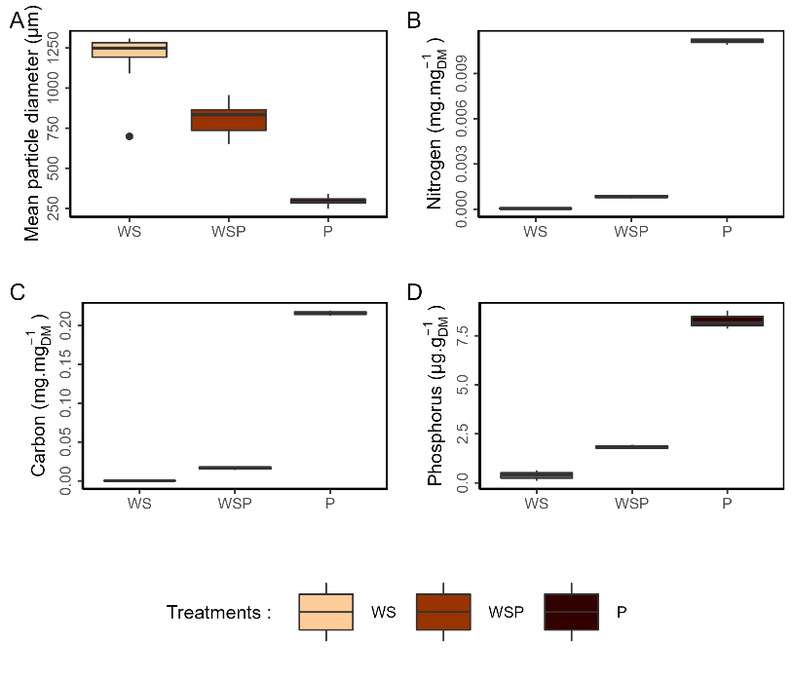
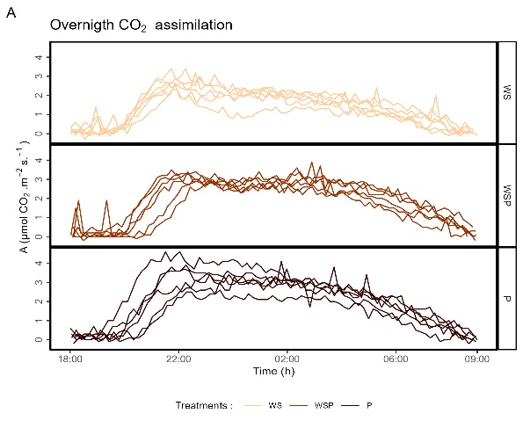
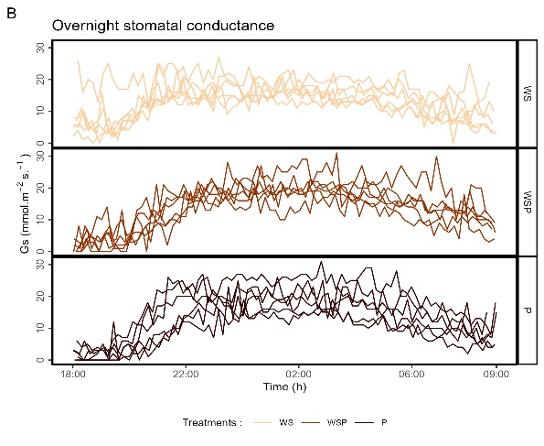
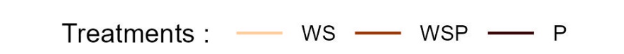
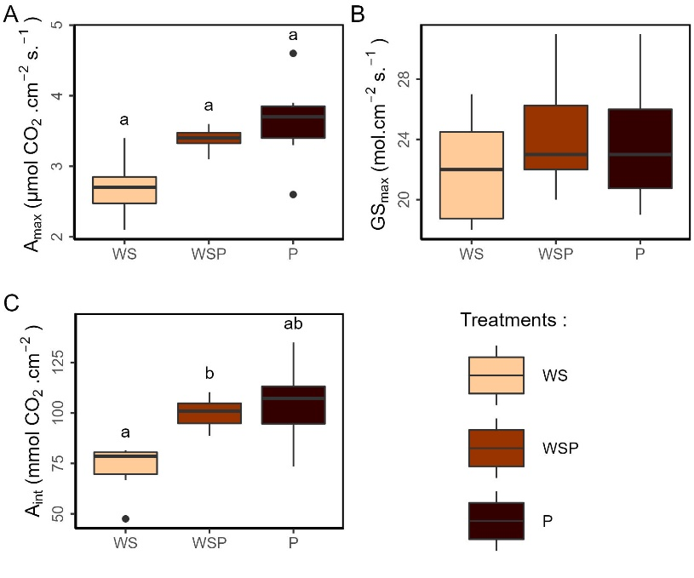
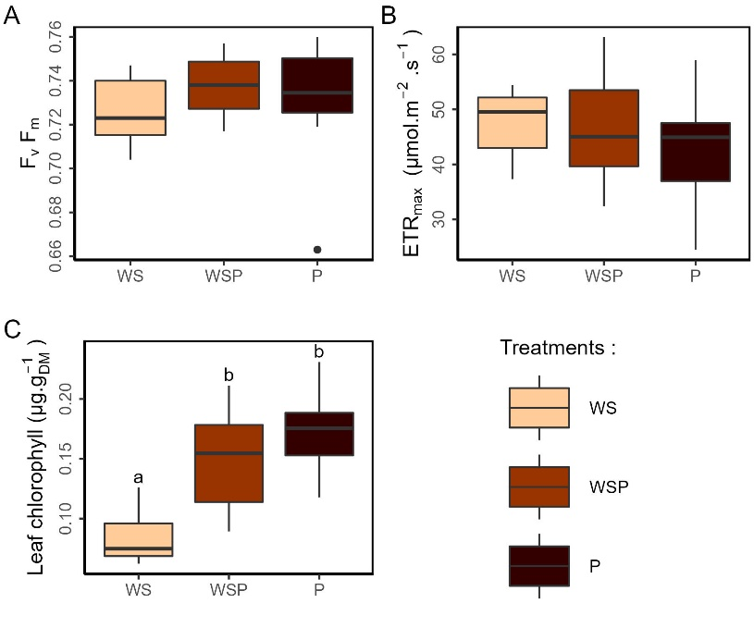
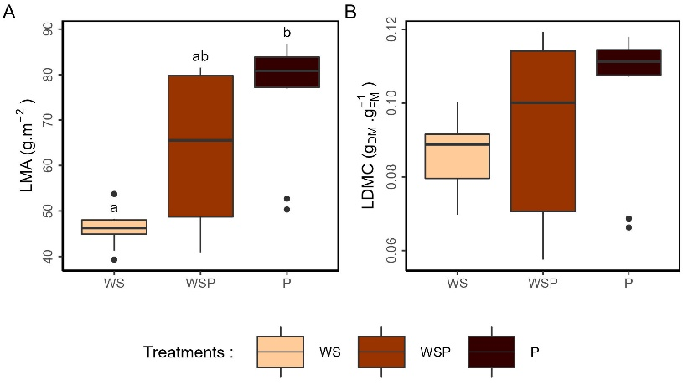
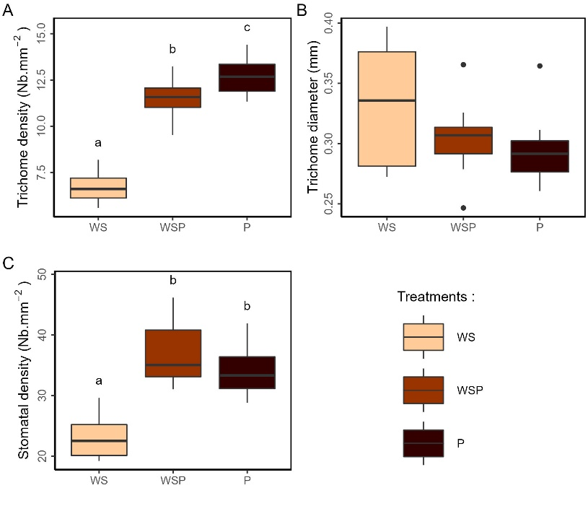
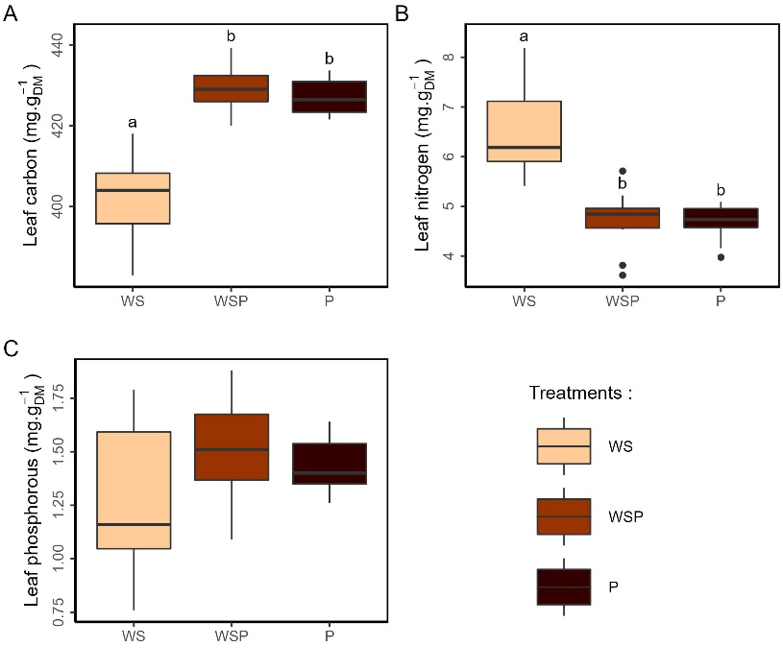
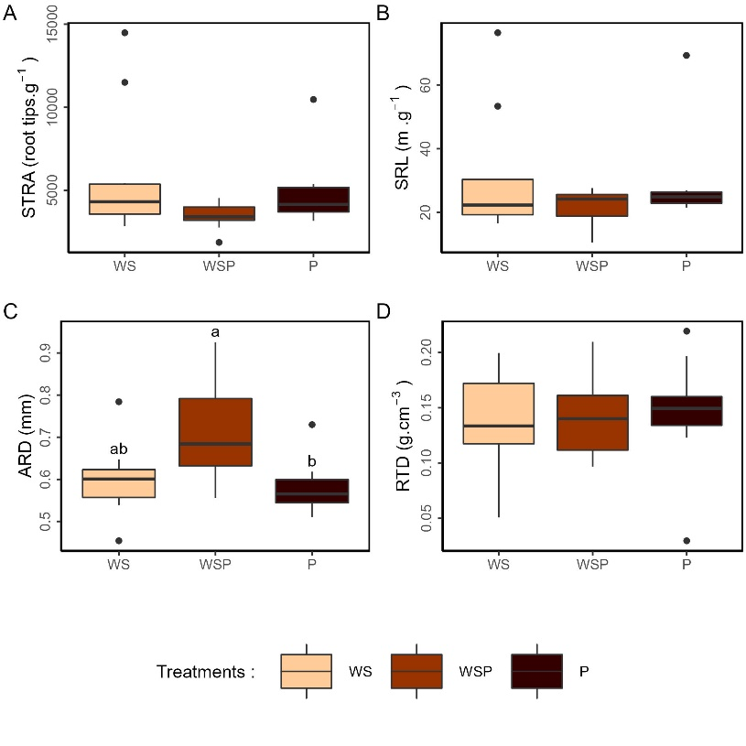
Fig. S1 Treatment granulometry and CNP content. Boxplots for soil (A) mean particle diameter (µm⁻¹) and, (B) N (mg.g⁻¹_{DM}), (C) C (mg.g⁻¹_{DM}), (D) P (µg.g⁻¹_{DM}) concentration . Different letters indicate significant differences between treatments, pairwise Wilcoxon test (α<0.05) after significant Kruskal-Wallis (α<0.05). WS – white sand, WSP – white sand/potting soil, P – potting soil

Fig. S2 Overnight CO₂ assimilation and stomatal conductance curves. Curves of overnight (A) CO₂ assimilation (A, µmol.m⁻².s⁻¹) and (B) stomatal conductance (Gs, mmol.m⁻².s⁻¹), These measurements were conducted on 6 extra plants per treatments. One plant per day with one of each treatment every three days over a month. WS – white sand, WSP – white sand/potting soil, P – potting soil

Fig. S3 Effect of substrate fertility on gas exchange. Boxplots for (A) maximal CO₂ assimilation (A_{max}, µmol.m⁻².s⁻¹), (B) maximal stomatal conductance (GS_{max} µmol.m⁻².s⁻¹) and, (C) integrated overnight Co₂ assimilation (A_{int}, mol.m⁻²). Different letters indicate significant differences between treatments, pairwise Wilcoxon test (α<0.05) after significant Kruskal-Wallis (α<0.05). WS – white sand, WSP – white sand/potting soil, P – potting soil
Fig. S4 Effect of substrate fertility on photosynthetic apparatus. Boxplots for (A) F_{v}F_{m,} (B) ETR_{max} (µmol.m⁻².s⁻¹) and (C) leaf chlorophyll content (µg.g⁻¹). Different letters indicate significant differences between treatments, pairwise Wilcoxon test (α<0.05) after significant Kruskal-Wallis (α<0.05). WS – white sand, WSP – white sand/potting soil, P – potting soil
Fig. S5 Effect of substrate fertility on leaf construction cost. Boxplots for (A) LMA (g.m⁻²) and (B) LDMC (g_{DM}.g_{FM}⁻¹). Different letters indicate significant differences between treatments, pairwise Wilcoxon test (α<0.05) after significant Kruskal-Wallis (α<0.05). WS – white sand, WSP – white sand/potting soil, P – potting soil
Fig. S6 Effect of substrate fertility on leaf trichomes and stomata. Boxplots for (A) trichomes density (Nb.mm⁻²), (B) trichome diameter (mm) and, (C) stomatal density (Nb.mm-2). Different letters indicate significant differences between treatments, pairwise Wilcoxon test (α<0.05) after significant Kruskal-Wallis (α<0.05). WS – white sand, WSP – white sand/potting soil, P – potting soil

Fig. S7 Effect of substrate fertility on leaf CNP content. Boxplots for (A) C, (B) N (mm) and, (C) P leaf content (mg.g⁻¹_{DM}). Different letters indicate significant differences between treatments, pairwise Wilcoxon test (α<0.05) after significant Kruskal-Wallis (α<0.05). WS – white sand, WSP – white sand/potting soil, P – potting soil
Fig. S8 Effect of substrate fertility on roots structure. Boxplots for (A) STRA (tips.g⁻¹), (B) SRL(cm.g⁻¹) (C) ARD (mm) and, (D) RTD (g.cm⁻³). Different letters indicate significant differences between treatments, pairwise Wilcoxon test (α<0.05) after significant Kruskal-wallis (α<0.05). WS – white sand, WSP – white sand/potting soil, P – potting soil
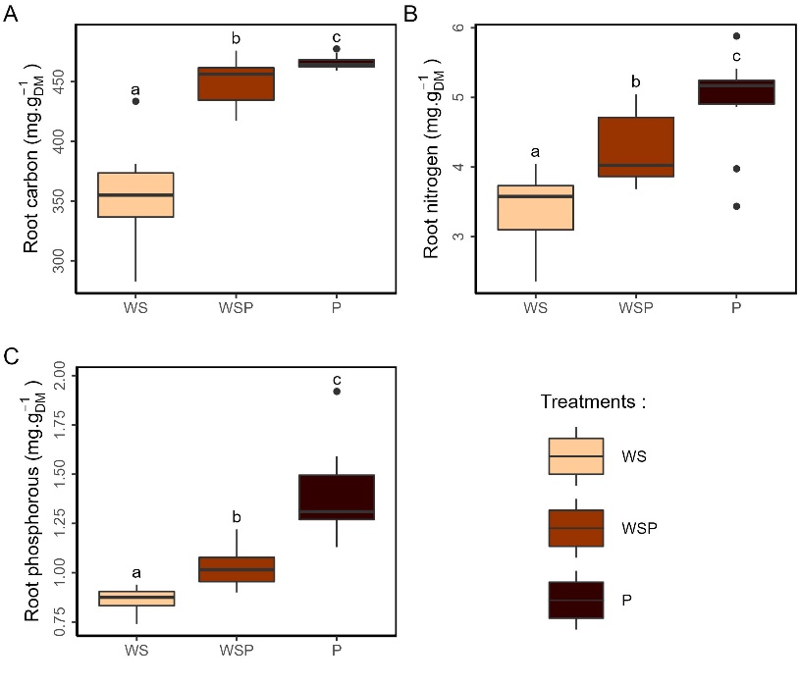
Fig. S9 Effect of substrate fertility on root CNP content. Boxplots for (A) root C, (B) N and, (C) P content (mg.g_{DM}⁻¹). Different letters indicate significant differences between treatments, pairwise Wilcoxon test (α<0.05) after significant Kruskal-wallis (α<0.05). WS – white sand, WSP – white sand/potting soil, P – potting soil

