Supplementary information

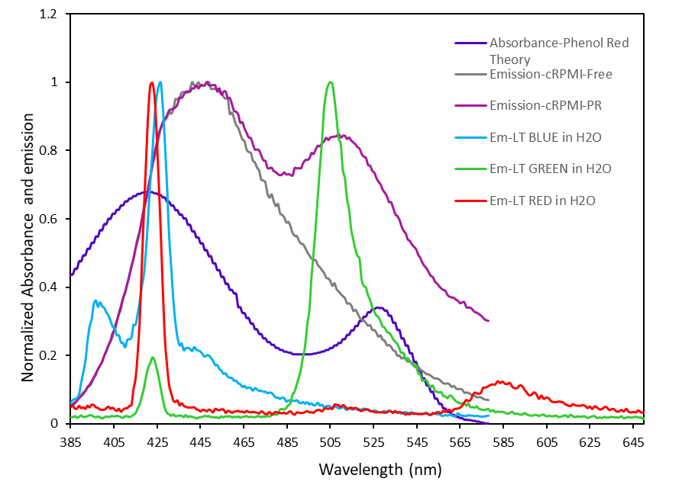
Figure SI1. Comparison of the absorbance and emission spectra of the different LysoTracker probes to compare the interference with the phenol red.

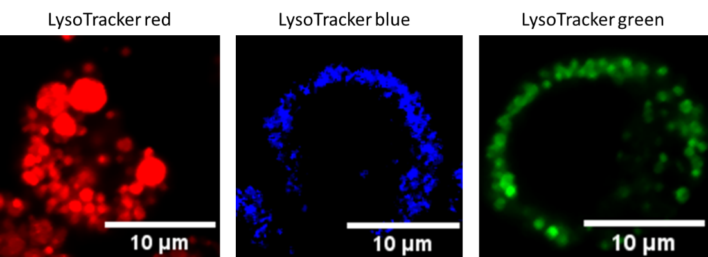
Figure SI2. Confocal microscopy images of different LysoTracker probes.

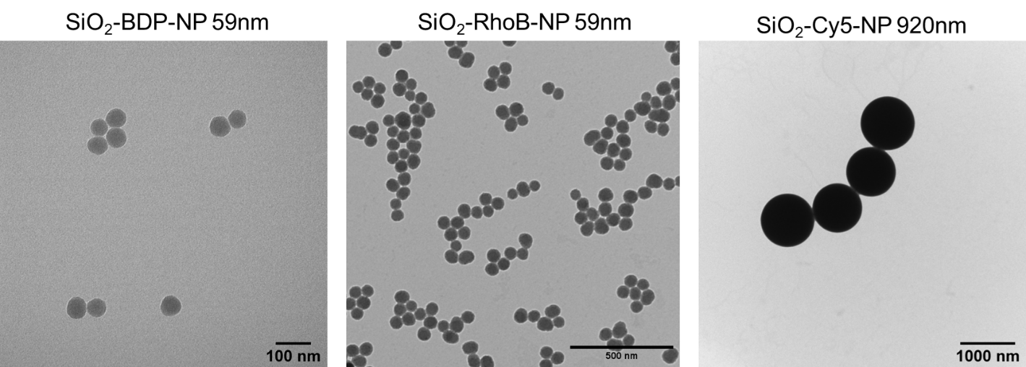Figure SI3. Transmission electron micrographs (TEM) of the different silica NP. From left to right: 59 nm SiO₂-Bodipy NP, 59 nm SiO₂-Rhodamine NP and 920 nm SiO₂-Cyanine5 particles.
Lamp-2
Merged
LysoTracker

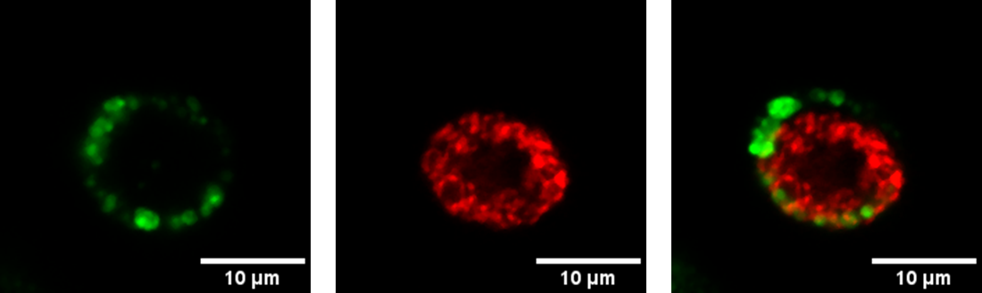
Figure SI4. Representative images of LysoTracker and Lamp-2 stainings in a single cell. Left: Lysosomes stained with LysoTracker Red probe (green), middle: Lysosomes stained with Lamp-2 antibody (red color) and right: merged channels LysoTracker and Lamp-2 of the same cell.

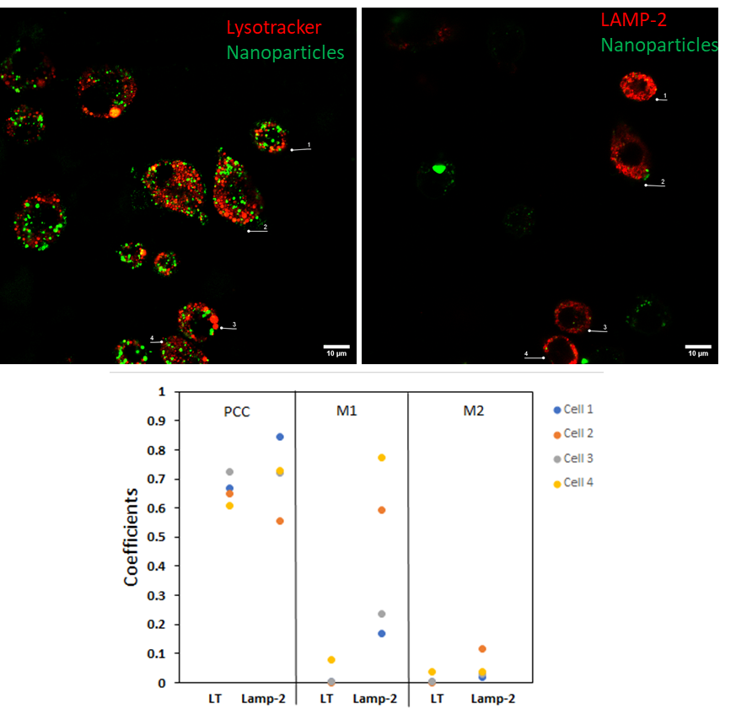

Figure SI5. Comparison of Pearson’s and Manders’ coefficients between live and fixed cells. The cells were exposed to SiO₂ Bodipy NP for 1h, stained with LysoTracker probe and imaged by CLSM. The same sample was fixed, stained for LAMP-2 and imaged. A total of 4 cells were analyzed for comparision, each cell has a representative color as it is shown in the coefficients plot. Each cell varies its colocalization coefficient for the NP with the lysosomes. This data demonstrate that the coefficients from live and fixed cells cannot be compared. Additionally, Pearson correlation coefficients is not enough to confirm the distribution of the fraction of the NP between the lysosomes.

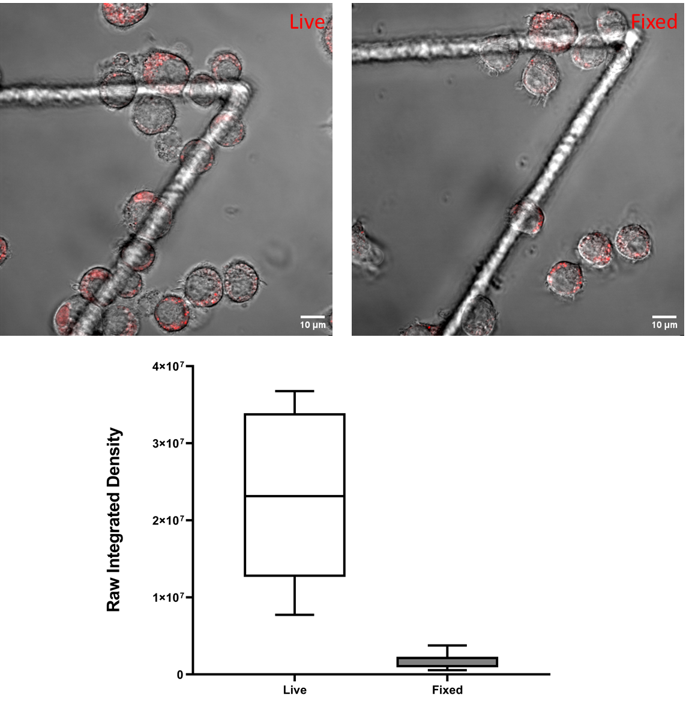
Figure SI6. Comparison of raw integrated intensity between live and fixed cells. Top two images represent CLSM data from live cells (left) and fixed cells (right). The cells were stained with LysoTracker Red probe for 1h and imaged. The same cells were fixed and washed following a fixation protocol and imaged using the same settings. At the bottom the boxplot show the raw integrated densities of live and fixed cells. The whiskers represent the standard deviations. Analysis was performed in 8 individual cells for each experiment. All the images were analyzed using ImageJ. There is a significant decrease in LysoTracker Red intensity between live and fixed cells.


Video SI1. Continuous live cell imaging of J774A.1 cells, stained with LysoTracker Red for 24 h, showing increased cell death over time.

Script SI1. Raw integrated densities

It was done comparing 10 cells for each lysotracker using image J comparing the raw intensity densities and the mean gray values, selecting each cell with a mask using the next script and manual threshold:
//setTool("rectangle");
rename("source");
run("In [+]");
run("In [+]");
run("Duplicate...", "title=mask");
run("In [+]");
run("In [+]");
run("Median...", "radius=5");
setAutoThreshold("Default dark");
//run("Threshold...");
setOption("BlackBackground", true);
run("Convert to Mask");
run("Dilate");
run("Create Selection");
run("Make Inverse");
run("Make Inverse");
roiManager("Add");
roiManager("Select", 4);
roiManager("Select", 0);
roiManager("Select", 2);
selectWindow("source");
roiManager("Select", 0);
roiManager("Select", 2);
run("Measure");

Masked, automatically adjusted the threshold., selected the interest area removing background noise. Measure the intensities and compare the raw integrated intensity for each treatment vs with phenol free

Script SI2. Colocalization analysis

path1 = " ______________________ ";
timepoint= ______________________;
//channel 1 - NPS
ThresholdA = ______________________ ;
//channel 2 - LT
ThresholdB = ______________________ ;
Path2 = " ______________________ /JACOP/";
filename= " ______________________.tif";

// IMPORTANT: DO THE NEXT BEFORE EACH MEASURMENT

//Check the channels order>
//channel 1 - NPS
//channel 2 - LT
// ADJUSTED IN CASE IT IS NEEDED THE ORDER AND CHECK EACH CHANNEL THE THRESHOLD

// #########
// OPEN DATA
// #########
open(filename);
selectWindow(filename);
rename("raw");
run("Select None");
roiManager("reset")
roiManager("Open", path1 +"/Roi.zip");
run("Colors...", "foreground=black background=black selection=yellow");
setBatchMode(true);
print("\\Clear");

// #######################
// CYCLE THROUGH EACH CELL
// #######################

for (cell = 0; cell < roiManager("count"); cell++){

//-------------------------------------------
// Cut out the cell and delete the background
//-------------------------------------------
selectWindow("raw");
run("Enhance Contrast", "saturated=0.35");
run("Select None");
roiManager("Select", cell);
run("Duplicate...", "duplicate title=[cell 1] frames="+timepoint);
run("Make Inverse");
run("Fill", "stack");
run("Select None");
rename("data");
run("Split Channels");

//------------------------
// Run the colocalization
//------------------------

//without Costes randomizations
run("JACoP ", "imga=C1-data imgb=C2-data thra="+ThresholdA+" thrb="+ThresholdB+" pearson overlap mm ccf=20 cytofluo ica costesrand=2-1-1000-0.001-0-false-true-true");

// with Costes randomizations (takes long)
//run("JACoP ", "imga=C1-data imgb=C2-data thra="+ThresholdA+" thrb="+ThresholdB+" pearson overlap mm costesthr ccf=20 cytofluo ica costesrand=2-1-1000-0.001-0-false-true-true");

//-----------------------------------------------------------
// Check the resulting windows, save them and then close them
//-----------------------------------------------------------

if (isOpen("Costes' threshold C1-data and C2-data")){
selectWindow("Costes' threshold C1-data and C2-data");
saveAs("Tiff", Path2 +cell+"_Costes' threshold C1-data and C2-data.tif");
close();
}

if (isOpen("Costes' mask")){
selectWindow("Costes' mask");
saveAs("Tiff", Path2 +cell+"_Costes' mask.tif");
close();
}

if (isOpen("Van Steensel's CCF between C1-data and C2-data")){
selectWindow("Van Steensel's CCF between C1-data and C2-data");
Plot.setStyle(3, "blue,none,2.0,Line");
saveAs("Tiff", Path2 +cell+"_Van Steensel's CCF between C1-data and C2-data.tif");
close();
}

if (isOpen("Cytofluorogram between C1-data and C2-data")){
selectWindow("Cytofluorogram between C1-data and C2-data");
Plot.setStyle(0, "black,none,2.0,Dot");
saveAs("Tiff", Path2 +cell+"_Cytofluorogram between C1-data and C2-data.tif");
close();
}

if (isOpen("ICA A (C1-data)")){
selectWindow("ICA A (C1-data)");
Plot.setStyle(1, "black,none,2.0,Dot");
saveAs("Tiff", Path2 +cell+"_ICA A (C1-data).tif");
close();
}

if (isOpen("ICA B (C2-data)")){
selectWindow("ICA B (C2-data)");
Plot.setStyle(1, "black,none,2.0,Dot");
saveAs("Tiff", Path2 +cell+"_ICA B (C2-data).tif");
close();
}

if (isOpen("Randomized images of C2-data")){
selectWindow("Randomized images of C2-data");
saveAs("Tiff", Path2 +cell+"_Randomized images of C2-data.tif");
close();
}

if (isOpen("Costes' method (C1-data & C2-data)")){
selectWindow("Costes' method (C1-data & C2-data)");
Plot.setStyle(3, "blue,none,3.0,Line");
Plot.setStyle(0, "white,none,1.0,Linehidden");
Plot.setStyle(1, "black,none,2.0,Circle");
saveAs("Tiff", Path2 +cell+"_Costes' method (C1-data & C2-data).tif");
close();
}

if (isOpen("C2-data")) {
selectWindow("C2-data");
saveAs("Tiff", Path2 +cell+"_C2-data.tif");
close();
}
if (isOpen("C1-data")) {
selectWindow("C1-data");
saveAs("Tiff", Path2 +cell+"_C1-data.tif");
close();
}

//------------------------------------------------------------------------
// Extract the coloc data from the Log window an post it in a result table
//------------------------------------------------------------------------

setResult("Cell", cell, "cell "+ cell);
logString = getInfo("Log");
selectWindow("Log");
saveAs("Text", Path2 +cell+"_Log.txt");
logString = getInfo("Log");
selectWindow("Log");
setResult("Pearsons correlation coefficient", cell, substring(logString, indexOf(logString, "Pearson's Coefficient:")+25, indexOf(logString, "Overlap Coefficient:")-2));
setResult("Overlap coefficient (no threshold)", cell, substring(logString, indexOf(logString, "Overlap Coefficient:")+23, indexOf(logString, "r^2=k1xk2:")-2));
setResult("k1 (no threshold)", cell, substring(logString, indexOf(logString, "r^2=k1xk2:")+14, indexOf(logString, "r^2=k1xk2:")+19));
setResult("k2 (no threshold)", cell, substring(logString, indexOf(logString, "r^2=k1xk2:")+23, indexOf(logString, "r^2=k1xk2:")+28));
setResult("Threshold A", cell, substring(logString, indexOf(logString, "Using thresholds (thrA=")+23, indexOf(logString, " and thrB=")));
logString = substring(logString, indexOf(logString, "r^2=k1xk2:")+28, lengthOf(logString));
setResult("Threshold B", cell, substring(logString, indexOf(logString, "thrB=")+5,indexOf(logString, "Overlap Coefficient:")-3));
logString = substring(logString, indexOf(logString, "Using thresholds ")+28, lengthOf(logString));
setResult("Overlap coefficient (with threshold)", cell, substring(logString, indexOf(logString, "Overlap Coefficient:")+23, indexOf(logString, "r^2=k1xk2:")-2));
setResult("k1 (with threshold)", cell, parseFloat(substring(logString, indexOf(logString, "r^2=k1xk2:")+14, indexOf(logString, "r^2=k1xk2:")+19)));
setResult("k2 (with threshold)", cell, parseFloat(substring(logString, indexOf(logString, "r^2=k1xk2:")+23, indexOf(logString, "r^2=k1xk2:")+28)));
setResult("Manders coefficient (without threshold) M1", cell, substring(logString, indexOf(logString, "Manders' Coefficients (original")+37, indexOf(logString, " (fraction of A overlapping B)")));
setResult("Manders coefficient (without threshold) M2", cell, substring(logString, indexOf(logString, " (fraction of A overlapping B)")+34, indexOf(logString, " (fraction of B overlapping A)")));
logString = substring(logString, indexOf(logString, "Manders' Coefficients (using threshold value of"), lengthOf(logString));
setResult("Manders coefficient (with threshold) M1", cell, substring(logString, indexOf(logString, "M1=")+3, indexOf(logString, " (fraction of A overlapping B)")));
setResult("Manders coefficient (without threshold) M2", cell, substring(logString, indexOf(logString, "M2=")+3, indexOf(logString, " (fraction of B overlapping A)")));
setResult("Van Steensel CCFmin", cell, substring(logString, indexOf(logString, "CCF min.:")+10, indexOf(logString, "(obtained")-1));
setResult("Van Steensel CCFmin peak value", cell, substring(logString, indexOf(logString, "dx=")+3, indexOf(logString, "CCF max.")-2));
logString = substring(logString, indexOf(logString, "CCF max.")-2, lengthOf(logString));
setResult("Van Steensel CCFmax", cell, substring(logString, indexOf(logString, "CCF max.:")+10, indexOf(logString, "(obtained")-1));
setResult("Van Steensel CCFmax peak value", cell, substring(logString, indexOf(logString, "dx=")+3, indexOf(logString, "Results for fitting")-3));
setResult("Cytofluorogram a", cell, substring(logString, indexOf(logString, "Cytofluorogram's parameters:")+32, indexOf(logString, "b: ")-3));
setResult("Cytofluorogram a", cell, substring(logString, indexOf(logString, "b: ")+3, indexOf(logString, "Correlation coefficient:")-3));
setResult("Cytofluorogram Correlation Coeffcient", cell, substring(logString, indexOf(logString, "Correlation coefficient: ")+25, indexOf(logString, "Li's")-2));
setResult("Li's ICQ", cell, substring(logString, indexOf(logString, "ICQ")+4, indexOf(logString, "Costes' randomization based colocalization:")-2));
setResult("Costes's R original ", cell, substring(logString, indexOf(logString, "r (original)")+13, indexOf(logString, "r (randomized)")-1));
setResult("Costes's R randomized ", cell, substring(logString, indexOf(logString, "r (randomized)")+15, indexOf(logString, "±")));
setResult("Costes's R original SD", cell, substring(logString, indexOf(logString, "±")+1, indexOf(logString, "(calculated from the fitted data")));
setResult("Costes's R P-value in %", cell,substring(logString, indexOf(logString, "(calculated from the fitted data")+42, indexOf(logString, "%")));

//------------------------
// Reset the log window
//------------------------

print("\\Clear");
selectWindow("Log");
run("Close" );

//-------------------------------------------
// End of cycle, goto next cell, if available
//-------------------------------------------

}

// #########
// CLOSE DATA
// #########

selectWindow("raw");
close();

