Supplementary Material 2 Forest Plot of Subgroup Analyses

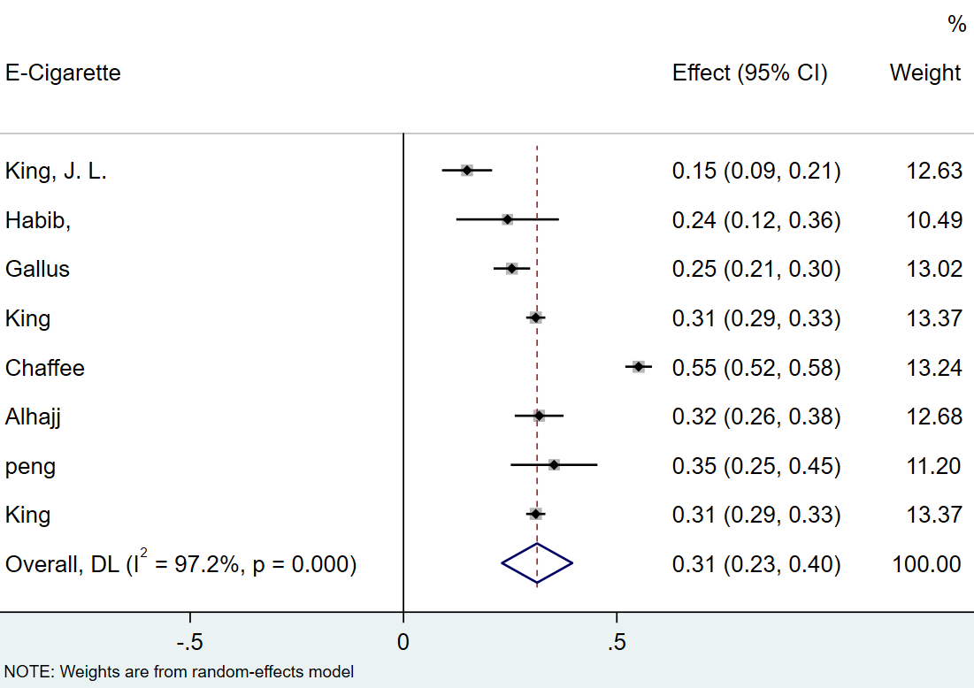
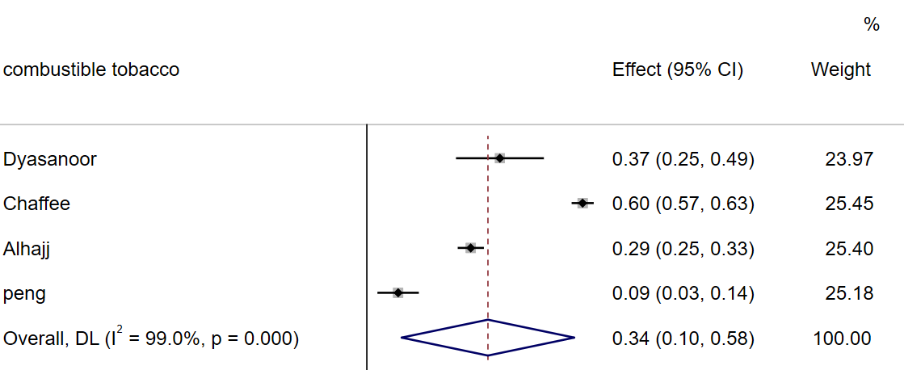

Fig 1. The effect Size and 95%CI of included studies based on Type of Smoking

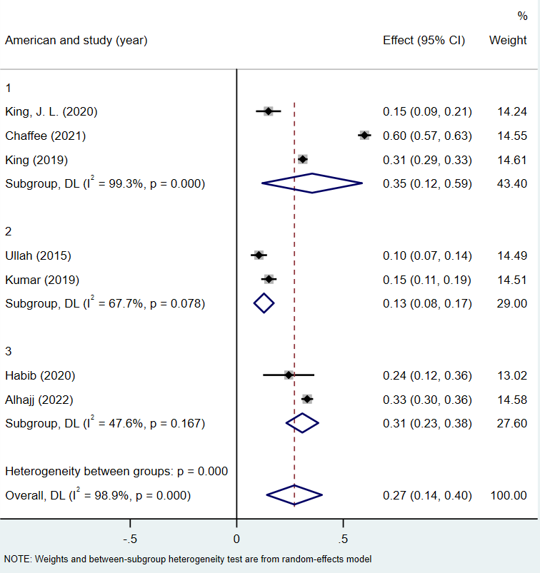

Fig 2. The effect Size and 95%CI of included studies based on Country

1: American;2: Pakistan;3: Saudi.

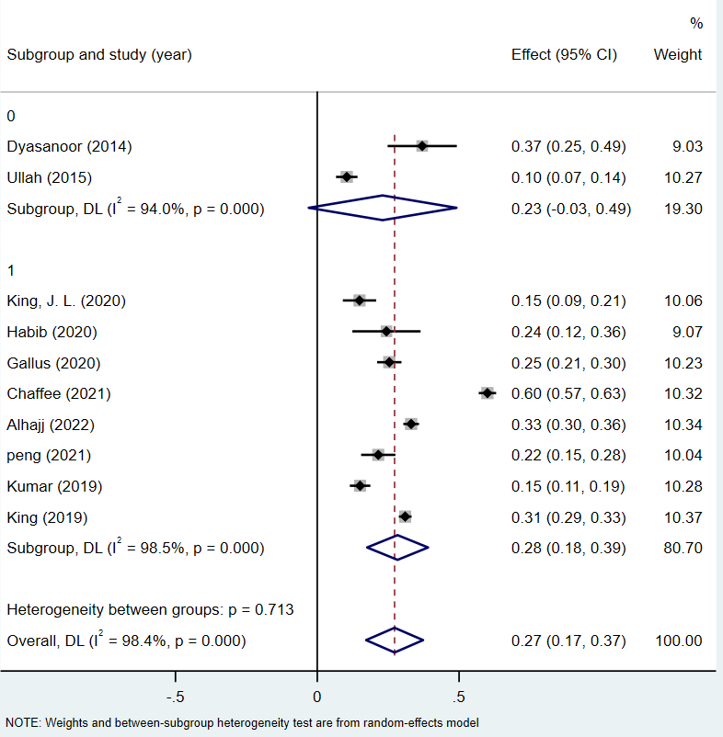
Fig 3. The effect Size and 95%CI of included studies based on Year of publication

0: 2014~2017;1: 2018～2022

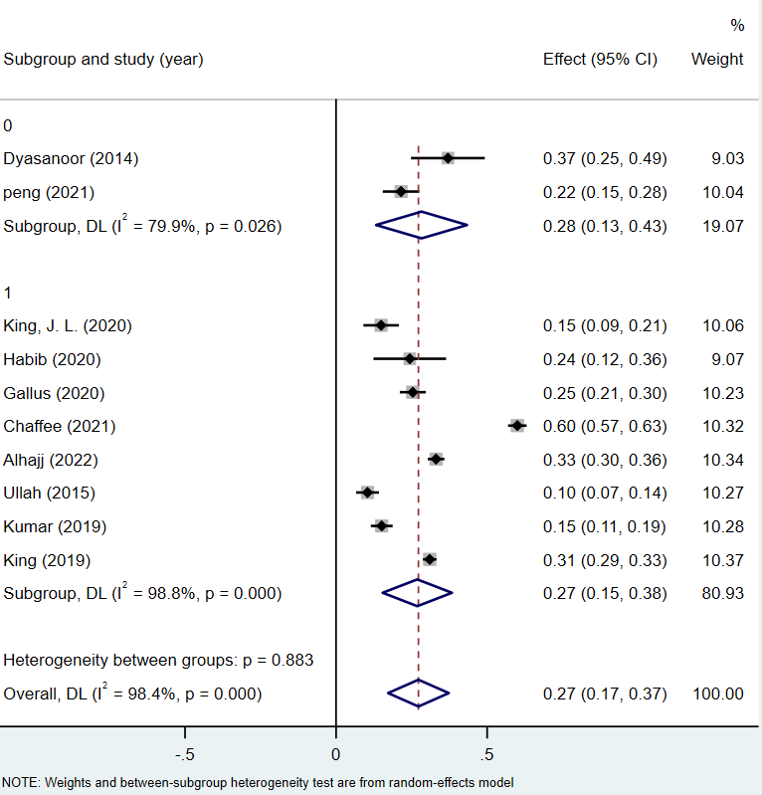

Fig 4. The effect Size and 95%CI of included studies based on Design
0:Case-control study;1:Cross-sectional studies.

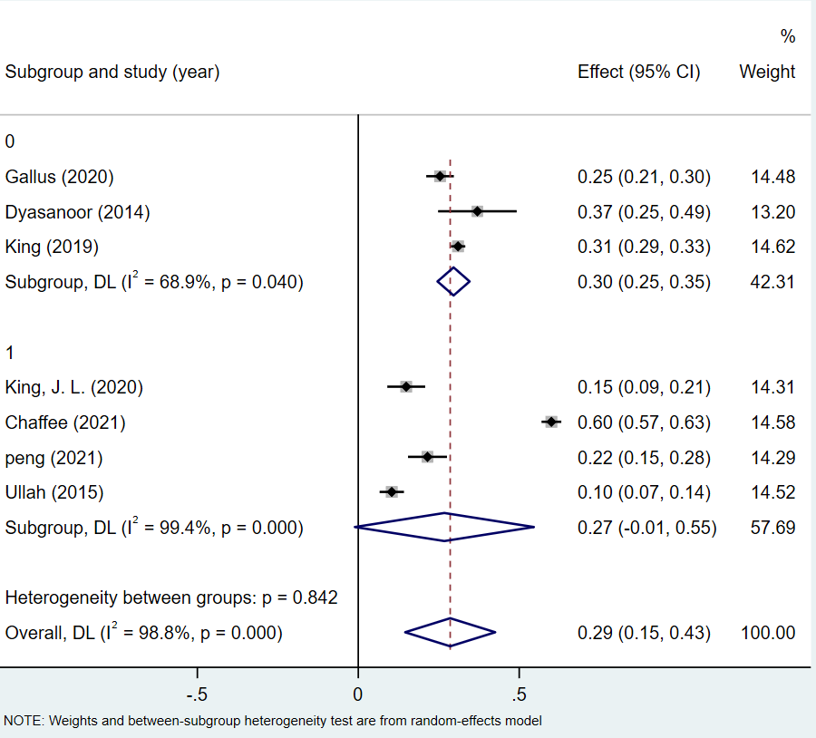

Fig 4. The effect Size and 95%CI of included studies based on Age
0:≥35;1:≤25

