Supplemental File S1
Identifying morphs of the Asian Hornet (Vespa velutina) and other of pests of quarantine importance with geometric morphometrics

Allan H. Smith-Pardo, PhD.
Biological Scientist
USDA-APHIS- Plant Protection and Quarantine (PPQ)
Science and Technology (S&T), Identification Technology Program (ITP)
801 I St. Suite 406, Sacramento, CA. 95814
allan.h.smith-pardo@usda.gov

P. David Polly, PhD.
Earth and Atmospheric Sciences, Biology, and Anthropology
Indiana University
1001 E. 10th Street
Bloomington, IN 47405
pdpolly@indiana.edu

Contents
Supplemental Figures
Figure S1.1: Procrustes superimposition. 3
Figure S1.2: Observed vs. Expected Distributions. 4
Figure S1.3: Morphospace (PCs 1 & 2). 5
Figure S1.4: Morphospace (PCs 1 & 3). 6
Figure S1.5: Morphospace (PCs 1 & 4). 7
Figure S1.6: Variance explained by principal component axes. 8
Supplemental Tables
Table S1.1: Principal component analysis summary. 9
Specimen List 11

Supplemental Figures

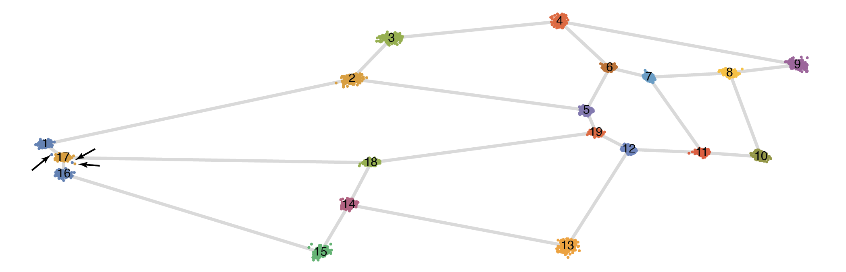

Figure S1.1: Procrustes superimposition.
This figure shows Procrustes superimposition of all specimens. The superimposed landmarks are shown as scatterplots over a wire frame representing the mean shape of the sample. Arrows point to three outlying landmarks on the specimen V-veluti-ardens-Indo-Perr-0043 where points 16 and 17 cross in a biologically implausible manner. This specimen was discarded from subsequent analyses.
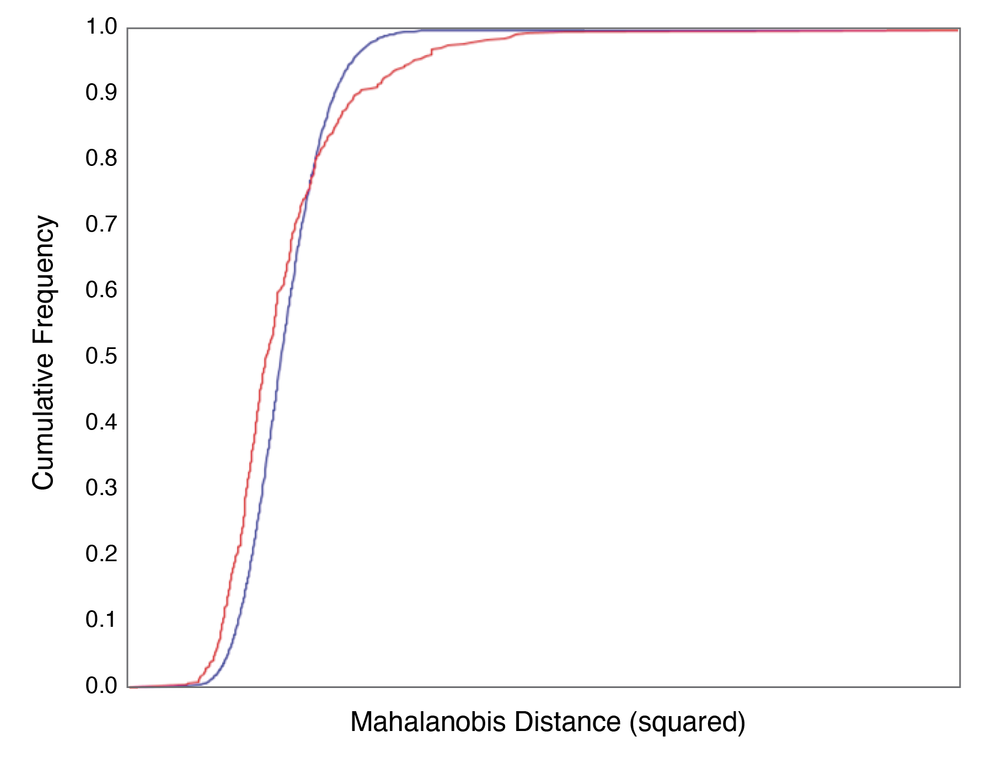
Figure S1.2: Observed vs. Expected Distributions. Blue curve shows expected cumulative distribution of Mahalanobis distance between the grand mean and individual Procrustes superimposed landmarks for the complete data set compared to the actual distribution in red. The shape of the red curve that a small number of unexpectedly distant shapes. The specimen V-veluti-ardens-Indo-Perr-0043 was found to have unusual placement of landmarks 1, 16 and 17 and was discarded from subsequent analyses. Outlier inspection was carried out in MorphoJ.
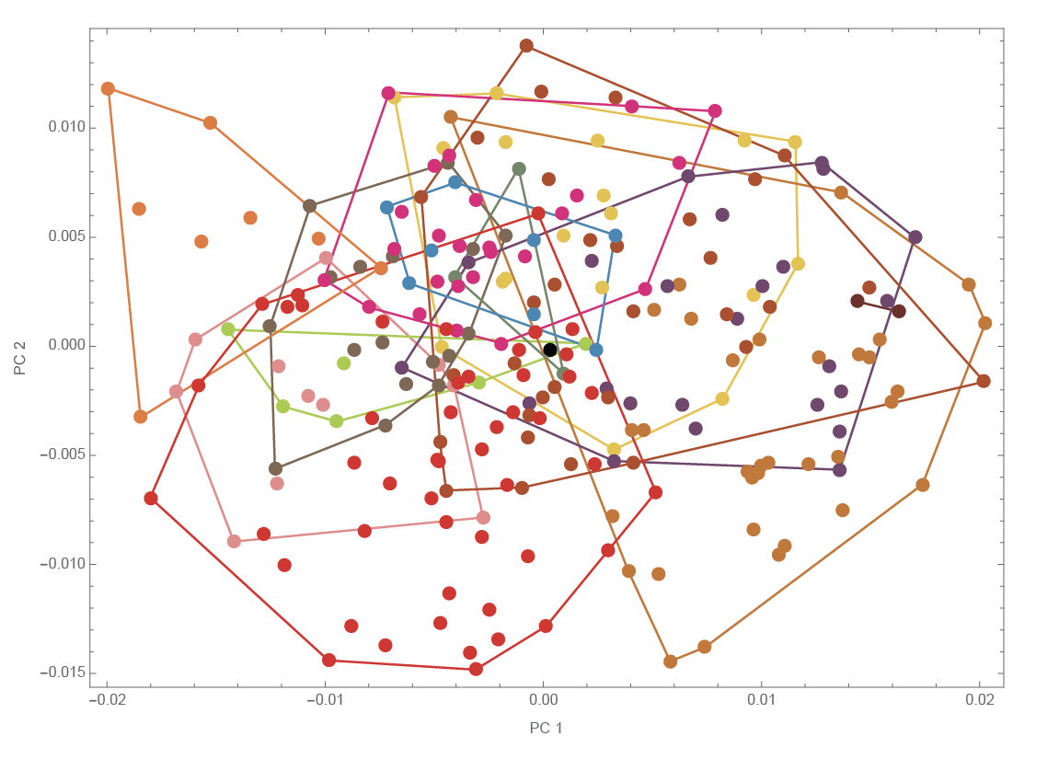
Figure S1.3: Morphospace (PCs 1 & 2). First two principal components of the forewing shape morphospace showing all individuals. Color scheme and groupings same as in Figure 4.
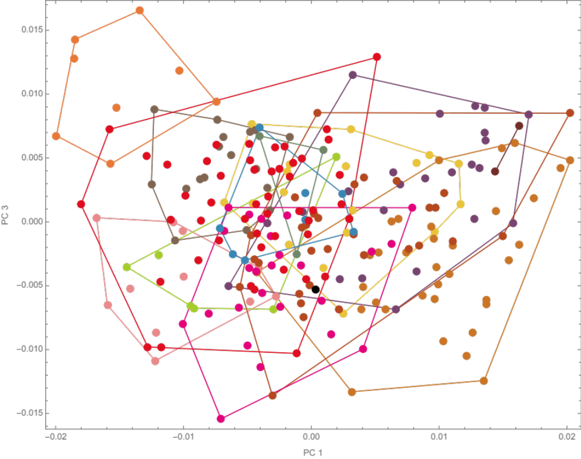
Figure S1.4: Morphospace (PCs 1 & 3). First and third principal components of the forewing shape morphospace showing all individuals. Color scheme and groupings same as in Figure 4.
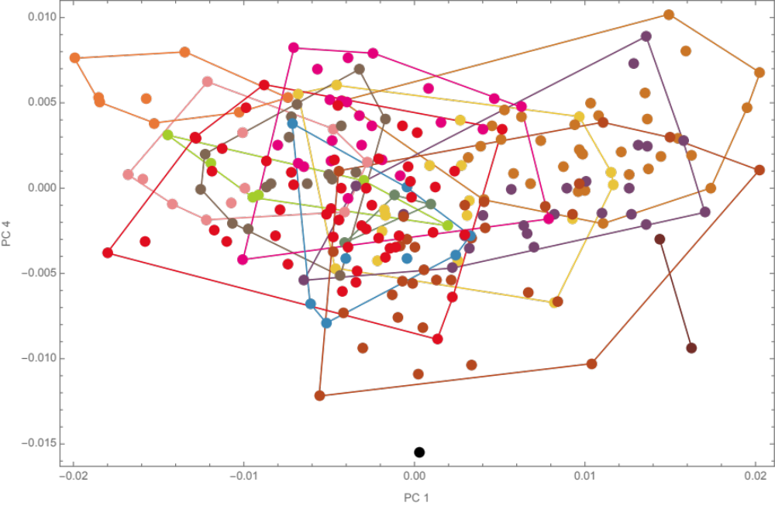
Figure S1.5: Morphospace (PCs 1 & 4). First and fourth principal components of the forewing shape morphospace showing all individuals. Color scheme and groupings same as in Figure 4.

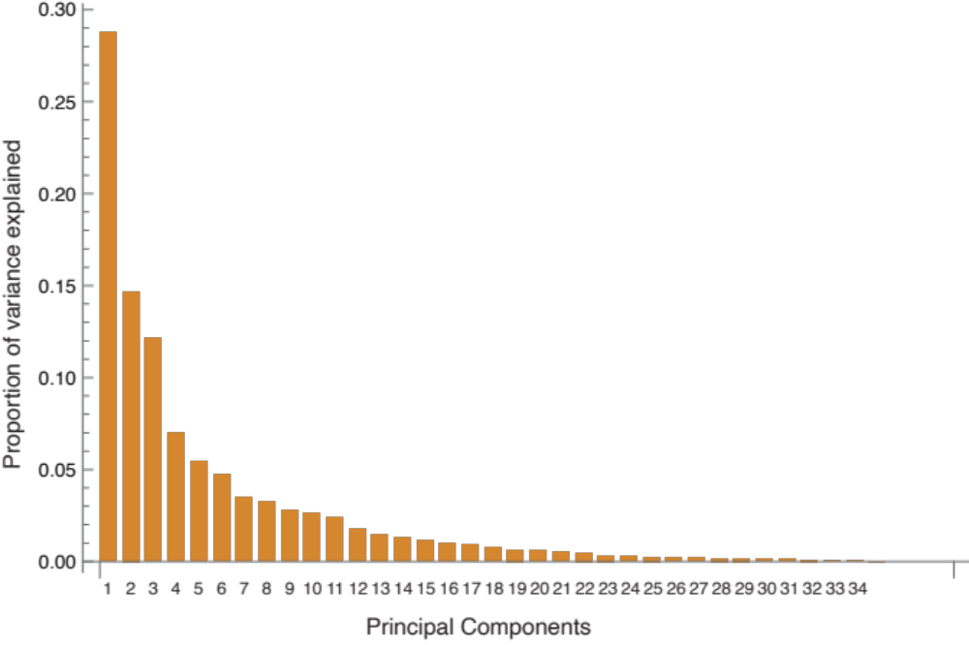
Figure S1.6: Variance explained by principal component axes. Bar chart showing the proportion of variance explained by each of 34 non-zero principal components.

Supplemental Tables

PC | Eigenvalue | Variance Explained | Cumulative Variance Explained
1 | 0.0000728 | 28.8% | 28.8%
2 | 0.0000371 | 14.7% | 43.5%
3 | 0.0000308 | 12.2% | 55.6%
4 | 0.0000177 | 7.0% | 62.6%
5 | 0.0000137 | 5.4% | 68.1%
6 | 0.0000120 | 4.7% | 72.8%
7 | 0.0000089 | 3.5% | 76.3%
8 | 0.0000082 | 3.3% | 79.6%
9 | 0.0000071 | 2.8% | 82.4%
10 | 0.0000067 | 2.6% | 85.0%
11 | 0.0000060 | 2.4% | 87.4%
12 | 0.0000045 | 1.8% | 89.2%
13 | 0.0000037 | 1.5% | 90.6%
14 | 0.0000033 | 1.3% | 92.0%
15 | 0.0000028 | 1.1% | 93.1%
16 | 0.0000025 | 1.0% | 94.1%
17 | 0.0000023 | 0.9% | 95.0%
18 | 0.0000020 | 0.8% | 95.7%
19 | 0.0000016 | 0.6% | 96.4%
20 | 0.0000014 | 0.6% | 97.0%
21 | 0.0000013 | 0.5% | 97.5%
22 | 0.0000012 | 0.5% | 97.9%
23 | 0.0000008 | 0.3% | 98.3%
24 | 0.0000007 | 0.3% | 98.5%
25 | 0.0000006 | 0.2% | 98.8%
26 | 0.0000006 | 0.2% | 99.0%
27 | 0.0000005 | 0.2% | 99.2%
28 | 0.0000004 | 0.2% | 99.4%
29 | 0.0000004 | 0.2% | 99.5%
30 | 0.0000003 | 0.1% | 99.7%
31 | 0.0000003 | 0.1% | 99.8%
32 | 0.0000002 | 0.1% | 99.9%
33 | 0.0000002 | 0.1% | 99.9%
34 | 0.0000001 | 0.1% | 100.0%
35 | 0.0000000 | 0.0% | 100.0%
36 | 0.0000000 | 0.0% | 100.0%
37 | 0.0000000 | 0.0% | 100.0%
38 | 0.0000000 | 0.0% | 100.0%

Table S1.1: Principal component analysis summary. For each of 34 non-zero principal components, the eigenvalue (variance in Procrustes units) is reported along with the percentage of the total shape variance it explains and the cumulative variance explained by it and lower PCs.

Specimen List
ID | Morph Name | Location | Collection | Number
V-veluti-ardens-Indo-Perr-0016 | ardens | Indonesia | Perr | 0016
V-veluti-ardens-Indo-Perr-0017 | ardens | Indonesia | Perr | 0017
V-veluti-ardens-Indo-Perr-0018 | ardens | Indonesia | Perr | 0018
V-veluti-ardens-Indo-Perr-0019 | ardens | Indonesia | Perr | 0019
V-veluti-ardens-Indo-Perr-0020 | ardens | Indonesia | Perr | 0020
V-veluti-ardens-Indo-Perr-0021 | ardens | Indonesia | Perr | 0021
V-veluti-ardens-Indo-Perr-0022 | ardens | Indonesia | Perr | 0022
V-veluti-ardens-Indo-Perr-0023 | ardens | Indonesia | Perr | 0023
V-veluti-ardens-Indo-Perr-0024 | ardens | Indonesia | Perr | 0024
V-veluti-ardens-Indo-Perr-0025 | ardens | Indonesia | Perr | 0025
V-veluti-ardens-Asia-Perr-0026 | ardens | Asia | Perr | 0026
V-veluti-ardens-Indo-Perr-0027 | ardens | Indonesia | Perr | 0027
V-veluti-ardens-NDet-Perr-0028 | ardens | Unknown | Perr | 0028
V-veluti-ardens-Indo-Perr-0029 | ardens | Indonesia | Perr | 0029
V-veluti-ardens-Indo-Perr-0030 | ardens | Indonesia | Perr | 0030
V-veluti-ardens-Indo-Perr-0031 | ardens | Indonesia | Perr | 0031
V-veluti-ardens-Indo-Perr-0023 | ardens | Indonesia | Perr | 0023
V-veluti-ardens-Indo-Perr-0009 | ardens | Indonesia | Perr | 0009
V-veluti-ardens-Indo-Perr-0010 | ardens | Indonesia | Perr | 0010
V-veluti-ardens-Indo-Perr-0011 | ardens | Indonesia | Perr | 0011
V-veluti-ardens-Indo-Perr-0012 | ardens | Indonesia | Perr | 0012
V-veluti-ardens-Indo-Perr-0013 | ardens | Indonesia | Perr | 0013
V-veluti-ardens-Indo-Perr-0014 | ardens | Indonesia | Perr | 0014
V-veluti-ardens-Indo-Perr-0015 | ardens | Indonesia | Perr | 0015
V-veluti-ardens-Indo-Perr-0016 | ardens | Indonesia | Perr | 0016
V-veluti-ardens-Indo-Perr-0017 | ardens | Indonesia | Perr | 0017
V-veluti-ardens-Indo-Perr-0018 | ardens | Indonesia | Perr | 0018
V-veluti-ardens-Indo-Perr-0019 | ardens | Indonesia | Perr | 0019
V-veluti-ardens-Indo-Perr-0005 | ardens | Indonesia | Perr | 0005
V-veluti-ardens-Indo-Perr-0006 | ardens | Indonesia | Perr | 0006
V-veluti-ardens-Indo-Perr-0043 | ardens | Indonesia | Perr | 0043
V-veluti-ardens-Indo-Perr-0158 | ardens | Indonesia | Perr | 0158
V-veluti-ardens-Indo-Perr-0159 | ardens | Indonesia | Perr | 0159
V-veluti-ardens-Indo-Perr-0261 | ardens | Indonesia | Perr | 0261
V-veluti-ardens-Indo-Perr-0262 | ardens | Indonesia | Perr | 0262
V-veluti-ardens-Indo-Perr-0263 | ardens | Indonesia | Perr | 0263
V-veluti-aurari-Eind-Perr-0002 | auraria | Kashmir | Perr | 0002
V-veluti-aurari-Indi-Perr-0003 | auraria | India | Perr | 0003
V-veluti-aurari-Indi-Perr-0004 | auraria | India | Perr | 0004
V-veluti-aurari-Indi-Perr-0012 | auraria | India | Perr | 0012
V-veluti-aurari-Indi-Perr-0013 | auraria | India | Perr | 0013
V-veluti-aurari-Nepa-Perr-0014 | auraria | Nepal | Perr | 0014
V-veluti-aurari-Indi-Perr-0040 | auraria | India | Perr | 0040
V-veluti-aurari-Nepa-Perr-0088 | auraria | Nepal | Perr | 0088
V-veluti-aurari-Nepa-Perr-0089 | auraria | Nepal | Perr | 0089
V-veluti-aurari-Indi-Perr-0092 | auraria | India | Perr | 0092
V-veluti-aurari-Nepa-Perr-0093 | auraria | Nepal | Perr | 0093
V-veluti-aurari-Indi-Perr-0094 | auraria | India | Perr | 0094
V-veluti-aurari-Chin-Perr-0095 | auraria | China | Perr | 0095
V-veluti-aurari-Nepa-Perr-0096 | auraria | Nepal | Perr | 0096
V-veluti-aurari-Nepa-Perr-0099 | auraria | Nepal | Perr | 0099
V-veluti-aurari-Indi-Perr-0100 | auraria | India | Perr | 0100
V-veluti-aurari-Nepa-Perr-0103 | auraria | Nepal | Perr | 0103
V-veluti-aurari-Nepa-Perr-0104 | auraria | Nepal | Perr | 0104
V-veluti-aurari-Indi-Perr-0105 | auraria | India | Perr | 0105
V-veluti-aurari-Indi-Perr-0106 | auraria | India | Perr | 0106
V-veluti-aurari-Indi-Perr-0107 | auraria | India | Perr | 0107
V-veluti-aurari-Indi-Perr-0108 | auraria | India | Perr | 0108
V-veluti-aurari-Indi-Perr-0109 | auraria | India | Perr | 0109
V-veluti-aurari-Nepa-Perr-0157 | auraria | Nepal | Perr | 0157
V-veluti-aurari-Nepa-Perr-0158 | auraria | Nepal | Perr | 0158
V-veluti-aurari-Nepa-Perr-0159 | auraria | Nepal | Perr | 0159
V-veluti-aurari-Nepa-Perr-0160 | auraria | Nepal | Perr | 0160
V-veluti-aurari-Nepa-Perr-0161 | auraria | Nepal | Perr | 0161
V-veluti-aurari-Burm-Perr-0166 | auraria | Burma | Perr | 0166
V-veluti-aurari-Nepa-Perr-0167 | auraria | Nepal | Perr | 0167
V-veluti-aurari-Nepa-Perr-0168 | auraria | Nepal | Perr | 0168
V-veluti-aurari-Nepa-Perr-0157 | auraria | Nepal | Perr | 0157
V-veluti-aurari-Bhut-Perr-0168 | auraria | Bhutan | Perr | 0168
V-veluti-aurari-Indi-Perr-0196 | auraria | India | Perr | 0196
V-veluti-aurari-Indi-Perr-0197 | auraria | India | Perr | 0197
V-veluti-aurari-Indi-Perr-0198 | auraria | India | Perr | 0198
V-veluti-aurari-Chin-Perr-0199 | auraria | China | Perr | 0199
V-veluti-aurari-Bhut-Perr-0200 | auraria | Bhutan | Perr | 0200
V-veluti-aurari-Chin-Perr-0201 | auraria | China | Perr | 0201
V-veluti-aurari-Chin-Perr-0202 | auraria | China | Perr | 0202
V-veluti-aurari-Chin-Perr-0203 | auraria | China | Perr | 0203
V-veluti-aurari-Bhut-Perr-0204 | auraria | Bhutan | Perr | 0204
V-veluti-aurari-Chin-Perr-0205 | auraria | China | Perr | 0205
V-veluti-aurari-Chin-Perr-0206 | auraria | China | Perr | 0206
V-veluti-aurari-Chin-Perr-0207 | auraria | China | Perr | 0207
V-veluti-aurari-Indi-Perr-0208 | auraria | India | Perr | 0208
V-veluti-aurari-Chin-Perr-0209 | auraria | China | Perr | 0209
V-veluti-aurari-Chin-Perr-0210 | auraria | China | Perr | 0210
V-veluti-aurari-Chin-Perr-0211 | auraria | China | Perr | 0211
V-veluti-aurari-Indi-Perr-0212 | auraria | India | Perr | 0212
V-veluti-aurari-Chin-Perr-0213 | auraria | China | Perr | 0213
V-veluti-aurari-Chin-Perr-0214 | auraria | China | Perr | 0214
V-veluti-aurari-Chin-Perr-0215 | auraria | China | Perr | 0215
V-veluti-aurari-Chin-Perr-0216 | auraria | China | Perr | 0216
V-veluti-aurari-Indi-Perr-0217 | auraria | India | Perr | 0217
V-veluti-aurari-Chin-Perr-0024 | auraria | China | Perr | 0024
V-veluti-aurari-Chin-Perr-0025 | auraria | China | Perr | 0025
V-veluti-aurari-Nepa-Perr-0311 | auraria | Nepal | Perr | 0311
V-veluti-aurari-Nepa-Perr-0312 | auraria | Nepal | Perr | 0312
V-veluti-celebe-Sulaw-Perr-0032 | celebensis | Sulawesi | Perr | 0032
V-veluti-celebe-Indo-Perr-0016 | celebensis | Indonesia | Perr | 0016
V-veluti-celebe-Indo-Perr-0017 | celebensis | Indonesia | Perr | 0017
V-veluti-celebe-Indo-Perr-0018 | celebensis | Indonesia | Perr | 0018
V-veluti-celebe-Indo-Perr-0019 | celebensis | Indonesia | Perr | 0019
V-veluti-celebe-Indo-Perr-0258 | celebensis | Indonesia | Perr | 0258
V-veluti-diverg-Mala-Perr-0010 | divergens | Malaysia | Perr | 0010
V-veluti-diverg-Mala-Perr-0020 | divergens | Malaysia | Perr | 0020
V-veluti-diverg-Mala-Perr-0021 | divergens | Malaysia | Perr | 0021
V-veluti-diverg-Mala-Perr-0022 | divergens | Malaysia | Perr | 0022
V-veluti-diverg-Mala-Perr-0023 | divergens | Malaysia | Perr | 0023
V-veluti-diverg-Mala-Perr-0024 | divergens | Malaysia | Perr | 0024
V-veluti-diverg-Mala-Perr-0025 | divergens | Malaysia | Perr | 0025
V-veluti-diverg-Mala-Perr-0031 | divergens | Malaysia | Perr | 0031
V-veluti-diverg-Mala-Perr-0115 | divergens | Malaysia | Perr | 0115
V-veluti-diverg-Mala-Perr-0116 | divergens | Malaysia | Perr | 0116
V-veluti-diverg-Mala-Perr-0117 | divergens | Malaysia | Perr | 0117
V-veluti-diverg-Mala-Perr-0118 | divergens | Malaysia | Perr | 0118
V-veluti-diverg-Mala-Perr-0119 | divergens | Malaysia | Perr | 0119
V-veluti-diverg-Mala-Perr-0120 | divergens | Malaysia | Perr | 0120
V-veluti-diverg-Mala-Perr-0121 | divergens | Malaysia | Perr | 0121
V-veluti-diverg-Mala-Perr-0122 | divergens | Malaysia | Perr | 0122
V-veluti-diverg-Mala-Perr-0123 | divergens | Malaysia | Perr | 0123
V-veluti-diverg-Mala-Perr-0124 | divergens | Malaysia | Perr | 0124
V-veluti-diverg-Mala-Perr-0125 | divergens | Malaysia | Perr | 0125
V-veluti-diverg-Mala-Perr-0126 | divergens | Malaysia | Perr | 0126
V-veluti-diverg-Mala-Perr-0146 | divergens | Malaysia | Perr | 0146
V-veluti-diverg-Mala-Perr-0147 | divergens | Malaysia | Perr | 0147
V-veluti-diverg-Mala-Perr-0148 | divergens | Malaysia | Perr | 0148
V-veluti-diverg-Mala-Perr-0149 | divergens | Malaysia | Perr | 0149
V-veluti-diverg-Mala-Perr-0150 | divergens | Malaysia | Perr | 0150
V-veluti-diverg-Mala-Perr-0151 | divergens | Malaysia | Perr | 0151
V-veluti-diverg-Mala-Perr-0152 | divergens | Malaysia | Perr | 0152
V-veluti-diverg-Mala-Perr-0153 | divergens | Malaysia | Perr | 0153
V-veluti-diverg-Mala-Perr-0154 | divergens | Malaysia | Perr | 0154
V-veluti-diverg-Mala-Perr-0164 | divergens | Malaysia | Perr | 0164
V-veluti-diverg-Mala-Perr-0119 | divergens | Malaysia | Perr | 0119
V-veluti-diverg-Mala-Perr-0120 | divergens | Malaysia | Perr | 0120
V-veluti-diverg-Mala-Perr-0121 | divergens | Malaysia | Perr | 0121
V-veluti-diverg-Mala-Perr-0167 | divergens | Malaysia | Perr | 0167
V-veluti-flavit-Chin-Perr-0155 | flavitarus | China | Perr | 0155
V-veluti-flavit-Chin-Perr-0156 | flavitarus | China | Perr | 0156
V-veluti-flores-Indo-Perr-0062 | floresiana | Indonesia | Perr | 0062
V-veluti-flores-Indo-Perr-0063 | floresiana | Indonesia | Perr | 0063
V-veluti-flores-Indo-Perr-0064 | floresiana | Indonesia | Perr | 0064
V-veluti-flores-Indo-Perr-0065 | floresiana | Indonesia | Perr | 0065
V-veluti-flores-Indo-Perr-0008 | floresiana | Indonesia | Perr | 0008
V-veluti-flores-Indo-Perr-0027 | floresiana | Indonesia | Perr | 0027
V-veluti-flores-Indo-Perr-0030 | floresiana | Indonesia | Perr | 0030
V-veluti-flores-Indo-Perr-0044 | floresiana | Indonesia | Perr | 0044
V-veluti-flores-Indo-Perr-0122 | floresiana | Indonesia | Perr | 0122
V-veluti-flores-Indo-Perr-0123 | floresiana | Indonesia | Perr | 0123
V-veluti-flores-Indo-Perr-0124 | floresiana | Indonesia | Perr | 0124
V-veluti-flores-Indo-Perr-0125 | floresiana | Indonesia | Perr | 0125
V-veluti-flores-Indo-Perr-0231 | floresiana | Indonesia | Perr | 0231
V-veluti-flores-Indo-Perr-0232 | floresiana | Indonesia | Perr | 0232
V-veluti-flores-Indo-Perr-0233 | floresiana | Indonesia | Perr | 0233
V-veluti-flores-Indo-Perr-0234 | floresiana | Indonesia | Perr | 0234
V-veluti-flores-Indo-Perr-0235 | floresiana | Indonesia | Perr | 0235
V-veluti-flores-Indo-Perr-0236 | floresiana | Indonesia | Perr | 0236
V-veluti-flores-Indo-Perr-0237 | floresiana | Indonesia | Perr | 0237
V-veluti-flores-Indo-Perr-0238 | floresiana | Indonesia | Perr | 0238
V-veluti-flores-Indo-Perr-0239 | floresiana | Indonesia | Perr | 0239
V-veluti-karnyi-Indo-Perr-0045 | karnyi | Indonesia | Perr | 0045
V-veluti-karnyi-Indo-Perr-0046 | karnyi | Indonesia | Perr | 0046
V-veluti-karnyi-Indo-Perr-0047 | karnyi | Indonesia | Perr | 0047
V-veluti-karnyi-Indo-Perr-0048 | karnyi | Indonesia | Perr | 0048
V-veluti-karnyi-Indo-Perr-0049 | karnyi | Indonesia | Perr | 0049
V-veluti-karnyi-Indo-Perr-0050 | karnyi | Indonesia | Perr | 0050
V-veluti-karnyi-Indo-Perr-0051 | karnyi | Indonesia | Perr | 0051
V-veluti-karnyi-Indo-Perr-0052 | karnyi | Indonesia | Perr | 0052
V-veluti-karnyi-Indo-Perr-0032 | karnyi | Indonesia | Perr | 0032
V-veluti-karnyi-Indo-Perr-0033 | karnyi | Indonesia | Perr | 0033
V-veluti-karnyi-Indo-Perr-0039 | karnyi | Indonesia | Perr | 0039
V-veluti-karnyi-Indo-Perr-0110 | karnyi | Indonesia | Perr | 0110
V-veluti-karnyi-Indo-Perr-0111 | karnyi | Indonesia | Perr | 0111
V-veluti-karnyi-Indo-Perr-0112 | karnyi | Indonesia | Perr | 0112
V-veluti-karnyi-Indo-Perr-0113 | karnyi | Indonesia | Perr | 0113
V-veluti-karnyi-Indo-Perr-0114 | karnyi | Indonesia | Perr | 0114
V-veluti-karnyi-Indo-Perr-0126 | karnyi | Indonesia | Perr | 0126
V-veluti-karnyi-Indo-Perr-0127 | karnyi | Indonesia | Perr | 0127
V-veluti-karnyi-Indo-Perr-0128 | karnyi | Indonesia | Perr | 0128
V-veluti-karnyi-Indo-Perr-0129 | karnyi | Indonesia | Perr | 0129
V-veluti-karnyi-Indo-Perr-0130 | karnyi | Indonesia | Perr | 0130
V-veluti-karnyi-Indo-Perr-0162 | karnyi | Indonesia | Perr | 0162
V-veluti-karnyi-Indo-Perr-0165 | karnyi | Indonesia | Perr | 0165
V-veluti-karnyi-Indo-Perr-0166 | karnyi | Indonesia | Perr | 0166
V-veluti-nigrit-Chin-Perr-0260 | nigrithorax | China | Perr | 0260
V-veluti-nigrit-Chin-Perr-0000 | nigrithorax | China | Perr | 0000
V-veluti-nigrit-Chin-Perr-0001 | nigrithorax | China | Perr | 0001
V-veluti-nigrit-Chin-Perr-0002 | nigrithorax | China | Perr | 0002
V-veluti-nigrit-Chin-Perr-0003 | nigrithorax | China | Perr | 0003
V-veluti-nigrit-Chin-Perr-0004 | nigrithorax | China | Perr | 0004
V-veluti-nigrit-Chin-Perr-0005 | nigrithorax | China | Perr | 0005
V-veluti-nigrit-Chin-Perr-0006 | nigrithorax | China | Perr | 0006
V-veluti-nigrit-Chin-Perr-0007 | nigrithorax | China | Perr | 0007
V-veluti-nigrit-Chin-Perr-0008 | nigrithorax | China | Perr | 0008
V-veluti-nigrit-Chin-Perr-0009 | nigrithorax | China | Perr | 0009
V-veluti-nigrit-Chin-Perr-0010 | nigrithorax | China | Perr | 0010
V-veluti-nigrit-Chin-Perr-0011 | nigrithorax | China | Perr | 0011
V-veluti-nigrit-Chin-Perr-0012 | nigrithorax | China | Perr | 0012
V-veluti-nigrit-Chin-Perr-0013 | nigrithorax | China | Perr | 0013
V-veluti-nigrit-Chin-Perr-0000 | nigrithorax | China | Perr | 0000
V-veluti-nigrit-Chin-Perr-0001 | nigrithorax | China | Perr | 0001
V-veluti-nigrit-Chin-Perr-0002 | nigrithorax | China | Perr | 0002
V-veluti-nigrit-Chin-Perr-0003 | nigrithorax | China | Perr | 0003
V-veluti-nigrit-Chin-Perr-0004 | nigrithorax | China | Perr | 0004
V-veluti-nigrit-Chin-Perr-0005 | nigrithorax | China | Perr | 0005
V-veluti-nigrit-Chin-Perr-0006 | nigrithorax | China | Perr | 0006
V-veluti-nigrit-Chin-Perr-0007 | nigrithorax | China | Perr | 0007
V-veluti-nigrit-Chin-Perr-0008 | nigrithorax | China | Perr | 0008
V-veluti-nigrit-Chin-Perr-0009 | nigrithorax | China | Perr | 0009
V-veluti-nigrit-Chin-Perr-0010 | nigrithorax | China | Perr | 0010
V-veluti-nigrit-Chin-Perr-0011 | nigrithorax | China | Perr | 0011
V-veluti-nigrit-Chin-Perr-0012 | nigrithorax | China | Perr | 0012
V-veluti-nigrit-Chin-Perr-0013 | nigrithorax | China | Perr | 0013
V-veluti-nigrit-Chin-Perr-0014 | nigrithorax | China | Perr | 0014
V-veluti-nigrit-Chin-Perr-0015 | nigrithorax | China | Perr | 0015
V-veluti-nigrit-Chin-Perr-0016 | nigrithorax | China | Perr | 0016
V-veluti-nigrit-Chin-Perr-0017 | nigrithorax | China | Perr | 0017
V-veluti-nigrit-Chin-Perr-0018 | nigrithorax | China | Perr | 0018
V-veluti-nigrit-Chin-Perr-0019 | nigrithorax | China | Perr | 0019
V-veluti-nigrit-Chin-Perr-0020 | nigrithorax | China | Perr | 0020
V-veluti-nigrit-Chin-Perr-0021 | nigrithorax | China | Perr | 0021
V-veluti-nigrit-Chin-Perr-0022 | nigrithorax | China | Perr | 0022
V-veluti-nigrit-Chin-Perr-0023 | nigrithorax | China | Perr | 0023
V-veluti-pruthi-Indi-Perr-0035 | pruthii | India | Perr | 0035
V-veluti-pruthi-Indi-Perr-0036 | pruthii | India | Perr | 0036
V-veluti-pruthi-Indi-Perr-0037 | pruthii | India | Perr | 0037
V-veluti-pruthi-Indi-Perr-0090 | pruthii | India | Perr | 0090
V-veluti-pruthi-Afgh-Perr-0091 | pruthii | Afghanistan | Perr | 0091
V-veluti-pruthi-Indi-Perr-0132 | pruthii | India | Perr | 0132
V-veluti-sumban-Indo-Perr-0066 | sumbana | Indonesia | Perr | 0066
V-veluti-sumban-Indo-Perr-0067 | sumbana | Indonesia | Perr | 0067
V-veluti-sumban-Indo-Perr-0068 | sumbana | Indonesia | Perr | 0068
V-veluti-sumban-Indo-Perr-0011 | sumbana | Indonesia | Perr | 0011
V-veluti-sumban-Indo-Perr-0026 | sumbana | Indonesia | Perr | 0026
V-veluti-sumban-Indo-Perr-0028 | sumbana | Indonesia | Perr | 0028
V-veluti-sumban-Indo-Perr-0029 | sumbana | Indonesia | Perr | 0029
V-veluti-sumban-Indo-Perr-0042 | sumbana | Indonesia | Perr | 0042
V-veluti-Nsubsp-Indo-Perr-0169 | new morph? | Indonesia | Perr | 0169
V-veluti-sumban-Indo-Perr-0133 | sumbana | Indonesia | Perr | 0133
V-veluti-sumban-Indo-Perr-0134 | sumbana | Indonesia | Perr | 0134
V-veluti-sumban-Indo-Perr-0135 | sumbana | Indonesia | Perr | 0135
V-veluti-sumban-Indo-Perr-0136 | sumbana | Indonesia | Perr | 0136
V-veluti-sumban-Indo-Perr-0137 | sumbana | Indonesia | Perr | 0137
V-veluti-sumban-Indo-Perr-0138 | sumbana | Indonesia | Perr | 0138
V-veluti-sumban-Indo-Perr-0139 | sumbana | Indonesia | Perr | 0139
V-veluti-sumban-Indo-Perr-0140 | sumbana | Indonesia | Perr | 0140
V-veluti-sumban-Indo-Perr-0141 | sumbana | Indonesia | Perr | 0141
V-veluti-sumban-Indo-Perr-0142 | sumbana | Indonesia | Perr | 0142
V-veluti-sumban-Indo-Perr-0143 | sumbana | Indonesia | Perr | 0143
V-veluti-sumban-Indo-Perr-0144 | sumbana | Indonesia | Perr | 0144
V-veluti-sumban-Indo-Perr-0145 | sumbana | Indonesia | Perr | 0145
V-veluti-sumban-Indo-Perr-0146 | sumbana | Indonesia | Perr | 0146
V-veluti-sumban-Indo-Perr-0147 | sumbana | Indonesia | Perr | 0147
V-veluti-sumban-Indo-Perr-0148 | sumbana | Indonesia | Perr | 0148
V-veluti-sumban-Indo-Perr-0259 | sumbana | Indonesia | Perr | 0259
V-veluti-timore-Indo-Perr-0069 | timorensis | Indonesia | Perr | 0069
V-veluti-timore-Indo-Perr-0070 | timorensis | Indonesia | Perr | 0070
V-veluti-timore-Indo-Perr-0071 | timorensis | Indonesia | Perr | 0071
V-veluti-timore-Indo-Perr-0072 | timorensis | Indonesia | Perr | 0072
V-veluti-timore-Indo-Perr-0073 | timorensis | Indonesia | Perr | 0073
V-veluti-timore-Indo-Perr-0149 | timorensis | Indonesia | Perr | 0149
V-veluti-timore-Indo-Perr-0150 | timorensis | Indonesia | Perr | 0150
V-veluti-timore-Indo-Perr-0151 | timorensis | Indonesia | Perr | 0151
V-veluti-varian-Laos-Perr-0024 | variana | Laos | Perr | 0024
V-veluti-varian-Laos-Perr-0025 | variana | Laos | Perr | 0025
V-veluti-varian-Laos-Perr-0000 | variana | Laos | Perr | 0000
V-veluti-varian-Laos-Perr-0001 | variana | Laos | Perr | 0001
V-veluti-varian-Vietn-Perr-0002 | variana | North Vietnam | Perr | 0002
V-veluti-varian-Myan-Perr-0009 | variana | Myanmar | Perr | 0009
V-veluti-varian-Myan-Perr-0015 | variana | Myanmar | Perr | 0015
V-veluti-varian-Thai-Perr-0038 | variana | Thailand | Perr | 0038
V-veluti-varian-Thai-Perr-0041 | variana | Thailand | Perr | 0041
V-veluti-varian-Myan-Perr-0097 | variana | Myanmar | Perr | 0097
V-veluti-varian-Indi-Perr-0098 | variana | India | Perr | 0098
V-veluti-varian-Myan-Perr-0101 | variana | Myanmar | Perr | 0101
V-veluti-varian-Laos-Perr-0102 | variana | Laos | Perr | 0102
V-veluti-varian-Thai-Perr-0162 | variana | Thailand | Perr | 0162
V-veluti-varian-Laos-Perr-0163 | variana | Laos | Perr | 0163
V-veluti-varian-Thai-Perr-0165 | variana | Thailand | Perr | 0165
V-veluti-varian-Thai-Perr-0152 | variana | Thailand | Perr | 0152
V-veluti-varian-Thain-Perr-0153 | variana | Northern Thailand | Perr | 0153
V-veluti-varian-Viet-Perr-0154 | variana | Vietnam | Perr | 0154
V-veluti-varian-Thai-Perr-0155 | variana | Thailand | Perr | 0155
V-veluti-varian-Thai-Perr-0156 | variana | Thailand | Perr | 0156
V-veluti-varian-Viet-Perr-0160 | variana | Vietnam | Perr | 0160
V-veluti-varian-Viet-Perr-0161 | variana | Vietnam | Perr | 0161
V-veluti-varian-Viet-Perr-0163 | variana | Vietnam | Perr | 0163
V-veluti-varian-Myan-Perr-0256 | variana | Myanmar | Perr | 0256
V-veluti-varian-Laos-Perr-0257 | variana | Laos | Perr | 0257
V-veluti-Nsubsp-NDet-Perr-0034 | new morph? | Unknown | Perr | 0034
V-veluti-Nsubsp-Indo-Perr-0131 | new morph? | Indonesia | Perr | 0131
V-veluti-veluti-Indo-Perr-0000 | vetulina | Indonesia | Perr | 0000
V-veluti-veluti-Indo-Perr-0001 | vetulina | Indonesia | Perr | 0001
V-veluti-veluti-Indo-Perr-0002 | vetulina | Indonesia | Perr | 0002
V-veluti-veluti-Indo-Perr-0003 | vetulina | Indonesia | Perr | 0003
V-veluti-veluti-Indo-Perr-0004 | vetulina | Indonesia | Perr | 0004
V-veluti-veluti-Indo-Perr-0005 | vetulina | Indonesia | Perr | 0005
V-veluti-veluti-Indo-Perr-0006 | vetulina | Indonesia | Perr | 0006
V-veluti-veluti-Indo-Perr-0007 | vetulina | Indonesia | Perr | 0007
V-veluti-veluti-Indo-Perr-0008 | vetulina | Indonesia | Perr | 0008
V-veluti-veluti-Indo-Perr-0009 | vetulina | Indonesia | Perr | 0009
V-veluti-veluti-Indo-Perr-0010 | vetulina | Indonesia | Perr | 0010
V-veluti-veluti-Indo-Perr-0011 | vetulina | Indonesia | Perr | 0011
V-veluti-veluti-Indo-Perr-0012 | vetulina | Indonesia | Perr | 0012
V-veluti-veluti-Indo-Perr-0013 | vetulina | Indonesia | Perr | 0013
V-veluti-veluti-Indo-Perr-0014 | vetulina | Indonesia | Perr | 0014
V-veluti-veluti-Indo-Perr-0015 | vetulina | Indonesia | Perr | 0015
V-veluti-veluti-Indo-Perr-0033 | vetulina | Indonesia | Perr | 0033
V-veluti-veluti-Indo-Perr-0035 | vetulina | Indonesia | Perr | 0035
V-veluti-veluti-Indo-Perr-0036 | vetulina | Indonesia | Perr | 0036
V-veluti-veluti-Indo-Perr-0038 | vetulina | Indonesia | Perr | 0038
V-veluti-veluti-Indo-Perr-0039 | vetulina | Indonesia | Perr | 0039
V-veluti-veluti-Indo-Perr-0040 | vetulina | Indonesia | Perr | 0040
V-veluti-veluti-Indo-Perr-0041 | vetulina | Indonesia | Perr | 0041
V-veluti-veluti-Indo-Perr-0042 | vetulina | Indonesia | Perr | 0042
V-veluti-veluti-Indo-Perr-0078 | vetulina | Indonesia | Perr | 0078
V-veluti-veluti-Indo-Perr-0079 | vetulina | Indonesia | Perr | 0079
V-veluti-veluti-Indo-Perr-0080 | vetulina | Indonesia | Perr | 0080
V-veluti-veluti-Indo-Perr-0081 | vetulina | Indonesia | Perr | 0081
V-veluti-veluti-Indo-Perr-0082 | vetulina | Indonesia | Perr | 0082
V-veluti-veluti-Indo-Perr-0083 | vetulina | Indonesia | Perr | 0083
V-veluti-veluti-Indo-Perr-0084 | vetulina | Indonesia | Perr | 0084
V-veluti-veluti-Indo-Perr-0085 | vetulina | Indonesia | Perr | 0085
V-veluti-veluti-Indo-Perr-0007 | vetulina | Indonesia | Perr | 0007
V-veluti-veluti-Indo-Perr-0240 | vetulina | Indonesia | Perr | 0240
V-veluti-veluti-Indo-Perr-0241 | vetulina | Indonesia | Perr | 0241
V-veluti-veluti-Indo-Perr-0242 | vetulina | Indonesia | Perr | 0242
V-veluti-veluti-Indo-Perr-0243 | vetulina | Indonesia | Perr | 0243
V-veluti-veluti-Indo-Perr-0244 | vetulina | Indonesia | Perr | 0244
V-veluti-veluti-Indo-Perr-0245 | vetulina | Indonesia | Perr | 0245
V-veluti-veluti-Indo-Perr-0246 | vetulina | Indonesia | Perr | 0246
V-veluti-veluti-Indo-Perr-0247 | vetulina | Indonesia | Perr | 0247
V-veluti-veluti-Indo-Perr-0248 | vetulina | Indonesia | Perr | 0248
V-veluti-veluti-Indo-Perr-0249 | vetulina | Indonesia | Perr | 0249
V-veluti-veluti-Indo-Perr-0250 | vetulina | Indonesia | Perr | 0250
V-veluti-veluti-Indo-Perr-0251 | vetulina | Indonesia | Perr | 0251
V-veluti-veluti-Indo-Perr-0252 | vetulina | Indonesia | Perr | 0252
V-veluti-veluti-Indo-Perr-0253 | vetulina | Indonesia | Perr | 0253
V-veluti-veluti-Indo-Perr-0254 | vetulina | Indonesia | Perr | 0254
V-veluti-veluti-Egyp-Perr-0255 | vetulina | Egypt | Perr | 0255
V-veluti-nigrit-Chin-CDFA-0001 | nigrithorax | China | CDFA | 0001
V-veluti-nigrit-Chin-CDFA-0002 | nigrithorax | China | CDFA | 0002
V-veluti-nigrit-Chin-CDFA-0003 | nigrithorax | China | CDFA | 0003
V-veluti-nigrit-Chin-CDFA-0004 | nigrithorax | China | CDFA | 0004
V-veluti-aurar?-Nepa-CDFA-0001 | auraria? | Nepal | CDFA | 0001
V-veluti-aurar?-Nepa-CDFA-0002 | auraria? | Nepal | CDFA | 0002
V-veluti-aurar?-Nepa-CDFA-0003 | auraria? | Nepal | CDFA | 0003
V-veluti-varian-Thai-CDFA-0001 | variana | Thailand | CDFA | 0001
V-veluti-varia?-Viet-CDFA-0001 | variana? | Vietnam | CDFA | 0001
V-veluti-varia?-Viet-CDFA-0002 | variana? | Vietnam | CDFA | 0002
V-veluti-varia?-Viet-CDFA-0003 | variana? | Vietnam | CDFA | 0003
V-veluti-varia?-Viet-CDFA-0004 | variana? | Vietnam | CDFA | 0004
V-veluti-varia?-Viet-CDFA-0005 | variana? | Vietnam | CDFA | 0005
V-veluti-varia?-Thai-CDFA-0006 | variana? | Thailand | CDFA | 0006
V-veluti-Nsubsp-Chin-CDFA-E001 | new morph? | China | CDFA | E001
V-veluti-Nsubsp-Chin-CDFA-E002 | new morph? | China | CDFA | E002
V-veluti-Nsubsp-Chin-CDFA-E003 | new morph? | China | CDFA | E003
V-veluti-Nsubsp-Chin-CDFA-E004 | new morph? | China | CDFA | E004
V-veluti-Nsubsp-Chin-CDFA-E005 | new morph? | China | CDFA | E005
V-veluti-Nsubsp-Chin-CDFA-E006 | new morph? | China | CDFA | E006
V-veluti-Nsubsp-Chin-BME-0003 | new morph? | China | BME | 0003
V-veluti-Nsubsp-Chin-BME-0005 | new morph? | China | BME | 0005
V-veluti-Nsubsp-Thai-BME-0001 | new morph? | Thailand | BME | 0001
V-veluti-Nsubsp-Thai-BME-0002 | new morph? | Thailand | BME | 0002
V-veluti-Nsubsp-Thai-BME-0004 | new morph? | Thailand | BME | 0004
V-veluti-veluti-Indo-BME-0001 | vetulina | Indonesia | BME | 0001
V-veluti-veluti-Indo-BME-0002 | vetulina | Indonesia | BME | 0002
V-veluti-nigrit-Utah-AMNH-0001 | nigrithorax | Utah | AMNH | 0001
V-veluti-Nsubsp-Chin-BME-0001 | new morph? | China | BME | 0001
V-veluti-undete-Utah-AMNH-0001 | undetermined | Utah | AMNH | 0001

See text for abbreviations.

