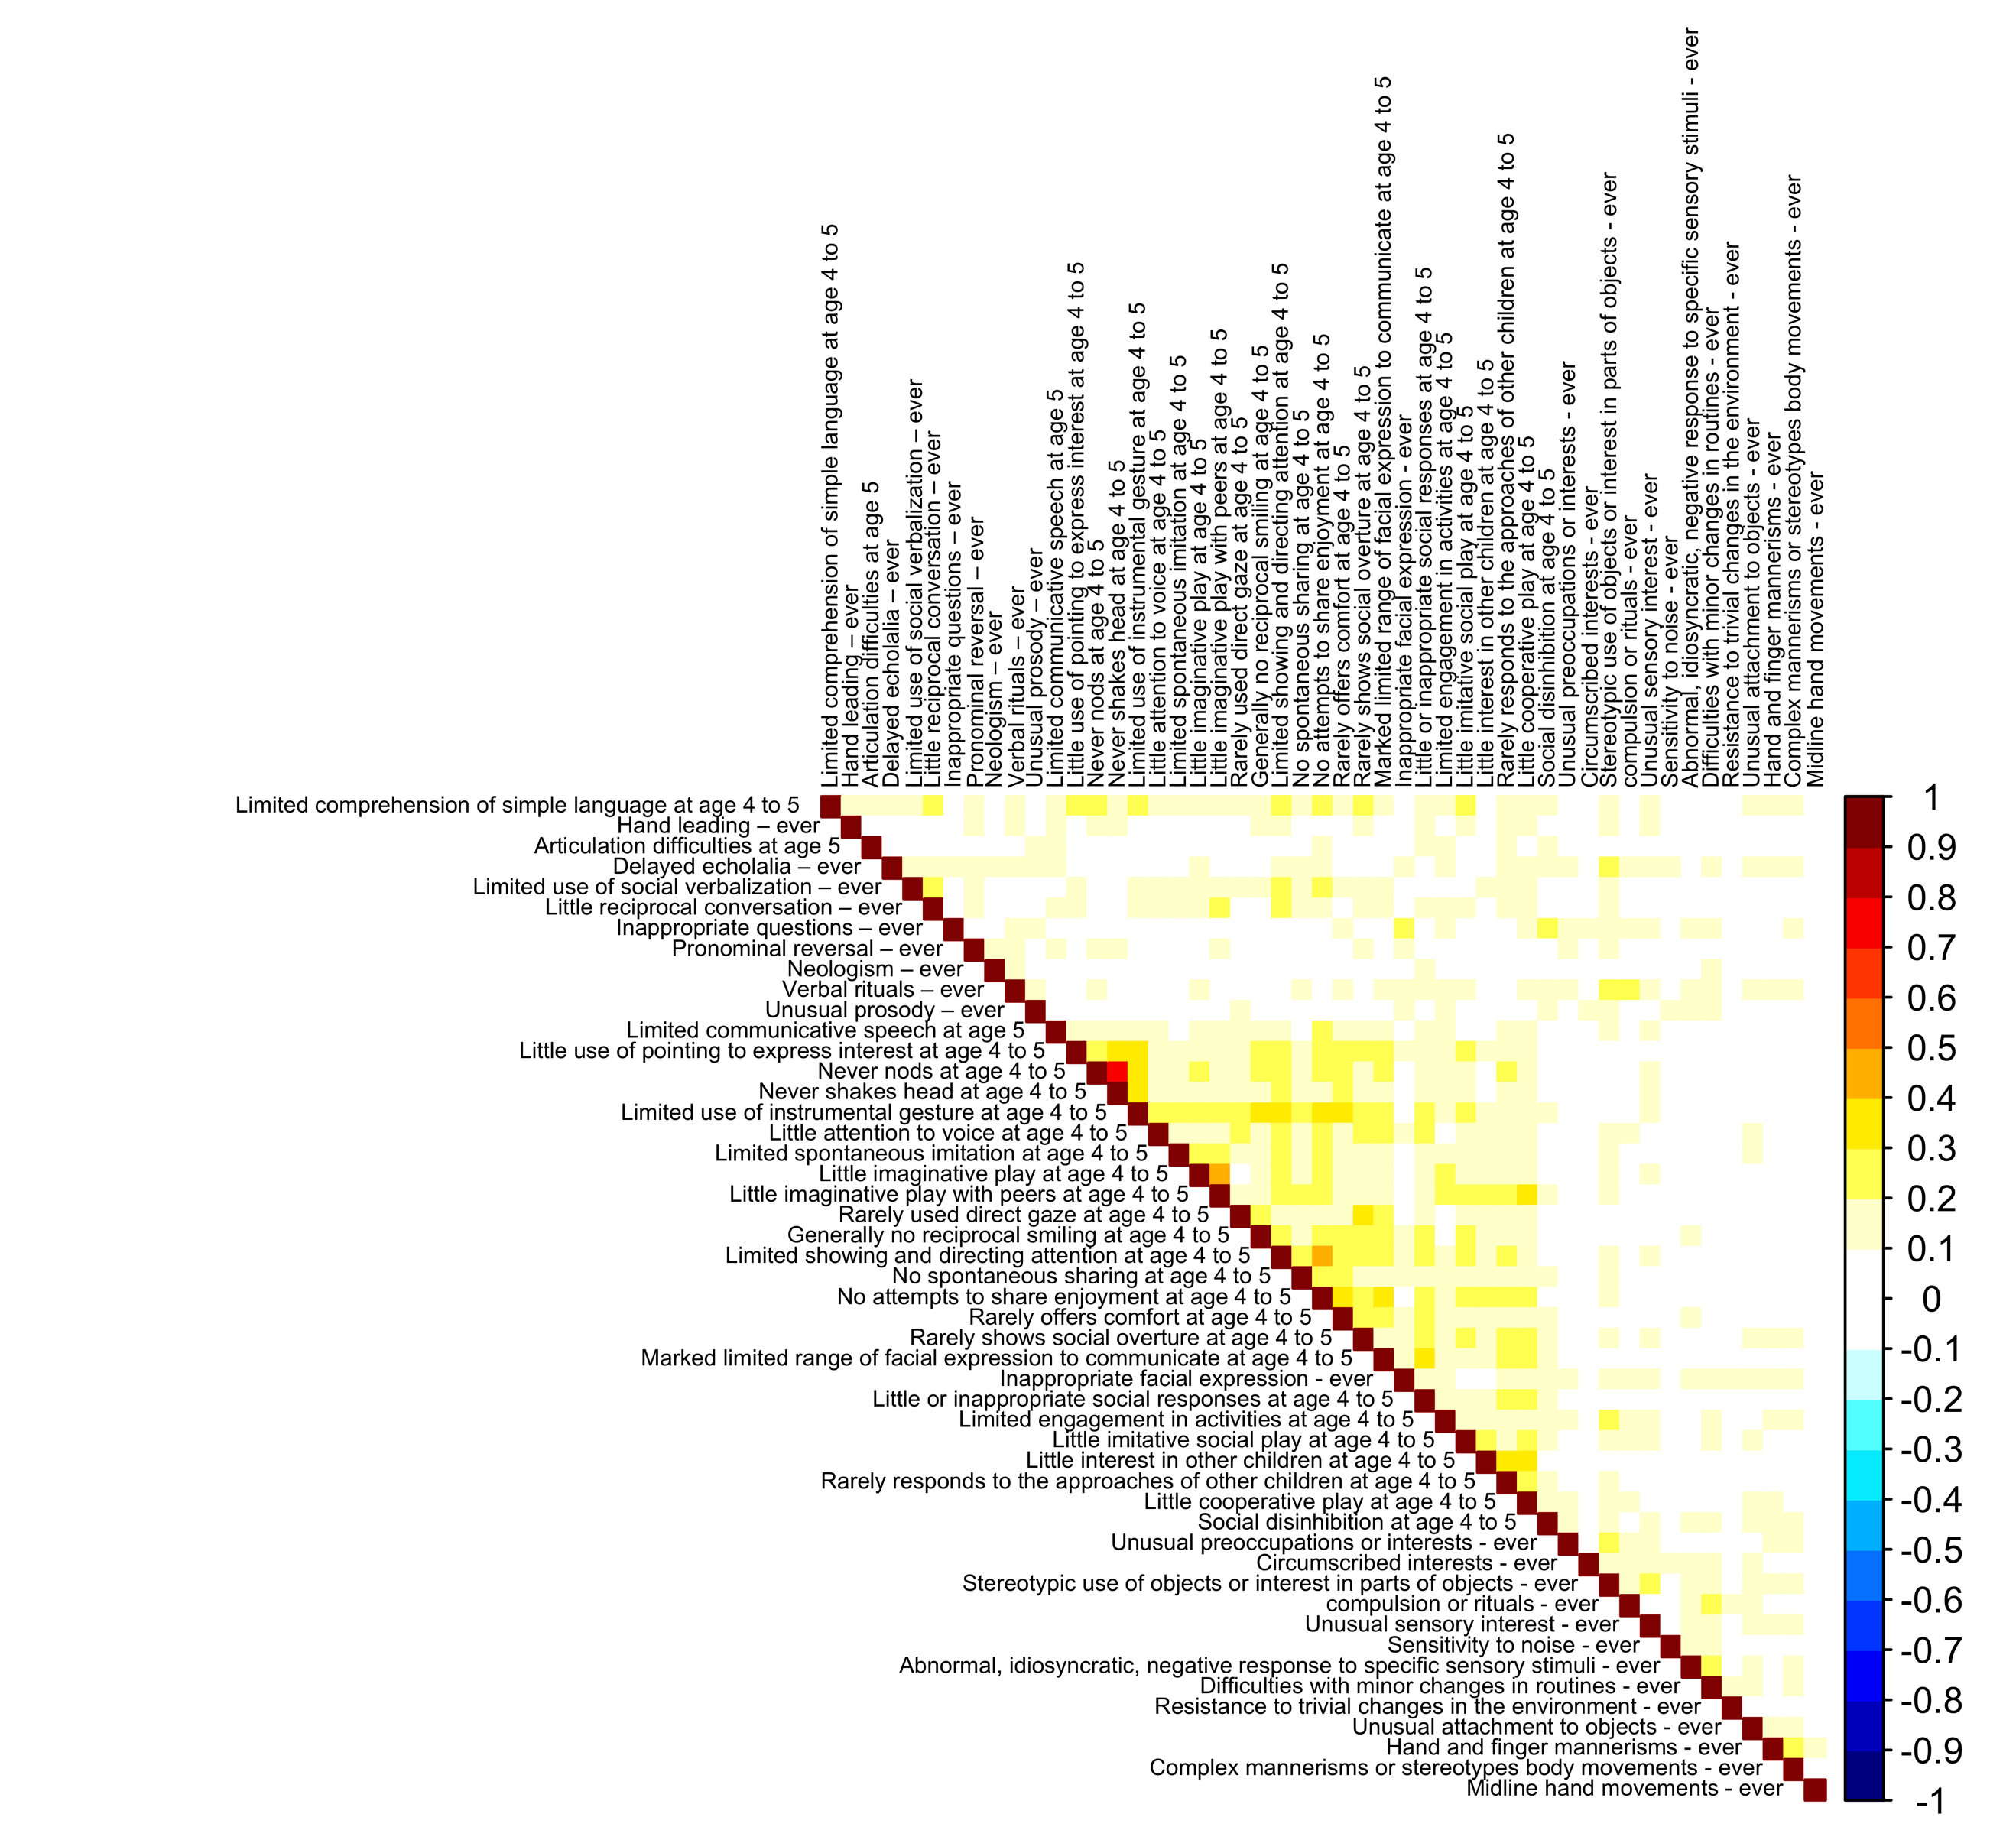
Figure S1. φ coefficients between atypicalities. The general associations between independent atypicalities are weak in the sample. Only "Never nods" and "Never shakes head" show a phi coefficient of 0.75.

