Extended data
Extended Data Fig. 1 Distributions of dissolved oxygen, transmission, and NO from the Chukchi Shelf to the southwestern side of the Chukchi Plateau.
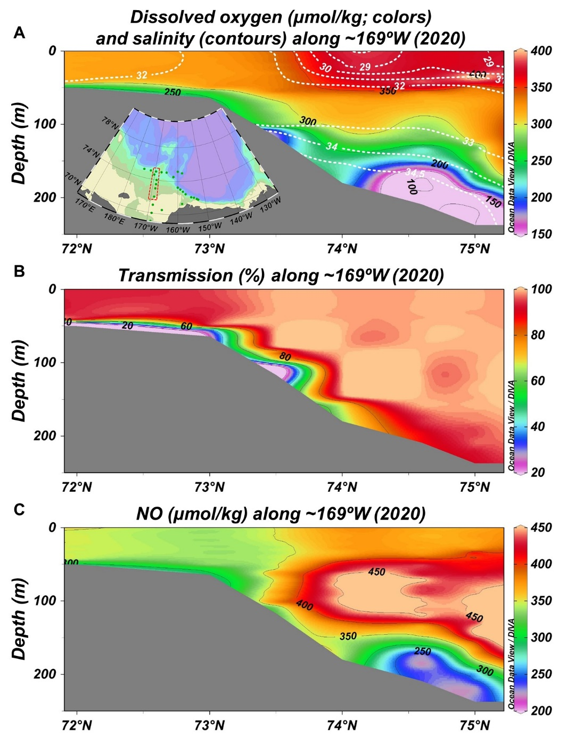
b
c
a
a–c, Vertical sections of (a) dissolved oxygen (μmol kg⁻¹), (b) transmission (%), and (c) NO (μmol kg⁻¹) along ~169° W in 2020. In (a), salinity contours are drawn as white dashed lines. The data were obtained from sensors attached to the CTD system in the 2020 R/V Mirai cruise. For the illustrations of vertical sections, we used the data in an area enclosed by a red square in the embedded map in (a).
Extended Data Fig. 2 Distributions of dissolved oxygen, aragonite saturation state, NO, and NO/PO from the East Siberian Sea to the Makarov Basin.
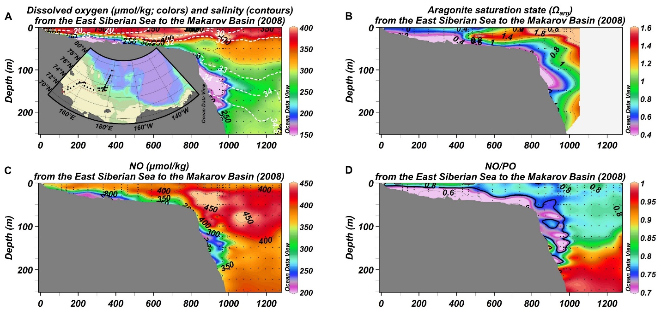
d
c
b
a
a–d, Vertical sections of (a) dissolved oxygen (μmol kg⁻¹), (b) aragonite saturation state (Ω_{arg}), (c) NO (μmol kg⁻¹), and (d) NO/PO along a line in the embedded map in (a). Black dots indicate the data points in each panel. In (a), salinity contours are drawn as white dashed lines. In (d), the contour of 0.75 is shown by a thick curve. The data were obtained from the International Siberian Shelf Study 2008⁵⁰ and the 2008 R/V Mirai cruise.
Extended Data Fig. 3 The Shadow zone of Pacific and Atlantic water inflows is characterized by low concentrations of dissolved oxygen along the shelf-slope of the East Siberian Sea.
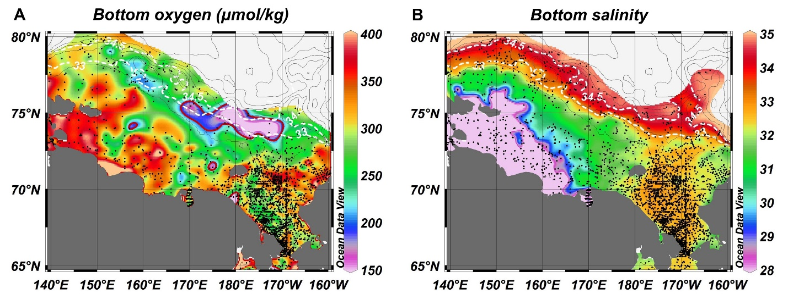
a
b
a, Dissolved oxygen (μmol kg⁻¹) and b, salinity at the bottom (depth < 500 m) of the shelf and shelf-slope regions of the East Siberian and Chukchi seas. Black dots indicate the data points in each panel. In (a), a region where the water with extremely low dissolved oxygen (<200 μmol kg⁻¹) was found along the shelf-slope of the East Siberian Sea is enclosed by a red contour. In (a) and (b), contours of salinity = 33 and 34.5 are shown as white dashed lines. The dissolved oxygen data were obtained from the Hydrochemical Atlas of the Arctic Ocean³⁰. The salinity data were obtained from the Environmental Working Group Joint US–Russian Atlas of the Arctic Ocean³¹.
Extended Data Fig. 4 Enhanced northward flow over the Chukchi Plateau in 2020 compared with that in 2008.
b
a
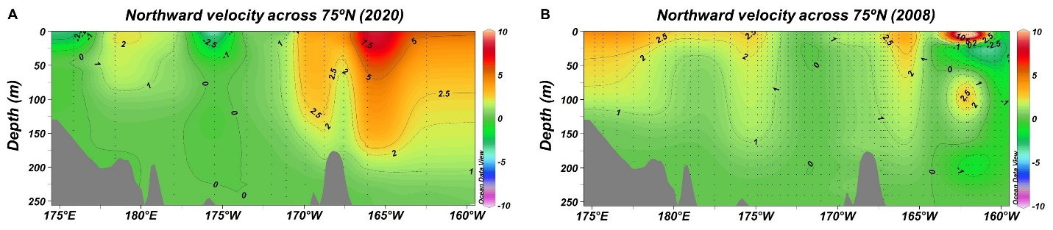
a, b, Northward geostrophic velocity (cm s⁻¹) across the 75° N section between 175° E and 160° W relative to 250 m in (a) 2020 and (b) 2008. Black dots indicate the data points in each panel. The data used for the calculations were obtained from the R/V Araon and Mirai cruises in 2020 and the R/V Mirai cruise in 2008.

