Supplementary Information for

Shrink of an ocean gyre in the Pacific Arctic and Atlantification open a door of shadow zone
Shigeto Nishino¹*†, Jinyoung Jung²†, Kyoung-Ho Cho², William J. Williams³, Amane Fujiwara¹, Akihiko Murata⁴, Motoyo Itoh¹, Michio Aoyama^{4,5}, Michiyo Yamamoto-Kawai⁶, Takashi Kikuchi¹, Eun Jin Yang² & Sung-Ho Kang⁷
¹Institute of Arctic Climate and Environment Research, Research Institute for Global Change, Japan Agency for Marine-Earth Science and Technology (JAMSTEC); Yokosuka, 237-0061, Japan.
²Division of Ocean Sciences, Korea Polar Research Institute; Incheon, 21990, Republic of Korea.
³Institute of Ocean Sciences, Fisheries and Oceans Canada; Sidney, BC, V8L 4B2, Canada.
⁴Global Ocean Observation Research Center, Research Institute for Global Change, Japan Agency for Marine-Earth Science and Technology (JAMSTEC); Yokosuka, 237-0061, Japan.
⁵Center for Research in Isotopes and Environmental Dynamics, University of Tsukuba; Tsukuba, 305-8577, Japan.
⁶Department of Ocean Sciences, Tokyo University of Marine Science and Technology; Minato-ku, Tokyo, 108-8477, Japan.
⁷Korea Polar Research Institute; Incheon, 21990, Republic of Korea.
*Corresponding author. Email: nishinos@jamstec.go.jp
†These authors contributed equally to this work
Supplementary Discussion | Water distribution in 2017, the year the Beaufort High collapsed.
In 2017, cold PW mainly occupied east of the Chukchi Plateau (Supplementary Fig. 1a). A frontal structure was found over the plateau. However, the front was obscure because the eastward intrusion of LHW was weak in 2017 (Supplementary Fig. 1a) compared to 2020 (Fig. 3d). The weak frontal structure over the Chukchi Plateau did not cause the strong frontal flow, resulting in a weak signal of low DO on the plateau (Supplementary Fig. 1b).
The collapse of Beaufort High occurred in 2017 for the first time³⁵. The Beaufort Gyre shrank to the east of the Chukchi Plateau that year; however, the Atlantic-origin water (including high-DO LHW) intruded along the shelf-slope only up to ~180° E, which is distant from the Chukchi Plateau (Supplementary Fig. 1a) (ref. ¹⁶). As a result, the ExLowDO water would have reminded on the shelf-slope, and it did not reach the Chukchi Plateau in 2017 (Supplementary Fig. 1b). In 2020 (i.e., we do not have enough data in 2018 and 2019 around the Chukchi Plateau), the Atlantic-origin water further intruded near the Chukchi Plateau, accompanying an eastward displacement of the ExLowDO water (Fig. 3g). Then the frontal flow along the Chukchi Plateau transported the ExLowDO water toward the north.
Supplementary Fig. 1 | Distributions of temperature, salinity, and dissolved oxygen in a region influenced by Pacific and Atlantic waters in 2017, the year the Beaufort High collapsed.
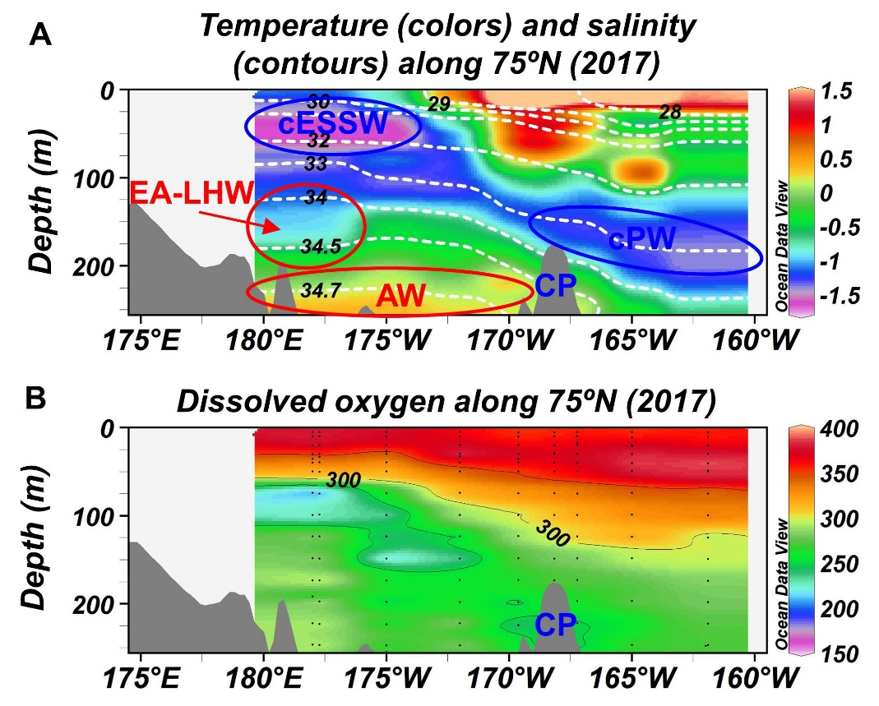
b
a
a, b, Vertical sections of (a) temperature (° C; colors) and salinity (white dashed contours) and (b) dissolved oxygen (μmol kg⁻¹) along 75° N in 2017. The data for the drawing of each vertical section was in an area enclosed by a blue dashed square in the enlarged map in Fig. 1. In (b), black dots indicate the data points. The data used were obtained from the R/V Mirai cruise in 2017. Abbreviations: Chukchi Plateau (CP), cold Pacific Water (cPW), cold East Siberian Sea Water (cESSW), eastern Arctic-derived Lower Halocline Water (EA-LHW), and Atlantic Water (AW).
Supplementary Table 1 | Expeditions, observation periods, and data sites.
Expeditions | Observation periods | Data sites
Araon 2020 | August 4 – August 31, 2020 | https://kpdc.kopri.re.kr/
Mirai 2002 | September 2 – October 10, 2002 | http://www.godac.jamstec.go.jp/darwin/e
2004 | September 1 – October 12, 2004 | http://www.godac.jamstec.go.jp/darwin/e
2008 | August 26 – October 9, 2008 | http://www.godac.jamstec.go.jp/darwin/e
2009 | September 7 – October 15, 2009 | http://www.godac.jamstec.go.jp/darwin/e
2010 | September 2 – October 16, 2010 | http://www.godac.jamstec.go.jp/darwin/e
2012 | September 3 – October 17, 2012 | http://www.godac.jamstec.go.jp/darwin/e
2013 | August 28 – October 21,2013 | http://www.godac.jamstec.go.jp/darwin/e
2014 | August 31 – October 10, 2014 | http://www.godac.jamstec.go.jp/darwin/e
2015 | August 24 – October 22, 2015 | http://www.godac.jamstec.go.jp/darwin/e
2016 | August 22 – October 5, 2016 | http://www.godac.jamstec.go.jp/darwin/e
2017 | August 23 – October 1, 2017 | http://www.godac.jamstec.go.jp/darwin/e
2018 | October 24 – December 7, 2018 | http://www.godac.jamstec.go.jp/darwin/e
2019 | September 28 – November 10, 2019 | http://www.godac.jamstec.go.jp/darwin/e
2020 | September 19 – November 2, 2020 | http://www.godac.jamstec.go.jp/darwin/e
BGEP 2003 | August 7 – September 7, 2003 | https://www2.whoi.edu/site/beaufortgyre/data/ctd-and-geochemistry/
2004 | July 29 – September 2, 2004
2005 | July 29 – September 1, 2005
2006 | August 5–- September 14, 2006
2007 | July 26 – August 31, 2007
2008 | July 17 – August 21, 2008
2009 | September 17 – October 15, 2009
2010 | September 15 – October 15, 2010
2011 | July 21 – August 18, 2011
2012 | August 2 – September 8, 2012
2013 | August 1 – September 2, 2013
2014 | September 21 – October 17, 2014
2015 | September 20 – October 16, 2015
2016 | September 22 – October 18, 2016
2017 | September 7 – October 2, 2017
2018 | September 7 – October 2, 2018
2019 | September 12 – October 4, 2019
2020 | September 14 – October 2, 2020
CBL 2002 | August 19 – September 23, 2002 | http://psc.apl.washington.edu/HLD/CBL/CBL.html
ISSS 2008 | August 15 – September 26, 2008 | https://cchdo.ucsd.edu/cruise/90JS20080815
The expeditions conducted by the R/V Araon (Korea) and R/V Mirai (Japan) are expressed as Araon and Mirai, respectively, with the expedition years. The Canada/US Beaufort Gyre Exploration Project using CCGS Louis S. St-Laurent is abbreviated as BGEP. The Chukchi Borderland Project and International Siberian Shelf Study carried out by the USCGC Polar Star (USA) in 2002 and Yacob Smirniskyi (Russia) in 2008, respectively, are presented as CBL 2002 and ISSS 2008.

Supplementary Data | R/V Mirai data from CTD and bottle samples.
The data are text files and separated by the CTD and bottle for each year (e.g., Mirai_CTD_2020.txt and Mirai_Btl_2020.txt). Once the issues related to a security incident have been resolved, the data can be retrieved from the R/V Mirai data site shown in Supplementary Table 1.

