SUPPLEMENTARY MATERIAL
Methods
Detection of SARS-CoV-2
SARS-CoV-2 detection was carried out by the following methods depending on their availability at the time of the analysis: a non-commercial, in-house PCR assay with primers and probes from the CDC 2019-nCoV PCR Panel and using the One-Step RT-PCR kit (Qiagen, Germany); commercial real-time RT-PCR assays, including the Allplex 2019-nCoV Assay (Seegene) and the Cobas SARS-CoV-2 Test (Roche Diagnostics); or TMA-based assays, including Procleix SARS-CoV-2 (Grifols) or Aptima SARS-CoV-2 (Hologic Inc.). Before performing the Qiagen and Seegene assays, total nucleic acids were extracted using the NucliSENS EasyMAG (bioMérieux, Marcy l’Etoile, France) or Microlab STARlet (Hamilton, CA, USA) system, depending on availability or the number of samples requiring extraction.
For comparisons of the cycle threshold (Ct) value, which is a good estimation of viral load, the TaqPathTM COVID-19 RT-PCR kit (Thermo Fisher Scientific, USA) was performed in all selected samples. This technique provides the Ct of three regions (ORF1ab, spike, and N genes). In this study we used the Ct provided from N gene quantitation, which is the value used in clinical reports. Clinical samples were maintained frozen (-80ºC) for further studies.
SARS-CoV-2 whole spike sequencing
Sample amplification was based on the ARTIC protocol (nCoV-2019 sequencing protocol V.3, Artic Network).[1] This method uses pair and impair primers to amplify overlapping amplicons (A) of the SARS-CoV-2 genome. We selected primers covering the complete spike region of SARS-CoV-2, from the 21658 bp to 25673 bp position, corresponding to the nCoV-2019_72 (A72) to nCoV-2019_84 (A84) overlapping amplicons (artic28-ncov2019/nCoV-2019.scheme.bed, Artic Network). Spike pair and impair primers were tested for efficacy and mixed in two different pools for the posterior two multiplexed PCRs. Each pool was optimized by adjusting primer concentration to that obtaining a balanced number of reads for each amplicon. Reverse transcription and PCR amplification were performed following the conditions established by the ARTIC protocol (nCoV-2019 sequencing protocol V.3, Artic Network).[1]
Purification of PCR products and library preparation were performed according to previously described methods.[2] Briefly, samples were normalized to 1.5 ng/µL, pooled in a single tube, and purified. Samples were then normalized to 4 nM before library preparation. Finally, the library was quantified by qPCR (KAPA Library Quantification Kit, Kapa Biosystems, Roche, Pleasanton, CA USA), denatured, and sequenced using the MiSeq platform (Illumina, San Diego, CA).
To investigate possible bias caused by the use of different primers, we amplified and deep-sequenced 26 samples from this study using both ARTIC primers and the N07 primers (Supplementary Table S3) used in our previous study.[2]

Bioinformatic analysis: InDel study
InDel analysis was done as reported by Andres et al.[2] Briefly, amplicons were reconstructed using FLASH, establishing a minimum of 20 overlapping bases and a maximum of 10% mismatches, while discarding low-quality reads. All reads with more than 5% of bases below a Phred Score of Q30 were filtered out. A fasta file was generated for each amplicon and each patient, and equal sequences were collapsed to obtain haplotypes with their corresponding frequencies. Low-abundance haplotypes (<0.1%) and those present only in the forward or reverse strand were discarded. Haplotypes common to both strands with frequencies above 0.1% (consensus haplotypes) were the basis of subsequent computations. Gaps were then removed, haplotypes were translated to amino acids, and stop haplotypes were trimmed after the stop. Single nucleotide deletions were excluded in this study, as they can be artifacts caused by PCR or sequencing errors. Spike gene deletions described to be a footprint of a particular variant, such as ΔH69-70 and ΔY144 for Alpha, ΔL242-244 for Beta, and Δ156-157 for Delta, were also excluded in the study.
Resulting amino acid haplotype sequences were realigned with MUSCLE (EMBL-EBI https://www.ebi.ac.uk/Tools/msa/muscle/), and whole genome consensus sequences were uploaded to the GISAID database (see codes in Table 1).[3] All computations were done in the R language and platform,[4] and in-house scripts were developed using the Biostrings,[5] Ape,[6] and ShortRead[7] packages.
Statistical analysis
The Wilcoxon test was used to determine whether there were differences in Ct values between samples with and without deletions. Pearson’s chi-square test was used to analyze associations between the presence or absence of deletions and patient sex or presence of COVID19 disease symptoms (eg, high fever, anosmia, ageusia, persistent headache).
References
1. nCoV-2019 sequencing protocol v3 (LoCost). https://www.protocols.io/view/ncov-2019-sequencing-protocol-v3-locost-bh42j8ye. Accessed 27 Oct 2021.
2. Andrés C, Garcia-Cehic D, Gregori J, Piñana M, Rodriguez-Frias F, Guerrero-Murillo M, et al. Naturally occurring SARS-CoV-2 gene deletions close to the spike S1/S2 cleavage site in the viral quasispecies of COVID19 patients. Emerg Microbes Infect. 2020;9:1900–11.
3. Elbe S, Buckland-Merrett G. Data, disease and diplomacy: GISAID’s innovative contribution to global health. Glob challenges (Hoboken, NJ). 2017;1:33–46.
4. Team RC. R: A language and environment for statistical computing. 2016.
5. Pages H, Aboyoun P, Gentleman R, DebRoy S. Biostrings:String objects representing biological sequences, and matching algorithms. R package 2.38.4. 2012.
6. Paradis E, Claude J, Strimmer K. APE: Analyses of Phylogenetics and Evolution in R language. Bioinformatics. 2004;20:289–90.
7. Morgan AM, Lawrence M, Anders S. Package “ShortRead.” Bioconductor Packag Maint. 2021.

Supplementary Figures Legends
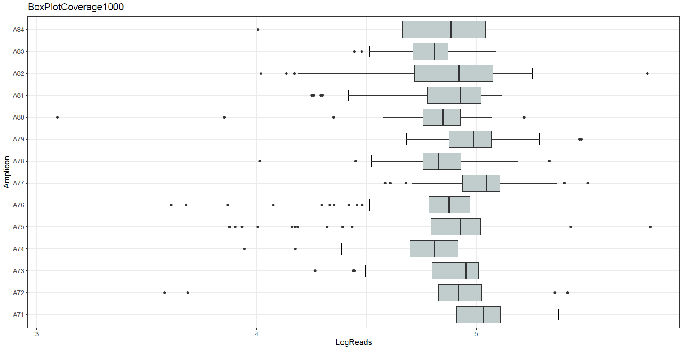
Supplementary Figure S1. Box plot of the coverage per amplicon represented as logarithm of the reads.

Supplementary Figure S2A to 2G. Bar plot of deletions per amplicon along the spike gene. Each bar plot found inside each table-box shows the deletion (blue columns), with the x axis providing the multiple alignment (MA) nucleotide positions and the amplitude of the deletion, and the y axis showing the frequency of the deletion (percentage) on the right and the number of reads on the left. As no insertions were observed, the MA positions correspond to S gene positions.
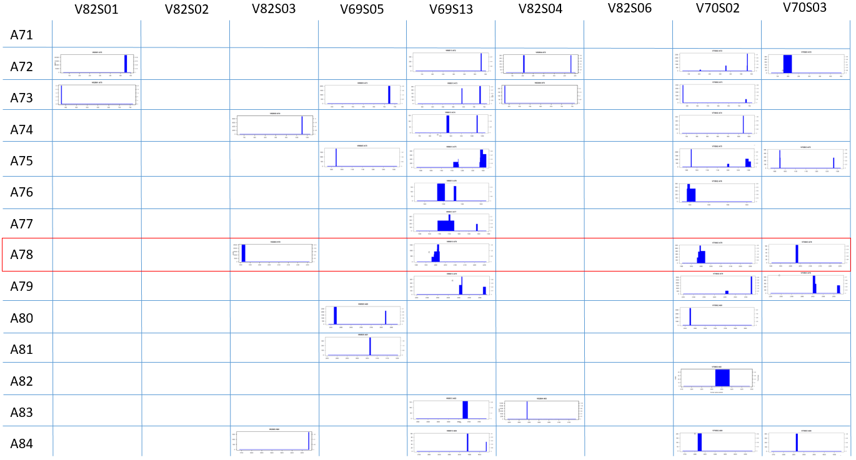
Supplementary Figure S2A. Variant B.1.5.
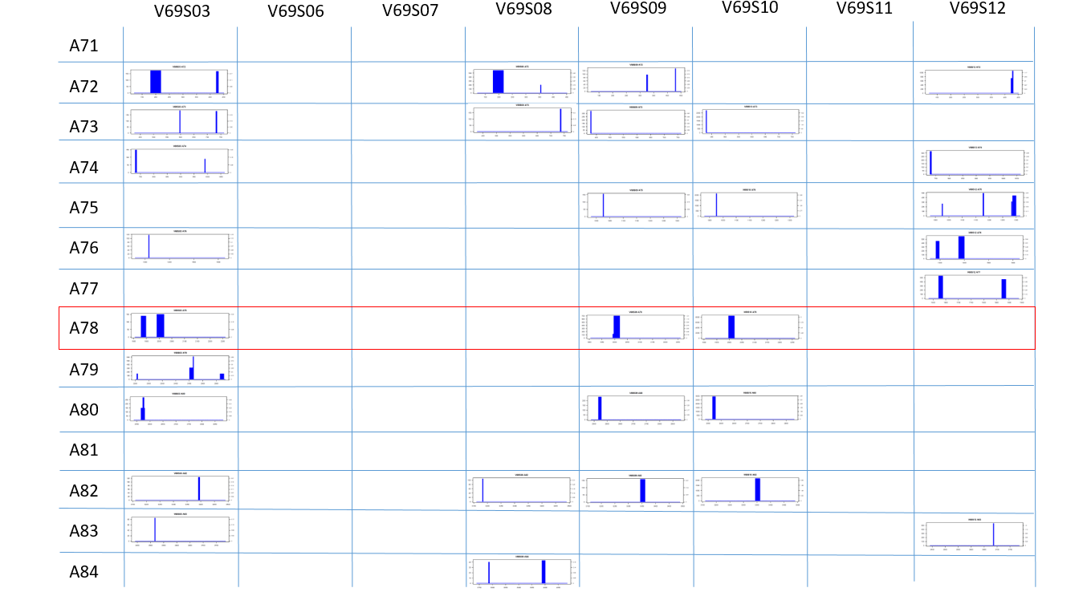
Supplementary Figure S2B. Variant B.1.1.

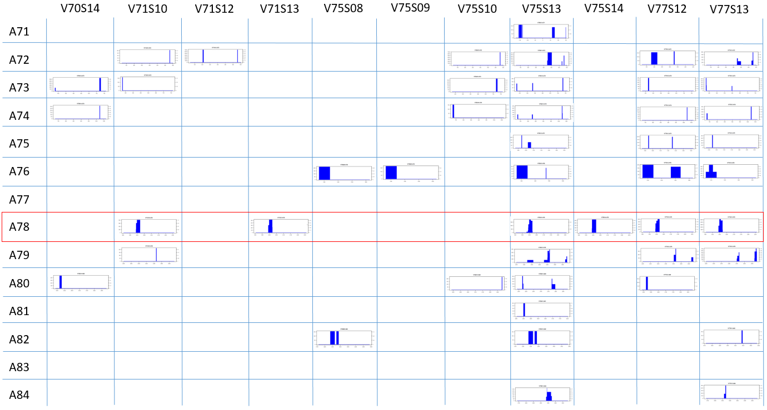
Supplementary Figure S2C. Variant B.1.177.

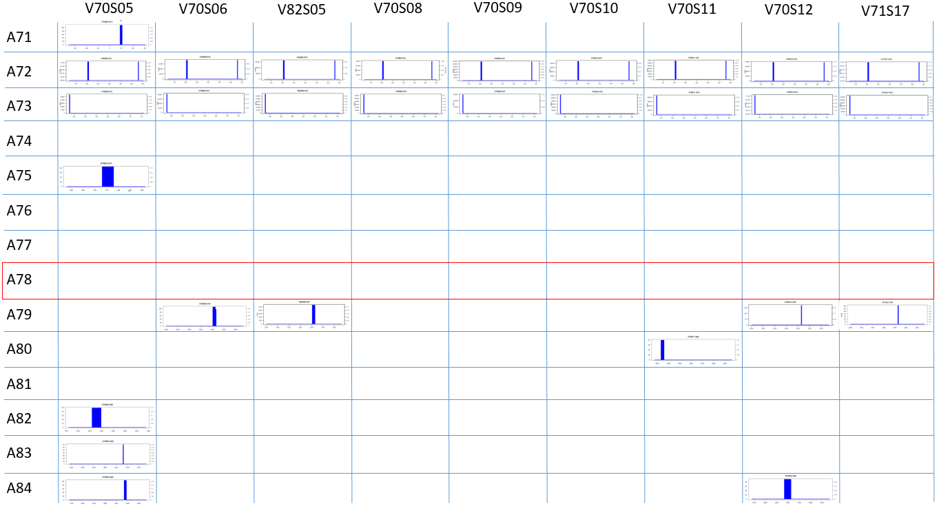
Supplementary Figure S2D. Variant B.1.17 (Alpha).

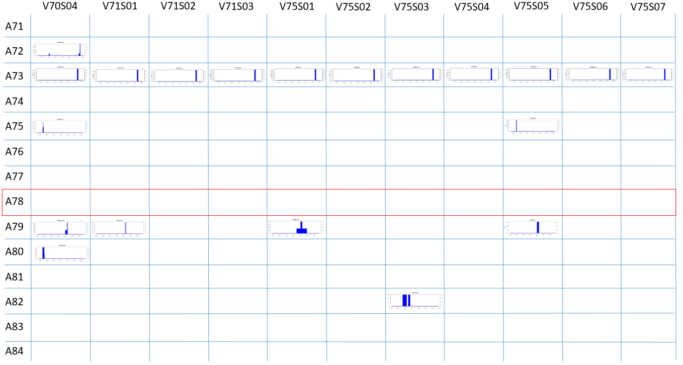
Suppelementary Figure S2E. Variant B.1.351 (Beta).

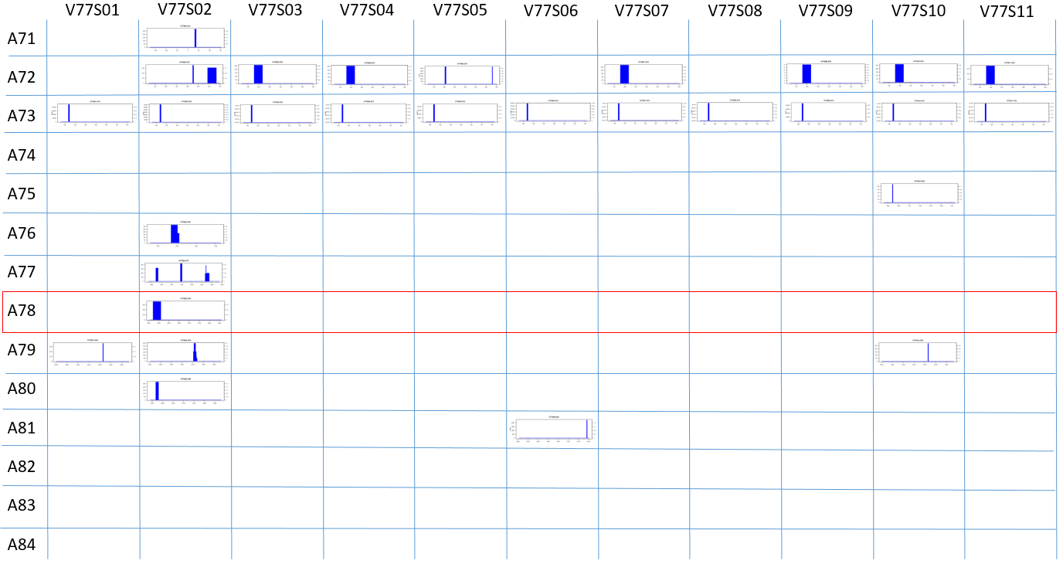
Supplementary Figure S2F. Variant B.1.617.2 (Delta).

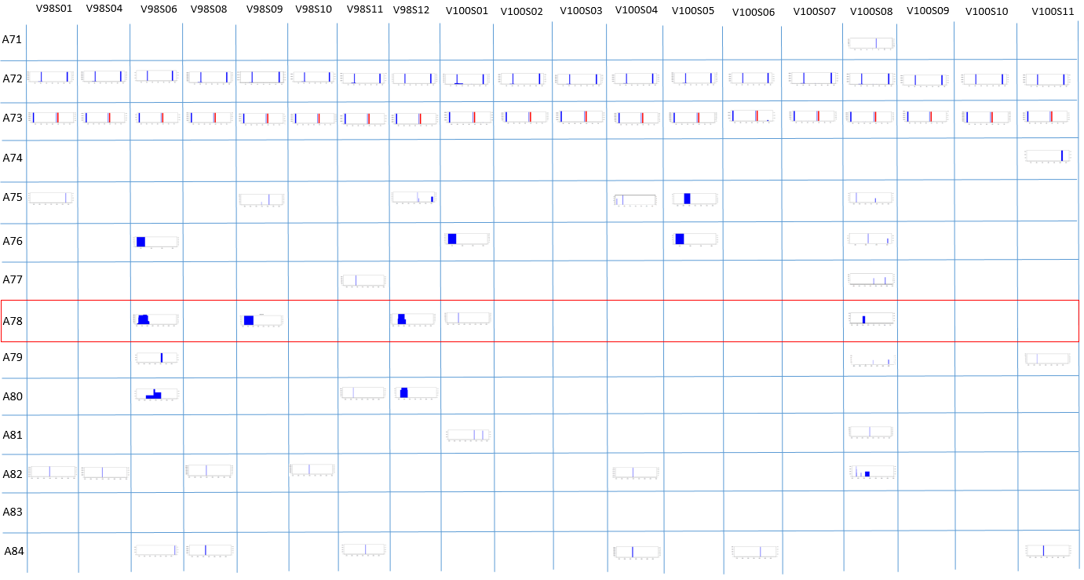
Supplementary Figure S2G. Variant B.1.1.529 (Omicron).

Supplementary Figure S3A to 3G. Bar plots with deletions that cause the appearance of a stop codon and that represent defective genomes.
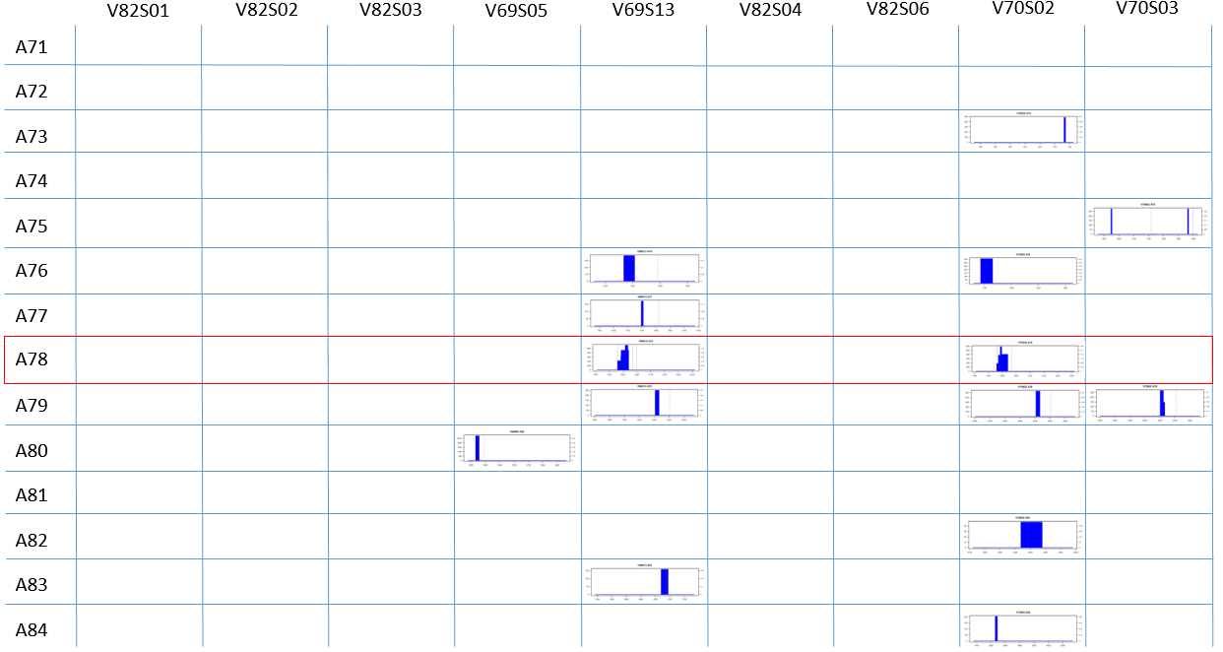
Supplementary Figure S3A. Variant B.1.5.

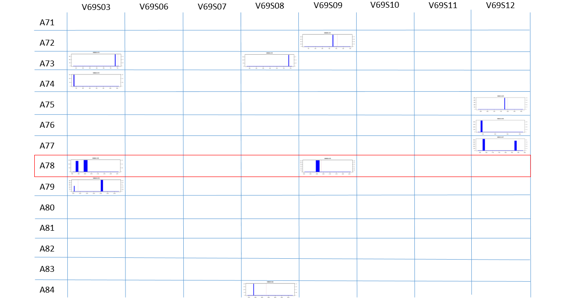
Supplementary Figure S3B. Variant B.1.1.

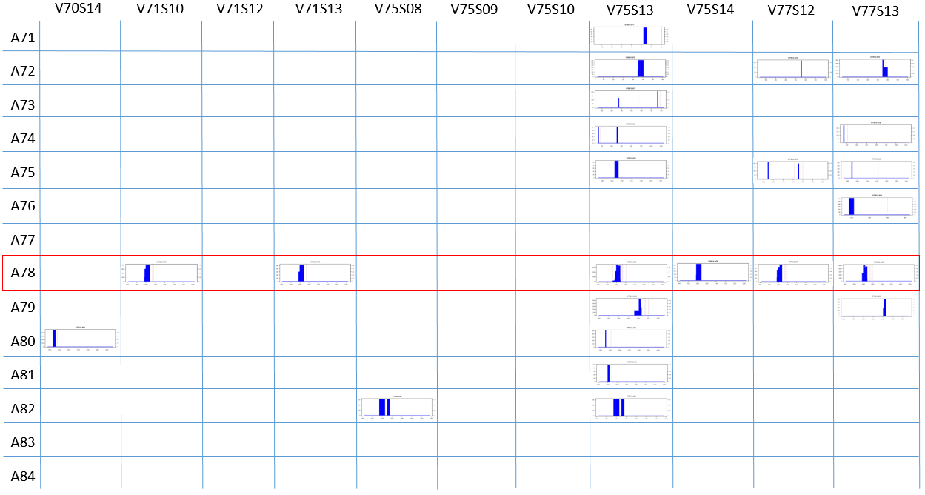
Supplementary Figure S3C. Variant B.1.177.

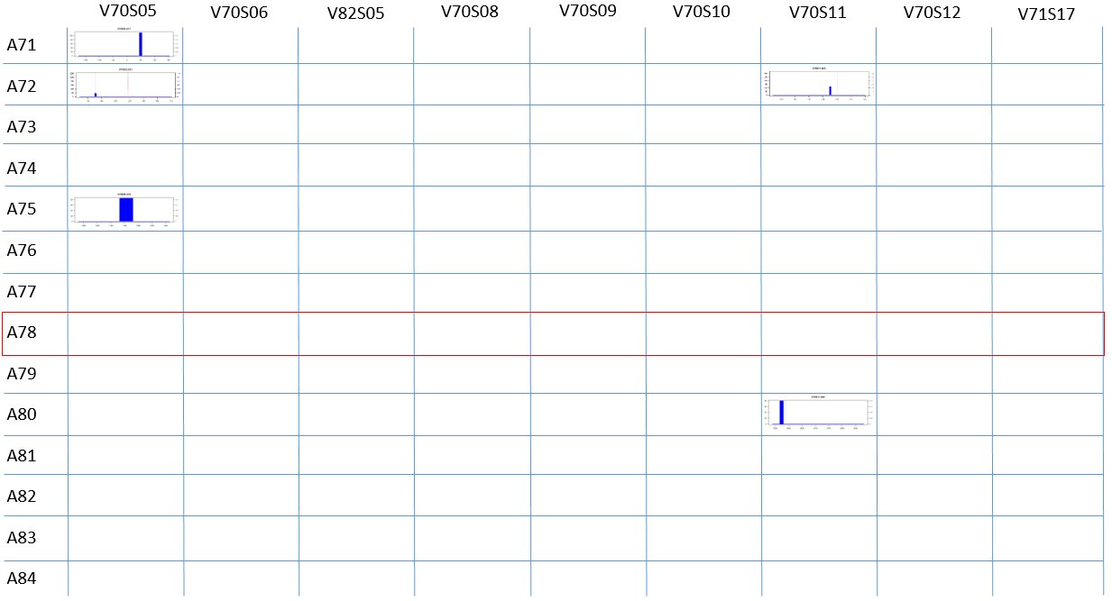
Supplementary Figure S3D. Variant B.1.1.7 (Alpha).

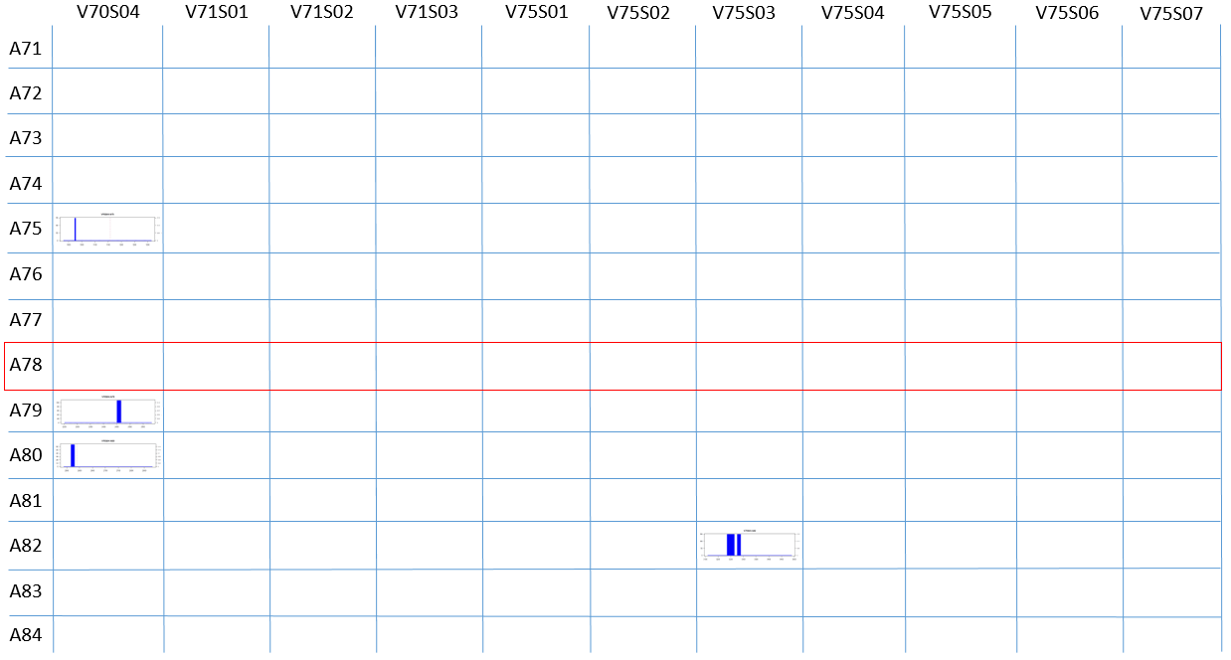
Supplementary Figure S3E. Variant B.1.351 (Beta).

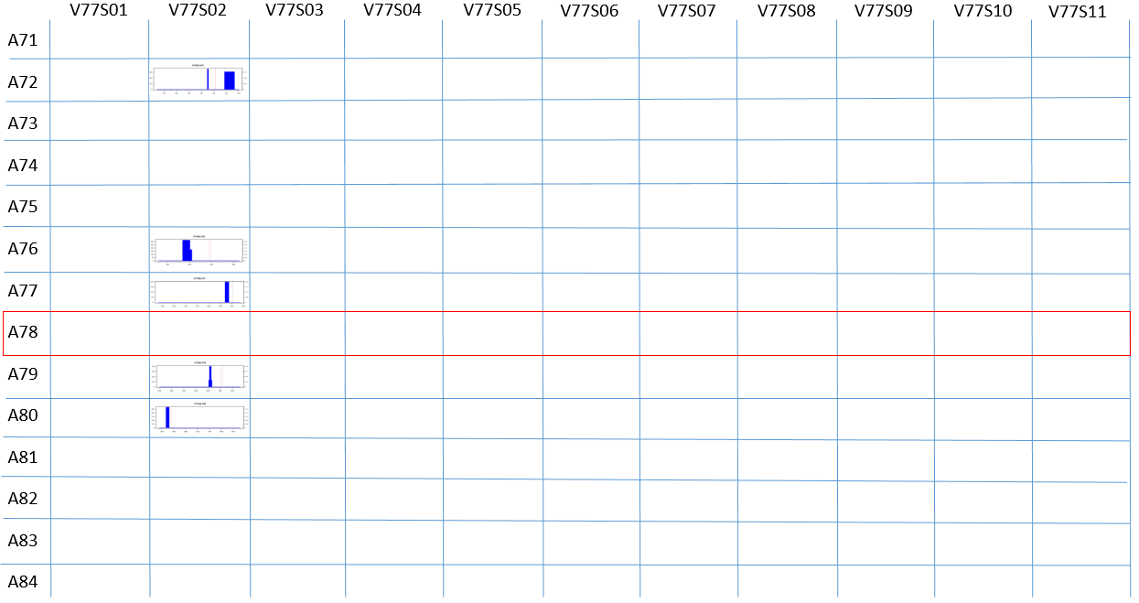
Supplementary Figure S3F. Variant B.1.617.2 (Delta).

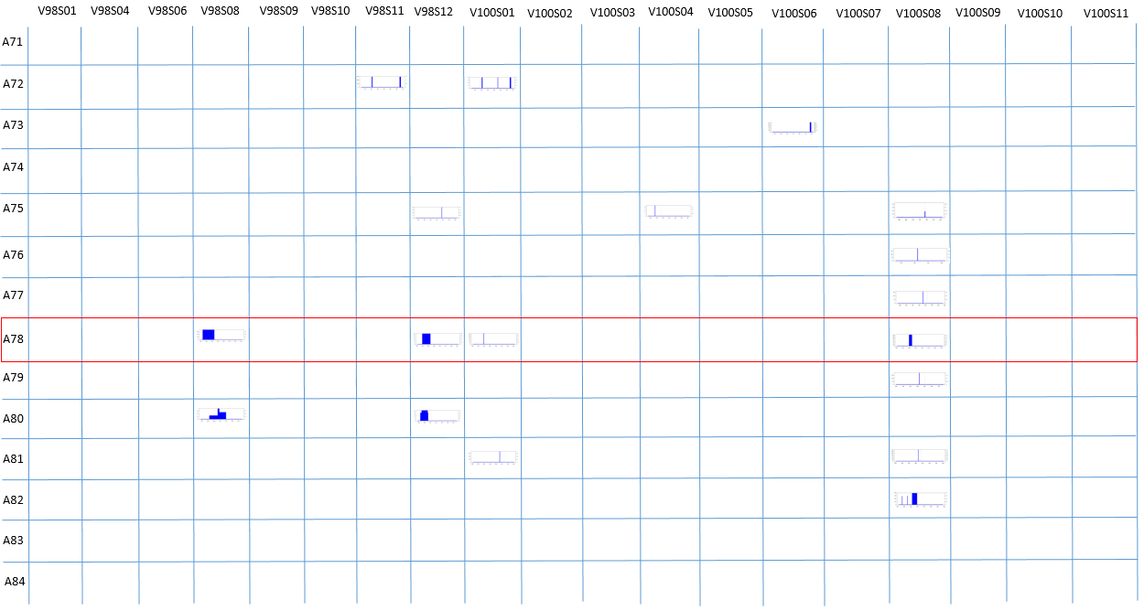
Supplementary Figure S3G. Variant B.1.1.529 (Omicron).

Supplementary Table Legends
Supplementary Table S1. Characteristics of patients. GISAID code refers to the uploaded complete consensus genome. Mild symptoms include fever, anosmia, ageusia, headache, etc. PC=primary care. H=Hospital. M=males, F=females, Ct=cycle threshold.
PATIENT ID | GISAID ID | LINEAGE | AGE | EXTRACTION DATE | Ct | TECHNIQUE | SYMPTOMS S/N | GENDER M o F | PRIMARY CARE Y/N | ENTRY HUVH Y/N | SAMPLE TYPE
V82S01 | EPI_ISL_819299 | B.1.5 | 60yo | 19/06/2020 | 33,996 | COBAS (TGT1) | N | F | N | N | naso/oropharyngeal exudate
V82S02 | EPI_ISL_819337 | B.1.5 | 67yo | 04/05/2020 | 32,791 | COBAS (TGT1) | Y | M | N | N | naso/oropharyngeal exudate
V82S03 | EPI_ISL_819295 | B.1.5 | 17yo | 29/04/2020 | 30,274 | COBAS (TGT1) | N | M | N | N | naso/oropharyngeal exudate
V69S05 | EPI_ISL_819335 | B.1.5 | 33yo | 27/04/2020 | 28,412 | COBAS (TGT1) | Y | F | N | Y | naso/oropharyngeal exudate
V69S13 | EPI_ISL_819297 | B.1.5 | 43yo | 30/04/2020 | 25,576 | COBAS (TGT1) | Y | F | Y | N | naso/oropharyngeal exudate
V82S04 | EPI_ISL_819344 | B.1.5 | 48yo | 18/05/2020 | 29,209 | COBAS (TGT1) | Y | M | N | N | naso/oropharyngeal exudate
V82S06 | EPI_ISL_819350 | B.1.5 | 78yo | 27/05/2020 | 26,914 | COBAS (TGT1) | Y | M | N | N | naso/oropharyngeal exudate
V70S02 | EPI_ISL_819298 | B.1.5 | 77yo | 02/06/2020 | 28,159 | COBAS (TGT1) | N | M | N | N | naso/oropharyngeal exudate
V70S03 | EPI_ISL_819355 | B.1.5 | 43yo | 04/06/2020 | 26,259 | COBAS (TGT1) | N | F | Y | N | naso/oropharyngeal exudate
V69S03 | EPI_ISL_819349 | B.1.1 | 59yo | 26/05/2020 | 25,253 | COBAS (TGT1) | Y | F | N | N | naso/oropharyngeal exudate
V69S06 | EPI_ISL_819351 | B.1.1 | 58yo | 28/05/2020 | 18,650 | COBAS (TGT1) | Y | M | Y | N | naso/oropharyngeal exudate
V69S07 | EPI_ISL_819352 | B.1.1 | NA | 29/05/2020 | 29,335 | COBAS (TGT1) | N | F | Y | N | naso/oropharyngeal exudate
V69S08 | EPI_ISL_819353 | B.1.1 | 14yo | 29/05/2020 | 19,199 | COBAS (TGT1) | Y | F | Y | N | naso/oropharyngeal exudate
V69S09 | EPI_ISL_819354 | B.1.1 | 44yo | 03/06/2020 | 21,577 | COBAS (TGT1) | N | M | Y | N | naso/oropharyngeal exudate
V69S10 | EPI_ISL_819356 | B.1.1 | 32yo | 05/06/2020 | 31,358 | COBAS (TGT1) | N | M | Y | N | naso/oropharyngeal exudate
V69S11 | EPI_ISL_819359 | B.1.1 | 21yo | 11/06/2020 | 21,287 | COBAS (TGT1) | Y | F | Y | N | naso/oropharyngeal exudate
V69S12 | EPI_ISL_819360 | B.1.1 | 32yo | 12/06/2020 | 26,849 | COBAS (TGT1) | Y | M | Y | N | naso/oropharyngeal exudate
V70S14 | EPI_ISL_1116590 | B.1.177 | NA | 15/02/2021 | 29,349 | COBAS (TGT1) | N | M | Y | N | naso/oropharyngeal exudate
V71S10 | EPI_ISL_1116569 | B.1.177 | 16yo | 17/02/2021 | 19,162 | COBAS (TGT1) | Y | M | Y | N | nasal swab
V71S12 | EPI_ISL_1116591 | B.1.177 | 35yo | 15/02/2021 | 31,232 | COBAS (TGT1) | Y | F | Y | N | naso/oropharyngeal exudate
V71S13 | EPI_ISL_1116585 | B.1.177 | 59yo | 16/02/2021 | 25,114 | COBAS (TGT1) | Y | F | Y | N | nasal swab
V75S08 | EPI_ISL_1669361 | B.1.177 | 69yo | 08/04/2021 | 21,202 | COBAS (TGT1) | Y | F | Y | Y | naso/oropharyngeal exudate
V75S09 | EPI_ISL_1391101 | B.1.177 | 13yo | 15/03/2021 | 26,236 | COBAS (TGT1) | N | M | Y | N | naso/oropharyngeal exudate
V75S10 | EPI_ISL_1391138 | B.1.177 | 70yo | 17/03/2021 | 30,796 | COBAS (TGT1) | Y | M | Y | N | naso/oropharyngeal exudate
V75S13 | EPI_ISL_1797511 | B.1.177 | 48yo | 16/04/2021 | 27,676 | COBAS (TGT1) | N | M | Y | N | naso/oropharyngeal exudate
V75S14 | EPI_ISL_1391158 | B.1.177 | 45yo | 19/03/2021 | 16,700 | COBAS (TGT1) | Y | M | Y | N | naso/oropharyngeal exudate
V77S12 | EPI_ISL_1391140 | B.1.177 | 91yo | 19/03/2021 | 25,078 | COBAS (TGT1) | Y | F | Y | N | naso/oropharyngeal exudate
V77S13 | EPI_ISL_1391141 | B.1.177 | 93yo | 19/03/2021 | 26,439 | COBAS (TGT1) | N | F | Y | N | naso/oropharyngeal exudate
V70S05 | EPI_ISL_1116562 | B.1.1.7 | 3yo | 17/02/2021 | 25,613 | COBAS (TGT1) | Y | M | Y | N | nasal swab
V70S06 | EPI_ISL_1116578 | B.1.1.7 | 4yo | 18/02/2021 | 25,640 | COBAS (TGT1) | N | M | Y | N | nasal swab
V82S05 | EPI_ISL_1116564 | B.1.1.7 | 3yo | 15/02/2021 | 28,386 | COBAS (TGT1) | Y | F | Y | N | nasal swab
V70S08 | EPI_ISL_1116558 | B.1.1.7 | NA | 18/02/2021 | 11,470 | COBAS (TGT1) | N | M | Y | N | nasal swab
V70S09 | EPI_ISL_1116565 | B.1.1.7 | 33yo | 15/02/2021 | 17,226 | COBAS (TGT1) | Y | F | Y | N | naso/oropharyngeal exudate
V70S10 | EPI_ISL_1116566 | B.1.1.7 | 2yo | 15/02/2021 | 22,313 | COBAS (TGT1) | Y | F | Y | N | naso/oropharyngeal exudate
V70S11 | EPI_ISL_1116557 | B.1.1.7 | 5yo | 16/02/2021 | 23,384 | COBAS (TGT1) | Y | F | Y | N | naso/oropharyngeal exudate
V70S12 | EPI_ISL_1116561 | B.1.1.7 | 2yo | 18/02/2021 | 22,431 | COBAS (TGT1) | Y | F | Y | N | naso/oropharyngeal exudate
V71S17 | EPI_ISL_1116580 | B.1.1.7 | 6yo | 16/02/2021 | 21,196 | COBAS (TGT1) | N | M | Y | N | naso/oropharyngeal exudate
V70S04 | EPI_ISL_1020573 | B.1.351 | 38yo | 03/02/2021 | 22,448 | COBAS (TGT1) | Y | F | Y | N | naso/oropharyngeal exudate
V71S01 | EPI_ISL_918301 | B.1.351 | 4yo | 19/01/2021 | 20,309 | COBAS (TGT1) | Y | M | Y | N | naso/oropharyngeal exudate
V71S02 | EPI_ISL_1080829 | B.1.351 | 72yo | 10/02/2021 | 17,353 | COBAS (TGT1) | Y | M | Y | N | naso/oropharyngeal exudate
V71S03 | EPI_ISL_1080831 | B.1.351 | 7yo | 12/02/2021 | 29,373 | COBAS (TGT1) | N | M | Y | N | nasal swab
V75S01 | EPI_ISL_2047723 | B.1.351 | 4yo | 26/04/2021 | 25,058 | COBAS (TGT1) | Y | F | Y | N | naso/oropharyngeal exudate
V75S02 | EPI_ISL_2162254 | B.1.351 | 4yo | 03/05/2021 | 19,736 | COBAS (TGT1) | N | M | Y | N | naso/oropharyngeal exudate
V75S03 | EPI_ISL_1797493 | B.1.351 | 62yo | 14/04/2021 | 22,577 | COBAS (TGT1) | N | F | Y | N | naso/oropharyngeal exudate
V75S04 | EPI_ISL_1908823 | B.1.351 | 1yo | 23/04/2021 | 14,673 | COBAS (TGT1) | Y | F | Y | N | naso/oropharyngeal exudate
V75S05 | EPI_ISL_2047794 | B.1.351 | 67yo | 29/04/2021 | 24,098 | COBAS (TGT1) | Y | F | Y | N | naso/oropharyngeal exudate
V75S06 | EPI_ISL_2047795 | B.1.351 | 67yo | 29/04/2021 | 14,445 | COBAS (TGT1) | Y | M | Y | N | naso/oropharyngeal exudate
V75S07 | EPI_ISL_1669413 | B.1.351 | 7yo | 06/04/2021 | NA | COBAS (TGT1) | Y | M | Y | N | naso/oropharyngeal exudate
V77S01 | EPI_ISL_2284919 | B.1.617.2 | 1yo | 12/05/2021 | 17,233 | COBAS (TGT1) | N | M | Y | N | naso/oropharyngeal exudate
V77S02 | EPI_ISL_2391926 | B.1.617.2 | 26yo | 25/05/2021 | 26,663 | COBAS (TGT1) | Y | M | Y | N | naso/oropharyngeal exudate
V77S03 | EPI_ISL_2391913 | B.1.617.2 | 43yo | 25/05/2021 | 16,119 | COBAS (TGT1) | Y | F | Y | N | naso/oropharyngeal exudate
V77S04 | EPI_ISL_2391912 | B.1.617.2 | 44yo | 25/05/2021 | 13,349 | COBAS (TGT1) | N | M | Y | N | naso/oropharyngeal exudate
V77S05 | EPI_ISL_2458145 | B.1.617.2 | 49yo | 25/05/2021 | 26,457 | COBAS (TGT1) | Y | F | Y | N | naso/oropharyngeal exudate
V77S06 | EPI_ISL_2458160 | B.1.617.2 | 27yo | 26/05/2021 | 30,427 | COBAS (TGT1) | Y | F | Y | N | naso/oropharyngeal exudate
V77S07 | EPI_ISL_2458155 | B.1.617.2 | 29yo | 26/05/2021 | 21,306 | COBAS (TGT1) | Y | F | Y | Y | naso/oropharyngeal exudate
V77S08 | EPI_ISL_2458152 | B.1.617.2 | 46yo | 26/05/2021 | 19,245 | COBAS (TGT1) | Y | M | Y | N | naso/oropharyngeal exudate
V77S09 | EPI_ISL_2458146 | B.1.617.2 | 47yo | 26/05/2021 | 14,529 | COBAS (TGT1) | Y | M | Y | N | naso/oropharyngeal exudate
V77S10 | EPI_ISL_2458140 | B.1.617.2 | 43yo | 26/05/2021 | 18,714 | COBAS (TGT1) | N | M | Y | N | naso/oropharyngeal exudate
V77S11 | EPI_ISL_2493136 | B.1.617.2 | 22yo | 01/06/2021 | 21,587 | COBAS (TGT1) | N | M | Y | N | naso/oropharyngeal exudate
V98S01 | EPI_ISL_8553063 | B.1.1.529 | 24yo | 17/12/2021 | NA | COBAS (TGT1) | NA | F | Y | N | naso/oropharyngeal exudate
V98S04 | EPI_ISL_8553046 | B.1.1.529 | 50yo | 17/12/2021 | NA | COBAS (TGT1) | NA | F | Y | N | naso/oropharyngeal exudate
V98S06 | EPI_ISL_8552995 | B.1.1.529 | 23yo | 17/12/2021 | NA | COBAS (TGT1) | NA | F | Y | N | naso/oropharyngeal exudate
V98S08 | EPI_ISL_8553066 | B.1.1.529 | 22yo | 17/12/2021 | NA | COBAS (TGT1) | NA | F | Y | N | naso/oropharyngeal exudate
V98S09 | EPI_ISL_8553061 | B.1.1.529 | 52yo | 17/12/2021 | NA | COBAS (TGT1) | NA | F | Y | N | naso/oropharyngeal exudate
V98S10 | EPI_ISL_8553227 | B.1.1.529 | 50yo | 16/12/2021 | NA | COBAS (TGT1) | NA | F | Y | N | naso/oropharyngeal exudate
V98S11 | EPI_ISL_8552957 | B.1.1.529 | 34yo | 16/12/2021 | NA | COBAS (TGT1) | NA | F | Y | N | naso/oropharyngeal exudate
V98S12 | EPI_ISL_3047229 | B.1.1.529 | 38yo | 15/12/2021 | NA | COBAS (TGT1) | NA | M | Y | N | naso/oropharyngeal exudate
V100S01 | EPI_ISL_8552968 | B.1.1.529 | 24yo | 15/12/2021 | NA | COBAS (TGT1) | NA | F | Y | N | naso/oropharyngeal exudate
V100S02 | EPI_ISL_7597244 | B.1.1.529 | 31yo | 15/12/2021 | NA | COBAS (TGT1) | NA | F | Y | N | naso/oropharyngeal exudate
V100S03 | EPI_ISL_855297 | B.1.1.529 | 32yo | 15/12/2021 | NA | COBAS (TGT1) | NA | M | Y | N | naso/oropharyngeal exudate
V100S04 | EPI_ISL_8553020 | B.1.1.529 | 36yo | 15/12/2021 | NA | COBAS (TGT1) | NA | M | Y | N | naso/oropharyngeal exudate
V100S05 | EPI_ISL_8553025 | B.1.1.529 | 35yo | 15/12/2021 | NA | COBAS (TGT1) | NA | M | Y | N | naso/oropharyngeal exudate
V100S06 | EPI_ISL_8553259 | B.1.1.529 | 28yo | 14/12/2021 | NA | COBAS (TGT1) | NA | M | Y | N | naso/oropharyngeal exudate
V100S07 | EPI_ISL_8553647 | B.1.1.529 | 31yo | 14/12/2021 | NA | COBAS (TGT1) | NA | M | Y | N | naso/oropharyngeal exudate
V100S08 | EPI_ISL_8553024 | B.1.1.529 | 57yo | 14/12/2021 | NA | COBAS (TGT1) | NA | F | Y | N | naso/oropharyngeal exudate
V100S09 | NA | B.1.1.529 | NA | NA | NA | COBAS (TGT1) | NA | NA | Y | N | naso/oropharyngeal exudate
V100S10 | NA | B.1.1.529 | NA | NA | NA | COBAS (TGT1) | NA | NA | Y | N | naso/oropharyngeal exudate
V100S11 | NA | B.1.1.529 | NA | NA | NA | COBAS (TGT1) | NA | NA | Y | N | naso/oropharyngeal exudate

Supplementary Table S2. Total number of reads per amplicon obtained from the 78 COVID-19-infected patients. NA indicates that amplification was unsuccessful and no amplicons were obtained during sequencing.
GISAID ID | Llinatge | Columna1 | A71 | A72 | A73 | A74 | A75 | A76 | A77 | A78 | A79 | A80 | A81 | A82 | A83 | A84 | total reads
EPI_ISL_819299 | B.1.5 | V82S01 | 180171 | 228175 | NA | 67185 | 189362 | 65457 | 104521 | 215520 | 115423 | 165291 | NA | 122280 | NA | 23991 | 1477376
EPI_ISL_819337 | B.1.5 | V82S02 | 236722 | 126471 | 129889 | 77333 | 620216 | NA | 251736 | 92577 | 294902 | 81140 | NA | 79512 | NA | 30151 | 2020649
EPI_ISL_819295 | B.1.5 | V82S03 | 48909 | 100342 | 32383 | 61555 | 27265 | 30251 | 38487 | 107999 | NA | 75212 | 18222 | 14871 | 69709 | 141270 | 766475
EPI_ISL_819335 | B.1.5 | V69S05 | 59287 | 119314 | 82406 | 84721 | 95784 | 122654 | 76572 | 100291 | 65861 | 67620 | 17841 | 76264 | 49487 | 18282 | 1036384
EPI_ISL_819297 | B.1.5 | V69S13 | 115690 | 111134 | 117480 | 73151 | 128069 | 102058 | 133318 | 81248 | 91786 | 68668 | 35982 | 63523 | 52409 | 24938 | 1199454
EPI_ISL_819344 | B.1.5 | V82S04 | 76258 | 70663 | 102169 | 15028 | 112223 | 33570 | 69235 | 56306 | 155310 | 38236 | 109038 | 60232 | 90667 | 107453 | 1096388
EPI_ISL_819350 | B.1.5 | V82S06 | 55478 | 260781 | 124467 | 140955 | 268908 | 148584 | 112595 | 125893 | 169374 | 58084 | 95902 | 15425 | 79391 | 93688 | 1749525
EPI_ISL_819298 | B.1.5 | V70S02 | 56164 | 58094 | 62756 | 38133 | 78899 | 55223 | 67951 | 45575 | 62095 | 40119 | 35383 | 10472 | 43375 | 34100 | 688339
EPI_ISL_819355 | B.1.5 | V70S03 | 55428 | 65919 | 75835 | 44382 | 86904 | 66628 | 79013 | 52659 | 71394 | 41580 | 52007 | 13674 | 46286 | 38363 | 790072
EPI_ISL_819349 | B.1.1 | V69S03 | 74190 | 90686 | 78070 | 64128 | 87225 | 80516 | 84226 | 66033 | 67171 | 64381 | 43646 | 56554 | 47715 | 19602 | 924143
EPI_ISL_819351 | B.1.1 | V69S06 | 86507 | 96193 | 93692 | 75954 | 93329 | 88489 | 118136 | 79371 | 82397 | 77730 | 64881 | 104698 | 51431 | 54297 | 1167105
EPI_ISL_819352 | B.1.1 | V69S07 | 53789 | 117433 | 91438 | 54310 | 113517 | 65910 | 89036 | 73434 | 51308 | 22418 | 19972 | 41298 | 42494 | 10149 | 846506
EPI_ISL_819353 | B.1.1 | V69S08 | 64029 | 110201 | 76401 | 48962 | 85054 | 84962 | 121463 | 75768 | 50449 | 54072 | 55832 | 32290 | 27884 | 21100 | 908467
EPI_ISL_819354 | B.1.1 | V69S09 | 68562 | 65086 | 66018 | 52557 | 66256 | 63164 | 76641 | 53316 | 60251 | 57254 | 45062 | 73022 | 38736 | 38502 | 824427
EPI_ISL_819356 | B.1.1 | V69S10 | 56735 | 107504 | 62183 | 69428 | 65034 | 112265 | 56067 | 88889 | 48194 | 75519 | 26248 | 79421 | 38607 | 20179 | 906273
EPI_ISL_819359 | B.1.1 | V69S11 | 56790 | 63012 | 65529 | 50924 | 67069 | 61533 | 73663 | 51476 | 62182 | 47690 | 43038 | 68962 | 34043 | 41939 | 787850
EPI_ISL_819360 | B.1.1 | V69S12 | 63594 | 85570 | 70239 | 50582 | 87224 | 78022 | 82513 | 59684 | 49033 | 49791 | 19592 | 44140 | 35694 | 15708 | 791386
EPI_ISL_1116590 | B.1.177 | V70S14 | 92249 | 79953 | 91515 | 56698 | 115622 | 83199 | 106053 | 71745 | 101242 | 60224 | 66658 | 19563 | 68132 | 49415 | 1062268
EPI_ISL_1116569 | B.1.177 | V71S10 | 94032 | 75331 | 105336 | 82394 | 94474 | 94356 | 126573 | 79166 | 100955 | 70866 | 110737 | 113219 | 73477 | 98567 | 1319483
EPI_ISL_1116591 | B.1.177 | V71S12 | 107971 | 99320 | 98066 | 81118 | 156318 | 119521 | 113663 | 100481 | 111096 | 92299 | 100102 | 75014 | 87324 | 24094 | 1366387
EPI_ISL_1116585 | B.1.177 | V71S13 | 87571 | 81658 | 88880 | 85122 | 104026 | 92577 | 114823 | 78882 | 103392 | 70851 | 104989 | 89877 | 74011 | 65260 | 1241919
EPI_ISL_1669361 | B.1.177 | V75S08 | 102187 | 69688 | 86358 | 74324 | 73905 | 72351 | 99389 | 64045 | 77889 | 73573 | 90015 | 113659 | 61058 | 101318 | 1159759
EPI_ISL_1391101 | B.1.177 | V75S09 | 98727 | 71355 | 86490 | 67638 | 76774 | 68628 | 86742 | 59735 | 74888 | 71140 | 83632 | 89344 | 61441 | 90599 | 1087133
EPI_ISL_1391138 | B.1.177 | V75S10 | 56959 | 126898 | 86203 | 68131 | 73630 | 93104 | 40564 | 80489 | 57164 | 57857 | 63051 | 32936 | 63406 | 107920 | 1008312
EPI_ISL_1797511 | B.1.177 | V77S12 | 129584 | 94883 | 135667 | 102186 | 124546 | 98019 | 59507 | 94355 | 72530 | 98131 | 56515 | 81944 | 66420 | 110128 | 1324415
EPI_ISL_1391158 | B.1.177 | V77S13 | 129078 | 129579 | 134781 | 119916 | 128995 | 121594 | 67562 | 109427 | 92664 | 110939 | 67729 | 83887 | 78597 | 122199 | 1496947
EPI_ISL_1391140 | B.1.177 | V75S13 | 97697 | 82536 | 92963 | 65416 | 87265 | 70434 | 85185 | 58959 | 92027 | 69325 | 76386 | 53336 | 63049 | 81677 | 1076255
EPI_ISL_1391141 | B.1.177 | V75S14 | 99420 | 58046 | 76605 | 80759 | 67026 | 66660 | 110095 | 65845 | 72605 | 71974 | 94027 | 119548 | 63456 | 109660 | 1155726
EPI_ISL_1116562 | B.1.1.7 | V70S05 | 48748 | 105558 | 56303 | 73317 | 53698 | 95824 | 51023 | 85346 | 53964 | 84169 | 58711 | 30009 | 42629 | 62970 | 902269
EPI_ISL_1116578 | B.1.1.7 | V70S06 | 61975 | 74786 | 83109 | 42006 | 79190 | 63200 | 86575 | 54562 | 82451 | 38610 | 60258 | 17486 | 43126 | 38333 | 825667
EPI_ISL_1116564 | B.1.1.7 | V82S05 | 162545 | 161503 | 134202 | 104445 | 161271 | 118698 | 47759 | 155011 | 103832 | 116879 | 72540 | 31591 | 117758 | 126743 | 1614777
EPI_ISL_1116558 | B.1.1.7 | V70S08 | 46021 | 79936 | 63161 | 54491 | 56045 | 74163 | 59725 | 58344 | 56724 | 37598 | 43732 | 59208 | 30129 | 72577 | 791854
EPI_ISL_1116565 | B.1.1.7 | V70S09 | 117283 | 136708 | 148901 | 83795 | 127297 | 119410 | 155899 | 92441 | 130987 | 58091 | 104791 | 85632 | 64777 | 118114 | 1544126
EPI_ISL_1116566 | B.1.1.7 | V70S10 | 86543 | 88873 | 119454 | 54675 | 107306 | 76502 | 120645 | 62927 | 110515 | 44677 | 86224 | 38493 | 56143 | 66178 | 1119155
EPI_ISL_1116557 | B.1.1.7 | V70S11 | 77852 | 67512 | 87700 | 47367 | 81365 | 60843 | 91880 | 53362 | 81099 | 52884 | 75396 | 34601 | 53599 | 48707 | 914167
EPI_ISL_1116561 | B.1.1.7 | V70S12 | 81255 | 77445 | 104561 | 52978 | 97169 | 69268 | 104971 | 58313 | 95787 | 51299 | 82467 | 34206 | 57294 | 54985 | 1021998
EPI_ISL_1116580 | B.1.1.7 | V71S17 | 98738 | 98622 | 128069 | 86541 | 112337 | 96512 | 128661 | 87090 | 112919 | 78074 | 115796 | 98978 | 81528 | 71957 | 1395822
EPI_ISL_1020573 | B.1.351 | V70S04 | 72348 | 64873 | 91867 | 24367 | 81902 | 66232 | 100713 | 54404 | 86327 | 38495 | 69864 | 35892 | 45601 | 54367 | 887252
EPI_ISL_918301 | B.1.351 | V71S01 | 94060 | 69278 | 91836 | 46838 | 84602 | 79784 | 92247 | 71177 | 79240 | 75819 | 95594 | 109349 | 70046 | 58154 | 1118024
EPI_ISL_1080829 | B.1.351 | V71S02 | 102017 | 88263 | 114009 | 63693 | 102344 | 105377 | 129810 | 95239 | 104585 | 89220 | 121661 | 138234 | 82233 | 96901 | 1433586
EPI_ISL_1080831 | B.1.351 | V71S03 | 126774 | 112227 | 121361 | 52741 | 146134 | 113124 | 101878 | 104562 | 129937 | 113456 | 112764 | 94713 | 114031 | 18429 | 1462131
EPI_ISL_2047723 | B.1.351 | V75S01 | 95969 | 88964 | 132128 | 32174 | 99186 | 76837 | 90809 | 64237 | 115487 | 60457 | 70689 | 52278 | 56596 | 100673 | 1136484
EPI_ISL_2162254 | B.1.351 | V75S02 | 111422 | 73152 | 102696 | 43301 | 56846 | 75597 | 102546 | 66600 | 82771 | 73287 | 95858 | 115447 | 68431 | 113099 | 1181053
EPI_ISL_1797493 | B.1.351 | V75S03 | 105295 | 66325 | 94406 | 36792 | 77637 | 68688 | 89947 | 59943 | 75203 | 72598 | 84142 | 94956 | 64221 | 100302 | 1090455
EPI_ISL_1908823 | B.1.351 | V75S04 | 114593 | 65376 | 91465 | 44472 | 75788 | 74624 | 111387 | 69915 | 81091 | 83931 | 100441 | 141581 | 69299 | 121239 | 1245202
EPI_ISL_2047794 | B.1.351 | V75S05 | 96018 | 79903 | 118486 | 32389 | 88113 | 71598 | 93870 | 58298 | 102233 | 59073 | 78216 | 72758 | 52117 | 93828 | 1096900
EPI_ISL_2047795 | B.1.351 | V75S06 | 100703 | 71054 | 96787 | 41035 | 76579 | 70793 | 110059 | 65186 | 94460 | 72924 | 84971 | 122365 | 64775 | 112734 | 1184425
EPI_ISL_1669413 | B.1.351 | V75S07 | 113441 | 80796 | 109746 | 50327 | 85647 | 81377 | 111431 | 71772 | 96841 | 83410 | 97483 | 129674 | 64785 | 123656 | 1300386
EPI_ISL_2284919 | B.1.617.2 | V77S01 | 119007 | 107420 | 94612 | 87128 | 89161 | 79438 | 114885 | 76752 | 88201 | 91004 | 110772 | 138024 | 75481 | 122533 | 1394418
EPI_ISL_2391926 | B.1.617.2 | V77S02 | 95069 | 113692 | 71151 | 109576 | 79502 | 118481 | 85582 | 112234 | 75176 | 117538 | 94922 | 81173 | 72021 | 149883 | 1376000
EPI_ISL_2391913 | B.1.617.2 | V77S03 | 126946 | 104124 | 101821 | 85792 | 101288 | 80455 | 119764 | 73396 | 95613 | 86381 | 112642 | 137440 | 81413 | 120760 | 1427835
EPI_ISL_2391912 | B.1.617.2 | V77S04 | 129324 | 94257 | 101482 | 105396 | 99484 | 81903 | 136317 | 85563 | 103748 | 94000 | 130509 | 180334 | 75787 | 127445 | 1545549
EPI_ISL_2458145 | B.1.617.2 | V77S05 | 127310 | 123350 | 91094 | 88614 | 129171 | 105192 | 76662 | 90965 | 110769 | 85466 | 94254 | 37121 | 93630 | 124786 | 1378384
EPI_ISL_2458160 | B.1.617.2 | V77S06 | 152233 | 122386 | 116582 | 98579 | 141701 | 94628 | 110785 | 114588 | 146335 | 115386 | 111752 | 46207 | 123005 | 150218 | 1644385
EPI_ISL_2458155 | B.1.617.2 | V77S07 | 127562 | 105437 | 99323 | 90868 | 101342 | 86865 | 120929 | 80362 | 102846 | 95054 | 115646 | 136012 | 80203 | 128046 | 1470495
EPI_ISL_2458152 | B.1.617.2 | V77S08 | 133210 | 87442 | 109150 | 99543 | 109529 | 97334 | 128660 | 89017 | 103503 | 102361 | 123923 | 148069 | 84285 | 138411 | 1554437
EPI_ISL_2458146 | B.1.617.2 | V77S09 | 119879 | 3814 | 89013 | 86008 | 84519 | 76668 | 114782 | 73387 | 87308 | 86149 | 108721 | 141069 | 71577 | 122095 | 1264989
EPI_ISL_2458140 | B.1.617.2 | V77S10 | 119023 | 104172 | 98905 | 103091 | 96040 | 96973 | 116462 | 93152 | 92359 | 95579 | 109465 | 153571 | 69958 | 142217 | 1490967
EPI_ISL_2493136 | B.1.617.2 | V77S11 | 114216 | 112178 | 96877 | 75286 | 109385 | 77984 | 112202 | 67735 | 97345 | 70189 | 113053 | 108709 | 76760 | 90515 | 1322434
EPI_ISL_8553063 | B.1.1.529 | V98S01 | 215083 | 50363 | 50935 | 52204 | 30943 | 26288 | 207752 | 52344 | 179780 | 60535 | 130987 | 107647 | 90268 | 70668 | 1325797
EPI_ISL_8553046 | B.1.1.529 | V98S04 | 127521 | 54361 | 41715 | 48076 | 28965 | 22582 | 153097 | 47485 | 141799 | 49050 | 71462 | 83016 | 56468 | 52496 | 978093
EPI_ISL_8552995 | B.1.1.529 | V98S06 | NA | NA | NA | NA | NA | NA | NA | 64471 | NA | NA | NA | 601959 | NA | 146433 | 812863
EPI_ISL_8553066 | B.1.1.529 | V98S08 | 205574 | 62892 | 49625 | 56583 | 38583 | 21515 | 203306 | 60251 | 176638 | 75066 | 115182 | 126545 | 74983 | 92544 | 1359287
EPI_ISL_8553061 | B.1.1.529 | V98S09 | 164260 | 81669 | 41237 | 66272 | 24640 | 35800 | 172116 | 65245 | 184487 | 87639 | 96229 | 118677 | 74305 | 56828 | 1269404
EPI_ISL_8553227 | B.1.1.529 | V98S10 | 201647 | 72797 | 53350 | 69416 | 63899 | 42016 | 225428 | 66568 | 171154 | 69651 | 104167 | 122270 | 66596 | 88126 | 1417085
EPI_ISL_8552957 | B.1.1.529 | V98S11 | 220546 | 77324 | 75747 | 39347 | 7524 | 7401 | 232379 | 52233 | 182470 | 49401 | 46008 | 93515 | 71264 | 45580 | 1200739
EPI_ISL_3047229 | B.1.1.529 | V98S12 | 204075 | NA | 95594 | NA | 14510 | NA | 321757 | 10346 | 300759 | NA | 128224 | 69172 | 57570 | 34835 | 1236842
EPI_ISL_8552968 | B.1.1.529 | V100S01 | 213904 | NA | 43499 | 8800 | 15406 | NA | 217555 | 28239 | 163603 | 40608 | 111880 | 83758 | 65725 | 55952 | 1048929
EPI_ISL_7597244 | B.1.1.529 | V100S02 | 105358 | 87976 | 27609 | 75502 | 33266 | 42913 | 107815 | 67971 | 122359 | 74595 | 71000 | 123907 | 42749 | 95640 | 1078660
EPI_ISL_855297 | B.1.1.529 | V100S03 | 165474 | 56187 | 47818 | 52130 | 20935 | 4787 | 169502 | 50740 | 156067 | 63385 | 96736 | 112955 | 59560 | 81352 | 1137628
EPI_ISL_8553020 | B.1.1.529 | V100S04 | 140744 | 47205 | 31398 | 51218 | 10104 | 19793 | 121441 | 48812 | 109733 | 58671 | 76516 | 102058 | 56397 | 64355 | 938445
EPI_ISL_8553025 | B.1.1.529 | V100S05 | 185094 | 57879 | 35339 | 60386 | 8002 | 11931 | 167187 | 57135 | 134314 | 70246 | 100325 | 125462 | 65118 | 84071 | 1162489
EPI_ISL_8553259 | B.1.1.529 | V100S06 | 120095 | 45604 | 18474 | 48426 | NA | 4087 | 123649 | 67420 | 54731 | 84741 | 58859 | 130661 | 42048 | 56392 | 855187
EPI_ISL_8553647 | B.1.1.529 | V100S07 | 160068 | 56203 | 36799 | 61014 | 33066 | 28661 | 161851 | 56007 | 125889 | 58282 | 93374 | 108485 | 57637 | 81282 | 1118618
EPI_ISL_8553024 | B.1.1.529 | V100S08 | 120511 | 83652 | 27864 | 69560 | 8578 | 32540 | 119784 | 77481 | 99604 | 88942 | 84466 | 122901 | 69088 | 67877 | 1072848
NA | B.1.1.529 | V100S09 | 114402 | 83614 | 48195 | 93550 | 35463 | 60451 | 214311 | 35713 | 70971 | 57261 | 59885 | 48270 | 32607 | 31737 | 986430
NA | B.1.1.529 | V100S10 | 171299 | 43183 | 70243 | 37519 | 64158 | 26278 | 198722 | 33328 | 194431 | 40471 | 94220 | 65837 | 68023 | 48325 | 1156037
NA | B.1.1.529 | V100S11 | 141047 | 84503 | 47786 | 72236 | 14957 | 71720 | 139915 | 54122 | 99967 | 68796 | 32298 | 55203 | 49317 | 24258 | 956125
 |  |  | A71 | A72 | A73 | A74 | A75 | A76 | A77 | A78 | A79 | A80 | A81 | A82 | A83 | A84 | total reads
 |  | Total | 8757859 | 6720663 | 6417303 | 5012854 | 6819496 | 5352864 | 9121761 | 5730959 | 8101994 | 5453382 | 6105562 | 7076443 | 4811260 | 6044155 | 91526555

Supplementary Table S3. Comparison of coverage between amplicons. IQR=interquartile range. CV=coefficient of variation (also known as RSD=relative standard deviation).
Amplicon | Log(Reads) Median | CV | IQR
A71 | 5,021 | 0,035 | 0,202
A72 | 4,899 | 0,052 | 0,196
A73 | 4,891 | 0,039 | 0,210
A74 | 4,784 | 0,040 | 0,219
A75 | 4,840 | 0,071 | 0,228
A76 | 4,788 | 0,064 | 0,188
A77 | 5,037 | 0,035 | 0,172
A78 | 4,837 | 0,035 | 0,173
A79 | 4,993 | 0,034 | 0,193
A80 | 4,798 | 0,056 | 0,170
A81 | 4,870 | 0,043 | 0,242
A82 | 4,866 | 0,061 | 0,356
A83 | 4,788 | 0,027 | 0,156
A84 | 4,815 | 0,058 | 0,376

Supplementary Table S4. Primers used to amplify the N07 region (see Andres et al[2] for further details).
N07 primers | Spike region | Primer MN908947.3Wuhan-Hu-1 | Size (nts) | Tm (ºC) | G/C(%) | Product size
Forward | 1798-1827 | 5' - CAGTGTTATAACACCAGGAACAAAT - 3' | 25 | 61.8 | 36 | 367 nts
Reverse | 2148-2175 | 5' - ATTTGTGGGTATGGCAATAGAGTTA - 3' | 25 | 63.2 | 36 | 367 nts

Supplementary Table S5. Coverage and frequency of deletions and defective genomes obtained in samples amplified in parallel using the ARTIC (amplicon A78) and N07 (region N07[2]) protocols. delNTS=number of deleted nucleotides. Hpl=haplotype (read with the same sequence).
 | N07 |  |  |  |  | A78
 | delNTS | Reads (Hpl) | Total reads per sample | Freq per amplicon | Defective genomes | delNTS | Reads, Hpl | Total reads A78 | Freq per amplicon | Defective genomes
V69S03 | 0 | 0 | 237449 | 0 | NO | 0 | 0 | 66033 | 0 | NO
V69S06 | 0 | 0 | 251265 | 0 | NO | 0 | 0 | 79371 | 0 | NO
V69S09 | 28 | 398 | 159700 | 0.25% | YES | 24 | 574 | 53316 | 1.08% | NO
 |  |  |  |  |  | 28 | 125 | 53316 | 0.23% | YES
 |  |  |  |  |  |  | 699 | 53316
V69S10 | 0 | 0 | 202720 | 0 | NO | 0 | 0 | 88889 | 0 | NO
V69S11 | 0 | 0 | 158182 | 0 | NO | 0 | 0 | 51476 | 0 | NO
V69S12 | 0 | 0 | 218836 | 0 | NO | 0 | 0 | 59684 | 0 | NO
V69S13 | 2 | 399 | 242697 | 0.16% | YES | 9 | 399 | 81248 | 0.49% | YES
 |  |  |  |  |  | 13 | 229 | 81248 | 0.28% | YES
 |  |  |  |  |  | 28 | 257 | 81248 | 0.32% | YES
 |  |  |  |  |  | 29 | 226 | 81248 | 0.28% | YES
 |  |  |  |  |  | 38 | 229 | 81248 | 0.28% | YES
 |  |  |  |  |  | 41 | 198 | 81248 | 0.24% | YES
 |  |  |  |  |  |  | 1538 | 81248
V70S02 | 2 | 4007 | 240491 | 1.67% | YES | 18 | 366 | 45575 | 0.8% | YES
 |  |  |  |  |  | 28 | 408 | 45575 | 0.9% | YES
 |  |  |  |  |  | 35 | 396 | 45575 | 0.87% | YES
 |  |  |  |  |  |  | 1170 | 45575
V70S03 | 0 | 0 | 219193 | 0 | NO | 0 | 0 | 52659 | 0 | NO
V70S04 | 0 | 0 | 222674 | 0 | NO | 0 | 0 | 54404 | 0 | NO
V70S05 | 0 | 0 | 254207 | 0 | NO | 0 | 0 | 85346 | 0 | NO
V70S06 | 0 | 0 | 217385 | 0 | NO | 0 | 0 | 54562 | 0 | NO
V82S05 | 0 | 0 | 232196 | 0 | NO | 0 | 0 | 155011 | 0 | NO
V70S08 | 0 | 0 | 234294 | 0 | NO | 0 | 0 | 58344 | 0 | NO
V70S09 | 0 | 0 | 209088 | 0 | NO | 0 | 0 | 92441 | 0 | NO
V70S10 | 0 | 0 | 214608 | 0 | NO | 0 | 0 | 62927 | 0 | NO
V70S11 | 0 | 0 | 216140 | 0 | NO | 0 | 0 | 53362 | 0 | NO
V70S12 | 2 | 286 | 215553 | 0.13% | YES | 0 | 0 | 58313 | 0 | NO
V70S12 | 7 | 318 | 215553 | 0.15% | YES
V70S12 |  | 604 | 215553
V70S14 | 0 |  | 243104 | 0 | NO | 0 | 0 | 71745 | 0 | NO
V71S10 | 22 | 385 | 165063 | 0.23% | YES | 22 | 204 | 79166 | 0.26% | YES
V71S10 | 28 | 685 | 165063 | 0.41% | YES | 28 | 400 | 79166 | 0.51% | YES
V71S10 | 29 | 320 | 165063 | 0.19% | YES | 29 | 206 | 79166 | 0.26% | YES
V71S10 |  | 1390 | 165063 |  |  |  | 810 | 79166
V71S12 | 0 | 0 | 250266 | 0 | NO | 0 | 0 | 100481 | 0 | NO
V71S13 | 23 | 472 | 221521 | 0.21% | YES | 23 | 225 | 78882 | 0.29% | YES
V71S13 | 28 | 1033 | 221521 | 0.47% | YES | 28 | 302 | 78882 | 0.38% | YES
V71S13 | 29 | 274 | 221521 | 0.12% | YES |  | 527 | 78882
V71S13 |  | 1779 | 221521
V71S17 | 0 | 0 | 232695 | 0 | NO | 0 | 0 | 87090 | 0 | NO
V71S01 | 2 | 472 | 231343 | 0.21% | YES | 0 | 0 | 71177 | 0 | NO
V71S02 | 0 | 0 | 224642 | 0 | NO | 0 | 0 | 95239 | 0 | NO

