Supplementary Material
Table S1 Summary of the bacterial and fungal representative operational taxonomic units (OTUs) after quality filtering and removal of low counts. OTUs were generated using 97% sequence similarity
 | Total counts | Total OTUs | Number of OTU per sample |  | Number of reads per sample |  | Number of reads per OTU
 |  |  | Min | Max | Min | Max | Min | Max
Bacteria | 1549832 | 10883 | 1807 | 2445 | 25305 | 45970 | 2 | 2176
Fungi | 4730414 | 4802 | 106 | 4474 | 2801 | 924636 | 2 | 49624

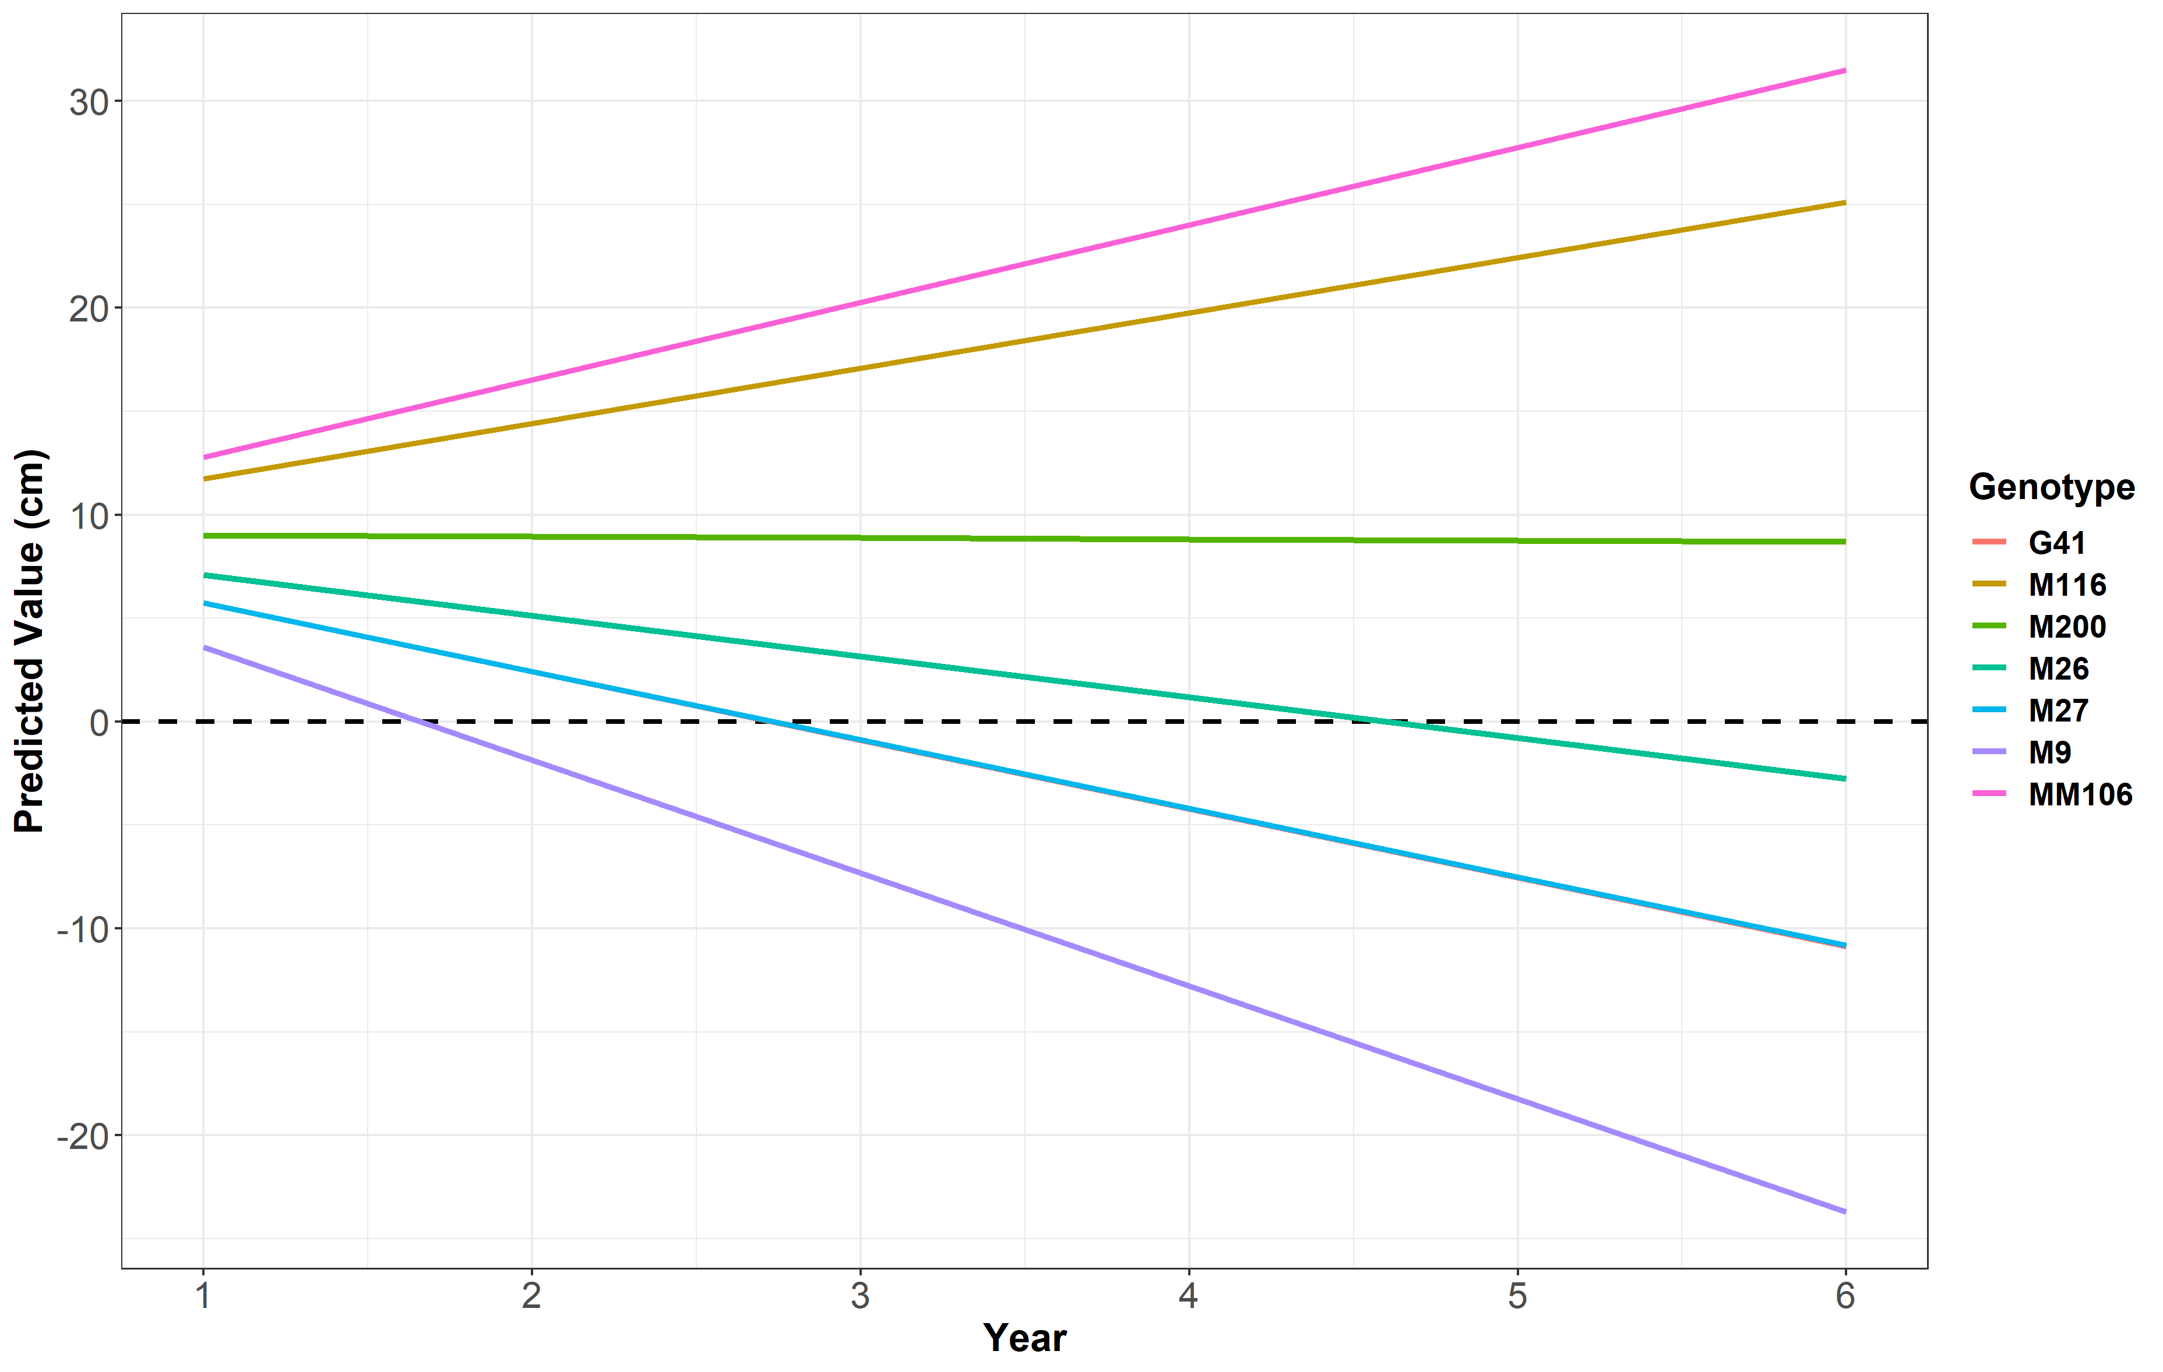
Fig S1 Predicted values from a randomly mixed model with a common intercept of temporal height difference between the alleyway and the previous tree station. Genotype effect was fixed in the model and tree pair location treated as random. Slope trend was calculated from best linear unbiased prediction (BLUP) values. A value above zero indicates a replant effect on the tree planted in the tree station and a value equal to or below zero indicates no replant effect on that genotype

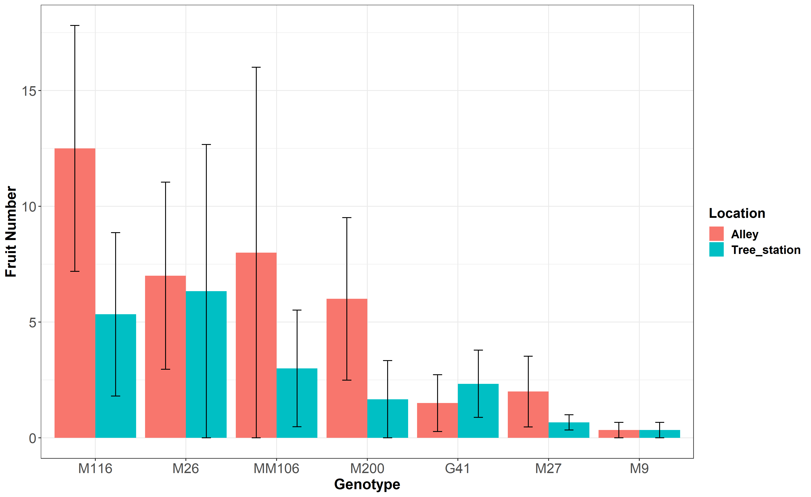
Fig S2 Mean number of fruit counted on each tree in 2021. The colour of the bar indicates the location in which the tree was planted. Red = Alleyway between previous rows, Blue = Previous tree station

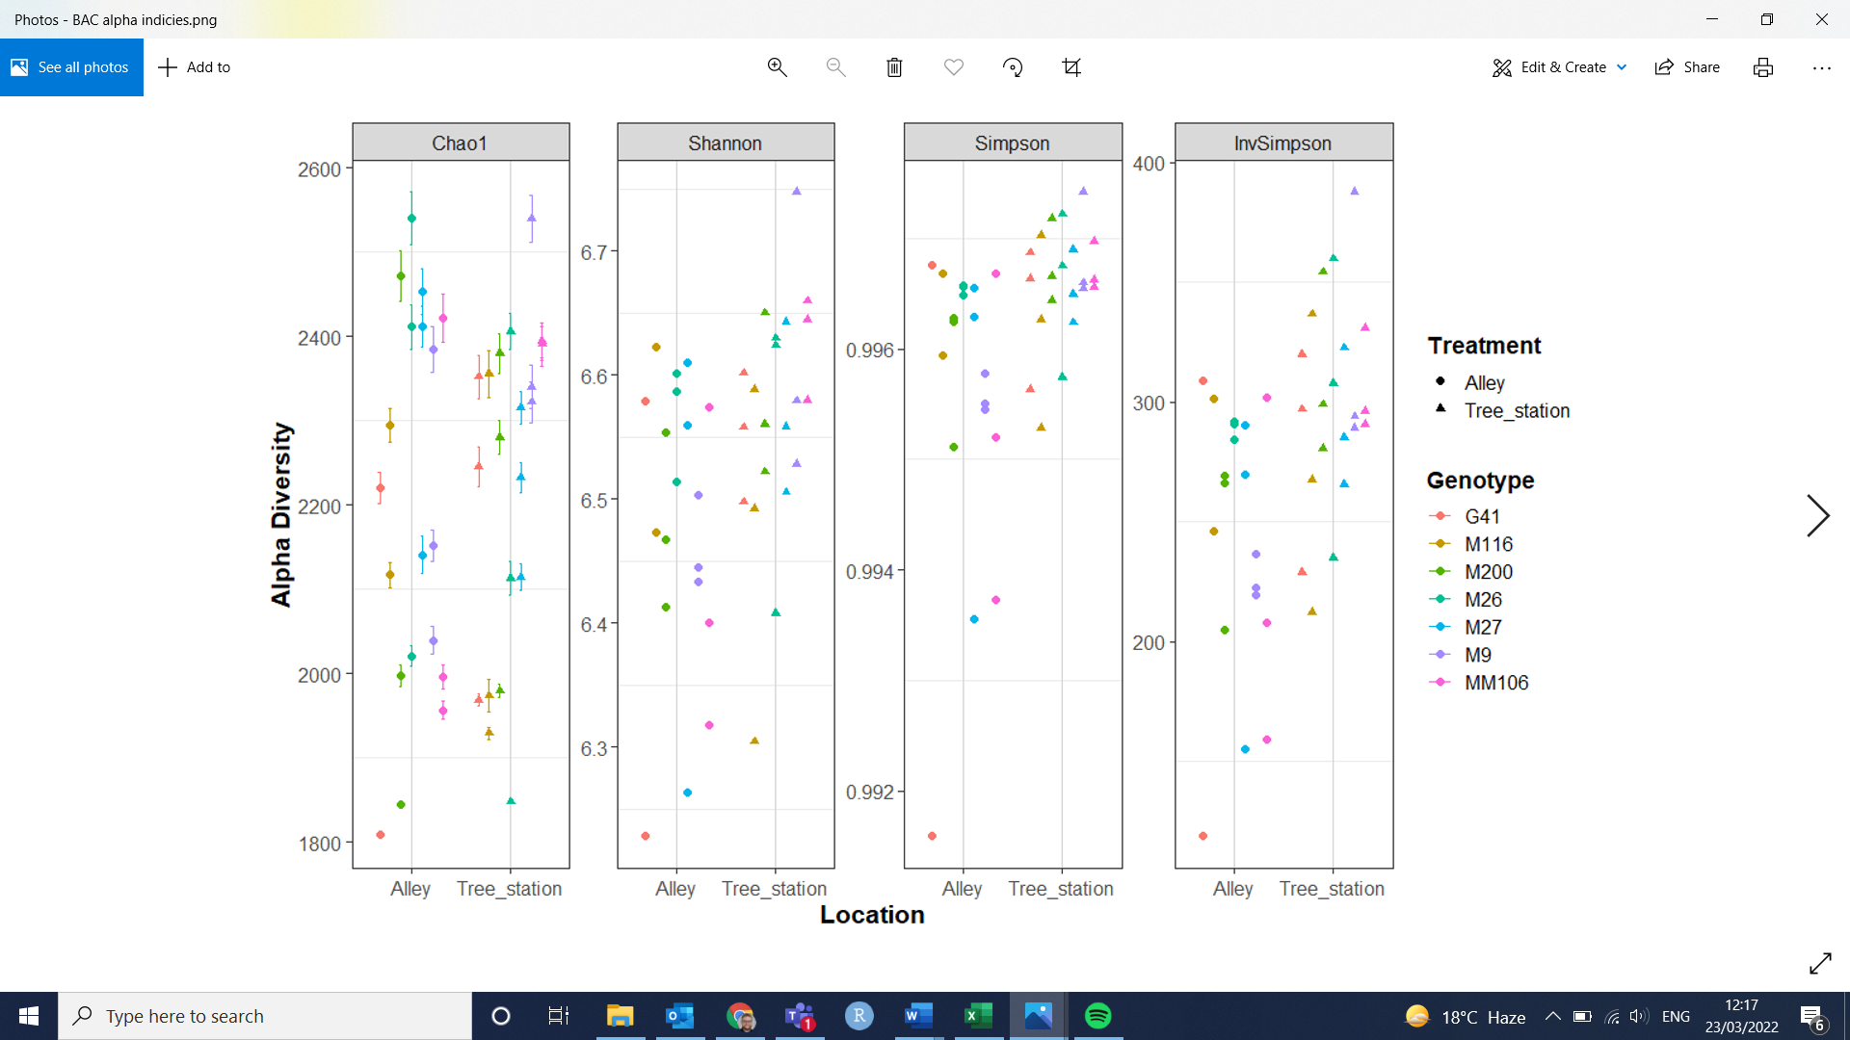
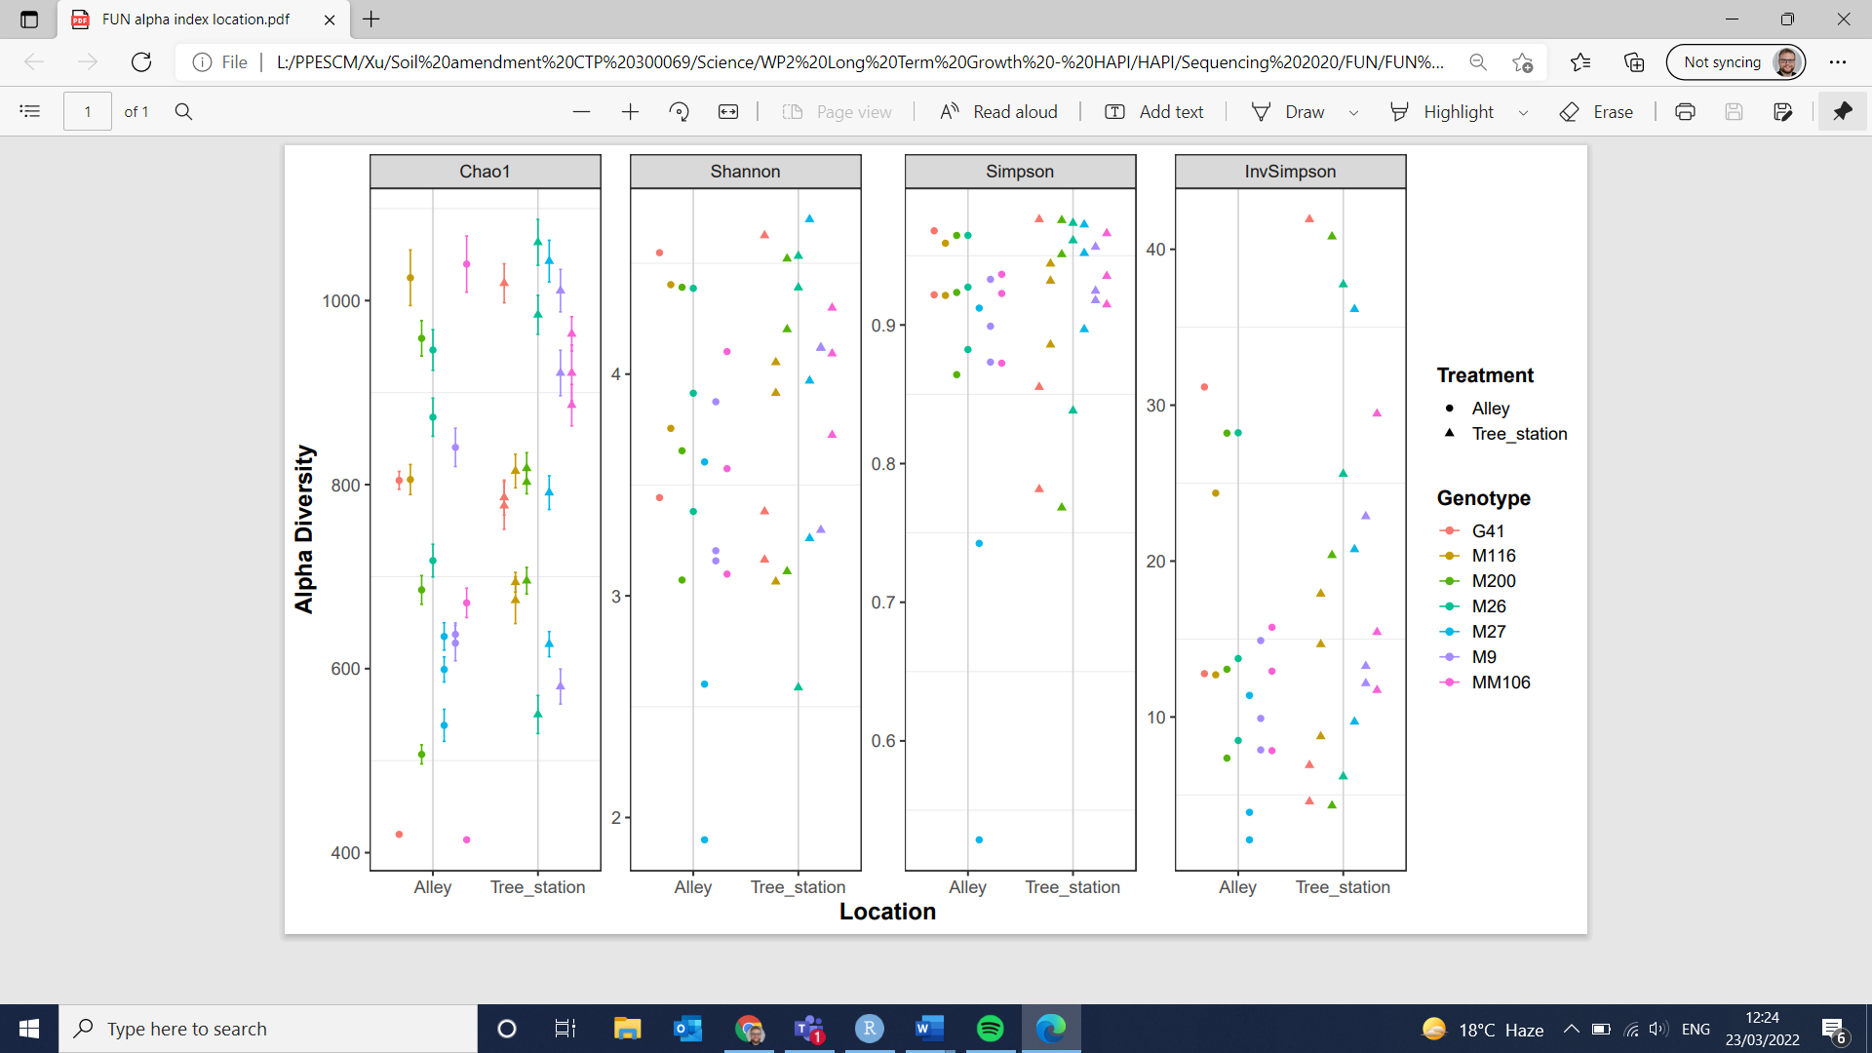
a
b
Fig Fig S3 Alpha (α) diversity measures, Chao1, Shannon, Simpson and InvSimpson for (a) bacteria and (b) fungi. The x-axis indicated the location the trees were replanted in, the previous tree station (▲) or the corresponding alleyway position between the rows (●). The colour indicates the rootstock genotype identity
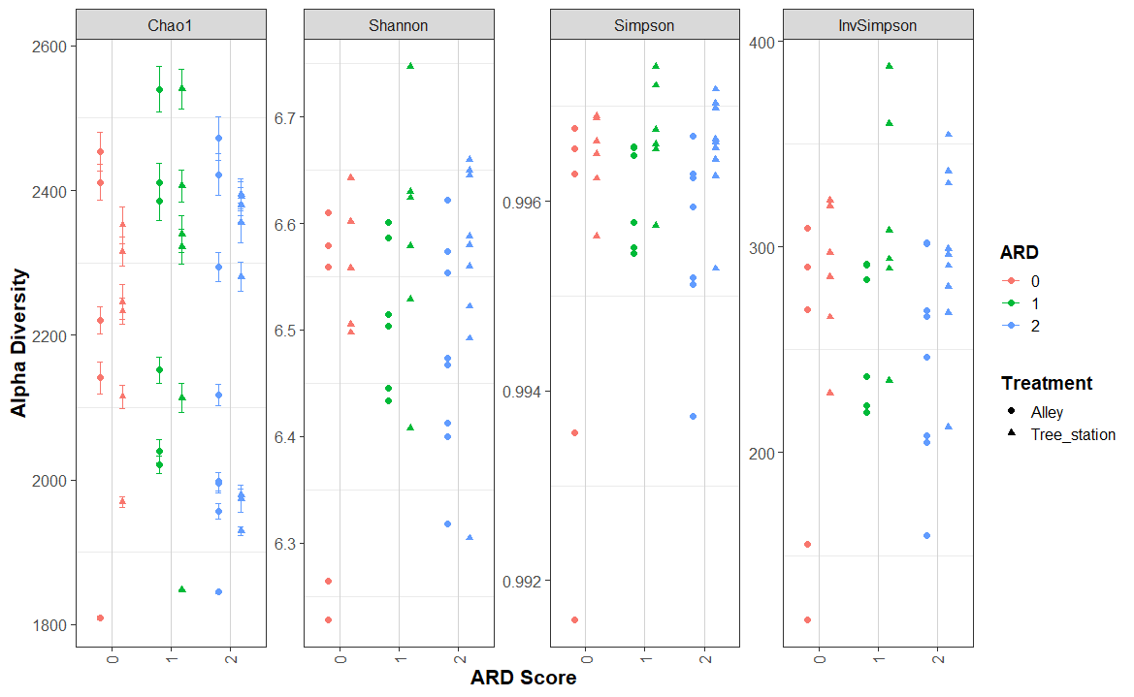
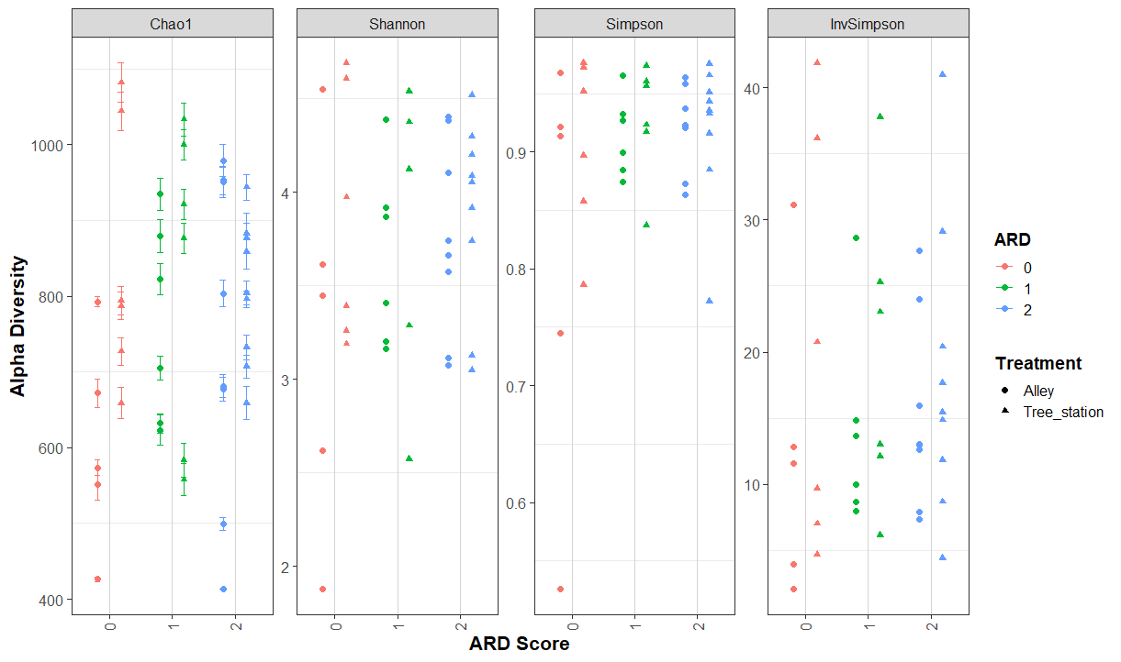
Fig S4 Alpha (α) diversity measures, Chao1, Shannon, Simpson and InvSimpson for (a) bacteria and (b) fungi. The x-axis indicates the ARD score associated with each genotype. The shape indicates the planting location of the tree, the previous tree station (▲) or the corresponding alleyway position between the rows (●).
a
b

