Supplementary information
Supplementary Figure 1. Comparison of serine/glycine metabolic pathway (SGP) related genes among normal thyroid tissue, papillary thyroid carcinoma, and anaplastic thyroid carcinoma using bulkr RNA seq data from our cohort or TCGA. a The bar graph of SGP related gene expression compares normal (blue, n=263) and thyroid tumor tissue (red, n=369) from our cohort. b Comparison of SGP gene expression in normal (n=57) and tumor (n=500) tissue from TCGA THCA cohort. c The SGP related gene expression among normal thyroid tissue, papillary thyroid carcinoma, and anaplastic thyroid carcinoma. Orange coloring of gene names indicates significant induction in ATC or PDTC (n=21) compared to PTC (n=348). Green coloring indicates significant reduction in ATC or PDTC compared to PTC. Pulple coloring indicates significant induction of tumor compared to normal without the significant difference between tumor types. Blue coloring indicates significant reduction in tumor tissue compared to normal. ***P<0.001, ****P<0.0001.

Supplementary Figure 2. Mitochondrial one carbon pathway enzymes, SHMT2 and MTHFD2 negatively correlated with TDS. a Correlation plot using “corrplot” in R packages. The correlation between TDS and SGP genes in primary tumors (348 PTC, 5 PD, and 16 ATC samples) in our cohort. Blue indicates a negative correlation between TDS and SGP genes, whereas red indicates a positive correlation. b Correlation plot between TDS and SGP genes in TCGA THCA tumor cohort (n=500). Blue dot, negative correlation; red dot, positive correlation. c Comparison of SGP gene expression in the TDS high group compared to the TDS low group. *P<0.05, ***P<0.001, ****P<0.0001.

Supplementary Figure 3. Gene expression of thyrocyte markers. Scatter plot of UMAP projection colored according to the mean CPM value of thyrocyte marker genes, such as TG, TPO, PAX8, TSHR, DUOX1, EPCAM, KRT18, and KRT19.

Supplementary Figure 4. Expression of serine and glycine metabolic genes. Violin plots comparing the expression levels of MTFMT, MTHFD1L, MTHFD2L, MTHFD1, MTHFR, PSPH, SFXN1, SFXN2, SFXN3, SLC1A4, SLC1A5, and FOLH1 among normal thyroid cells, papillary thyroid cancer cells, and anaplastic thyroid cancer cells. Mean values are written at the top of each plot. *P<0.05, **P<0.01, ***P<0.001; CPM, count per million.

Supplementary Figure 5. Importance of mitochondrial SHMT2 and MTHFD2 in dedifferentiation of thyroid cancer cells in scRNA-seq analysis of thyroid cancer. a The SGP gene expression in scRNA-seq. Orange coloring of gene names indicates significant induction in ATC (n=5) compared to PTC (n=7). Green coloring indicates significant reduction in ATC compared to PTC. Pulple coloring indicates significant induction of tumor compared to normal without the significant difference between tumor types. Blue coloring indicates significant reduction in tumor tissue compared to normal. b Scatter plots with expression level (log CPM) of SHMT2, MTHFD2, SHMT1, or PHGDH on the x-axis and TDS score on the y-axis. Each dot represents the mean value of each tissue, and the red lines indicate the fitted linear regression. c GSEA between SM-low TDS-high cells and SM-high TDS-low cells. *P<0.05, **P<0.01, ***P<0.001; CPM, count per million.

Supplementary Figure 6. Knock-down of SHMT2 by siRNA reduced cell viability and mitochondrial respiration of thyroid cancer cells. a-b SHMT2 expression and cell viability by SHMT2 knock-down using 20 nM siRNA in BCPAP cells for 48 hours. c-d SHMT2 expression and cell viability after treatment with SHMT2 siRNA for 48 hours in 8505C cells. e-f Effect of SHMT2 knock-down using siRNA on SHMT2 expression and cell viability in FRO cells. All experiments were performed independently at least three times. *P<0.05, ***P<0.001.
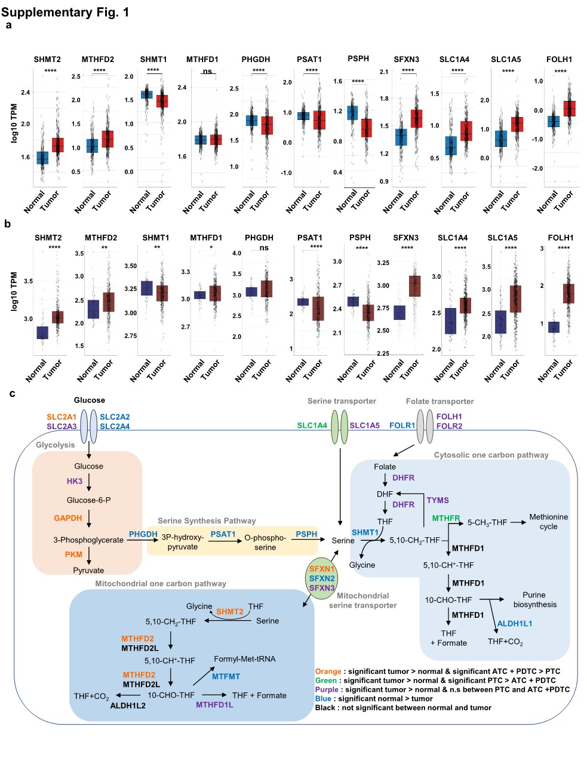
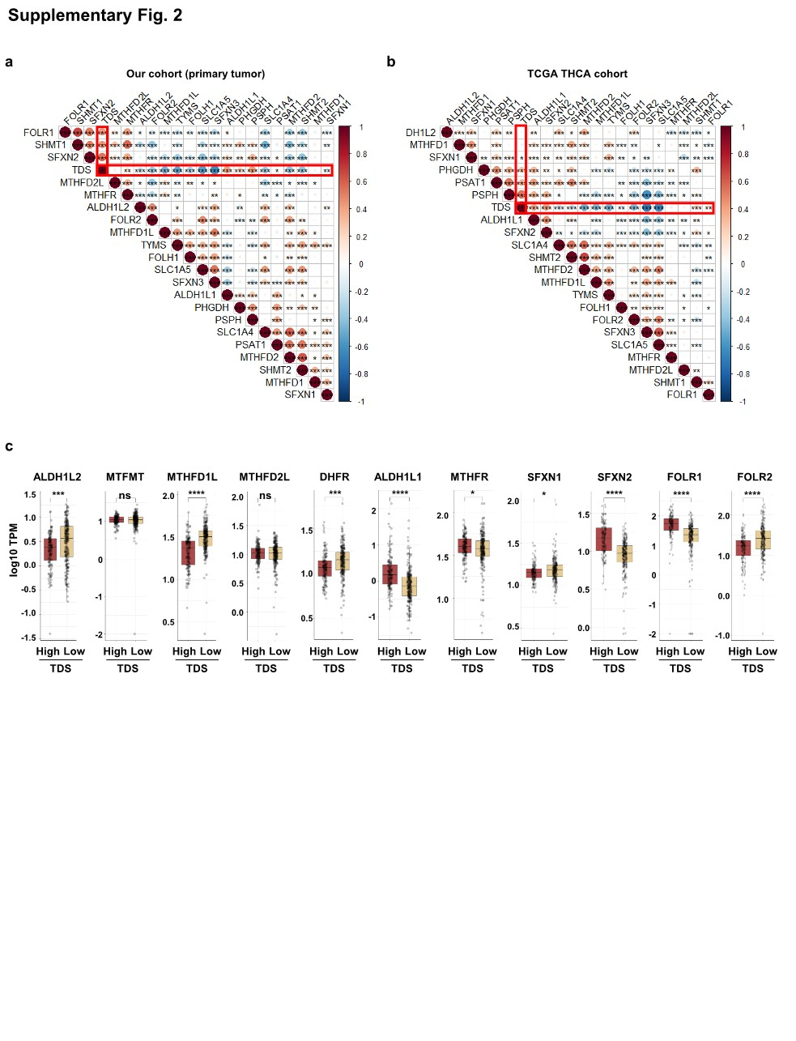
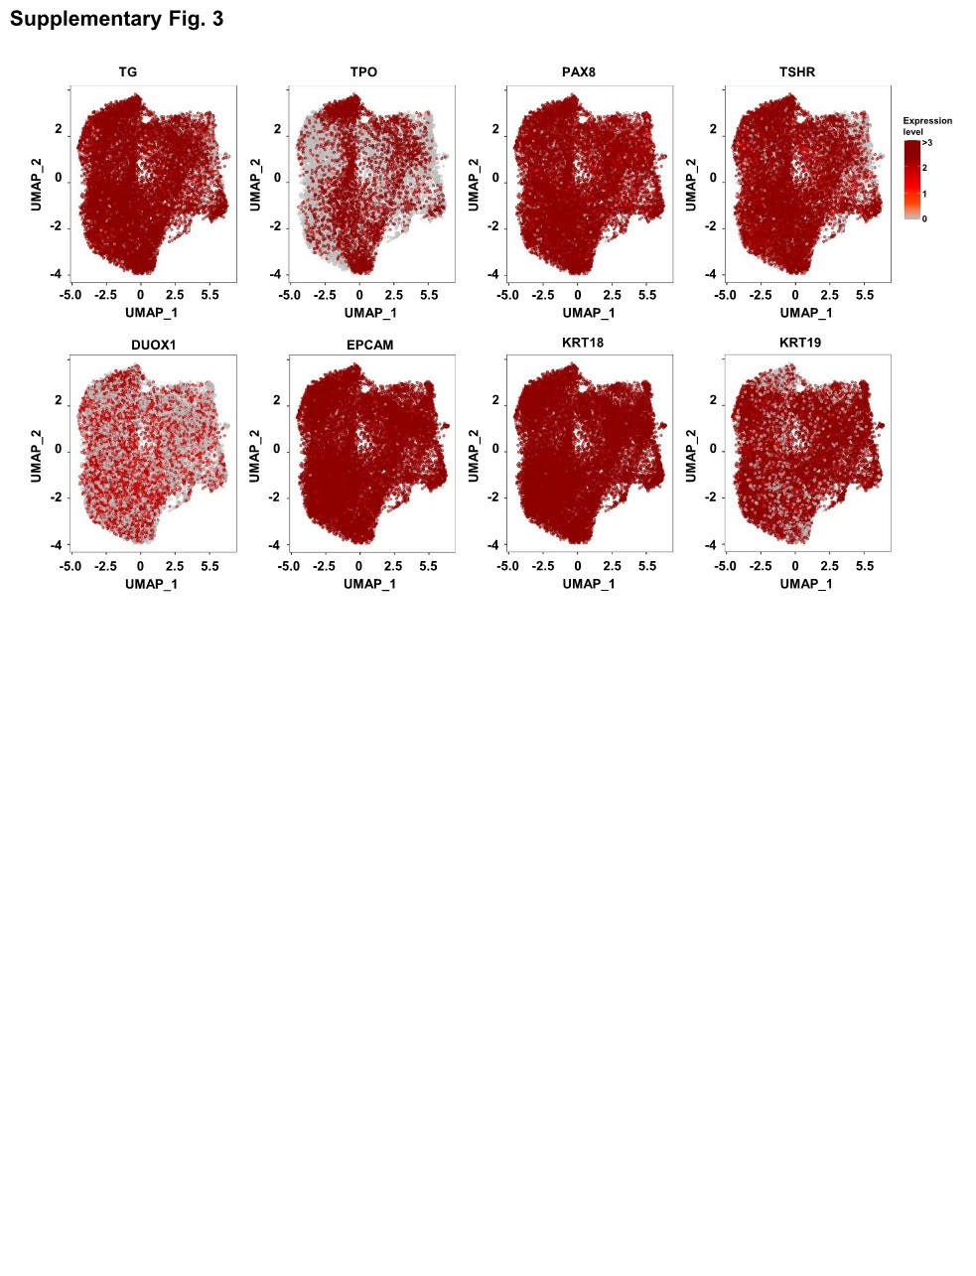

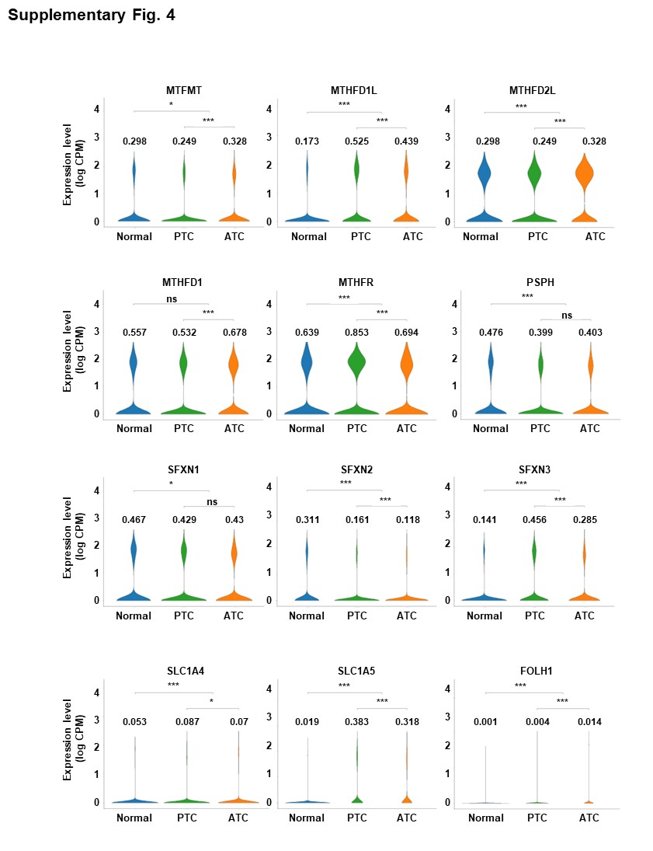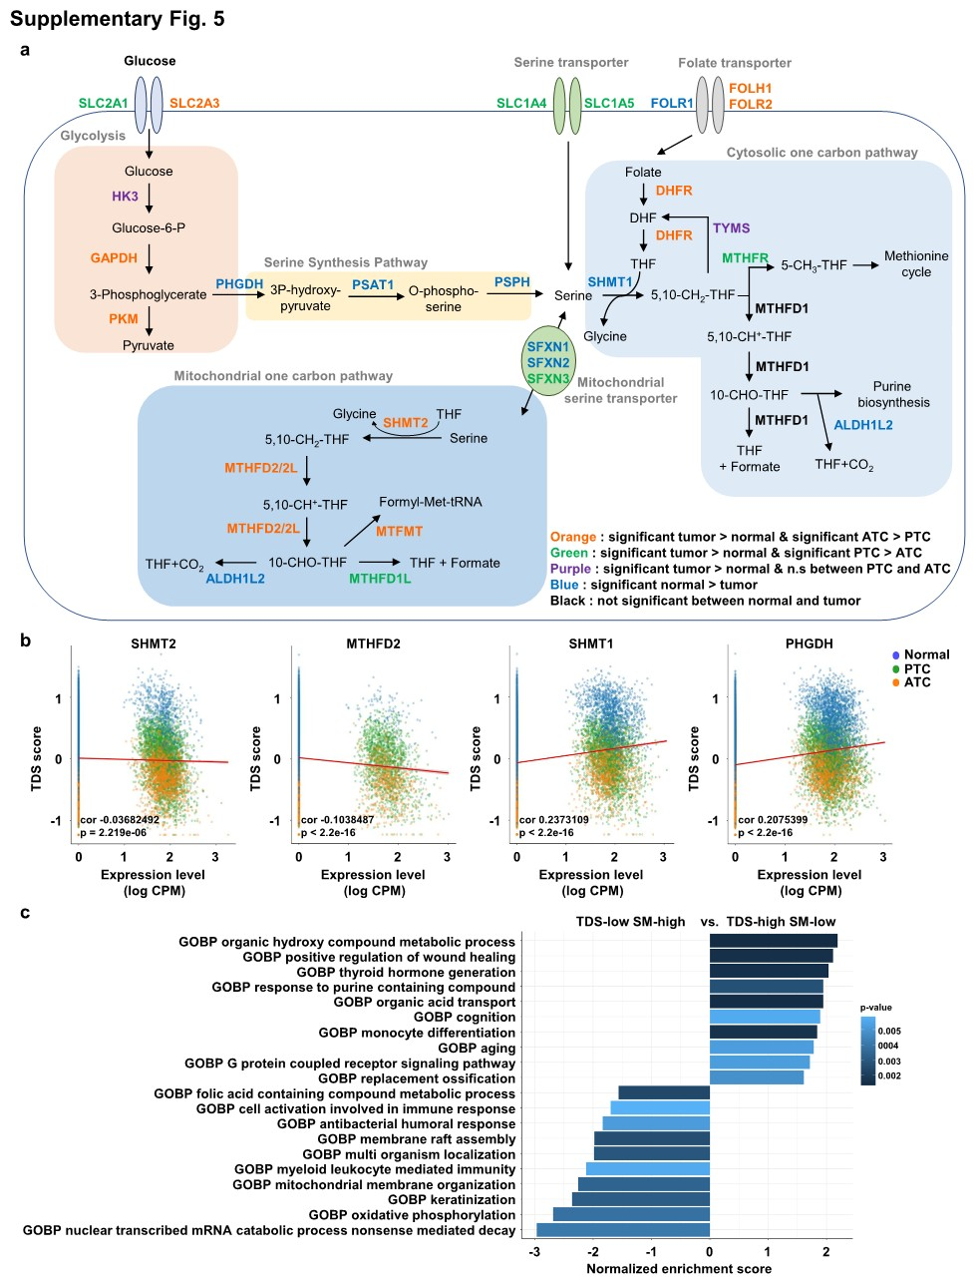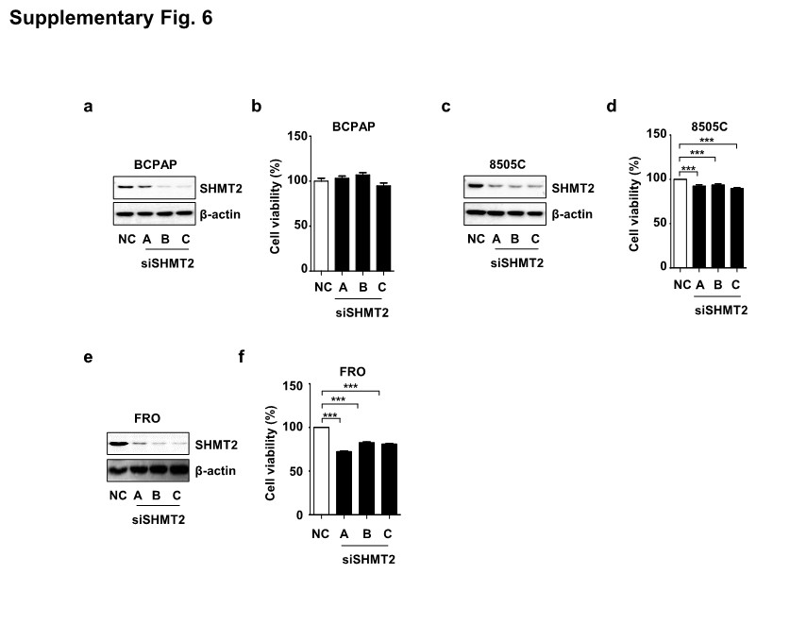

Supplementary Table 1. Relationship between SHMT2 expression and clinicopathologic factors in patients with thyroid cancer (N=369)
Variable |  | Number of patients | SHMT2 expression
 |  | Number of patients | Low (N=185) | High (N=184) | P-value
Age, years |  |  | 50.2±14.6 | 51.5±16.4 | 0.417
Sex | Male  Female | 88  281 | 46 (24.9)  139 (75.1) | 42 (22.8)  142 (77.2) | 0.646
Tumor size, mm |  |  | 1.50±1.43 | 2.16±2.07 | 0.000
Extracapsular  invasion | No  Yes | 155  212 | 91 (49.2)  94 (50.8) | 66 (35.9)  118 (64.1) | 0.010
Extrathyroidal  extension | No  Yes | 196  171 | 98 (53)  87 (47) | 100 (54.3)  84 (45.7) | 0.791
Central lymphnodemeta | No  Yes | 169  198 | 94 (50.8)  91 (49.2) | 77 (41.8)  107 (58.2) | 0.084
Lateral lymphnodemeta | No  Yes  NA | 236  132 | 126 (68.1)  59 (31.9) | 111 (60.3)  73 (39.7) | 0.119
Lymphovascular invasion | No  Yes | 56  311 | 33 (17.8)  152 (82.2) | 25 (13.6)  159 (86.4) | 0.262
Recurrence | No  Yes | 316  53 | 162 (87.6)  23 (12.4) | 154 (83.7)  30 (16.3) | 0.289
Distant metastasis | No  Yes | 347  22 | 179 (96.8)  6 (3.2) | 168 (91.3)  16 (8.7) | 0.027
Cancer type | PTC primary  PD primary  ATC primary | 348  5  16 | 182 (98.4)  1 (0.5)  2 (1.1) | 166 (90.2)  4 (2.2)  14 (7.6) | 0.003
Data are presented as n (%) or mean ± standard deviation unless otherwise noted. P-values were obtained from unpaired t-tests for continuous parametric variables and the Mann–Whitney U test for nonparametric variables. The chi-squared test and Fisher’s exact test were used to evaluate the significance of the correlations of SHMT2 expression with clinical and pathological parameters. AJCC, American Joint Committee on Cancer; SHMT2, serine hydroxymethyltransferase 2.

Supplementary Table 2. Relationship between MTHFD2 expression and clinicopathological factors in patients with thyroid cancer (N=369)
Variable |  | Number of patients | MTHFD2 expression
 |  | Number of patients | Low (N=185) | High (N=183) | P-value
Age, years |  |  | 50.6±14.9 | 51.0±16.0 | 0.805
Sex | Male  Female | 87  281 | 44 (23.8)  141 (76.2) | 43 (23.5)  140 (76.5) | 0.948
Tumor size, mm |  |  | 1.62±1.52 | 2.00±1.98 | 0.036
Extracapsular  invasion | No  Yes | 157  211 | 87 (47.0)  98 (53.0) | 70 (38.3)  113 (61.7) | 0.089
Extrathyroidal  extension | No  Yes | 198  170 | 97 (52.4)  88 (47.6) | 101 (55.2)  82 (44.8) | 0.596
Central lymphnodemeta | No  Yes | 171  197 | 89 (48.1)  96 (51.9) | 82 (44.8)  101 (55.2) | 0.526
Lateral lymphnodemeta | No  Yes | 236  131 | 120 (64.9)  65 (35.1) | 117 (63.9)  66 (36.1) | 0.852
Lymphovascular invasion | No  Yes | 58  310 | 30 (16.2)  155 (83.8) | 28 (15.3)  155 (84.7) | 0.810
Recurrence | No  Yes | 316  52 | 161 (87.0)  24 (13.0) | 155 (84.7)  28 (15.3) | 0.522
Distant metastasis | No  Yes | 347  21 | 180 (97.3)  5 (2.7) | 167 (91.3)  16 (8.7) | 0.013
Cancer type | PTC primary  PD primary  ATC primary | 347  5  16 | 182 (98.4)  2 (1.1)  1 (0.5) | 165 (90.2)  3 (1.6)  15 (8.2) | 0.001
Data are presented as n (%) or mean ± standard deviation unless otherwise noted. P-values were obtained from unpaired t-tests for continuous parametric variables and the Mann–Whitney U test for nonparametric variables. The chi-squared test and Fisher’s exact test were used to evaluate the significance of the correlations of MTHFD2 expression with clinical and pathological parameters. AJCC, American Joint Committee on Cancer; MTHFD2, methylenetetrahydrofolate dehydrogenase.

Supplementary Table 3. Relationship between TDS score and clinicopathological factors in patients with thyroid cancer (N=369)
Variable |  | Number of patients | TDS score
 |  | Number of patients | TDS < 0 (N=231) | TDS > 0 (N=138) | P-value
Age, years |  |  | 51.6±15.6 | 49.7±15.4 | 0.238
Sex | Male  Female | 88  281 | 51 (22.1)  180 (77.9) | 37 (26.8)  101 (73.2) | 0.302
Tumor size, mm |  |  | 1.86±1.74 | 1.77±1.92 | 0.637
Extracapsular  invasion | No  Yes | 157  212 | 89 (38.5)  142 (61.5) | 68 (49.3)  70 (50.7) | 0.043
Extrathyroidal  extension | No  Yes | 198  171 | 128 (55.4)  103 (44.6) | 70 (50.7)  68 (49.3) | 0.382
Central lymphnodemeta | No  Yes | 171  198 | 99 (42.9)  132 (57.1) | 72 (52.5)  66 (47.8) | 0.082
Lateral lymphnodemeta | No  Yes | 237  132 | 141 (61.0)  90 (39.0) | 96 (69.6)  42 (30.4) | 0.098
Lymphovascular invasion | No  Yes | 58  311 | 31 (13.4)  200 (86.6) | 26 (18.8)  111 (80.4) | 0.117
Recurrence | No  Yes | 316  53 | 200 (86.6)  31 (13.4) | 116 (84.1)  22 (15.9) | 0.504
Distant metastasis | No  Yes | 347  22 | 214 (92.6)  17 (7.4) | 133 (96.4)  5 (3.6) | 0.142
Cancer type | PTC primary  PD primary  ATC primary | 348  5  16 | 215 (93.1)  1 (0.4)  15 (6.5) | 133 (96.4)  4 (2.9)  1 (0.7) | 0.005*
Data are presented as n (%) or mean ± standard deviation unless otherwise noted. P-values were obtained from unpaired t-tests for continuous parametric variables and the Mann–Whitney U test for nonparametric variables. The chi-squared test and Fisher’s exact test were used to evaluate the significance of the correlations of TDS with clinical and pathological parameters. TNM classification from the AJCC seventh edition was used. AJCC, American Joint Committee on Cancer; TDS, thyroid differentiation score.

Supplementary Table 4. Relationship between SHMT2 expression and clinicopathological factors in thyroid cancer patients in TCGA-THCA cohort (N=500)
Variable |  | Number of patients | SHMT2 expression
 |  | Number of patients | Low (N=250) | High (N=250) | P-value
Age, years |  |  | 45.5±15.5 | 49.0±16.0 | 0.015
Sex | Male  Female | 135  365 | 68 (27.2)  182 (72.8) | 67 (26.8)  183 (73.2) | 0.076
Tumor size, mm |  |  | 1.35±1.07 | 1.44±1.07 | 0.369
T stage | T1-T2  T3-T4 | 308  192 | 170 (68.0)  80 (32.0) | 138 (55.2)  112 (44.8) | 0.003
Extrathyroidal  extension | No  Yes | 482  18 | 248 (99.2)  2 (0.8) | 234 (93.6)  16 (6.4) | 0.001
Lymph node metastasis | No  Yes | 277  223 | 152 (60.8)  98 (39.2) | 125 (50.0)  125 (50.0) | 0.015
M stage | M0  M1 | 492  8 | 248 (99.2)  2 (0.8) | 244 (97.6)  6 (2.4) | 0.154
Stage | I  II  III  IV | 284  52  111  53 | 157 (62.8)  32 (12.8)  47 (18.8)  14 (5.6) | 127 (50.8)  20 (8.0)  64 (25.6)  39 (15.6) | 0.000
Overall survival | Alive  Dead | 484  16 | 243 (97.2)  7 (2.8) | 241 (96.4)  9 (3.6) | 0.611
Disease-specific survival | Alive  Dead | 493  7 | 248 (99.2)  2 (0.8) | 245 (98.0)  5 (2.0) | 0.253
Disease-free interval event | No  Yes | 474  26 | 239 (95.6)  11 (4.4) | 235 (94.0)  15 (6.0) | 0.420
BRAF^{V600E} mutation | No  Yes | 268  232 | 150 (60.0)  100 (40.0) | 118 (47.2)  132 (52.8) | 0.004
Data are presented as n (%) or mean ± standard deviation unless otherwise noted. P-values were obtained from unpaired t-tests for continuous parametric variables and the Mann–Whitney U test for nonparametric variables. The chi-squared test and Fisher’s exact test were used to evaluate the significance of the correlations of SHMT2 expression with clinical and pathological parameters. TNM classification from the AJCC seventh edition was used. AJCC, American Joint Committee on Cancer; SHMT2, serine hydroxymethyltransferase 2.

Supplementary Table 5. Relationship between MTHFD2 expression and clinicopathological factors in thyroid cancer patients in TCGA-THCA cohort (N=500)
Variable |  | Number of patients | MTHFD2 expression
 |  | Number of patients | Low (N=250) | High (N=250) | P-value
Age, years |  |  | 47.8±15.2 | 46.8±16.5 | 0.462
Sex | Male  Female | 135  365 | 68 (27.2)  182 (72.8) | 67 (26.8)  183 (73.2) | 0.920
Tumor size, mm |  |  | 1.43±1.11 | 1.36±1.03 | 0.475
T stage | T1-T2  T3-T4 | 308  192 | 159 (63.6)  91 (36.4) | 149 (59.6)  101 (40.4) | 0.358
Extrathyroidal  extension | No  Yes | 482  18 | 243 (97.2)  7 (2.8) | 239 (95.6)  11 (4.4) | 0.337
Lymph node metastasis | No  Yes | 277  223 | 168 (67.2)  82 (32.8) | 109 (43.6)  141 (56.4) | 0.000
M stage | M0  M1 | 492  8 | 245 (98.0)  5 (2.0) | 247 (98.8)  3 (1.2) | 0.476
Stage | I  II  III  IV | 284  52  111  53 | 137 (54.8)  33 (13.2)  61 (24.4)  19 (7.6) | 147 (58.8)  19 (7.6)  50 (20.0)  34 (13.6) | 0.024
Overall survival | Alive  Dead | 484  16 | 243 (97.2)  7 (2.8) | 241 (96.4)  9 (3.6) | 0.611
Disease-specific survival | Alive  Dead | 493  7 | 247 (98.8)  3 (1.2) | 246 (98.4)  4 (1.6) | 0.703
Disease-free interval event | No  Yes | 474  26 | 238 (95.2)  12 (4.8) | 236 (94.4)  14 (5.6) | 0.687
BRAF^{V600E} mutation | No  Yes | 268  232 | 159 (63.6)  91 (36.4) | 109 (43.6)  141 (56.4) | 0.000
Data are presented as n (%) or mean ± standard deviation unless otherwise noted. P-values were obtained from unpaired t-tests for continuous parametric variables and the Mann–Whitney U test for nonparametric variables. The chi-squared test and Fisher’s exact test were used to evaluate the significance of the correlations of MTHFD2 expression with clinical and pathological parameters. TNM classification from the AJCC seventh edition was used. AJCC, American Joint Committee on Cancer; MTHFD2, methylenetetrahydrofolate dehydrogenase.

