Supplementary material
Table S1. Location of 20 mixed fruit orchards and geographic information. Hive identity, proportion of surrounding forest (FO), agricultural (AG), and urbanized covers (UR) at 250 and 600 m radii for each orchard are given. Each orchard is classified into one of the three main landscape types including predominantly forested (F), predominantly agricultural (A), and predominantly urbanized (U) landscapes. Asterisks indicate two hives and one orchard excluded from our analyses.
Province | Orchard | Hive ID | Latitude | Longitude | FO250m | AG250m | UR250m | FO600m | AG600m | UR600m | Landscape type
Songkhla | SK1 | T37 | 6.973208 | 100.3331 | 0.00 | 70.84 | 29.16 | 0.00 | 70.77 | 29.23 | A
Songkhla | SK2 | T43 | 6.97946 | 100.1456 | 99.60 | 0.40 | 0.00 | 99.57 | 0.41 | 0.02 | F
Songkhla | SK3 | T40 | 7.229335 | 100.3721 | 0.00 | 93.36 | 6.64 | 0.00 | 89.55 | 10.45 | A
Songkhla | SK4 | T13 | 7.077052 | 100.449 | 0.00 | 15.20 | 84.44 | 0.00 | 19.57 | 80.06 | U
Songkhla | SK5 | T15 | 6.995961 | 100.5025 | 0.00 | 0.00 | 100.00 | 0.00 | 5.26 | 92.12 | U
Songkhla | SK6 | T6 | 6.898159 | 100.2546 | 0.00 | 99.73 | 0.27 | 0.00 | 99.65 | 0.33 | A
Songkhla | SK7 | T9 | 6.897327 | 100.2385 | 73.81 | 26.18 | 0.01 | 73.80 | 26.19 | 0.01 | F
Songkhla | SK8 | T23, T16 | 7.157521 | 100.2596 | 0.00 | 94.43 | 5.57 | 11.17 | 78.96 | 3.35 | A
Songkhla | SK9 | T11, T44 | 6.93622 | 100.1345 | 0.00 | 1.58 | 98.38 | 5.74 | 19.04 | 75.17 | U
Songkhla | SK10 | T1, T2 | 7.119086 | 100.2095 | 0.00 | 99.42 | 0.02 | 0.00 | 99.41 | 0.04 | A
Songkhla | SK11 | T38, T45 | 7.016836 | 100.1486 | 92.08 | 0.12 | 7.78 | 90.60 | 1.69 | 7.65 | F
Songkhla | SK12 | T35 | 7.030031 | 100.1492 | 0.00 | 99.52 | 0.01 | 0.00 | 98.68 | 0.02 | A
Phatthalung | PL13 | T17, T20 | 7.22713 | 100.1793 | 0.00 | 99.21 | 0.79 | 0.00 | 99.22 | 0.78 | A
Phatthalung | PL14 | T26, T19 | 7.189061 | 100.0979 | 0.00 | 62.14 | 35.81 | 0.16 | 89.71 | 9.43 | A
Phatthalung | PL15 | T29, T21 | 7.327679 | 100.0306 | 0.00 | 74.75 | 25.25 | 0.00 | 75.00 | 24.54 | A
Phatthalung | PL16 | T27 | 7.401799 | 100.03 | 0.00 | 100.00 | 0.00 | 0.00 | 99.88 | 0.12 | A
Phatthalung | PL17 | T18, T32* | 7.529596 | 99.93848 | 0.00 | 98.98 | 1.02 | 19.66 | 79.41 | 0.93 | A
Phatthalung | PL18 | T33, T28 | 7.420979 | 99.93997 | 0.00 | 99.37 | 0.63 | 2.80 | 95.95 | 1.25 | A
Phatthalung | PL19 | T22, T30 | 7.38369 | 99.98612 | 44.67 | 41.71 | 13.61 | 0.97 | 98.45 | 0.58 | A
Songkhla | SK0* | T46* | 7.004158 | 100.1407 | 91.98 | 0.24 | 7.77 | 90.49 | 1.78 | 7.64 | F

Table S2. Spearman correlations with all proportions of surrounding agricultural, forest, and urbanized landscapes at 250 and 600 m radii. Asterisks indicate significant correlations: * P < 0.05, ** P < 0.01, *** P < 0.001. Abbreviations: AG: agricultural cover; FO: forest cover; UR: urbanized cover.
 | AG250m | FO250m | UR250m | AG600m | FO600m
AG250m
FO250m | -0.57***
UR250m | -0.64*** | -0.15
AG600m | 0.86*** | -0.40** | -0.50***
FO600m | -0.48*** | 0.62*** | -0.03 | -0.55***
UR600m | -0.50*** | -0.34* | 0.90*** | -0.56*** | -0.10

Table S3. Models are shown in the procedure of step-wise deletion of non-significant (P > 0.05) fixed factors for colony weights across 19 sites in Songkhla and Phatthalung, Southern Thailand. We assessed significance by comparing each model with a given explanatory variable/interaction to the same model without this variable (models compared to each other are listed in groups of two or three) using the anova function in the lme4 package (based on likelihood-ratio tests and chisquare statistics). Values of Akaike Information Criterion (AIC), variance of fixed effects (marginal R²: R²m), and variance of fixed and random effects (conditional R²: R²c) for each candidate model are given. Non-significant fixed factors detected to be removed in the step-wise process are shown in bold. All P-values were adjusted by using the False Discovery Rate (FDR) for multiple testing. We eventually selected one model with the lowest AIC value (highlighted in yellow) for each landscape composition (i.e., agricultural cover (AG); forest cover (FO); urbanized cover (UR)) between two spatial scales (i.e., within 250 and 600 m radii), which best explained landscape effects on colony weights.
Model | AIC | R²_{m} | R²_{c} | logLik | χ2 | df | P-value | corrected P-value
Forest cover
At a 250 m radius
Colony.weight.sqrt ~ Time * FO250m + (1|Site/Hive.ID) | 1421.1 | 0.36 | 0.87 | -703.53 | 6.807 | 1 | 0.009 | 0.009
Colony.weight.sqrt ~ Time + FO250m + (1|Site/Hive.ID) | 1425.9 | 0.36 | 0.86 | -706.94
Colony.weight.sqrt ~ Time * FO250m + (1|Site/Hive.ID) | 1421.1 | 0.36 | 0.87 | -703.53 | 291.28 | 3 | < 0.001 | < 0.001
Colony.weight.sqrt ~ 1 + (1|Site/Hive.ID) | 1706.3 | 0.00 | 0.58 | -849.17
At a 600 m radius
Colony.weight.sqrt ~ Time * FO600m + (1|Site/Hive.ID) | 1420.8 | 0.39 | 0.87 | -703.38 | 5.987 | 1 | 0.014 | 0.014
Colony.weight.sqrt ~ Time + FO600m + (1|Site/Hive.ID) | 1424.8 | 0.38 | 0.86 | -706.38
Colony.weight.sqrt ~ Time * FO600m + (1|Site/Hive.ID) | 1420.8 | 0.39 | 0.87 | -703.38 | 291.58 | 3 | < 0.001 | < 0.001
Colony.weight.sqrt ~ 1 + (1|Site/Hive.ID) | 1706.3 | 0.00 | 0.58 | -849.17
Agricultural cover
At a 250 m radius
Colony.weight.sqrt ~ Time * AG250m + (1|Site/Hive.ID) | 1404.6 | 0.39 | 0.87 | -695.31 | 22.371 | 1 | < 0.001 | < 0.001
Colony.weight.sqrt ~ Time + AG250m + (1|Site/Hive.ID) | 1425.0 | 0.38 | 0.86 | -706.5
Colony.weight.sqrt ~ Time * AG250m + (1|Site/Hive.ID) | 1404.6 | 0.39 | 0.87 | -695.31 | 307.72 | 3 | < 0.001 | < 0.001
Colony.weight.sqrt ~ 1 + (1|Site/Hive.ID) | 1706.3 | 0.00 | 0.58 | -849.17
At a 600 m radius
Colony.weight.sqrt ~ Time * AG600m + (1|Site/Hive.ID) | 1402.0 | 0.43 | 0.88 | -694.03 | 23.066 | 1 | < 0.001
Colony.weight.sqrt ~ Time + AG600m + (1|Site/Hive.ID) | 1423.1 | 0.42 | 0.86 | -705.56
Colony.weight.sqrt ~ Time * AG600m + (1|Site/Hive.ID) | 1402.0 | 0.43 | 0.88 | -694.03 | 310.300 | 3 | < 0.001
Colony.weight.sqrt ~ 1 + (1|Site/Hive.ID) | 1706.3 | 0.00 | 0.58 | -849.17
Urbanized cover
At a 250 m radius
Colony.weight.sqrt ~ Time * UR250m + (1|Site/Hive.ID) | 1421.7 | 0.27 | 0.87 | -703.85 | 10.098 | 1 | 0.001
Colony.weight.sqrt ~ Time + UR250m + (1|Site/Hive.ID) | 1429.8 | 0.26 | 0.86 | -708.89
Colony.weight.sqrt ~ Time * UR250m + (1|Site/Hive.ID) | 1421.7 | 0.27 | 0.87 | -703.85 | 290.660 | 3 | < 0.001
Colony.weight.sqrt ~ 1 + (1|Site/Hive.ID) | 1706.3 | 0.00 | 0.58 | -849.17
At a 600 m radius
Colony.weight.sqrt ~ Time * UR600m + (1|Site/Hive.ID) | 1419.5 | 0.27 | 0.87 | -702.72 | 12.194 | 1 | < 0.001
Colony.weight.sqrt ~ Time + UR600m + (1|Site/Hive.ID) | 1429.6 | 0.27 | 0.86 | -708.82
Colony.weight.sqrt ~ Time * UR600m + (1|Site/Hive.ID) | 1419.5 | 0.27 | 0.87 | -702.72 | 292.900 | 3 | < 0.001
Colony.weight.sqrt ~ 1 + (1|Site/Hive.ID) | 1706.3 | 0.00 | 0.58 | -849.17

Table S4. Proportions of the four main agricultural land-use types, i.e. paddy fields (PD), oil palm plantations (OP), rubber plantations (RB), and fruit orchards (OR), within a 600 m radius around each study orchard are given. We further classified each study orchard into either low or high surrounding land-use according to the proportion of agricultural land-use types in the surrounding area. We referred to low land-use when the proportion of each land-use type was lower than the average proportion of each land-use type, and to high land-use when the proportion of each land-use type was higher than the average proportion of each land-use type, respectively.
Province | Orchard | Hive ID | PD600m | % PD level | OP600m | % OP level | RB600m | % RB level | OR600m | % OR level
Songkhla | SK1 | T37 | 1.97 | High | 0.11 | Low | 67.47 | High | 0.04 | Low
Songkhla | SK2 | T43 | 0.00 | Low | 0.01 | Low | 0.39 | Low | 0.02 | Low
Songkhla | SK3 | T40 | 0.00 | Low | 2.33 | High | 86.94 | High | 0.29 | Low
Songkhla | SK4 | T13 | 14.74 | High | 0.15 | Low | 4.65 | Low | 0.00 | Low
Songkhla | SK5 | T15 | 0.00 | Low | 0.00 | Low | 4.96 | Low | 0.30 | Low
Songkhla | SK6 | T6 | 0.00 | Low | 0.00 | Low | 99.61 | High | 0.04 | Low
Songkhla | SK7 | T9 | 0.00 | Low | 0.00 | Low | 26.17 | Low | 0.02 | Low
Songkhla | SK8 | T23, T16 | 8.74 | High | 3.32 | High | 63.66 | Low | 1.34 | High
Songkhla | SK9 | T11, T44 | 0.49 | Low | 0.05 | Low | 17.18 | Low | 1.11 | High
Songkhla | SK10 | T1, T2 | 0.00 | Low | 0.00 | Low | 99.30 | High | 0.02 | Low
Songkhla | SK11 | T38, T45 | 0.00 | Low | 0.00 | Low | 1.52 | Low | 0.17 | Low
Songkhla | SK12 | T35 | 0.00 | Low | 0.02 | Low | 98.33 | High | 0.33 | Low
Phatthalung | PL13 | T17, T20 | 0.00 | Low | 0.49 | High | 98.59 | High | 0.00 | Low
Phatthalung | PL14 | T26, T19 | 0.00 | Low | 0.13 | Low | 89.45 | High | 0.08 | Low
Phatthalung | PL15 | T29, T21 | 0.00 | Low | 0.00 | Low | 74.87 | High | 0.00 | Low
Phatthalung | PL16 | T27 | 0.00 | Low | 0.06 | Low | 99.72 | High | 0.05 | Low
Phatthalung | PL17 | T18 | 0.03 | Low | 0.02 | Low | 77.85 | High | 1.50 | High
Phatthalung | PL18 | T33, T28 | 0.05 | Low | 0.00 | Low | 95.25 | High | 0.39 | High
Phatthalung | PL19 | T22, T30 | 0.00 | Low | 0.07 | Low | 97.75 | High | 0.57 | High
 |  | Average | 1.26 |  | 0.39 |  | 65.76 |  | 0.36

Figure S1. Examples of foraging loads, i.e., pollen load (A), nectar load (B), and resin load (C), which carried by Tetragonula fuscobalteata across 19 landscapes in Songkhla and Phattalung provinces, Southern Thailand.
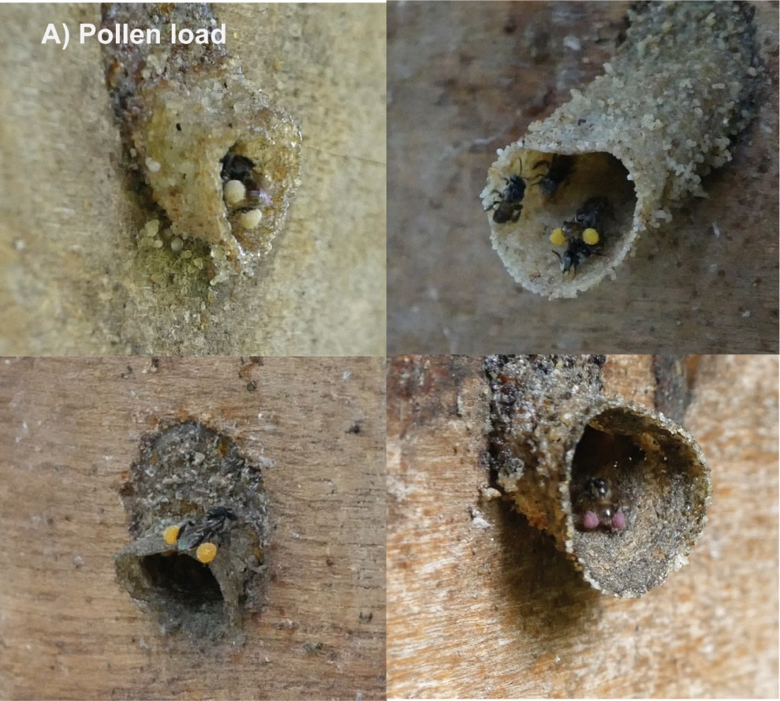
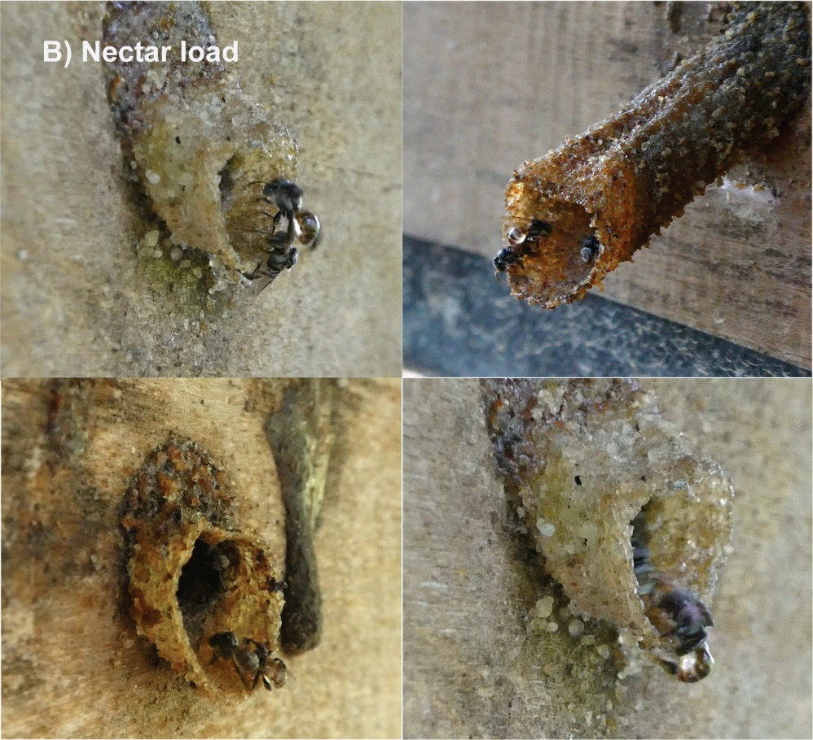

Figure S1. (Cont.) Examples of foraging loads, i.e., pollen load (A), nectar load (B), and resin load (C), which carried by Tetragonula fuscobalteata across 19 landscapes in Songkhla and Phattalung provinces, Southern Thailand.
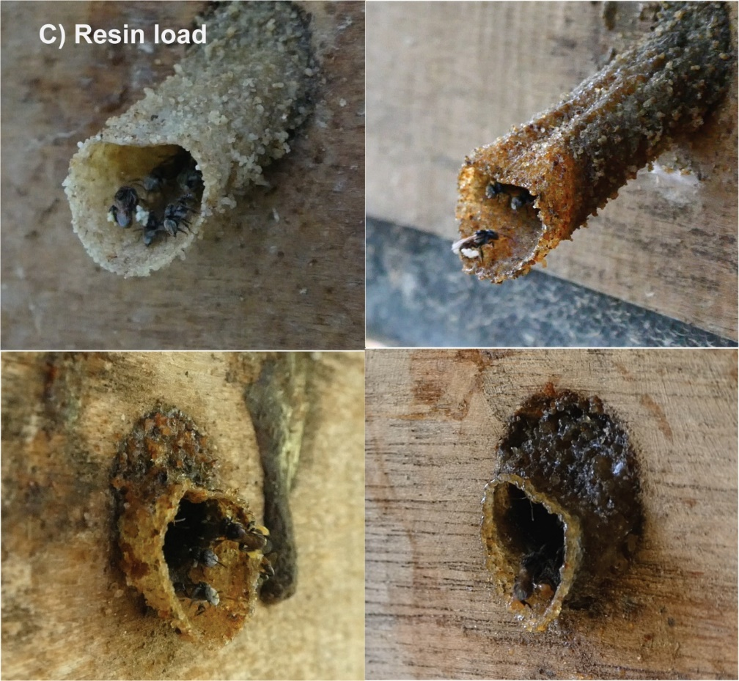

Figure S2. Colony weights over the hive placement time across 19 landscapes in Songkhla and Phattalung provinces, Southern Thailand.
Figure S3. Mean (± SE) colony weights over time after hive placement across 19 landscapes in Songkhla and Phattalung provinces, Southern Thailand (n = 28 colonies).
Figure S4. The number of departing foragers in 5 min over the hive placement time across 19 landscapes in Songkhla and Phattalung provinces, Southern Thailand.
Figure S5. The number of returning foragers in 5 min over the hive placement time across 19 landscapes in Songkhla and Phattalung provinces, Southern Thailand.
Figure S6. The number of pollen-carrying foragers in 5 min over the hive placement time across 19 landscapes in Songkhla and Phattalung provinces, Southern Thailand.
Figure S7. The number of nectar-carrying foragers in 5 min over the hive placement time across 19 landscapes in Songkhla and Phattalung provinces, Southern Thailand.
Figure S8. The number of resin-carrying foragers in 5 min over the hive placement time across 19 landscapes in Songkhla and Phattalung provinces, Southern Thailand.
Figure S9. Mean (± SE) departing (A) and returning (B) foragers per 5 min over time after hive placement separate for three main landscape types across 19 sites in Songkhla and Phatthalung, Southern Thailand.

