Taurine, Homotaurine, GABA and hydrophobic amino acids content influences “in vitro” antioxidant and SIRT1 modulation activities of enzymatic protein hydrolysates from algae

Carlos Terriente-Palacios ^{a, b}, Susana Rubino Campoy ª, Maria Hortós ª, César Peteiro ^{c}. Massimo Castellari ^{*, a}

ª IRTA Food Industries – Finca Camps I Armet s/n, 17121 – Monells, Girona (Spain)
Tel. 972 63 00 52 Ext.1414
^{b} Escuela Internacional de Doctorado UNED - Calle Bravo Murillo 38, 28015 Madrid, Spain
^{c} Spanish Institute of Oceanography of the Spanish National Research Council (IEO, CSIC), Oceanographic Center of Santander, Marine Culture Units “El Bocal”, Seaweeds Center, Barrio Corbanera s/n., 39012 Monte, Santander (Spain)
*Corresponding author: e-mail Massimo.Castellari@irta.cat

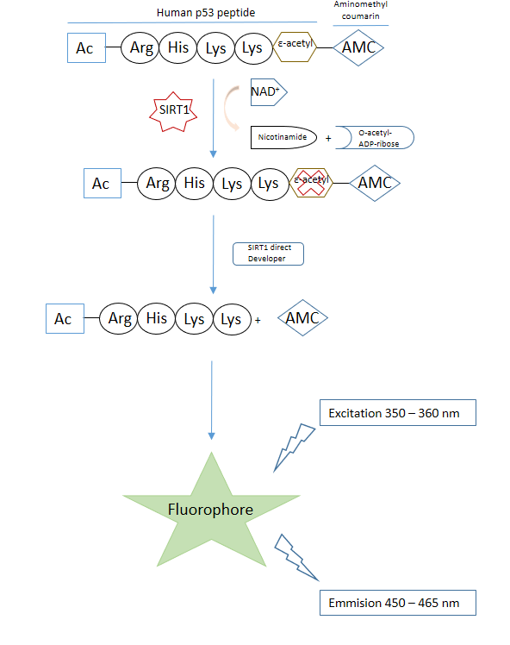

Figure S1. Principle of the SIRT1 Fluorescence screening assay used in this study.

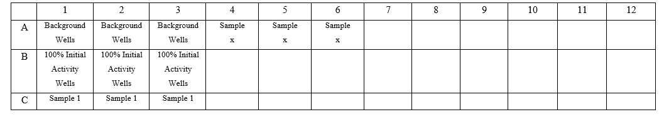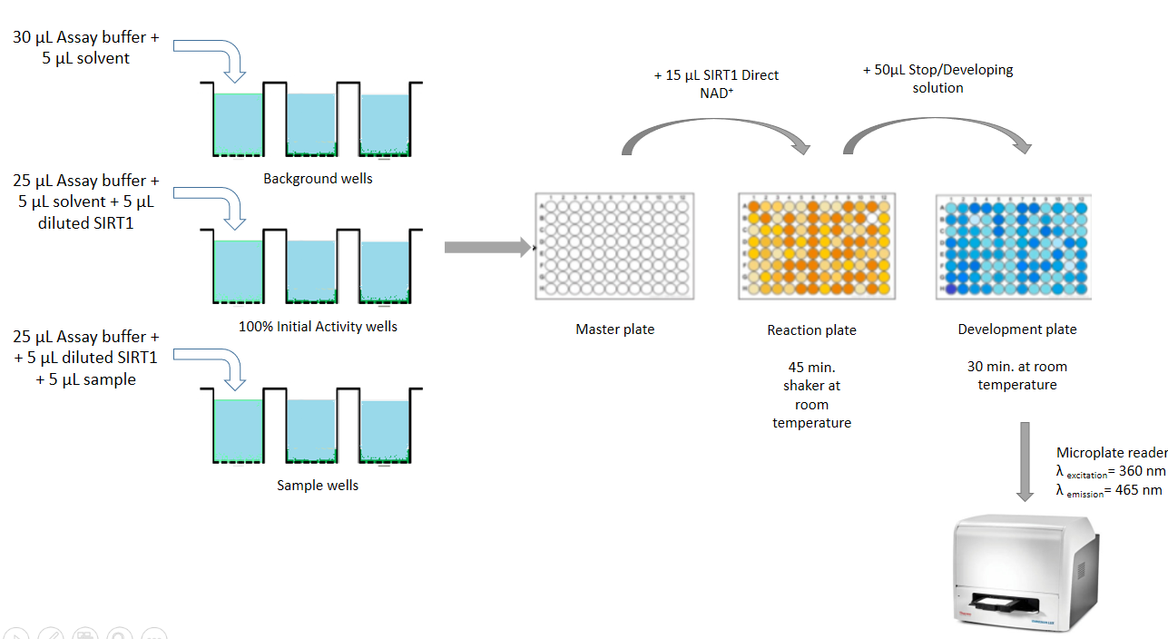
Figure S2. Scheme of the Assay protocol of ABNOVA SIRT1 Fluorescence kit.
Table S1. Amino acid profiles of 36 algal protein hydrolysates. Data are expressed as g / 100 g protein. Each value is the mean of n = 3 independent determinations ± standard deviation.

Amino acids | Porphyra sp. | Gigartina pistillata | Chondrus crispus | Enteromorpha intestinalis | Mastocarpus stellatus | Palmaria palmata | Gelidium corneum | Plocamium cartilagineum | Centroceras clavulatum | Halopithys incurva
His | 1.05 ± 0.15 | 0.41 ± 0.03 | 0.87 ± 0.18 | 1.64 ± 0.65 | 1.38 ± 0.34 | 1.46 ± 0.21 | 0.48 ± 0.05 | 1.85 ± 0.08 | 1.58 ± 0.06 | 1.33 ± 0.06
Thr | 4.35 ± 0.21 | 4.70 ± 0.04 | 1.88 ± 0.02 | 2.72 ± 0.13 | 2.23 ± 0.01 | 4.23 ± 0.65 | 5.40 ± 0.06 | 5.23 ± 1.41 | 4.53 ± 0.71 | 3.29 ± 0.19
Lys | 4.45 ± 0.32 | 6.23 ± 0.25 | 11.1 ± 0.87 | 5.66 ± 0.75 | 8.29 ± 0.08 | 10.7 ± 1.36 | 5.07 ± 1.96 | 5.08 ± 0.32 | 5.31 ± 1.94 | 6.45 ± 1.54
Met | 1.02 ± 0.07 | 0.44 ± 0.10 | 0.09 ± 0.01 | 0.56 ± 0.08 | 0.55 ± 0.07 | 0.86 ± 0.09 | 3.51 ± 0.04 | 2.10 ± 0.12 | 2.67 ± 0.01 | 2.89 ± 0.84
Val | 4.03 ± 0.21 | 6.94 ± 2.12 | 3.22 ± 0.72 | 9.97 ± 0.34 | 3.28 ± 0.69 | 4.50 ± 0.86 | 13.9 ± 1.30 | 4.60 ± 0.25 | 8.14 ± 0.91 | 7.75 ± 1.73
Ileu | 2.98 ± 0.34 | 1.87 ± 0.17 | 4.09 ± 0.46 | 6.09 ± 1.39 | 2.84 ± 0.36 | 4.37 ± 0.61 | 7.20 ± 0.89 | 4.60 ± 0.23 | 6.62 ± 0.89 | 7.09 ± 0.60
Leu | 5.23 ± 0.14 | 3.63 ± 0.58 | 5.58 ± 0.90 | 10.7 ± 1.18 | 4.45 ± 0.41 | 5.20 ± 0.48 | 10.6 ± 0.44 | 8.84 ± 1.70 | 14.4 ± 2.52 | 16.6 ± 1.79
Phe | 2.02 ± 0.11 | 2.32 ± 0.89 | 3.22 ± 0.26 | 5.52 ± 0.15 | 3.55 ± 0.52 | 4.75 ± 1.73 | 5.20 ± 0.62 | 5.81 ± 0.95 | 6.07 ± 1.78 | 4.75 ± 0.31
∑EAA | 25.1 | 26.5 | 30.0 | 43.5 | 26.6 | 29.4 | 49.5 | 42.0 | 46.6 | 47.3
Hyptau | 0.03 ± 0.01 | nd | nd | nd | 0.01 ± 2.12 | 0.01 ± 2.36 | nd | nd | nd | nd
Hyp | 0.02 ± 0.00 | nd | 0.03 ± 0.00 | 0.05 ± 0.00 | 0.10 ± 0.03 | 0.10 ± 0.02 | 0.03 ± 0.01 | 0.03 ± 0.01 | 0.03 ± 0.01 | 0.04 ± 0.01
Tau | 0.35 ± 0.02 | 0.38 ± 0.02 | 0.24 ± 0.01 | 0.26 ± 0.01 | 0.14 ± 0.01 | 0.06 ± 0.01 | 0.03 ± 0.01 | 0.04 ± 0.01 | 0.02 ± 0.04 | 0.04 ± 0.01
Htau | 0.06 ± 0.01 | 0.05 ± 0.00 | 0.04 ± 0.00 | 0.04 ± 0.01 | 0.05 ± 0.01 | 0.02 ± 0.01 | 0.01 ± 0.01 | 0.02 ± 0.01 | 0.004 ± 0.01 | 0.02 ± 0.01
Arg | 4.97 ± 0.12 | 3.39 ± 0.50 | 2.54 ± 0.07 | 2.27 ± 0.07 | 2.29 ± 0.14 | 4.94 ± 0.63 | 6.58 ± 1.20 | 5.27 ± 0.38 | 7.00 ± 1.02 | 6.78 ± 0.72
Ser | 13.3 ± 0.24 | 2.21 ± 0.11 | 6.88 ± 1.17 | 3.50 ± 0.69 | 2.35 ± 1.01 | 10.7 ± 1.50 | 4.01 ± 0.36 | 6.00 ± 1.39 | 4.16 ± 0.21 | 4.68 ± 0.16
Gly | 6.81 ± 0.34 | 2.17 ± 0.26 | 7.97 ± 0.19 | 4.17 ± 0.62 | 5.34 ± 0.15 | 10.6 ± 1.27 | 4.55 ± 0.72 | 6.75 ± 0.14 | 4.16 ± 1.51 | 4.68 ± 1.25
Asp | 5.32 ± 0.18 | 2.94 ± 0.52 | 4.23 ± 1.50 | 6.73 ± 0.41 | 6.47 ± 1.69 | 9.81 ± 0.94 | 8.62 ± 1.08 | 13.4 ± 0.55 | 9.80 ± 1.15 | 8.93 ± 1.03
Glu | 10.0 ± 0.33 | 5.09 ± 1.54 | 4.85 ± 1.62 | 12.1 ± 2.02 | 5.86 ± 0.51 | 8.01 ± 1.60 | 11.4 ± 0.26 | 12.8 ± 0.46 | 10.0 ± 1.80 | 8.55 ± 0.61
Cys | 1.15 ± 0.04 | nd | 3.22 ± 1.76 | 0.29 ± 0.64 | 1.32 ± 0.51 | 2.98 ± 0.59 | 0.03 ± 0.00 | 1.17 ± 0.38 | 1.30 ± 0.09 | 0.97 ± 0.01
Pro | 2.72 ± 0.24 | 5.41 ± 1.39 | 4.78 ± 0.95 | 7.81 ± 0.15 | 3.14 ± 0.05 | 7.67 ± 1.66 | 4.89 ± 0.94 | 4.01 ± 0.33 | 3.49 ± 0.87 | 5.11 ± 0.33
Ala | 2.31 ± 0.32 | 7.30 ± 0.16 | 1.48 ± 0.91 | 7.52 ± 0.73 | 5.93 ± 1.15 | 6.38 ± 0.42 | 5.41 ± 0.04 | 7.99 ± 0.61 | 5.58 ± 0.32 | 6.27 ± 0.83
GABA | 1.25 ± 0.08 | 1.14 ± 0.01 | 1.05 ± 0.11 | 0.88 ± 0.01 | 0.82 ± 2.74 | 0.35 ± 0.02 | 0.39 ± 0.01 | 0.29 ± 0.06 | 0.19 ± 0.05 | 0.37 ± 0.03
Tyr | 3.55 ± 0.17 | 0.04 ± 0.01 | 0.82 ± 0.02 | 4.15 ± 0.06 | 2.19 ± 0.17 | 1.01± 0.07 | 2.75 ± 0.22 | 3.05 ± 0.04 | 3.49 ± 0.09 | 2.73 ± 0.90
∑NEAA | 51.9 | 30.1 | 38.1 | 56.2 | 36.0 | 62.7 | 48.7 | 60.9 | 49.2 | 49.2
Total Amino acids | 77.0 | 56.7 | 68.2 | 99.1 | 62.6 | 98.9 | 100 | 99.0 | 95.5 | 99.4

Amino acids | Aphanizomenon flos-aquae | Caulerpa lentillifera | Codium sp. | Dunaliella salina | Athrospira platensis |  |  | Chlorella vulgaris |  |  | Tetraselmis chui |  |  | Auxenochlorella pyrenoidosa |  |  | Nanochloropsis sp. |  |  | Ulva lactuca
His | 1.18 ± 0.77 | 1.40 ± 0.27 | 1.00 ± 0.06 | 0.47 ± 0.03 | 1.55 ± 0.19 |  |  | 3.00 ± 0.22 |  |  | 2.07 ± 0.19 |  |  | 2.56 ± 0.18 |  |  | 0.59 ± 0.06 |  |  | 1.13 ± 0.15
Thr | 5.08 ± 0.66 | 1.62 ± 0.06 | 0.77 ± 0.17 | 1.59 ± 0.13 | 1.57 ± 0.13 |  |  | 4.55 ± 0.83 |  |  | 2.43 ± 1.22 |  |  | 5.08 ± 1.15 |  |  | 3.02 ± 0.79 |  |  | 2.94 ± 0.77
Lys | 5.85 ± 0.48 | 0.31 ± 0.02 | 1.78 ± 0.03 | 2.62 ± 0.77 | 5.57 ± 0.98 |  |  | 10.3 ± 1.02 |  |  | 3.48 ± 0.83 |  |  | 7.55 ± 1.06 |  |  | 2.30 ± 0.84 |  |  | 3.47 ± 1.08
Met | 1.00 ± 0.11 | 1.15 ± 0.16 | 0.68 ± 0.10 | 0.03 ± 0.00 | 2.48 ± 0.15 |  |  | 1.26 ± 0.25 |  |  | 0.60 ± 0.15 |  |  | 0.56 ± 0.14 |  |  | 0.13 ± 0.01 |  |  | 1.84 ± 0.08
Val | 1.52 ± 0.14 | 6.33 ± 0.87 | 2.35 ± 0.45 | 1.73 ± 0.14 | 5.24 ± 0.96 |  |  | 2.80 ± 0.18 |  |  | 4.31 ± 1.23 |  |  | 4.30 ± 1.11 |  |  | 4.62 ± 1.09 |  |  | 2.40 ± 1.15
Ileu | 5.90 ± 0.01 | 3.42 ± 0.53 | 1.16 ± 0.06 | 7.65 ± 0.82 | 4.27 ± 0.80 |  |  | 4.44 ± 0.93 |  |  | 1.86 ± 1.20 |  |  | 3.13 ± 0.09 |  |  | 11.9 ± 1.21 |  |  | 2.16 ± 0.99
Leu | 7.28 ± 1.65 | 5.79 ± 0.72 | 1.92 ± 0.55 | 6.34 ± 0.84 | 7.36 ± 1.00 |  |  | 6.94 ± 0.82 |  |  | 3.51 ± 0.73 |  |  | 5.08 ± 1.02 |  |  | 3.86 ± 0.75 |  |  | 4.02 ± 1.17
Phe | 5.60 ± 0.79 | 3.30 ± 0.87 | 1.35 ± 0.33 | 1.45 ± 0.80 | 2.21 ± 0.18 |  |  | 5.38 ± 0.18 |  |  | 0.01 ± 0.00 |  |  | 4.22 ± 0.81 |  |  | 0.32 ± 0.04 |  |  | 2.46 ± 0.04
∑EAA | 33.4 | 23.3 | 11.0 | 21.9 | 30.3 |  |  | 38.8 |  |  | 18.3 |  |  | 32.5 |  |  | 26.8 |  |  | 20.4
Hyptau | nd | nd | nd | nd | nd |  |  | nd |  |  | nd |  |  | 0.01 ± 0.01 |  |  | nd |  |  | nd
Hyp | 0.02 ± 0.00 | 0.08 ± 0.01 | 0.02 ± 0.01 | 0.02 ± 0.00 | 1.07 ± 0.13 |  |  | 0.36 ± 0.01 |  |  | 0.04 ± 0.00 |  |  | 0.37 ± 0.05 |  |  | 0.02 ± 0.01 |  |  | 0.82 ± 0.01
Tau | 0.24 ± 0.01 | 0.39 ± 0.02 | 0.38 ± 0.01 | 0.35 ± 0.00 | 0.35 ± 0.03 |  |  | 0.31 ± 0.00 |  |  | 0.25 ± 0.05 |  |  | 0.27 ± 0.00 |  |  | 0.15 ± 0.06 |  |  | 0.03 ± 0.00
Htau | 0.04 ± 0.00 | 0.06 ± 0.00 | 0.05 ± 0.00 | 0.04 ± 0.00 | 0.04 ± 0.00 |  |  | 0.04 ± 0.00 |  |  | 0.04 ± 0.00 |  |  | 0.04 ± 0.00 |  |  | 0.03 ± 0.00 |  |  | 0.02 ± 0.00
Arg | 5.35 ± 0.42 | 2.15 ± 0.21 | 1.03 ± 0.12 | 0.37 ± 0.03 | 11.6 ± 0.76 |  |  | 10.3 ± 1.04 |  |  | 1.75 ± 0.06 |  |  | 6.16 ± 0.98 |  |  | 1.50 ± 0.92 |  |  | 2.65 ± 0.99
Ser | 4.72 ± 0.35 | 3.52 ± 0.92 | 1.04 ± 0.03 | 1.62 ± 0.19 | 5.81 ± 1.06 |  |  | 5.47 ± 1.05 |  |  | 3.20 ± 0.99 |  |  | 3.41 ± 0.07 |  |  | 2.75 ± 0.18 |  |  | 4.55 ± 1.20
Gly | 5.35 ± 0.34 | 3.87 ± 0.42 | 1.78 ± 0.16 | 3.28 ± 0.04 | 7.45 ± 1.06 |  |  | 8.97 ± 1.17 |  |  | 2.67 ± 1.18 |  |  | 8.97 ± 0.82 |  |  | 7.62 ± 0.79 |  |  | 1.75 ± 0.03
Asp | 7.47 ± 1.76 | 13.0 ± 1.65 | 1.35 ± 0.18 | 4.21 ± 0.73 | 13.1 ± 0.99 |  |  | 12.1 ± 0.77 |  |  | 5.48 ± 1.25 |  |  | 10.7 ± 1.01 |  |  | 8.43 ± 1.13 |  |  | 2.97 ± 0.94
Glu | 11.3 ± 0.45 | 11.6 ± 0.67 | 4.35± 0.39 | 5.78 ± 1.04 | 19.9 ± 0.99 |  |  | 14.5 ± 1.09 |  |  | 6.05 ± 1.09 |  |  | 12.5 ± 0.85 |  |  | 11.5 ± 0.91 |  |  | 2.35 ± 0.88
Cys | 0.02 ± 0.00 | 0.10 ± 0.06 | 0.17 ± 0.07 | 1.10 ±0.01 | 1.75 ± 0.11 |  |  | 1.75 ± 0.24 |  |  | 0.31 ± 0.02 |  |  | 0.29 ± 0.04 |  |  | 0.01 ± 0.00 |  |  | 1.26 ± 0.12
Pro | 5.00 ± 1.64 | 5.71 ± 1.16 | 1.39± 0 .35 | 3.78 ± 0.74 | 3.18 ± 0.93 |  |  | 3.61 ± 1 .14 |  |  | 1.58 ± 0.31 |  |  | 5.36 ± 1.09 |  |  | 4.91 ± 0.79 |  |  | 1.87 ± 0.07
Ala | 6.95 ± 0.34 | 8.03 ± 0.01 | 1.68 ± 0.47 | 7.03 ± 0.55 | 10.7 ± 0.82 |  |  | 9.85 ± 1.04 |  |  | 5.37 ± 0.87 |  |  | 10.0 ± 0.73 |  |  | 9.59 ± 0.75 |  |  | 2.18 ± 0.15
GABA | 1.05 ± 0.08 | 1.28 ± 0.09 | 1.27 ± 0.05 | 0.91± 0 .03 | 0.83 ± 0.05 |  |  | 0.94 ± 0.05 |  |  | 0.63 ± 0.20 |  |  | 0.72 ± 0.12 |  |  | 0.49 ± 0.05 |  |  | 0.37 ± 0.03
Tyr | 0.42 ± 0.03 | 2.97 ± 0.20 | 1.00 ± 0.12 | 0.48 ± 0.16 | 1.88 ± 0.12 |  |  | 2.09 ± 0.06 |  |  | 1.23 ± 0.11 |  |  | 2.86 ± 0.05 |  |  | 1.40 ± 0.19 |  |  | 1.40 ± 0.22
∑NEAA | 47.9 | 52.8 | 15.5 | 28.9 | 77.7 |  |  | 70.4 |  |  | 28.6 |  |  | 61.7 |  |  | 48.4 |  |  | 22.2
Total Amino acids | 81.4 | 76.1 | 26.5 | 50.9 | 108 |  |  | 109 |  |  | 46.9 |  |  | 94.3 |  |  | 75.2 |  |  | 42.6

Amino acids | Codium decorticatum | Ascophyllum nodosum | Sargassum fusiforme | Eisenia byciclis | Laminaria ochroleuca | Himanthalia elongata | Undaria pinnatifida | Odonella aurita | Fucus vesiculosus | Bifurcaria bifurcata
His | 0.55 ± 0.15 | 0.53 ± 0.13 | 0.21 ± 0.08 | 0.50 ± 0.01 | 3.12 ± 0.48 | 5.66 ± 0.69 | 0.90 ± 0.01 | 0.74 ± 0.11 | 1.83 ± 0.50 | 1.91 ± 0.20
Thr | 0.91 ± 0.03 | 1.08 ± 0.11 | 0.70 ± 0.05 | 0.86 ± 0.14 | 1.61 ± 0.22 | 2.29 ± 0.36 | 9.04 ± 0.57 | 2.73 ± 0.21 | 3.84 ± 0.63 | 5.36 ± 0.35
Lys | 1.67 ± 0.21 | 2.06 ± 0.86 | 0.86± 0.01 | 0.58 ± 0.08 | 3.10 ± 0.44 | 5.05 ± 0.54 | 7.48 ± 0.66 | 12.1 ± 0.32 | 9.53 ± 0.40 | 5.60 ± 0.21
Met | 1.21 ± 0.22 | 0.06 ± 0.01 | 0.69 ± 0.09 | 1.22 ± 0.06 | 0.12 ± 0.02 | 0.35 ± 0.06 | 0.16 ± 0.02 | 0.16 ± 0.06 | 0.14 ± 0.01 | 0.30 ± 0.02
Val | 3.92 ± 1.20 | 1.29 ± 0.12 | 0.52 ± 0.02 | 1.01 ± 0.15 | 5.97 ± 0.33 | 3.53 ± 0.21 | 3.07 ± 0.52 | 2.20 ± 0.37 | 3.86 ± 0.59 | 5.38 ± 0.23
Ileu | 1.88 ± 0.19 | 0.85 ± 0.02 | 0.38 ± 0.12 | 0.80 ± 0.13 | 3.65 ± 0.69 | 0.09 ± 0.01 | 5.07 ± 0.60 | 8.74 ± 0.25 | 1.36 ± 0.24 | 4.34 ± 0.63
Leu | 2.47 ± 0.24 | 1.09 ± 0.06 | 1.83 ± 0.21 | 1.84 ± 0.08 | 6.58 ± 0.23 | 2.30 ± 0.52 | 0.88 ± 0.02 | 3.38 ± 0.70 | 3.41 ± 0.22 | 7.31 ± 0.30
Phe | 1.88 ± 0.24 | 0.48 ± 0.18 | 0.77 ± 018 | 0.77 ± 0.06 | 0.78 ± 0.06 | 0.04 ± 0.01 | 3.51 ± 0.68 | 2.86 ± 0.44 | 1.22 ± 0.34 | 5.10 ± 0.27
∑EAA | 14.5 | 7.44 | 5.96 | 7.58 | 24.9 | 19.3 | 30.1 | 32.9 | 25.2 | 35.3
Hyptau | nd | nd | nd | nd | nd | nd | nd | nd | nd | nd
Hyp | 0.03 ± 0.01 | 0.02 ± 0.01 | 0.03 ± 0.01 | 0.02 ± 0.01 | 0.04 ± 0.01 | 0.39 ± 0.01 | 0.04 ± 0.00 | 0.02 ± 0.00 | 0.10 ± 0.01 | 0.14 ± 0.00
Tau | 0.009 ± 0.000 | 0.19 ± 0.00 | 0.25 ± 0.00 | 0.23 ± 0.00 | 0.25 ± 0.01 | 0.22 ± 0.01 | 0.19 ± 0.05 | 0.19 ± 0.01 | 0.21 ± 0.01 | 0.001 ± 0.000
Htau | 0.007 ± 0.00 | 0.045 ± 0.00 | 0.035 ± 0.00 | 0.033 ± 0.00 | 0.045 ± 0.00 | 0.045 ± 0.00 | 0.038 ± 0.00 | 0.038 ± 0.00 | 0.031 ± 0.00 | 0.008 ± 0.00
Arg | 1.35 ± 0.02 | 0.28 ± 0.01 | 1.25 ± 0.08 | 0.98 ± 0.01 | 1.78 ± 0.01 | 0.88 ± 0.11 | 6.93 ± 0.13 | 0.04 ± 0.00 | 3.00 ± 0.22 | 5.10 ± 0.42
Ser | 1.62 ± 0.08 | 0.88 ± 0.07 | 0.61 ± 0.03 | 0.95 ± 0.08 | 7.45 ± 0.68 | 5.66 ± 0.40 | 9.11 ± 0.48 | 1.46 ± 0.20 | 4.04 ± 0.23 | 4.91 ± 0.71
Gly | 1.93 ± 0.23 | 0.60 ± 0.05 | 0.84 ± 0.09 | 1.22 ± 0.16 | 11.1 ± 0.63 | 1.36 ± 012 | 5.37 ± 0.60 | 11.4 ± 0.60 | 9.53 ± 0.53 | 5.38 ± 0.45
Asp | 1.44 ± 0.18 | 1.55 ± 0.15 | 2.35 ± 0.11 | 2.22 ± 0.31 | 3.26 ± 0.21 | 11.2 ± 0.51 | 7.56 ± 0.28 | 2.20 ± 0.19 | 11.7 ± 0.36 | 17.6 ± 0.51
Glu | 4.00 ± 1.1 | 2.55 ± 0.84 | 3.49 ± 1.20 | 4.64 ± 1.20 | 3.38 ± 0.71 | 6.87 ± 0.38 | 8.37 ± 0.28 | 6.75 ± 0.33 | 11.3 ± 0.47 | 23.3 ± 0.48
Cys | 0.21 ± 0.06 | 0.03 ± 0.00 | 0.48 ± 0.03 | 1.50 ± 0.18 | 3.36 ± 0.29 | 2.12 ± 0.05 | 0.16 ± 0.06 | 0.01 ± 0.00 | 0.05 ± 0.01 | 0.02 ± 0.00
Pro | 3.15 ± 0.51 | 0.63 ± 0.05 | 0.60 ± 0.01 | 0.60 ± 0.01 | 9.48 ± 0.64 | 1.21 ± 0.21 | 1.64 ± 0.25 | 8.08 ± 0.55 | 6.74 ± 0.10 | 4.91 ± 0.21
Ala | 1.62 ± 0.08 | 0.75 ± 0.11 | 1.54 ± 0.17 | 1.16 ± 0.22 | 9.48 ± 0.71 | 10.4 ± 0157 | 2.47 ± 0.33 | 0.65 ± 0.09 | 9.53 ± 0.71 | 12.3 ± 0.41
GABA | 0.18 ± 001 | 0.68 ± 0.02 | 0.72 ± 0.01 | 0.74 ± 0.00 | 0.85 ± 0.01 | 0.65 ± 0.06 | 0.64 ± 0.08 | 1.12 ± 0.13 | 0.51 ± 0.03 | 0.008 ± 0.000
Tyr | 2.39 ± 0.03 | 0.25 ± 0.09 | 0.16 ± 0.02 | 0.34 ± 0.08 | 0.64 ± 0.09 | 1.43 ± 0.12 | 0.04 ± 0.06 | 1.7 5 ±0.23 | 1.73 ± 0.52 | 2.16 ± 0.31
∑NEAA | 24.4 | 8.45 | 12.3 | 14.6 | 51.1 | 42.5 | 42.6 | 33.8 | 58.4 | 75.8
Total Amino acids | 38.9 | 15.8 | 18.3 | 22.2 | 76.0 | 61.8 | 72.7 | 66.8 | 83.6 | 111

Amino acids | Fucus guiryi | Pelvetia canaliculata | Halopteris scoparia | Gongolaria baccata | Cladostephus spongiosus | Ericaria selaginoides
His | 0.49 ± 0.04 | 0.02 ± 0.00 | 0.28 ± 0.01 | 0.54 ± 0.06 | 0.24 ± 0.02 | 0.54 ± 0.01
Thr | 0.99 ± 0.02 | 0.84 ± 0.02 | 0.54 ± 0.03 | 0.39 ± 0.01 | 0.27 ± 0.06 | 0.60 ± 0.07
Lys | 2.40 ± 0.06 | 0.84 ± 0.03 | 0.58 ± 0.07 | 1.81 ± 0.03 | 0.76 ± 0.04 | 2.43 ± 0.15
Met | 2.05 ± 0.00 | 0.03 ± 0.01 | 0.35 ± 0.04 | 0.14 ± 0.00 | 0.09 ± 0.02 | 0.21 ± 0.01
Val | 0.69 ± 0.04 | 0.94 ± 0.05 | 0.65 ± 0.06 | 0.55 ± 0.08 | 0.74 ± 0.09 | 0.87 ± 0.13
Ileu | 0.26 ± 0.08 | 0.73 ± 0.03 | 0.54 ± 0.07 | 0.45 ± 0.04 | 0.48 ± 0.02 | 0.50 ± 0.04
Leu | 0.93 ± 0.07 | 1.22 ± 0.16 | 1.11 ± 0.14 | 1.29 ± 0.17 | 0.79 ± 0.15 | 1.40 ± 0.16
Phe | 0.26 ± 0.12 | 0.67 ± 0.11 | 0.22 ± 0.04 | 0.38 ± 0.05 | 6.06 ± 0.69 | 0.87 ± 0.13
∑EAA | 8.07 | 5.29 | 4.27 | 5.55 | 9.40 | 7.40
Hyptau | nd | 0.01 ± 0.00 | nd | nd | nd | nd
Hyp | 0.02 ± 0.00 | 0.01 ± 0.00 | 0.01 ± 0.00 | 0.03 ± 0.00 | 0.01 ± 0.00 | 0.04 ± 0.01
Tau | 0.12 ± 0.00 | 0.07 ± 0.00 | 0.04 ± 0.00 | 0.06 ± 0.00 | 0.05 ± 0.00 | 0.06 ± 0.01
Htau | 0.01 ± 0.00 | 0.02 ± 0.00 | 0.01 ± 0.00 | 0.02 ± 0.00 | 0.01 ± 0.00 | 0.02 ± 0.00
Arg | 0.84 ± 0.15 | 0.74 ± 0.01 | 0.55 ± 0.08 | 0.64 ± 0.01 | 0.38 ± 0.02 | 0.60 ± 0.07
Ser | 0.99 ± 0.04 | 0.90 ± 0.03 | 0.94 ± 0.04 | 0.39 ± 0.02 | 0.70 ± 0.12 | 0.67 ± 0.11
Gly | 3.84 ± 0.17 | 0.96 ± 0.03 | 2.22 ± 0.18 | 0.81 ± 0.12 | 1.76 ± 0.46 | 1.32 ± 0.20
Asp | 3.86 ± 0.58 | 1.46 ± 0.26 | 2.85 ± 0.36 | 3.80 ± 0.25 | 2.00 ± 0.32 | 3.48 ± 0.27
Glu | 4.24 ± 0.36 | 3.74 ± 0.54 | 3.13 ± 0.52 | 2.60 ± 0.12 | 2.80 ± 0.40 | 3.86 ± 0.11
Cys | 0.02 ± 0.00 | 3.63 ± 0.01 | 1.34 ± 0.32 | 1.97 ± 0.13 | 1.81 ± 0.16 | 0.98 ± 0.00
Pro | 1.87 ± 0.41 | 1.34 ± 0.29 | 1.60 ± 0.13 | 1.66 ± 0.30 | 0.76 ± 0.09 | 1.27 ± 0.11
Ala | 2.78 ± 0.17 | 2.57 ± 0.29 | 3.49 ± 0.18 | 3.90 ± 0.35 | 1.49 ± 0.10 | 1.25 ± 0.12
GABA | 0.27 ± 0.02 | 0.09 ± 0.01 | 0.25 ± 0.12 | 0.11 ± 0.10 | 0.11 ± 0.01 | 0.39 ± 0.01
Tyr | 0.55 ± 0.02 | 0.29 ± 0.10 | 0.32 ± 0.01 | 0.15 ± 0.02 | 0.49 ± 0.02 | 0.32 ± 0.09
∑NEAA | 19.4 | 15.8 | 16.7 | 16.1 | 12.1 | 14.3
Total Amino acids | 27.5 | 21.1 | 21.0 | 22.7 | 21.6 | 21.7

Table S2. SIRT1 activation / inhibition percentages of the enzymatic protein hydrolysates from algae species.
(Mean of n=3 independent determinations ± std. dev.).

Alage specie |  | % Inhibition | %Activation
Red Algae | Porphyra sp |  | 83.3 ± 1.23
Red Algae | Gigartina pistillata |  | 68.8 ± 0.98
Red Algae | Chondrus crispus |  | 56.5 ± 2.32
Red Algae | Mastocarpus stellatus |  | 32.6 ± 2.47
Red Algae | Palmaria palmata | 16.0 ± 0.85
Red Algae | Gelidium corneum | 46.9 ± 1.49
Red Algae | Plocammium Cartilagineum | 32.1 ± 2.38
Red Algae | Centroceras clavulatum | 57.7 ± 2.85
Red Algae | Halopithys incurva | 23.4 ± 0.65
Median |  | 32.1^{b} | 62.7ª
Green Algae | Afanizomenon flos-aquae |  | 62.8 ± 2.85
Green Algae | Caulerpa lentillifera |  | 98.2 ± 3.44
Green Algae | Codium sp |  | 88.6 ± 3.87
Green Algae | Dunaliella salina |  | 63.2 ± 2.14
Green Algae | Spirulina platensis |  | 66.7 ± 1.45
Green Algae | Chlorella vulgaris |  | 60.9 ± 0.54
Green Algae | Tetraselmis chui |  | 39.1 ± 0.85
Green Algae | Auxenochlorella pyrenoidosa |  | 54.5 ± 1.58
Green Algae | Ulva lactuca | 41.4 ± 1.14
Green Algae | Enteromorpha intestinalis |  | 60.3 ± 1.45
Green Algae | Codium decorticatum | 73.5 ± 2.85
Median |  | 57.5ª | 62.8ª
Brown Algae | Ascophyllum nodosum |  | 30.5 ± 2.55
Brown Algae | Sargassum fusiforme |  | 33.6 ± 1.74
Brown Algae | Eisenia byciclis |  | 26.7 ± 0.41
Brown Algae | Laminaria ochroleuca |  | 49.2 ± 0.18
Brown Algae | Himanthalia elongata |  | 41.9 ± 2.22
Brown Algae | Undaria pinnatifida |  | 25.6 ± 2.96
Brown Algae | Odonella aurita |  | 105 ± 3.87
Brown Algae | Fucus vesiculosus | 2.30 ± 0.11
Brown Algae | Bifurcaria bifurcata | 80.5 ± 1.85
Brown Algae | Fucus guiryi | 46.8 ± 1.37
Brown Algae | Pelvetia canaliculata | 55.8 ± 2.49
Brown Algae | Stypocaulon scoparium | 63.9 ± 2.97
Brown Algae | Gongolaria baccata | 57.7 ± 1.75
Brown Algae | Cladostephus spongiosum | 70.2 ± 1.69
Brown Algae | Cystoseira tamariscifolia | 34.4 ± 0.65
Brown Algae | Nanochloropsis sp. | 4.80 ± 0.17
Median |  | 55.8ª | 37.8^{b}

