SUPPLEMENTARY FILE #6

Entire ANOVA table outputs from the statistical analysis of onset latency and duration of activation in standing and walking conditions

From statistical analysis of standing conditions
Statistical output from the three-way analysis of onset latency, including muscle, perturbation direction and sensory condition as factors.
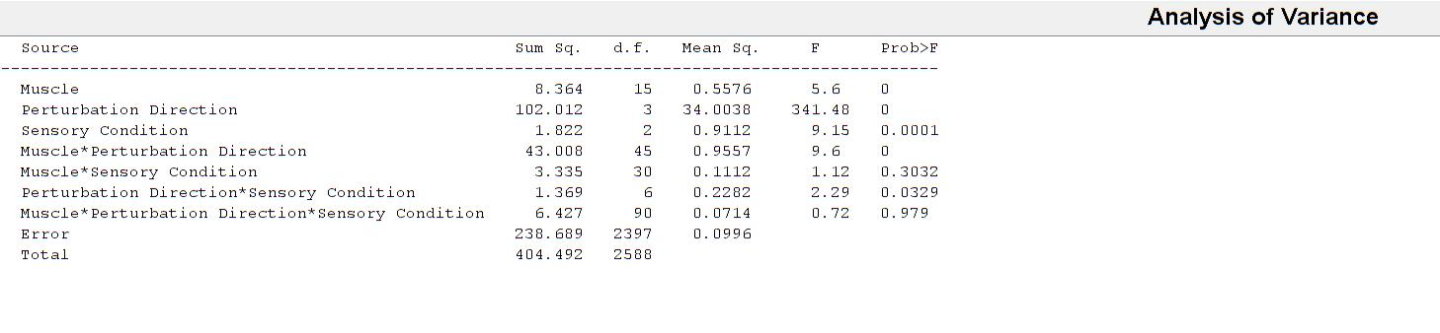
Statistical output from the three-way analysis of duration of activation, including muscle, perturbation direction and sensory condition as factors.
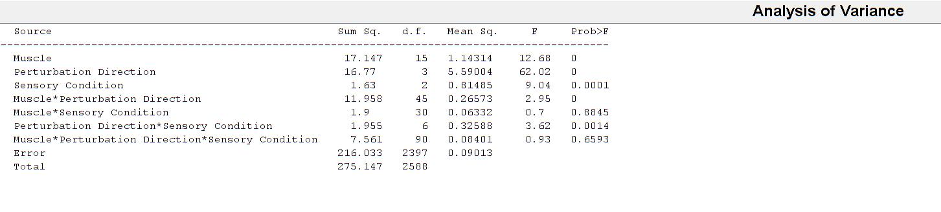
From statistical analysis of walking conditions
Statistical output from the three-way analysis of onset latency, including muscle, perturbation direction and perturbation side as factors.
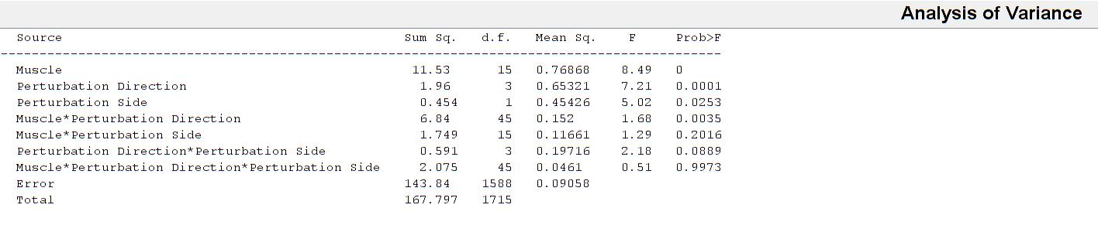
Statistical output from the three-way analysis of duration of activation, including muscle, perturbation direction and perturbation side as factors.
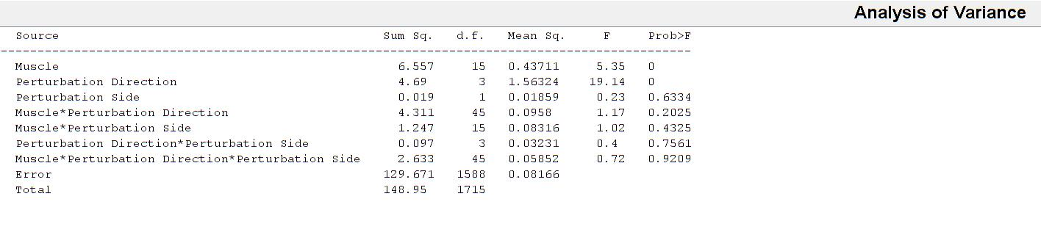

From statistical analysis of visual conditions
Statistical output from the two-way analysis of onset latency, including muscle and perturbation direction as factors.
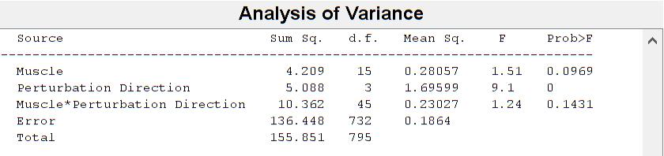
Statistical output from the two-way analysis of duration of activation, including muscle and perturbation direction as factors.
