Substituent Effects on Fluorescence Properties of AIEgens Based on Coumarin-3-formylhydrazone and their application in cell imaging

Panpan Chen · Yang Zhao · Zhigang Niu · Enju Wang
Key Laboratory of Tropical Medicinal Resource Chemistry of Ministry of Education, Key Laboratory of Tropical Medicinal Plant Chemistry of Hainan Province, College of Chemistry & Chemical Engineering, Hainan rmal University, Haikou, 571158, China
*Corresponding author: E-mail address: enjuwang@163.com

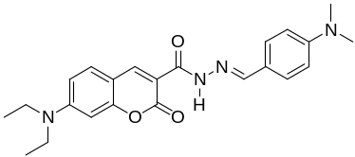
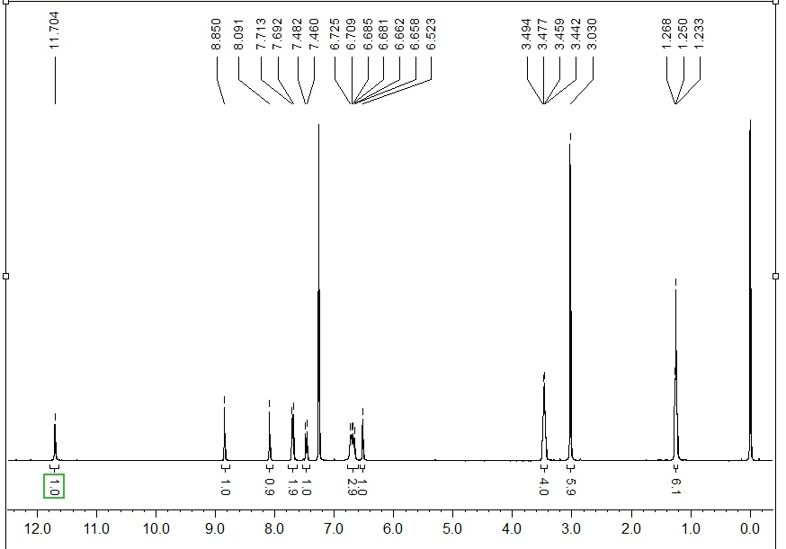
Fig. S1 ¹H NMR spectrum of CFH-1 (CDCl₃)

Fig. S2 ¹³C NMR spectrum of CFH-1 (CDCl₃)

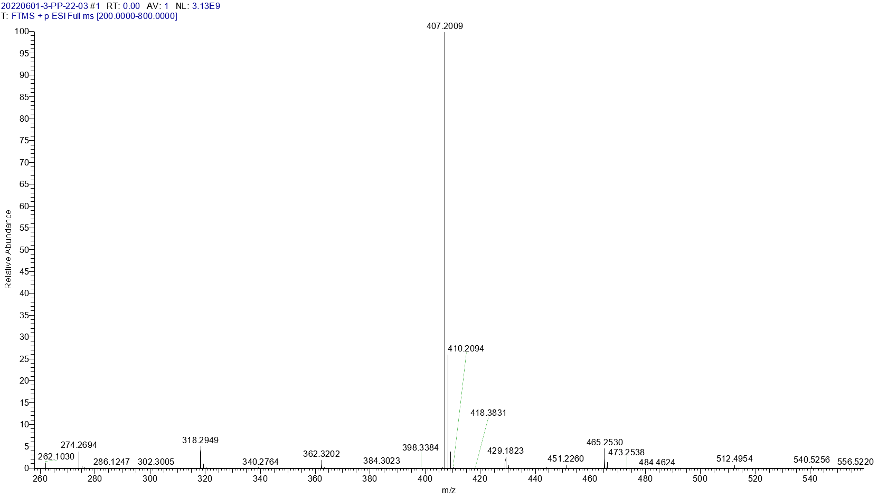
Fig. S3 HRMS spectrum of CFH-1
calculated for [M+H]⁺ 407.2083, found 407.2009.
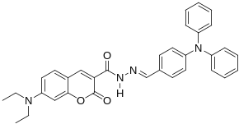
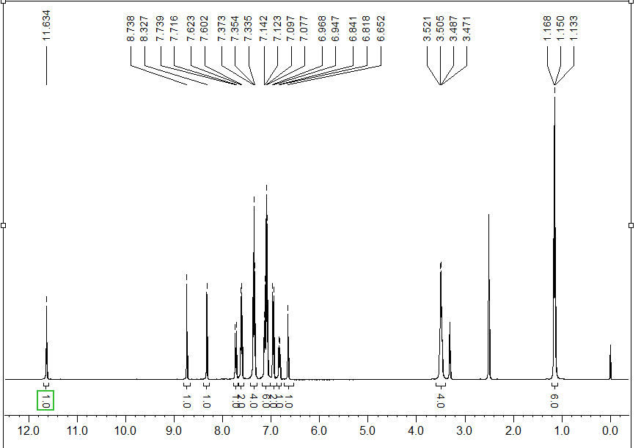
Fig. S4 ¹H NMR spectrum of CFH-2 (DMSO-d₆)
Fig. S5 ¹³C NMR spectrum of CFH-2 (DMSO-d₆)
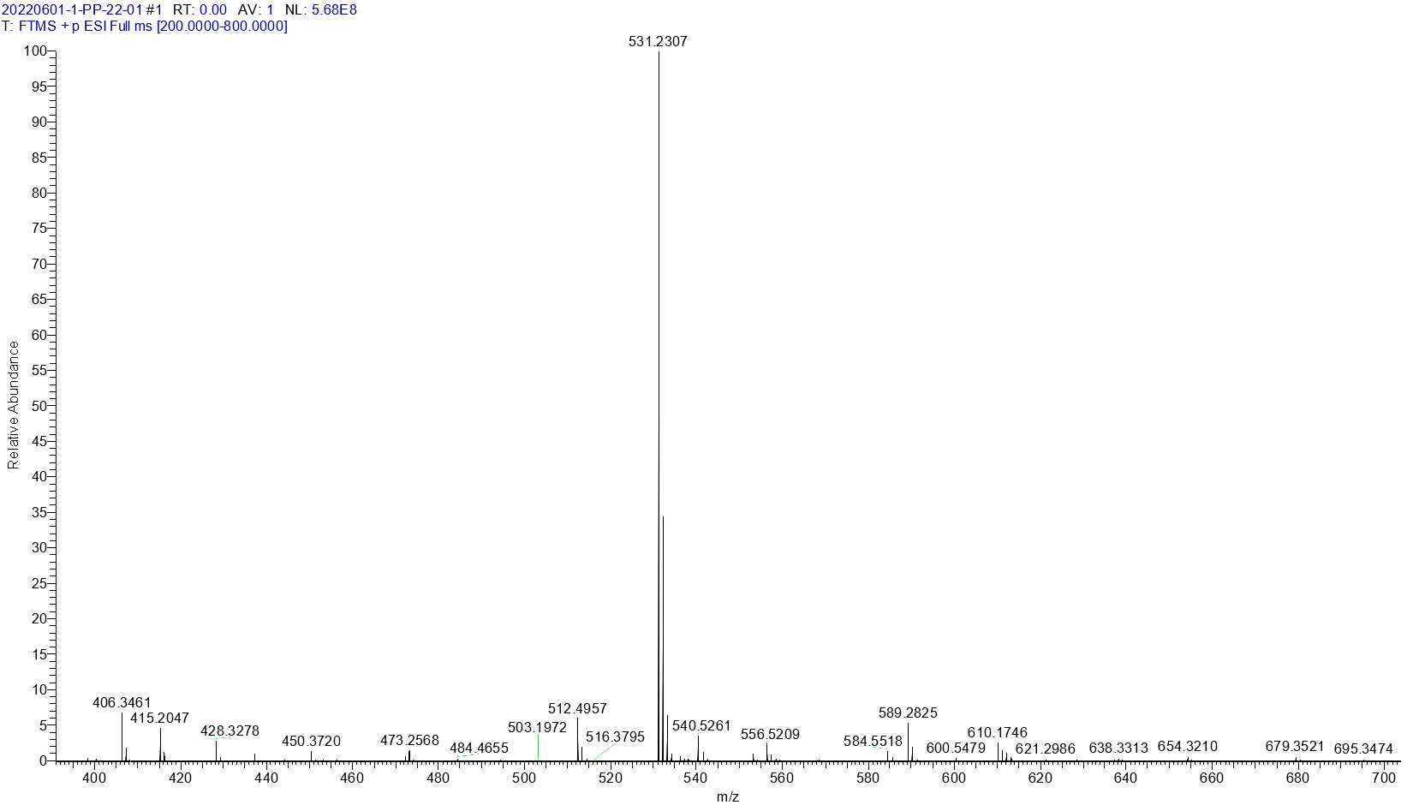
Fig. S6 HRMS spectrum of CFH-2
calculated for [M+H]⁺ 531.2396, found 531.2307.

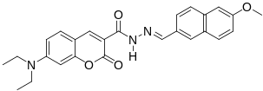
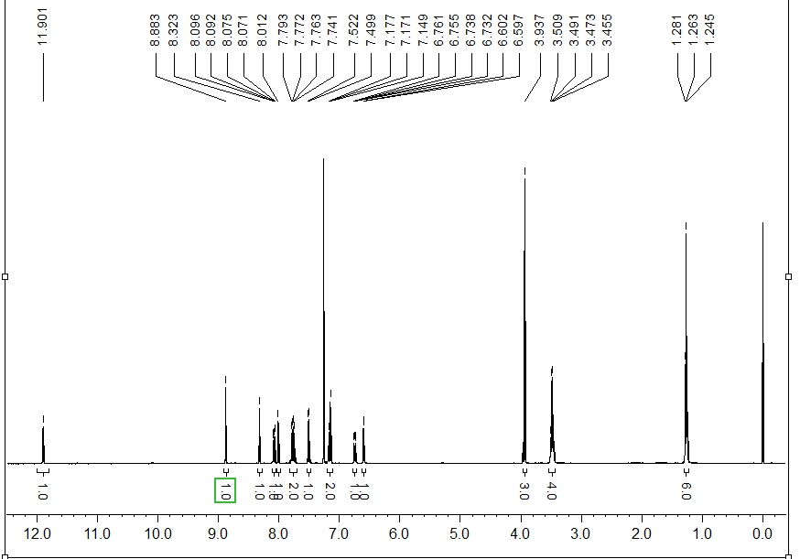
Fig. S7 ¹H NMR spectrum of CFH-3 (CDCl₃)
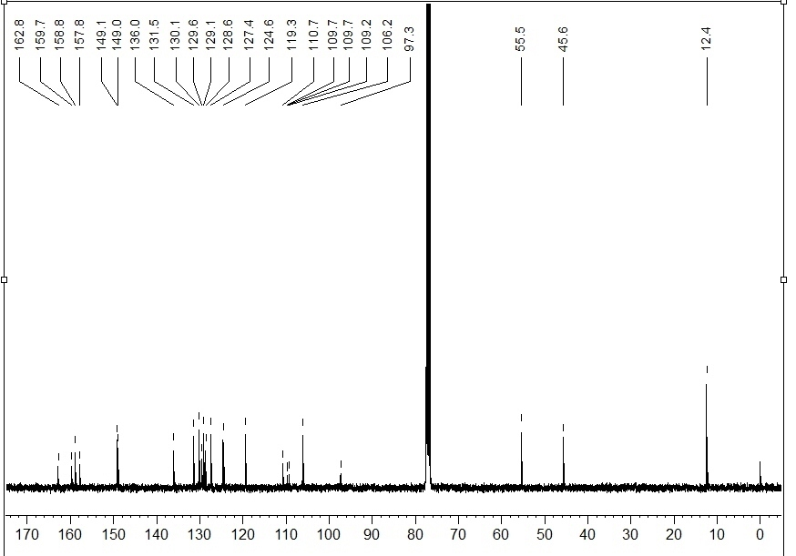
Fig. S8 ¹³C NMR spectrum of CFH-3 (CDCl₃)

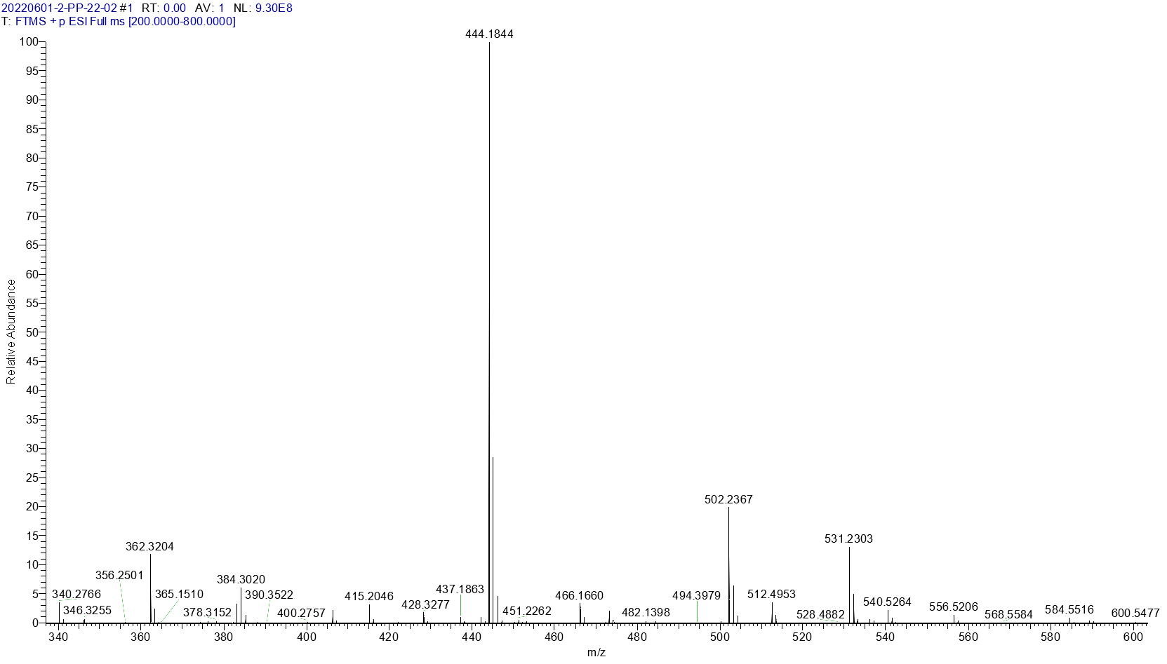
Fig. S9 HRMS spectrum of CFH-3
calculated for [M+H]⁺ 444.1923, found 444.1844.
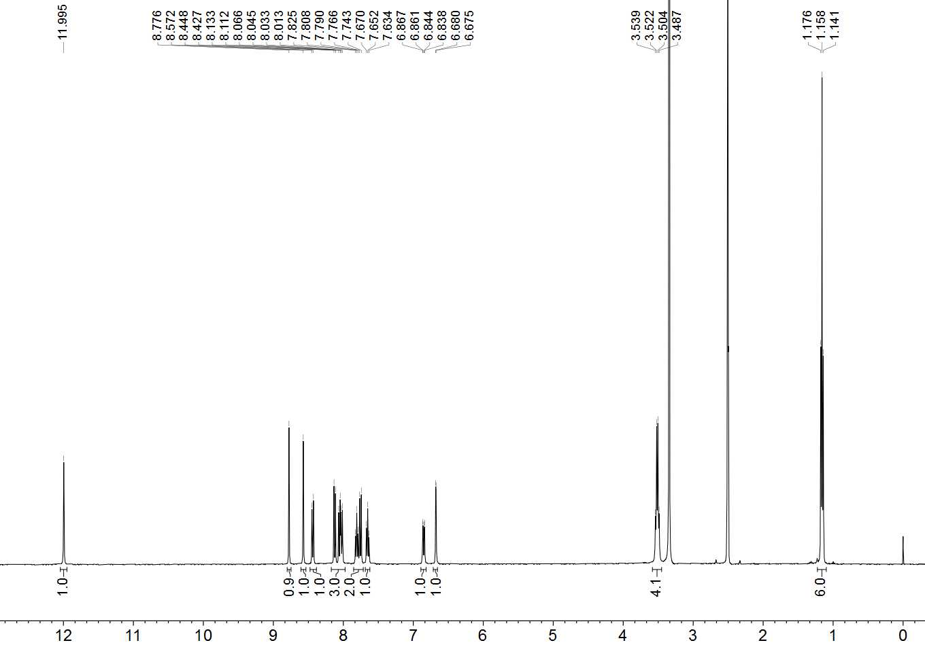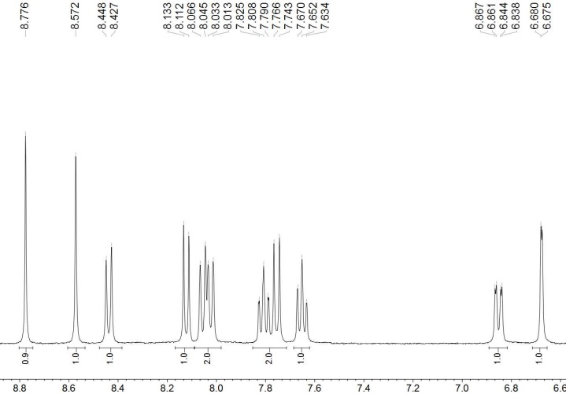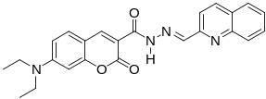
Fig. S10 ¹H NMR spectrum of CFH-4 (DMSO-d)

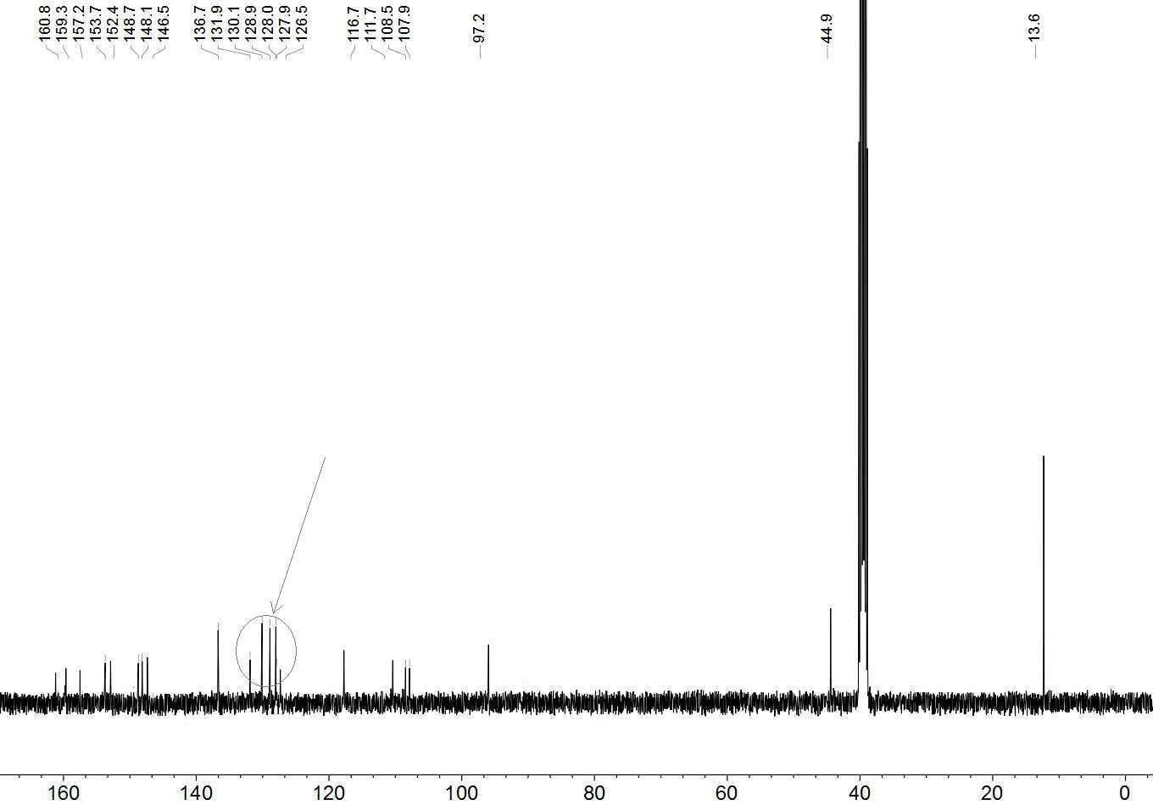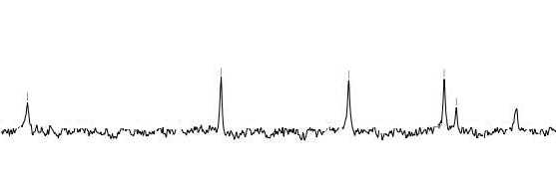
Fig. S11 ¹³C NMR spectrum of CFH-4 (CDCl₃)

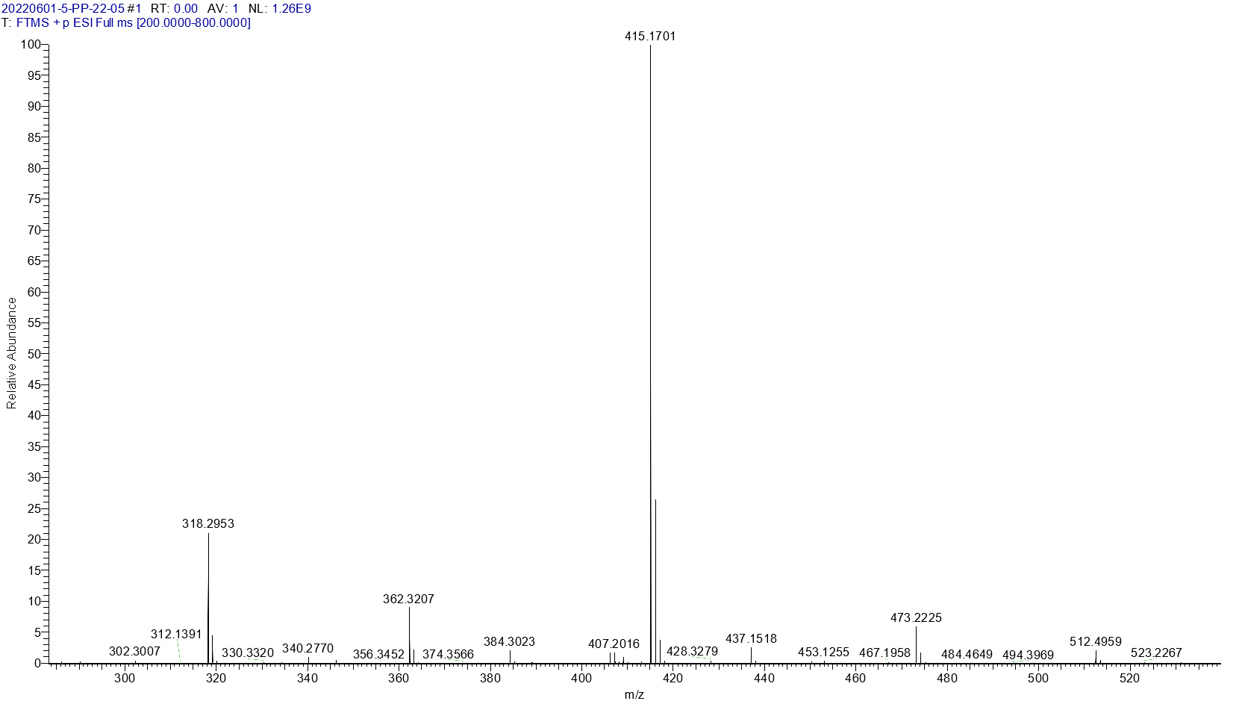Fig. S12 HRMS spectrum of CFH-4
calculated for [M+H]⁺ 415.1770, found 445.1701.

Table S1. Crystal data and structure refinement for CFH-1 and CFH-3
Compound | CFH-1 |  |  | CFH-3
Empirical formula | C₂₄H₂₈Cl₂N₄O₃ |  |  | C₂₆H₂₅N₃O₄
Formula weight | 491.40 |  |  | 443.49
Temperature/K | 293(2) |  |  | 293
Crystal system | triclinic |  |  | triclinic
Space group | P-1 |  |  | P-1
a/Å | 8.6282(7) |  |  | 7.8072(4)
b/Å | 10.2236(7) |  |  | 12.2224(6)
c/Å | 14.3769(11) |  |  | 12.2647(6)
α/° | 105.355(6) |  |  | 107.514(4)
β/° | 94.295(6) |  |  | 92.142(4)
γ/° | 92.636(6) |  |  | 93.747(4)
Volume/Å³ | 1216.64(16) |  |  | 1111.69(10)
Z | 2 |  |  | 2
ρ_{calc}g/cm³ | 1.341 |  |  | 1.325
μ/mm⁻¹ | 0.300 |  |  | 0.091
F(000) | 516.0 |  |  | 468.0
Crystal size/mm³ | 0.3 × 0.2 × 0.1 |  |  | 0.11 × 0.1 × 0.07
Radiation | Mo Kα (λ = 0.71073) |  |  | Mo Kα (λ = 0.71073)
2θ range for data collection/° | 4.39 to 59.228 |  |  | 6.466 to 59.304
Index ranges | -11 ≤ h ≤ 11, -13 ≤ k ≤ 13, -19 ≤ l ≤ 17 |  |  | -10 ≤ h ≤ 10, -16 ≤ k ≤ 12, -16 ≤ l ≤ 16
Reflections collected | 10404 |  |  | 11136
Independent reflections | 5685 [R_{int} = 0.0348, R_{sigma} = 0.0531] |  |  | 5336 [R_{int} = 0.0409, R_{sigma} = 0.0609]
Data/restraints/parameters | 5685/0/302 |  |  | 5336/0/301
Goodness-of-fit on F² | 1.023 |  |  | 1.004
Final R indexes [I>=2σ (I)] | R₁ = 0.0670, wR₂ = 0.1602 |  |  | R₁ = 0.0644, wR₂ = 0.1529
Final R indexes [all data] | R₁ = 0.1276, wR₂ = 0.2077 |  |  | R₁ = 0.1263, wR₂ = 0.1981
Largest diff. peak/hole / e Å⁻³ | 0.51/-0.44 |  |  | 0.22/-0.24

