Supplementary Information for

Fabricating the Strongest and Toughest Aramid Fibers
by Small Addition of Carbon Nanotubes

Jiajun Luo, Yeye Wen, Xiangzheng Jia, Xudong Lei, Zhenfei Gao, Muqiang Jian, Zhihua Xiao, Jiangwei Zhang, Tao Li, Xianqian Wu*, Enlai Gao*, Kun Jiao*, Jin Zhang*

Correspondence to: wuxianqian@imech.ac.cn, enlaigao@whu.edu.cn, jiaokun-cnc@pku.edu.cn, jinzhang@pku.edu.cn

This PDF file includes:
Supplementary Methods
Supplementary Notes 1 to 3
Supplementary Figures 1 to 25
Supplementary Tables 1 to 10
Supplementary References
Description of Supplementary Videos 1 to 4
Supplementary Methods
Materials
All chemicals, including dimethylacetamide (DMAc, ≥99%) with water content lower than 50 ppm, single-walled carbon nanotube (SWNT, >95%), lithium chloride (LiCl, >99%), ethylenediamine (>99%), polyvinylpyrrolidone (K30), nitric acid (HNO₃, 65-68%), dimethyl sulfoxide (DMSO, >99%), terephthaloyl chloride (TPC, >99%), p-phenylenediamine (PPD, >99%) and 5-(6)-Amino-2-(4-aminobenzene)benzimidazole (PABZ, ≥99.5%) were purchased from suppliers. All reagents were used as received without further purification.
Preparation of long-SWNT dispersion
SWNTs (0.5 g) were dispersed in concentrated HNO₃ (65% w/w, 250 mL) by sonication for 1 h. After sonication, the SWNT-HNO₃ mixture was refluxed at 140°C for 4 h under vigorous stirring. The as-prepared solution was then washed 4~5 times using deionized water to remove the residual HNO₃ and impurities by centrifugation at 10000 rpm for 15 minutes. Then, the resultant long-SWNT was dispersed in deionized water and then was purified by dialysis to remove the residual HNO₃.

Preparation of short-SWNT dispersion
The short-SWNT was prepared by violently sonicating the long-SWNT dispersion for 3 h in ice-water bath using an Ultrasonic Cell Disruption System with 60% power (1500W).

Preparation of short carboxylated SWNT (sc-SWNT) dispersion
The short-SWNT was reoxidized in HNO₃ solution (40% w/w, 250 mL) at 90°C for 2 h while stirring vigorously and refluxing. Subsequently, the as-prepared sc-SWNT dispersion was washed by centrifuging (10000 rpm for 15 minutes) and dialysis to remove the residual HNO₃.

Preparation of short aminated SWNT (sa-SWNT) dispersion
Excess ethylenediamine was added into sc-SWNT dispersion to react with the carboxyl groups of sc-SWNTs. The amination process was conducted at 90 °C for 12 h while stirring vigorously and refluxing. Next, the as-prepared solution was purified through dialysis to remove the residual ethylenediamine. The al-SWNT dispersion was prepared through the animation of long-SWNT under the same procedures. The as-SWNT solution was prepared through the animation of short-SWNT under the same procedures.

In situ synthesis of sa-SWNT/heterocyclic aramid spinning dope
The sa-SWNT dispersion was mixed with polyvinylpyrrolidone (m_{sa-SWNT}: m_{polyvinylpyrrolidone} = 1:3) by stirring for 30 minutes and ultrasonication for 10 minutes in an ice bath using an Ultrasonic Cell Disruption System with 60% power (1500W). Then, the solution was treated by freeze dryer to obtain sa-SWNT powder. Subsequently, the optimized amount of sa-SWNT powder was dispersed in DMAc using an Ultrasonic Cell Disruption System with 60% power (900W) for 15 minutes in an ice bath under N₂ flow. Then the obtained homogenous sa-SWNT/DMAc dispersion was slowly added in to the mixture containing LiCl and DMAc. Subsequently, the optimized amount of PPD and PABZ was added into the reaction system and the mixture was kept stirring for about 1 h. After cooling the mixture to below 10°C, the TPC was added, and then the reaction was conducted under stirring for 1.5 h. After reaction, a black viscous spinning dope with a dynamic viscosity of 40000-60000 mPa·s was obtained. As a control sample, the pure heterocyclic aramid spinning dope was obtained following a similar prepare procedure without adding the sa-SWNT powder. The al-SWNT/heterocyclic aramid, as-SWNT/heterocyclic aramid and sc-SWNT/heterocyclic aramid spinning dopes were prepared under the same procedures by adding al-SWNT, as-SWNT and sc-SWNT powder, respectively.

Preparation of sa-SWNT-HAF nanofibers
The sa-SWNT-HAFs (0.04 g) and KOH (0.06 g) were added to DMSO (20 mL)¹. Then the mixture was magnetically stirred for fixed times. The sc-SWNT-HAF and HAF nanofibers were prepared under the same procedures.

Focused ion beam (FIB) and SEM tomography
FIB-SEM tomography is an important approach for the study on spatial distribution of structure². The sample is repeatedly sliced with the FIB and each newly cross-section is imaged with the SEM. Different from TEM tomography, high resolution and large volume size are able to be satisfied by FIB-SEM tomography at the same time. The quality of SEM imaging, the accuracy of FIB processing and the stability of system are the key factors for the excellent final result. FIB-SEM dataset was collected using the Crossbeam 550 (ZEISS). The FIB was operated at 300 pA during the collection of the dataset. To ensure accurate slice thickness 5 nm, drift correction was automatically performed before each step. The excellent SEM images of the new cross-section were collected with the EHT 1.5 kV, and the SE2 detector with the grid was set to 350 V. Dwell time of 50 ns, line average of 20 were performed. The pixel size was 4 nm. The pixel dimensions of the image were 2038 × 1536 pixels. The image stacking and 3D reconstruction were performed with the professional software Dragonfly (ORS). The automatic structure segmentation, based on the boundary conditions, was performed using deep learning module trained with U-Net model.

Wide angle X-ray scattering (WAXS) measurements
WAXS measurements were performed on a Xenocs Xeuss SAXS/WAXS system using an incident Cu-Kα X-ray beam perpendicular to the fiber axis. The wavelength dimension of the X-ray was 0.154 nm and the distance between the detector and the sample was 50 mm. The resulting analysis of the WAXS pattern was performed by Foxtrot software. The orientation degree is an important indicator for evaluating the alignment of fibers, which is calculated by the ordered crystals of certain crystal planes inside the fibers³⁻⁶. The orientation degree of HAFs was quantified by using the Herman’s orientation factor ($f$), which is defined as follows,
$f= \frac{3\cos^{2}{φ}-1}{2}$, (1)
where $φ$ is the angle between the fiber axis and the c-axis crystal unit and $(\cos^{2}{φ})$is the average value of the square of the cosine of the azimuthal angle of HAFs, which is calculated as follows,
$\left(\cos^{2}{φ}\right)= \frac{\int_{0}^{π/2}{I\left(φ\right)\cos^{2}{φ}\sin{φ}dφ}}{\int_{0}^{π/2}{I\left(φ\right)\sin{φ}dφ}}$, (2)
where $I\left(φ\right)$is the intensity at an azimuthal angle of $φ$.

Small angle X-ray scattering (SAXS) measurements
SAXS measurements were performed on a beam line (BL19U2) at Shanghai Synchrotron Radiation Facility. The wavelength dimension of the X-ray was 0.103 nm and the distance between the detector and the sample was 5800 mm. The resulting analysis of the SAXS patterns was performed by FIT 2D software and xPolar software. SAXS can be used to study the scattering phenomenon in the small angle range, and analyze the internal structure of fibers within the micro-size, such as the misorientation angle⁷. The angle between the microfiber and the fiber axis direction is defined as the misorientation angle ($B_{φ}$). $B_{φ}$ was calculated from the SAXS equatorial streak feature with the Ruland streak method and using Equation:
$B_{obs} = \frac{1}{sl_{f}} +B_{φ}$, (3)
where $s$ is the scattering vector, $B_{obs}$ is the full width at the half-maximum of the azimuthal profile, $l_{f}$ is the fibril length, and s can be determined by Equation:
$s = \frac{2\sin{θ}}{λ}$, (4)
where $θ$ is the half value of the scattering angle, and $λ$ is the wavelength dimension of the X-ray. All azimuthal distributions can be modeled by Lorentz functions.

Quasi-static Mechanical properties tests
Quasi-static tensile tests were conducted on a Nano-Tensile Tester–testing system (SHIMADZU EZ-LX 5N) at a loading rate of 1 mm min⁻¹. Samples for tensile test were prepared by sticking fibers to rectangular paper frames with a gauge length of 20 mm using epoxy resin glue. The samples were loaded between the two clamp stages with the top clamp stage applying uniaxial tension on the samples along the vertical direction. The diameter of each specimen was measured by optical microscope before the tensile test. After the tensile test measurement, quantitative analysis of the modulus and toughness was carried out by Origin 2020b software. The modulus was equal to the slope of the curves at 0.5-0.75% strain, and the toughness was calculated by integral area of the tensile curves. The values of tensile strength, modulus, elongation at break and toughness are the average of 10 valid test results, where the few samples that broke near the clamps were excluded from the calculations.

Stress relaxation measurements
The stress relaxation experiment of fibers was carried out based on the Agilent T150UTM nanotensile testing platform designed and produced by Agilent. The test sample was fixed on the paper with diamond hole in the middle with epoxy resin glue, and the test length of the sample was 20 mm. The initial preload was set to 750 μN to ensure that the fiber was in a tight state during tension. The initial strain was set as 1.5%, and the initial loading was carried out at a loading strain rate of 1×10⁻³ s⁻¹, and the strain was maintained for 5000 s to fully relax. The tensile speed in the loading process was controlled by strain rate. In this study, six groups of experiments were conducted for each group of samples, and the samples closest to the average value were selected for discussion and analysis. Finally, we discuss the experimental results in terms of the curve of the normalized stress versus the relaxation time.

Other characterizations
The dispersion and detailed structure of SWNTs were investigated by SEM (FEI Quattro S, acceleration voltage 5–10 kV), TEM (FEI Tecnai F20; acceleration voltage 200 kV), Raman spectroscopy (Horiba, LabRAM HR 800, 532 nm laser wavelength), XPS (Kratos Analytical Axis-Ultra spectrometer with Al Kα X-ray source). The dispersion of SWNTs was investigated by Laser Particle Size Analyzer (BLUEWAVE S3500) and zeta potential instrument (Anton Paar, Austria). The radial cross-section of HAFs and sa-SWNT-HAFs was cut by Ultramicrotome (Leica EM UC6). The axial cross-section of HAFs and sa-SWNT-HAFs was cut by a focused ion beam (FIB) using (ZEISS Crossbeam 550). The observation of SWNTs inside fibers was operated by TEM (FEI Tecnai F20; acceleration voltage 200 kV) and aberration-corrected atomic-resolved TEM (Titan Cubed Themis G2 300; 80 kV).

Supplementary Note 1: Further discussion on dispersion of SWNTs prepared from different process
Laser particle size analyzer and zeta potential instrument were usually used to characterize the dispersion of materials. D90 is used to express the corresponding particle size when the cumulative particle size distribution number of a sample reached 90% (Supplementary Fig. 3a). The zeta potential is used to expresses the stability of the material in solution (Supplementary Fig. 3b). The solution is generally considered well dispersed when its absolute value exceeds 30 mV. Due to the bundle morphology of SWNTs, the D90 of raw SWNTs is the highest, and the absolute value of zeta potential is the lowest, indicating that the raw SWNTs has the poorest dispersion. With the stepwise modification of SWNTs, the D90 gradually decreases, and the absolute values of zeta potential gradually increases, which means that the dispersion is gradually stable. Especially, the sc-SWNTs have the best dispersity. Although after the amination process of sc-SWNTs, the resultant sa-SWNTs can still maintain good dispersity.

Supplementary Note 2: Further discussion on XPS characterization of SWNTs
XPS spectra (Fig. 2e) demonstrated the successful preparation of sa-SWNT because of the present of N1s peak in the curve of sa-SWNT. Additionally, due to the process of reoxidation of short-SWNTs, sc-SWNTs possess more reactive carboxyl groups by means of XPS-peak-differentation-imitating analysis of C 1s, compared with long-SWNTs and short-SWNTs (Supplementary Fig. 2a-d). Therefore, after amination reaction with ethylenediamine, sa-SWNTs have more nitrogen content, compared with al-SWNTs and as-SWNTs (Supplementary Fig. 2e, f). Most importantly, the contents of nitrogen element in amide groups and amino groups are close to the same by means of XPS-peak-differentation-imitating analysis of N 1s, which indicates that each ethylenediamine molecule tends to react with one carboxyl group of sc-SWNT and generates a free reactive amino group, rather than crosslink two sc-SWNTs (Fig. 2f).

Supplementary Note 3: Further discussion on porosities of HAFs and sa-SWNT-HAFs derived from FIB and FIB/SEMT
The void microstructure and porosities of HAFs and sa-SWNT-HAFs was characterized using FIB and FIB/SEMT. Due to the weak interaction between heterocyclic aramid chains, more voids are generated in HAFs during the process of wet spinning (Fig. 3d, e and Supplementary Fig. 9a-c). By contrast, with addition of sa-SWNT, the sa-SWNT-HAFs possess less voids and keep a dense microstructure. In order to study the void distribution in detail, the 3D void microstructures of HAFs and sa-SWNT-HAFs were reconstructed using FIB/SEMT (Supplementary Videos 1 to 4). The results show that sa-SWNT-HAFs have uniform void distribution and a lower porosity (0.0068%) than HAFs (0.017%) (Supplementary Fig. 9d). The compact structure obtained from wet-spinning is benefited from the strong interfacial interaction between heterocyclic aramid chains and sa-SWNTs, and high degree of orientation and crystallinity induced by sa-SWNTs.

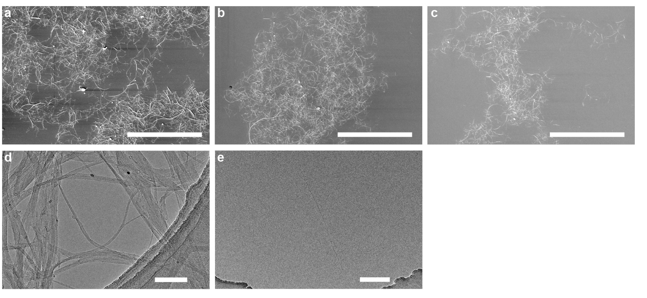

Supplementary Fig. 1 | Morphology characterization of SWNTs. SEM images of (a) long-SWNTs, (b) short-SWNTs and (c) sc-SWNTs. TEM images of SWNTs for (d) long-SWNTs and (e) sa-SWNTs. Scale bars, 10 μm in a, b, c; 100 nm in d; 200 nm in e.

Supplementary Fig. 2 | Structure characterization of different SWNTs. XPS spectra of C 1s of (a) long-SWNTs, (b) short-SWNTs. and (c) sc-SWNTs. d, Comparison of the carboxyl content of long-SWNTs, short-SWNTs and sc-SWNTs. e, XPS spectra of different animated SWNTs. f, Comparison of the N content of different animated SWNTs.

Supplementary Fig. 3 | Dispersion characterization of SWNTs prepared from different process. a, D90 distribution of different SWNTs. b, Zeta potential of different SWNTs.

Supplementary Fig. 4 | Comparison of the I_{G}/I_{D} values of different SWNTs from Raman spectra analysis.

Supplementary Fig. 5 | Schematic diagram of the fabrication steps of fibers. a, Schematic diagram of preparation of spinning dope. b, Schematic diagram of wet spinning.

Supplementary Fig. 6 | The XPS high-resolution N 1s spectra of the product from the reactions of sa-SWNTs and TPC.

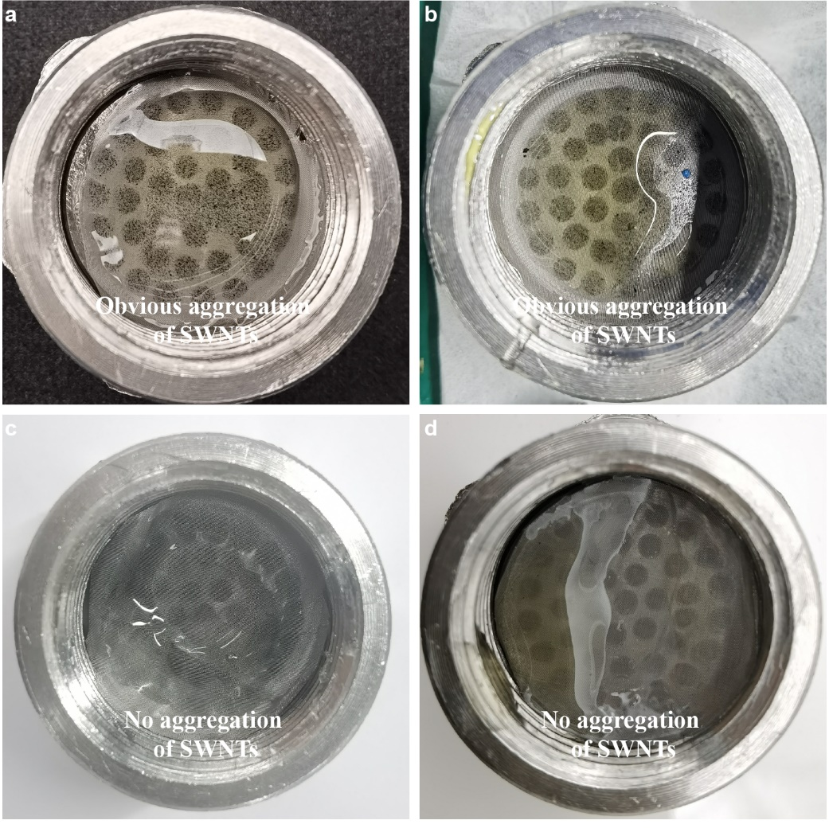
Supplementary Fig. 7 | Spinnability characterization of pinning dopes after the wet spinning process for six hours with the addition of (a) al-SWNTs, (b) as-SWNTs, (c) sc-SWNTs and (d) sa-SWNTs.

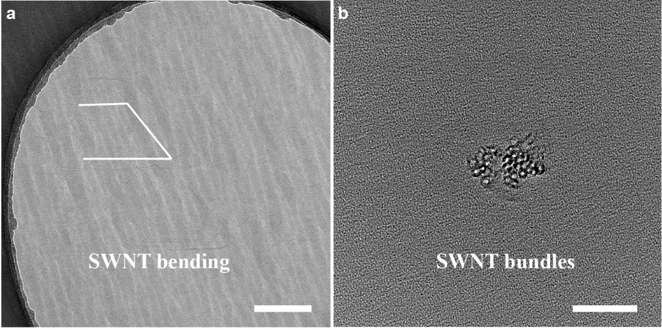

Supplementary Fig. 8 | The TEM images of the axial cross-section and radial cross-section of al-SWNT-HAFs. a, TEM image of the radial cross-section of al-SWNT-HAFs prepared by embedded ultramicrotome. Scale bar, 100 nm. b, TEM image of the axial cross-section of al-SWNT-HAFs prepared by FIB. Scale bar, 20 nm.

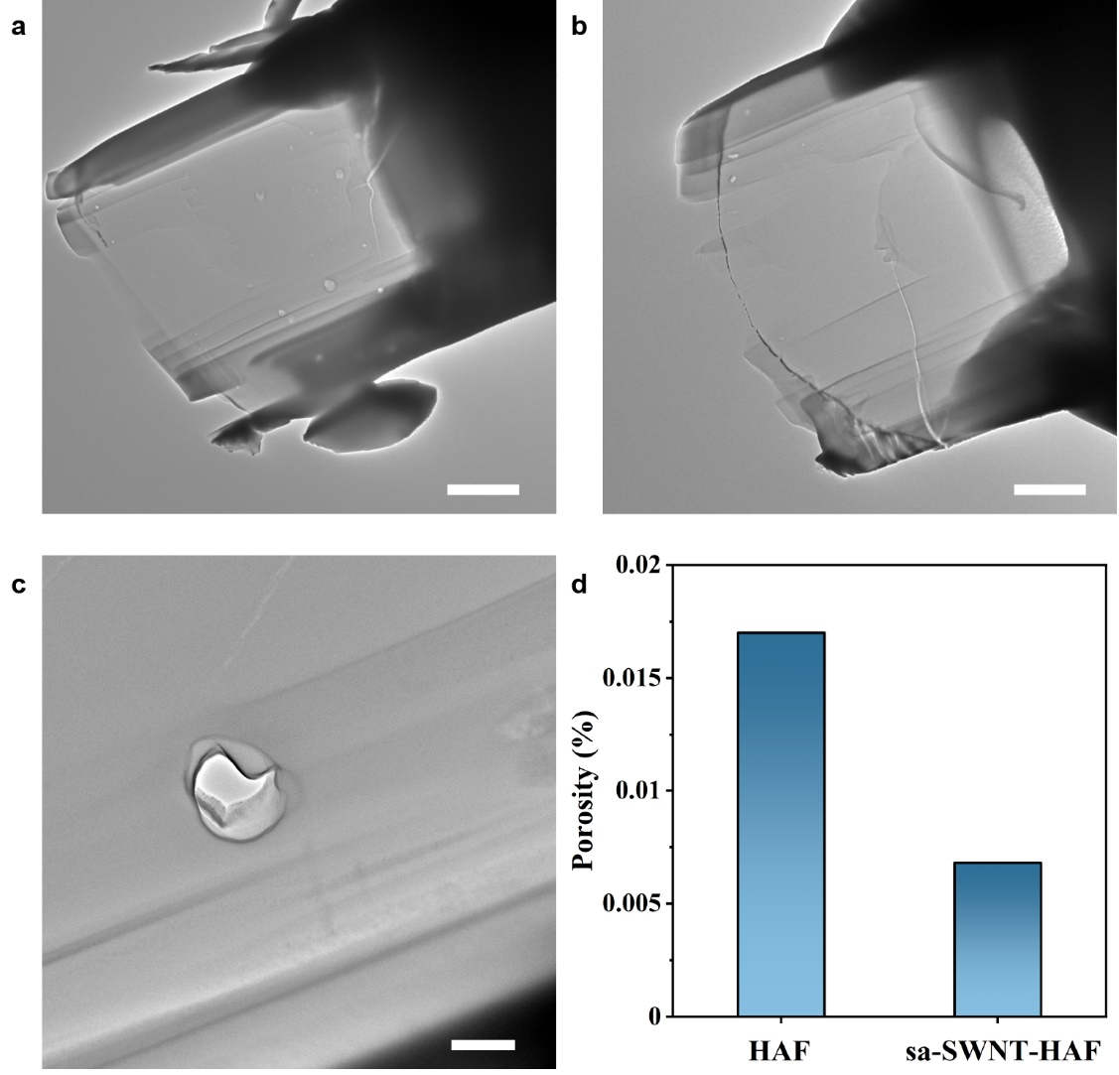
Supplementary Fig. 9 | Calculation of porosities of HAFs and sa-SWNT-HAFs. TEM images of (a) HAFs and (b) sa-SWNT-HAFs prepared by FIB. c, The TEM images of pore morphology prepared by FIB for HAFs. Scale bars, 2 μm in a, b; 200 nm in c. d, Porosities of HAFs and sa-SWNT-HAFs derived from FIB/SEMT.

Supplementary Fig. 10 | 2D-WAXS analysis of different fibers. a, 1D-WAXS curves of different fibers from 2D-WAXS analysis. b, Comparison of the FWHM of different fibers from the 1D-WAXS curves. c, The azimuthal intensity profile of different fibers from the 2D-WAXS analysis. The lines were achieved by Lorentz fitting.

Supplementary Fig. 11 | 2D-WAXS analysis of as-SWNT-HAFs and sa-SWNT-HAFs. a, 2D-WAXS patterns of as-SWNT-HAFs. b, Comparison of the 1D-WAXS curves of as-SWNT-HAFs and sa-SWNT-HAFs from 2D-WAXS analysis. c, The azimuthal intensity profiles of as-SWNT-HAFs and sa-SWNT-HAFs from the 2D-WAXS analysis. The lines were achieved by Lorentz fitting. d, Comparison of the degree of orientation of as-SWNT-HAFs and sa-SWNT-HAFs from 2D-WAXS analysis.

Supplementary Fig. 12 | 2D-WAXS analysis of sa-SWNT-HAFs with different concentrations of sa-SWNTs. 2D-WAXS patterns of sa-SWNT-HAFs with (a) 0.01%, (b) 0.025%, (c) 0.05%, (d) 0.075%, (e) 0.1% concentration of sa-SWNTs. f, The azimuthal intensity profile of sa-SWNT-HAFs with different concentrations of sa-SWNTs from the 2D-WAXS analysis. The lines were achieved by Lorentz fitting. g, Comparison of the degree of orientation of sa-SWNT-HAFs with different concentrations from the 2D-WAXS analysis. h, Comparison of the 1D-WAXS curves with different concentrations of sa-SWNT-HAFs from the 2D-WAXS analysis. i, Comparison of the FWHM with different concentrations of sa-SWNT-HAFs from the 1D-WAXS curves.

Supplementary Fig. 13 | 2D-SAXS analysis of sa-SWNT-HAFs with different concentrations of sa-SWNTs. 2D-SAXS patterns of sa-SWNT-HAFs with (a) 0.01%, (b) 0.025%, (c) 0.05%, (d) 0.075%, (e) 0.1% concentration of sa-SWNTs. f, Comparison of the microfibril misorientation degree with different concentrations of sa-SWNT-HAFs from 2D-SAXS analysis.

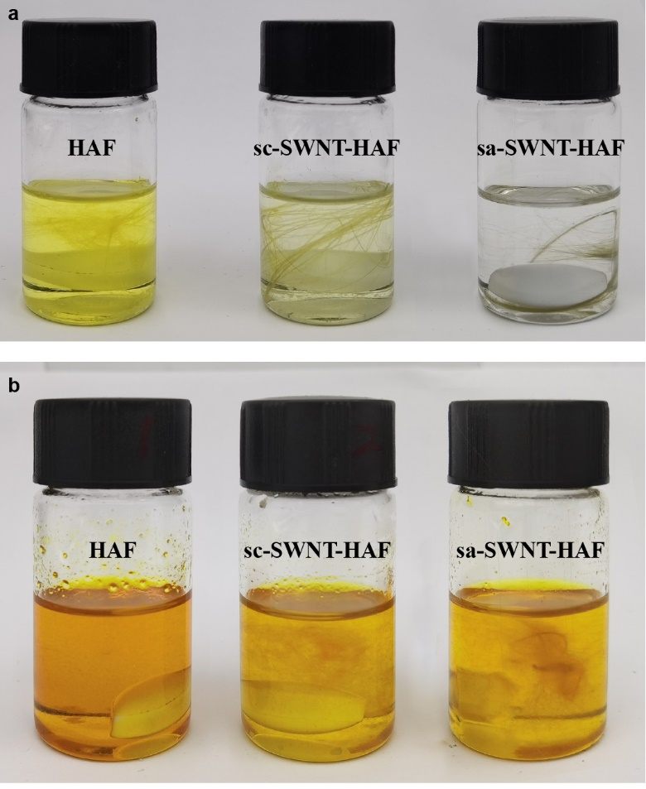

Supplementary Fig. 14 | Digital photographs of different fibers dissolved in KOH/DMSO solution for different times. HAFs, sc-SWNT-HAFs and sa-SWNT-HAFs dissolved in KOH/DMSO solution for (a) 1 hour and (b) 12 hours.

Supplementary Fig. 15 | Stress-versus-strain curves of different fibers. Stress-versus-strain curves of (a) HAFs, (b) al-SWNT-HAFs, (c) sc-SWNT-HAFs, (d) as-SWNT-HAFs, (e) sa-SWNT-HAFs.

Supplementary Fig. 16 | Stress-versus-strain curves of sa-SWNT-HAFs with different concentrations. Stress-versus-strain curves of sa-SWNT-HAFs with (a) 0.00%, (b) 0.01%, (c) 0.025%, (d) 0.05%, (e) 0.075%, (f) 0.1% concentration of sa-SWNTs.

Supplementary Fig. 17 | Strength and elongation at break of typical high-performance fibers reinforced by CNTs. The data are shown in Supplementary Table S10, are taken from the literature.

Supplementary Fig. 18 | Schematic diagram of the mini-SHTB experiment. While a sleeve-typed bullet launched by a gas gun struck the mass block fixed at the end of the incident bar, a tensile wave was generated and propagates along the incident bar. When it reaches the specimen clamped at the end of the incident bar, the dynamic tension was applied on the single fiber specimen, causing its ultimate failure.

Supplementary Fig. 19 | The analysis of dynamic tensile strength. a, Typical signals of the incident wave and force. b, Typical stress-strain curve and strain rate-strain curve. c, Stress-versus-strain curves of HAFs, sc-SWNT-HAFs and sa-SWNT-HAFs at different strain rates. d, Comparison of the tensile strength with different strain rates of HAFs, sc-SWNT-HAFs and sa-SWNT-HAFs. Error bars indicate the standard deviation of tensile strength.

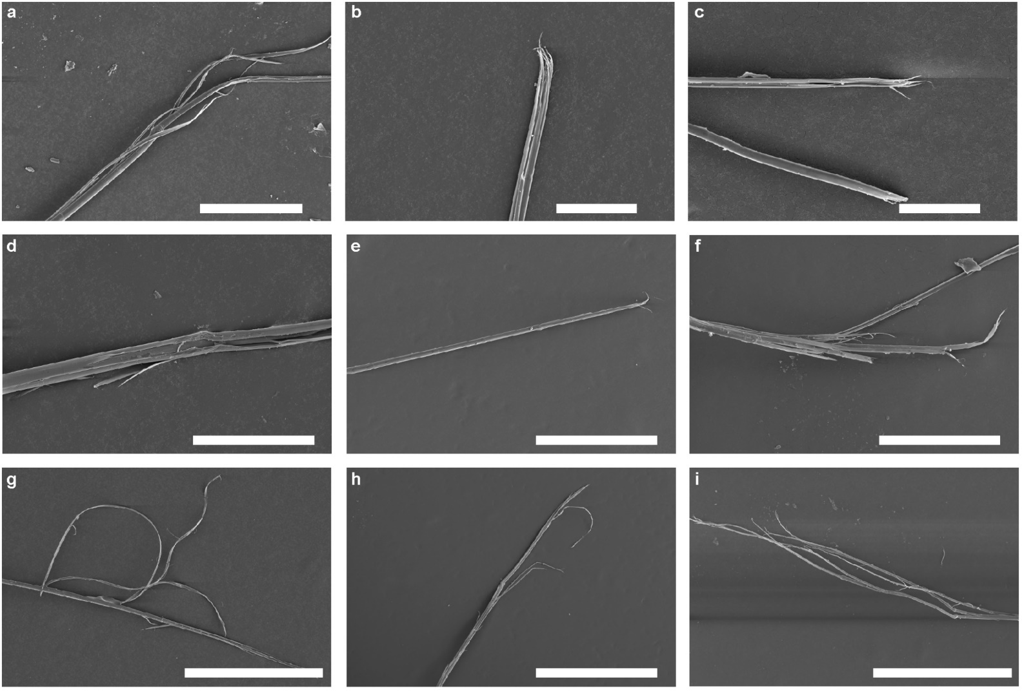

Supplementary Fig. 20 | SEM images of the fracture point of different fibers at different strain rates. SEM images of the fracture point of (a) HAFs, (b) sc-SWNT-HAFs and (c) sa-SWNT-HAFs at strain rates of 0.00083 s⁻¹. SEM images of the fracture point of (d) HAFs, (e) sc-SWNT-HAFs and (f) sa-SWNT-HAFs at strain rates of 950 s⁻¹. SEM images of the fracture point of (g) HAFs, (h) sc-SWNT-HAFs and (i) sa-SWNT-HAFs at strain rates of 1400 s⁻¹. Scale bars, 200 μm in a, f; 50 μm in b, c; 100 μm in d; 300 μm in e; 500 μm in g, h, i.

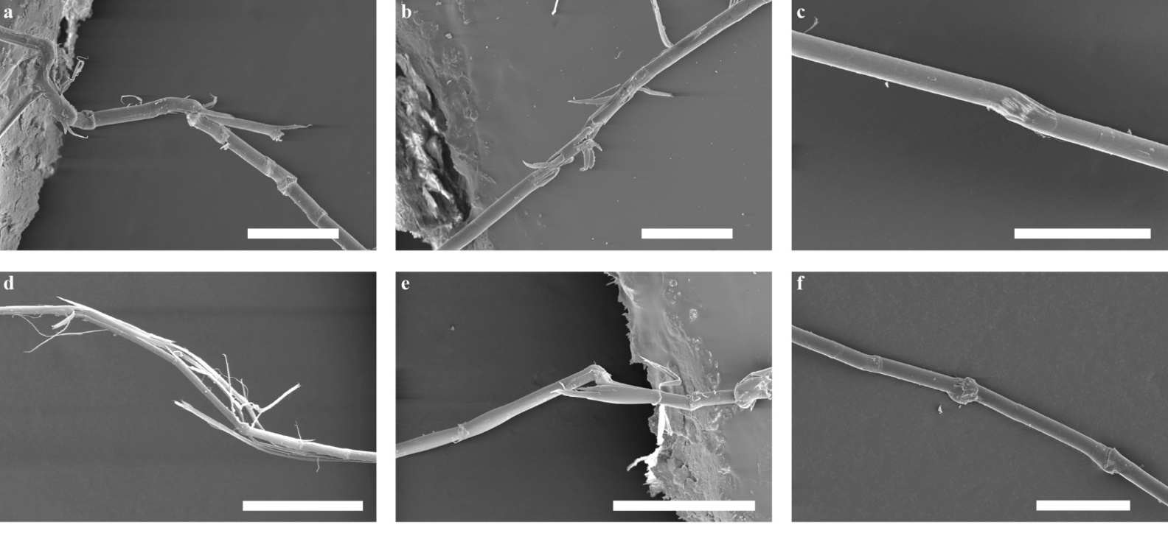

Supplementary Fig. 21 | SEM images of the kink bond of different fibers at different strain rates. SEM images of the kink bond of (a) HAFs, (b) sc-SWNT-HAFs and (c) sa-SWNT-HAFs at strain rates of 950 s⁻¹. SEM images of the kink bond of (d) HAFs, (e) sc-SWNT-HAFs and (f) sa-SWNT-HAFs at strain rates of 1400 s⁻¹. The kink bond was formed away from the fracture point of fiber, due to the sudden release of stress after fiber tensile fracture in the tensile tests. Scale bars, 200 μm in a, b, c, f; 50 μm in d, e.

Supplementary Fig. 22 | Schematic of the laser-shock induced PDMS film swelling impact on a single fiber. The laser ablated the 100 nm thick gold film to create a fast expanding plasma on the surface, causing the fast expansion of the 76 μm thick polydimethylsiloxane (PDMS) layer, which impacted the single fiber specimen with high velocity.

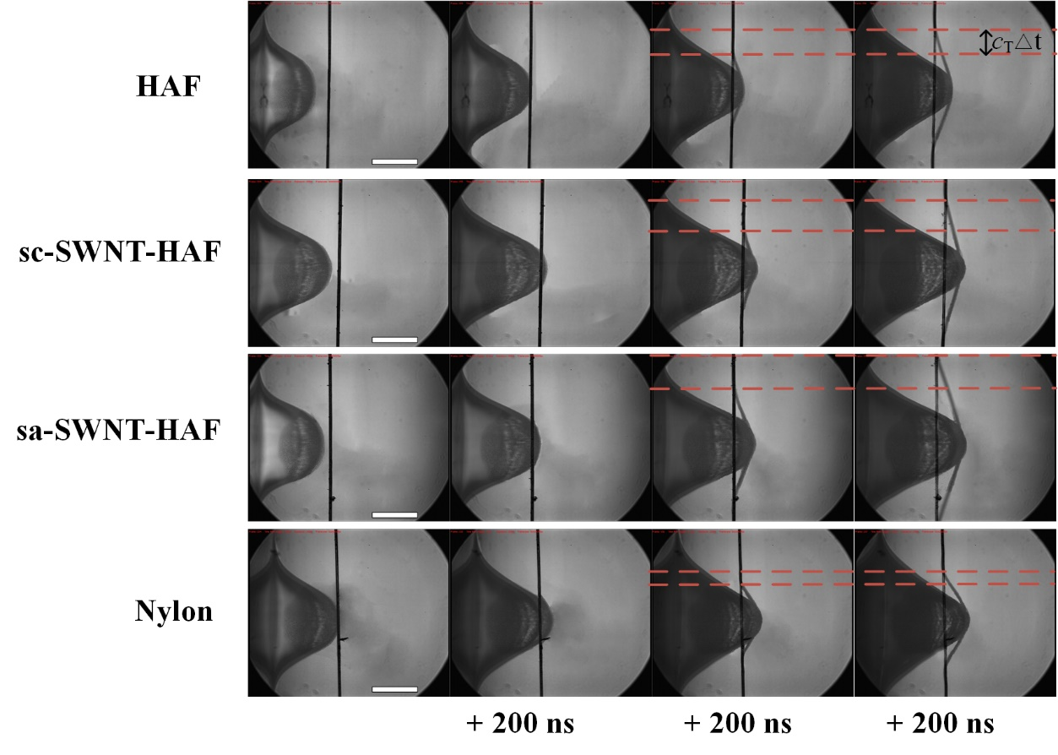
Supplementary Fig. 23 | The deformation process under transverse impact for different fibers. Scale bar, 300 μm.

Supplementary Fig. 24 | The SEDP of different fibers. The orange dots in the figure are collected from reference⁸. Error bars indicate the standard deviation of SEDP.

Supplementary Fig. 25 | Theoretical calculations and simulations of composite fibers. a, Stress-strain curve of crystalline heterocyclic aramid. Herein, optimal length of single heterocyclic aramid chain was adopted as initial length of crystalline heterocyclic aramid to calculate the applied strain. b, Molecular structure of six types of polymers. c, Simulation snapshots of HAF. d, Energy evolution of HAF. The temperature increases from 0.01 K to 1000 K and then decreases to 298 K. The temperature is controlled as 298 K for 2 ns.

Supplementary Table 1 | Mechanical properties of HAFs.

Number | Stress  (GPa) | Modulus  (GPa) | Elongation  at break (%) | Toughness  (MJ m⁻³)
1 | 5.20 | 128.3 | 4.10 | 105.8
2 | 5.24 | 121.6 | 4.28 | 116.9
3 | 5.08 | 125.7 | 4.39 | 114.4
4 | 5.21 | 130.3 | 4.23 | 111.2
5 | 5.02 | 120.9 | 4.20 | 106.9
6 | 4.95 | 121.1 | 4.31 | 111.0
7 | 5.29 | 122.4 | 4.57 | 108.0
8 | 5.24 | 127.6 | 4.29 | 121.8
9 | 5.00 | 128.6 | 4.14 | 107.7
10 | 4.95 | 124.4 | 4.18 | 103.5
Average | 5.12 | 125.1 | 4.27 | 110.7

Supplementary Table 2 | Mechanical properties of sa-SWNT-HAFs with 0.05% concentration of sa-SWNTs.

Number | Stress  (GPa) | Modulus  (GPa) | Elongation  at break (%) | Toughness  (MJ m⁻³)
1 | 6.4 | 133.6 | 5.45 | 183.9
2 | 6.49 | 144.4 | 5.63 | 199.3
3 | 6.35 | 143.3 | 5.44 | 184.2
4 | 6.42 | 138.1 | 5.49 | 186.4
5 | 6.43 | 143.9 | 5.08 | 166.1
6 | 6.59 | 146.3 | 5.22 | 181.5
7 | 6.25 | 140.4 | 5.01 | 165.1
8 | 6.36 | 145.4 | 5.34 | 183.4
9 | 6.51 | 142.9 | 5.59 | 197.3
10 | 6.57 | 138.2 | 5.49 | 192.7
Average | 6.44 | 141.7 | 5.37 | 184.0

Supplementary Table 3 | Mechanical properties of sa-SWNT-HAFs with 0.01% concentration of sa-SWNTs.

Number | Stress  (GPa) | Modulus  (GPa) | Elongation  at break (%) | Toughness  (MJ m⁻³)
1 | 5.52 | 134.7 | 4.31 | 122.7
2 | 5.31 | 140.5 | 4.4 | 129.7
3 | 5.49 | 129.3 | 4.48 | 123
4 | 5.42 | 131.2 | 4.38 | 121.2
5 | 5.33 | 137.4 | 4.34 | 119.9
6 | 5.49 | 130.2 | 4.45 | 126.5
7 | 5.45 | 126.7 | 4.5 | 126
8 | 5.43 | 132.5 | 4.4 | 123.7
9 | 5.34 | 130.3 | 4.38 | 121.5
10 | 5.43 | 134.1 | 4.33 | 122.3
Average | 5.42 | 132.7 | 4.40 | 123.7

Supplementary Table 4 | Mechanical properties of sa-SWNT-HAFs with 0.025% concentration of sa-SWNTs.

Number | Stress  (GPa) | Modulus  (GPa) | Elongation  at break (%) | Toughness  (MJ m⁻³)
1 | 5.64 | 141.7 | 4.86 | 149
2 | 5.84 | 141.4 | 5.06 | 160.6
3 | 5.71 | 139 | 4.99 | 152.8
4 | 5.63 | 143.3 | 4.75 | 143.5
5 | 5.77 | 133.7 | 4.92 | 151.5
6 | 5.74 | 139.4 | 5.07 | 160.3
7 | 5.87 | 136.7 | 4.79 | 146.3
8 | 5.76 | 135.5 | 5.17 | 158.5
9 | 5.75 | 143.6 | 4.95 | 154.7
10 | 5.97 | 133.5 | 5.02 | 156.3
Average | 5.77 | 138.8 | 4.96 | 153.4

Supplementary Table 5 | Mechanical properties of sa-SWNT-HAFs with 0.075% concentration of sa-SWNTs.

Number | Stress  (GPa) | Modulus  (GPa) | Elongation  at break (%) | Toughness  (MJ m⁻³)
1 | 6.02 | 140.2 | 4.9 | 155.5
2 | 6 | 139 | 4.68 | 146.9
3 | 5.99 | 145.4 | 4.83 | 152.9
4 | 6.07 | 140.1 | 5.02 | 162.7
5 | 5.97 | 144.2 | 4.84 | 153
6 | 6.01 | 142.7 | 4.61 | 142.7
7 | 5.85 | 141 | 4.94 | 152.5
8 | 5.75 | 142.8 | 5.06 | 159.2
9 | 5.8 | 146.2 | 4.66 | 146.4
10 | 6.05 | 141.7 | 4.85 | 154.1
Average | 5.95 | 142.3 | 4.84 | 152.6

Supplementary Table 6 | Mechanical properties of sa-SWNT-HAFs with 0.1% concentration of sa-SWNTs.

Number | Stress  (GPa) | Modulus  (GPa) | Elongation  at break (%) | Toughness  (MJ m⁻³)
1 | 5.63 | 137.4 | 4.14 | 116.6
2 | 5.52 | 140.9 | 4.26 | 120.9
3 | 5.91 | 129 | 4.51 | 129.4
4 | 5.81 | 135.3 | 4.15 | 117.9
5 | 5.53 | 141.4 | 4.62 | 132.7
6 | 5.82 | 133.4 | 4.63 | 136.9
7 | 5.83 | 132.4 | 4.53 | 134.6
8 | 5.67 | 134.3 | 4.66 | 137.9
9 | 5.89 | 132.8 | 4.51 | 133.3
10 | 5.85 | 130 | 4.35 | 123.3
Average | 5.75 | 134.7 | 4.43 | 128.3

Supplementary Table 7 | Mechanical properties of al-SWNT-HAFs with 0.05% concentration of al-SWNTs.

Number | Stress  (GPa) | Modulus  (GPa) | Elongation  at break (%) | Toughness  (MJ m⁻³)
1 | 4.46 | 117.3 | 3.87 | 85.2
2 | 4.02 | 127.2 | 3.59 | 76.7
3 | 3.81 | 127.3 | 3.45 | 70.6
4 | 4.28 | 126.7 | 3.66 | 81.0
5 | 3.97 | 125.7 | 3.44 | 71.6
6 | 4.07 | 120.8 | 3.95 | 86.4
7 | 4.04 | 124.6 | 3.54 | 75.3
8 | 4.36 | 122.8 | 3.71 | 80.8
9 | 4.22 | 125.3 | 3.62 | 80.6
10 | 4.00 | 126.6 | 3.42 | 72.0
Average | 4.12 | 124.4 | 3.63 | 78.0

Supplementary Table 8 | Mechanical properties of sc-SWNT-HAFs with 0.05% concentration of sc-SWNTs.

Number | Stress  (GPa) | Modulus  (GPa) | Elongation  at break (%) | Toughness  (MJ m⁻³)
1 | 5.24 | 146.9 | 4.07 | 112.8
2 | 5.37 | 143.7 | 4.16 | 117.0
3 | 5.23 | 138.3 | 4.15 | 113.2
4 | 5.18 | 143.8 | 3.94 | 105.8
5 | 5.25 | 145.3 | 3.93 | 106.8
6 | 5.14 | 143.8 | 3.94 | 105.2
7 | 5.38 | 129.2 | 4.28 | 114.5
8 | 5.48 | 139.1 | 4.28 | 121.0
9 | 5.33 | 134.9 | 4.09 | 108.6
10 | 5.27 | 143.7 | 3.92 | 106.6
Average | 5.29 | 140.9 | 4.08 | 111.2

Supplementary Table 9 | Mechanical properties of as-SWNT-HAFs with 0.05% concentration of as-SWNTs.

Number | Stress  (GPa) | Modulus  (GPa) | Elongation  at break (%) | Toughness  (MJ m⁻³)
1 | 5.85 | 133.9 | 4.78 | 143.8
2 | 5.95 | 132.5 | 4.77 | 145.7
3 | 5.84 | 137.5 | 4.61 | 142
4 | 5.98 | 128.5 | 5.1 | 159
5 | 6.04 | 140.6 | 4.56 | 142.1
6 | 5.8 | 140 | 4.38 | 130.4
7 | 5.7 | 140.8 | 4.39 | 130.8
8 | 6.03 | 132.8 | 4.46 | 135.7
9 | 5.63 | 142.7 | 4.3 | 123.8
10 | 5.72 | 141 | 4.43 | 129.9
Average | 5.85 | 137.0 | 4.58 | 138.3

Supplementary Table 10 | Strength and elongation at break of typical high-performance fibers reinforced by CNTs.

Materials | CNT  wt % | Strength  (GPa) | Elongation  at break (%) | Ref.
Kevlar |  | 4 | 3 | 9
Kevlar-CNT | 1 | 5 | 3.5 | 9
PBO-1 |  | 2.6 | 2 | 10
PBO-1-CNT | 10 | 4.2 | 2.8 | 10
PBO-2 |  | 1.18 | 3 | 11
PBO-2-CNT | 0.54 | 1.51 | 2.8 | 11
PBO-3 |  | 1.36 | 2.2 | 12
PBO-3-CNT | 1.5 | 2.17 | 2.7 | 12
UHMWPE |  | 3.51 | 4.03 | 13
UHMWPE-CNT | 5 | 4.17 | 4.65 | 13
HAF (This work) |  | 5.12 | 4.27
sa-SWNT-HAF  (This work) | 0.05 | 6.44 | 5.37

Supplementary References
- Yang, B., Wang, L., Zhang, M., Luo, J. & Ding, X. Timesaving, high-efficiency approaches to fabricate aramid nanofibers, ACS Nano 13, 7886-7897 (2019).
- Wan, S. et al., High-strength scalable MXene films through bridging-induced densification. Science 374, 96-99 (2021).
- Li, K. et al., Enhancing mechanical properties of aromatic polyamide fibers containing benzimidazole units via temporarily suppressing hydrogen bonding and crystallization. J. Appl. Polym. Sci. 132, 42482 (2015).
- Ding, X., Kong, H., Qiao, M., Hu, Z. & Yu, M. Study on crystallization behaviors and properties of f-iii fibers during hot drawing in supercritical carbon dioxide. Polymers 11, 856 (2019).
- Yang, C. et al., Constructing mainstay-body structure in heterocyclic aramid fiber to simultaneously improve tensile strength and toughness. Compos. Pt. B-Eng. 202, 108411 (2020).
- Ran, S. et al., Structural changes during deformation of Kevlar fibers via on-line synchrotron SAXS/WAXD techniques. Polymer 42, 1601-1612 (2001).
- Zhu, C. et al., Relationship between performance and microvoids of aramid fibers revealed by two-dimensional small-angle X-ray scattering. J. Appl. Crystallogr. 46, 1178-1186 (2013).
- Xie, W. et al., Dynamic strengthening of carbon nanotube fibers under extreme mechanical impulses. Nano Lett. 19, 3519-3526 (2019).
- O'Connor, I., Hayden, H., Coleman, J. N. & Gun'ko, Y. K. High‐strength, high‐toughness composite fibers by swelling Kevlar in nanotube suspensions. Small 5, 466-469 (2009).
- Kumar, S. et al., Synthesis, structure, and properties of PBO/SWNT Composites&. Macromolecules 35, 9039-9043 (2002).
- Hu, Z. et al., One-pot preparation and continuous spinning of carbon nanotube/poly (p-phenylene benzobisoxazole) copolymer fibers. J. Mater. Chem. 22, 19863-19871 (2012).
- Zhou, C., Wang, S., Zhang, Y., Zhuang, Q. & Han, Z. In situ preparation and continuous fiber spinning of poly (p-phenylene benzobisoxazole) composites with oligo-hydroxyamide-functionalized multi-walled carbon nanotubes. Polymer 49, 2520-2530 (2008).
- Ruan, S., Gao, P. & Yu, T. X. Ultra-strong gel-spun UHMWPE fibers reinforced using multiwalled carbon nanotubes. Polymer 47, 1604-1611 (2006).

Description of Supplementary Videos 1 to 4
Movie S1. A series of sections derived from FIB/SEM of HAFs
Movie S2. A series of sections derived from FIB/SEM of sa-SWNT-HAFs
Movie S3. 3D observation of reconstructed void microstructure derived from FIB/SEMT of HAFs.
Movie S4. 3D observation of reconstructed void microstructure derived from FIB/SEMT of sa-SWNT-HAFs.

