Supplemental information

Fig. S1 Alignments of TfBOP1/2 and AtBOP1/2 proteins. BTB/POZ domain (Pfam: 00651), DUF3420 domain (Pfam: 11900) and ankryin (ANK) domain (Pfam: 00023) are highlighted by red, green and blue boxes, respectively. DUF3420 and ANK domains are partially overlapped.

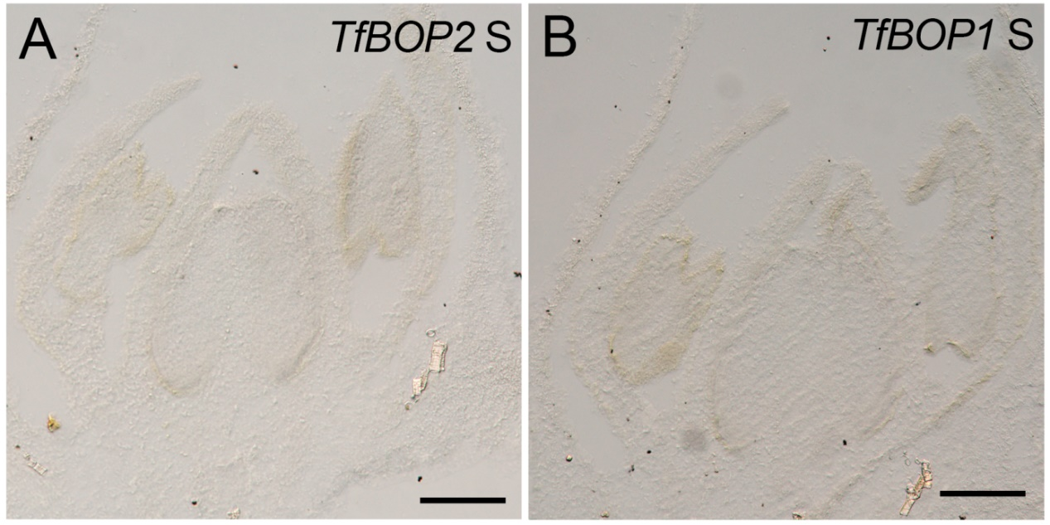
Fig. S2 RNA in situ hybridization of TfBOP2 (A) and TfBOP1 (B) in stage 8 flower buds of wild-type using sense probes. Scale bars: 100 μm.

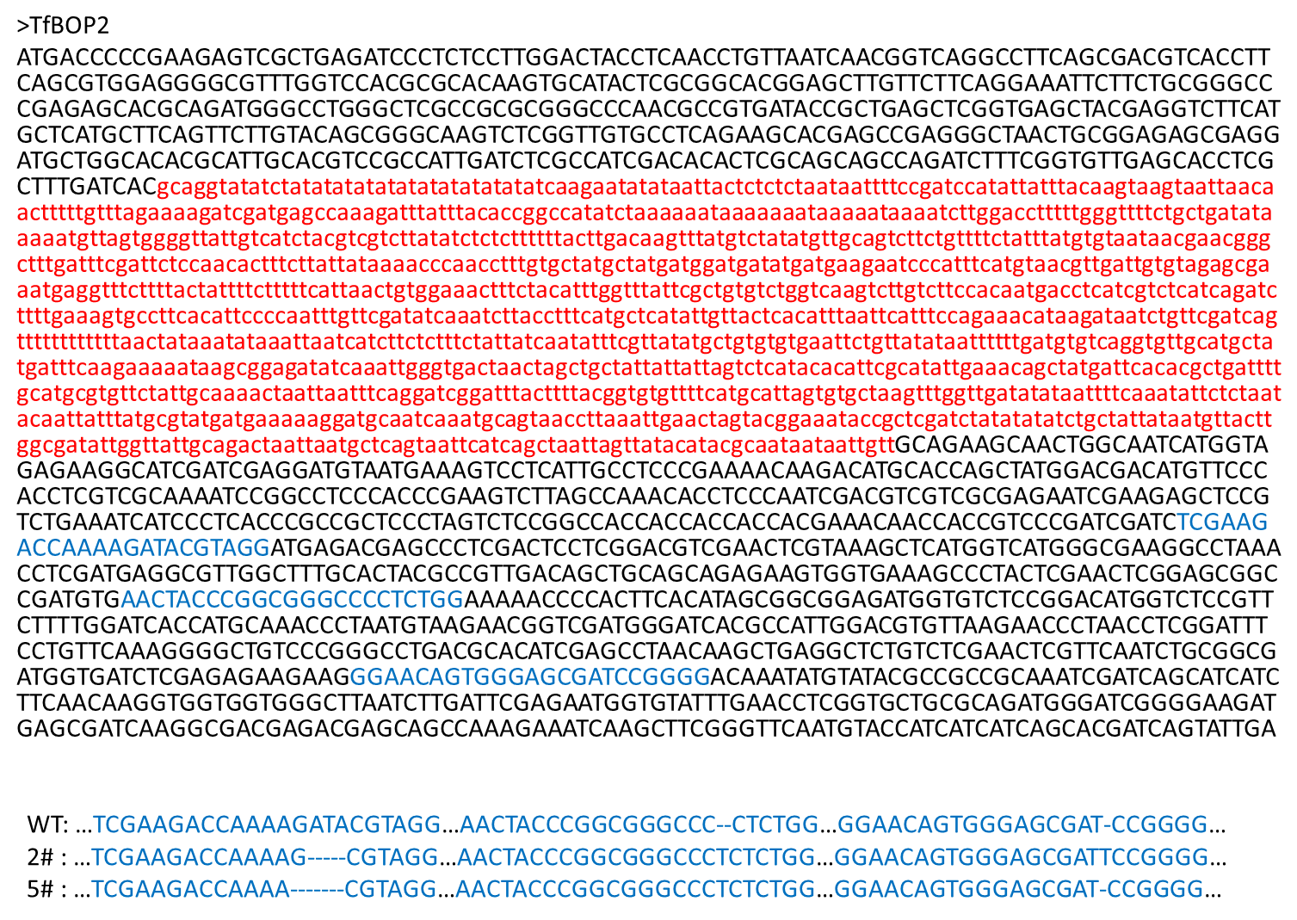
Fig. S3 CRISPR/Cas9 genome editing. Upper panel: The genomic DNA sequence of TfBOP2. The black and red characters represent exons and introns, respectively; PAMs (Protospacer Adjacent Motifs) and different CRISPR/Cas9 targets are highlighted in blue. Lower panel: Mutations in the WT and two TfBOP2-Cas9 plants analyzed in this study.

Fig. S4. Neighbor-joining tree for the KNOX transcription factors. The bootstrap value (percentage, based on 1000) is marked at each node, and the accession numbers are indicated as the suffix of each sequence. KNAT3 was chosen as an outgroup.

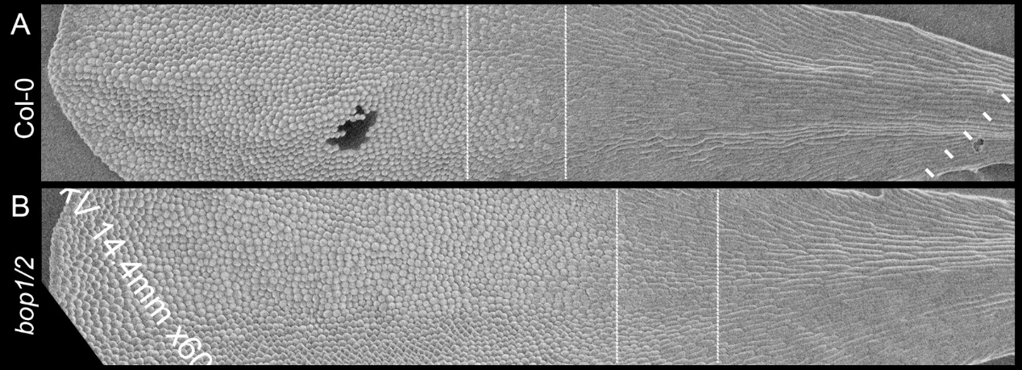
Fig. S5 Epidermal cell morphologies of wild-type (A) and bop1 bop2 (B) mutant of Arabidopsis thaliana. White lines indicate the proximal claw (right), intermediate (middle) and distal blade (left) regions, respectively.

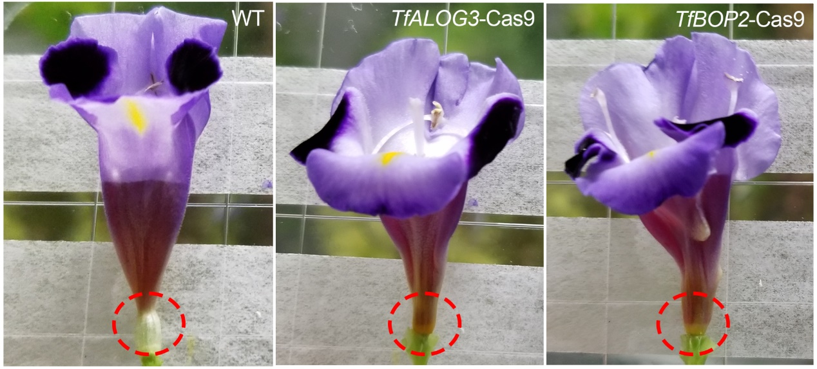
Fig. S6 Application of 200 μl water containing 0.1% Safranin O to different flowers. The red dashed circle indicates the corolla neck.

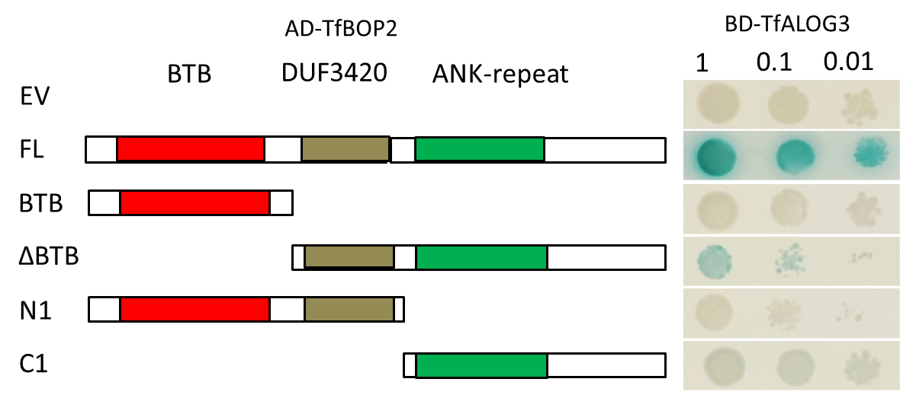
Fig. S7 Yeast two-hybrid assays using SD-LW/X-Gal media (SD medium minus Trp, Leu and supplemented with X-Gal) showing that TfBOP2 interacts with TfALOG3 partially through the DUF3420, ANK-repeat and C-terminal domains.

Tab. S1 DEGs from the transcriptomic data.

Tab. S2 GO annotation of DEGs

Tab. S3 Possible downstream genes of TfBOP2.

Tab. S4 Primers used in this study

