Supplementary Materials
For
A metabolism-related gene-based prognostic and immunotherapy model for hepatocellular carcinoma
Hai-chao Zhao#, Zi-ang Liu#, Chang-zhou Chen, Lu Liu, Huang-qin Song, Yan-zhang Tian,*, Hao-liang Zhao*

Contents:
- Supplementary Figures

Supplementary Figures

Figure S1. Enrichment analysis of MRGs. (a) The top15 of BP, CC, and MF are presented on the histogram. (b) Top 9 pathways for CC enrichment correspond to the circle plot. (c) Top 8 pathways for MF enrichment correspond to the circle plot.
Figure S2. IC50 of candidate drugs in forest map. DOMG, Temsirolimus, AZD8055, SB590885, and Elesclomol performed a higher IC50 in the high-risk group. Gemcitabine, Bleomycin, EpothiloneB, and Mitomycin performed a higher IC50 in the low-risk group.

Figure S3. The expression of 12 MRGs in tumor and normal tissue. The expression of (a) LPCAT1, (b) CDC20, (c)UCK2 and (d) FLVCR1 were higher in tumor tissues. The expression of (e-l) CISH, HMGCS2, IL33, IYD, BCO2, STEAP4, CFHR3 and LCAT were higher in normal tissues; *p < 0.05, **p < 0.01, ***p < 0.001.
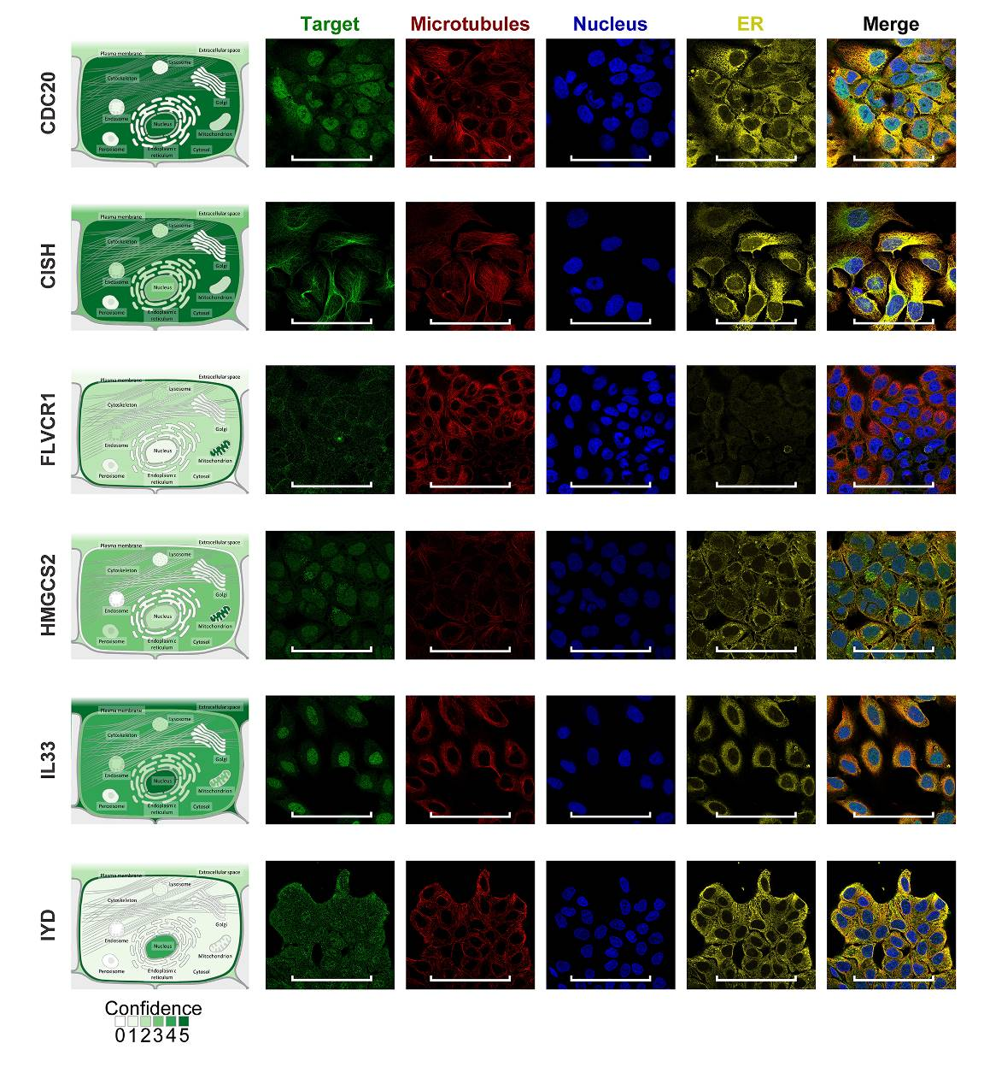Figure S4. Immunofluorescence of genes protein located in cellular. The locations of genes protein were CDC20, CISH, FLVCR1, HMGCS2, IL33, and IYD, respectively. Scale bar: 100 μm (white).

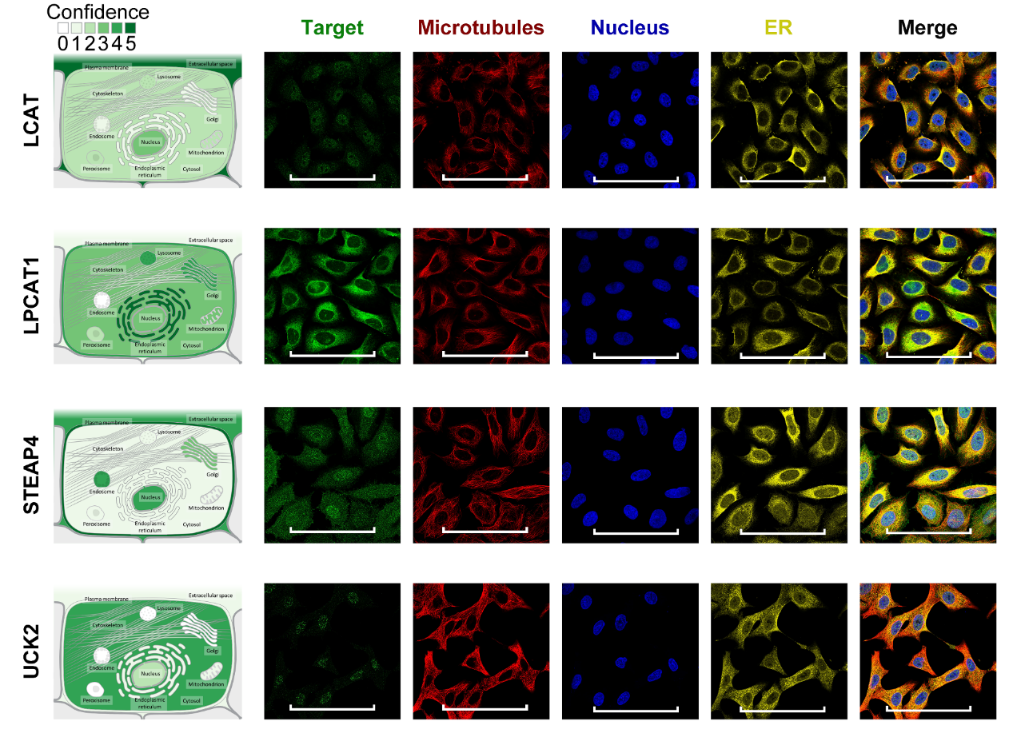
Figure S5. Immunofluorescence of genes protein located in cellular. The locations of genes protein were LCAT, LPCAT1, STEAP4, and UCK2, respectively. Scale bar: 100 μm (white).

Figure S6. Receiver operating characteristic (ROC) analysis of 12 MRGs. The AUC value of ROC curves in (a-l) BCO2, CDC20, CFHR3, CISH, FLVCR1, HMGCS2, IL33, IYD, LCAT, LPCAT1, STEAP4 and UCK2 were 0.939, 0.980, 0.738, 0.626, 0.981, 0.740, 0.826, 0.797, 0.960, 0.864, 0.857 and 0.978, respectively.
Figure S7. Genomic analysis and Oncoprint visual summarize of alteration of 12 MRGs. (a) UCK2 and FLVCR1 were analyzed with a higher rate in HCC patients. (b) Summarize of genomic variation of 12 MRGs in HCC. (c) The alterations in BCO2, CISH, FLVCR1, HMGCS2, IYD, LCAT, LPCAT1, STEAP4, and UCK2 were shown respectively.

Figure S8. Kaplan-Meier survival curves of 12 MRGs. Kaplan-Meier survival curves showed Overall survival comparing the high and low expression of (a) BCO2, (b) CDC20, (c) CFHR3, (d) CISH, (e) FLVCR1, (f) HMGCS2, (g) IL33, (h) IYD, (i) LCAT, (j) LPCAT1, (k) STEAP4, and (l) UCK2.
Figure S9. Immune cell infiltration levels of 6 MRGs in this model. (a) IL33, (b) CISH, (c) FLVCR1, (d) LPCAT1, (e) STEAP4, and (f) UCK2 levels with tumor-infiltrating immune cells in HCC.
Figure S10. Immune cell infiltration levels of other 6 MRGs in this model. (a) BCO2, (b) IYD, (c) CDC20, (d) HMGCS2, (e) CFHR3, and (f) LCAT levels with tumor-infiltrating immune cells in HCC.

Figure S11. Marker genes somatic copy number alterations (SCNAs) affect the infiltrating levels of immune cells in HCC. Box plots show the distributions of each TIIC subset for each DNA SCNAs in HCC using the same statistical tests as in the ‘mutation’ module, including deep deletion (purple), arm-level deletion (blue), diploid/normal (grey), arm-level gain (yellow), high amplification (red). The immune-infiltrating abundance of (a)BCO2, (b)CISH, (c)HMGCS2, (d)IL33, (e)IYD, (f)LCAT, (g)LPCAT1, and (h)STEAP4 were examined; *p < 0.05, **p < 0.01, ***p < 0.001.

