 | Solvants extraction
 | n-hexane | Dichloromethane | n-butanol | Ethyl acetate
Zones of inhibition (mm) | 00 | 00 | 14 | 26
Table S1 Antifungal activity of the various organic extracts from the culture filtrates of SZ03 strain

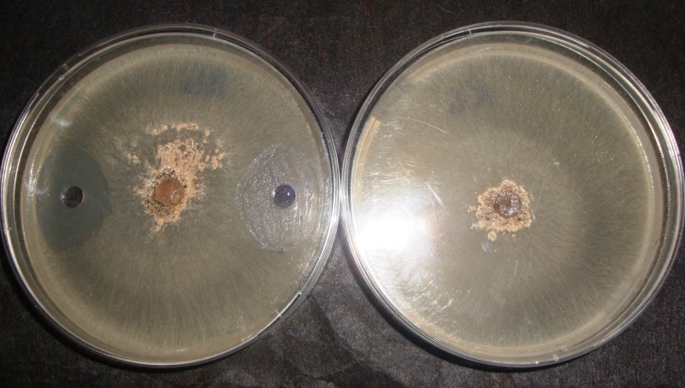
Fig. S1 Antifungal activity of the culture filtrate of Streptomyces lincolnensis strain SZ03 on the mycelial growth of Rhizoctonia solani (left) and a control culture (right). Photography was taken after 3 days culture on ISP2 medium at 25°C

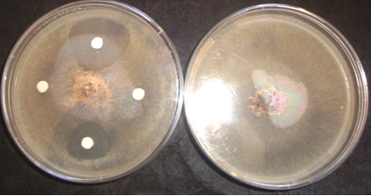
DA
EA
B
H
Fig. S2 Antibiography showing the antifungal activity (left) of Ethyl acetate (EA), n-Butanol (B), Dichloromethane (D) and n-Hexane (H) extracts from the supernatant culture of Streptomyces lincolnensis strain SZ03 on the mycelial growth of Rhizoctonia solani and the control culture (left). Photography was taken after 3 days culture on ISP2 medium at 25°C

Microbiological revelation of active fractions
Front of solvent (B.A.E)
A 254 nm
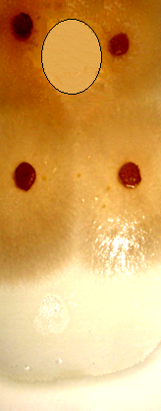
Fraction B (Rf = 0,50)
Fraction A (Rf = 0,80)
Inactive fraction against R. solani
Active Fraction against R. solani
Fig. S3 Bioautography showing two fractions (A) and (B) in the ethyl acetate extract form the supernatant culture of Streptomyces lincolnensis strain SZ03 under UV (254 nm) light and their antifungal activities against the mycelial growth of Rhizoctonia solani

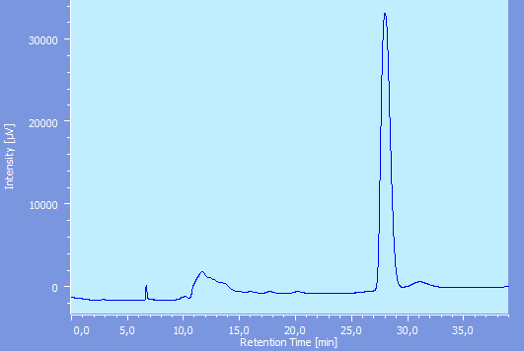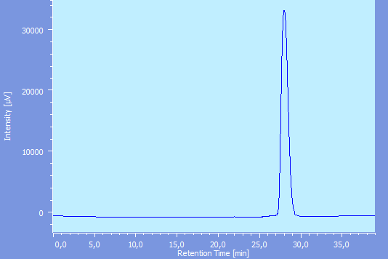
F2
ATB_F2 _CH2
C
B
F2
ATB_AE_SZ03_ CH1
F3"
F1
A

Fig. S4 Elution profiles from the HPLC analysis (obtained at 220 nm) of the ethyl acetate extract of the culture filtrate of Streptomyces lincolnensis strain SZ03 (A) and after purification by a second re-injection of the "F2" fraction (B)

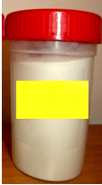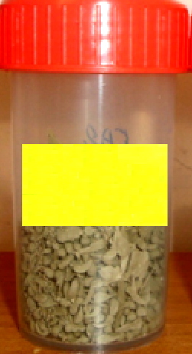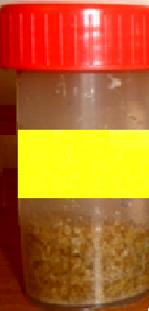
SAP
CAP
WTP
Fig. S5 Photography showing the three formulated biofungicides: wettable talcum powder (WTP), clay-sodium alginate propagules and sodium alginate propagules based on spores of Streptomyces lincolnensis strain SZ03

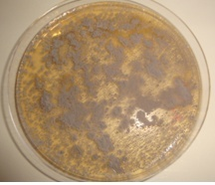
Fig. S6 Pure culture of Streptomyces lincolnensis strain SZ03 on ISP2 medium. Photography was taken after 7 days incubation at 30°C

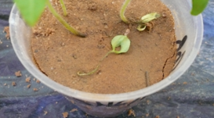
Fig. S7 Photography showing the Rhizoctonia solani damping off of tomato seedlings. Arrows indicated dead seeds after 12 days culture

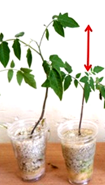
Fig. S8 Photography showing the growth promotion effect of WTP biofungicide on tomato cv. Aïcha seedlings (left) compared to seedling from the negative control (right). Photography was taken after 4 weeks culture

