Supporting information
Competitive effects of macroalgae Caulerpa taxifolia on key physiological processes in a scleratinian coral Turbinaria peltata under thermal stress
Authors:Jian rong Fu, Jie Zhou, Hui ting Yang, Jia li Zhou, Yan ping Zhang, Li Liu
Table 1
Summary of values of water chemistry data for all treatments.The results are presented as means ± standard deviation.
 | Coral |  | Coral exposed to algae |  | Coral contact with algae
 | 27ºC | 30ºC | 27ºC | 30ºC | 27ºC | 30ºC
Temperature [ºC] | 27.1±0.1 | 30±0.2 | 26.9± 0.3 | 30 ±0.2 | 27± 0.2 | 30 ±0.2
PH | 8.03 ±0.04 | 8.03± 0.04 | 8.02± 0.04 | 8.03± 0.05 | 8.02 ±0.04 | 8.03 ±0.05
Salinity | 32.1 ±0.6 | 32.2± 0.5 | 32.1 ±0.6 | 32.1 ±0.7 | 32.2 ±0.4 | 32.0 ±0.6

Table 2
Two way ANOVA output of different variables for T.peltata with bold values indicating significant effects on the variable. F=F-value; p=p-value(significance <0.05).
Variable | Source of variation | F | p
Growth Rate | Algae | F(2,8) = 28.8 | <0.01
Growth Rate | Temperature | F(1,4) = 7.8 | 0.049
Growth Rate | Interaction | F(2,8) = 28 | <0.01
Feeding Rate | Algae | F(2,8) = 14.6 | <0.01
Feeding Rate | Temperature | F(1,4) = 119.8 | <0.01
Feeding Rate | Interaction | F(2,8) = 4.7 | 0.04
Zooxanthellae | Algae | F(2,8) = 0.75 | 0.5
Zooxanthellae | Temperature | F(1,4) = 21.9 | 0.01
Zooxanthellae | Interaction | F(2,8) = 9 | 0.01
Chl a | Algae | F(2,8) = 1.6 | 0.27
Chl a | Temperature | F(1,4) = 90.9 | <0.01
Chl a | Interaction | F(2,8) = 7.2 | 0.02
Protein | Algae | F(2,8) = 31.9 | <0.01
Protein | Temperature | F(1,4) = 4.3 | 0.11
Protein | Interaction | F(2,8) = 2.9 | 0.12
SOD | Algae | F(2,8) = 38.8 | <0.01
SOD | Temperature | F(1,4) = 16.0 | 0.02
SOD | Interaction | F(2,8) = 2.4 | 0.16
CAT | Algae | F(2,8) = 10.0 | <0.01
CAT | Temperature | F(1,4) = 64.5 | <0.01
CAT | Interaction | F(2,8) = 5.1 | 0.04

Table 3
Data of various physiological indicators, the results are presented as means ± standard deviation.
Variable | Zooxanthellae×10⁶ (cell cm⁻²)
 | 27℃ |  |  | Mean±sd | 30℃ |  |  | Mean±sd
Coral | 1.46 | 1.17 | 1.27 | 1.3±0.14 | 0.74 | 0.65 | 0.78 | 0.72±0.07
Coral exposed to algae | 1.08 | 0.85 | 0.94 | 0.94±0.08 | 0.84 | 0.89 | 1.01 | 0.91±0.09
Coral contact with algae | 0.76 | 1.10 | 0.81 | 0.89± 0.18 | 0.83 | 1.12 | 0.95 | 0.96±0.15
 | Chl a (µg cm⁻²)
 | 27℃ |  |  | Mean±sd | 30℃ |  |  | Mean±sd
Coral | 18.6 | 17.2 | 15.6 | 17.1±1.5 | 8.05 | 4.24 | 9.27 | 7.19±2.6
Coral exposed to algae | 14.25 | 15.2 | 11.05 | 13.5±2.2 | 14.89 | 12.61 | 11.12 | 12.88±1.9
Coral contact with algae | 8.32 | 8.99 | 12 | 9.77±1.9 | 8.39 | 14.46 | 10.39 | 11.08±3.1
 | Feeding Rate (ind ployp⁻¹h⁻¹)
 | 27℃ |  |  | Mean±sd | 30℃ |  |  | Mean±sd
Coral | 32.15 | 27.34 | 28.80 | 29.43±2.5 | 18.04 | 20.10 | 20.84 | 19.66±1.45
Coral exposed to algae | 24.33 | 24.59 | 24.04 | 24.32±0.28 | 19.20 | 18.84 | 18.64 | 18.92±0.34
Coral contact with algae | 24.98 | 27.73 | 21.30 | 24.67±3.22 | 11.9 | 13.98 | 12.60 | 12.83±1.05
 | Protein (mg cm⁻²)
 | 27℃ |  |  | Mean±sd | 30℃ |  |  | Mean±sd
Coral | 5.81 | 3.61 | 4.77 | 4.73±1.1 | 4.02 | 4.11 | 4.03 | 4.05±0.05
Coral exposed to algae | 3.06 | 3.03 | 2.81 | 2.97±0.14 | 3.53 | 3.15 | 3.20 | 3.29±0.21
Coral contact with algae | 2.70 | 2.87 | 1.66 | 2.41±0.65 | 0.94 | 1.20 | 1.54 | 1.23±0.3
 | Growth Rate (mg cm⁻² d⁻¹)
 | 27℃ |  |  | Mean±sd | 30℃ |  |  | Mean±sd
Coral | 4.3 | 5.39 | 2.59 | 4.09±1.41 | 0.74 | 0.52 | 0.79 | 0.68±0.14
Coral exposed to algae | 1.86 | 2.48 | 0.85 | 1.73±0.82 | 0.92 | 0.31 | 1.17 | 0.8±0.44
Coral contact with algae | 1.57 | 2.22 | 0.43 | 1.41±0.9 | 1.06 | 0.48 | 0.17 | 0.57±0.45
 | SOD(U mgprot⁻¹)
 | 27℃ |  |  | Mean±sd | 30℃ |  |  | Mean±sd
Coral | 104.6 | 94.9 | 120.7 | 106.7±13 | 160.1 | 177.3 | 228.2 | 188.5±35.4
Coral exposed to algae | 183.4 | 207.1 | 200.9 | 197.1±12.3 | 230.2 | 177.7 | 179 | 195.6±30
Coral contact with algae | 307.3 | 279.3 | 277.9 | 288.1±16.6 | 285.9 | 382.6 | 394.5 | 354.3±59.56
 | CAT(U mgprot⁻¹)
 | 27℃ |  |  | Mean±sd | 30℃ |  |  | Mean±sd
Coral | 4.99 | 5.11 | 3.02 | 4.37±1.17 | 34.28 | 27.85 | 31.57 | 31.23±3.2
Coral exposed to algae | 29.91 | 27.00 | 12.57 | 23.16±9.29 | 26.96 | 17.20 | 32.60 | 25.59±7.79
Coral contact with algae | 15.62 | 23.99 | 31.11 | 23.57±7.75 | 41.62 | 56.61 | 58.06 | 52.10±9.1

Fig.1 Experimental operating system. System control (gray) with feedback loop to adjust conditions. Seawater at different temperatures 27ºC (blue) and 30ºC (red) heated in different collection sumps and then fed into the tanks. Macroalgae treatments are applied, (a) T. peltata (b) T. peltata exposed to C. taxifolia, Algae box (green). (c) T. peltata in contact with C. taxifolia. Each group has three parallel tanks with three corals per tank.

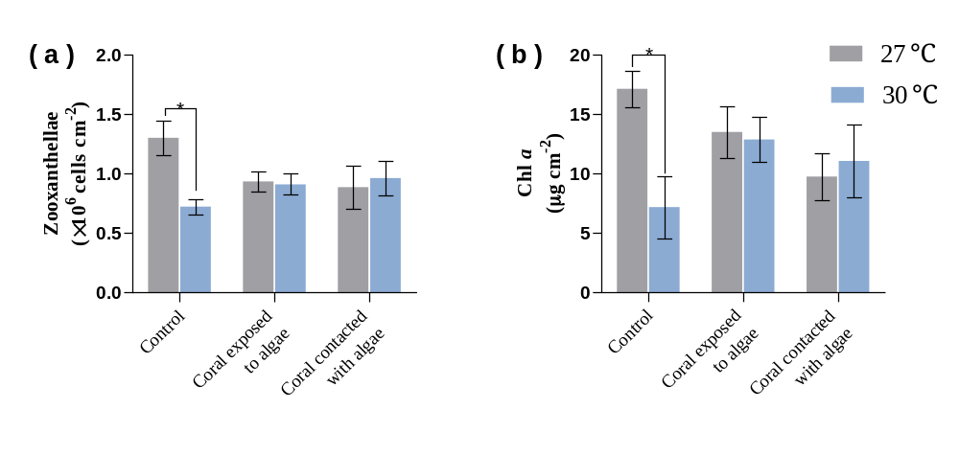
Fig.2 The effect of different temperatures of 27ºC (gray) and 30ºC (blue) on the (a) zooxanthellae, (b) Chl a of macroalgae-treated corals after 4 weeks of experiment, Different letters indicate that there are significant differences between macroalgae treatments at the same temperature (P < 0.05), * indicates that there are significant differences between different temperatures (P < 0.05). Data are expressed in terms of mean ± standard deviation, n=3.
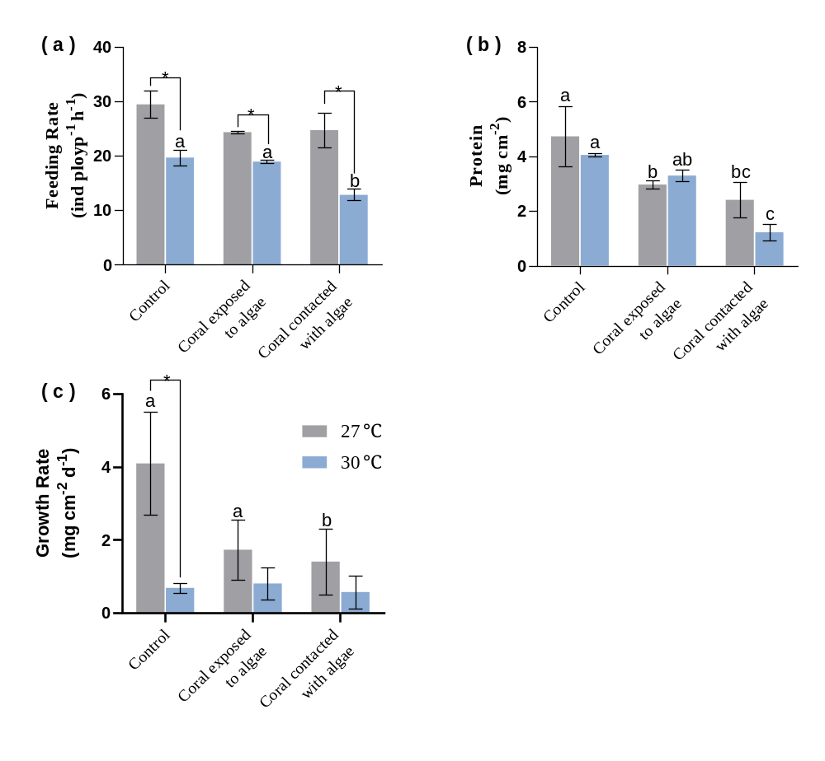
Fig.3 The effect of different temperatures of 27ºC (gray) and 30ºC (blue) on the (a) feeding rate (b) protein and (c) growth rate, of macroalgae-treated corals after 4 weeks of experiment. Different letters indicate that there are significant differences between macroalgae treatments at the same temperature (P < 0.05), * indicates that there are significant differences between different temperatures (P < 0.05). Data are expressed in terms of mean ± standard deviation, n=3.

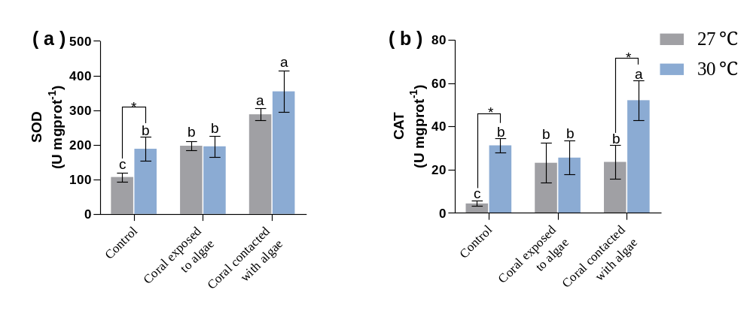
Fig.4 The effect of different temperatures of 27ºC (gray) and 30ºC (blue ) on the (a) SOD, (b) CAT of macroalgae-treated corals after 4 weeks of experiment,Different letters indicate that there are significant differences between macroalgae treatments at the same temperature (P < 0.05), * indicates that there are significant differences between different temperatures (P < 0.05). Data are expressed in terms of mean ± standard deviation, n=3.

