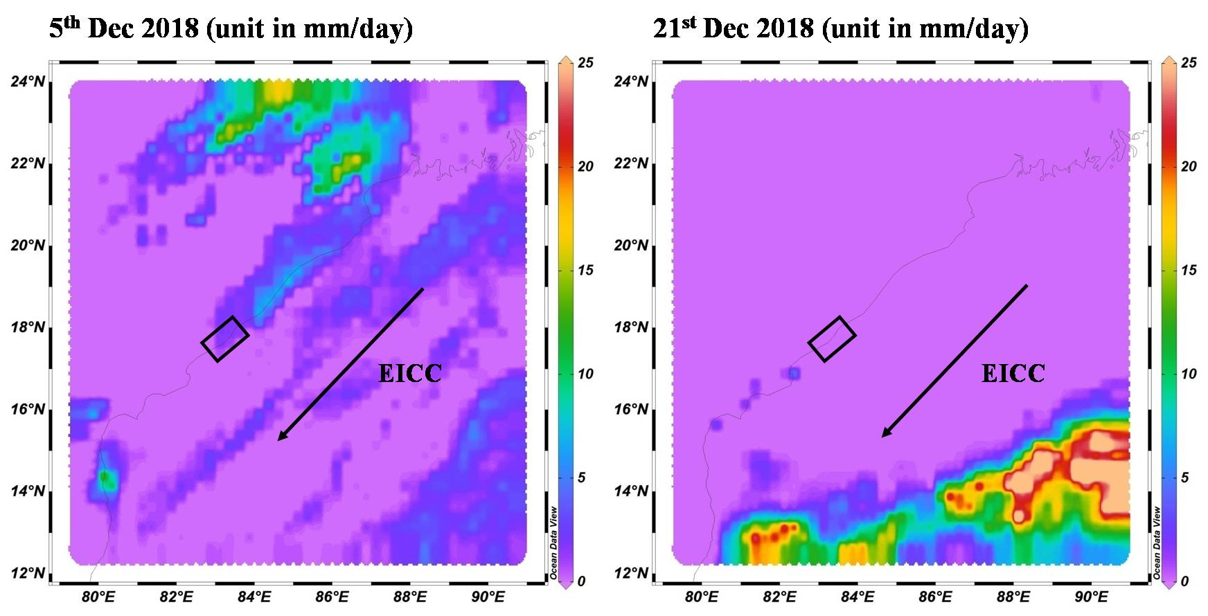

Supplementary Fig. S1: Daily rainfall data three days before the first phase and second phase of sampling (study area is shown by the rectangle)

Supplementary Table 1: Bacterial counts of sewage water samples
Bacterial group | PBM discharge (CFU/ml) | CHP discharge (CFU/ml) | TVM discharge (CFU/ml) | NKP discharge (CFU/ml)
HBC | 6.24×10⁴ | 1.12×10⁴ | 2.46×10⁵ | 4×10³
TC | 3.69×10⁴ | 4.8×10³ | 3.88×10⁴ | 3.6×10⁴
EC | 6.1×10² | 2.83×10⁴ | 1.34×10⁴ | 5×10¹
EF | 1.7×10² | 2×10¹ | 0 | 1.12×10³
PA | 3.2×10² | 5.2×10³ | 2.65×10⁵ | 1.28×10³
HBC: Heterotrophic bacterial count; TC: Total coliforms; EC: Escherichia coli; EF: Enterococcus faecalis; PA: Pseudomonas aeruginosa.

Supplementary Table 2: MAR indexes of isolates from industrial isolates and from port isolates during different seasons
Parameter | Industrial isolates | Port related isolates
Parameter | Dec 2019 | August 2019 | June 2020
% Of isolates that have MAR index > 0.2 | 0.464 | 0.363 | 0.269
MAR: Multiple antibiotic-resistant

