SUPPLEMENTARY

Clinical Data
Both patients fulfill the 2019 EULAR/ACR classification criteria for SLE, including positive ANA at least once as obligatory entry criterion (Table S1).

Supplementary Methods

Whole exome sequencing
Genomic DNA was extracted from blood using Qiamp DNA Blood Mini Kit (Qiagen). Whole exome sequencing was carried out as previously described [1].

Sanger sequencing
Genomic DNA flanking the UNC93B1 (NC_000011) mutation was amplified by PCR using gene- specific primers (Eurofins MWG Operon; for- GAATGCCTTCGGTGATTGGAG, rev- GTTCCT GTTTCCTTCCCCAAATC) and sequenced in both directions using the BigDye Terminator v1.1 Cycle Sequencing Kit (Applied Biosystems) on a 3130xl Genetic Analyzer (Applied Biosystems). Data were analyzed using the Vector NTI® Software (Life Technologies).

Cell culture
Passage-matched fibroblasts (passages 4 – 15) were cultured in DMEM complete medium (DMEM high glucose 4,5 g/l supplemented with 2 mM L-Glutamine, 1 % antibiotica/antimycotica, 5 % NEAA, 10 % FCS). EBV-transformed LCLs were cultured in RPMI-1640 complete medium (RPMI-1640 supplemented with 2 mM L-Glutamine, 1 % antibiotica/antimycotica, 5 % NEAA, 10 % FCS). For isolation of human peripheral blood mononuclear cells (PBMCs), whole blood, diluted with PBS, was gently layered over an equal volume of Biocoll (Sigma-Aldrich) and centrifuged for 30 minutes at 400 g without brake. The intermediate layer containing PBMCs was gently removed and added to prewarmed medium.

Retroviral transduction and fluorescence activated cell sorting
For retroviral transduction of human citrine-tagged UNC93B1 into HEK293 cells, the pR 5' LTR-hUNC93B plasmid was used. The E92G mutation was introduced by site-directed mutagenesis using the QuikChange Lightning Site-Directed Mutagenesis Kit (Agilent). For each viral supernatant to be produced, 1 x 10⁶ HEK293T cells were plated in 2 mL complete DMEM. After 24 h, cells were transfected with retroviral constructs (1 µg per well) as well as the retroviral packaging plasmids gag-pol (1 µg per well) and VSV-G (1 µg per well) using polyethylenimine (Sigma). Cells were incubated at 37 °C, 5 % CO₂ for 12 h, prior to medium change. 48 h upon transfection, the viral supernatant was harvested and added to target cells: HEK293XL-hTLR3-HA, HEK293XL-hTLR7-HA, HEK293XL-hTLR8-HA or HEK293XL-hTLR9-HA cells (Invivogen), seeded to 80 % confluence. After 24 h at 37 °C, 5 % CO₂, medium was changed to complete DMEM and transduced cells were passaged three times before frozen stocks were prepared. UNC93B1-mCitrine-positive cells were sorted for equal green fluorescence on a FACS Aria cell sorter (BD Biosciences) in a 96 well plate at a density of 2 x 10⁴ cells/well in DMEM supplemented with 10 % FCS, 2 mM L-glutamine, 1 % antibiotica/antimycotica and 1 mg/ml blasticidin.
For the generation of UNC93B1-transgenic RAW264.7 cells, Unc_WT, Unc_H412R and Unc_D34A constructs were generated as previously reported [2] on MCSV-based retroviral vectors with IRES-PuromycinR-T2A-mCherry double selection. Unc93b1 genes were codon-optimized and contained a 3xFlag C-terminal tag. Unc_E92G construct was generated by site-directed mutagenesis from Unc_WT using Q5 Site Directed Mutagenesis Kit (New England BioLabs) using the following primers: F: CACTACGACGgcACATACAGAGAAG and R: CAGGATCAGCTGCATCTG. Viral supernatants were produced by transfecting GP2-293 cells (HEK293-derived packaging cells expressing viral gag and pol proteins) with the UNC93B1 plasmids (1.7 µg per well) along with a VSV-G plasmid (0.8 µg per well), pre-incubated with Lipofectamine 3000 transfection reagent (Invitrogen). After overnight incubation at 37 °C, the transfected GP2-293 cells were transferred to 32 °C for a further 24 hours. Viral supernatants were centrifuged to remove packaging cells before applying to Unc93b1^{-/-} RAW264.7 target cells, with the addition of polybrene (Sigma-Aldrich). Target cells were centrifuged at 1000 x g for 30 minutes at 32 °C, and further incubated at 32 °C overnight before transferring to 37 °C incubator (5 % CO₂ maintained throughout). UNC93B1-IRES-mCherry-positive RAW264.7 cells were sorted 2 days post-transduction for equal red fluorescence on a FACS Aria II cell sorter (BD Biosciences) and cultured in RPMI supplemented with 10 % FCS, L-glutamine, penicillin-streptomycin, sodium pyruvate and HEPES (pH7.2; Invitrogen). TLR7 expression in UNC93B1-reconstituted RAW264.7 cells was measured by fixation/permeabilization using BD Cytofix/Cytoperm (BD Biosciences), intracellular staining with anti-TLR7 antibody (clone A94B10, MABF2273 Sigma-Aldrich; 1:200) followed by Alexa Fluor 488 goat anti-mouse IgG (A11029, Invitrogen; 1:1000), and data acquisition on a FACS Symphony flow cytometer (BD Biosciences).

Cytokine analysis
Plasma was collected from blood collected in heparin tubes by centrifugation (2000 rpm) at 4 °C for 20 minutes. Cytokines were measured using the LEGENDplex™ Human Inflammation Panel 1 (BioLegend) according to the manufacturer's instructions. For experiments using PBMCs or stably transduced HEK293XL cells, cytokines were measured in cell culture supernatants using the LEGENDplex Human Anti-Virus Response Panel (BioLegend) according to the manufacturer's instructions. Data were collected on a FACS flow cytometer (LSRII, Becton Dickinson) and analyzed with the LEGENDplex Data Analysis V8.1 software (BioLegend). In RAW264.7 cells, tumor necrosis factor alpha (TNF-ɑ) production was measured by fixation/permeabilization using BD Cytofix/Cytoperm (BD Biosciences) and intracellular staining with APC anti-mouse TNF-ɑ antibody (clone MP6-XT22, 506308 Biolegend; 1:200) followed by acquisition on a CytoFLEX flow cytometer (Beckman Coulter). Flow cytometric data was analysed on FlowJo (Becton Dickinson).

Immunoprecipitation and Western blot analysis
Cells were lysed in RIPA buffer (50 mM Tris-HCl, pH 7.4, 150 mM NaCl, 1 mM EDTA, 1 % Triton X-100, 1 mM sodium orthovanadate, 20 mM sodium fluoride) supplemented with 1x Complete Protease Inhibitor Cocktail, 1x PhosSTOP phosphatase inhibitors (Roche) and DNase I (Qiagen). Protein concentration was determined using a BCA Kit (Thermo Scientific). Lysates were resolved in a 4 – 12 % NuPAGE Bis-Tris gel under reducing and denaturing conditions and blotted onto a nitrocellulose membrane (BA83, Sigma-Aldrich). Membranes were blocked in 5 % dry milk and probed using the following antibodies: anti-TLR7 (#5632, CST; 1:1000), anti-HA (#ab9110, abcam; 1:1000), anti-citrine (#632381, takarabio; 1:1000) and anti-β-actin (A5316, Sigma-Aldrich; 1:5000). Immunoreactive signals were detected by chemiluminescence (Lumi-Light PLUS, Roche).
For Myd88 immunoprecipitation, RAW264.7 cells were incubated with 500 ng/ml R848 at 37 °C, 5 % CO₂ for 0, 15, 30 or 60 minutes prior to collection. Cells were collected by scraping in cold PBS and lysed in buffer containing 50 mM Tris-HCl, pH 7.4, 150 mM NaCl, 10 % glycerol, 1 % NP-40 and supplemented with EDTA-free cOmplete Protease Inhibitor Cocktail (Roche), PhosSTOP (Roche) and 1 mM PMSF. Cell lysates were incubated for 1 hour on a 4 °C rotator and cleared of insoluble material by centrifugation, then incubated with anti-MyD88 antibody (AF3109 R&D Systems; 1 µg/sample) overnight, followed by Protein G agarose beads (pre-blocked with 1 % BSA) for 2 hours at 4 °C the next day. Beads were washed four times in lysis buffer, then precipitated proteins were eluted by heating in SDSxPAGE buffer to 65 °C for 15 minutes.
For Flag immunoprecipitation, RAW264.7 cells were lysed in buffer containing 50 mM Tris-HCl, 150 mM NaCl, 5 mM EDTA, 0.5 % NP-40, 1x EDTA-free Complete Protease Inhibitor Cocktail (Roche) and 1 mM PMSF. Cell lysates were incubated for 1 hour on a 4 °C rotator and cleared of insoluble material by centrifugation, then incubated with M2 anti-Flag matrix (Sigma) (pre-blocked with 1 % BSA) for 2 hours on a 4 °C rotator. Beads were washed four times in lysis buffer, then precipitated proteins were competitively eluted with 150 ng/µl 3xFlag-peptide (Sigma) in lysis buffer for 30 minutes at room temperature. Eluted proteins were denatured in SDSxPAGE buffer for 1 hour at room-temperature. Proteins were separated by SDS–PAGE (Bio-Rad TGX precast gels) and transferred to Immobilon PVDF membranes (Millipore) in a Trans-Blot Turbo transfer system (Bio-Rad). Membranes were probed with antibodies against MyD88 (AF3109 R&D Systems; 1:200), IRAK2 (#4367 CST; 1:1000), TLR7 (clone 726606, MAB7156 R&D Systems; 1:640), Flag (clone M2, F1804, Sigma-Aldrich; 1:1000), and GAPDH (GA1R, MA5-15738 Invitrogen; 1:2000). Blots were developed using the ChemiDoc MP system (Bio-Rad).

Cell stimulation
Cells were stimulated as indicated with poly(I:C) HMW (tlrl-pic, Invivogen); R848 (resiquimod, tlrl-r848, Invivogen); Pam2CSK4 (tlrl-pm2s-1, Invivogen); ODN2006 (tlrl-2006, Invivogen), ODN1668 (5’-TCCATGACGTTCCTGATGCT-3’, all phosphorothioate linkages, synthesized by Integrated DNA Technologies), LPS-EB Ultrapure (tlrl-3pelps, Invivogen), polyU_19mer (all phosphorothioate linkages, Integrated DNA Technologies), ssRNA40 (ssRNA40 5’-GCCCGUCUGUUGUGUGACUC-3’, Eurofins MWG Operon). If not otherwise indicated, ssRNA40 and ODN2006 were complexed in a 1:1 ratio with poly-L-arginine (Sigma-Aldrich). Unless otherwise specified, cells were stimulated for 24 h at 37 °C and 5 % CO₂. RAW264.7 macrophages were stimulated for 6 hours at 37 °C and 5 % CO₂, with the addition of BD GolgiPlug at 1:1000 dilution after 30 minutes of stimulation.

Whole blood assay
Heparin blood was distributed in 24 well plates at 1 ml per well. Plates were incubated on a shaker incubator at 300 rpm and 37 °C. For interferon activation, blood was incubated with 1 µg/ml poly(I:C) (HMW, Invivogen) for 5 h and then either treated with 1 µM and 2 µM ruxolitinib (MedChemExpress) or left untreated for additional 10 h.

Quantitative real-time RT-PCR
Total RNA was extracted from PBMCs or from lysed whole blood using the ReliaPrep RNA Cell Miniprep System (Promega) followed by DNase I digestion. RNA was reverse transcribed using the GoScript Reverse Transcription System (Promega). Gene expression was determined by quantitative real-time RT-PCR using the Taqman Universal PCRMaster Mix (Applied Biosystems) on an ABI7300 and normalized to glyceraldehyde-3-phosphate dehydrogenase (for-GAAGGTGAAGGTCGGAGTC, rev-GAAGATGGTGATGGGATTTC, and FAM-CAAGCTTCCCGTTCTCAGCC-TAMRA) and hypoxanthine phosphoribosyltransferase 1 (Hs02800695_m1; Thermo Fisher) expression. For calibration, a calibrator cDNA was included in each assay. Target genes were analyzed using predesigned TaqMan probes (Thermo Fisher) for IFI27 (Hs01086373_g1), IFI44 (Hs00951349_m1), IFI44L (Hs00915292_m1), IFIT1 (Hs01675197_m1), ISG15 (Hs01921425_s1), RSAD2 (Hs01057264_m1), and SIGLEC1 (Hs00988063_m1). The IFN score was calculated as previously described [1].

Protein Structure Modeling
Illustration of the complex TLR7–UNC93B1 (PDB 7CYN) was prepared using UCSF ChimeraX [3].

Statistical analysis
Statistical significance was determined by ANOVA. Values of p < 0.05 were considered statistically significant. Data are represented as means ± SD.

Study approval
Written informed consent was obtained by all participating members of the family or their legal guardians. Patients were enrolled in an ongoing study on the pathogenesis of chilblain lupus approved by the ethics committee of the Medical Faculty, Technische Universität Dresden.

Figure S1

Figure S1. Clinical findings in patient 1. (A) Petechial exanthema, at  of age. (B) Erythematous maculopapular rash, and (C) hematoma on the face and blood blot formation on tongue due to mucosal bleeding, at  of age. (D) Extensive panniculitis. (E) Brain MRI (T2-weighted, turbo inversion recovery magnitude) at  of age, demonstrating posterior reversible encephalopathy (PRES) with bilateral hyperintense signal in the supratentorial subcortical region.

Figure S2
Figure S2. Basal secretion of pro-inflammatory cytokines in lymphoblastoid cells. Levels of IL-6 and TNF-α in medium of cultured lymphoblastoid cells (hLCL) from the two patients (P1, P2), four wild type controls (Co1-Co4) and an UNC93B1-deficient individual (UNC-). Mean ± SD of triplicate technical replicates. ***, p<0.001, ANOVA. Data are representative of at least three independent experiments.

Figure S3
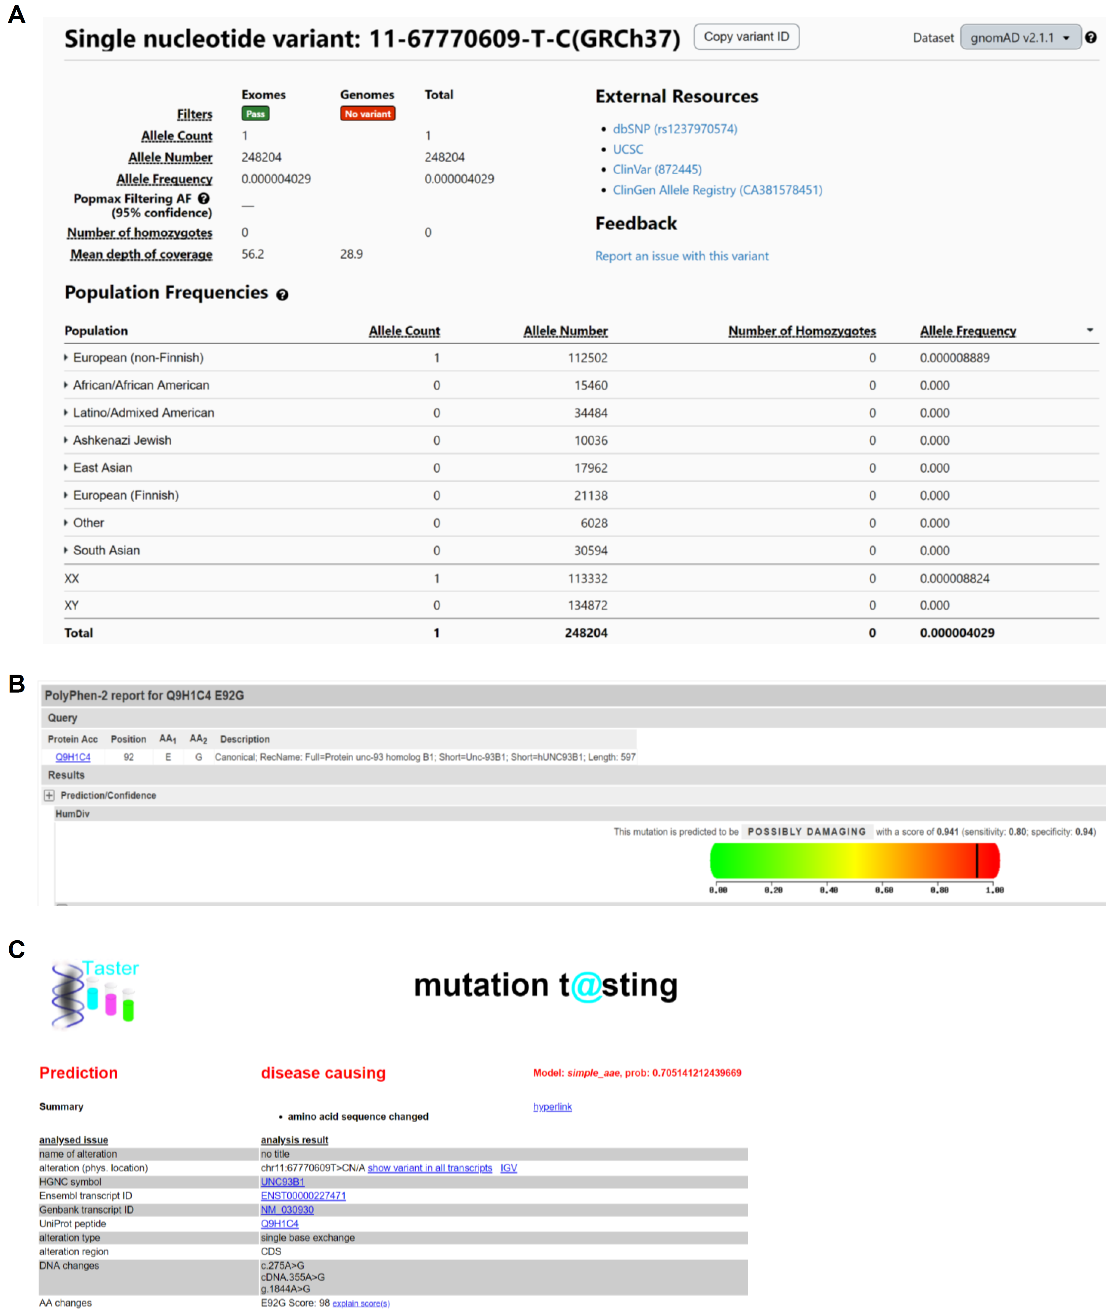

Figure S3. Bioinformatic analysis of the E92G variant in UNC93B1. (A) Minor allele frequency retrieved from the gnomAD database. (B, C) Prediction of functional effects by PolyPhen-2 and Mutation Taster.

Figure S4
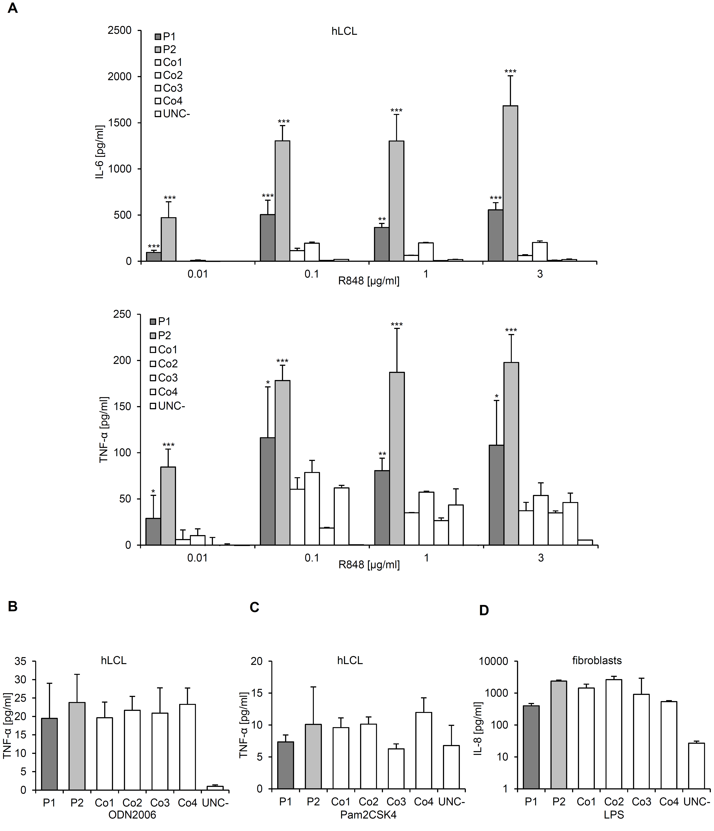
Figure S4. Secretion of pro-inflammatory cytokines by LCLs and fibroblasts in response to various stimuli. (A) Levels of IL-6 and TNF-α in medium of cultured LCLs from the two patients (P1, P2) and four wild type controls (Co1-Co4) after stimulation with increasing doses of R848. (B, C) TNF-α secretion by LCLs in response to ODN2006 (5 µM) or Pam2CSK4 (1 µg/ml). UNC-, UNC93B1-deficient control. (D) IL-8 secretion by primary fibroblasts in response to LPS (10 ng/ml). Mean ± SD of triplicate technical replicates. *, p<0.05; **, p<0.01; ***, p<0.001, ANOVA. ***, p<0.001 vs. mean of wild type controls, ANOVA. Data are representative of at least three (A), four (B) or two (C, D) independent experiments.

Figure S5
Figure S5. RNA40 stimulation of PBMCs and expression TLR7 in LCLs. (A) TNF-α secretion by PBMCs from patients (P1, P2) and four wild type controls (Co1-Co4) in response to the TLR7/8 agonist RNA40 (1 µg/ml), either alone, or after endosomal delivery with poly-L-arginine (pLA), without or with 50 µM hydroxychloroquine (HCQ). ***, p<0.001 vs. controls, ANOVA. (B) Representative Western blot analysis of whole cell lysate of lymphoblastoid cells (hLCL) using anti-TLR7 antibody. Data are representative of at least three (A), or two (B) independent experiments.

Figure S6
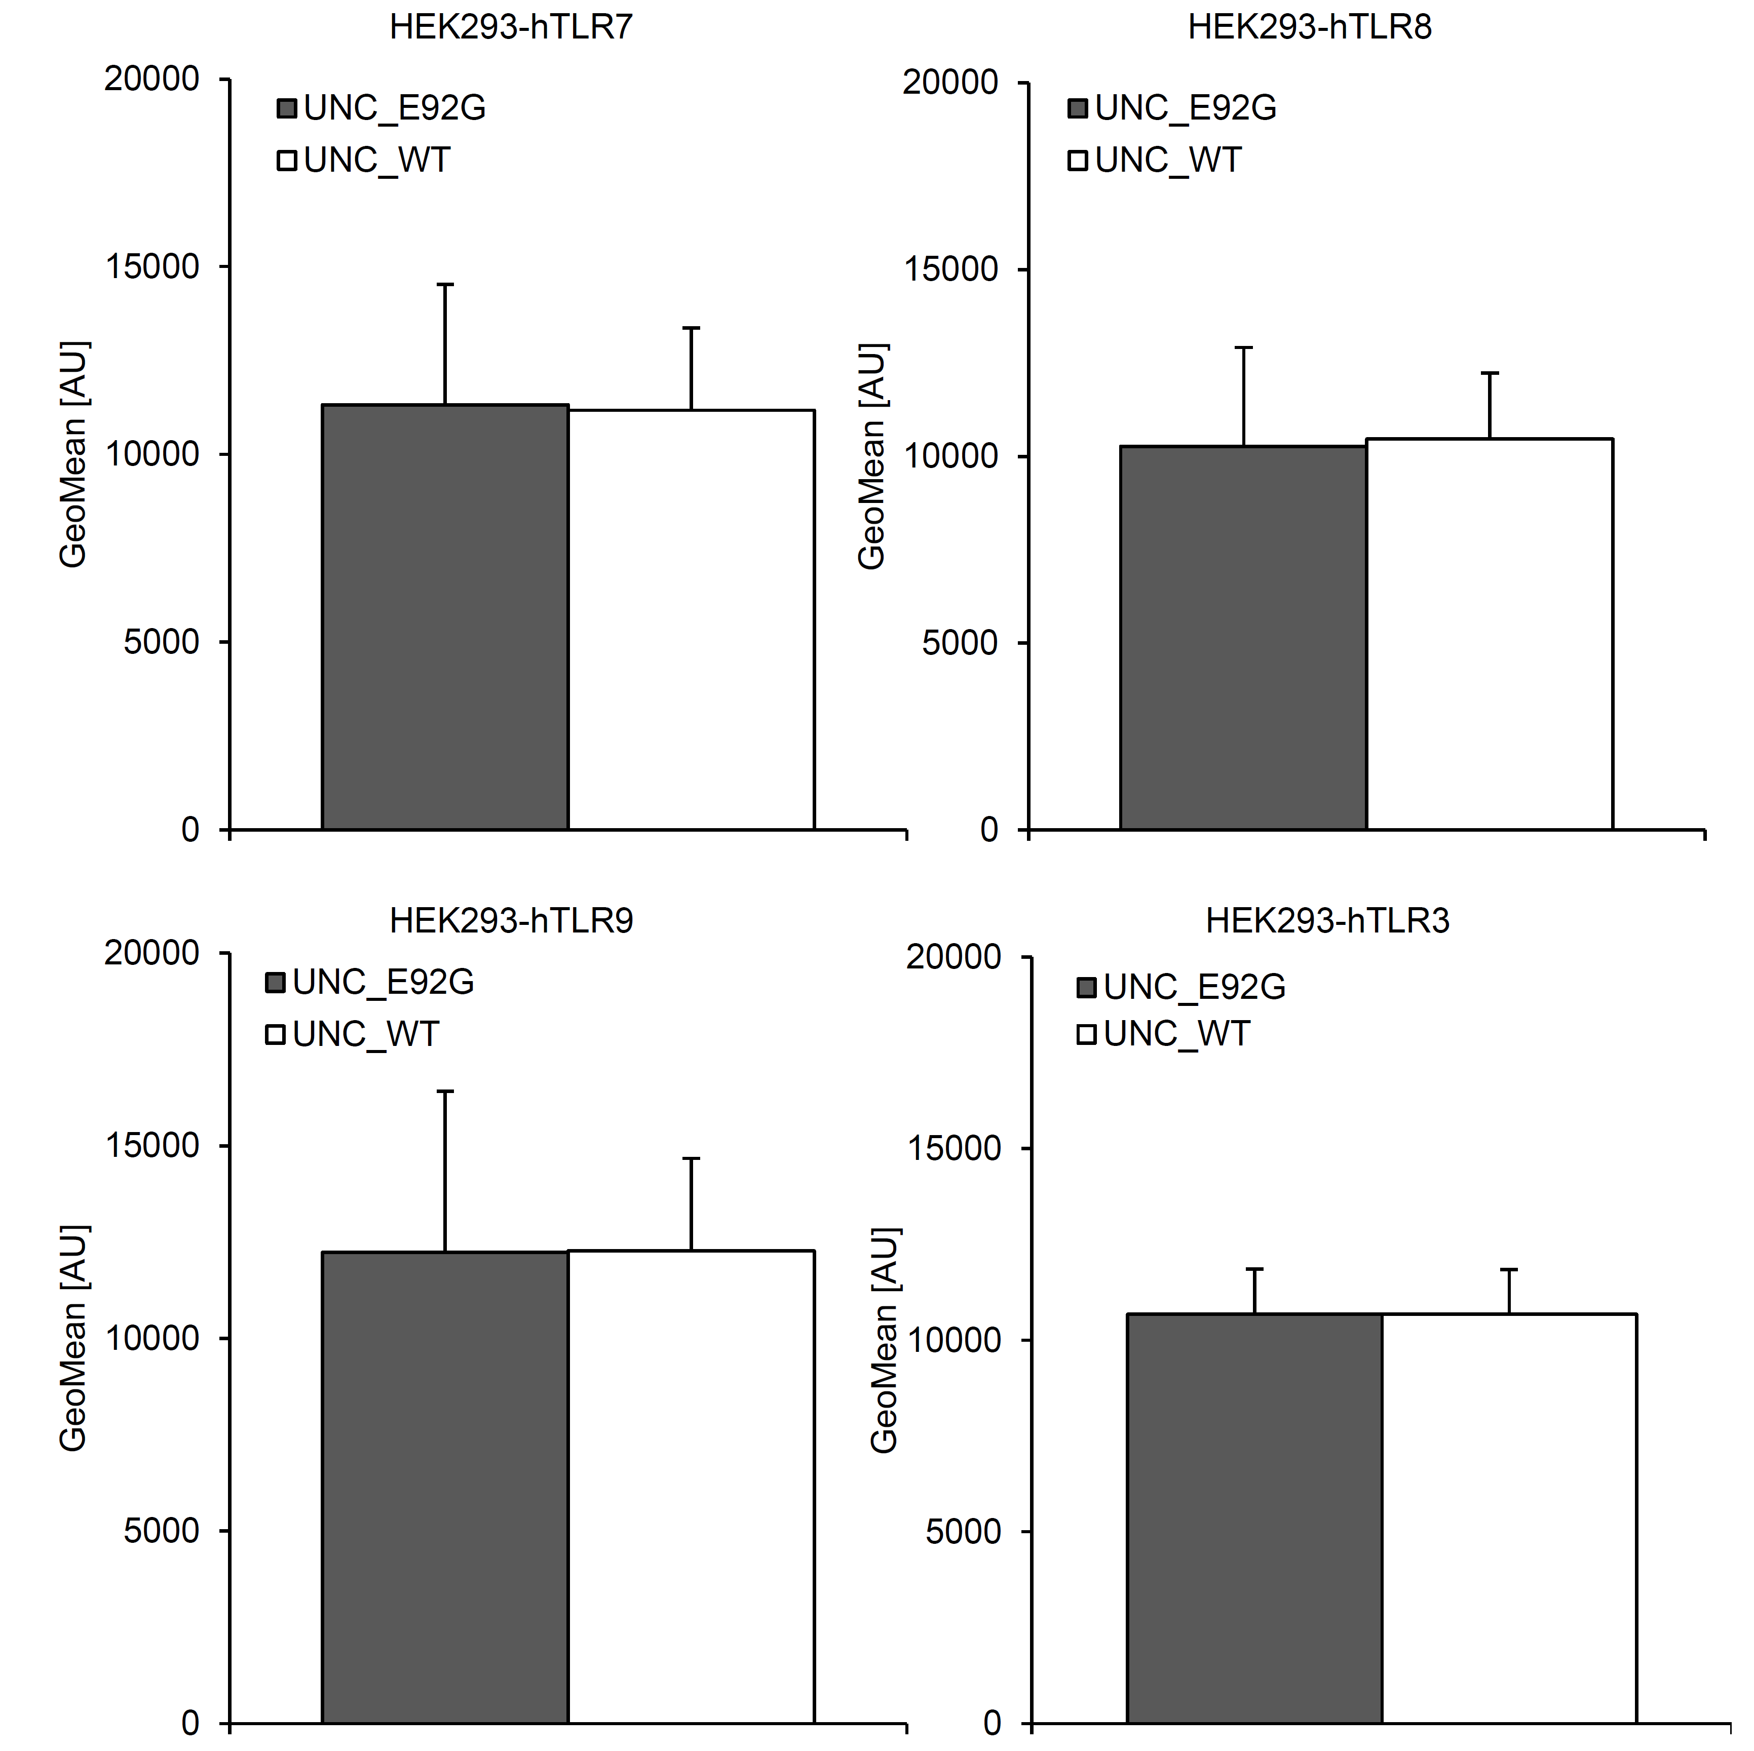
Figure S6. Fluorescence activated cell sorting of HEK293 cells transduced with citrine-tagged UNC93B1. Mean fluorescence intensities of HEK293 cells with stable expression of TLR7 (HEK293-hTLR7), TLR8 (HEK293-hTLR8), TLR9 (HEK293-hTLR9), or TLR3 (HEK293-hTLR3), after transduction with wild type (UNC_WT) or mutant (UNC_E92G) citrine-tagged UNC93B1-cDNA. Cells were sorted to equal citrine expression. Mean ± SD of triplicate technical replicates.

Figure S7
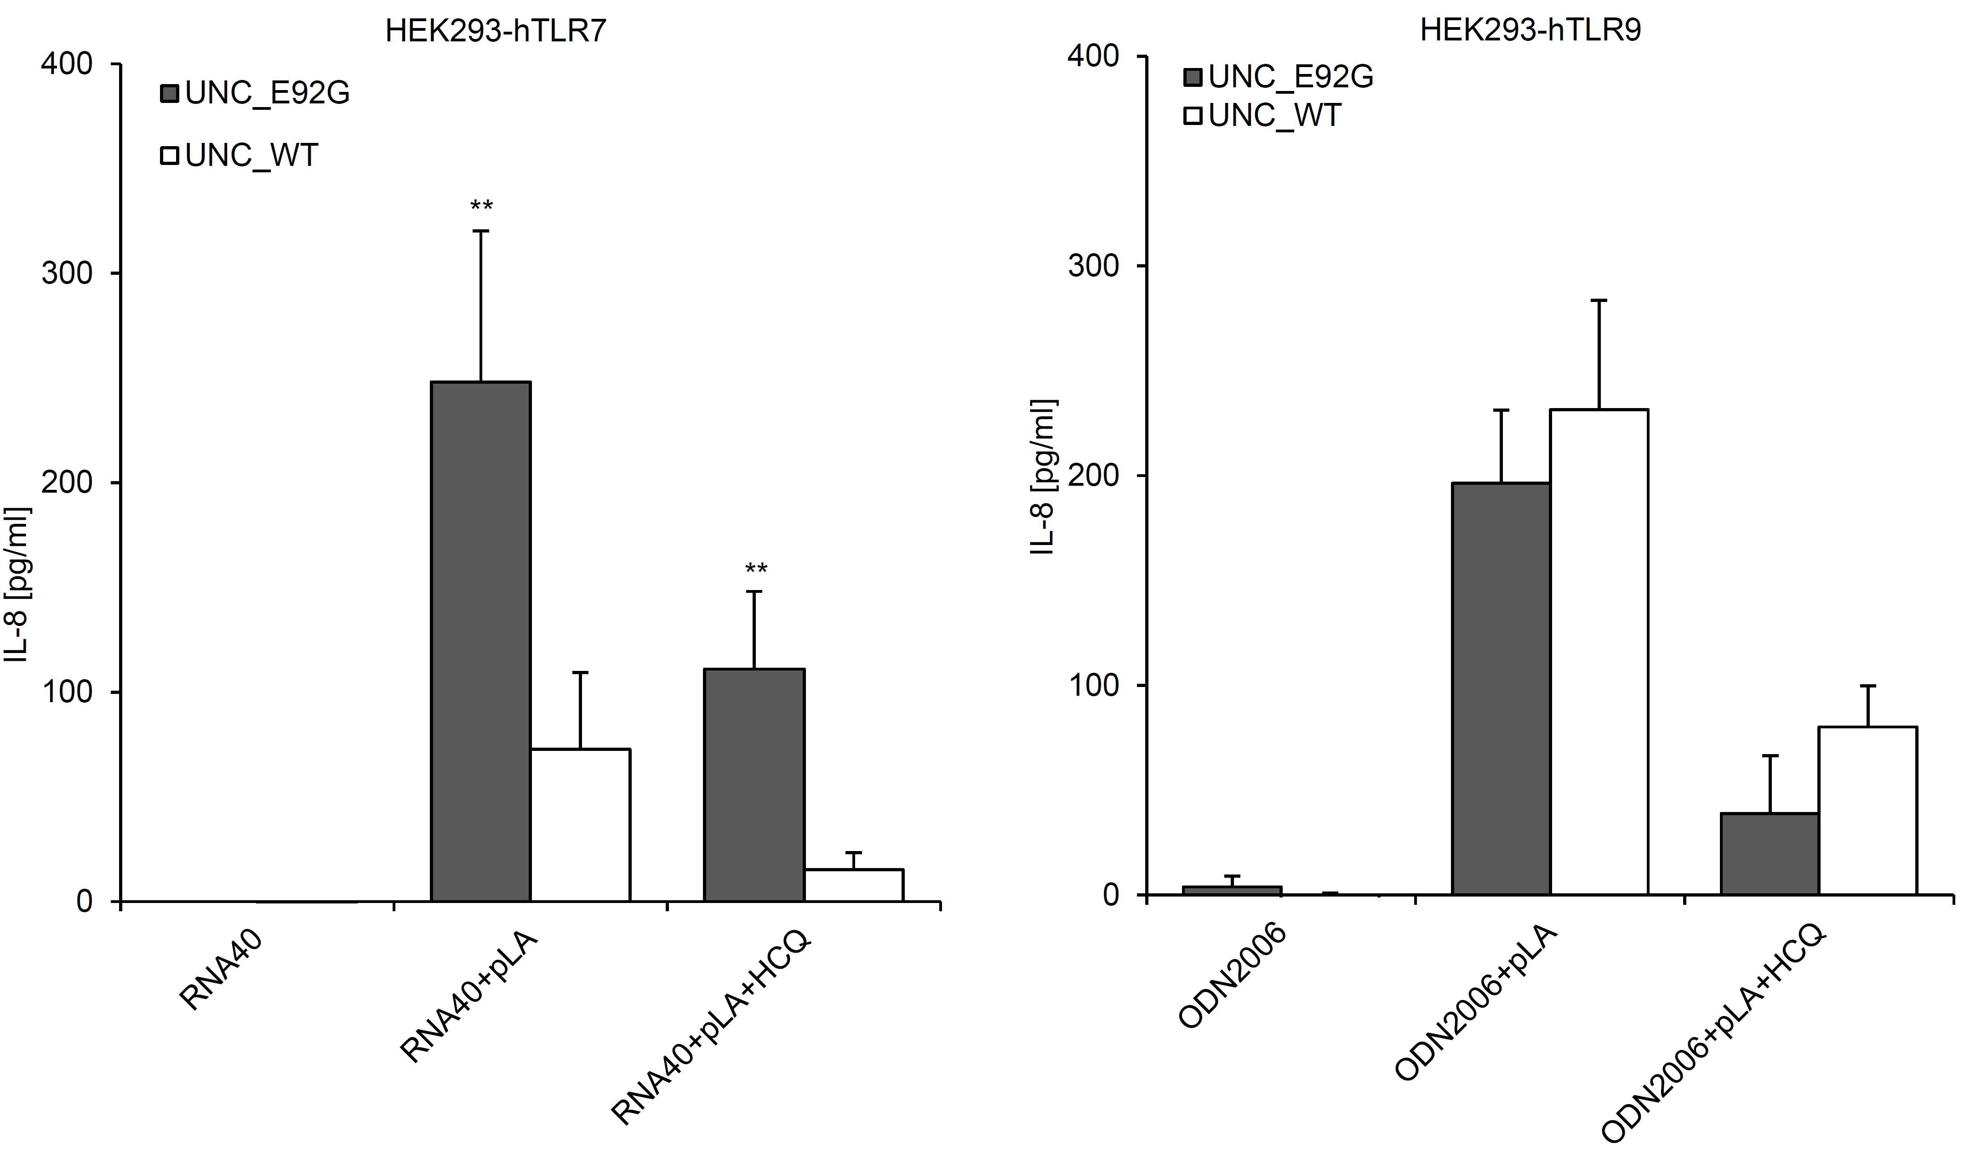
Figure S7. Stimulation of TLR7 and TLR9 in HEK293 cells expressing wild type or mutant UNC93B1. HEK293 cells stably expressing TLR7 (HEK293-hTLR7) or TLR9 (HEK293-hTLR9) were transduced with wild type (UNC_WT) or mutant citrine-tagged UNC93B1 (UNC_E92G) and then sorted to equal citrine expression. HEK293_hTLR7 were stimulated with 10 µg/ml RNA40 alone, RNA40 plus poly-L-arginine (pLA) or RNA40 plus pLA and 50 µM hydroxychloroquine (HCQ). HEK293_hTLR9 were stimulated with 1 µM ODN2006 alone, ODN2006 plus poly-L-arginine (pLA) or ODN2006 plus pLA and 50 µM hydroxychloroquine (HCQ). IL-6 secretion into culture medium was measured after 24 h. Mean ± SD of triplicate technical replicates. **, p<0.01 vs. UNC_WT, ANOVA. Data are representative of three independent experiments.

Figure S8
Figure S8. Expression analysis of UNC93B1-reconstituted murine RAW264.7 cells. Unc93b1^{-/-} RAW264.7 target cells were transduced with wild type (Unc_WT) or mutant (Unc_E92G, Unc_D34A, Unc_H412) UNC93B1. UNC93B1-IRES-mCherry-positive RAW264.7 cells were sorted to equal red fluorescence by flow cytometry. Intracellular TLR7 was stained with anti-TLR7 antibody followed by Alexa Fluor 488 goat anti-mouse IgG.

Figure S9
Figure S9. Whole blood assay. IFN scores of whole blood from patients (P1, P2) and a wild type control (Co) as determined by qRT-PCR analysis of seven IFN-stimulated genes. Unlike control cells, patient cells exhibit strong IFN scores in whole blood at basal level, which further increased upon addition of 1 µg/ml poly(I:C). IFN scores are markedly suppressed by 1 (+) or 2 (++) µM ruxolitinib. Mean ± SD of triplicate technical replicates. **, p<0.01; ***, p<0.001 vs. untreated, ANOVA. Data are representative of three independent experiments.
Table S1. Fulfillment of the 2019 EULAR/ACR classification criteria for SLE [4] of patients.
Clinical domains and criteria | Weight | Patient 1 | Patient 2
Constitutional  Fever | 2 | 2
Hematologic  Leukopenia  Thrombocytopenia  Autoimmune hemolysis | 3  4  4 | 3  4  4 | 3  4  4
Neuropsychiatric  Delirium  Psychosis  Seizure | 2  3  5 | 2  3  5 | 2  3  5
Mucocutaneous  Non-scarring alopecia  oral ulcers  Subacute OR discoid lupus  Acute cutaneous lupus | 2  2  4  6 | 2  4 | 4
Serosal  Pleural or pericardial effusion  Acute pericarditis | 5  6 | 5 | 5
Musculoskeletal  Joint involvement | 6 | 6
Renal  Proteinuria >0.5 g/24 h  Renal biopsy Class II or V lupus nephritis  Renal biopsy Class III or IV lupus nephritis | 4  8  10 | 4  8 | 4  8
Immunological domains and criteria
Antiphospholipid antibodies  Anti-cardiolipin antibodies OR  Anti-β2GP1 antibodies OR  Lupus anticoagulant | 2 | 2 | 2
Complement proteins  Low C3 OR low C4  Low C3 AND low C4 | 3  4 | 4 | 4
SLE-specific antibodies  Anti-dsDNA antibody OR  Anti-Smith antibody | 6 | 6 | 6
Total score  SLE classification requires at least one clinical criterion and ≥10 points.  Within each domain, only the highest weighted criterion is counted towards the total score. |  | 40 | 38

Supplementary References
1. Wolf C, Brück N, Koss S, Griep C, Kirschfink M, Palm-Beden K, et al. Janus kinase inhibition in complement component 1 deficiency. J Allergy Clin Immunol. 2020;146:1439-1442.e5.
2. Majer O, Liu B, Kreuk LSM, Krogan N, Barton GM. UNC93B1 recruits syntenin-1 to dampen TLR7 signalling and prevent autoimmunity. Nature. 2019;575:366–70.
3. Goddard TD, Huang CC, Meng EC, Pettersen EF, Couch GS, Morris JH, et al. UCSF ChimeraX: Meeting modern challenges in visualization and analysis. Protein Sci. 2018;27:14–25.
4. Aringer M, Costenbader K, Daikh D, Brinks R, Mosca M, Ramsey-Goldman R, et al. 2019 European League Against Rheumatism/American College of Rheumatology classification criteria for systemic lupus erythematosus. Ann Rheum Dis. 2019;78:1151–9.

