Supplementary Information for
Similarity of shallow and deep earthquakes in seismic moment release
Xin Cui¹, Zefeng Li^{1, 2*} and Yan Hu^{1, 2}
- Laboratory of Seismology and Physics of Earth’s Interior, School of Earth and Space Sciences, University of Science and Technology of China, Hefei, China
- Mengcheng National Geophysical Observatory, University of Science and Technology of China, Mengcheng, China

Corresponding author: Zefeng Li (zefengli@ustc.edu.cn)

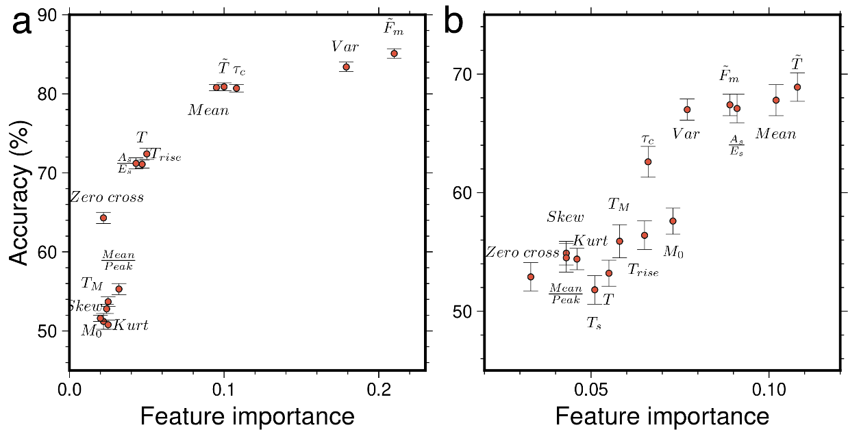
Figure S1. Relationship of dichotomy accuracies of individual features and their random forest feature importance for shallow and deep earthquake classification (a) and for intermediate-depth and deep-focus earthquake classification (b).

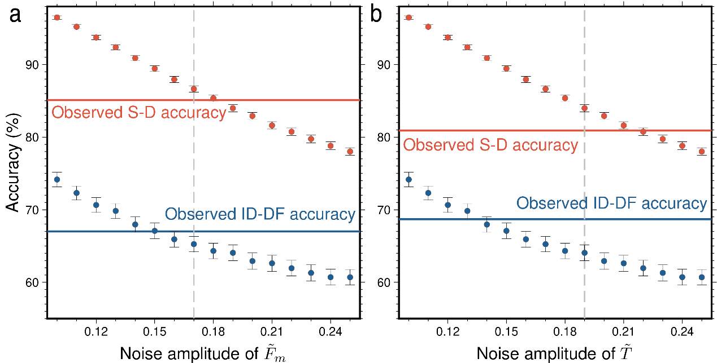
Figure S2. Classification accuracies of synthetic ${\tilde{F}}_{m}$ (a) and $\tilde{T}$ (b) with different noise amplitude. S-D: shallow vs deep; ID-DF: intermediate-depth vs deep-focus.
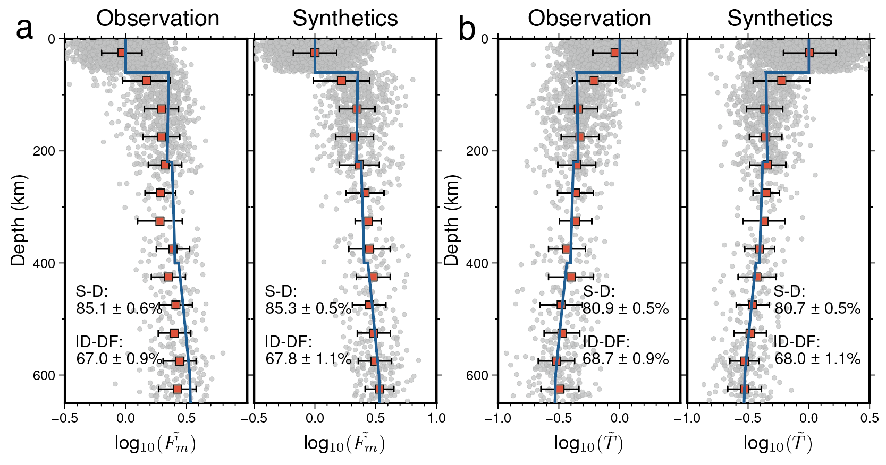
Figure S3. Depth variation of STF features ${\tilde{F}}_{m}$ and $\tilde{T}$ and interpretation as Earth’s depth-varying rigidity (a) Left panel: depth-dependency of ${\tilde{F}}_{m}$. Gray dots represent the ${\tilde{F}}_{m}$ of individual earthquakes. Red squares with vertical bars are the average and standard deviation over a 50-km bin. Green stars represent large tsunami earthquakes. The blue curve represents theoretical prediction of ${\tilde{F}}_{m}$ using a modified Preliminary Reference Earth model under a constant strain drop assumption (after Vallée, 2013). Right panel: synthetic ${\tilde{F}}_{m}$ as predicted at the SCARDEC earthquakes’ depth using a modified Preliminary Reference Earth model under a constant strain drop assumption. Gaussian perturbation is added to each predicted value (standard deviation 0.18 for 0 - 60 km and 0.15 for 60 – 700 km). (b) Similar to (a) but for $\tilde{T}$ (standard deviation 0.22 for 0 - 60 km and 0.14 for 60 – 700 km). S-D: shallow and deep earthquake classification; ID-DF: intermediate-depth and deep-focus earthquake classification.

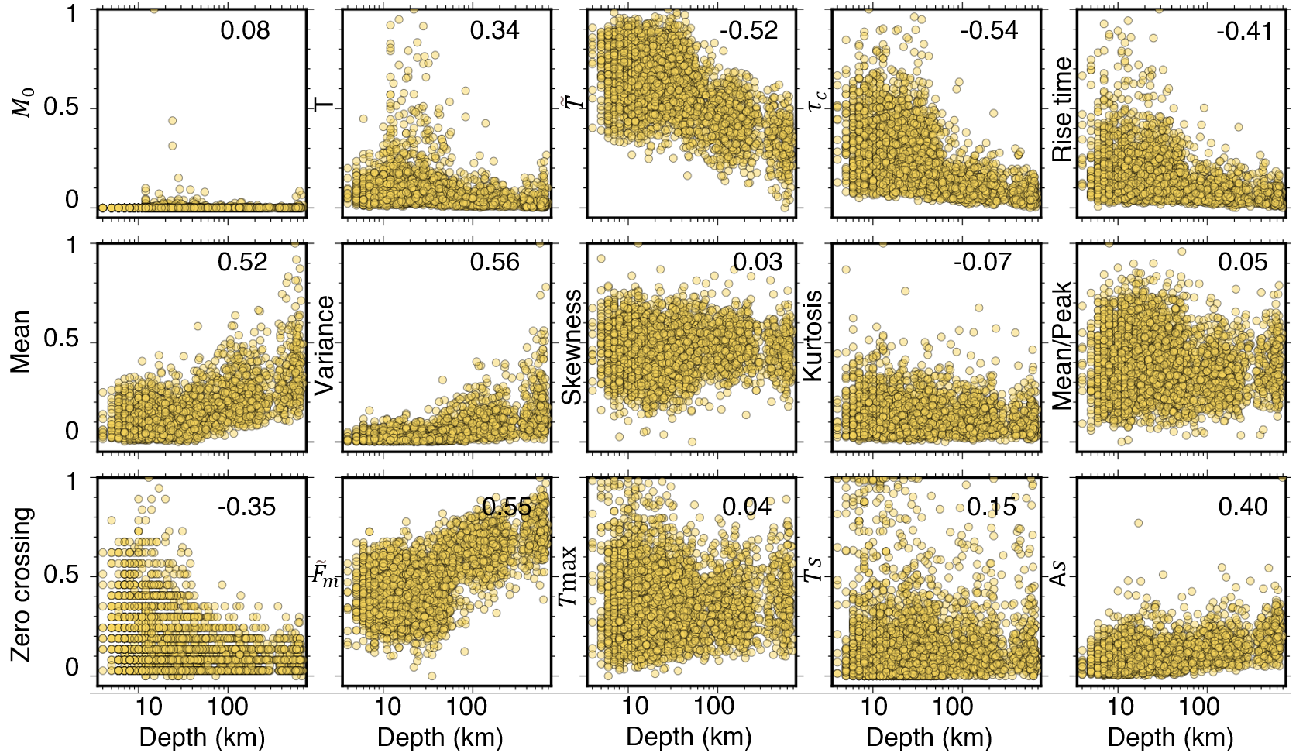
Figure S4. Spearman coefficient relations of STF features and depth for shallow and deep earthquakes.

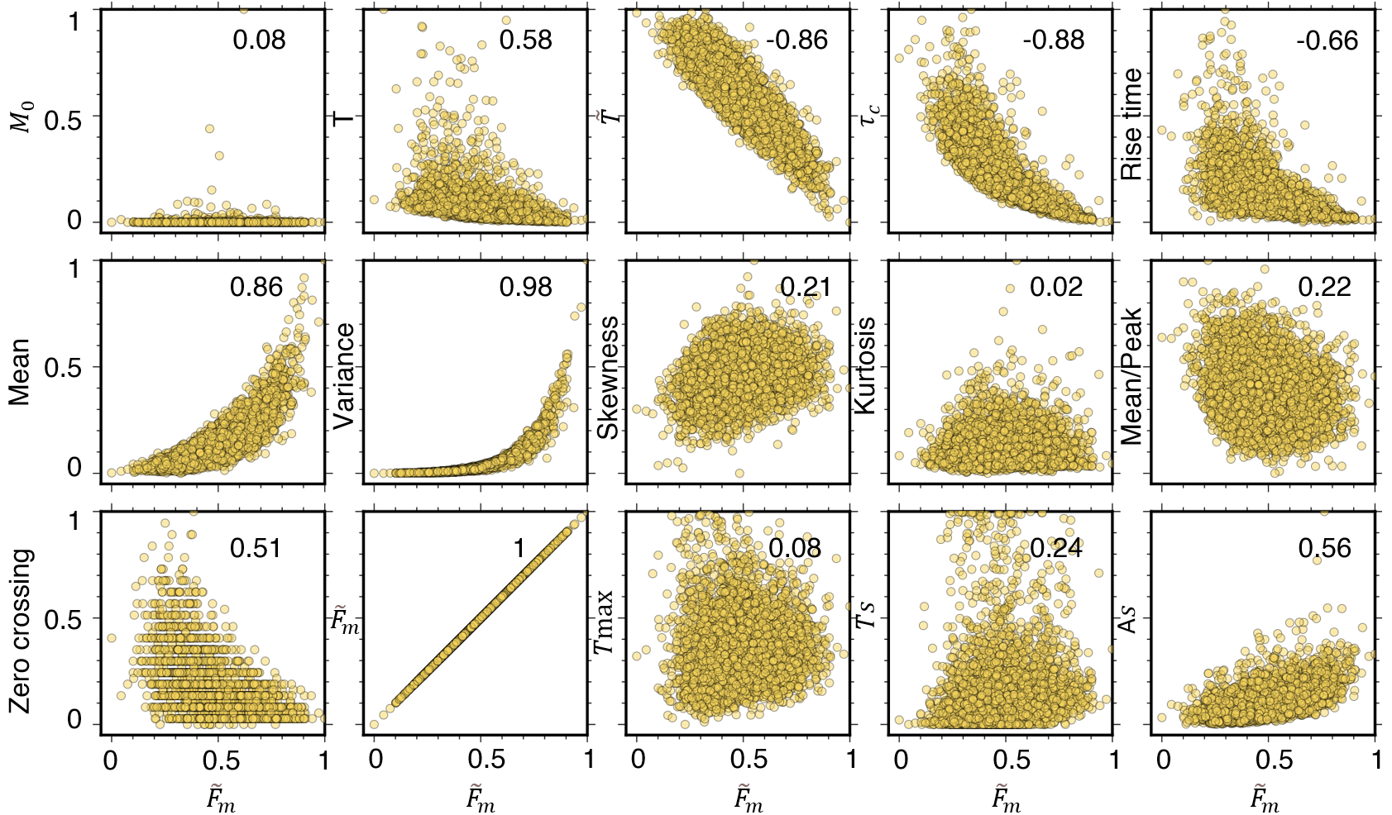
Figure S5. Spearman coefficient relations of STF features and ${\tilde{F}}_{m}$ for shallow and deep earthquakes.

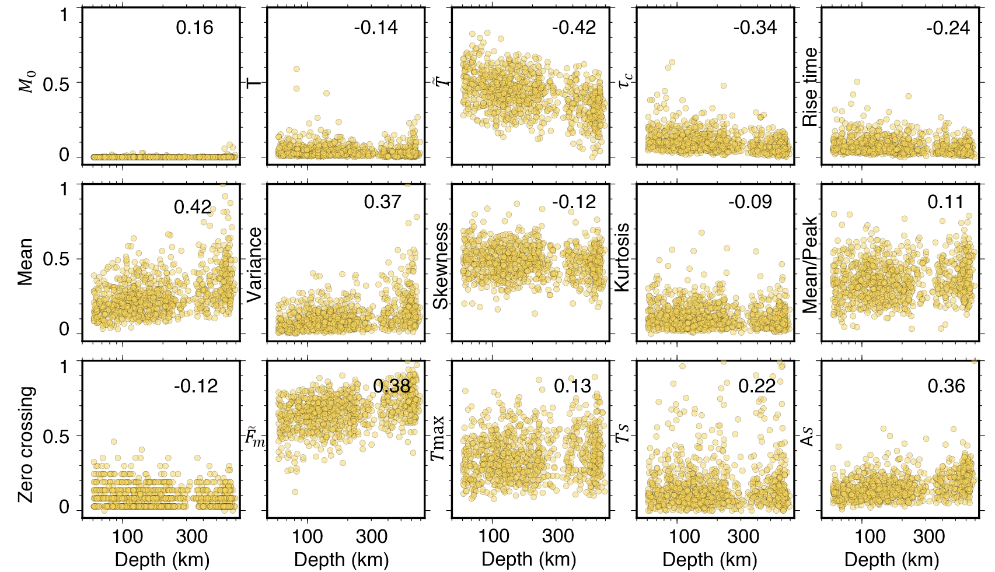
Figure S6. Spearman coefficient relations of STF features and depth for intermediate-depth and deep-focus earthquakes.

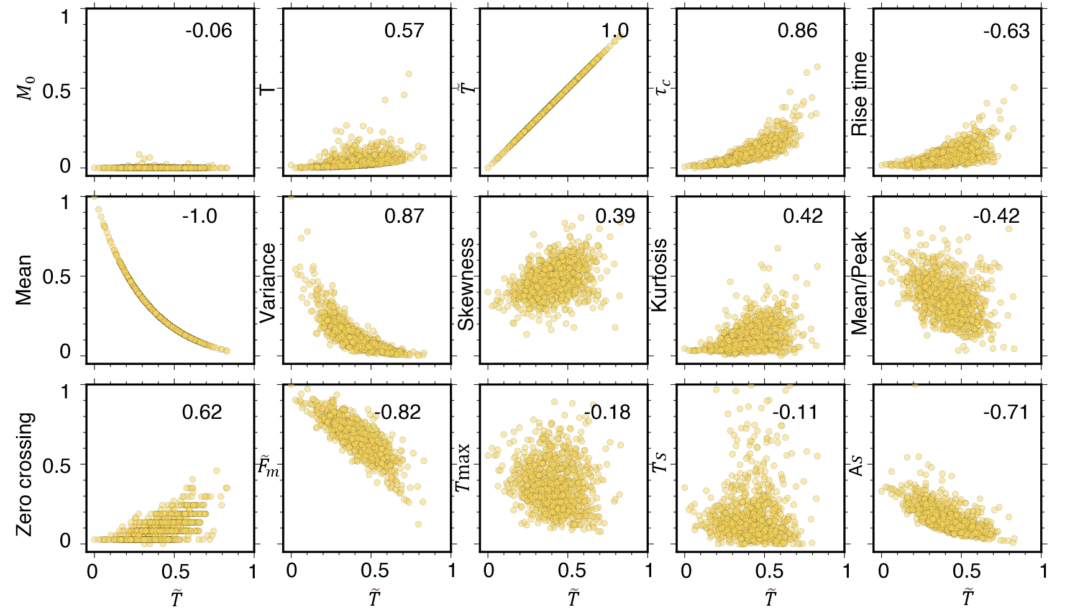
Figure S7. Spearman coefficient relations of STF features $\tilde{T}$ for intermediate-depth and deep-focus earthquakes.

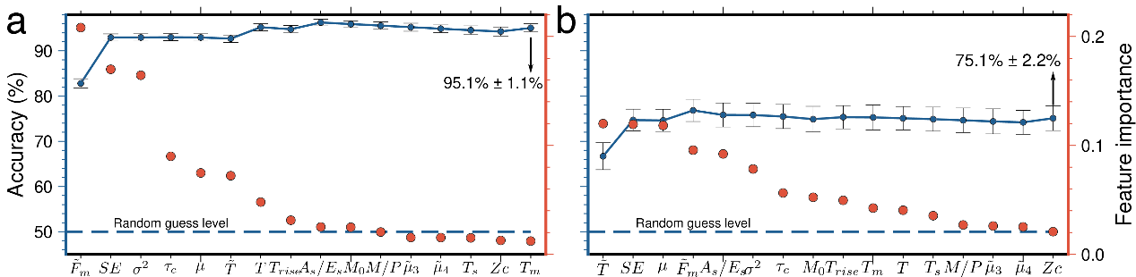
Figure S8. Random forest classification accuracy with an additional feature, scaled energy. (a) The red dots are the feature importance for shallow and deep earthquake classification (the Y label on the right). The blue dots are the accuracies of random forest classification by progressively adding features into the model from the highest to the lowest importance (the Y label on the left). (b) Similar to the left panel but for intermediate-depth and deep-focus earthquake classification.

