Online Resource 2
Mapping of resistance loci in wheat line Milan/S87230//Babax to South African races of Puccinia striiformis f. sp. tritici
Euphytica
Renée Prins^{1,2*}, Corneli de Klerk¹, Willem H.P. Boshoff³, Cornel M. Bender³, Zacharias A. Pretorius³, Kirsty S Botha¹, Elsabet Wessels¹
¹CenGen (Pty) Ltd, 78 Fairbairn Street, Worcester 6850, South Africa
²Department of Genetics, Stellenbosch University, Private Bag X1, Matieland 7602, Stellenbosch, South Africa
³Department of Plant Sciences, University of the Free State, Bloemfontein 9300, South Africa
* Corresponding author e-mail: cengen@cengen.co.za

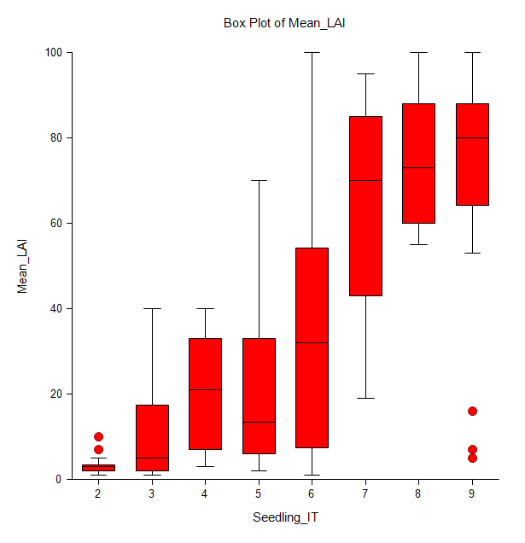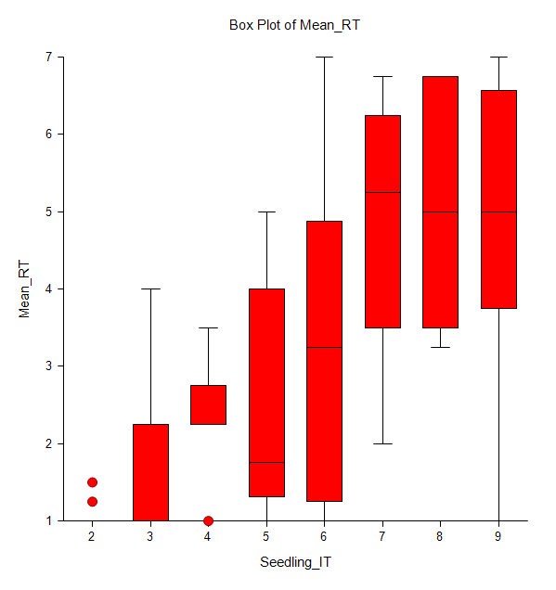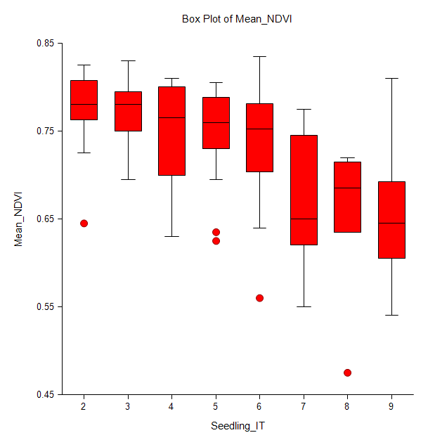
c
b
a

