Table S1 Comparison of the fatty acid profiles of strain XHP0099^{T} and closely related type strains within the genus Paracoccus.
Strains: 1, XHP0099^{T}; 2, ‘‘Paracoccus siganidrum’’ M26; 3, Paracoccus alkanivorans 4-2^{T}; 4, Paracoccus saliphilus DSM 18447^{T}; 5, Paracoccus salsus EGL L200073^{T}

Fatty acid | 1 | 2 | 3 | 4 | 5*
Straight-chain
C_{16:00} | 2.9 | tr | 1.1 | 1.5 | 2.2
C_{17:00} | 2.1 | 6.0 | tr | tr | 6.9
C_{18:00} | 18.3 | 4.4 | 10.8 | 10.6 | 12.1
Hydroxy
C_{10:0} 3-OH | 1.3 | 2.5 | 1.5 | 2.0 | 2.1
Unsaturated
C_{19:0} cyclo ω8c | - | 4.4 | 21.1 | 8.0 | tr
11-methyl-C_{18:1} ω7c | 1.8 | tr | tr | - | 7.4
Summed features
summed feature 2 | 1.6 | 1.9 | 1.2 | tr | tr
summed feature 4 | 2.8 | 1.68 | 2.8 | 1.8 | tr
summed feature 8 | 69.4 | 76.3 | 59.9 | 74.5 | 57.3

*Data from Gao et al.(2022) and this study. Values are percentages of total fatty acids. Fatty acids amounting to less than 1.0% in all strains are not shown. Major components (>10.0%) are highlighted in bold type; tr, trace amount (<1.0%); –, not detected.
Summed features represent groups of two or three fatty acids that cannot be separated by using the Microbial Identification System. Summed feature 2 comprised C_{14:0} 3-OH and/or iso-C_{16:1}; summed feature 4 consists of C_{20:1} ω7c and/or C_{20:1} ω9c and summed feature 8 consists of C_{18:1} ω7c and/or C_{18:1} ω6c.

Table S2 Occurrence of methylotrophy genes in strain XHP0099^{T} and closely related type strains within the genus Paracoccus.
Strains: 1, XHP0099^{T}; 2, ‘‘Paracoccus siganidrum’’ M26; 3, Paracoccus alkanivorans 4-2^{T}; 4, Paracoccus saliphilus DSM 18447^{T}; 5, Paracoccus alcaliphilus DSM 8512^{T}. +, present; -, absent.

Gene cluster | 1 | 2 | 3 | 4 | 5
Formaldehyde oxidation | + | - | + | + | -
XoxF-type methanol oxidation | + | + | + | + | -
Calvin cycle type 1 | + | + | - | - | +
Calvin cycle type 2 | - | - | - | - | -
Serine cycle type 1 | - | + | + | + | +
Serine cycle type 2 | - | - | - | + | -
Serine cycle type 3 | - | - | - | - | -

Table S3 Negative traits of XHP0099^{T} in API 20NE tests and API ZYM tests

API 20NE tests | arginine dihydrolase, D-glucose fermentation, hydrolysis of gelatin, hydrolysis of urea and production of indole and assimilation of adipic acid, capric acid, D-glucose, D-maltose, D-mannose, D-mannitol, L-arabinose, malic acid, N-acetylglucosamine, phenylacetic acid, potassium gluconate, trisodium citrate.
API ZYM tests | acid phosphatase, alkaline phosphatase, esterase (C₄), esterase lipase (C₈), leucine arylamidase, naphthol-AS-BI-phosphohydrolase, α-glucosidase.
Data from and this study.

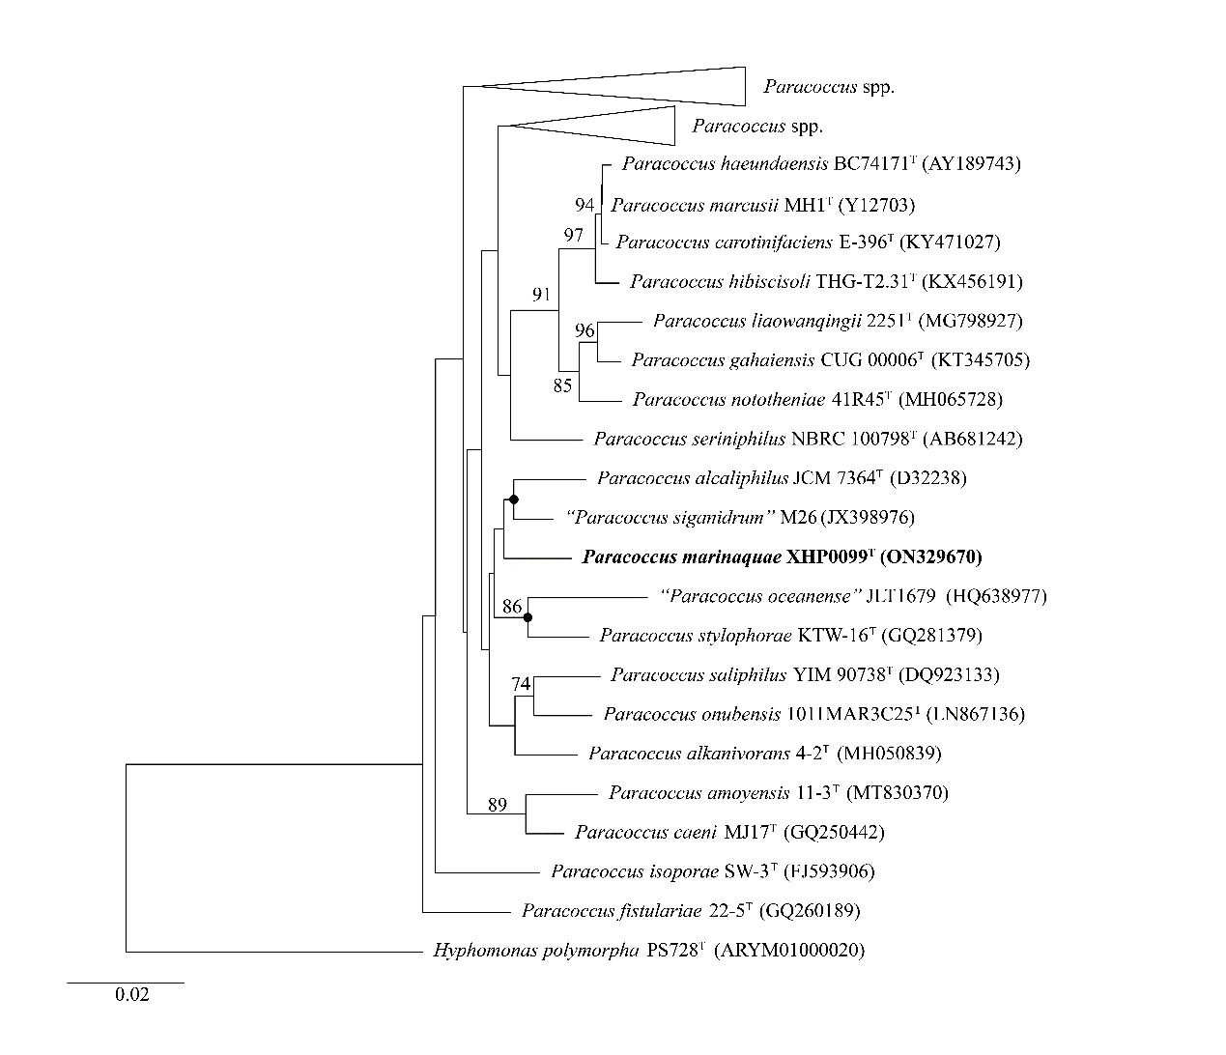
Fig. S1 Neighbor-joining tree from a comparative analysis of 16S rRNA gene sequences showing the phylogenetic relationships between strain XHP0099^{T} and other species of the genus Paracoccus. Bootstrap values (expressed as percentages of 1000 replications) >70% are shown at the branch points. Filled circles indicate nodes that were also found with the maximum-likelihood and minimum-evolution methods. The GenBank accession numbers are indicated in the brackets at the end of the tip labels. Hyphomonas polymorpha PS728^{T} is used as out group. Bar, 0.02 substitutions per nucleotide position.

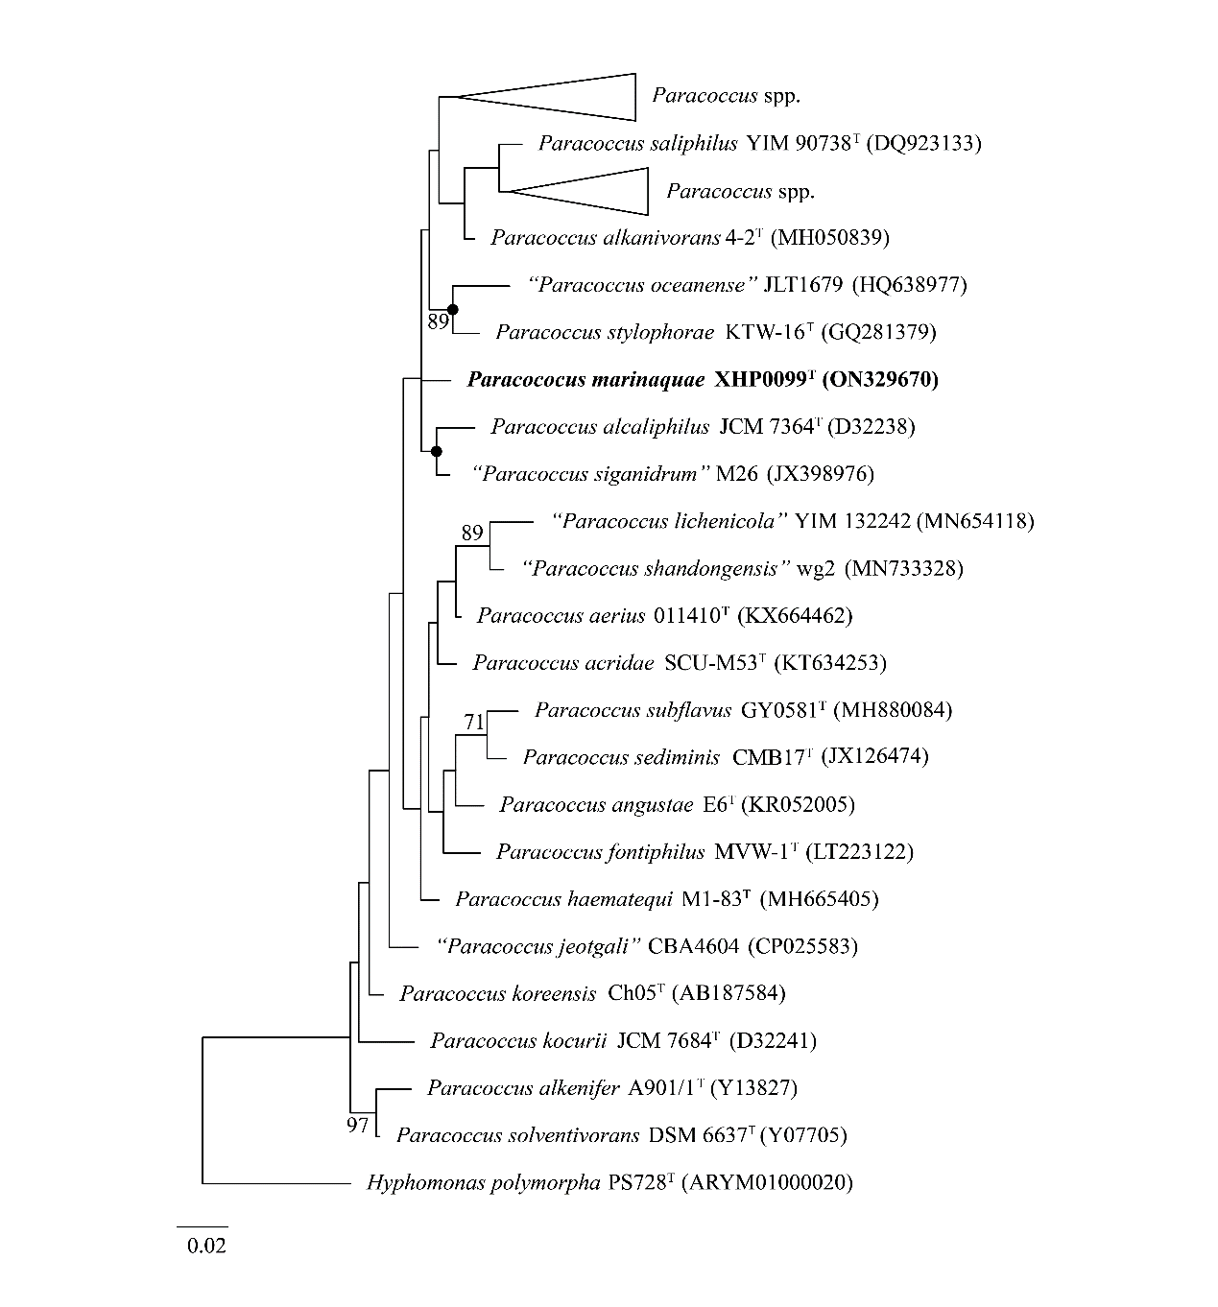

Fig. S2 Maximum-likelihood phylogenetic tree based on 16S rRNA gene sequences showing the position of strain XHP0099^{T}. Bootstrap values (expressed as percentages of 1000 replications) of above 70% are shown at the branch points nodes. Hyphomonas polymorpha PS728^{T} is used as out group. Bar, 0.02 substitutions per nucleotide position.

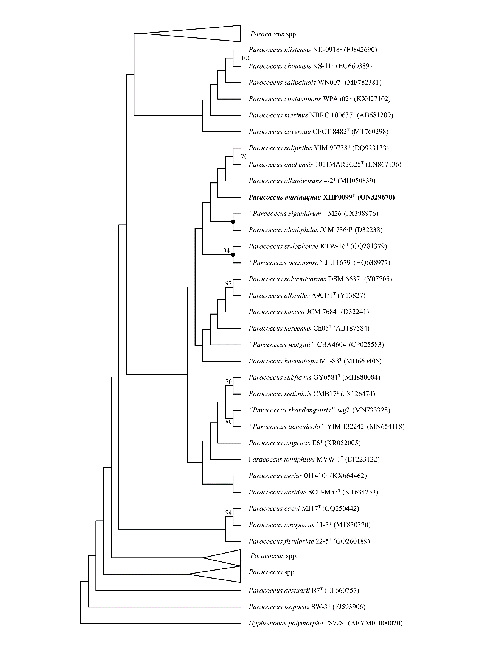

Fig. S3 Maximum-parsimony phylogenetic tree based on 16S rRNA gene sequences showing the position of strain XHP0099^{T}. Bootstrap values (expressed as percentages of 1000 replications) of above 70% are shown at the branch points nodes. Hyphomonas polymorpha PS728^{T} is used as out group.

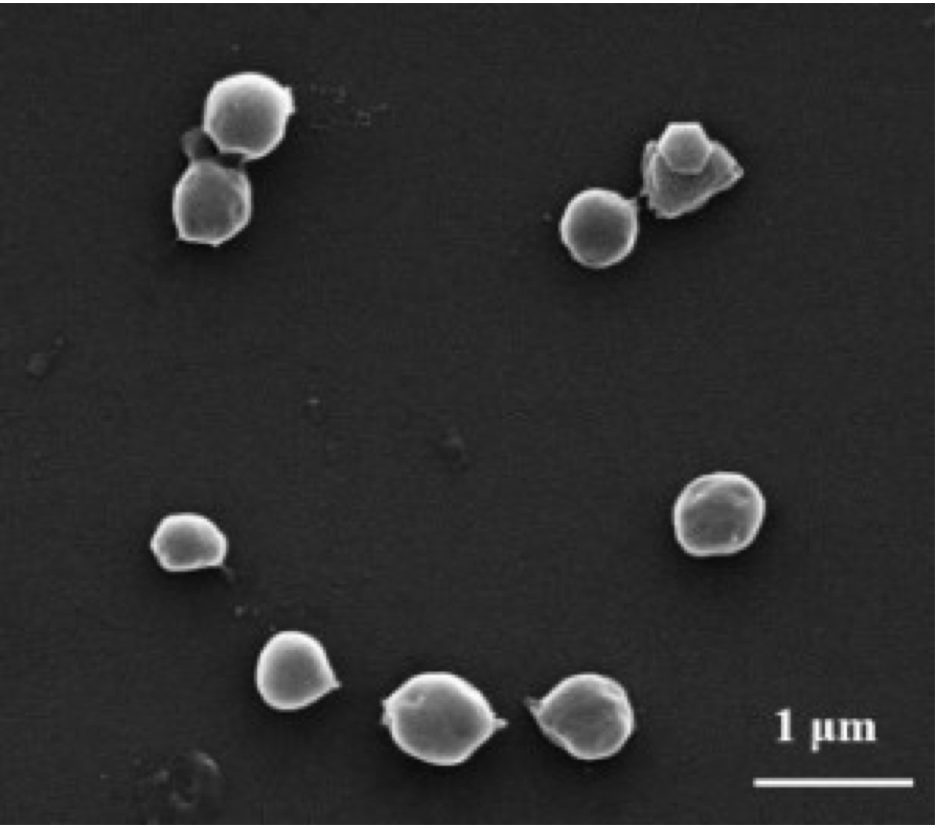

Fig. S4 The cell morphology of strain XHP0099^{T} was observed under scanning electron microscopy (SEM). Bar, 1.0 μm.

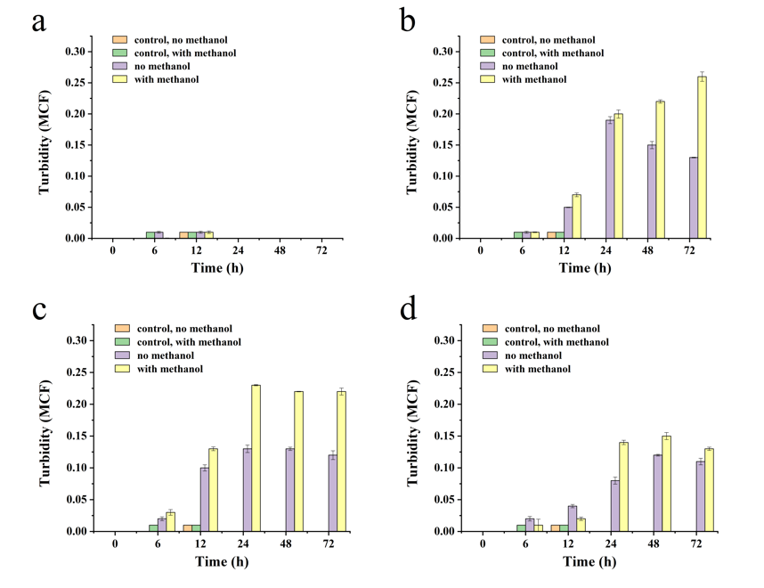

Fig. S5 The growth of Paracoccus spp. in different methylotrophic substrates. a, XHP0099^{T}; b, “Paracoccus siganidrum” DSM 26381; c, Paracoccus alkanivorans CGMCC 1.13669^{T}; d, P. saliphilus DSM 18447^{T}.

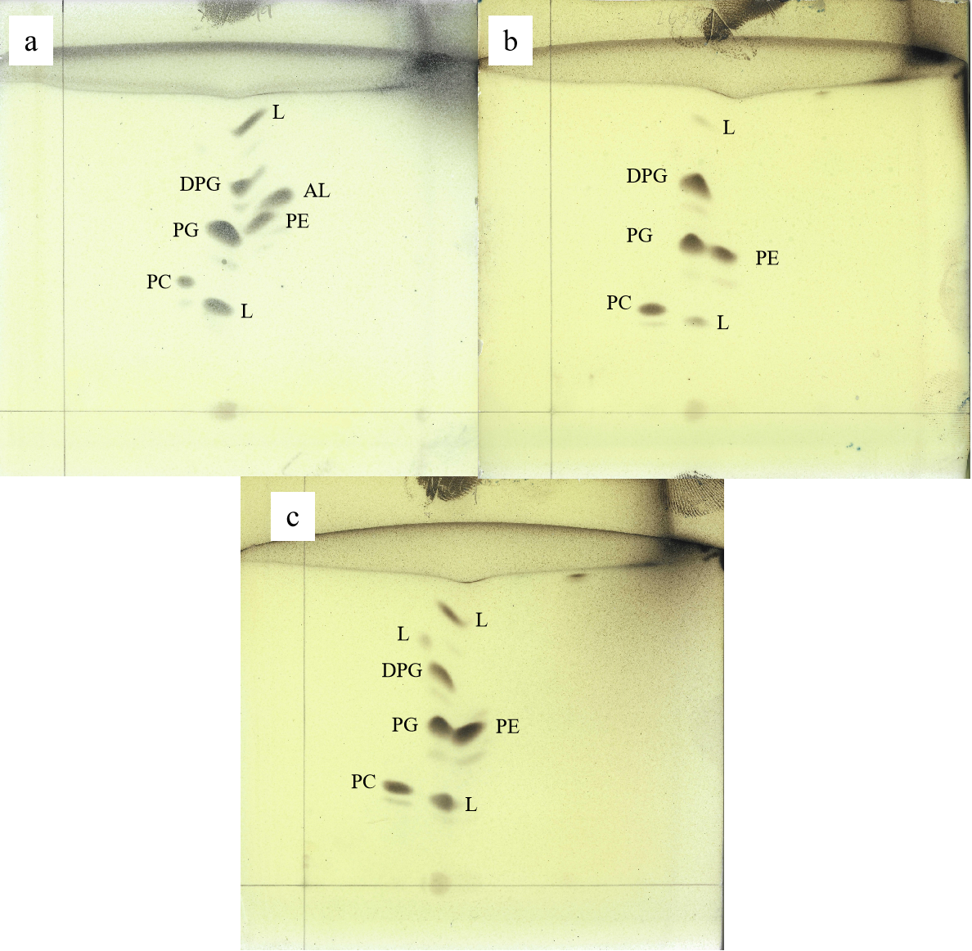
Fig. S6 Two-dimensional thin-layer chromatogram of polar lipid profile of strains: a, XHP0099^{T}; b, “Paracoccus siganidrum” DSM 26381; c, Paracoccus alkanivorans CGMCC 1.13669^{T}.
DPG, diphosphatidylglycerol; PC, phosphatidylcholine; PE, phosphatidylethanolamine; PG, phosphatidylglycerol; AL, aminolipid; L, unidentified polar lipid

