
Radiation

Increasing 60 kg N ha⁻¹> N topdressing ratio

Leaf area
Chlorophyll content
PAR
Photosynthetic rate

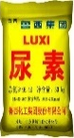
(Urea)
N application methods
Four N levels
0, 120, 180 and 240 kg N ha⁻¹

Four N topdressing ratio
0:0, 7:3, 6:4 and 5:5

Fertilizer
Canopy photosynthesis analysis

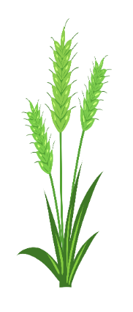
6:4

240 kg N ha⁻¹
Protein
Sedimentation value
Wet gluten
Hardness

Grain quality and yield
analysis

5:5
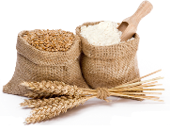
Yield
Harvest index

240 kg N ha⁻¹
6:4>5:5>7:3

