Table 2 Gains and NF at pump power 20dBm & input power +23.5dBm
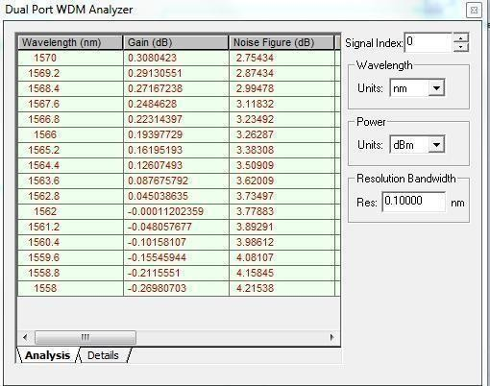

Table 3 Gains and NF at pump power 20dBm & input power +25.5dBm

